Module Code: LCBB4005
Module Title: Global Business Environment Assessment 2

Student Name:Velko Chakalov
Student Id:1917352
Lecturer name:Rexon Nting

Contents
Introduction 3
COVID-19 pandemic, a critical analysis of the developments that Zara has aroused in the previous months 4
Pestel Analysis 6
Illustrating the recommendations I assume will be beneficial to Zara 9
Porters Five Forces 9
Recommendations 11
Conclusion 12
References 13

Introduction
Global factors directly affect the business and influence the companies' decision-making on various perspectives like a mission statement, organising procedures, resources, and marketing strategies. This impact of global factors on business is known as the global Business environment that influences every business directly or indirectly. Zara is a leading fashion market dominator in the fashion industry with its outstanding service and procedures (Zara.com, 2020). In this report, the business environment of Zara after Covid-19 will be analysed, and the current scenario of the company will be evaluated with Pestel analysis and Porters five forces analysis. Lastly, some recommendations will be proposed to bring in the business operations, which will enhance the business model and activities of Zara after the covid situation (Bloomberg.com, 2020).

COVID-19 pandemic, a critical analysis of the developments that Zara has aroused in the previous months
Covid-19 pandemic has affected the ongoing fashion industry to a great extent. Customers and potential buyers are cutting off their costs, so most of them ignore their fashion sector as it is not as significantly important as the other ones. The recession that the world is facing is allowing the fashion industry faces a slight decline. Zara has been affected by the decline in the retail and fashion industry and to cope with that Zara is taking some steps that may enhance the company's sales and revenue margin. Zara has faced a 19% decline in manufacturing and stock in trade (Bloomberg.com, 2020). The owner of Zara has to close more than 12000 outlets of Zara all over the world by June, which is quite a threat. After that Zara has taken some steps which are—
- Reduce production
Zara is well-known for its flexible supply chain and the less and explicit production method of the brand. In this pandemic timeline, Zara has reduced almost 19% of its stock-in-trade and made the changes for not wasting their capital. Even if they had produced the products, they would have been unsold, and ultimately Zara would have faced tremendous loss. The unique supply chain of Zara has really made things easier and efficiently executed. Zara has benefited from the adaptable contract that enables the company to adjust quickly to changes in demand. This softened the impact on earnings that exceeded analyst estimates even though they were less than half last year's level and as a result, stocks rose as much as 6.7% (Zara.com, 2020).
- Investment on E-commerce
The largest clothing chain operator in the world has shown steady improvement after suffering its only record loss in the first quarter. Chairman Pablo Isla is moving forward with a plan to invest about $3 billion over the next three years in e-commerce, renovations and new stores to better position Inditex when the pandemic ends. Investment On the E-Commerce site and selling the products online have really impacted the sales of the products and have reached almost 75% increment in the sales and revenue margin (Parma et al., 2020).
- Faster Delivery and Faster service
Customers are getting faster delivery as Zara has a big supply chain with the possible number of suppliers. Zara is really pulling the covid situation off and becoming profitable again with online selling. As most of the rivals of Zara are facing the consequences of Covid and getting late shipping, Zara doesn't understand any such issues and is quite fast at delivery and order placement. The new model of Zara has impacted the technological part and the quicker delivery propositions, which has made Zara one of the most preferred brands for customers. This new online shift and flexible supplier relationship has favoured Zara and increased their shares accordingly (Parma et al., 2020).

Pestel Analysis
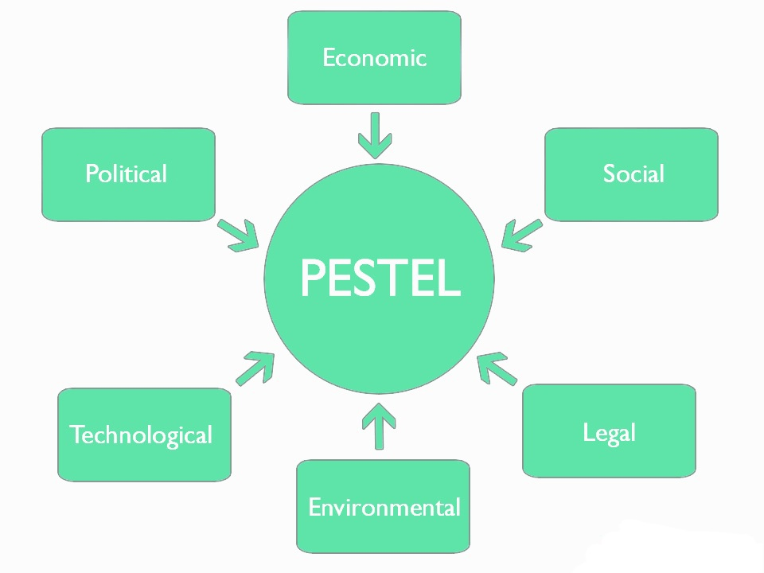
Talking about the fashion industry, Zara has always been the most innovative and industrialised brand, and they've always come up with innovatively exceptional ideas about fashion. But after the pandemic period, the outer look of the fashion industry has changed(Vukkadala et al., 2020). The pest analysis of Zara is given below to illustrate the whole concept of the internal and external environment of Zara.

Figure 1: PESTEL Analysis Model (Parma et al., 2020)
Political environment
Zara, as a Spanish brand, has experienced all of the advantages of running a business. In a political sense, the country's comprehensive trade deals are among the main pros of operating a business in the EU. This not only makes it relatively easy to import raw materials and export finished goods within the European Union, but it also makes it easy for Zara to send its merchandise around the world at a low cost and with little effort (Martimroll.com, 2020). Though Brexit will affect the global market and the companies may face some harmful consequences due to that. Rather than that, the world economy may influence fashion and industry, but as Zara is a brand that looks for demand first and then produces the products, things are optimistic for it.
Economic Environment
As Spain is one of the most unemployed country, this implies that labour expenses are relatively low. Especially outstanding to the other countries in Western Europe the labour cost of Zara is really low and this side should get some attention. Actually, a major part of its goods are manufactured and prepared in Spain by Zara and in that case this low labour cost enables them to reduce costs and thereby increase profitability. Again, the low labour cost in Spain is undoubtedly an advantage for Zara and is supportingg it from the very beginning of the business. Zara is a well-recognised company, so they might assume that those less familiar with its products are very costly. On the other hand, when Zara is compared to other European highly recommended fashion icons, it is contemplated to be a relatively inexpensive brand. This facilitates and boosts the enterprise to withstand any situation (Martimroll.com, 2020).
Sociocultural Environment
Zara is fashionable and along with that affordable. This is the main differentiating factor that have changed the fate of Zara and made it one of the most successful brand in Europe and globally. Zara is a brand that delivers best quality products and ensure that customers are happy with the output and their feedbacks are taken accordingly.Customers love the service that provides them and takes their opinion seriously and that's why is the social culture environment of Zara is quite favourable and in their court. Their optimistic and sophisticated brand presence with a highly motivated and enthusiastic customer base is the ladder of their fate and profit margins. While in 21st century, clothing shopping may not be an excellent equivalent event for the internet but customers now expect to order their clothing from online and want to enjoy the facility of online shopping that is provided by the brands. Zara is now focusing more on online purchase as the customers are okay with this new concept of purchasing (Martimroll.com, 2020).
Technological Environment
after seeing the evolution that is happening and Technology sectors are has started to think about investing more on technological aspects of the business. Do there was a time when Zara was not logically that song now as Zara has started to invest in the technological site of the business this environment of Technology is favourable for for Zara. Catering to the customers demand Zara has started online shopping and online purchase systems. Zara has always been inspired by the the wontons and designers of the customers and this very thing has made Zara take a technological change in the business (Martimroll.com, 2020).
Legal Environment
Zara is a company that has always stayed in the lines of law and executed the law every time. The most important and crucial law for the fashion industry is the law of copyright. Anything that other brand have innovated can never be used by Zara and this is something that Sarah has always cherished and maintained throughout their business model. But sometimes copyright problems may arise and Zara may fall into these copyright law precautions. So this can be a threat for the business (Martimroll.com, 2020).
Environmental Environment
When it comes to fashion industry one of the most crucial environment is the environmental environment. As after the manufacture part a lot of waste is generated from fashion industry manufacturer companies. Zara is quick and fast fashion industrial brand and is following cost-leadership method for innovation as well. and this part of the business and supply chain has enabled less waste production than most of the fashion industry brands. So the stocking inventory system of Zara has really benefited in the environmental environment and given Zara a plus point (Martimroll.com, 2020).

Illustrating the recommendations I assume will be beneficial to Zara.

Porters Five Forces
After the covid-19 pandemic has taken over the world, all the industries have been hampered, and the business world has faced a great decline because people's luxury has stopped and people are looking for necessities now. The porter's fibe forces analysis of Zara is given below.
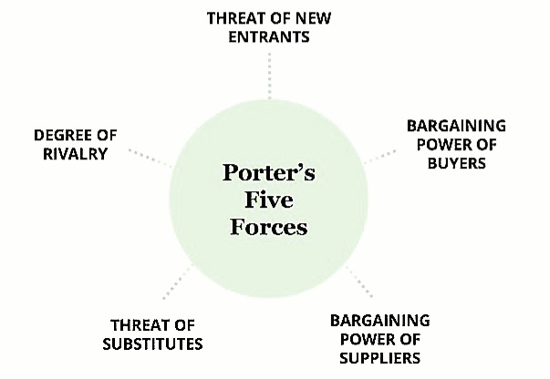
Figure 2: Porters five forces model (Worthington and Britton, 2015)
Bargaining power of Buyers: Moderate
Though the world is going to a pandemic period right now, the buyer's power still remains moderate. The retail industry is rising again with leaps and bounds and the power of buyers has become moderate, as they are the decision-maker. After Covid almost all the brands are taking precautionary steps to hold onto customers (Sarker and Al Saeed, 2020).
Bargaining power of Suppliers: Moderately high
After pandemic, most of the countries have gone into a lockdown situation, so suppliers' demand has increased quite alarmingly. Global suppliers are not able to fulfil the demands of these brands. The available suppliers have a primary advantage to have a great impact and a larger portion in agreements. Concerning the quality, Zara is sticking to good and promising suppliers, which has given the suppliers moderately high priority (Sarker and Al Saeed, 2020).
Threat of New Entrants: High
The garments and fashion industry has now flourished and new entrants are willing to start their business. So the threat for new entrants is high and that may affect the current market explicitly. People are now at an experimental period of time; they are switching brands and trying new things. Though Zara is an innovative and exclusive brand, new entrants' threat remains high (Sarker and Al Saeed, 2020).
Threat of Substitutes: Moderate
The threat of substitute is moderate, and there are two reasons for this. One is, Zara is an innovative and experimental brand that introduces the new and fashionable collection. Unique is the USP for Zara that makes the threat of substitute low. But, as people can get the same quality product in the local market at a lower rate, it can be rated moderate (Sarker and Al Saeed, 2020).
Degree of rivalry: Moderate
The fashion Indus is always in a throat-cutting competition. All the competitors come up with innovative and exciting ideas to get the market and become a market leader. So the love rivalry factor is moderate in Zara's perspective. Because, Zara has its own unique selling points, cost-leadership and innovation have derived it from the rest of the industry companies (Sarker and Al Saeed, 2020).

Recommendations
- Again, in order to compete in the market somehow, all of these must be reviewed by the company regularly. For one particular intention, Zara has become a top manufacturer: it sells high-end garments and accessories at an affordable price. With reduced labour costs maintaining a high shareholder margin, the core business model of the company is fine. There is some uncertainty about the legality issues, but Zara should be more than enough mature to deal with them.
- Throughout the garment and retail market, there is very strong rivalry. Now, in terms of attractiveness, all the forces of the five porters also have a major impact on the industry. Among the five forces, competitive rivalry for existing players is strongest, accompanied by pressures from new entrants that decrease the attractiveness of the industry. In order to ensure customer loyalty in the garment industry, these two factors allow a company to react aggressively but morally.
- The rivalry from each of these processes ensures that companies keep costs as low as they can possibly make money. Although this same company does seem to have a resilient faster growth rate in its competitor in the initial stage of production, which is clearly evident through its earnings growth. Zara’s possibilities have also been fruitful. Indeed, the textile industry is a feasible area for profitable investment.
- Via ongoing trends, market demand changes and transient characteristics of clients. Based on the predictions in the case, the industry has a promising outlook as businesses consolidate their relaxation field in attracting and retaining participants. The main problems are economic decline, personal income volatility, dealing with preferred customers, stringent service regulations in less developed countries and the ability to be creative and inventive (Cai and Choi, 2020).

Conclusion
After all the discussion and recommendations are given on the situation of Zara, there is no doubt that Zara can overcome the covid-19 situation and the decline in sales. For doing that Zara must take some innovative and exclusive attempts to differentiate the company from the rest of the market and attract customers to become impulsive about buying. These recommendations are based on the previously taken actions of Zara, and the outputs of these recommendations have really paid off to other companies as well. Zara is a strong brand in their industry, and it is evident that their current situation if the decline will come to an end, and this brand will continue being the market dominator again.

References


