Student name: | Ionela Olivia Lupsa | Student ID number: | 2416880
Programme: | BA (Hons) Leadership and Management Skills in the Workplace
Module: | Project Management
Module code: | LCLM5003 | Contributio n to Overall Module  Assessment (%): | 100%
Module Leaders: | Rexon Nting  Doreen Nyaa Amundam | Internal  Verifier: | Md Kalam  Samuel Ofori
Assignment Title: | A Project portfolio. | Word count or  equivalent. | 3880
Submission  deadline: | Submit part A, B & C as a single portfolio document using the template provided  28/04/ 2026- 14:00 (2PM) | Return date for  provisional marks and written  feedback: | 28/05/2026

Executive Summary
The West Midlands Flood Recovery: Highway Reconstruction and Reopening Project is devoted to the recovery of the main transportation infrastructure that was destroyed by the intensive floods caused by the River Severn breach in July 2025. The disaster greatly impacted major towns like Worcester, Shrewsbury and Kidderminster, which affected transportation, emergency response operations and the economy. The primary goal of the project will be to recover and reopen key highways to facilitate the safe transportation of people, commodities, and emergency services to contribute to the recovery of the region. Some of the major activities involved in the project are the assessment of the damages, the removal of the debris, the resurfacing of the roads, the rebuilding of the bridges, and the provision of the traffic safety systems. The implementation of a structured project management approach is implemented through tools such as the Work Breakdown Structure (WBS), Gantt Chart and risk management planning in order to achieve efficient implementation within the timeframe of an estimated 10-12 weeks. The project budget will be about 1.5 million pounds, which will be divided into labour, materials, equipment, and a contingency fund to overcome unforeseen risks. The main stakeholders are the local government authorities, construction contractors, the emergency services, utility providers, and local communities and integration and participation are the keys to a successful project implementation. In general, the project will help to restore transportation connectivity, improve the safety of the population, and contribute to the economic and social recovery of the communities located in the West Midlands after the flood disaster.
Table of Contents
Part A: Project proposal poster 4
Introduction 4
Project overview 4
Project objectives 4
Project scope 4
Stakeholders 5
Risk management 5
Resource allocation 6
Conclusion 6
Part B: Reflections from the feedback received from the tutor and peers 6
Part C: Project Management Plan 8
Introduction 8
Project description 8
Scope 9
Work breakdown structure 10
Project Management 10
Damage Assessment and Inspection 11
Debris Removal and Site Preparation 11
Reconstruction and Repair 11
Traffic Control and Safety Measures 12
Final Inspection and Project Handover 12
Quad Chart 12
Gantt Chart 13
Stakeholders' involvement 13
Allocation of resources 15
Risk Analysis 16
Conclusion 18
References 19

List of Figures
Figure 1: Poster 5
Figure 2: Work Breakdown Structure (WBS) 12
Figure 3: Quad Chart 14

List of Tables
Table 1: Risk Management 8
Table 2: Gantt Chart 16
Table 3: Stakeholder Matrix 18
Table 4: Risk Analysis Table 20

Part A: Project proposal poster
Project title: West Midlands Flood Recovery: Highway Reconstruction and Reopening
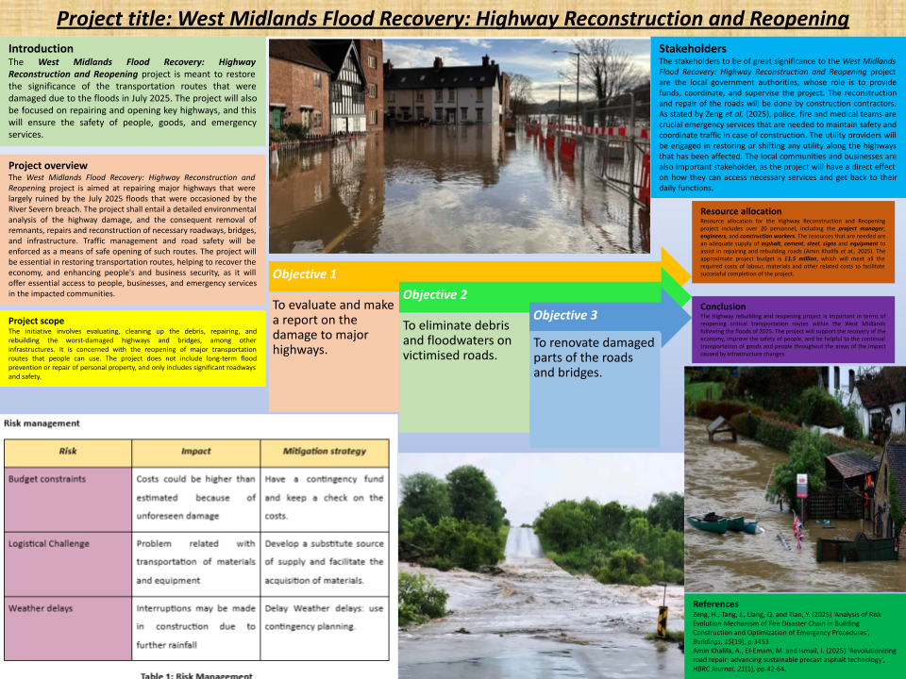

Figure 1: Poster

Introduction
The West Midlands Flood Recovery: Highway Reconstruction and Reopening project is meant to restore the significance of the transportation routes that were damaged due to the floods in July 2025. The project will also be focused on repairing and opening key highways, and this will ensure the safety of people, goods, and emergency services.

Project overview
The West Midlands Flood Recovery: Highway Reconstruction and Reopening project is aimed at repairing major highways that were largely ruined by the July 2025 floods that were occasioned by the River Severn breach. The project shall entail a detailed environmental analysis of the highway damage, and the consequent removal of remnants, repairs and reconstruction of necessary roadways, bridges, and infrastructure. Traffic management and road safety will be enforced as a means of safe opening of such routes. The project will be essential in restoring transportation routes, helping to recover the economy, and enhancing people's and business security, as it will offer essential access to people, businesses, and emergency services in the impacted communities.

Project objectives
- To evaluate and make a report on the damage to major highways.
- To eliminate debris and floodwaters on victimised roads.
- To renovate damaged parts of the roads and bridges.
- To install road signs and road controls.

Project scope
The initiative involves evaluating, cleaning up the debris, repairing, and rebuilding the worst-damaged highways and bridges, among other infrastructures. It is concerned with the reopening of major transportation routes that people can use. The project does not include long-term flood prevention or repair of personal property, and only includes significant roadways and safety.

Stakeholders
The stakeholders to be of great significance to the West Midlands Flood Recovery: Highway Reconstruction and Reopening project are the local government authorities, whose role is to provide funds, coordinate, and supervise the project. The reconstruction and repair of the roads will be done by construction contractors. As stated by Zeng et al. (2025), police, fire and medical teams are crucial emergency services that are needed to maintain safety and coordinate traffic in case of construction. The utility providers will be engaged in restoring or shifting any utility along the highways that has been affected. The local communities and businesses are also important stakeholders, as the project will have a direct effect on how they can access necessary services and get back to their daily functions.

Risk management
Risk | Impact | Mitigation strategy
Budget constraints | Costs could be higher than estimated because of unforeseen damage | Have a contingency fund and keep a check on the costs.
Logistical Challenge | Problem related with transportation of materials and equipment | Develop a substitute source of supply and facilitate the acquisition of materials.
Weather delays | Interruptions may be made in construction due to further rainfall | Delay Weather delays: use contingency planning.

Table 1: Risk Management

Resource allocation
Resource allocation for the Highway Reconstruction and Reopening project includes over 20 personnel, including the project manager, engineers, and construction workers. The resources that are needed are an adequate supply of asphalt, cement, steel, signs and equipment to assist in repairing and rebuilding roads (Amin Khalifa et al., 2025). The approximate project budget is £1.5 million, which will meet all the required costs of labour, materials and other related costs to facilitate successful completion of the project.

Conclusion
The Highway rebuilding and reopening project is important in terms of reopening critical transportation routes within the West Midlands following the floods of 2025. The project will support the recovery of the economy, improve the safety of people, and be helpful to the continual transportation of goods and people throughout the areas of the impact caused by infrastructure changes.

Part B: Reflections from the feedback received from the tutor and peers
Having introduced the first project proposal, the West Midlands Flood Recovery: Highway Reconstruction and Reopening project, I got valuable feedback concerning it, provided by my tutor and peers, which proved essential in terms of the final project plan. The feedback gave information on aspects in which I was good and those that I needed to work on.
What I did well:
Effective Expression of Objectives: The feedback indicated a well-organised set of project objectives that were in harmony with the general aim, which is the restoration of important highways. I ensured that the goals were specific, measurable and attainable, which appealed to the audience. The thoroughness in explaining the important tasks, including the clearing of the roadside, the reparation of the roads, and security controls, was complemented. This preoccupation with clear and actionable objectives resulted in the stakeholders being able to comprehend the scope and priorities of the project more easily.
Comprehensive Stakeholder Identification: I received praise for the identification of the most significant stakeholders, which were local government authorities, construction contractors, emergency services, utility providers, and the communities affected. On this note, Ramoglou et al. (2023) stated that the management of infrastructure projects should work closely with the major stakeholders, including government officials, contractors, other emergency agencies, service providers, and local communities, since their participation determines the success of projects and their social acceptance. In the feedback, it was observed that this was an exhaustive list of stakeholders and appropriately ranked in terms of their project contribution. The need to communicate effectively with these stakeholders was realised as a central factor in the success of the project.
Risk Management Aspects: Inclusion of possible risks as weather delays, budgetary constraints and logistical difficulties, was adequately welcomed. My suggested mitigation measures were viewed as effective and proactive measures to counter such risks, and these were contingency planning, cost monitoring, and alternate supply routes. This strategy proved that I was able to think about possible issues and had answers.
Needed improvements for the final project
Resource Allocation Clarification: The resource allocation section was well received; however, it was observed that I would have gone further to give details regarding human resources and material resources. As an example, when I stated that there would need to be more than 20 personnel, it was recommended that I offer detailed information on what they would be doing and what their qualifications would be. In the same manner, I ought to specify the amounts of materials required at every stage of the project, instead of expressing it in general terms, such as having enough stock.
Budget Breakdown: The other area where improvement was made was the budget breakdown. Although I stated that the cost is estimated as being approximately 1.5 million pounds, it was mentioned in the feedback that such a breakdown of the financial expenditure would be beneficial, especially in the aspects of labour costs, material costs, and contingency costs. According to Kerzner (2022), a more detailed table of project costs, which involves the cost of labour, material, and contingency, enhances financial control and helps to make better project budgeting. I will give a more detailed budget, which will include the amount of costs related to each stage of the project, as well as the cost of equipment, labour, and unforeseen expenses.
Stakeholder Engagement Plan: Despite having identified key stakeholders, based on the responses, I was advised to improve the stakeholder engagement plan. I will put more concrete plans in place on how the various stakeholders will be engaged during the project.
The feedback from my tutor and classmates gave me a good guide on how to improve my project plan. Although my feedback on the objectivity of the goals and stakeholder identification and risk management strategies was positive, I can use the feedback to work on the details of the timeline, resources, budgetary breakdown, and stakeholder engagement strategies. These advancements will make sure that the end project plan is thorough, feasible and implementable successfully.

Part C: Project Management Plan

Introduction
The West Midlands Flood Recovery: Highway Reconstruction and Reopening is an initiative aimed at restoring damaged critical infrastructure, which occurred as a result of the crippling floods that occurred in July, 2025 as a result of the River Severn breach. Worcester, Shrewsbury and Kidderminster were some of the worst-hit towns where the majority of highways were washed off, and business and local communities were heavily hit. The project is set on opening up important highways and taking into account reconstruction of the required roadways, bridges and utilities to offer efficient and secure transportation to the residents, business and emergency services. The project will be organised based on the project management method, such as risk management, allocation of resources and involvement of stakeholders, such that the project will minimise the delays, cost management and quality delivery within the stipulated 10–12-week time span. This approach will not only take care of the immediate, urgent recovery needs but also be involved in long-term restoration of the transportation infrastructure in the area.

Project description
The project is the West Midlands Flood Recovery: Highway Reconstruction and Reopening, whose objective is to restore crucial transportation infrastructure following a disastrous flood in July 2025. As per the given scenario, the River Severn was compromised due to a strange weather pattern in the Atlantic that led to flooding, which led to tremendous devastation in some of the cities, such as Worcester, Shrewsbury and Kidderminster. Hundreds and hundreds of homes and businesses were flooded, as well as electricity networks and streets. This also resulted in the fact that the movement of goods, services and the response operations to emergencies in particular was significantly influenced by the disruption of the transportation systems and network, including big highways. The key objective of this project is to reopen the key roads in the West Midlands that have been most affected in the region to experience the free flow of goods, people and emergency services. The project will encompass the total assessment and renovation of roads, bridges and other infrastructure. This includes clearing the road, repairing and resurfacing roads, the reconstruction of the structures of bridges and the installation of the traffic safety measures.
The key components of the project are:
- Damage Assessment: It is an overall survey of the highways that are damaged, regions requiring urgent work.
- Highway and Bridge Reconstruction: Rebuilding and overlays of roads and rebuilding and repairing structural items like bridges and tunnels.
- Safety: This is to install road signs, barriers and other traffic control implements to ensure that the construction and the post repair is safe.
- Timeline: The project is to be fulfilled in the period of 10-12 weeks, with milestones that will be executed gradually to be achieved on schedule.
According to Davis (2023), effective transportation helps business organisations to reopen and communities to resume their lives, thus the project is very critical towards the economic recovery. In this venture, the budget will be about 1.5 million pounds, comprising the labour, materials, equipment and contingency costs. The project will ensure that the required transport infrastructure is rejuvenated, and this will result in long-term recovery of the West Midlands.

Scope
The West Midlands Flood Recovery: Highway Reconstruction and Reopening project is aimed at reinstating an important transportation channel that was considerably destroyed by the 2025 flooding. The project will involve accessing, repairing and rebuilding damaged highways, bridges, and other infrastructure to provide important access to transportation of goods, services, and emergency responders. On this point, Boakye et al. (2022) have stated that the main goals of rapid restoration of transport infrastructure after natural disaster events are to provide economic recovery and to be sure that citizens are safe. Activities included in the project will include, but not be limited to, getting rid of the debris, resurfacing the roads, repairing the structures of the bridges and tunnels to be used and installation of the safety measures that are needed to be taken, such as road signs and barriers. Nevertheless, it is not comprehensive in flood prevention or environmental mitigation over the long term, but only in the recovery of infrastructure in the short term. Moreover, the repairs of the private property and long-term urban planning will not be included in this project since they will not be part of its immediate scope.

Work breakdown structure
The project titled the West Midlands Flood Recovery: Highway Reconstruction and Reopening have several phases, which have certain tasks and deliverables. The WBS divides the project into manageable parts, which implies that there is clear management and an organised implementation. The project has a detailed Work Breakdown Structure, which is shown below:
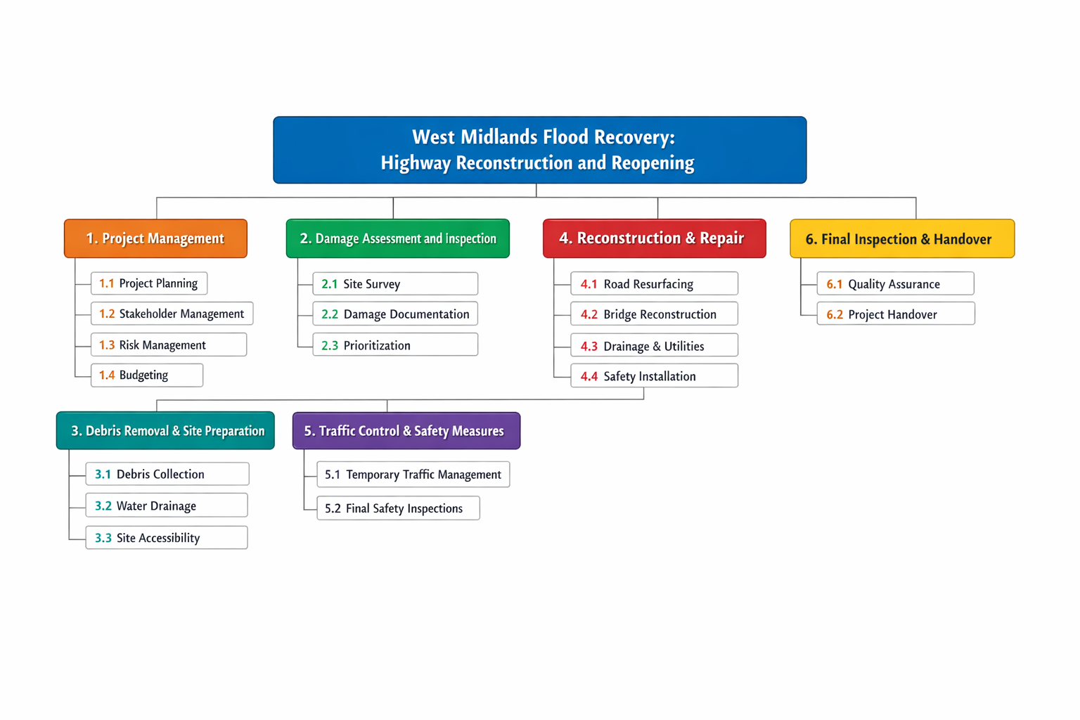

Figure 2: Work Breakdown Structure (WBS)

Project Management
The phase of the West Midlands Flood Recovery: Highway Reconstruction and Reopening project, which is the Project Management, has a number of essential elements. Project Planning entails the establishment of the scope, goals and objectives that will be used to guide the project. The Stakeholder Management is concentrated on defining the appropriate stakeholders and creating communication strategies (Limani et al., 2024). Risk Management involves the process of determining the risks, evaluating their effects and developing mitigation strategies. Finally, Budgeting entails setting up the project budget and constant monitoring of the financial resources in order to keep the project within the budget and on schedule during the term of the project.

Damage Assessment and Inspection
The Damage Assessment and Inspection stage is aimed at assessing the level of flood damage to highways and infrastructure. Site Survey, which entails physical inspection of roads, bridges and utilities that are affected with the aim of determining the extent of the damage. Damage Documentation provides complete documentation of the level of damage to road surfaces, structural and utilities. The priority is of paramount importance in order to determine the most urgent points which should be repaired as soon as possible to restore the vital roads of transportation to guarantee a quick recovery process and the minimum inconvenience to the movement.

Debris Removal and Site Preparation
The Debris Removal and Site Preparation stage aims at cleaning the areas that have been affected to be rebuilt. Franca et al. (2025) stated that debris collection is the process of cleaning up debris caused by floods on the roads, bridges and environs to regain access. Water Drainage assures that the right drainage systems are laid down so that flooding can be avoided in the future. Site Accessibility, which is part of the preparation of construction sites, is concerned with making the areas available to the repair work accessible to the machinery and equipment. The stage is necessary to establish a safe and functional setting where further rebuilding and fixing of infrastructure will be possible.

Reconstruction and Repair
The reconstruction and repair phase is aimed at repairing the damaged infrastructure. Road Resurfacing is the process that entails repairing and resurfacing roads to ensure safety on the road (de Bortoli et al., 2022). Bridge Reconstruction is concerned with the deterioration of bridges and overpasses and will maintain their safety and functionality. The specialised services of the Drainage and Utilities give attention to the reconstruction of damaged drainage and utilities like water, electricity and communication lines along the highways. Safety Installation involves the provision of road signs, barriers, and other safety systems that are needed to make sure that drivers and pedestrians remain safe during and after the repairs.

Traffic Control and Safety Measures
Traffic Control and Safety Measures entail safe transportation on construction sites. Temporary Traffic Management involves the installation of detours and temporary traffic lights to ensure the traffic is diverted safely over the construction. Last Safety Checks, all installed safety requirements like the signage and barriers, are checked against the regulatory standards to avoid accidents and ensure the easy movement of traffic.

Final Inspection and Project Handover
Final Inspection and Project Handover provide quality and completion of the project. Quality Assurance involves quality examination of repairs and reconstructions to ensure that they are of the required standards. Project Handover ensures that the highways are operational and safely transferred to local authorities who can use them.

Quad Chart
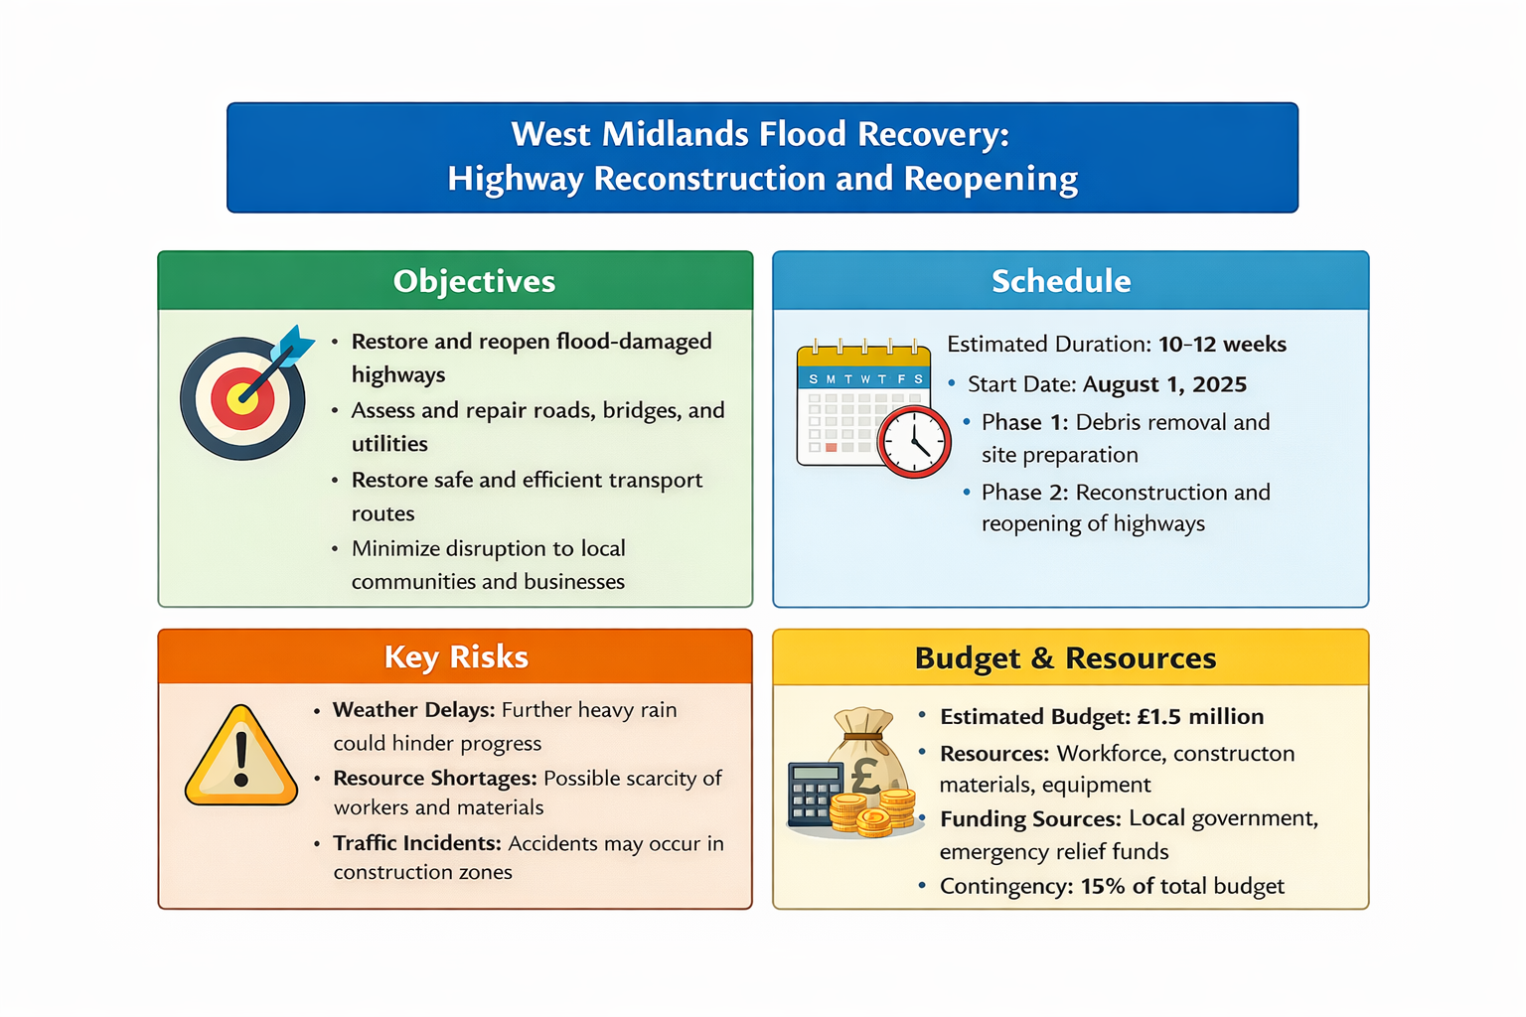

Figure 3: Quad Chart
The quad chart of West Midlands Flood Recovery: Highway Reconstruction and Reopening gives a clear and concise vision of the important issues of the project. The objectives section focuses on the recovery of flood-wrecked highways, the evaluation of essential infrastructure, and the reduction of the impact of floods on the local population. The Schedule presupposes the time frame of an estimated 10-12 weeks, and two significant stages: the removal of the debris and site preparation, then reconstruction and opening. The Key Risks point to possible weather delays, resource unavailability and traffic incidents, whereas the Budget and Resources section outlines a projected fund of £1.5 million, covered by local government and emergency reliefs, with a 15% contingency.

Gantt Chart
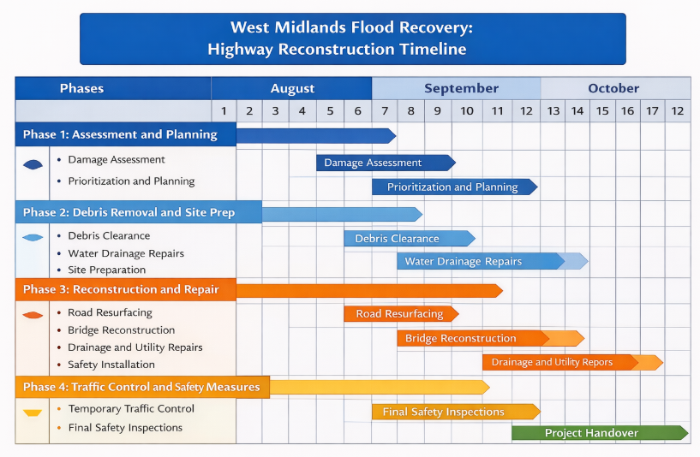

Table 2: Gantt Chart

Stakeholders' involvement
The effective completion of the West Midlands Flood Recovery: Highway Reconstruction and Reopening project lies in the active participation of different stakeholders with a particular role to play in ensuring that the goals are achieved in an efficient way. The communication and coordination of these stakeholders will be very important in ensuring that there are minimal disruptions and the project moves on.
Key Stakeholders:
Local Government Authorities (Worcester, Shrewsbury, Kidderminster): They will ensure general supervision of the project, regulatory concessions and capital. About them, they are mandated to make sure that the project is in tandem with the local development plans and needs.
Emergency Services (Police, Fire, Medical): The task of this category is to provide safety in the process of construction and organise road blocks, detours, and access to the emergency areas in case of an emergency.
Contractors Construction: They will be in charge of carrying out the reconstruction and repairing work of the roads, bridges and restoration of utilities.
Utility Providers: They are necessary in reconnecting services like electricity, water and communication lines that are destroyed during the flooding process. Their contribution is essential in ensuring maximum accessibility of highways and the safety of the people.
Local Communities and Businesses: The stakeholders in this category are the ones directly affected by the project because the reopening of highways would make essential access to citizens and businesses to continue their usual functions.
According to Maqbool et al. (2022), the Stakeholder Matrix helps to assist with mapping the level of influence, interest and involvement of each of the groups. It will inform the communication and make sure that the concerns of the stakeholders are addressed accordingly.
Stakeholder | Role | Interest | Influence | Communication plan
Local government authorities | Funding, project oversight and approvals | High | High | Regular meetings and progress reports
Emergency services | Safety, coordination of road closures | High | Medium | Daily updates and safety protocols
Construction contractors | Execution of repairs, road resurfacing | Medium | High | Weekly status meetings and reporting issues
Utility providers | Restore essential services and utilities | High | Medium | Direct collaboration and scheduling inspection
Local communities and businesses | Access restoration and resumption of services | High | Low | Public updates community forms and newsletters

Table 3: Stakeholder Matrix

Allocation of resources
The successful implementation of the West Midlands Flood Recovery: Highway Reconstruction and Reopening project requires proper resource allocation to be successful. When the human, material, and financial resources are managed properly, it will keep the project on schedule, as well as keep it on time and ensure that it is completed within the stipulated budget.
Human Resources:
Various stages of the project will require a great number of different professionals who can be skilled. A Project Manager will oversee the project, do general coordination, planning and communication. The technical part will be done by the engineers and Construction Workers, including the resurfacing of the roads, bridge repairs and restoration of the infrastructure. The utility technicians help to collaborate with utility providers to restore electricity, water and communication lines on the highways (Grigg, 2025). Moreover, there will be a Safety Officer who will be in charge of the health and safety guidelines during the project. The human resource requirement is estimated at:
- Project Manager: 1
- Engineers and Site Supervisors: 4-5.
- Construction Workers: 15-20
- Utility Technicians: 5
- Safety Officers: 2
Material Resources:
Other material resources are the construction materials, machinery and safety equipment to rehabilitate the highways and other facilities on which they are supported. The main supplies required consist of:
- Asphalt Cement and Steel to re-lay roads and repair bridges (Zhao et al., 2023).
- Restoration of broken utility networks Drainage Systems and Pipes.
- Construction and post construction Safety Road Signage, Barriers and Traffic Control devices.
- Heavy machinery like excavators, bulldozers, cranes and trucks to ease the task of clearing the mess, digging and moving materials.
Financial Resources:
The project is estimated to cost 1.5 million pounds, which will take into account the cost of labour, material, equipment and the cost of unforeseen occurrences. It also includes a contingency fund of 15%, which is used when something goes amiss during the course of construction. The budgetary allocation will be the following:
- Labor Costs: £600,000
- Materials: £400,000
- Equipment and Machinery: £300,000
- Contingency Fund: £200,000
Through an adequate distribution of such resources, the project will be in a good position to deal with the complexities of highway restoration and reconstruction. Then, it will be necessary to monitor the consumption of the resources regularly to make sure that the project is running on schedule and within the budget.

Risk Analysis
Type | Risk | Impact | Mitigation strategy
Internal | Miscommunication between stakeholders | Generate confusion due to ineffective communication | Needs to develop a robust communication plan on a regular basis
Internal | Logistical challenge | Occurs  difficulty in transporting materials | Needs to read an alternative plan regarding the supply routes
Internal | Budget constraints | Unforeseen costs like labour shortages or price increases of materials | Needs to establish a contingency fund and adjust procurement strategies
External | Weather delays | Construction might be delayed | Needs to monitor the weather forecast
External | Public safety incidents | An accident can arise from working in flood-affected areas | Need to implement strict safety protocols on regular updates

Table 4: Risk Analysis Table
The West Midlands Flood Recovery project has several risks, such as weather delays as a result of the continuous rainfall, an increase in the budget due to unforeseen expenses and transporting the materials which are not easily available by road. The safety incidents are also an issue, and they need stringent safety measures. Miscommunication among stakeholders would lead to delays; however, a sound communication strategy will overcome it. The mitigation strategies cover weather monitoring, contingency fund, alternative supply route, safety measures, and keeping the stakeholders informed and aligned through clear communication.

Conclusion
In conclusion, the project is the West Midlands Flood Recovery: Highway Reconstruction and Reopening, which is a very important project that seeks to rebuild the infrastructure that provides transportation facilities in the towns that have been affected, so as to rebuild the transport facilities and restore access and movement within the communities. The project aims at both short-term requirements and long-term recovery, which is aimed at reopening of highways, rebuilding damaged bridges, and restoring damaged utility infrastructure. The project would reduce disruption, be safe, and be within its budget limit through proper planning, adequate management and involvement of the stakeholders. With the help of the defined project management strategy, the risk management strategies, and the presence of well-defined communication channels, the project is highly likely to be completed within the allocated 10-12 weeks. This initiative will be of key importance in aiding the West Midlands to recover and succeed in the aftermath of the flooding disaster once the successful completion.

References
Part A
Amin Khalifa, A., El-Emam, M. and Ismail, I. (2025) ‘Revolutionizing road repair: advancing sustainable precast asphalt technology’, HBRC Journal, 21(1), pp.42-64.
Zeng, H., Tang, J., Liang, Q. and Tian, Y. (2025) ‘Analysis of Risk Evolution Mechanism of Fire Disaster Chain in Building Construction and Optimization of Emergency Procedures’, Buildings, 15(19), p.3453.
Part B
Kerzner, H. (2025) Project management: a systems approach to planning, scheduling, and controlling. New Jersey: John Wiley & Sons.
Ramoglou, S., Zyglidopoulos, S. and Papadopoulou, F. (2023) ‘Is there opportunity without stakeholders? A stakeholder theory critique and development of opportunity-actualization’, Entrepreneurship Theory and practice, 47(1), pp.113-141.
Part C
Boakye, J., Guidotti, R., Gardoni, P. and Murphy, C. (2022) ‘The role of transportation infrastructure on the impact of natural hazards on communities’, Reliability Engineering & System Safety, 219, p.108184.
Davis, V. (2023) Inclusive transportation: A manifesto for repairing divided communities. Washington: Island Press.
de Bortoli, A., Féraille, A. and Leurent, F. (2022) ‘Towards road sustainability—part II: applied holistic assessment and lessons learned from french highway resurfacing strategies’, Sustainability, 14(12), p.7336.
Franca, M.J., Cook, R., Pourzangbar, A., Xia, X., Valero, D., Vanzo, D., Bayón, A. and Wright, N. (2025) ‘Why Should Urban Debris Dynamics Be Considered in Urban Flood Management?’, Water Resources Research, 61(12), p.e2025WR041574.
Grigg, N.S. (2025) ‘Digital transformation in water utilities: Status, challenges, and prospects’, Smart Cities, 8(3), p.99.
Limani, E., Hajdari, L., Limani, B. and Krasniqi, J. (2024) ‘Enhancing stakeholder engagement: Using the communication perspective to identify and enhance stakeholder communication in place management’, Cogent Business & Management, 11(1), p.2383322.
Maqbool, R., Rashid, Y. and Ashfaq, S. (2022) ‘Renewable energy project success: Internal versus external stakeholders' satisfaction and influences of power‐interest matrix’, Sustainable Development, 30(6), pp.1542-1561.
Zhao, Y., Peng, Y., Zhao, Q., Chen, Y. and Chu, X. (2023) ‘Preparation of a green sustained-release microcapsule-type anti-icing agent for asphalt pavement and its application demonstration project’, ACS omega, 8(5), pp.4906-4920.

