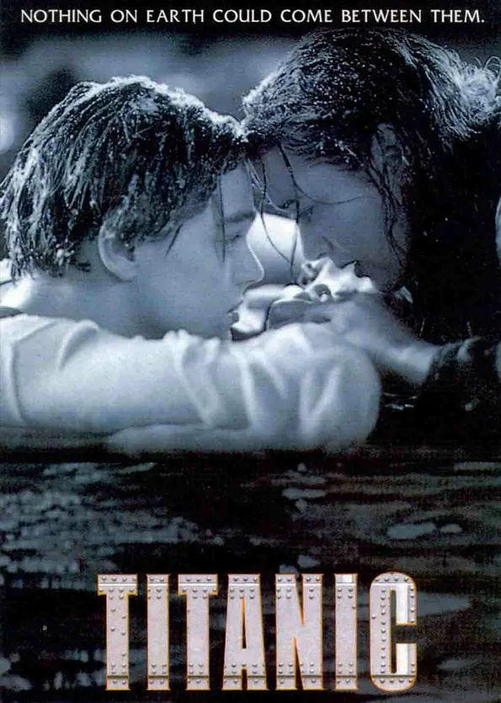

The Boundary of Economics:
Is Human Nature Reliable in the Face of Disaster?
A QUANTITATIVE RESEARCH PROJECT

2005347 Liya An∣Applied Quantitative Business Research∣4th December 2020

Abstract

Generally, the cases of “sunken ships” do not seem to belong to the study field that economics should care about, because they seem to query about human nature and hearts. But economics has extended its research boundary to the classical philosophical propositions. These two articles composed by a group of economists have displayed how empirical scientists perceived the issue of “value of life”. They share similar research methods but the later piece applies an extended sample size. Since both of them treat the case study with mono-method, which may probably result in missed casual variables, the author of this report suggests to adopt mixed method, involving qualitive research method, to include much more dimensions and push the study further. Besides, considering the risk of “sampling on the dependent variables” may induce biased output and discourage generalization, the questionable part of this research design needs further discussion.

Contents
Abstract 1

- Introduction and Rationale 2
1.1 Introduction 3
1.2 Rationale for choice of articles 4
- Discussion of Methodology and Research Design 2
2.1 Life and Death in Shipwreck 3
2.2 Hypotheses and Data Analysis in “Who perished on the Titanic?” 4
2.2.1 Hypotheses 3
2.2.2 Titanic Survivor Data Analysis 4
2.3 Hypotheses and Data Analysis in “Gender, social norms, and survival in maritime disasters” 2
2.3.1 Research on Sunken Ship after Enlarging Sample Size 2
2.3.2 Hypotheses and Data Analysis 2
3. Recommendations 2
4. Conclusion 3
- Bibliography 4
- Appendices 5

- Introduction and Rationale

1.Introduction

What is economics? If the publication of “An Inquiry into the Nature and Causes of the Wealth of Nations” by Adam Smith in 1776 is taken as the standard for the formal birth of economics, the development of economics has been less than 200 years. In the first 100 years, the name of economics has not been formally defined. In the last 100 years, the name of economics has been fixed, but the meaning of economics has been changing.

Lionel Robbins, the British economist, put forward that the economics is "the science which studies human behavior as a relationship between ends and scarce means which have alternative uses"(1932, p.67). Namely, it is a science to study human behavior and deals with the relationship between purpose and scare means with multiple uses. In a word, as long as the issues related to human behavior, they belong to the research scope of economics, which is not willing to impose too many restrictions on itself.

The term “economic imperialism” was described by Gary Becker, a prestigious Chicago economist more than 30 years ago. He pushed the boundaries of economics to other various fields and applied the theory of rational choice to social sciences, especially sociology (Lazear, 200, p.105). However, from the point view of the author of this thesis, “economic imperialism” comes to a new era─Today’s economics also shows the characteristics of imperialism, which implies all problems are involved and intertwined, but the theory behind it is no longer completely rational choice theory.

Nowadays, economics and many other disciplines have crossed each other, such as artificial intelligence and economics, geography and economics, law and economics, political economy and so on. The issue of “the value of life” is originally a classic philosophical proposition, which economists dare not touch. How do economists view the value of life? Is everyone’s life equal? Intuitively, it is believed that people are created equal. However, if questions were proposed in this way, “Is the life of a dying old man and that of a young man equal value? Is the life of an important scientist and that of an illiterate the same value?” Michael J. Sandel, Harvard political professor, has put forward the famous “Trolley problem”: Suppose you are a train driver who is driving a train, and in the process of the train running, you suddenly find five people on the front track who don’t know they are in the impeding danger and if you don’t change the track, these five people will be killed. At this time, you have found that there is another unknown person on the railway track on the side of the fork road, if you change the trajectory, you will kill this man instead of the other five. The question is: as a train driver, should you keep the track unchanged (killing five person) or change the track (killing one person)? Behind the choice, everyone implies his/her judgment of “value of life”.

This is a very interesting “thought game”. However, in today’s outbreak of the new crown epidemic, what human beings are facing is often not a “thought game”, but a real and practical problem─the outbreak of the epidemic was caught off guard, and many countries and regions had run on medical resources. Suppose when there are only three ventilators in a hospital, but there are 10 patients waiting for help, who will a doctor go first? Doctors in Italy and many other European countries say that they will give priority to rescuing young people rather than old people, because young people are more likely to be rescued, and their lives are more valuable than that of old people. These decisions and measures immediately have triggered a heated discussion around the whole world, and of course, aroused economists’ interest and came into their researches as well. Then, how do the economists consider when it comes to human nature and moral issues?

1.2 Rationale for Choice of Articles

Economists is said to be the most humble people in the world because they never carry out moral criticism, but find ways to regulate people’s behavior in the premise of recognizing human nature. The following two articles are composed by a group of economists, trying to discuss one of the most famous maritime disasters in the history─ the shipwreck of the Titanic. Both of these two articles are appropriate materials that are able to enlighten readers and their authors conduct impressive researches deserving to be closely studies by novice quantitative learners.

They applied the quantitative research methods─ linear probability models, sampling and regression analysis, trying to expose what had exactly happened in this world-shaking disaster almost 100 years ago and eventually they revealed a series of appalling truth by their researches, for example, social network will increase the probability of survival; British chivalry is just a legend in life-and-death events; Captain and crew members will probably abandon the passengers and evacuate first. The most heart-shaking discovery coming from this group of economists is that regardless of human nature, social norms and leadership of the captain are the determinants in the extreme situation, especially in the maritime disasters. The case of the ship “unsinkable” is a rare example of glory of human nature, if not the only one, does not make universal sense and the heroic deeds in this story just goes to the captain Edward Smith, who commands WCF order!

Therefore, the reasons that these two articles have been chosen for my report can be a) understanding the significance of sampling and regression analysis; b) comprehending the limits of the explanatory power of mono-method research given that the complexity of the empirical world; c) perceiving how economists do the interdisciplinary research.

- Discussion of Methodology and Research Design

2.1Life and Death in Shipwreck

On April 14, 1912, the world’s largest passenger ship, Titanic, with the most luxurious internal facilities, sank in the Atlantic Ocean. There are totally 2207 crew members and passengers on the board, including 1316 passengers and 891 crew members. Finally, 1517 people were killed (Frey, et al., 2001, p.36). This is one of the most famous shipwrecks in human history and has been remade into a film many times. Now, this most famous shipwreck in the history of the world can be closely viewed in the submarine tour program launched by the city of St. John in Canada.

Economists have always been interested in this ship, not in romantic love stories, but about who died and who survived. In 2011, Frey, a prestigious economist at the University of Warwick, Switzerland and his two Australia collaborators published an article on the study the proposition of “life and death” by studying the list of survivors of the Titanic. One year later, two Sweden economists, Mikael Elinder and Oscar Erixson, published another paper on the same issue with expanded samples.

2.2 Hypotheses and Data Analysis in “Who perished on the Titanic?”

2.2.1 Hypotheses

To begin with, Frey and his partners proposed 5 categories/determinants (physical strength, economic resources, nationality, social support and social norms) as independent variables, while the dependent variable is “whether or not someone survived the event” (Frey, et al., 2011, p. 38). The first three are classified as individual aspects, and the rest are considered as social attributes. And in the thesis, the researchers focused on five hypotheses:

The first question: if you are an adult male or if you have a higher social status, will this help improve your survival rate?
The second question: Is it easier for people with companions to survive, or are they more likely to survive alone?
The third question: The root cause of the Convention is that the crew should give priority to passengers to escape, leaving themselves behind. The captain with the highest rank should be the last to leave the sunken ship. Is this really the case? Do passengers really have a higher survival rate than crew member?
The fourth question: The generally accepted social norm is that old and weak, women and children will be given priority. The Titanic came out of Southampton of England with the largest number of British passengers. Thus, has the chivalry shown in the movie really appeared on this ship?
The fifth question: Titanic is also an international cruise ship with passengers of all nationalities on board. Will nationalities affect the final survival rate?

    - Titanic Survivor Data Analysis

The total number of people on board was 2207. After hitting the iceberg, the lifeboats were far from enough, resulting final death toll of 1517, accounting for 68%. Many of the information of the dead cannot be clarified. Although there are 32% survivors, the data is not complete either. Thus, the hypotheses can only be tested on the basis of data that has been found. Seven eight percent of the group of people on board were men and 22% were women. If the crew were excluded from the crew and only looked at the passengers, 35% of them were women, a slight increase. However, on the whole, the number of men on board was still more than that of women. Among the last survivors, 72% of women survived and only 20% of men survived. From the regression analysis, the adult males suffer very a low probability of surviving (the symbol *** displays the statistically significance is at the level of 0.1%). Furthermore, survive rate of females s is much higher than that of males by more than 50 percent. Since there was a big gap between the two sex, “women first” virtually had happened on Titanic.
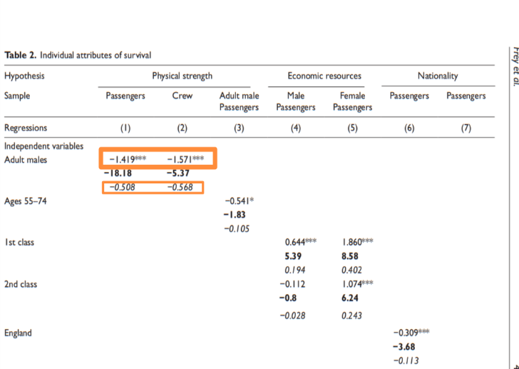
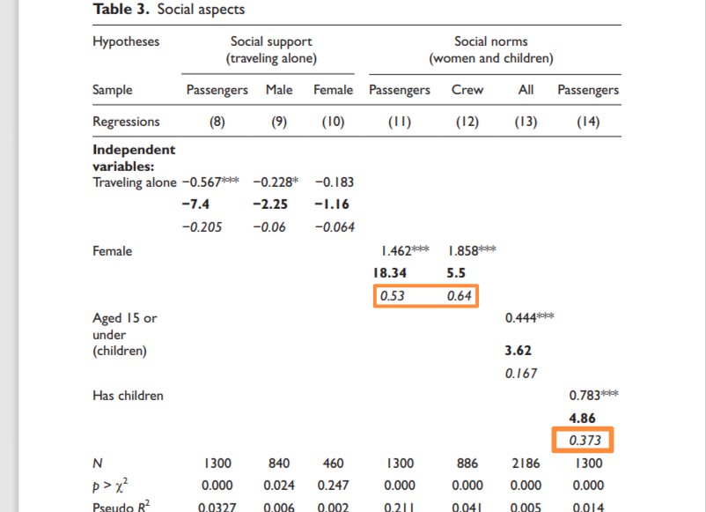

Figure 1: The graph is cited from Frey’s thesis, and the red square is added by the author of this report.

In terms of statistics related to children, women with children had a 37 percent survive rate higher than adults. As for children, there are about 5% of children under the age of 16 on board, but their survive rate is 0.48, closing to half, while the adult survive rate is only 0.3. Therefore, people on this ship did follow the principle of “women and children first” when they were evacuating.

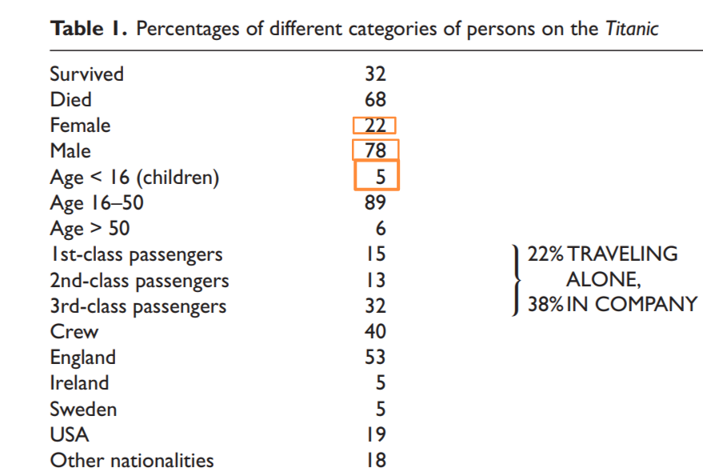
Figure 2: The graph is cited from Frey’s thesis, and the red square is added by the author of this report.

In regard with the data related to the economic level. The survival rate of first-class and second-class passengers is significantly higher, while the survival rate of third-class passengers is lower than the average, which indicates that the rich, for example, are more likely to survive. It may be that the poor let the rich go first, or it may be that the rich know more about the situation, and their position is easier to grab the lifeboat. In terms of nationality, statistics show that the survival rate of Americans is particularly high. Maybe the proportion of Americans buying first-class and second-class cabins is relatively high.

The results of this study are quite consistent with those reflected in the film, which is very touching. But other researchers will continue to ask: is this a universal rule?

2.1 Hypotheses and Data Analysis in “Gender, social norms, and survival in maritime disasters”

    - Research on Sunken Ship after Enlarging Sample Size

If the case study only focuses on Titanic, the research seems to be not so complete and rigorous enough. In order to develop the research, two Swedish empirical economists Mikael Elinder and Oscar Erixson, studied the issue further in 2012 by expending the samples. They collected a total of 18 shipwrecks in various seas around the world from 1852 to 2011. The sample size of 18 shipwrecks, involving 15,000 passengers and crew members as well as more than 30 nationalities, is big enough to make this study more convincing. Besides, in the appendix, they have specially stressed that one shipwreck, HMS Birkenhead (1852), has been added into the database for this is the second case giving similar command of WCF after Titanic.

    - Hypotheses and Data Analysis

Similar to Frey and his partners, Elinder and Erixson applied “linear probability models” (2012, p. 13224) and regression analysis on this research as well. They propose eight hypotheses as the following:
H₁: Women have a higher survive rate than men in maritime disasters.
H₂: Crew members have a higher survive rate than passengers.
H₃: The survive rate of women improves when the captain command WCF.
H₄: Women are in worse position than men, when the ship sank quickly.
H₅: When female passengers account for a small proportion of the total number of passengers, their survival rate will increase.
H₆: The longer the voyage, the better the survival rate of women.
H₇: The role of gender difference in survival rate gradually faded away after World War I.
H₈: British chivalry is a determinant to rise the survival rate of women.

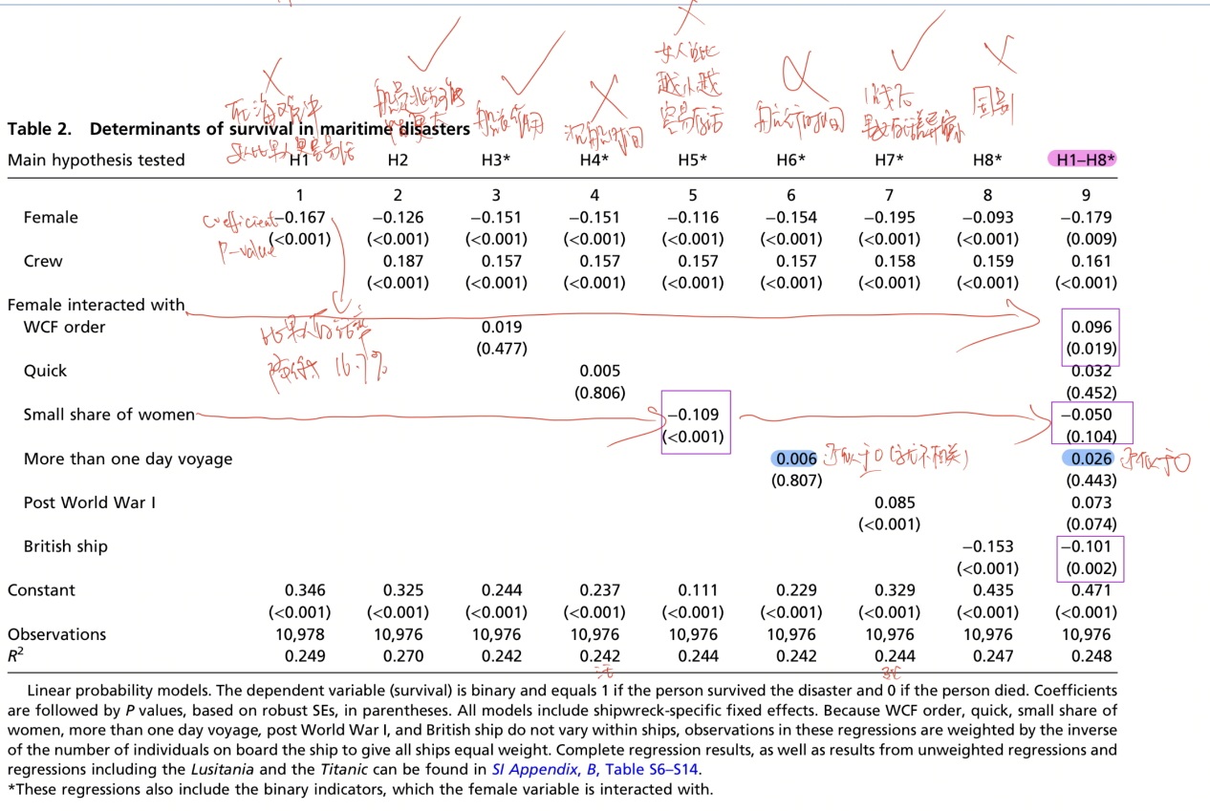
Figure 3: This graph is created by Elinder and Erixson
(The purple, red and blue marks are from the author of this report)

The researchers focus mainly on samples from other 16 shipwrecks (main sample), excluding Titanic disaster and test the eight hypotheses primarily on database of these uninvestigated maritime disasters.

Notably, they have conducted comparative analysis by formulating a control group of Titanic─ the Lusitania, which sank in 1915. They compared the results of the Lusitania with that of Titanic：there were 1959 crew and passengers on Lusitania, similar to 2207 on Titanic. The final survival rate was 32%, similar to that of Titanic. But examining the data of the final survivors, they have a few surprising findings.

Firstly, the survival rate of women and children is significantly lower than that of male adults, which implies men do not give priority to women and children. Secondly, the survival rate of passengers in third-class cabins is higher than that of passengers in first-class and second-class cabins. The only explanation is that third-class passengers are working class, and their bodies are much stronger, resulting in a higher survival rate when escaping. Thirdly, the survival rate of the crew on the Lusitania was higher than that of the passenger, which meant that the crew members fled away first, leaving the passengers behind. All above conclusions indicate that the people on the Lusitania escaped according to the “law of jungle”─ the strongest people survive.

According to coefficient (-0.167) of column 1 (p<0.001), the survive rate of women is decreased by 16.7%. Hence, it can be inferred that in these shipwrecks, in the vast majority of cases, men have a greater survival advantage than women, and male adults have a greater chance to survive. The miracle of “women and children first” happened only a few times (Titanic and Birkenhead). The “law of jungle” on Lusitania is a more common situation.

What’s more, their findings challenge Frey’s conclusion that there is no clear correlation between shipwreck time and chivalry (the coefficient (0.006) of column 6 is approximate to zero). Several of the 18 shipwreck took longer time than the Titanic, and passengers had more time to make decisions. However, the passengers on these ships still followed the “law of jungle” to evacuate, and the miracle of chivalry did not happen. In addition, the conjecture that “the British are more chivalrous” has also been denied (It was only when the data of Titanic and Birkenhead have been counted that the numbers of coefficient rose a little bit, from -0.153 to -0.101). The author even finds that when a British ship is shipwrecked, the disadvantage of women on board is more obvious, and the ugly performance of British people when fleeing for their lives is no different from that of other countries. Through the study of these shipwrecks, two authors have made some new discoveries on the behavior of the crew, especially the captain. They summed up all the data and found that the survival rates of crew and captain were significantly higher than those of passengers. Despite the fact the crew can swim and have physical advantage, such a significant difference shows that in most shipwrecks, the crew and the captain abandon the passengers, which is the fundamental reason for their high survival rate.

They also found that the behavior of the captain has a significant impact on the mode of escape behavior of all people. In all cases of chivalry miracles, the captain gave clear instructions to women and children to go first. When the captain gives this order, the survival rate of women is increased by 9.6 percent. The result is shown in column 9, a joint test (H₁-H₈) with data inclusion of Titanic and Birkenhead. A surviving crew recalled that Edward Smith, the captain of Titanic, explicitly ordered the crew to shoot at the men who were trying to board the lifeboat first (History, 2009). It was captain Smith’s stern orders that led to the miracle of humanity on the Titanic.

- Recommendations
The legend of Titanic is an appropriate example to learn statistic methods for beginners or novice researchers of empirical study. The above two articles both applied the typical statistics methods, such as sampling, linear probability model, and regression analysis. The first piece focuses on the only one case, but the later one extends the sample size to a certain scale; the first study proposes five hypotheses on the premise of individual attributes and social aspects, while the later study put forward eight hypotheses and tries to answer the questions about the casualty between the survival rate and gender and social norms. In terms of variables, the first piece distinguishes five determinants as independent variables in which three of them relates to individual factors and the rest relates to social factors, and the dependent variable is “to survive or not”. Since considering the impact of multiple variables is one of the biggest advantages of regression (Gallo, 2015), in the later article, the dependent variable is survival rate as well, but independent variables are far more complex than the previous article, including Female, Crew, WCF, WCF order*Female, Quick, Quick*Female, Small share of women, Small share of women*Female, more than one day voyage, More than one day voyage *Female, Post WWI*Female, British ship, British ship*Female.
The later thesis seems to be ambitious because it introduces the main sample (MS) resulting from the extend sampling. The researchers perceived the other 16 shipwrecks (MS) except for Titanic and Berkenhead, and designed a joint analysis represented by “H₁-H₈”, by which they have distinguished the particular case from the general situation.

However, no matter Frey’s study or the speculation of the two Sweden experts, both of two researches are conducted in the mono-method and attempt to “explain” or “predict” the dichotomous variable “demise or survival” based on a series of interpretive variables. While there is nothing to be mentioned about combining alternative methodology to try to explore and investigate the truth in the deeper layer. However, “clearing the significance bar wasn’t the same with the same thing as finding the truth” (Ellenberg, 2014, p. 156), which means the details of empirical world is infinite and complex enough, and mono-method cannot deal with everything. Thus, it is advisable to triangulate between the various approaches to get some more ideas of the real numbers, which implies qualitative research can be integrated on the issue of shipwreck investigation.

The author of Big Data: A Revolution That Will Transform How We Live, Work, and Think asserts that “knowing what, not why, is good enough” in the era of big data, (Mayer-Schönberger, 2013, p.71). However, it is actually not enough to only know what it is, but essential to know the reasons behind the phenomenon, where qualitative method will work. By this means, an investigation will not only explain and predict different survival rates for different people, but also tells why resulting from the different rates. For example, when WCF order had been commanded, why and how did people follow this rule even though they were fully aware what it implied? Why was the survival rate still low in the second and third-class cabins, relative to that of the first class, even though with the protection of WCF order? On the contrary, why did the women in the first- class cabin finally refuse to get into the lifeboats? Why had the musicians continued to play for two hours and five minutes before the ship completely sank? Why were the lifeboats not loaded to capacity (Schubak, 2020)? All those riddles and details are waiting for unveil by qualitative research.

Quantitative dataset of various interpretive variables, such as “crew”, “passengers”, “gender” so on and so forth, allows the researchers to observe and correlate outputs of those variables in order to explain what had happened under the “social norms” on Titanic. While the qualitative dataset includes the interviews and surveys from journalists, the testimonies and memories of survivors, recollections of families of victims, so on and so forth. These information and dataset will hunt out overlooked or missed factors, and better understand and explain the quantitative model. In a word, the mixed method will yield much more precise judgements and assertions with the cross-checking the outcomes between the data types.

The only problem concerned with the dataset of qualification is the validity of the sampling in that the sample frame has to be confined to the survivors for the death cannot speak and that randomness has been weakened may result in the doubt of representativeness of the sample. This is indeed a problem of “sampling on the dependent variable”.

Sampling on the dependent variable is a highly appealing, almost logical, research strategy when one is looking for the causes of an observed event. It is particularly interesting when the event of interest is rare, thereby making random sampling infeasible (Forgues, 2012, p.270). But it is universally admitted that the risk of sampling on the dependent variable can be sample selection bias and false inferences (Short et al., 2002). Notably, in this Titanic case, the bias is bound to come out from interviewing or surveying only survivors who come mostly from individuals of higher social class or the groups dominantly constituted by women and children. However, for all this, some esteemed scholars stressed, “the bias induced by selecting on the dependent variable does not imply that we should never take into account values of the dependent variable when designing research” (King, et la. 1994, p. 129). Therefore, the punchline of this mixed method lies in how to avoid “a complete lack of variance in the dependent variable or to biased regression coefficients” (King, et la. 1994, p. 129).

- Conclusion
Shipwrecks are a very intriguing topic and attract researchers to make various studies. From the sunken ships, professionals have explored the history of porcelain, tea and international trade. Economist, on the other hand, saw the choice of human nature from the shipwreck and summed up the universal characteristics of “human nature is despicable” (Schubak, 2020). Captain Smith’s choice to protect women and children on the Titanic is only an occasional human brilliance (Schlenoff, 2012).

In the view of general readers, “sunken ships” do not seem to belong to the category that economics should care about, but economics has extended its boundary here and deepened our understanding of human nature with statistical methods. These two articles and the examples of wrecks are not just to draw the conclusion that human nature is despicable, but to illustrate the flexibility and university of economic methods, which are widely used in the study of various problems by various disciplines, that helps us better and more comprehensive understanding of the world.

- Bibliography

Ellenberg, Jordan (2014) How not to Be Wrong: The Power of Mathematical Thinking, Now York: The Penguin Press.

Elinder, M. and Erixson, O. (2012) ‘Gender, Social Norms, and Survival in Maritime Disaster’, Proceedings of the National Academy of Science, 109(33), pp. 13220-13224.

Forgues, B. (2012) ‘Sampling on the dependent variable is not always that bad: Quantitative case-control designs for strategic organization research’, Strategic organization, 10(3), pp.269–275.

Frey, Bruno S. et al (2011) ‘Who perished on the Titanic? The importance of social norms’, Rationality and Society, 23(1), pp. 35-49.

Gallo, A. (2015) A Refresher on Regression Analysis. Available at: https://hbr.org/2015/11/a-refresher-on-regression-analysis (Accessed: 29 November 2020)

History (2009) The Titanic: Sinking & Facts. Available at: https://www.history.com/topics/early-20th-century-us/titanic (Accessed: 29 November 2020)

King, G. et la. (1994) Designing Social Inquiry: Scientific Inference in Qualitative Research, Princeton: Princeton University Press.

Lazear, E.P. (2000) ‘Economic Imperialism’, The Quarterly Journal of Economics, 115(1), pp. 99-146.
Mayer-Schönberger, V. and Cukier, K. (2013) Big Data: A Revolution That Will Transform How We Live, Work, and Think, MA: Houghton Mifflin Harcourt.
Robbins, L. (1932) An Essay on the Nature and Significance of Economic Science. London: Macmillan.

Schlenoff, D.C.(2012) ‘Titanic: Resonance and Reality’, Scientific American, 4th April. Available at: https://www.scientificamerican.com/article/titanic-resonance-reality/ (Accessed: 25 November 2020)

Schubak, Adam (2020) 35 Fascinating Details About the Titanic That You Probably Never Knew: There are quite a few things James Cameron Left out, 8 April. Available at: https://www.goodhousekeeping.com/life/g19809308/titanic-facts/?slide=7 (Accessed: 29 November 2020)

Short, J. C., Ketchen, D. J. Jr and Palmer, T. B. (2002) ‘The Role of Sampling in Strategic Management Research on Performance: A Two-study Analysis’, Journal of
Management 28(3): 363–85.

Starbuck, W. H. (2006) The Production of Knowledge: The Challenges of Social Science Research. Oxford: Oxford University Press.

6.Appendices

Elinder, M. and Erixson, O. (2012) ‘Gender, Social Norms, and Survival in Maritime Disaster’, Proceedings of the National Academy of Science, 109(33), pp. 13220-13224. Available at: https://www.pnas.org/content/pnas/109/33/13220.full.pdf

Frey, Bruno S. et al (2011) ‘Who perished on the Titanic? The importance of social norms’, Rationality and Society, 23(1), pp.35-49. Available at: https://journals-sagepub-com.ezproxy.uwtsd.ac.uk/doi/pdf/10.1177/1043463110396059

Cameron, J. (2003) Ghost of the Abyss[video]. Available at: https://www.youtube.com/watch?v=ZfEsb0rZX-c

聂辉华(2002) ‘道德风险：发奖金还是给股权，如何有效激励员工？’ 不完美世界的博弈：契约经济学35讲【播客】.http://app.vistopia.com.cn/download Huihua, Nie (2020). ‘Moral Hazard: How to effectively motivate employees?’ The Game of Imperfect World: 35 Lectures on Contract Economics[podcast]. Available at: http://app.vistopia.com.cn/download (Accessed: 26 November 2020)
Elinder, M. and Erixson, O. (2012) ‘Gender, Social Norms, and Survival in Maritime Disaster’, Proceedings of the National Academy of Science, 109(33), pp. 13220-13222.

