Simulation of Real World Scenarios
  Name: Rhodri Hywel Davies
  Student Number: 1651558
  Date: 8 January 2018
  Module: M5X01241 Product Simulation & Analysis
  Table of Contents
  FEA Simulation – Basketball Hoop 2
  ❖ Study Results – Yield Strength 3
  ❖ Study Results – Displacement 4
  FEA Simulation – Bolmen Stool 5
  ❖ Study Results – Factor of Safety 6
  Flow Simulation 7
  ❖ Lamborghini travelling at 30mph 7
  ❖ Lamborghini travelling at 100mph 8
  ❖ MCR car travelling at 30mph 8
  ❖ MCR car travelling at 100mph 9
  Plastic Simulation 10
  ❖ Drill Body iteration 1 10
  ❖ Drill Body iteration 2 11
  ❖ Funnel – Iteration 1 11
  ❖ Funnel – Iteration 2 12
  Undercut & Draft Analysis 13
  ❖ Undercut Analysis 13
  ❖ Draft Analysis 14
  References 15


FEA Simulation – Basketball Hoop
The first model I have simulated is the predefined model, named ‘Basketball rim v3’. I’ve used its results as a benchmark for the three adaptions listed below. I have placed a force simulating Michael Jordan scoring a slam dunk to the basketball rim. I’ve calculated his weight in Newtons and multiplied it by 3 to simulate the effect on the rim from a slam dunk during a game of basketball.
The purpose of this simulation is to analyse the deformation characteristics, bracket strength and ensuring I understand how to modify this model to improve the characteristics where needed.
In the table below, I have listed the benchmark model and the 3 adaptions with images to show the fixtures and load locations. I have placed the fixtures and loads on identical locations on each model, with each model being set with a 2883N load.
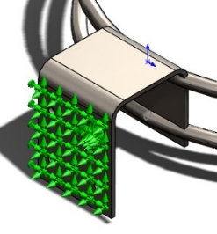  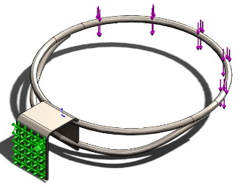 | Model name: Basketball rim v3 | Fixture details  Load details
  Entities: | 1 face
  Type: | Fixed Geometry
  Entities: | 1 face, 1 plane
  Type: | Apply force
  Values: | ---, ---, -2883 N
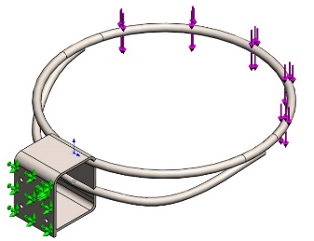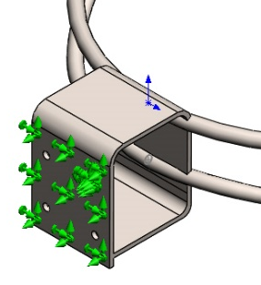 | Model name: Basketball rim v3 adaptation 1
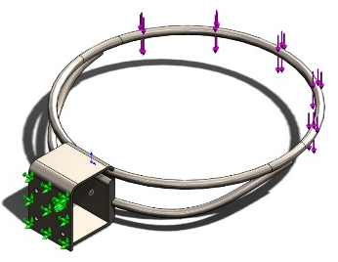  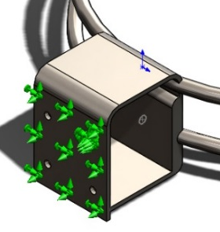 | Model name: Basketball rim v3 adaptation 2
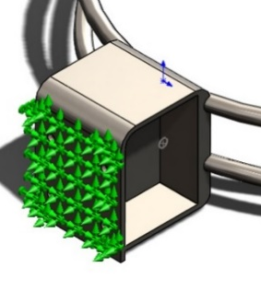  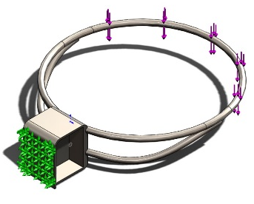 | Model name: Basketball rim v3 adaptation 3

Study Results – Yield Strength
Name: Stress | Type: von Mises Stress |  | Conclusion
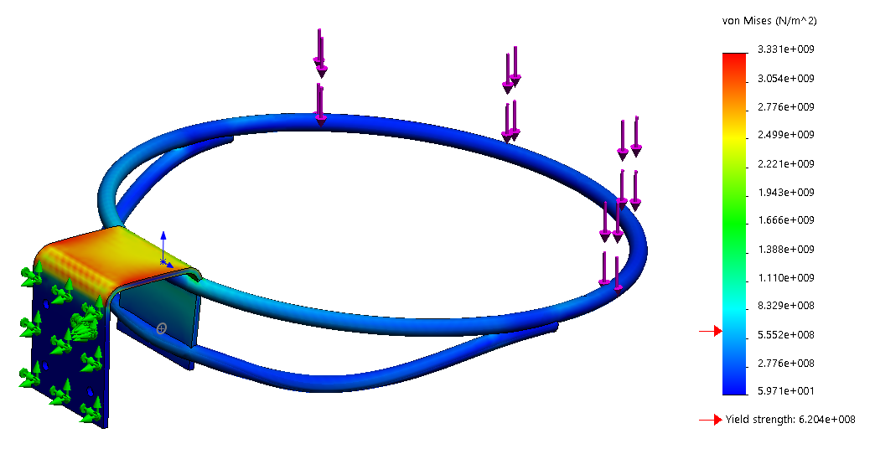 |  | 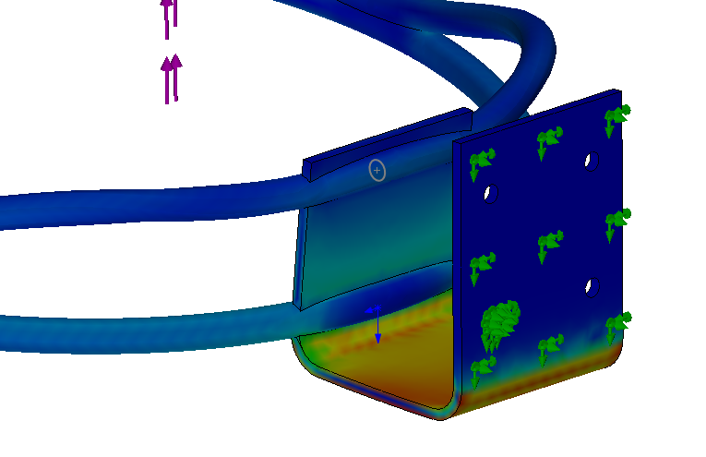 | This model is weakened by its bracket, the lack of material allows the bracket to bend. Its yield strength is also low.
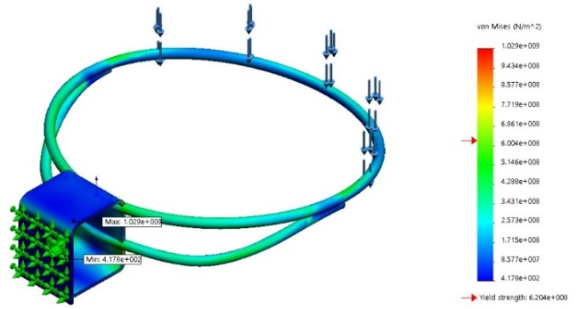 |  | 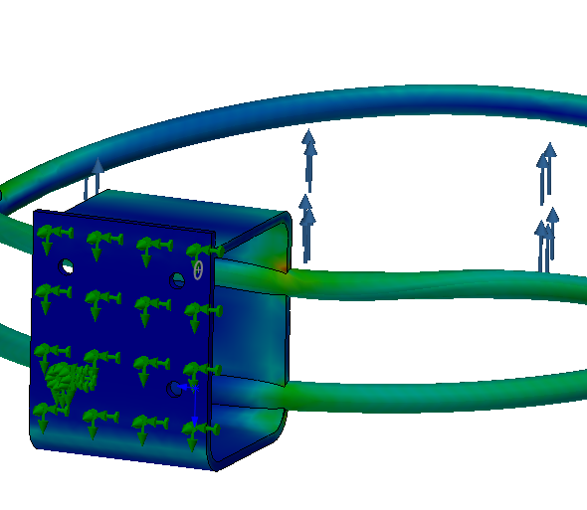 | For the second iteration, I have added a plate on the bottom of the bracket to reduce its movement. The modification has improved the model slightly, however, the yield strength is at 6.204e+008 which indicates the rim still fails the stress test.
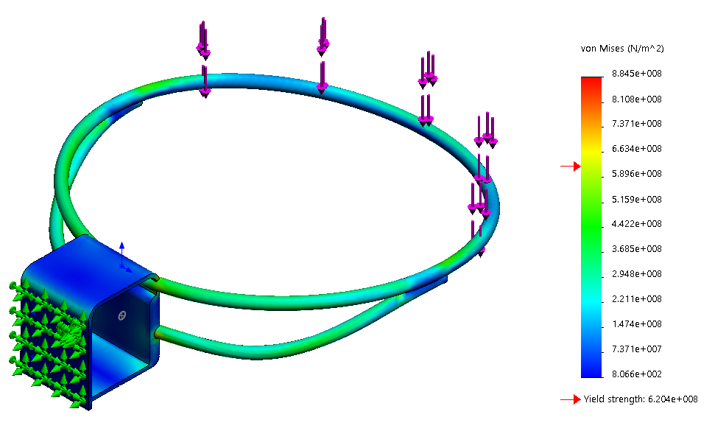 |  | 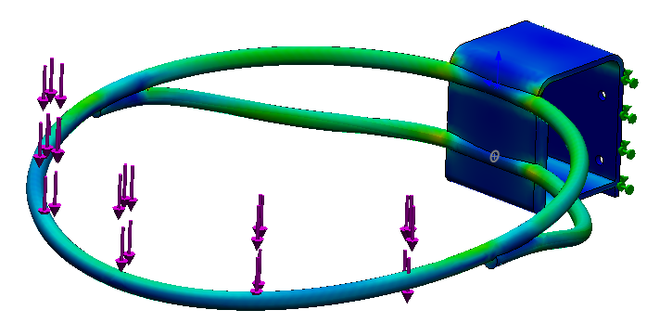 | My third iteration has been improved slightly from thickening the front section of the bracket. It has increased the yield strength to 6.204e+008 but has still failed overall.
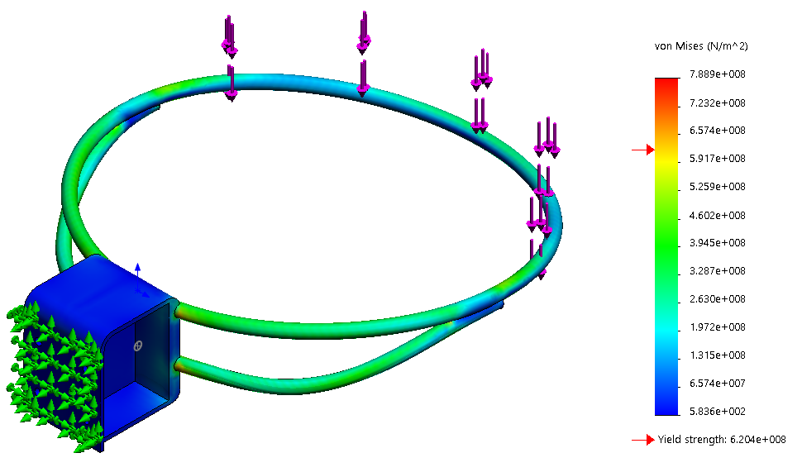 |  | 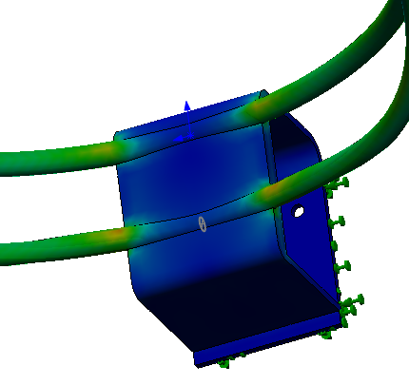 | This fourth model has been modified by introducing a thick plate in the middle of the bracket. It has again improved the yield strength, in result, it has only failed on the slight orange/red patches as seen to the left.

Study Results – Displacement

Name: Displacement | Type: URES Resultant Displacement |  | Conclusion
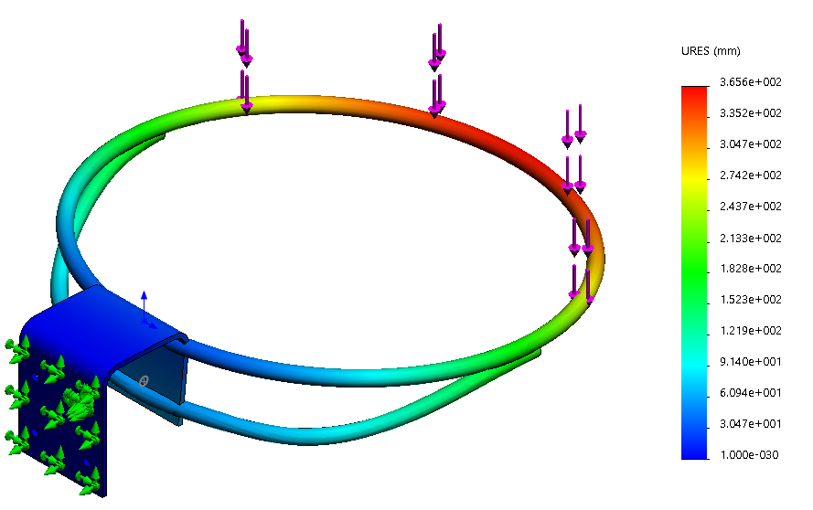 |  | 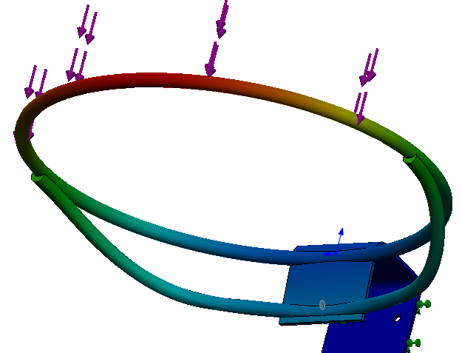 | Displacement on the predefined model is 365.6mm which is large. It also has minor displacement near the bracket.
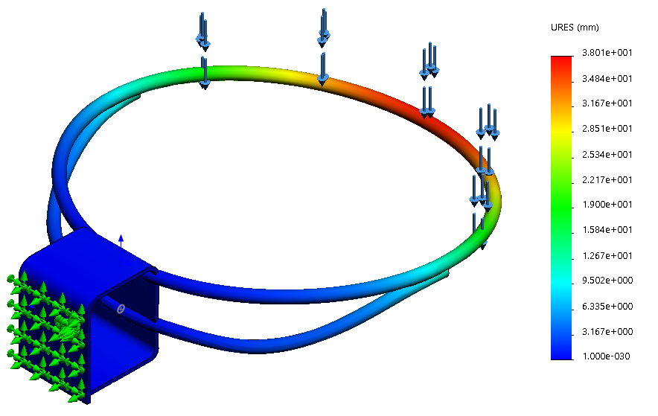 |  | 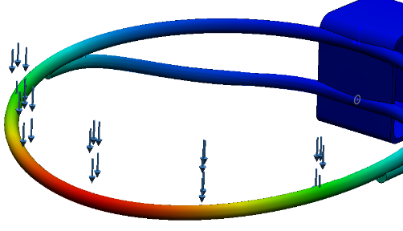 | This second iteration has improved, with a max displacement of 38.01mm.  The displacement near the bracket has also minimized to a low figure. I will need to improve the strength of the bracket.
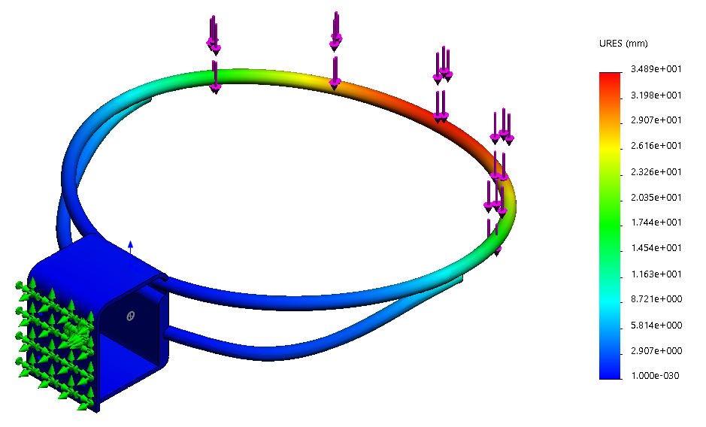 |  | 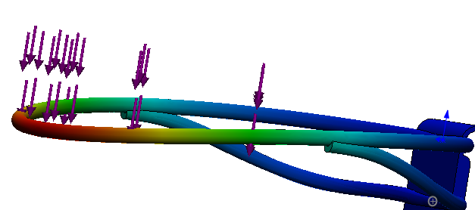 | Displacement on this third iteration has decreased to a max of 10.4840853mm.
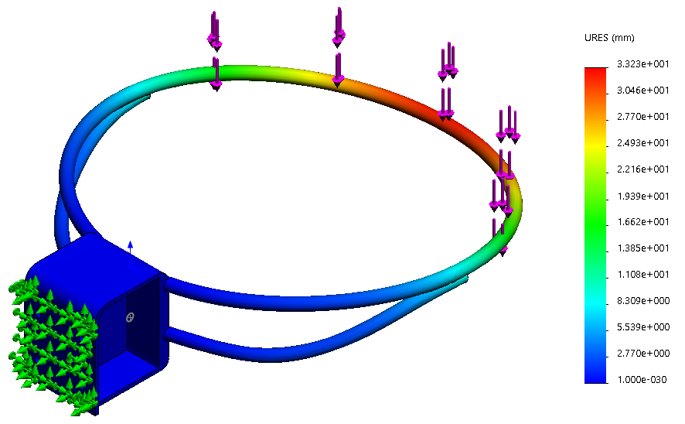 |  | 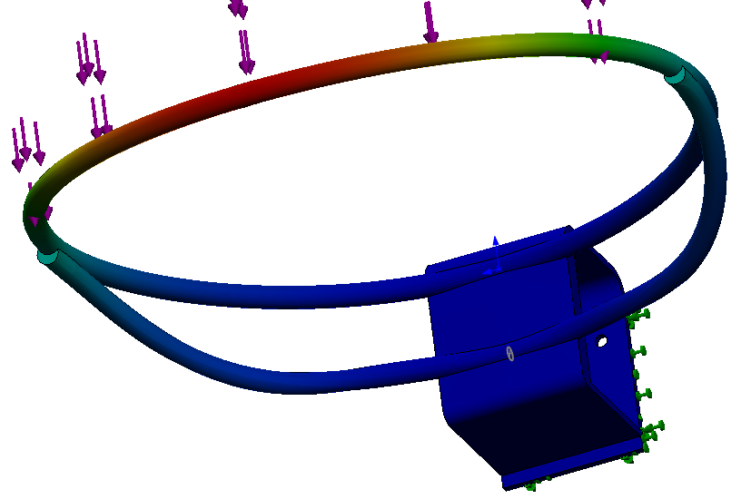 | This final iteration has also decreased its maximum displacement, to 10.0328505mm. I believe its modifications have drastically improved its characteristics.

FEA Simulation – Bolmen Stool
For this task, I have simulated a force of 100kg being placed on a bolmen stool. Yet again I’ve used the predefined model as a benchmark model, and have modified it by adding strengthening ribs to its design.
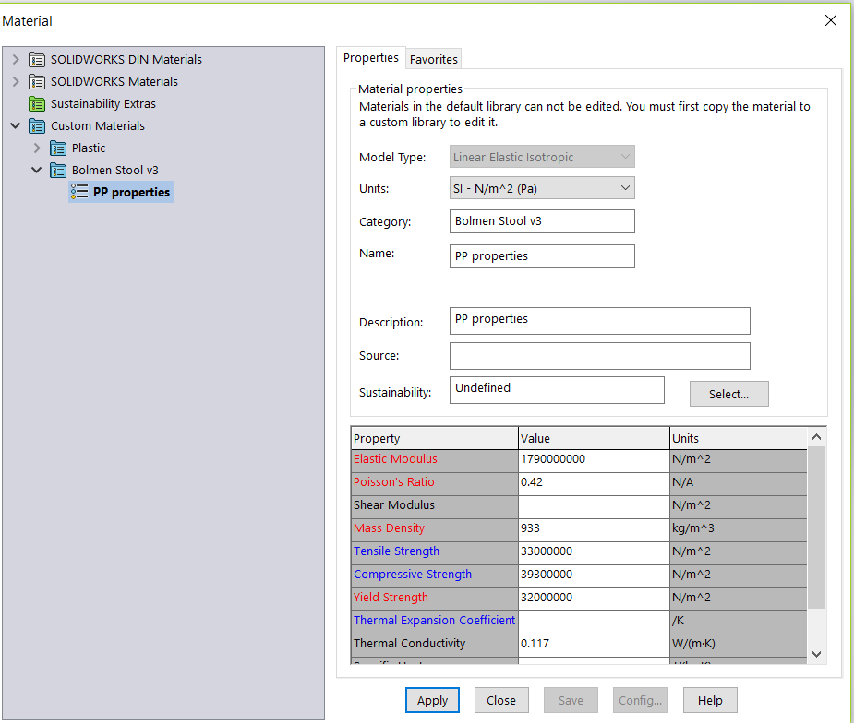
The purpose of this simulation is to work from a designer’s point of view to optimize the performance characteristics by adding strengthening ribs to the stool, without over engineering it or making it hard to manufacture. It must reach the Factor of Safety of 3.
As Solidworks did not have the correct properties needed for the specified material ‘polypropylene’, I have researched for the correct properties and specified the material accurately on Solidworks.
(MatWeb Material Property Data)

In the table below, I have listed the benchmark model and the modified parts along with their simulated properties. I have applied a force of 980.665N to the top of the stool with a fixture on each leg.
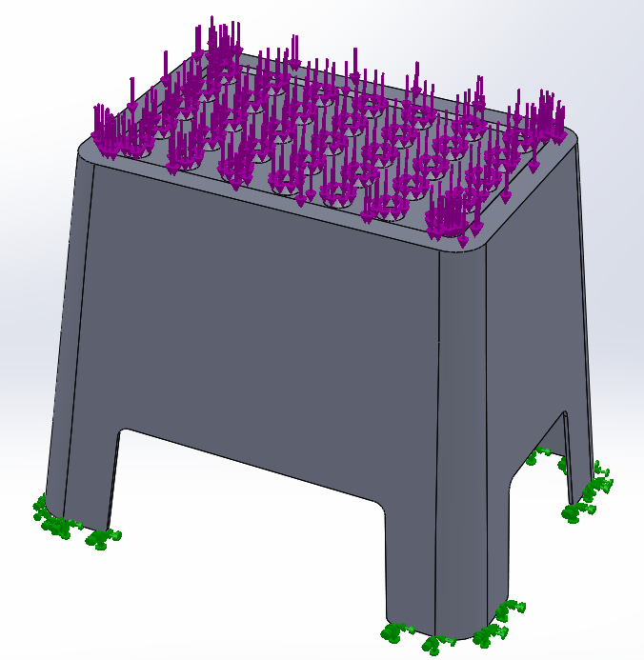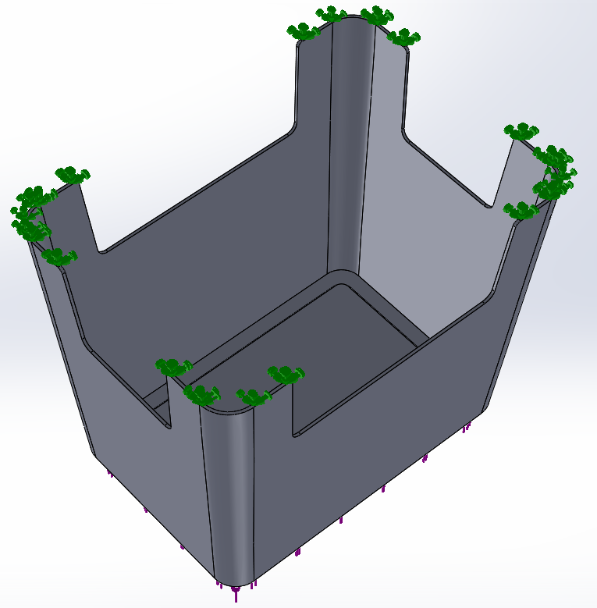 |  | Model name: Bolmen Stool v3 | Fixture details  Load details
  Entities: | 4 face(s)
  Type: | Fixed Geometry
  Entities: | 37 face(s)
  Value: | 980.665 N
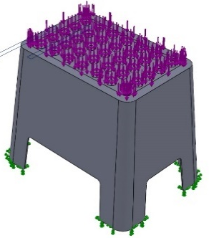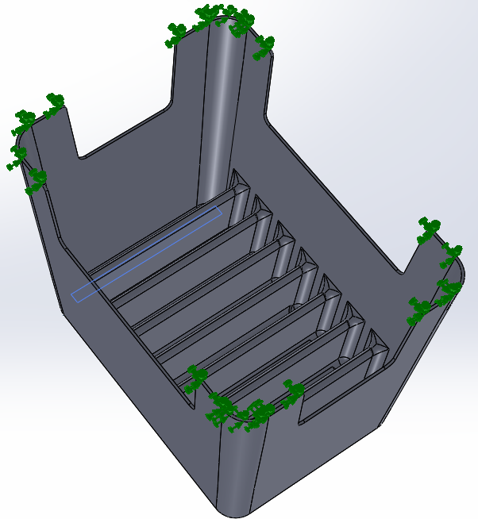 |  | Model name: Bolmen Stool v3 adaption 1
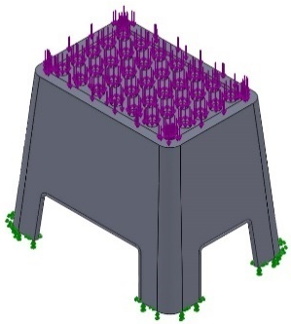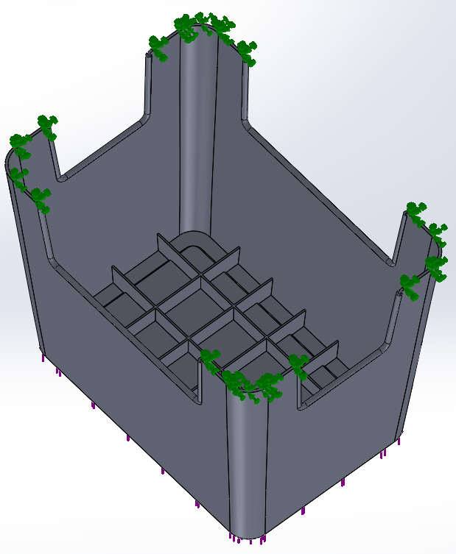 |  | Model name: Bolmen Stool v3 adaption 2

Name: Factor of Safety |  | Type: Max von Mises Stress | Conclusion
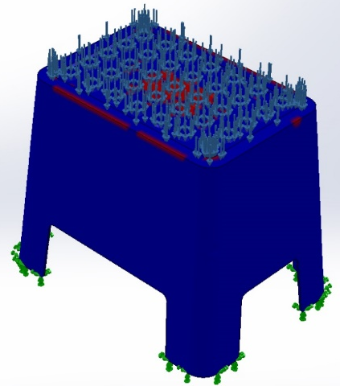 | 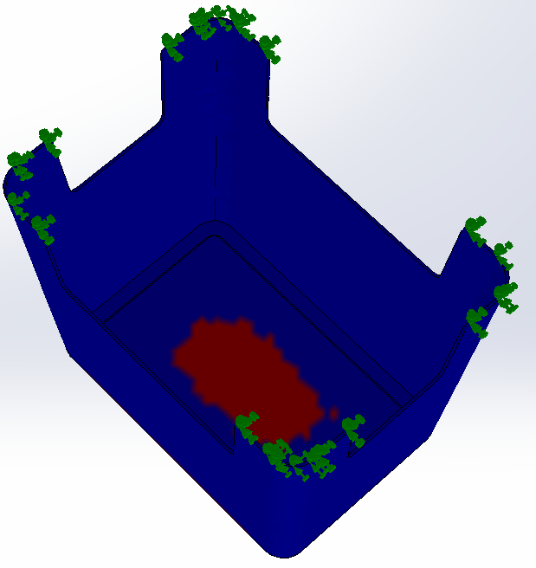 |  | This benchmark predefined model has only reached a factor of safety of 1.70674. to reach a factor of safety of 3, I will modify the model by adding thick ribs to the inside.
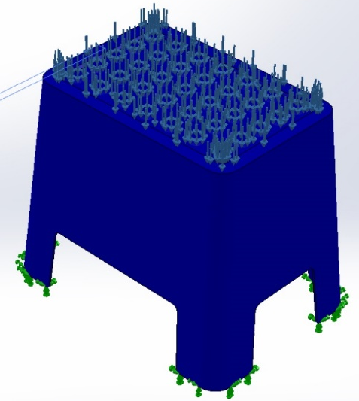 | 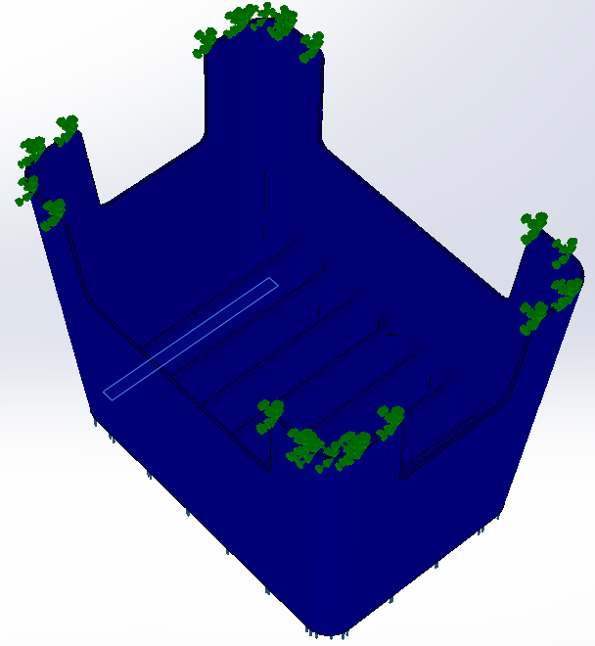 |  | For this second iteration, I have introduced thick ribs and fillets to ensure maximum strength. Its factor of safety is 15.1769. However, this is clearly overengineered and I will now modify the ribs to be manufacturable and maintain its reliability.
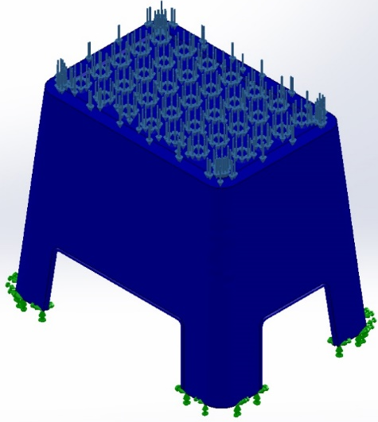 | 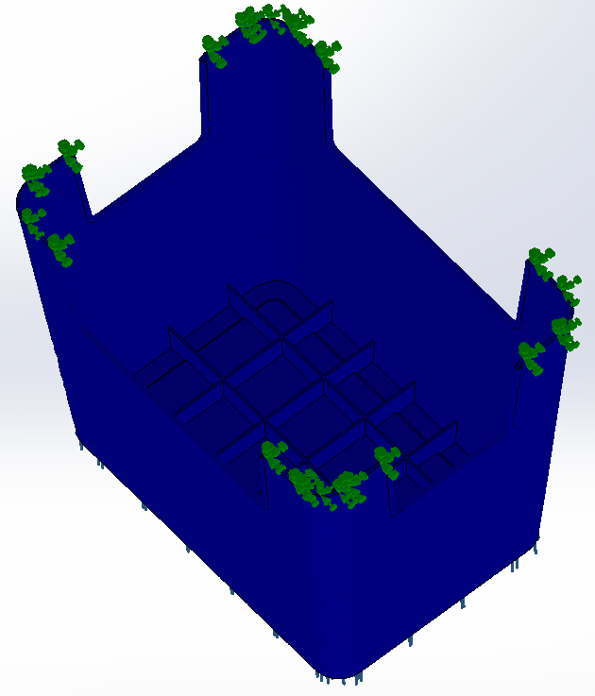 |  | I have used crossing ribs instead of thick single ribs to make the third iteration more effective. This final iteration has a factor of safety of 3.30848. This is manufacturable as its ribs are now thinner and simple.

Study Results – Factor of Safety

Flow Simulation
I have been asked to simulate two predefined car models travelling at 30mph and 100mph using FlowXpress on Solidworks.
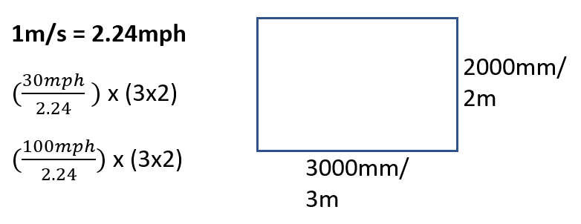
The purpose of this simulation is to learn how to analyze the velocity and flow trajectories of the two vehicles, by taking into consideration their design characteristics. I will compare the two’s inlet and outlet results and how different speeds effect both cars.
I will use the formulas shown on the side to simulate both cars travelling at 30mph and 100mph.
Below are the predefined models and a report analysing the simulations.

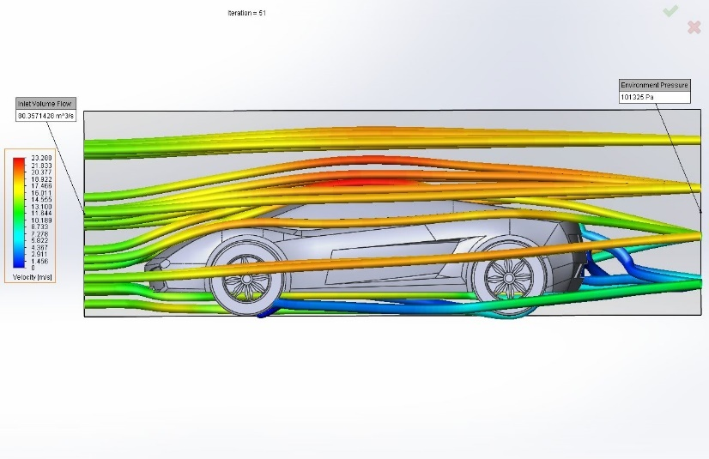
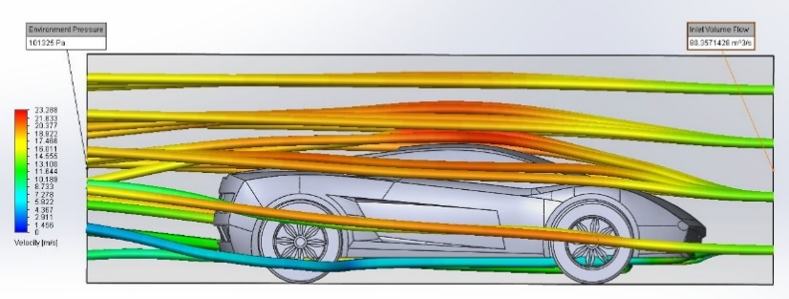
Lamborghini travelling at 30mph
Outlet at 30mph:
Inlet at 30mph:
Model name: | Lamborghini Assembly 30mph.SLDASM
Fluid: | Air
Inlet | Volume Flow Rate: 80.3571 m^3/s
Inlet | Environment Pressure: 101325.00 Pa
Results: | Maximum Velocity: 24.451 m/s
Conclusion:
By analysing the flow trajectories from the inlet simulation, we see that there is little drag on the upper part of the vehicle, whereas the bottom part, near the bumper, has a slight blue trajectory. This shows the velocity at around 5 and 8 m/s.
The outlet simulation shows us that there is a lot of drag underneath and behind the vehicle. Velocity of 0 to 4 m/s is generated in these areas.

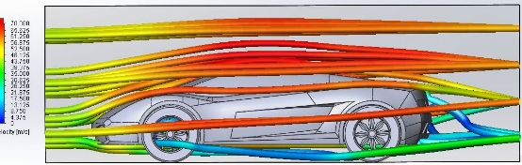
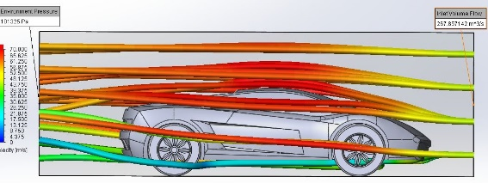
Lamborghini travelling at 100mph
Outlet at 100mph:
Inlet at 100mph:
Model name: | Lamborghini Assembly 100mph.SLDASM
Fluid: | Air
Inlet | Volume Flow Rate: 267.8571 m^3/s
Inlet | Environment Pressure: 101325.00 Pa
Results: | Maximum Velocity: 82.941 m/s
Conclusion:
The inlet shows at higher speeds, the vehicle suffers minor drag underneath the bumper with velocity of 27 - 30m/s. Whereas the top half of the vehicle hits maximum velocity of up to 82.941m/s.
The low velocity in the outlet shows us that there is a lot of drag being generated below and behind the car. To improve these areas, it would be advised for the vehicle’s height to be lowered and/or introduce some form of spoiler to the front/rear of the vehicle.

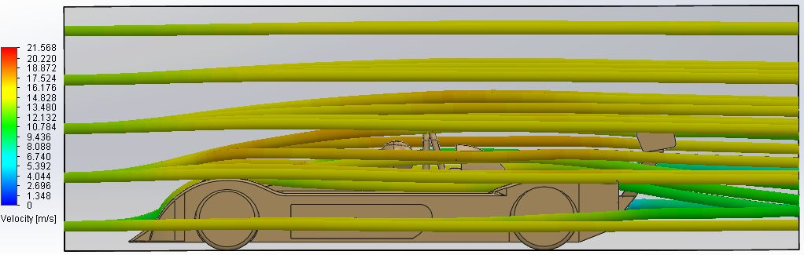
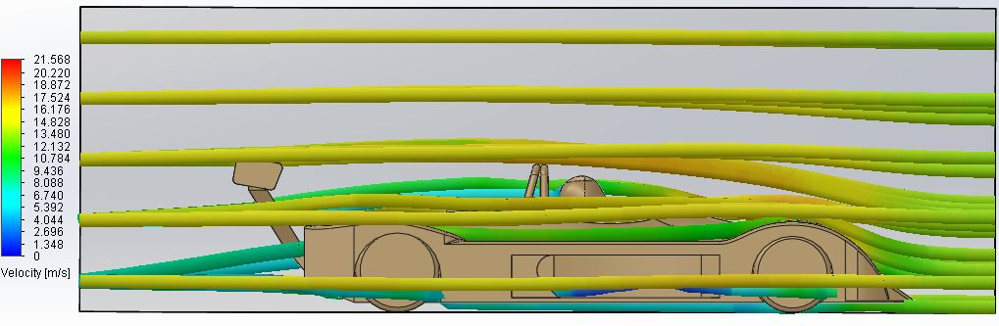
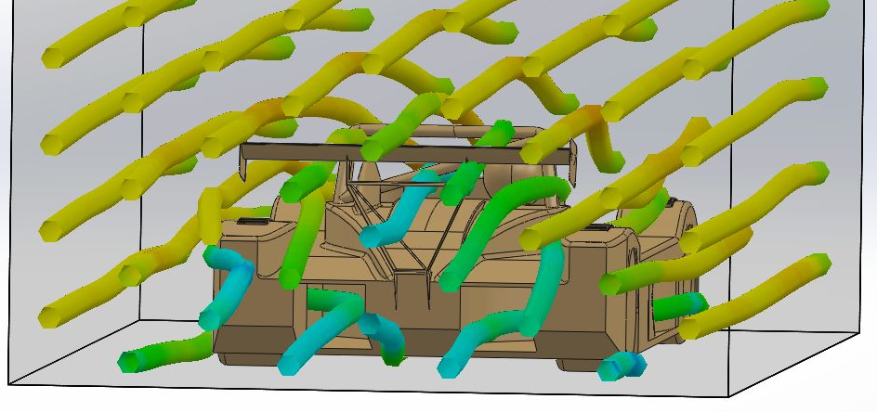
MCR car travelling at 30mph
Inlet at 30mph:
Outlet at 30mph:
Model name: | MCR Assembly 30mph.SLDASM
Fluid: | Air
Inlet | Volume Flow Rate: 80.3571 m^3/s
Inlet | Environment Pressure: 101325.00 Pa
Results: | Maximum Velocity: 21.860 m/s
Conclusion:
Through analyzing the inlet, we see the MCR car has a maximum velocity of 21.860m/s which is slightly lower than the Lamborghini. Flow trajectories show that the lack of aerodynamics towards center vehicle means lower velocity.

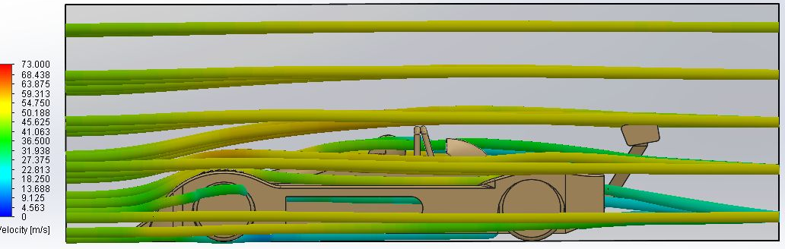
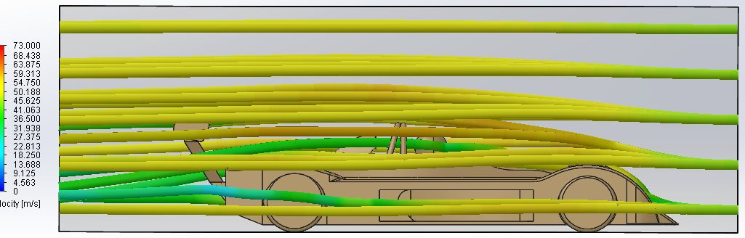
MCR car travelling at 100mph
Outlet at 100mph:
Inlet at 100mph:
Model name: | MCR Assembly 100mph.SLDASM
Fluid: | Air
Inlet | Volume Flow Rate: 267.8571 m^3/s
Inlet | Environment Pressure: 101325.00 Pa
Results: | Maximum Velocity: 73.406 m/s
Conclusion:
Again, the MCR has a maximum velocity lower than the Lamborghini, at 73.406m/s.
By analyzing the outlet, we see that there is a lot of ‘dead air’/area of low velocity being generated through the large vents on the side of the vehicle through to the rear.
This might be useful for stability however.
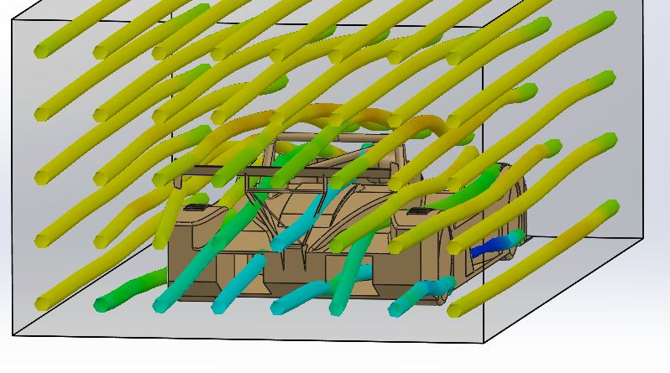

Plastic Simulation
I have been asked to simulate two predefined models, a funnel and a drill body being injection molded. I will choose appropriate gate location(s) for the simulation and analyze different iterations to see which is best.
The purpose of this task is to understand how to analyze and investigate the results of Fill Time, Ease of Fill, Gate Filling Contribution, Cooling Time, Sink Marks, Weld Lines, and Air Entrapment in relation to the gate locations.
Below, are the results and reports of the two models simulated.

Drill Body iteration 1
I have placed a gate of 4mm diameter on the top corner of the body to create a uniform filling pattern.
Fill Time | 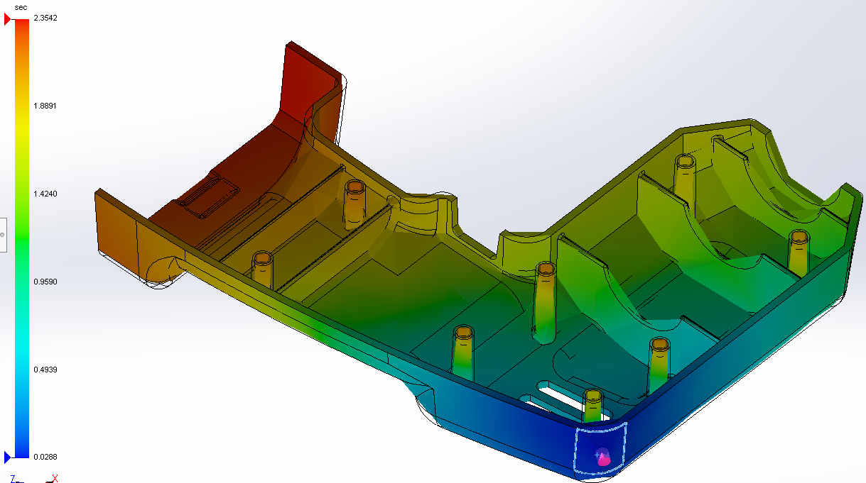
This part can be successfully filled with an injection pressure of 44.4 MPa (6438.49 psi) in 2.3542 seconds.
The top corner of the battery section of the shell takes the longest to fill which was expected, being the furthest corner from the gate.
Cooling Time | 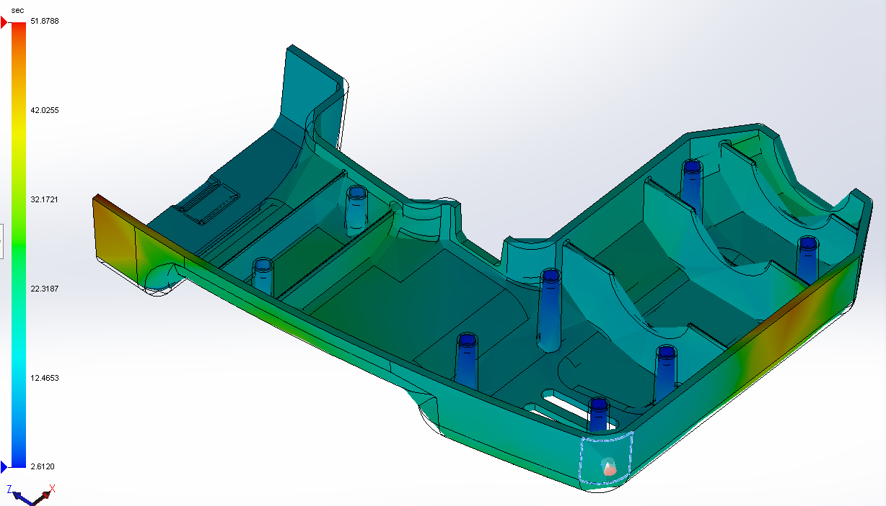
Since the Maximum Temperature at ‘End of Fill’ has remained within 10 deg C of the starting melt temperature, there is little to no risk of plastics material degradation. This model has a maximum cooling time of 51.8788 seconds, located at the top of the shell and at the bottom corner of the battery shell.
Sink Marks | 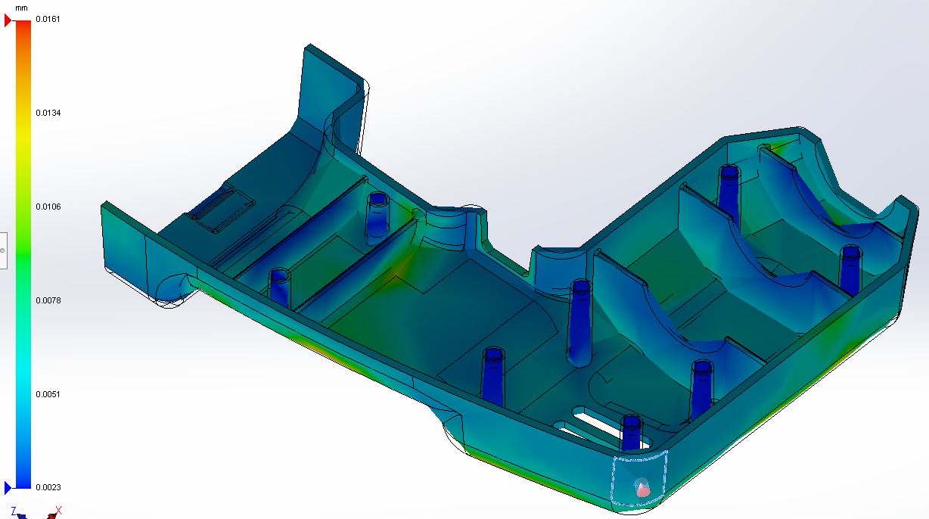
The maximum sink mark simulated is 0.0161mm which is minor. The sink marks are nearest to the ribs, being small, the depression on the material will likely be minor.

Drill Body iteration 2
I have placed a gate of 4mm diameter on one of the ribs on the top half of the drill, and on the exterior on the handle to create a more equal fill.
Fill Time | 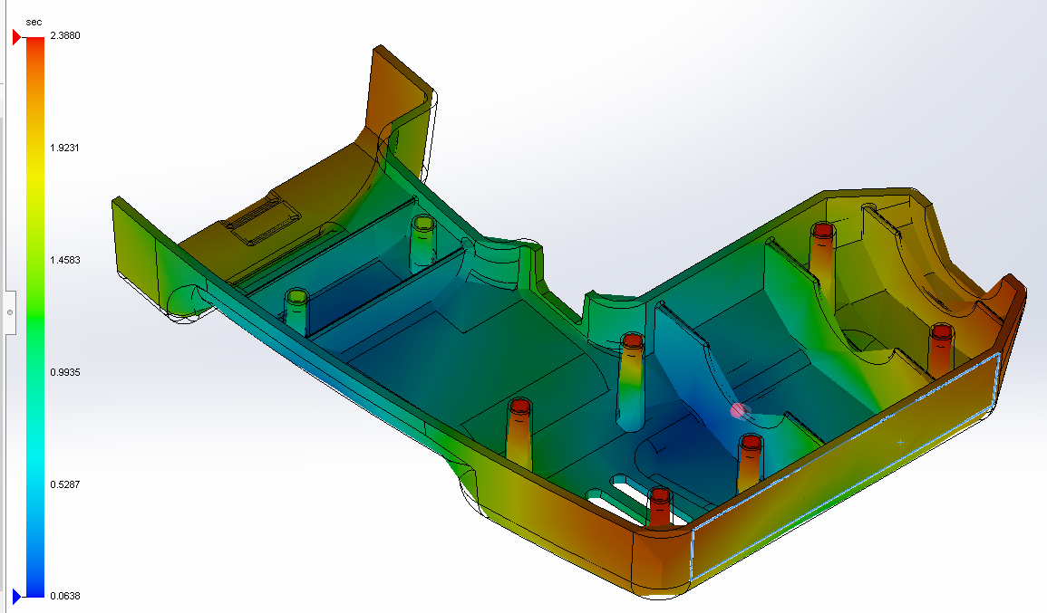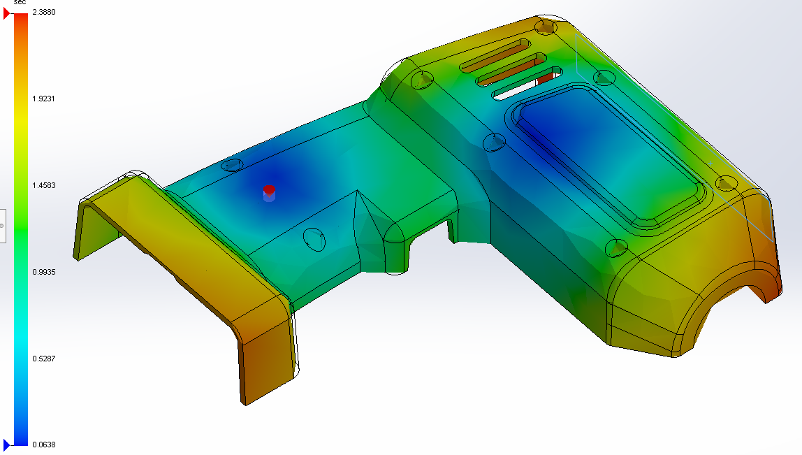
Even with an extra gate, this iteration takes a fractionally longer time to fill. At 2.3880 seconds, the shell takes little to none to fill.
Gate Filling Contribution |  | 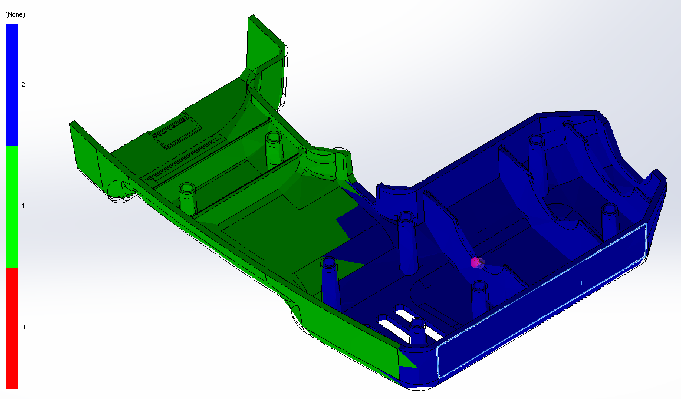
As this iteration has two gates located on the shell, gate filling contribution has been split in two, rather equally and without any failure.
Weld Lines and Air Entrapment |  | 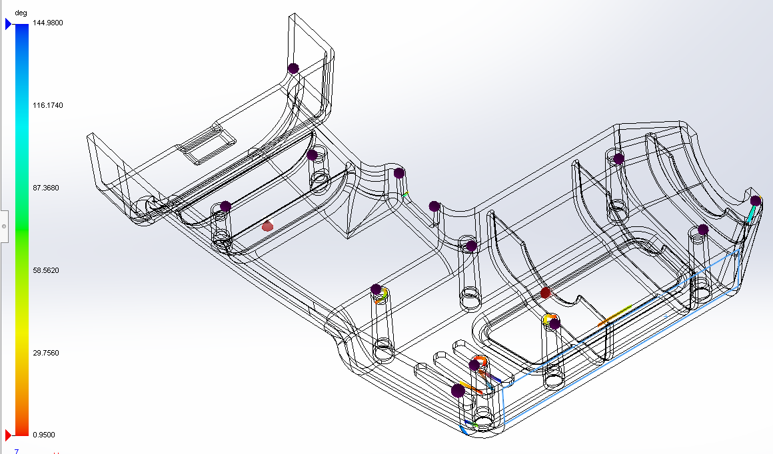
In this iteration, little amount of weld lines appears. This is where the injected plastic meets and joins, around mold core features which can lead to cosmetic defects and typically weakens the model (around the shelled vents).
There are air entrapments located on top of corners/assembly guides which is where the air from the mold cavity cannot be vented. Better ventilation or different gate locations are needed.

Funnel – Iteration 1
I have placed a gate of 5mm diameter on top of the funnel.
Fill Time | 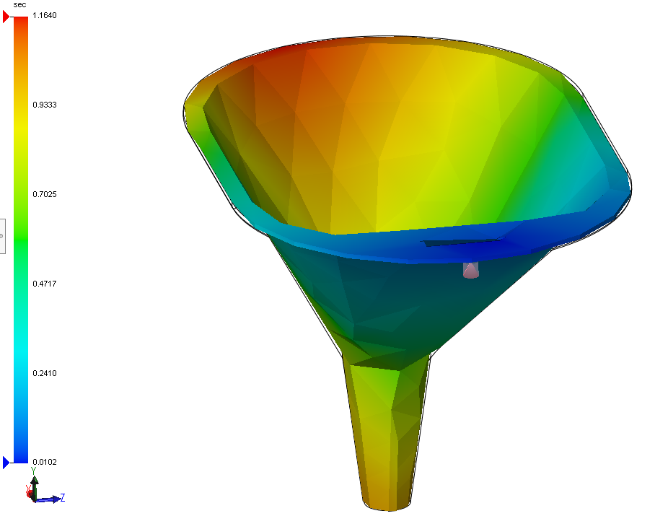
Although this iteration fills quickly, at 1.1640 seconds. The flow is uneven, and I will need to choose a location suitable for a uniform flow.
Ease of Fill | 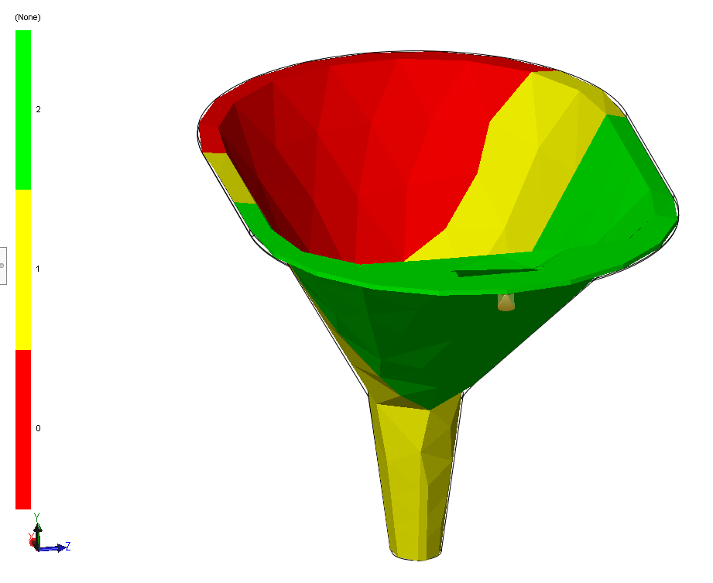
This part can be successfully filled with an injection pressure of 100.0 MPa (14507.00 psi) which will likely cause filling and packing problems at the molding machine. The yellow indicates where the injection pressure exceeds 70% of the specified pressure, whereas red 85%.
Weld Lines and Air Entrapment | 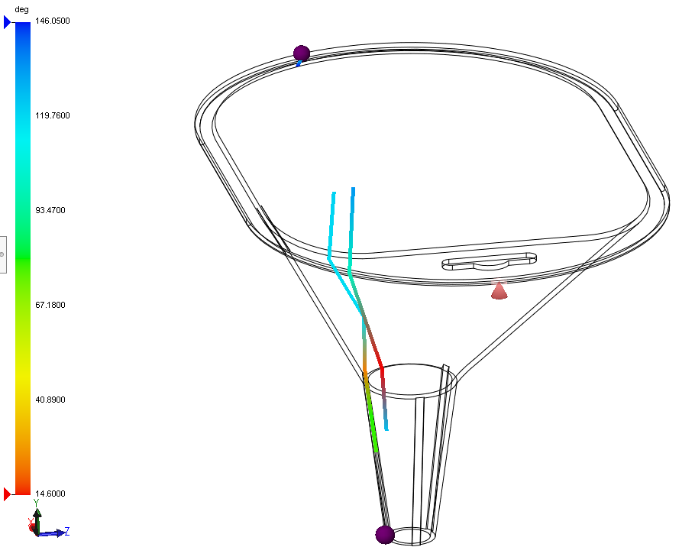
There are a few weld lines that may cause depression due to the size, but only two sections of air entrapment meaning a little more ventilation is required to create the model without possible deformities.

Funnel – Iteration 2
I have placed a gate of 5mm diameter inside the funnel, towards half way down.
Ease of Fill | 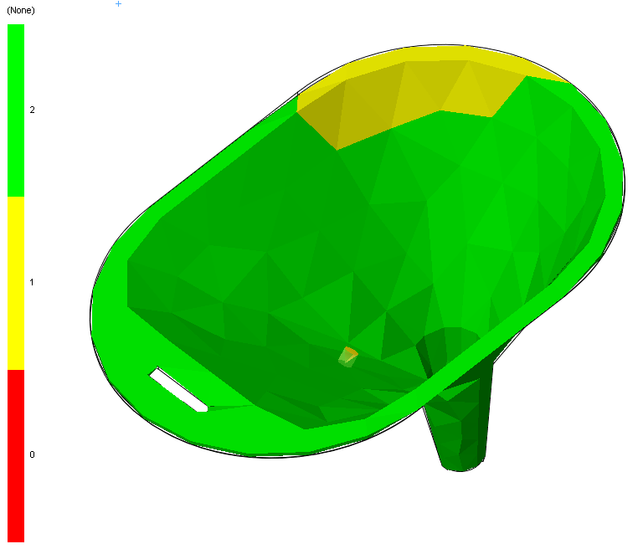
This part can be successfully filled with an injection pressure of 87.3 MPa (12666.21 psi). The yellow zone of the simulation shows the pressure within a reasonable range of 87.31% of the max pressure limit specified.
however, through mass usage of the injection machine, there might be additional injection pressure loss. Therefore, improving ease of fill before manufacturing is recommended.
Cooling Time | 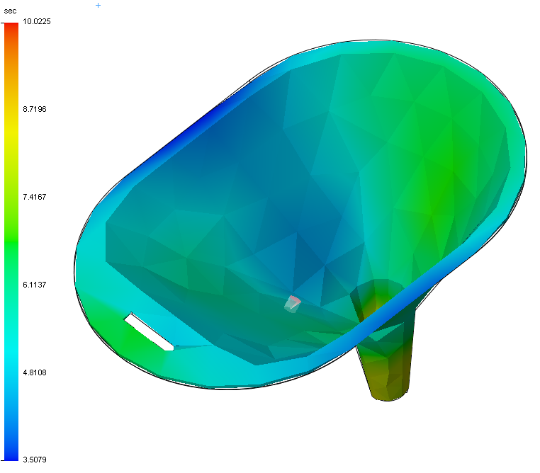
The Maximum Temperature at ‘End of Fill’ has remained within 10 degrees C of the starting melt temperature, therefore little to no risk of plastics material degradation occur.
Cooling effects in this simulation could cause filling and packing problems, as the minimum flow front temperature is less than the starting melt temperature by more than 10 deg C.

Sink Marks | 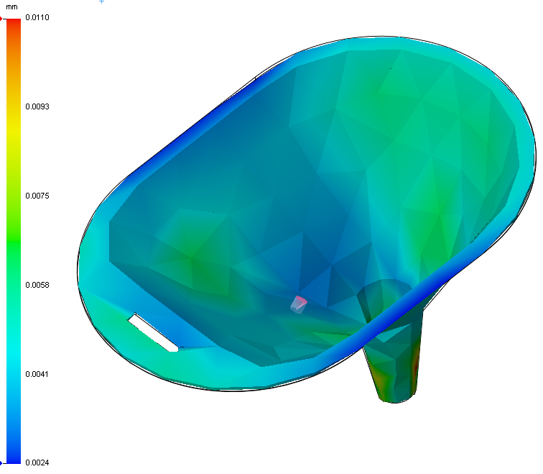
Sink marks have occurred in relation with the cooling time simulation. Sink marks occur near thicker areas of the injected model, and cool at a slower rate. This has resulted in a shrinkage of the thicker area. At about 0.0075mm in the more evident green areas, this shrinkage is minor.

Undercut & Draft Analysis
I have been asked to analyze a predefined model of a camera shell regarding draft and undercut criteria. The purpose of this task is to be able to understand manufacturing processes and its limits. I must modify the model for it to be manufacturable.

Undercut Analysis
 |  | Key: | 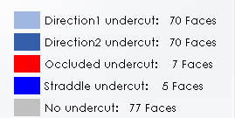
Analysis  Through simulating this model on Undercut analysis, I have chosen to tackle the 7 faces of occluded undercut because of the problems that this would create for manufacturing.  I believe the larger undercut highlighted in red on the right is an unnecessary undercut. However, the clip in the center of the model is a concern, as it allows the design to function more effectively.  Conclusion  As seen in the pictures below, to tackle the issues, I’ve filled the large undercut on the right of the design and have also cleared the little circular clip in the center.  However, I’ve decided to keep the highest clip as an undercut for the product to be able to safely clip into place. This will mean higher costing as there’ll be need for a slide in core to ensure manufacturing this component is possible. |  |  | 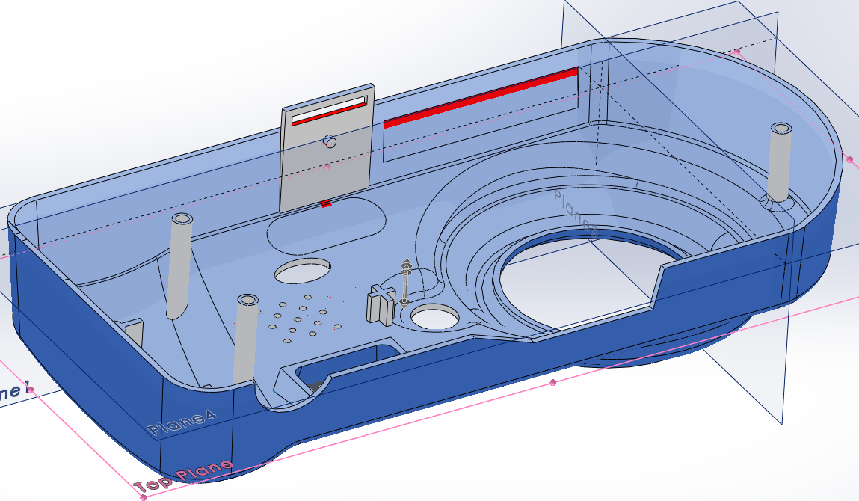
 |  |  | 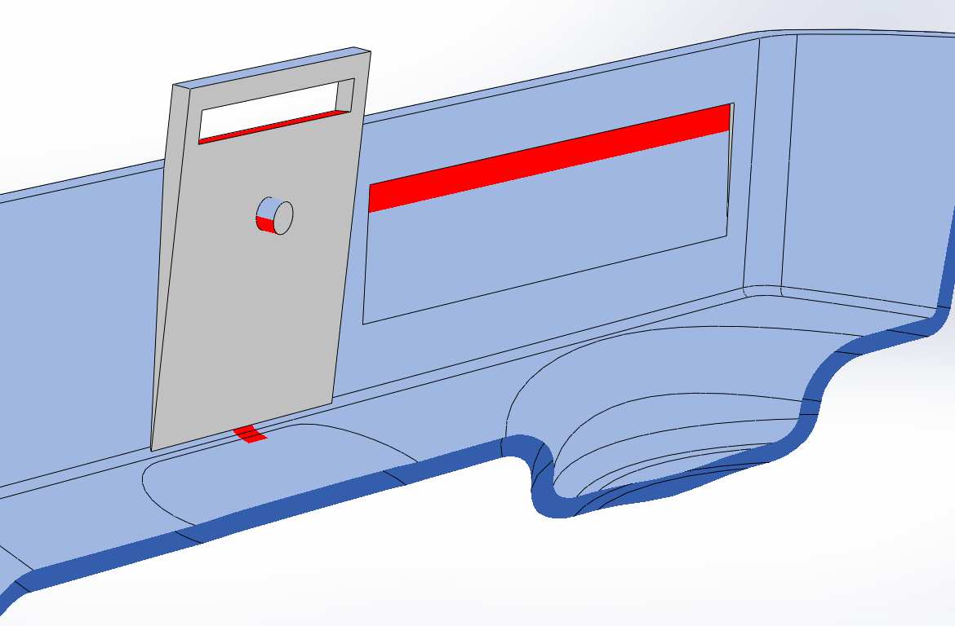
 |  |  | 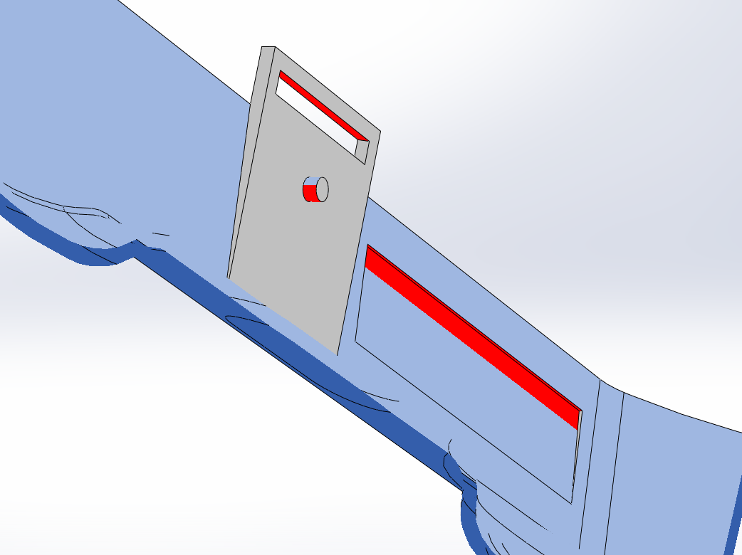
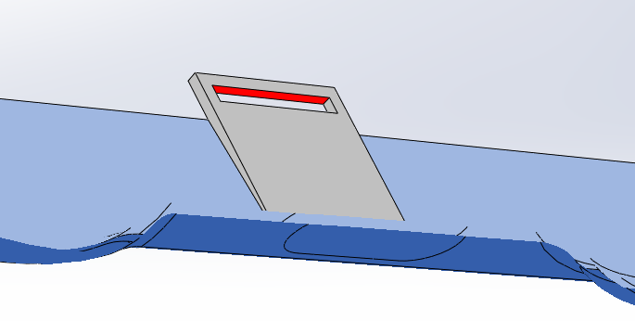  Result: |  |  | 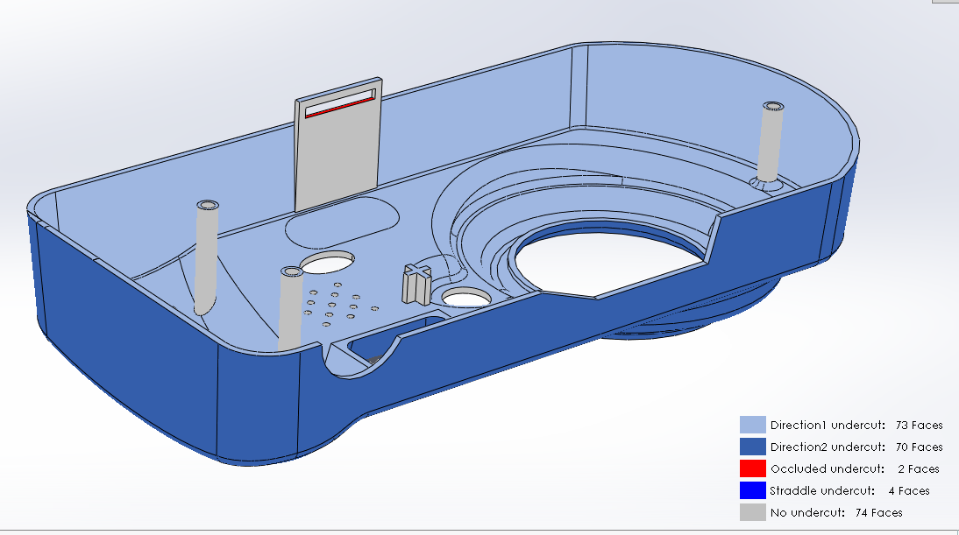

Draft Analysis
 |  |  | Key: | 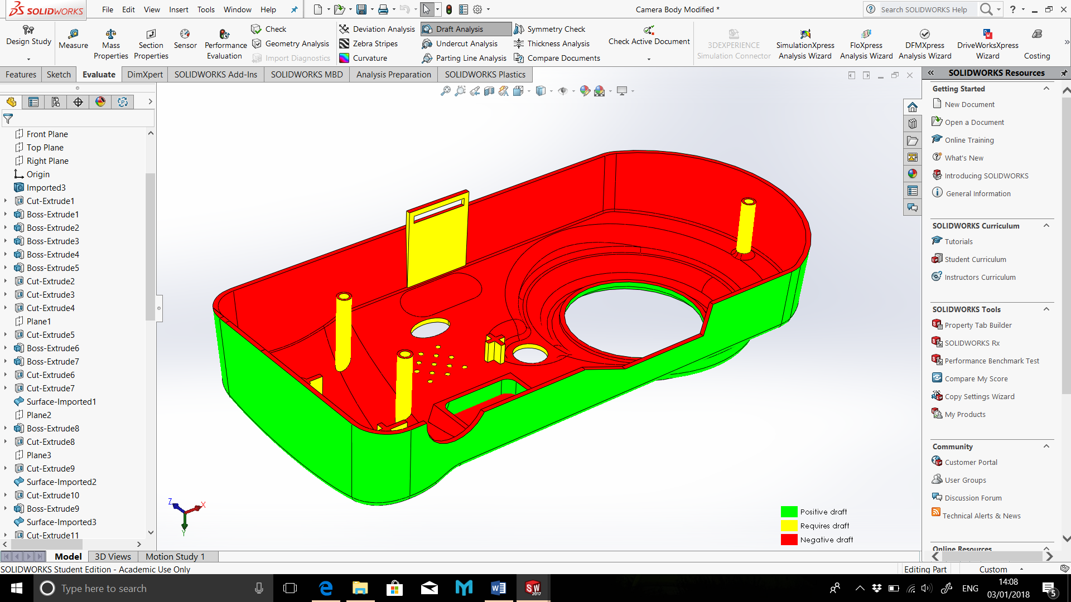
Analysis
I have set the draft angle parameters to 2.00deg and this is the outcome.
The yellow indicates where draft needs to be included. I’ll need to modify each one as draft is an essential part in manufacturing success.
Drafts need to be in place to able tooling to be removed from the mold.
Conclusion  I have successfully managed to modify the model to ensure its manufacturability. I have drafted everything to be either positive or negative draft. The section circled on the right had a positive draft, therefore I have modified it to be a negative draft as there is no way for the mold to get through from the other side.  Below are the results, and the final, modified camera shell. |  | 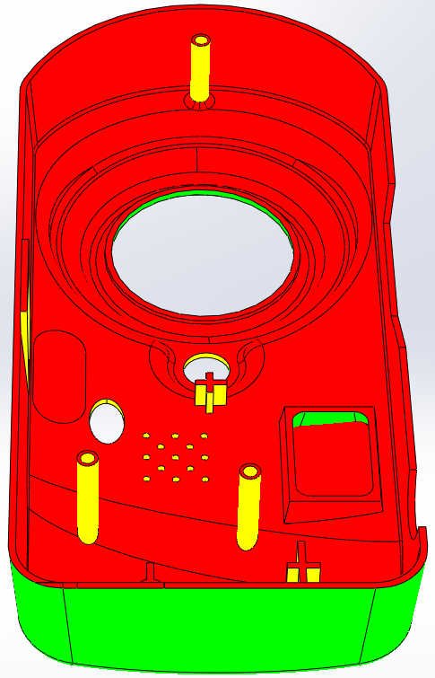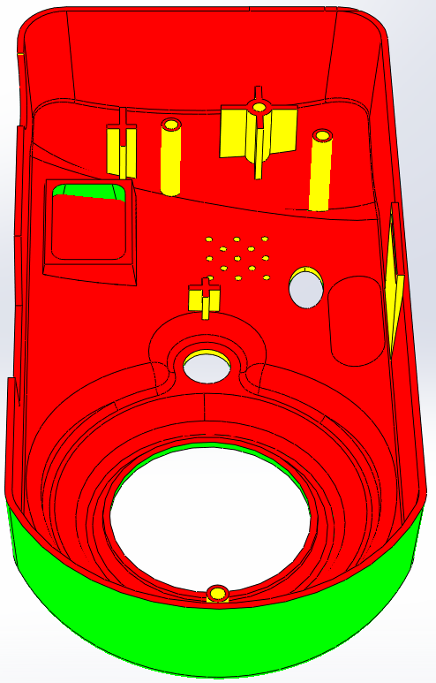
Result:  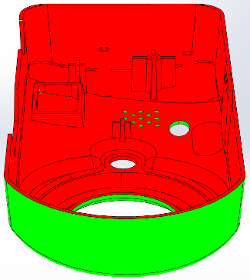  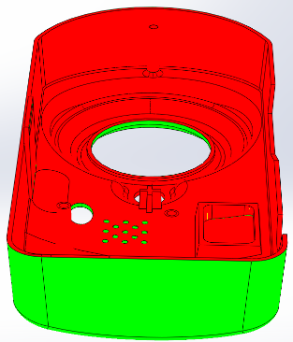  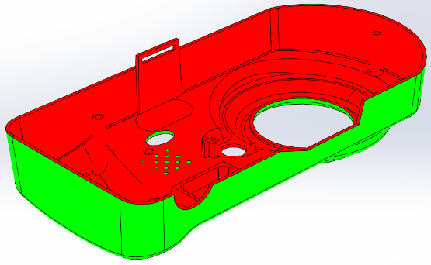 | Modified shell:  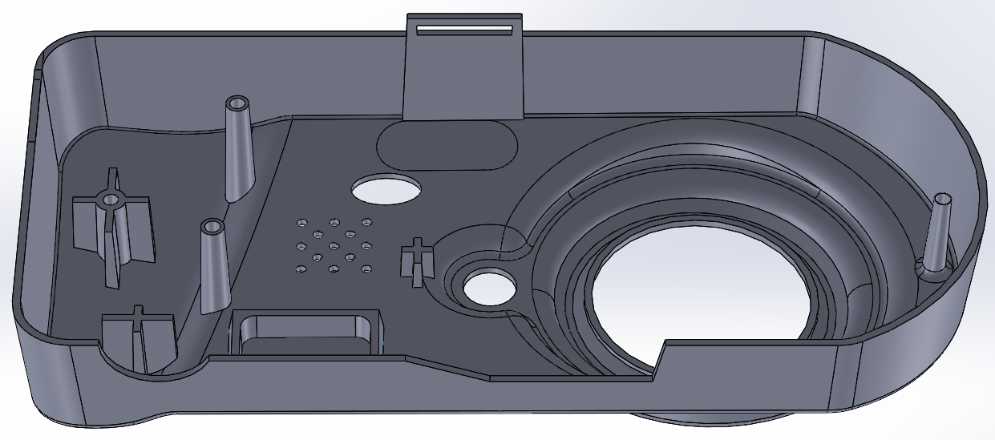

References
(n.d.). Retrieved from MatWeb Material Property Data: http://www.matweb.com/

