  Component One: Student Journal (Learning Log)  What are the key skills required when working in the housekeeping team? | Student No: | 2133695
 | Module Title: | Operation Hotel Facilities
 | Module Code: | BMIH4006
 | Lecturer: | Lola Villard
There are a few critical competencies that are necessary for success in the housekeeping team function. I've learnt the value of these abilities and how they contribute to the overall efficacy and efficiency of the housekeeping department via my education and work experience in the hospitality sector.
Attention to detail is one of the essential abilities needed for the housekeeping staff. The hotel's public spaces, guest rooms, and other places are all under the care of the housekeeping staff. To make sure that no blemishes or stains are overlooked, everything is put away correctly, and the appearance is impeccable, this calls for a sharp eye for detail (Chibili, 2019). Another important skill in the housekeeping team is time management. Housekeepers often have a tight schedule to adhere to, with multiple rooms and tasks to complete within a specific timeframe. Effective time management ensures that tasks are completed efficiently, allowing for the smooth operation of the department. Prioritizing tasks, organizing workflow, and using time-saving techniques can help housekeepers meet deadlines and deliver prompt service (Bringer, 2018). In order to make sure that all obligations are met within the allotted time, I learnt the value of planning and prioritising chores during my time working in the housekeeping department.
Teamwork and Communication skills are also vital when working in the housekeeping team. Housekeepers frequently interact with other departments, such as front office and maintenance, as well as with guests. Clear and effective communication is necessary to understand and fulfil guest requests, coordinate with colleagues, and report any maintenance or cleanliness issues (Gil-Soto et al., 2019). I experienced the significance of communication during my internship when I had to communicate with the front office to ensure timely room turnovers and address guest concerns. By maintaining open lines of communication, the housekeeping team can work cohesively with other departments and provide seamless service to guests.
I'm thinking about how important collaboration and flexibility are in this position as I continue to research the essential abilities needed to function in the cleaning team. Working closely with coworkers to ensure the department runs well and guests are satisfied requires collaboration on the side of housekeeping.
The housekeeping team relies on teamwork since efficient task completion necessitates coordinated efforts from all team members. In my experience, hectic times like peak hotel occupancy or when big groups check in or depart are when I've seen the value of collaboration in action. I was able to achieve deadlines and uphold strict standards of cleanliness by assigning jobs to team members, prioritising duties, and cooperating with one another. Effective teamwork not only enhances productivity but also creates a positive work environment where mutual support and cooperation thrive (Xia et al., 2020).
Flexibility is another key skill that plays a vital role in the housekeeping team. The hospitality industry is dynamic and unpredictable, with varying guest demands and unexpected situations arising at any moment. Being adaptable and flexible allows housekeepers to respond to changing circumstances, adjust schedules, and handle challenging situations effectively (Cottrell, 2019). For instance, during my internship, I encountered instances where guests requested early check-ins or late check-outs, which required the housekeeping team to adapt their plans and accommodate these requests promptly. By being flexible, housekeepers can provide excellent service while maintaining guest satisfaction.
Understanding industry standards and best practises is necessary for translating theoretical knowledge into practical applications. I have discovered the value of employing appropriate cleaning methods, abiding by safety regulations, and applying sustainable practises in the housekeeping division via my studies. This theoretical knowledge can be directly applied in industry settings to ensure efficient and effective housekeeping operations. For example, understanding the correct usage of cleaning agents and equipment helps in achieving optimal cleanliness while minimizing damage to surfaces (Leiter and Bakker, 2010). Additionally, knowledge of sustainability practices enables housekeepers to conserve resources and contribute to the hotel's environmental initiatives.
The topic of key skills required in the housekeeping team holds significant importance in the hospitality industry. Housekeeping is an integral part of a hotel's operations, directly impacting the guest experience and overall reputation (Chan et al., 2020). A well-maintained and clean environment enhances guest satisfaction, contributes to positive reviews, and encourages repeat business. On the other side, any lapses in cleaning might result in complaints from visitors, unfavourable reviews, and significant reputational harm. Being able to provide great cleaning service is therefore essential for retaining a competitive advantage in the market and guaranteeing the profitability of the hotel (Mullins and Doss, 2013).

Word Count | 746

Component Two: Practical Task - Scenario

Problem | Why did it happen? | What are you going to do? | How will you prevent this from happening in the future? | What measures would you introduce to improve team effectiveness?
1. Room not properly cleaned | Lack of attention to detail by the housekeeping team | Conduct a thorough inspection of the room to identify any areas that were not cleaned properly. Apologize to the guest and offer to have the room cleaned again immediately. | Reinforce the importance of attention to detail during training sessions and emphasize the need for thorough cleaning and inspection. This is going to be short term goal. | Timeframe: Within 1 week  Implement a quality control system where team leaders or supervisors conduct regular inspections to ensure cleaning standards are met (Raghubalan and Raghubalan, 2016). Regularly provide feedback and training to improve attention to detail.
2. Dust and debris in the room | Insufficient cleaning techniques and equipment | Assign a skilled housekeeper to thoroughly clean the room, paying particular attention to dusting and vacuuming. Conduct a second inspection to ensure cleanliness before allowing the guest to re-enter (Quick, 2020). | Provide additional training on proper cleaning techniques, including dusting and vacuuming, and ensure that the housekeeping team has access to appropriate cleaning equipment. This is going to be short term goal. | Timeframe: Within 1 week  Evaluate and update the housekeeping inventory to ensure an adequate supply of effective cleaning tools and materials. Conduct regular training sessions on proper equipment usage and cleaning techniques.
3. Stains on the bedding | Inadequate stain removal methods and products | Replace the stained bedding with fresh, clean linens. Instruct the housekeeping team to utilize stain removal techniques and products effectively. | Train the housekeeping team on the proper handling and treatment of different types of stains. Provide them with appropriate stain removal products and tools (Ouyang et al., 2019). This is going to be short term goal. | Timeframe: Within a few days  Implement a regular review of stain removal methods and products, considering advancements in technology and industry best practices. Share stain removal tips and best practices among the team.
4. Unclean bathroom fixtures | Oversight during the cleaning process | Assign a housekeeper to thoroughly clean and disinfect all bathroom fixtures, including sinks, toilets, and showers. Conduct a final inspection to ensure cleanliness. | Develop a comprehensive cleaning checklist that covers all areas and fixtures in the bathroom. Provide clear instructions on the proper cleaning and disinfection procedures for each fixture. This is going to be short term goal. | Timeframe: Within 3 days  Implement a buddy system where housekeepers cross-check each other's work to ensure all areas are properly cleaned and inspected. Conduct regular audits to ensure compliance with cleaning standards and provide feedback for improvement (Further Cased, 2012).
5. Insufficient amenities | Lack of restocking procedures | Apologize to the guest and promptly provide the required amenities. Develop a system to track and monitor amenity usage to ensure timely restocking. | Establish a clear procedure for monitoring and restocking amenities, including regular inventory checks and communication with suppliers. Ensure that housekeepers have easy access to amenities and are aware of restocking responsibilities. This is going to be short term goal. | Timeframe: Within a few weeks  Implement a logbook or digital system to track and record amenity usage, ensuring efficient restocking practices. Provide training on inventory management and communication channels with suppliers.
6. Lack of communication with the guest | Failure to address guest concerns and requests promptly | Apologize to the guest for the inconvenience and assure them that their concerns will be addressed. Offer compensation or alternative solutions based on the guest's preferences and needs (Ferdinand and Bitch., 2017). | Emphasize the importance of prompt guest communication and empower the housekeeping team to address guest concerns proactively. Develop a clear process for escalating and resolving guest issues. This is going to be medium-term goal. | Timeframe: 1 month  Implement a communication protocol where the housekeeping team reports guest requests or concerns promptly to ensure timely resolution. Provide training on effective guest communication and conflict resolution techniques.
7. Lack of supervision and accountability | Inadequate oversight and management | Conduct a review of the housekeeping team's performance and address any shortcomings or gaps in supervision. Assign a dedicated team leader to provide guidance, support, and accountability. | Implement regular performance evaluations and feedback sessions to assess individual and team performance. Set clear expectations and goals for the team and establish performance metrics. This is going to be medium term goal. | Timeframe: 2 months  Assign team leaders or supervisors to oversee the work of the housekeeping team, providing guidance, support, and ensuring accountability for their performance. Conduct regular team meetings and foster a culture of continuous learning and improvement (Johnston et al., 2012).
Table 1: An action plan for the complaint

Component Three: Presentation

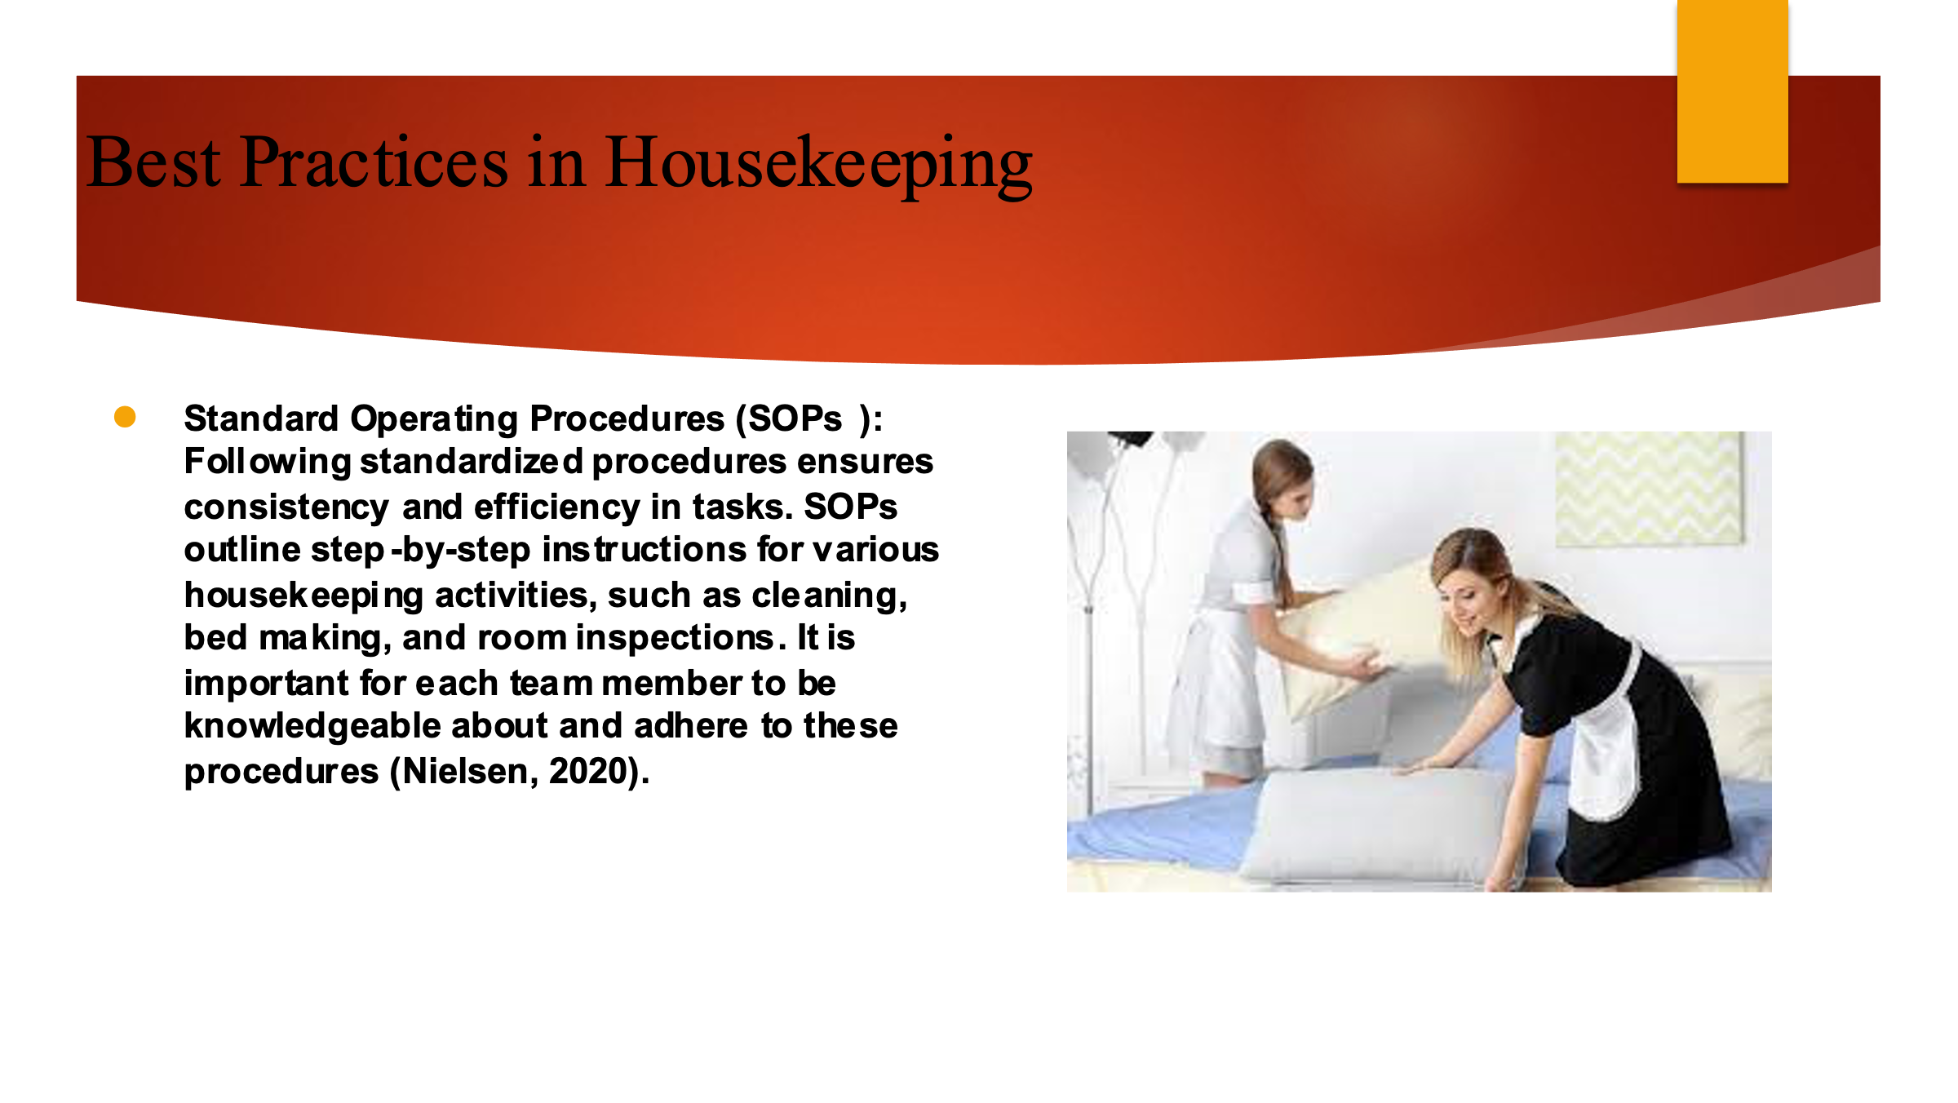

Training Notes:
Best Practices in Housekeeping
Standard Operating Procedures (SOPs): Following standardized procedures ensures consistency and efficiency in tasks. SOPs outline step-by-step instructions for various housekeeping activities, such as cleaning, bed making, and room inspections. It is important for each team member to be knowledgeable about and adhere to these procedures (Nielsen, 2020).
Time Management: Effective time management is crucial in meeting deadlines and providing timely service. Planning tasks efficiently, prioritize based on urgency, and avoid rushing through tasks. Using time-saving techniques like grouping similar tasks together to maximize productivity.
Attention to Detail: Paying attention to detail is essential in delivering exceptional service. Ensure thorough cleaning, proper placement of amenities, and meticulous bed making. Any issues that may affect the guest experience, such as maintenance needs or insufficient supplies (Jones, 2010).

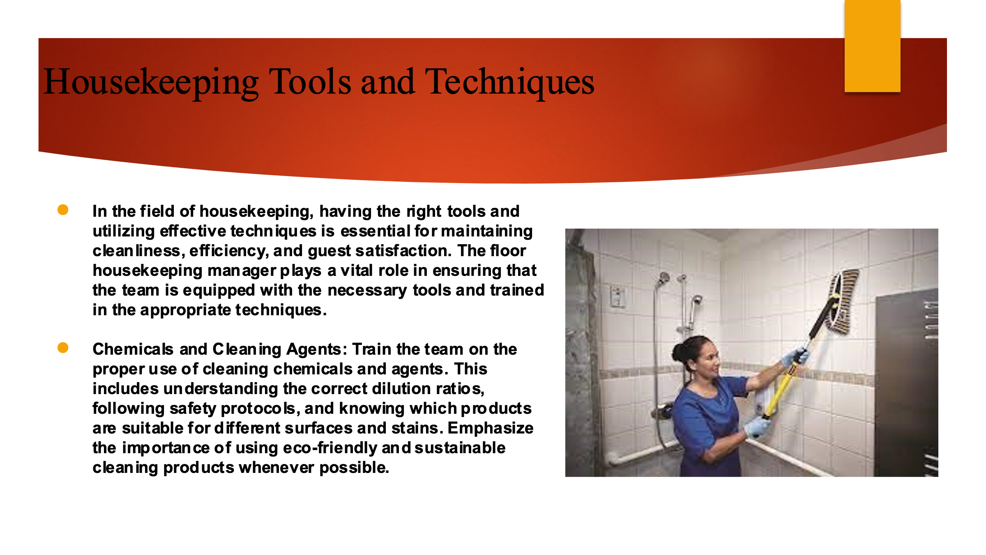

Training Notes:
Housekeeping Tools and Techniques
In the field of housekeeping, having the right tools and utilizing effective techniques is essential for maintaining cleanliness, efficiency, and guest satisfaction. The floor housekeeping manager plays a vital role in ensuring that the team is equipped with the necessary tools and trained in the appropriate techniques.
Chemicals and Cleaning Agents: Train the team on the proper use of cleaning chemicals and agents. This includes understanding the correct dilution ratios, following safety protocols, and knowing which products are suitable for different surfaces and stains. Emphasize the importance of using eco-friendly and sustainable cleaning products whenever possible (Rogers, 2020).
Time Management: Teach the team effective time management techniques to optimize productivity. This includes planning and prioritizing tasks, setting realistic goals, and efficiently allocating resources. Encourage them to develop daily and weekly cleaning schedules to ensure that all areas are thoroughly cleaned and maintained.
Teamwork and Communication: Promote teamwork and effective communication within the housekeeping team. Encourage them to collaborate, coordinate tasks, and support each other to ensure efficient workflow. Foster a culture of open communication, where team members can share feedback, suggestions, and challenges they encounter during their work (Whiting and Symon, 2020).
Inspection and Quality Control: Establish a system for regular inspections to assess the quality of cleaning and identify any areas that require improvement. Conduct spot checks, use checklists, or implement a feedback mechanism from guests or other departments. This helps to maintain consistency and ensures that brand standards are upheld.

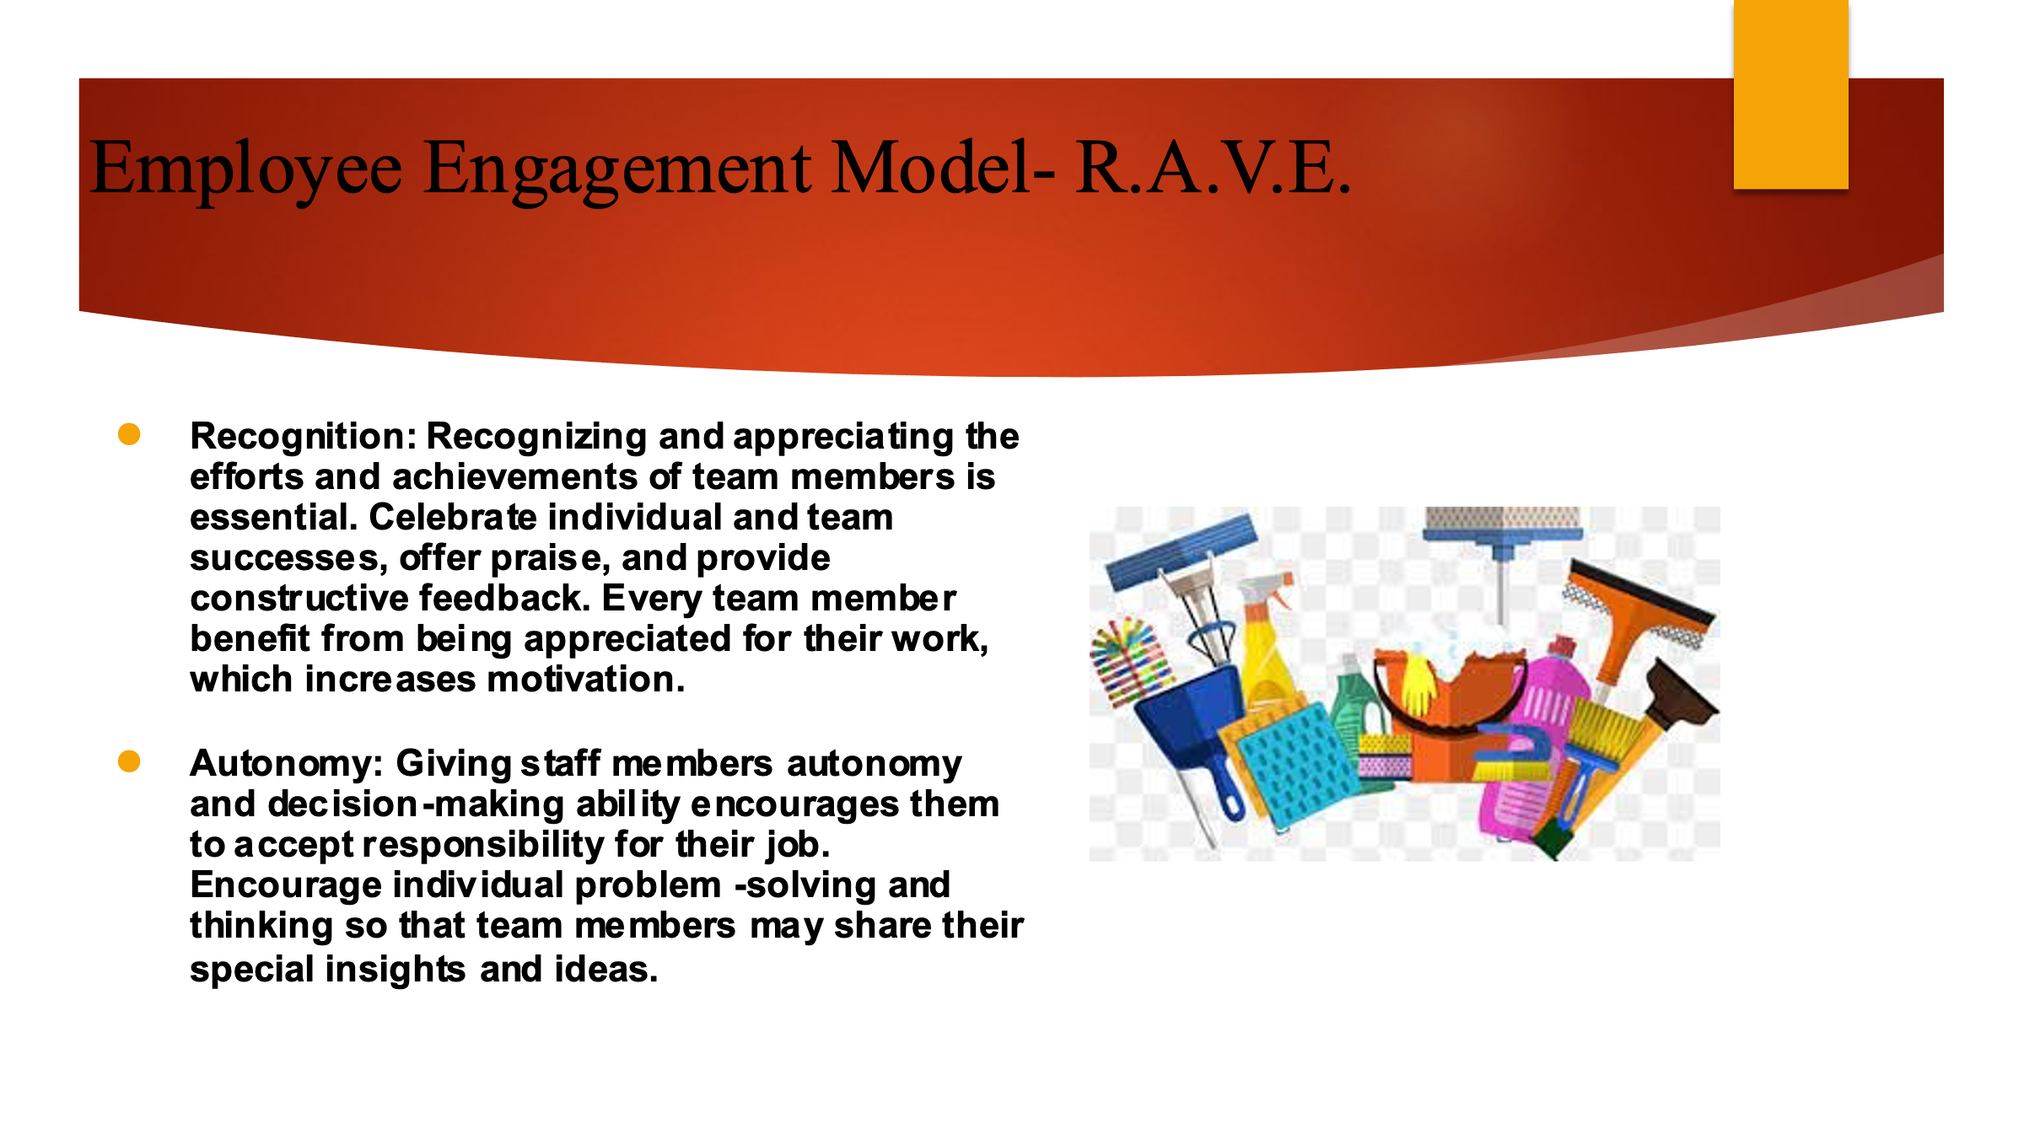
Training Notes:
Employee Engagement Model - R.A.V.E.
Recognition: Recognizing and appreciating the efforts and achievements of team members is essential. Celebrate individual and team successes, offer praise, and provide constructive feedback. Every team member benefit from being appreciated for their work, which increases motivation (Sharma et al., 2019).
Autonomy: Giving staff members autonomy and decision-making ability encourages them to accept responsibility for their job. Encourage individual problem-solving and thinking so that team members may share their special insights and ideas.
Vision and Purpose: through creating a more encompassing vision, direction can be given to team members internally. This facilitates in setting equality standard internally.
Enablement: Providing the necessary resources, tools, and training enables employees to perform their jobs effectively. Ensure access to proper equipment, cleaning products, and ongoing training opportunities. Support professional growth and development to enhance skills and knowledge (Thébaud et al., 2021).

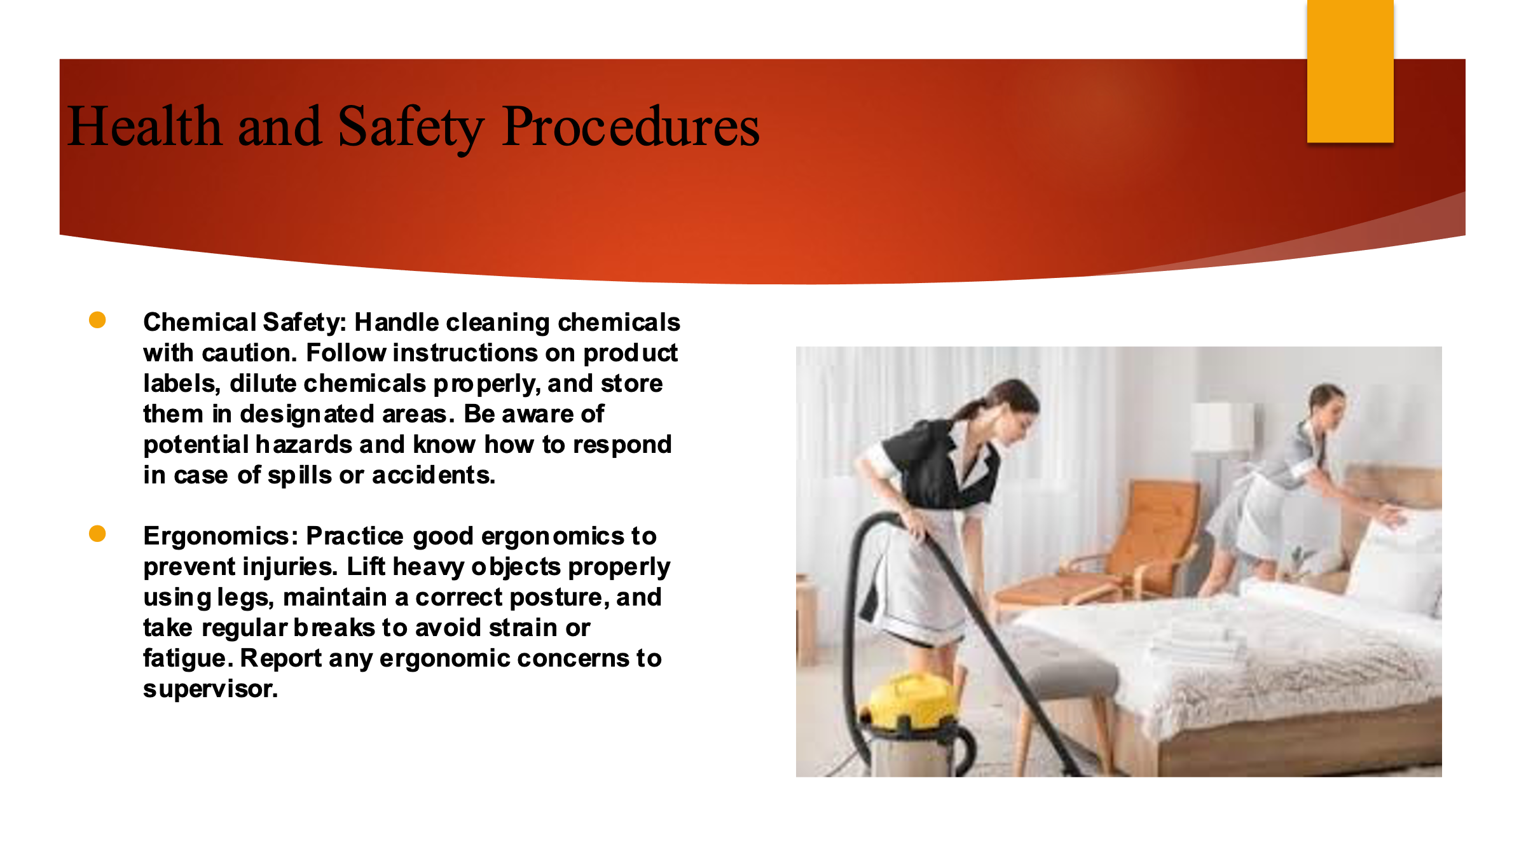

Training Notes:
Health and Safety Procedures
Chemical Safety: Handle cleaning chemicals with caution. Follow instructions on product labels, dilute chemicals properly, and store them in designated areas. Be aware of potential hazards and know how to respond in case of spills or accidents.
Ergonomics: Practice good ergonomics to prevent injuries. Lift heavy objects properly using legs, maintain a correct posture, and take regular breaks to avoid strain or fatigue. Report any ergonomic concerns to supervisor.
Infection Control: Implement proper infection control measures to prevent the spread of diseases. Follow established protocols for cleaning and disinfecting high-touch surfaces, and maintain good personal hygiene, including frequent handwashing (Brody, 2019).
To reinforce the importance of Health and Safety procedures, this will engage in a role-playing activity. In pairs, one person will play the role of a housekeeper demonstrating correct Health and Safety practices, while the other person will observe and provide feedback. Switch roles after a few minutes. This activity will help identify areas for improvement and ensure that everyone is following the proper procedures.
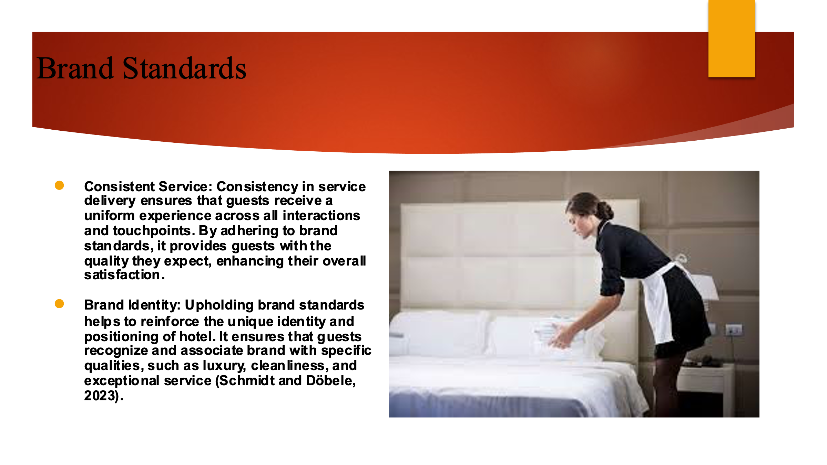

Training Notes:
Brand Standards
Consistent Service: Consistency in service delivery ensures that guests receive a uniform experience across all interactions and touchpoints. By adhering to brand standards, it provides guests with the quality they expect, enhancing their overall satisfaction.
Brand Identity: Upholding brand standards helps to reinforce the unique identity and positioning of hotel. It ensures that guests recognize and associate brand with specific qualities, such as luxury, cleanliness, and exceptional service (Schmidt and Döbele, 2023).
Guest Perception: Meeting or exceeding brand standards positively influences guest perception. Consistently delivering on the brand promise builds trust and confidence in hotel, encouraging guests to choose the business for future stays and recommend to others.

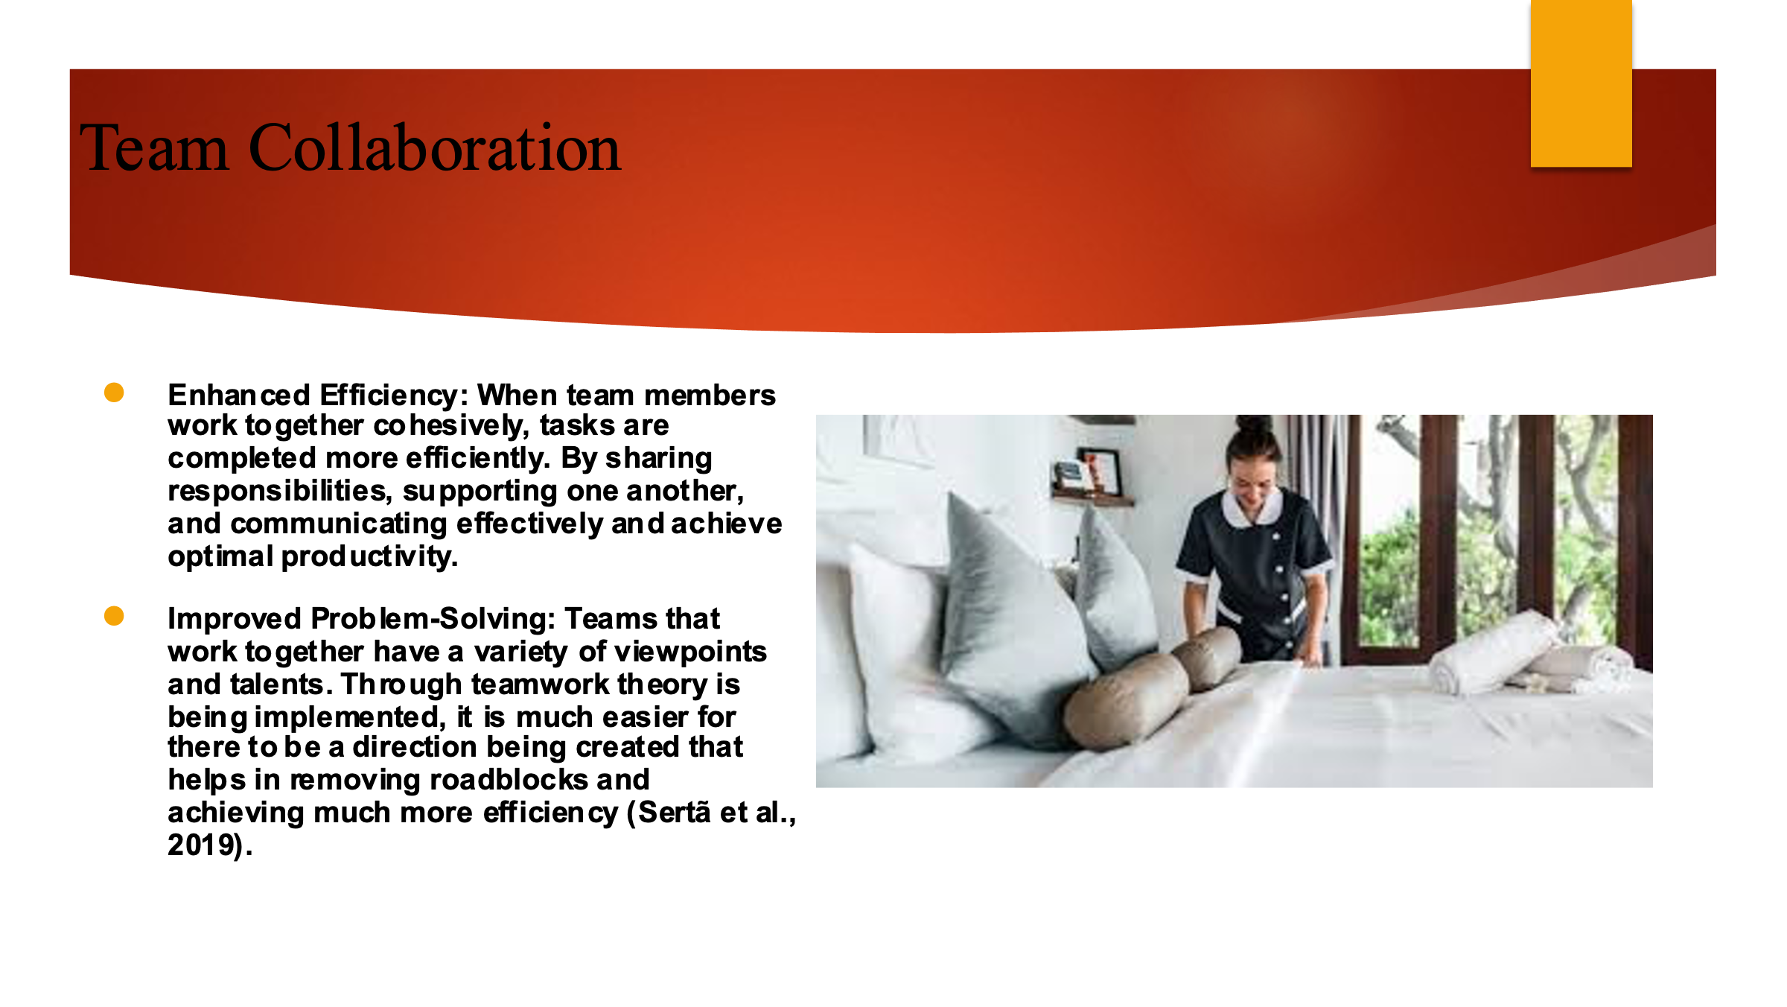

Training Notes:
Team Collaboration
Enhanced Efficiency: When team members work together cohesively, tasks are completed more efficiently. By sharing responsibilities, supporting one another, and communicating effectively and achieve optimal productivity.
Improved Problem-Solving: Teams that work together have a variety of viewpoints and talents. Through teamwork theory is being implemented, it is much easier for there to be a direction being created that helps in removing roadblocks and achieving much more efficiency (Sertã et al., 2019).
Positive Work Environment: Focusing upon internal work culture being developed helps in being able to create collaborative environments for growth. Higher job satisfaction and greater staff engagement result from it because it stimulates open communication, ideas sharing, and a supportive environment.

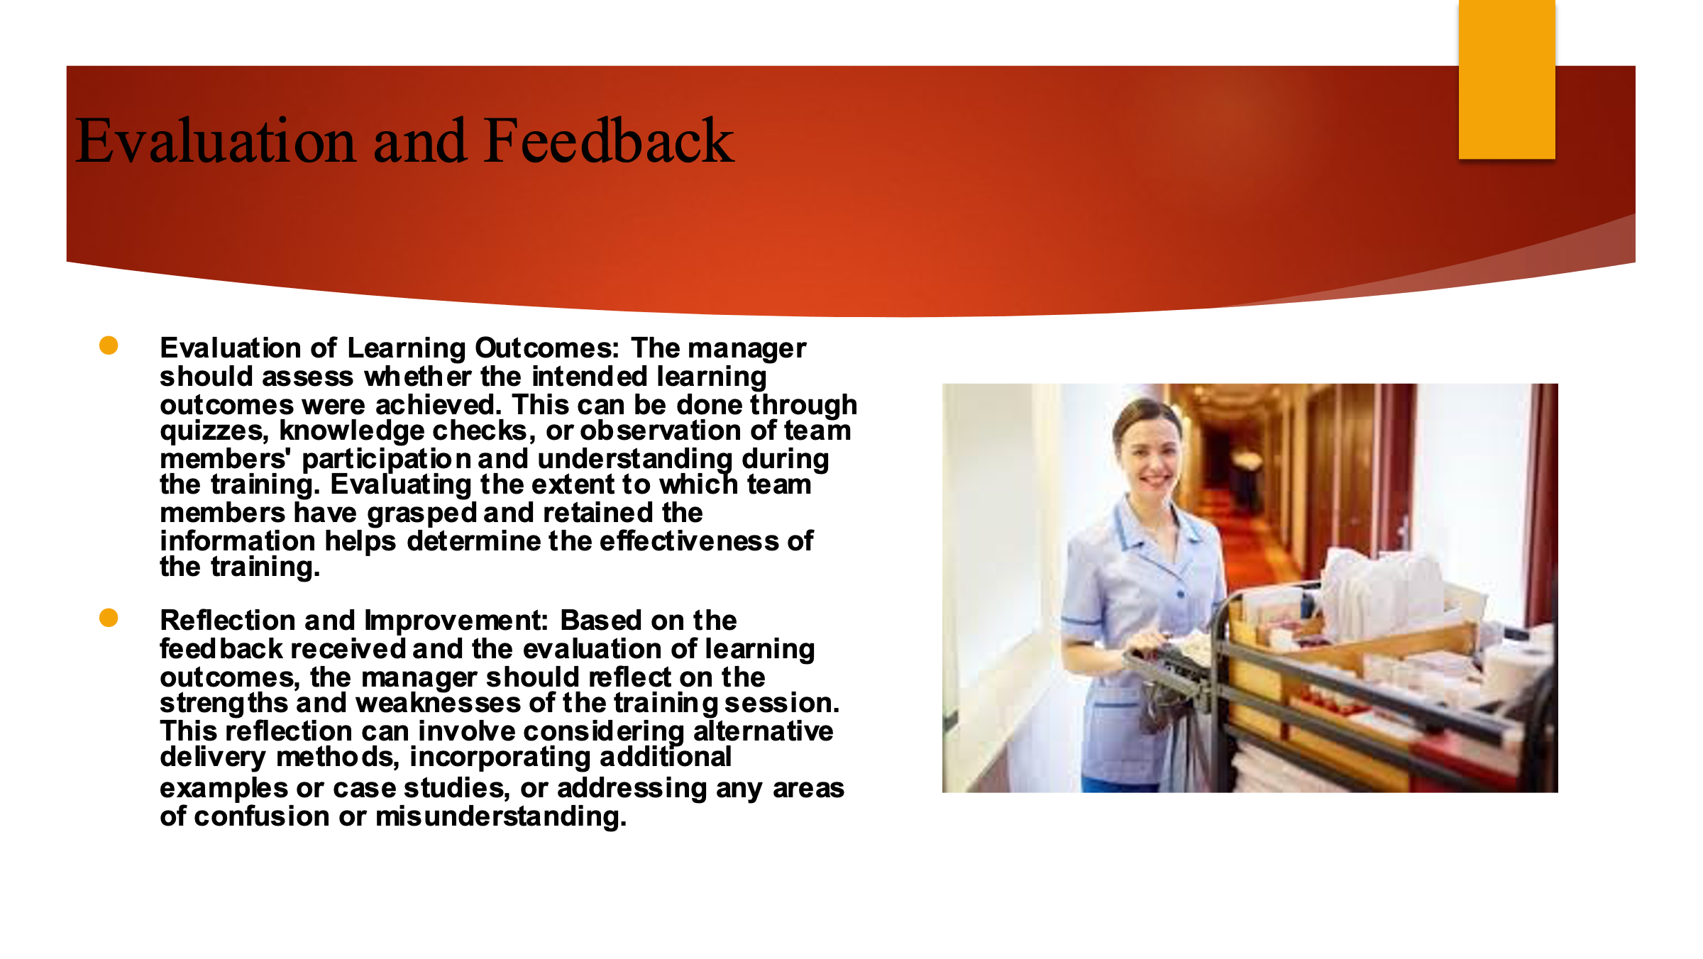

Training Notes:
Evaluation and Feedback
Evaluation of Learning Outcomes: The manager should assess whether the intended learning outcomes were achieved. This can be done through quizzes, knowledge checks, or observation of team members' participation and understanding during the training (Tesone, 2010). Evaluating the extent to which team members have grasped and retained the information helps determine the effectiveness of the training.
Reflection and Improvement: Based on the feedback received and the evaluation of learning outcomes, the manager should reflect on the strengths and weaknesses of the training session. This reflection can involve considering alternative delivery methods, incorporating additional examples or case studies, or addressing any areas of confusion or misunderstanding.
Continuous Training and Development: The manager should use the feedback and evaluation results as a basis for continuous improvement. This may involve scheduling follow-up training sessions or workshops to reinforce key concepts, addressing specific areas of improvement, or identifying opportunities for ongoing professional development (Rutherford, 2021).
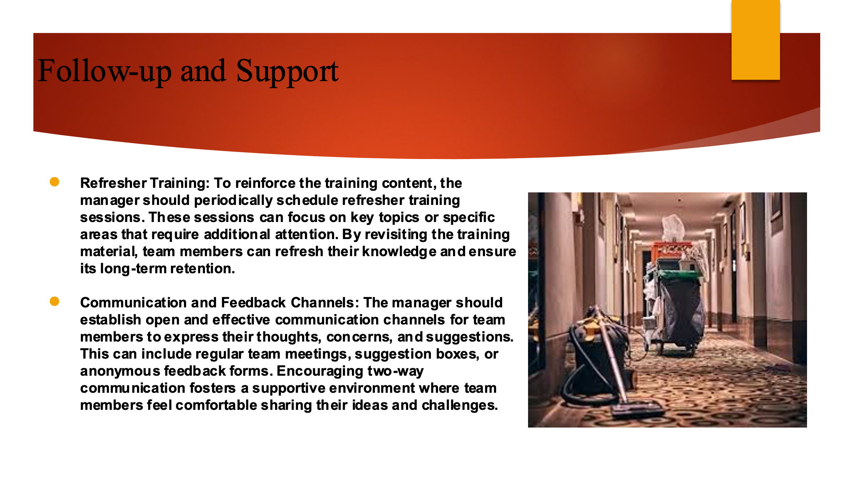

Training Notes:
Follow-up and Support
Refresher Training: To reinforce the training content, the manager should periodically schedule refresher training sessions. These sessions can focus on key topics or specific areas that require additional attention. By revisiting the training material, team members can refresh their knowledge and ensure its long-term retention.
Communication and Feedback Channels: The manager should establish open and effective communication channels for team members to express their thoughts, concerns, and suggestions. This can include regular team meetings, suggestion boxes, or anonymous feedback forms. Encouraging two-way communication fosters a supportive environment where team members feel comfortable sharing their ideas and challenges.
Recognition and Rewards: The manager should recognize and reward team members' efforts and achievements. Acknowledging exceptional performance, providing incentives, or implementing an employee recognition program motivates team members to excel in their roles and reinforces the importance of the training content (Olimovich and Khudoynazarovich, 2020).
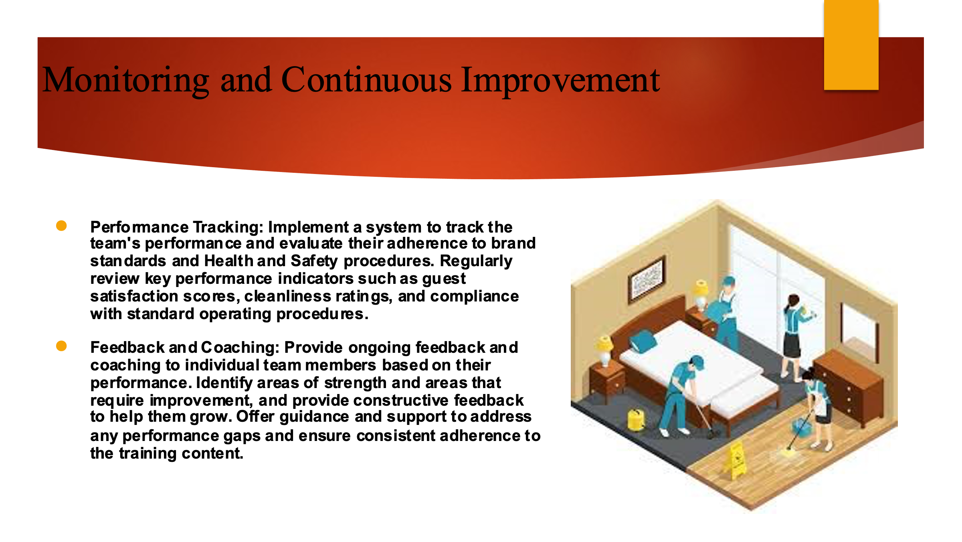

Training Notes:
Monitoring and Continuous Improvement
Performance Tracking: Implement a system to track the team's performance and evaluate their adherence to brand standards and Health and Safety procedures. Regularly review key performance indicators such as guest satisfaction scores, cleanliness ratings, and compliance with standard operating procedures.
Feedback and Coaching: Provide ongoing feedback and coaching to individual team members based on their performance. Identify areas of strength and areas that require improvement, and provide constructive feedback to help them grow. Offer guidance and support to address any performance gaps and ensure consistent adherence to the training content.
Team Meetings and Discussions: Conduct regular team meetings to discuss challenges, share best practices, and brainstorm ideas for improvement. Encourage open dialogue and create a safe space for team members to voice their opinions and suggestions. Collaboratively identify areas where the team can collectively enhance their skills and performance (BRUžA et al., 2019).
Training Needs Assessment: Periodically assess the team's training needs to identify any knowledge or skill gaps. This can be done through surveys, individual discussions, or performance evaluations. Use this information to develop targeted training programs or workshops to address specific areas of improvement and provide continuous learning opportunities.
Collaboration with Other Departments: Foster collaboration with other departments, such as front desk and maintenance, to ensure seamless coordination and communication. Regularly communicate with these departments to address any housekeeping-related issues, gather feedback, and identify opportunities for process improvement.
Industry Benchmarking: Stay informed about industry trends and best practices in housekeeping. Benchmark the team's performance against industry standards and seek opportunities to implement innovative practices that can enhance efficiency, guest satisfaction, and team performance (Sarode, 2020).
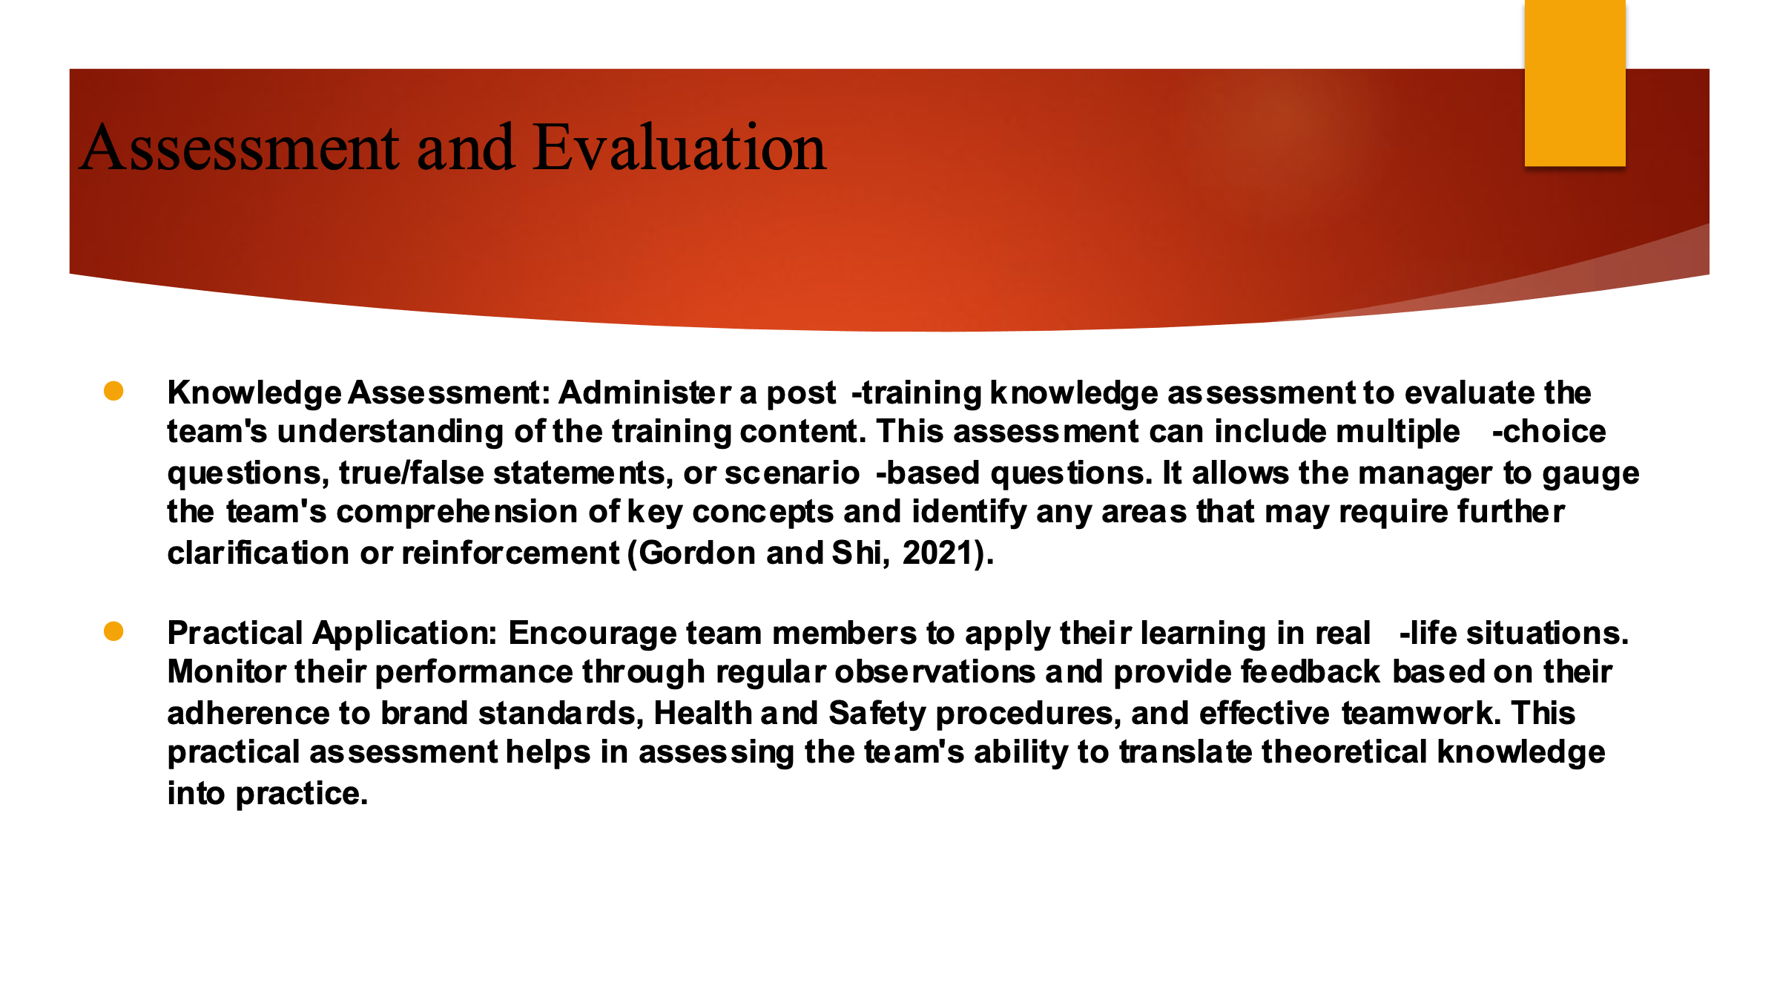

Training Notes:
Assessment and Evaluation
Knowledge Assessment: Administer a post-training knowledge assessment to evaluate the team's understanding of the training content. This assessment can include multiple-choice questions, true/false statements, or scenario-based questions. It allows the manager to gauge the team's comprehension of key concepts and identify any areas that may require further clarification or reinforcement (Gordon and Shi, 2021).
Practical Application: Encourage team members to apply their learning in real-life situations. Monitor their performance through regular observations and provide feedback based on their adherence to brand standards, Health and Safety procedures, and effective teamwork. This practical assessment helps in assessing the team's ability to translate theoretical knowledge into practice.
Manager's Evaluation: The floor housekeeping manager plays a crucial role in evaluating the team's performance. Conduct regular performance evaluations and provide constructive feedback to individual team members. Assess their overall adherence to brand standards, Health and Safety procedures, and teamwork. Identify areas for improvement and provide guidance for further development.
Training Effectiveness Survey: Distribute a training effectiveness survey to the team, allowing them to provide feedback on the training presentation. Gather their opinions on the content, delivery style, and overall effectiveness. This feedback helps in refining future training sessions and addressing any areas of improvement.

References
Bringer, E. 2018 Employee engagement: apmcbcal mtroduction. 2nd ed. HR Fundamentals. London: CIPO and Kogan Page.
Brody, D., 2019. Housekeeping by design: Hotels and labor. University of Chicago Press.
BRUžA, D., MILOLOžA, I. and SANTO, T., 2019. Pre-opening hotel management–phases and procedures. Under the auspices of the President of the Republic of Croatia, p.33.
Chan, E.S., Okumus, F. and Chan, W., 2020. What hinders hotels’ adoption of environmental technologies: A quantitative study. International Journal of Hospitality Management, 84, p.102324.
Chibili, M.N., 2019. Hotel Management–Viewed from Above. In Modern Hotel Operations Management (pp. 92-117). Routledge.
Cottrell, S. 2019 The Study Skills Handbook. 5th ed. London: Red Globe Press.
Ferdinand, N. and Bitch., P. 2017. Events Management -An internatonol Approach. 2nd ed. London: SAGE Publications Ltd.
Further Cased, M. 2012. Housekeeping Management. London: Wiley. Fallon, M. & Rutherford, O. 2010. Hotel Management and Operations. London: Pearson.
Gil-Soto, E., Armas-Cruz, Y., Morini-Marrero, S. and Ramos-Henríquez, J.M., 2019. Hotel guests’ perceptions of environmentally friendly practices in social media. International Journal of Hospitality Management, 78, pp.59-67.
Gordon, S. and Shi, X., 2021. Engaging Hotel Managers Through Managerial Support. ICHRIE Research Reports, 6(1), p.1.
Johnston, R., Clark, G. & Shelve, M. (2012) Service Operations Management. London: Pearson.
Jones, I (2010) Professional Management of Housekeeping OP<ratlanS. London:
Leiter, M. P. and Bakker, A. B. (2010) Work Engagement: A Handbook of Essential Theory and Research. Hove [England]: Psychology Press.
Mullins, L and Doss, P. (2013) Hospitality Management and Organisational Behaviour. 5th ed. Harlow: Pearson.
Nielsen, D., 2020. Standard Operating Procedures Manual. Routledge.
Olimovich, D.I. and Khudoynazarovich, S.A., 2020. The cost-effectiveness of improving the quality of hotel services. Academy, (55), pp.40-42.
Ouyang, Z., Wei, W. and Chi, C.G., 2019. Environment management in the hotel industry: does institutional environment matter?. International Journal of Hospitality Management, 77, pp.353-364.
Quick, L 2020. Managing Events. Hell Challenges, Real Outcomes. London: SAGE Publications Ltd.
Raghubalan, G. and Raghubalan, S. 2016. Hotel Housekeepng - Operations And Management. Ord ed. India: Oxford University Pre..
Rogers, T. 2020. conferences and conventions p &pot industry (2nd ed., Events management series). Oxford ; Boston: Butterworth-Heinemann.
Rutherford, D.G., 2021. Hotel management and operations. Routledge.
Sarode, A., 2020. A STUDY ON THE BEST PRACTICES ADOPTED FOR EFFECTIVE HOTEL MANAGEMENT.
Schmidt, S. and Döbele, M., 2023. Housekeeping. In Dementia Companion: Guide for Additional Caregivers in Nursing Care (pp. 177-184). Berlin, Heidelberg: Springer Berlin Heidelberg.
Sertã, A.L., Elmimouni, H., Barkhuus, L., Cox, R. and Rode, J., 2019, May. Digital housekeeping, gender and domestic work. In Extended abstracts of the 2019 CHI conference on human factors in computing systems (pp. 1-4).
Sharma, N., Chaudhao N. and Singh, V. (2019) Management Techniques Ear Employee Engagement Contemporary OrganaatIons. Hershey, PennsWvanla: IGI Global.
Tesone, O. (2010) Principles Of Management For The Hospitality Industry. 1st ed. London: Routledge.
Vallen, G. & Valkn,1. (2012) Managing Hotel Operations. London: Pearson.
Wood, R. (2013) Key Concepts in Hospitality Management. London: Sage.
Thébaud, S., Kornrich, S. and Ruppanner, L., 2021. Good housekeeping, great expectations: Gender and housework norms. Sociological Methods & Research, 50(3), pp.1186-1214.
Whiting, R. and Symon, G., 2020. Digi-housekeeping: the invisible work of flexibility. Work, employment and society, 34(6), pp.1079-1096.
Xia, H., Vu, H.Q., Law, R. and Li, G., 2020. Evaluation of hotel brand competitiveness based on hotel features ratings. International Journal of Hospitality Management, 86, p.102366.

