
Construction Portfolio
Fundamentals of construction technology
30 April 2026
Isobel Baldwin-Pritchard (2502740)
UWTSD
Table of Contents
Introduction 2
Historical Study 3
Ground contamination due to its industrial past 3
Recommendations for site investigations 4
Hydrology 4
Depth of varying materials 4
Made ground 4
Flood Risk 5
Building regulations 5
Involvement of local authorities 5
Proposed Foundation Solution 6
Referencing 7

Introduction
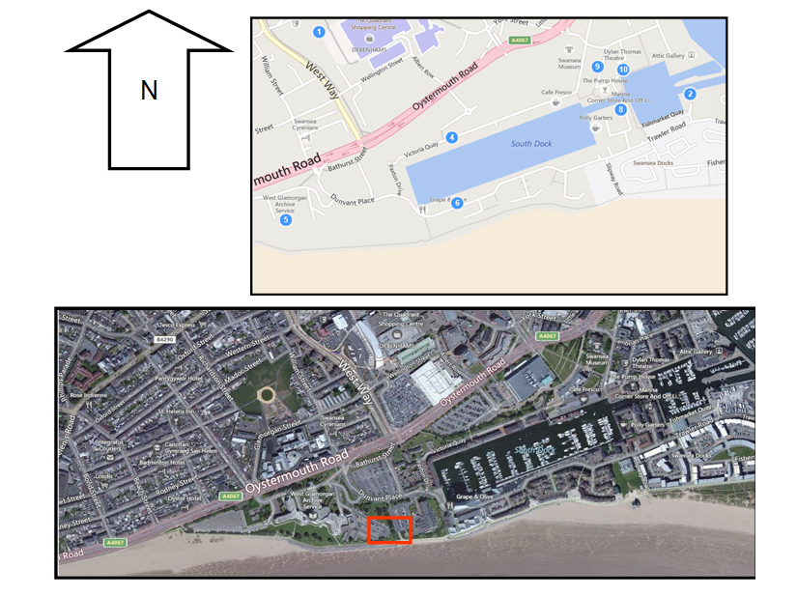
The City and County of Swansea have entered into a joint agreement with Marriott Hotels to develop a new restaurant and ice-cream parlour, incorporating a manager’s apartment on the Swansea foreshore. The proposed site lies between County Hall and the Marriott Hotel, as illustrated in the accompanying images, and will partially use the existing car parks serving both neighbouring facilities. The development will provide approximately 2,000 square metres of gross internal area at ground floor level. The ground floor will accommodate a restaurant, café bar, ice-cream parlour, and a fully equipped kitchen with associated storage areas, while the second floor will include a self-contained manager’s apartment, meeting rooms, and staff welfare facilities. Designed to engage with its coastal setting, the building will feature a glass façade and open directly onto the promenade.
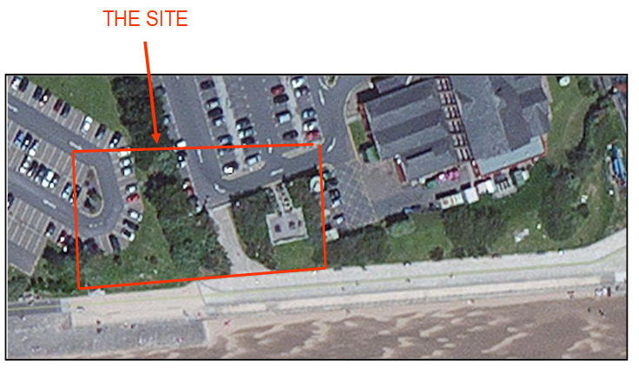

Historical Study
The construction history of the South Dock area in Swansea began ceremonially on 26 February 1852 when Marquis of Worcester cut the first sod using an ornate mahogany wheelbarrow and steel shovel. Captain Evan Morgan vice-chairman of the Swansea Dock Company carried the sod.
Construction soon ran into financial trouble, and under the Swansea Harbour Act 1857 the project was taken over by the Swansea Harbour Trust which completed the dock. 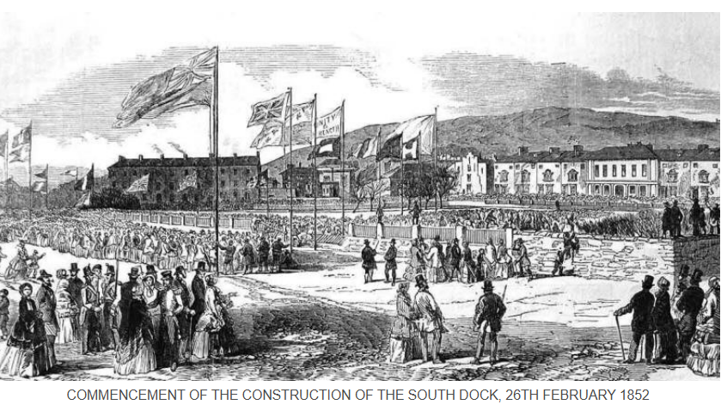
The south dock officially opened on 23 September 1859, with the ceremony performed by Emily Charlotte Talbot.
The dock went on to operate as a major commercial port for over a century handling coal exports, fish, and other cargoes. Structural improvements followed including a new river entrance and lock system completed in 1903, replacing earlier gate arrangements.
The South Dock handled commercial shipping for well over a century, and was famous for its thriving fish market, which was established in 1905, and for the export of coal. At one time there had been eleven coal-shipping appliances in the main dock area, although this number had fallen to just four by the mid-1930s. Other cargoes included iron ore, timber, sand & gravel, and potatoes. Sadly, a general decline in trade lead to the closure of the South Dock in 1971 but, within a few years, it had been acquired by the City Council and was being developed as the Marina we see today.
Declining trade led to the dock’s closure in 1971, but it was later redeveloped by the city council into the modern marina, preserving elements of its original infrastructure. (Swansea and Port Talbot Docks Website)

Ground contamination due to its industrial past
Opened in 1859, the dock emerged at a time when Swansea was undergoing a remarkable period of industrial expansion. During the 18th and 19th centuries, the town had developed into one of the world’s leading centres for copper production, particularly in the lower Tawe Valley.
This rapid growth was driven largely by the availability of abundant, high-quality coal in the region, which was essential for powering the energy-intensive process of smelting copper.
The area became so dominant in the industry that it earned the nickname Copperopolis. Copper ore itself was not sourced locally in large quantities, so it was transported by sea from places such as Cornwall, Anglesey and even from overseas. Ships would arrive loaded with ore, which was then processed in the numerous smelting works lining the banks. The finished copper could then be exported worldwide, making Swansea a crucial hub in global industrial trade.
The opening of the dock in 1859 significantly enhanced this operation, providing improved facilities for the handling, storage, and transportation of raw materials and finished goods. It allowed for more efficient movement of cargo, supported the continued expansion of heavy industry and reinforced Swansea’s position as a key port during the height of Britain’s industrial era.

Recommendations for site investigations

Hydrology
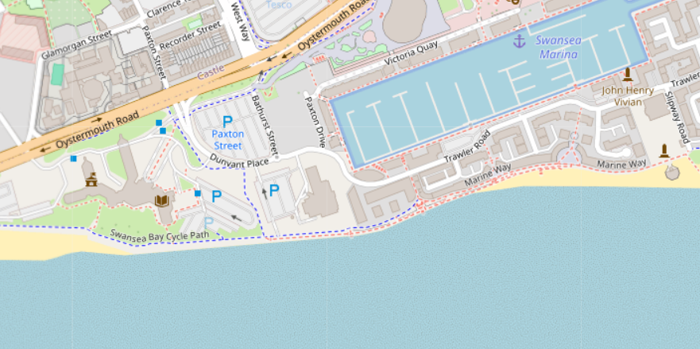
Hydrology is one of the main concerns for this site due to the close proximity to the sea. This can affect the site area due to high tidal range which drives strong coastal currents, sediment, transport, and significant flood risk. This all impacts a foundation solution ( Map of Swansea Spaces)
Depth of varying materials
Based on the boreholes log given and the tidal range of Swansea bay the material wash out may change during a period of time therefore an accurate and revised borehole log specific to the site will be required. Swansea Bay and the Gower Peninsula are located within the Severn Estuary, and the beaches and coastline experience the second highest tidal range in the world. The sea will advance and retreat twice daily with an average height of 8.5m. (Tidal Times – Swansea)
Made ground
Based on the borehole logs that consist of various materials from -0.50 to -1.45 including brick, shale, ashes, sand and clay.
The categorisation, analysis and reporting of ‘made ground’ is a recurring nightmare for the modern laboratory. Traditionally a by-product of land reclamation schemes, a container of the stuff can contain traces of anything from steel, concrete and brick to nappies and Coke cans (AGS)

Flood Risk
Another important concern, given the site’s coastal location and its close proximity to the sea, is the increasing risk of flooding. With sea levels rising year on year driven by factors associated with climate change there is a growing likelihood of both gradual inundation and more frequent extreme events such as storm surges. This elevates the vulnerability of low-lying coastal developments and places additional pressure on long-term design considerations.
The absence of adequate sea defences further heightens this risk. Without protective measures such as sea walls, revetments or managed shoreline strategies, the site could be exposed to erosion, water ingress and ground instability. These factors can have a direct impact on the performance and durability of foundations, potentially leading to settlement issues, loss of bearing capacity or even structural damage over time.
As a result, flood risk must be carefully assessed at the design stage, often through detailed flood risk assessments and coastal modelling. This may influence the overall foundation strategy, requiring elevated floor levels, flood-resistant construction methods or deeper and more robust foundation systems designed to withstand changing ground conditions. Incorporating appropriate mitigation measures is essential to ensure the long-term resilience and safety of the development. (Swansea Bay Shoreline management)

Building regulations
Building regulations that are recommended will be A, C and H
Foundations are required to transmit the load of the building safely to the ground. Therefore, all buildings should have adequate foundations (normally concrete), which will vary from one project to another depending on the circumstances of each case.
These foundations can be cast as deep-fill filling most of the trench or shallow-fill where the minimum thickness to transfer the load to the soil is provided. In this case this will not be practical engineered foundation solutions will be required like pilling or ground improvement. (GOV.WALES)

Involvement of local authorities
A building regulations inspector for foundations in Wales plays a critical role in ensuring that any new construction meets the required legal standards for safety, durability and performance. Their primary responsibility is to verify that foundation work complies with the Building Regulations, with particular attention to structural integrity, appropriate depth, ground conditions and effective drainage provision.
Before any concrete is poured, the inspector will visit the site to examine the foundation trenches. At this stage, they assess whether the excavations are deep and wide enough, check that they reach suitable load-bearing ground and confirm that there are no issues such as soft spots, groundwater ingress or contamination that could compromise the stability of the structure. If necessary, they may require adjustments such as deeper excavation or engineered solutions before approving the next stage of work.
In addition to on-site inspections, the inspector reviews construction drawings and specifications to ensure they align with regulatory requirements. This includes checking that the proposed foundation design is appropriate for the soil type and the intended building load, as well as ensuring compliance with drainage standards to prevent issues like water accumulation or subsidence.
Throughout the construction process, the inspector may carry out further visits at key stages to confirm ongoing compliance. Once all foundation and related works have been completed to the required standard, they contribute to the approval process that leads to the issuance of a final completion certificate.
This document is essential, as it provides formal confirmation that the work meets regulatory standards and is often required during property sales, refinancing, or insurance assessments. (Quick Guide to Building Regs)

Proposed Foundation Solution
Roger Bullivant Limited worked with The Bristol Port Company and Shear Design Consulting Civil and Structural Engineers to develop a piling solution for a new development within Royal Portbury Dock.

I would advise on the use of piling of the foundation solution. I have research similar ground conditions with an approved piling contractor, and I can draw similarities to the Royal Portbury Docks site this area shares the same tidal range and part of the same river / estuary mouth. It also share similarities in the ground conditions being on made ground and sand clay make up.

Challenging Ground Conditions: The site presented a complex soil profile:
• 2.0m of made ground
• Very soft sandy gravelly clay to 16.0m
• Silty sands with shell fragments to 26.0m
• Mercia Mudstone from 28.0m to 30.0m (Roger Bulivant)

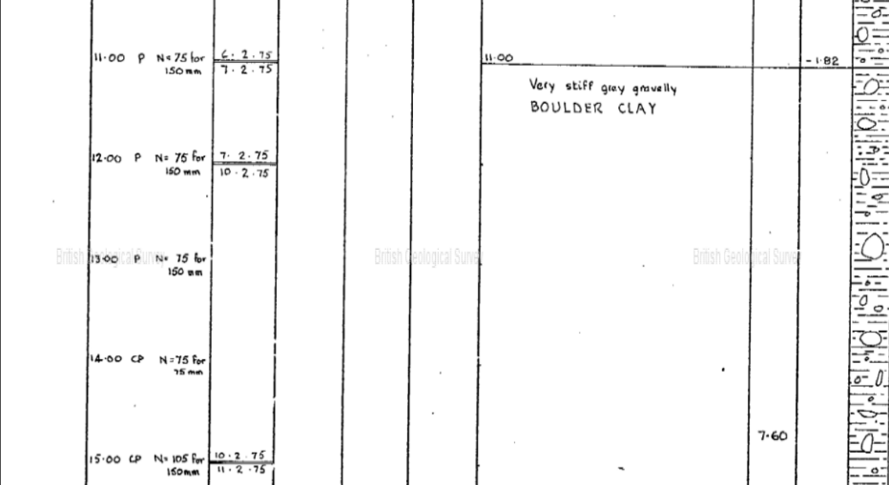
The boreholes diagram indicates that the uppermost 7 metres of ground consists of material that is not suitable for supporting standard building foundations. This typically means the soil in this layer may be weak, compressible, loosely compacted or prone to movement conditions that could lead to excessive settlement or structural instability if built upon directly.
Such ground might include made ground, soft clay, silt, peat or loose sand, all of which lack the strength and consistency required to safely bear loads from a structure.
As a result, any proposed development on the site would require an engineered foundation solution to ensure stability and safety. This could involve techniques such as piling, where deep foundations transfer the building load down to stronger, more stable strata beneath the unsuitable layer. Alternatively, ground improvement methods such as soil stabilisation, compaction or the use of reinforced raft foundations might be considered depending on the specific ground conditions and the type of structure being built.
In practical terms, this finding has important implications for design, cost, and construction methodology. It means that a simple shallow foundation, such as strip or pad footings, would not be appropriate without additional engineering measures. Instead, a geotechnical assessment would be required to determine the most effective solution, ensuring that the building’s load is adequately supported while minimising the risk of long-term settlement or failure.

Referencing
Page 3: Swansea and Port Talbot Docks Website (Historical Study)
Page 4: Map of Swansea Spaces - Swansea (Recommendations for site investigations – Hydrology – Attached Photo)
Page: 4: Tide times - Swansea (Recommendations for site investigation – Depth of various materials)
Page 4: AGS – Association of Geotechnical and Geoenvironmental Specialists – The problem of made ground (Recommendations for site investigation – Made Ground)
Page 5: Swansea_Bay_Shoreline_Management_Plan (1).pdf (Recommendations for site investigation – Flood Risk)
Page 5: Building regulations: outbuildings: Foundations | GOV.WALES (Building Regulation)
Page 5: Quick Guide to the Building Regs (Building Regulations – Involvement of local authorities)
Page 6: Shed 8, Bristol Port, Royal Portbury Dock | Roger Bullivant Limited (Proposed foundation solution)

