

LOCATION: Swansea | LLEOLIAD: abertawe
LEVEL 4 | LEFEL 4
EXAMINATION PERIOD | CYFNOD ARHOLIADAU
JaN 2026 | JaN 2026

MODULE CODE: ACDA4013
Embedded C

TIME: 2 HOURS
ANSWER ALL QUESTIONS

Total Marks: 100

This exam does not allow the use of reference materials, scraps of paper, online resources, or observing any practice sessions.

- Equipment or materials required – PC running CAD software or Pencil/Ruler/Paper
- Use the Answer Sheet to respond to theoretical questions, including topics. Screenshots of schematic circuits, code, and simulation results should be included in a separate MS Word document.
- Save the name of the word Document in this pattern ‘Exam_studentname_studentid’ and upload the file in Moodle. Submissions made before or after the exam time will not be accepted.

QUESTION 1
Design a circuit using the PIC16F877A microcontroller, where LEDs are connected to pins RB0 through RB7, each with a 100Ω current-limiting resistor. The LEDs should turn ON simultaneously, with a delay of half a second.
The project should include the following components:
  - Design the circuit using simulation software. [10 Marks]
  - Write a C program to accomplish the specified counting task. [10 Marks]
  - Execute the simulation to verify the operation of the circuit and program. [5 Marks]
QUESTION 2
Demonstrate a down counter using 7- Segment Display each with a 100Ω current-limiting resistor by considering the following conditions. Consider Common Anode 7- Segment display using the hex values given below.
0 | 1 | 2 | 3 | 4 | 5 | 6 | 7 | 8 | 9
0XC0 | 0XF9 | 0XA4 | 0XB0 | 0X99 | 0X92 | 0X82 | 0XF8 | 0X80 | 0X90
- When a push button is connected to port pin RC7 is pressed once, the 7 segments should count down from 9 to 1 within a delay of 100ms.
- The counter should stop counting when the button is released.
The project should include the following components:
- Design the circuit using simulation software. [10 Marks]
- Write a C program to accomplish the specified counting task. [10 Marks]
- Execute the simulation to verify the operation of the circuit and program. [5 Marks]
QUESTION 3
The circuit shown below has been made available to you on Moodle, named ‘Question 3’,
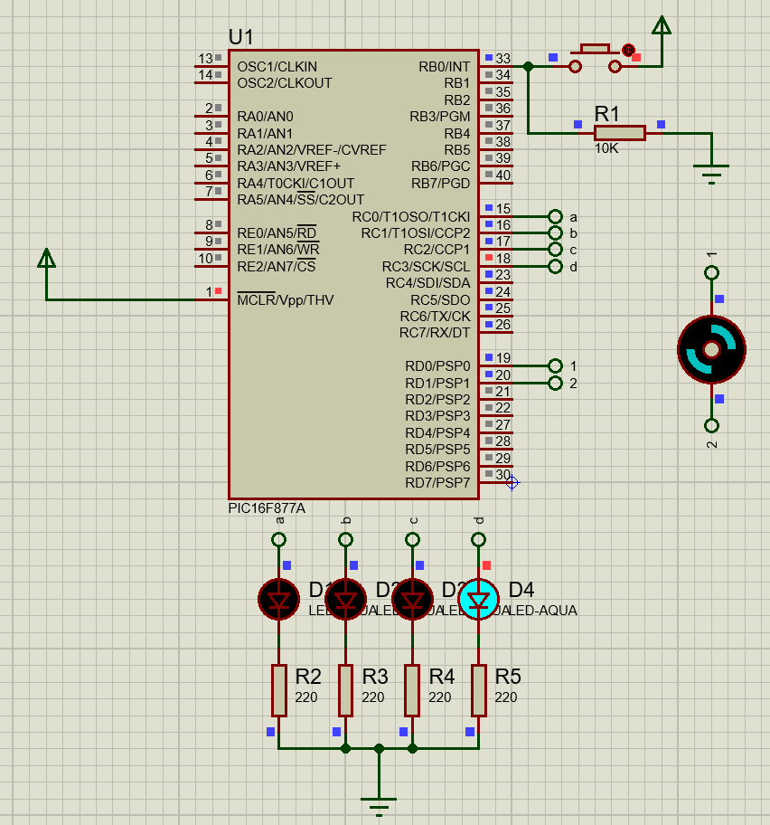
Simulate the provided Proteus circuit file on Moodle. Observe its behaviour when the push button is pressed. Identify the sequence and logic of operation of the LEDs and motor. Then, Answer the following questions.
- Based on your understanding from the simulation:
- Write a CCS C program that exactly replicates the working of the circuit. [13 Marks]
- Briefly explain:
- What happens when the button is pressed? [4 Marks]
- How the motor and LEDs are controlled using PORTC and PORTD. [4 Marks]
- The role of RD0 and RD1 in motor control. [4 Marks]

QUESTION 4
Below is the given Program
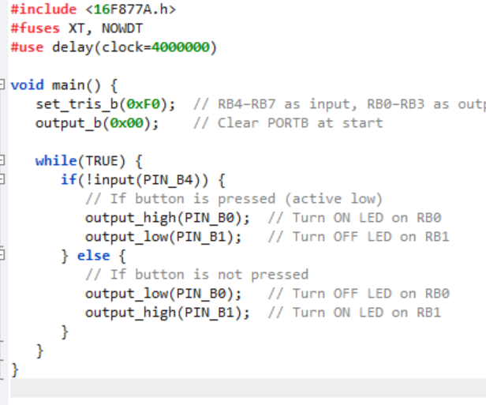
Answer the Following
      - Identify and describe the operation performed by the program when executed.
[5 Marks]
      - Based on your understanding of the program, design a circuit schematic that would support its functionality. [5 Marks]
      - Write and run the program in a simulation environment. Submit the program and provide a screenshot of the simulated circuit. [5 Marks]
      - What does the set_tris_b(0xF0) instruction indicate regarding PORTB configuration? [5 Marks]
      - Explain how the LED switching in the program is controlled in real time without using any delay. [2 Marks]
      - What issues may arise if the button input is connected without an appropriate pull-up or pull-down resistor? [3 Marks]

Diwedd/End

