Learning in a Digital Era
Assignment 1: E-Portfolio

Ryan Prosser – 2014948

Bachelor of Science (Part-time):Computing (Data & Information Systems)

e-Portfolio
https://ryanprosser99.wixsite.com/2014948
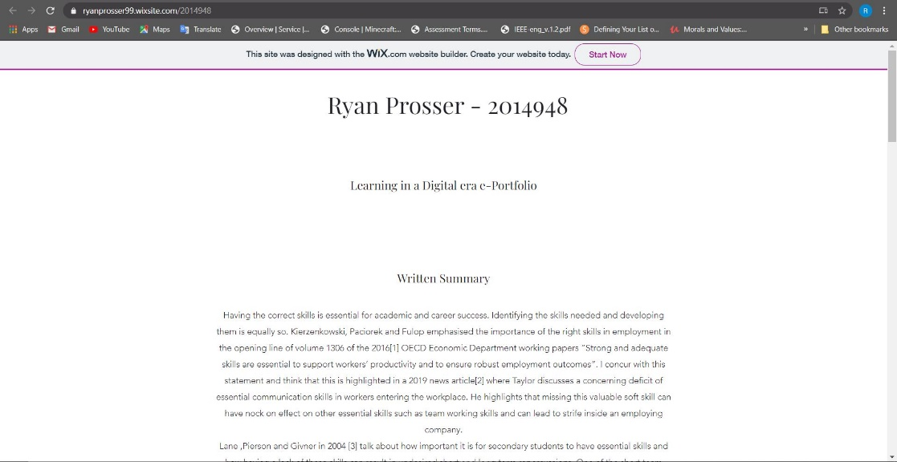

Task 1 – Written summary
https://ryanprosser99.wixsite.com/2014948
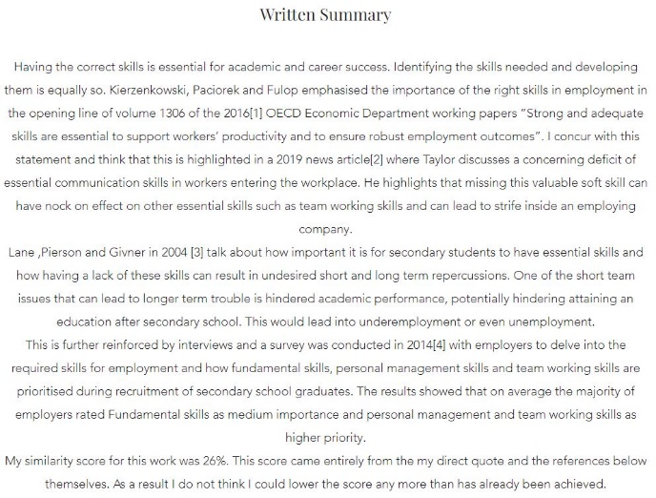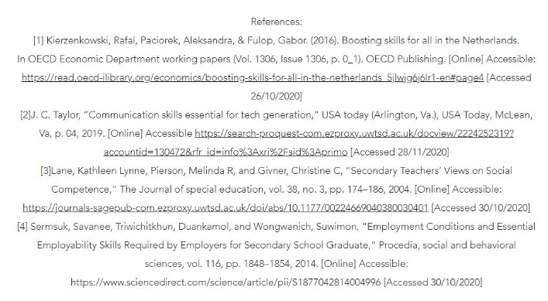

Task 2 – Mind Map
https://ryanprosser99.wixsite.com/2014948
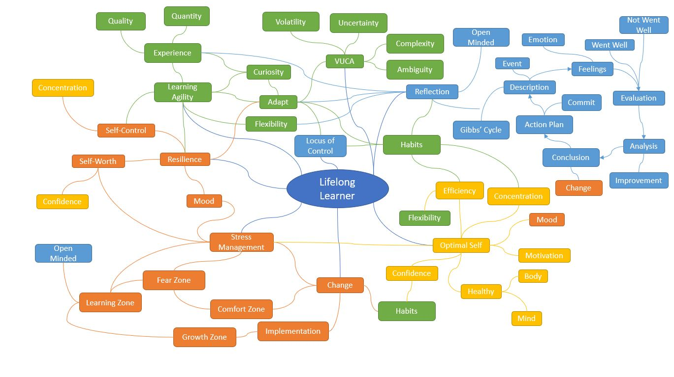
Task 3 – Video presentation.
https://youtu.be/0juDII0Q_ug
https://ryanprosser99.wixsite.com/2014948
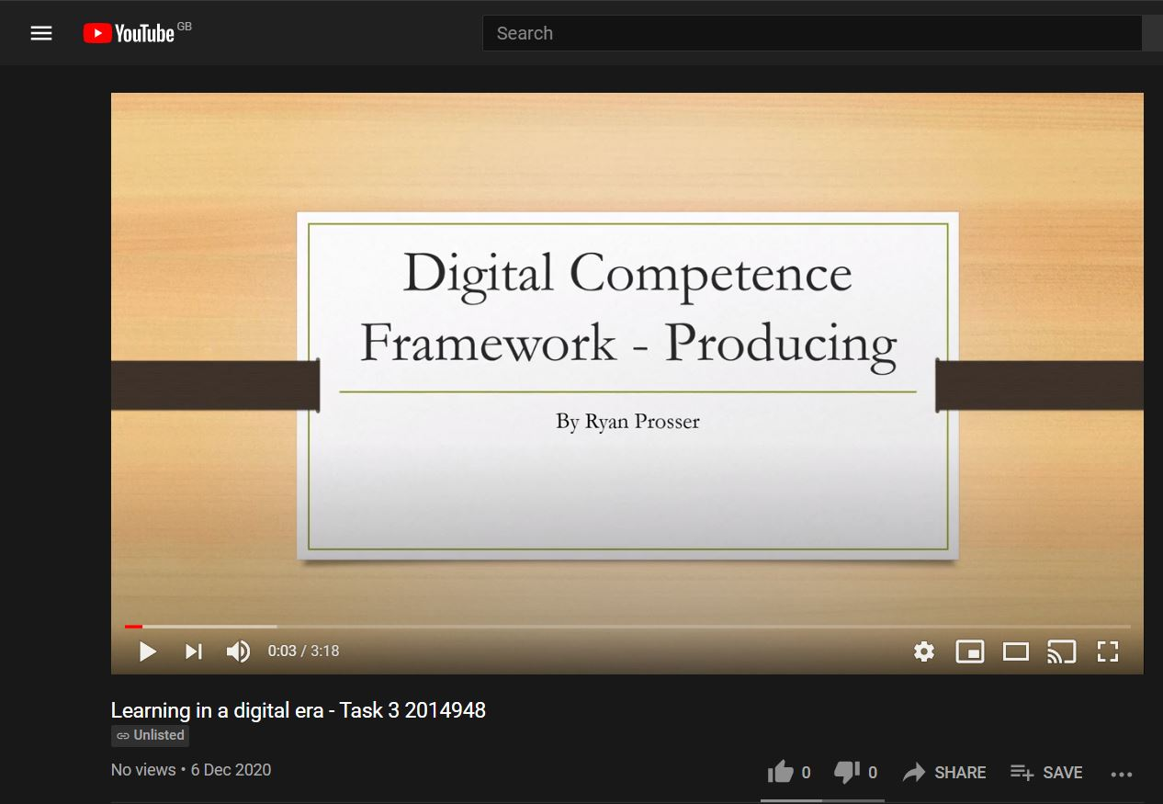

Task 4 – Academic poster.
Incomplete

