

Food & Beverage Operations
Assessment of practical tasks (Menu Engineering)

Student ID: 2126405
Hajera khatun
Tutor Charlotte Joyner

Contents

Assignment 2 3
Introduction: 3
Types of Menus: 3
Types of Meal: 4
Menu Course Sequence: 4
Menu Engineering: 5
Menu: 5
Conclusion: 10
Reference: 10

Assignment 2

Introduction:
The heart of any restaurant is its Menu, which is a list of the dishes that may be ordered in a restaurant or that are to be served at a banquet and showcases everything that the hotel has to offer for food and beverages. Restaurant foods represent a substantial portion of children's dietary intake; hence a perfect menu impacts a lot in them (Krukowski, Eddings & West, 2011). It is designed carefully with their target cater and the customer they wish to serve and ensure customer satisfaction. Furthermore, our menu choices from field to plate have the potential to improve both air quality and climate, hence it is favorable for both climate and the restaurant to have such conscious minds while making a menu (Course). It educates the customers about the price and details of the food they want, including the necessary warning about certain foods. The hotel selected for this Assessment is a 4-star hotel named Hotel Trinity, and to create and design a fixed-price Christmas Party menu to offer during the Christmas period.

Types of Menus:
There are different types of menus to go for, some of the prominent ones are;
Table d’hôtel: Food items grouped are usually found here, they may be grouped according to a similar price, package meal with a predetermined price, or 3-5 course meals at a fixed price.
A la Carte: A separate menu with each dish priced and categorized separately irrespective of price.
Static Menu: In restaurants like McDonald’s where the same menus are served every day are static menus, the restaurant’s concept is built around these menus.
Cycle Menu: Seasonal cycle menus, menus changed each day or bi day a week, offers variety with purchase of similar products.
Single Use: Menus that are made for a single occasion and never used a second time after that.
Du Jour Menu: Menu containing lists like ‘Item of the day or Item of the week’ falls under it.
There are way more types of menus available in different hotels and restaurants. For the project, we will be making a static menu for the Christmas season.

Types of Meal:
Breakfast: The first meal one takes after rising from a long night’s sleep, and is a very impactful meal for the whole day.
Brunch: A combined form of meal between breakfast and lunch, whose time can be extended until 3 pm.
Lunch: Meal taken in the midday, varies from culture to culture about the portion and type of food.
High Tea: The evening meal or dinner of the working class, also known as meat tea or tea time consisting of hot dishes, bread butter, jam, etc.
Elevenses: A snack taken in the morning but also similar to afternoon tea.
Dinner: Varying from culture to culture it is regarded as the most important meal of the day, taken at noon or in the evening.
Supper: Late-night evening snacks fall under it; some also recall it as an informal dinner.

Menu Course Sequence:
Appetizer: Any type of food served at the start of a meal to kindle the appetite, generally in low portions. For regular menu items, appetizers stand out as having the highest values of energy, fat, saturated fat, and sodium compared with all other menu item types, hence appetizer is one of the most important meals (Wu & Sturm, 2013).
Soup: Thick or thin soup, also used to emulsify appetite.
Salad: Green salad with some dressing served on a small plate.
Fish: Served just before the main course, to make the palate ready for heavier meals.
Main Course: It is the main meal of the course, usually meat, served with a sauce or roast gravy with potatoes and green vegetables.
Dessert: The sweet items at the end of the meal compensate for low blood sugar.
Cheese: Biscuits, bread, celery, and so on.
Beverage: All types of hot or cold drinks.
Menu Design:
It will be working as a silent salesperson at the hotel Trinity and its cover is the symbol of the hotel’s identity. The design, colors, paper, illustrations, and type should reinforce the image of the restaurant along with ensuring the intended message is the received message, hence becomes an extension of the personality of the restaurant (Bowen & Morris, 1995).
Single page: Contains everything on the front, and if needed more space, the beverage and dessert take the backside of the page with the focal point just above the center.
Double Page: Contains an outside cover with the name of the hotel, and a picture appropriate to its theme containing main items highlighted in focal points, with beverages on the back or along the side to accompany any dish.

Menu Engineering:
A way to design a menu, pushing the most profitable dish’s sales, used to evaluate menus by assessing sales volume, and contribution margins for each item on the menu and food sales margins which are then classified or grouped and increasing profitability per guest in addition to being a memorable one is known as menu engineering (Saraswati & others, 2020).
Strategies:
- Plow horses: Increasing menu price or decreasing the cut portion.
- Stars: Keeping food as it is, but increasing a stable amount of price.
- Puzzles: To reposition various items and advertise to boost sales.
- Dogs: Replacing items with the lowest sales from the menu with new ones.
With everything in mind, A fixed-price menu of Hotel Trinity during the Christmas period is made.

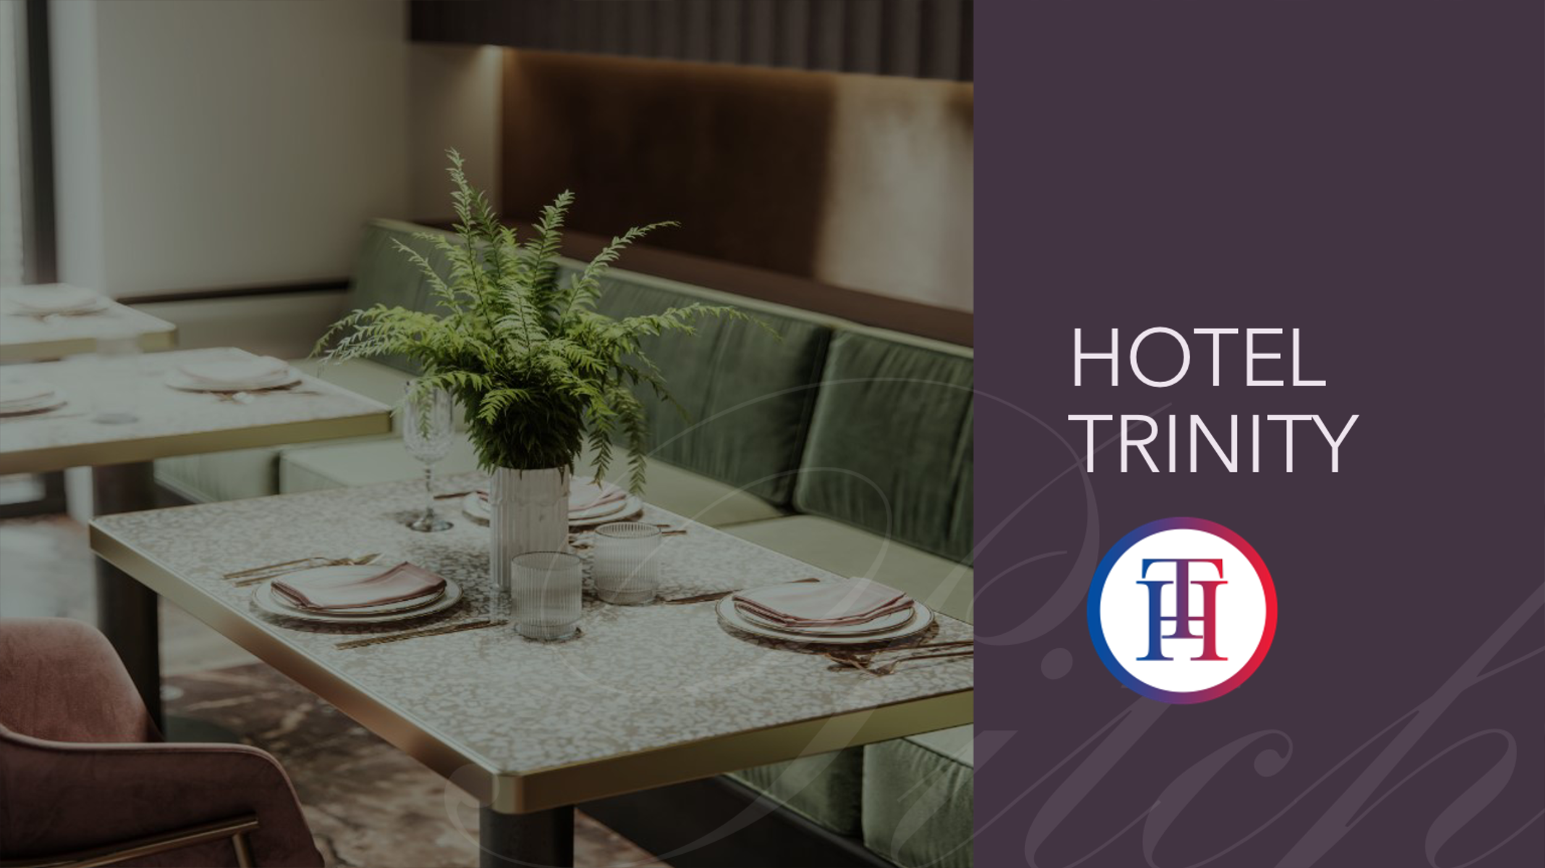
Menu:

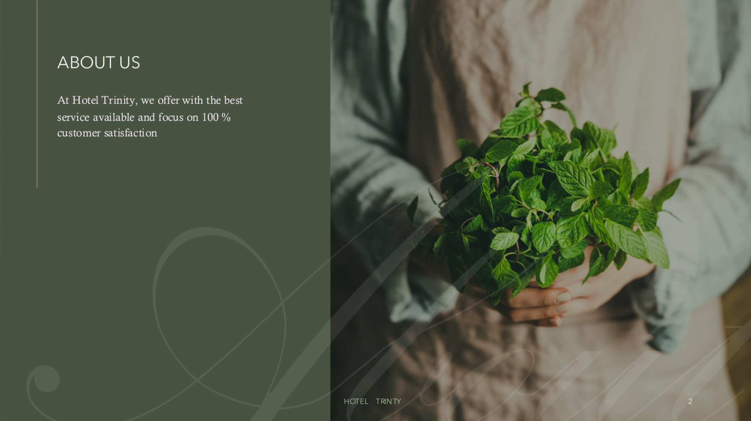

About us
At Hotel Trinity, we offer the best service available and focus on 100 % customer satisfaction

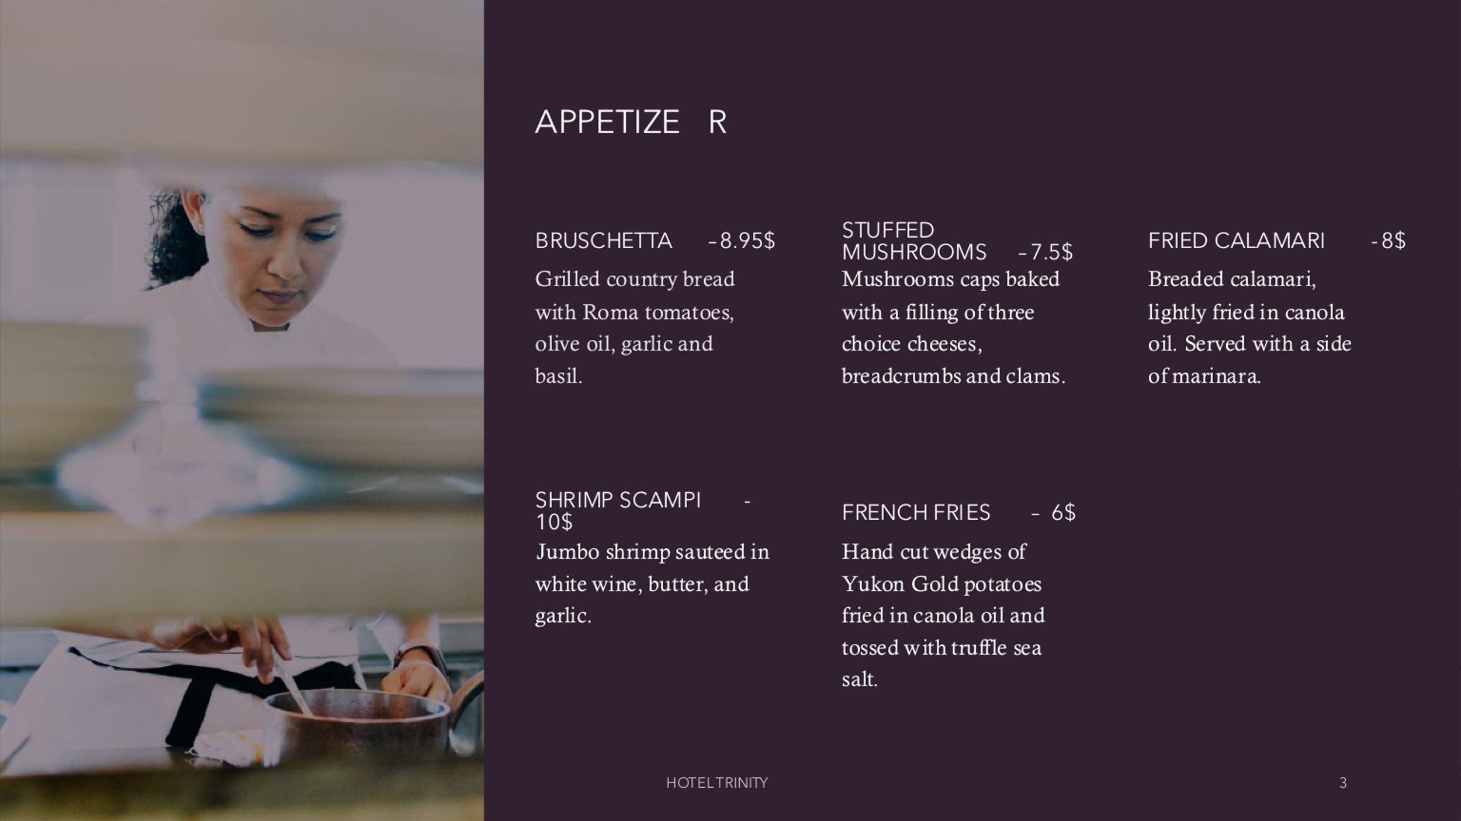

Appetizer
Bruschetta –8.95£
Grilled country bread with Roma tomatoes, olive oil, garlic, and basil.
Stuffed Mushrooms –7.5£
Mushrooms caps baked with a filling of three choice slices of cheese, breadcrumbs, and clams.
Fried Calamari -8£
Breaded calamari, lightly fried in canola oil. Served with a side of marinara.
Shrimp scampi -10£
Jumbo shrimp sauteed in white wine, butter, and garlic.
French Fries – 6£
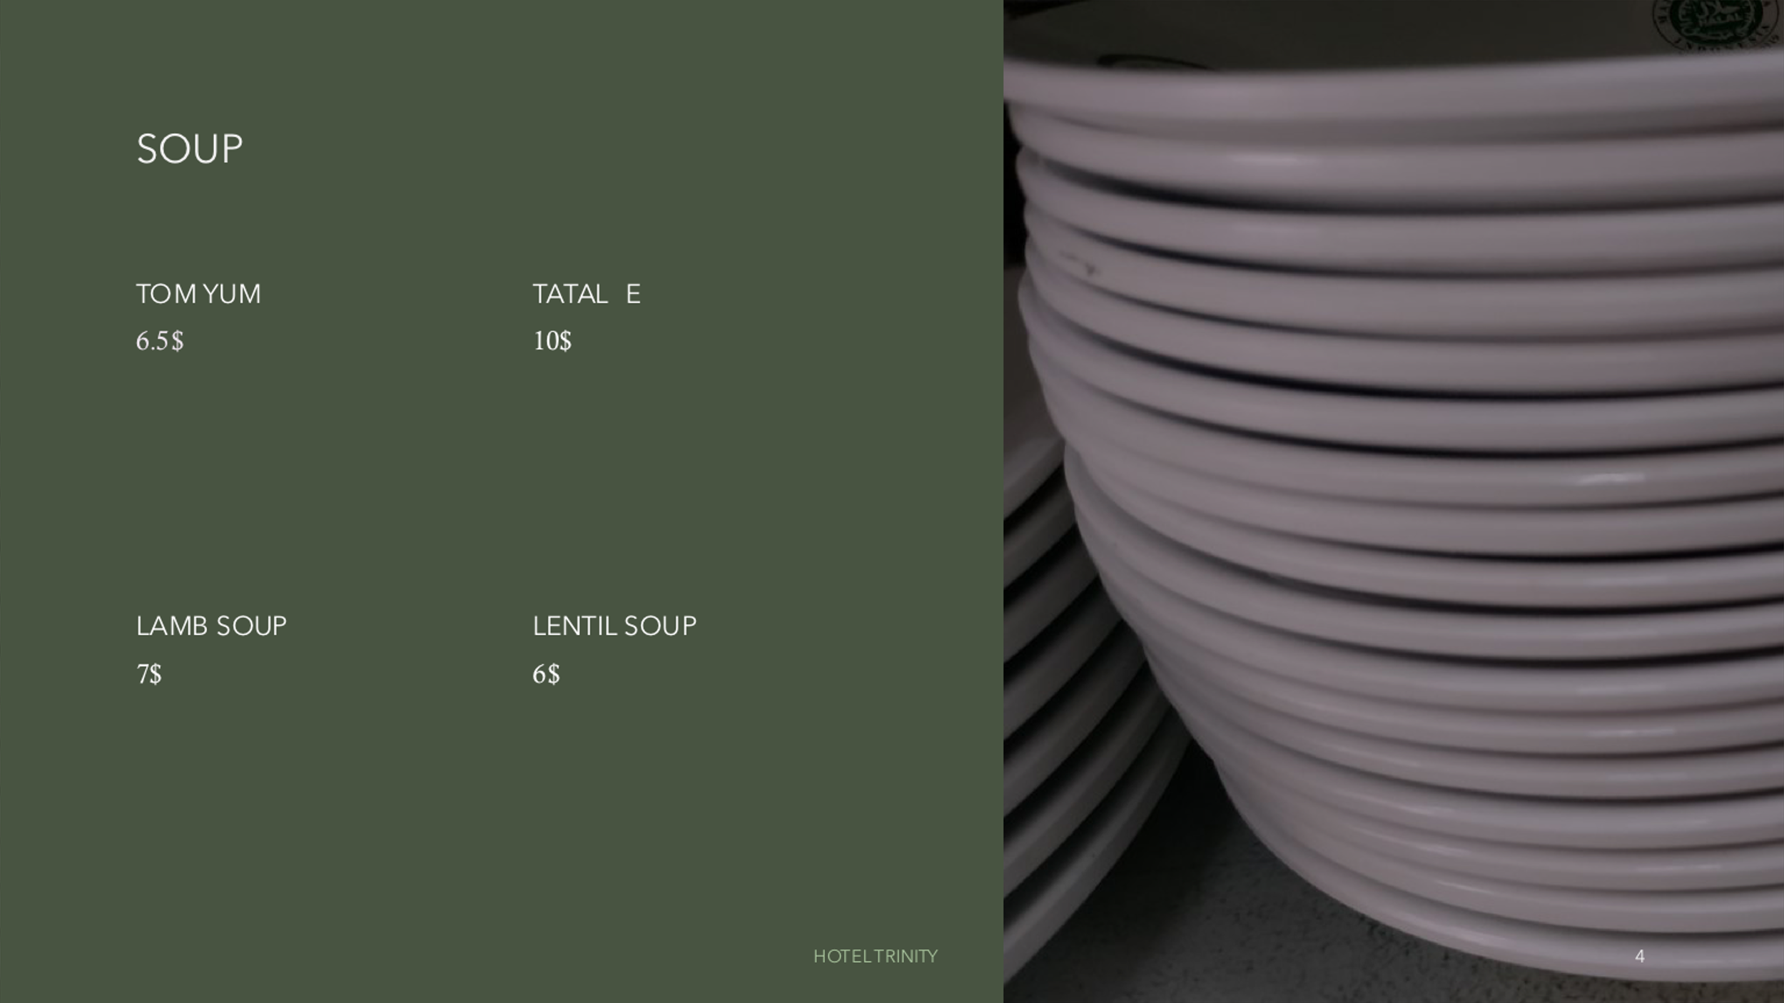
Hand-cut wedges of Yukon Gold potatoes fried in canola oil and tossed with truffle sea salt.

Soup
Tom Yum – 6.5£
Tatale – 10£
Lamb soup -7£
Lentil soup – 6£
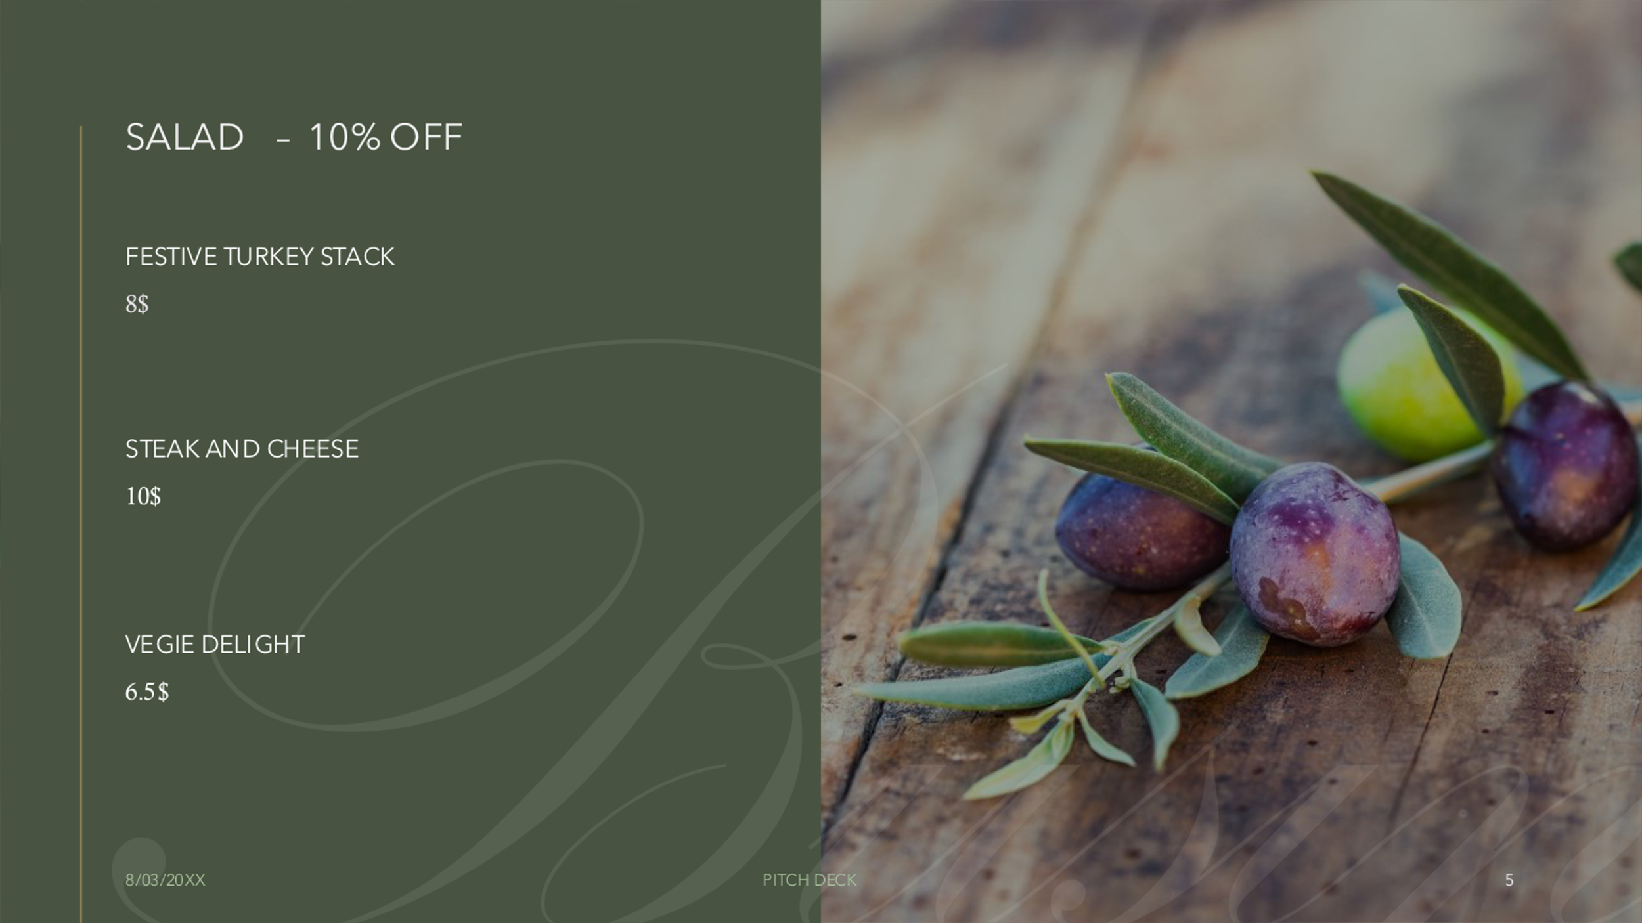

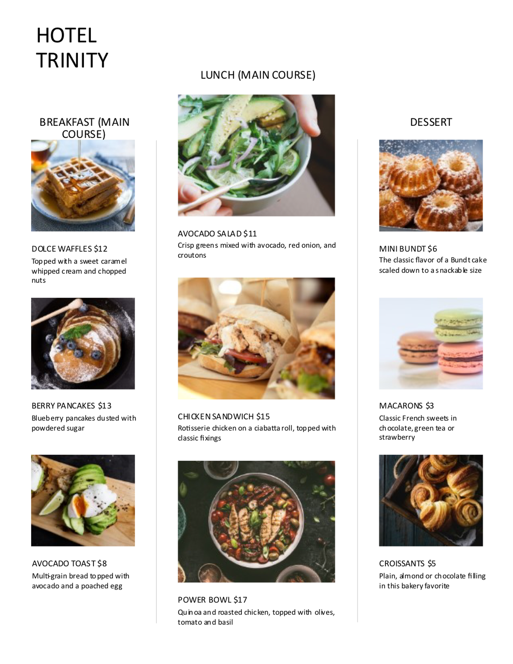
Salad – 10% off (non-veg)
Festive turkey stack -8£
Steak and cheese -10£
Veggie delight 6.5£

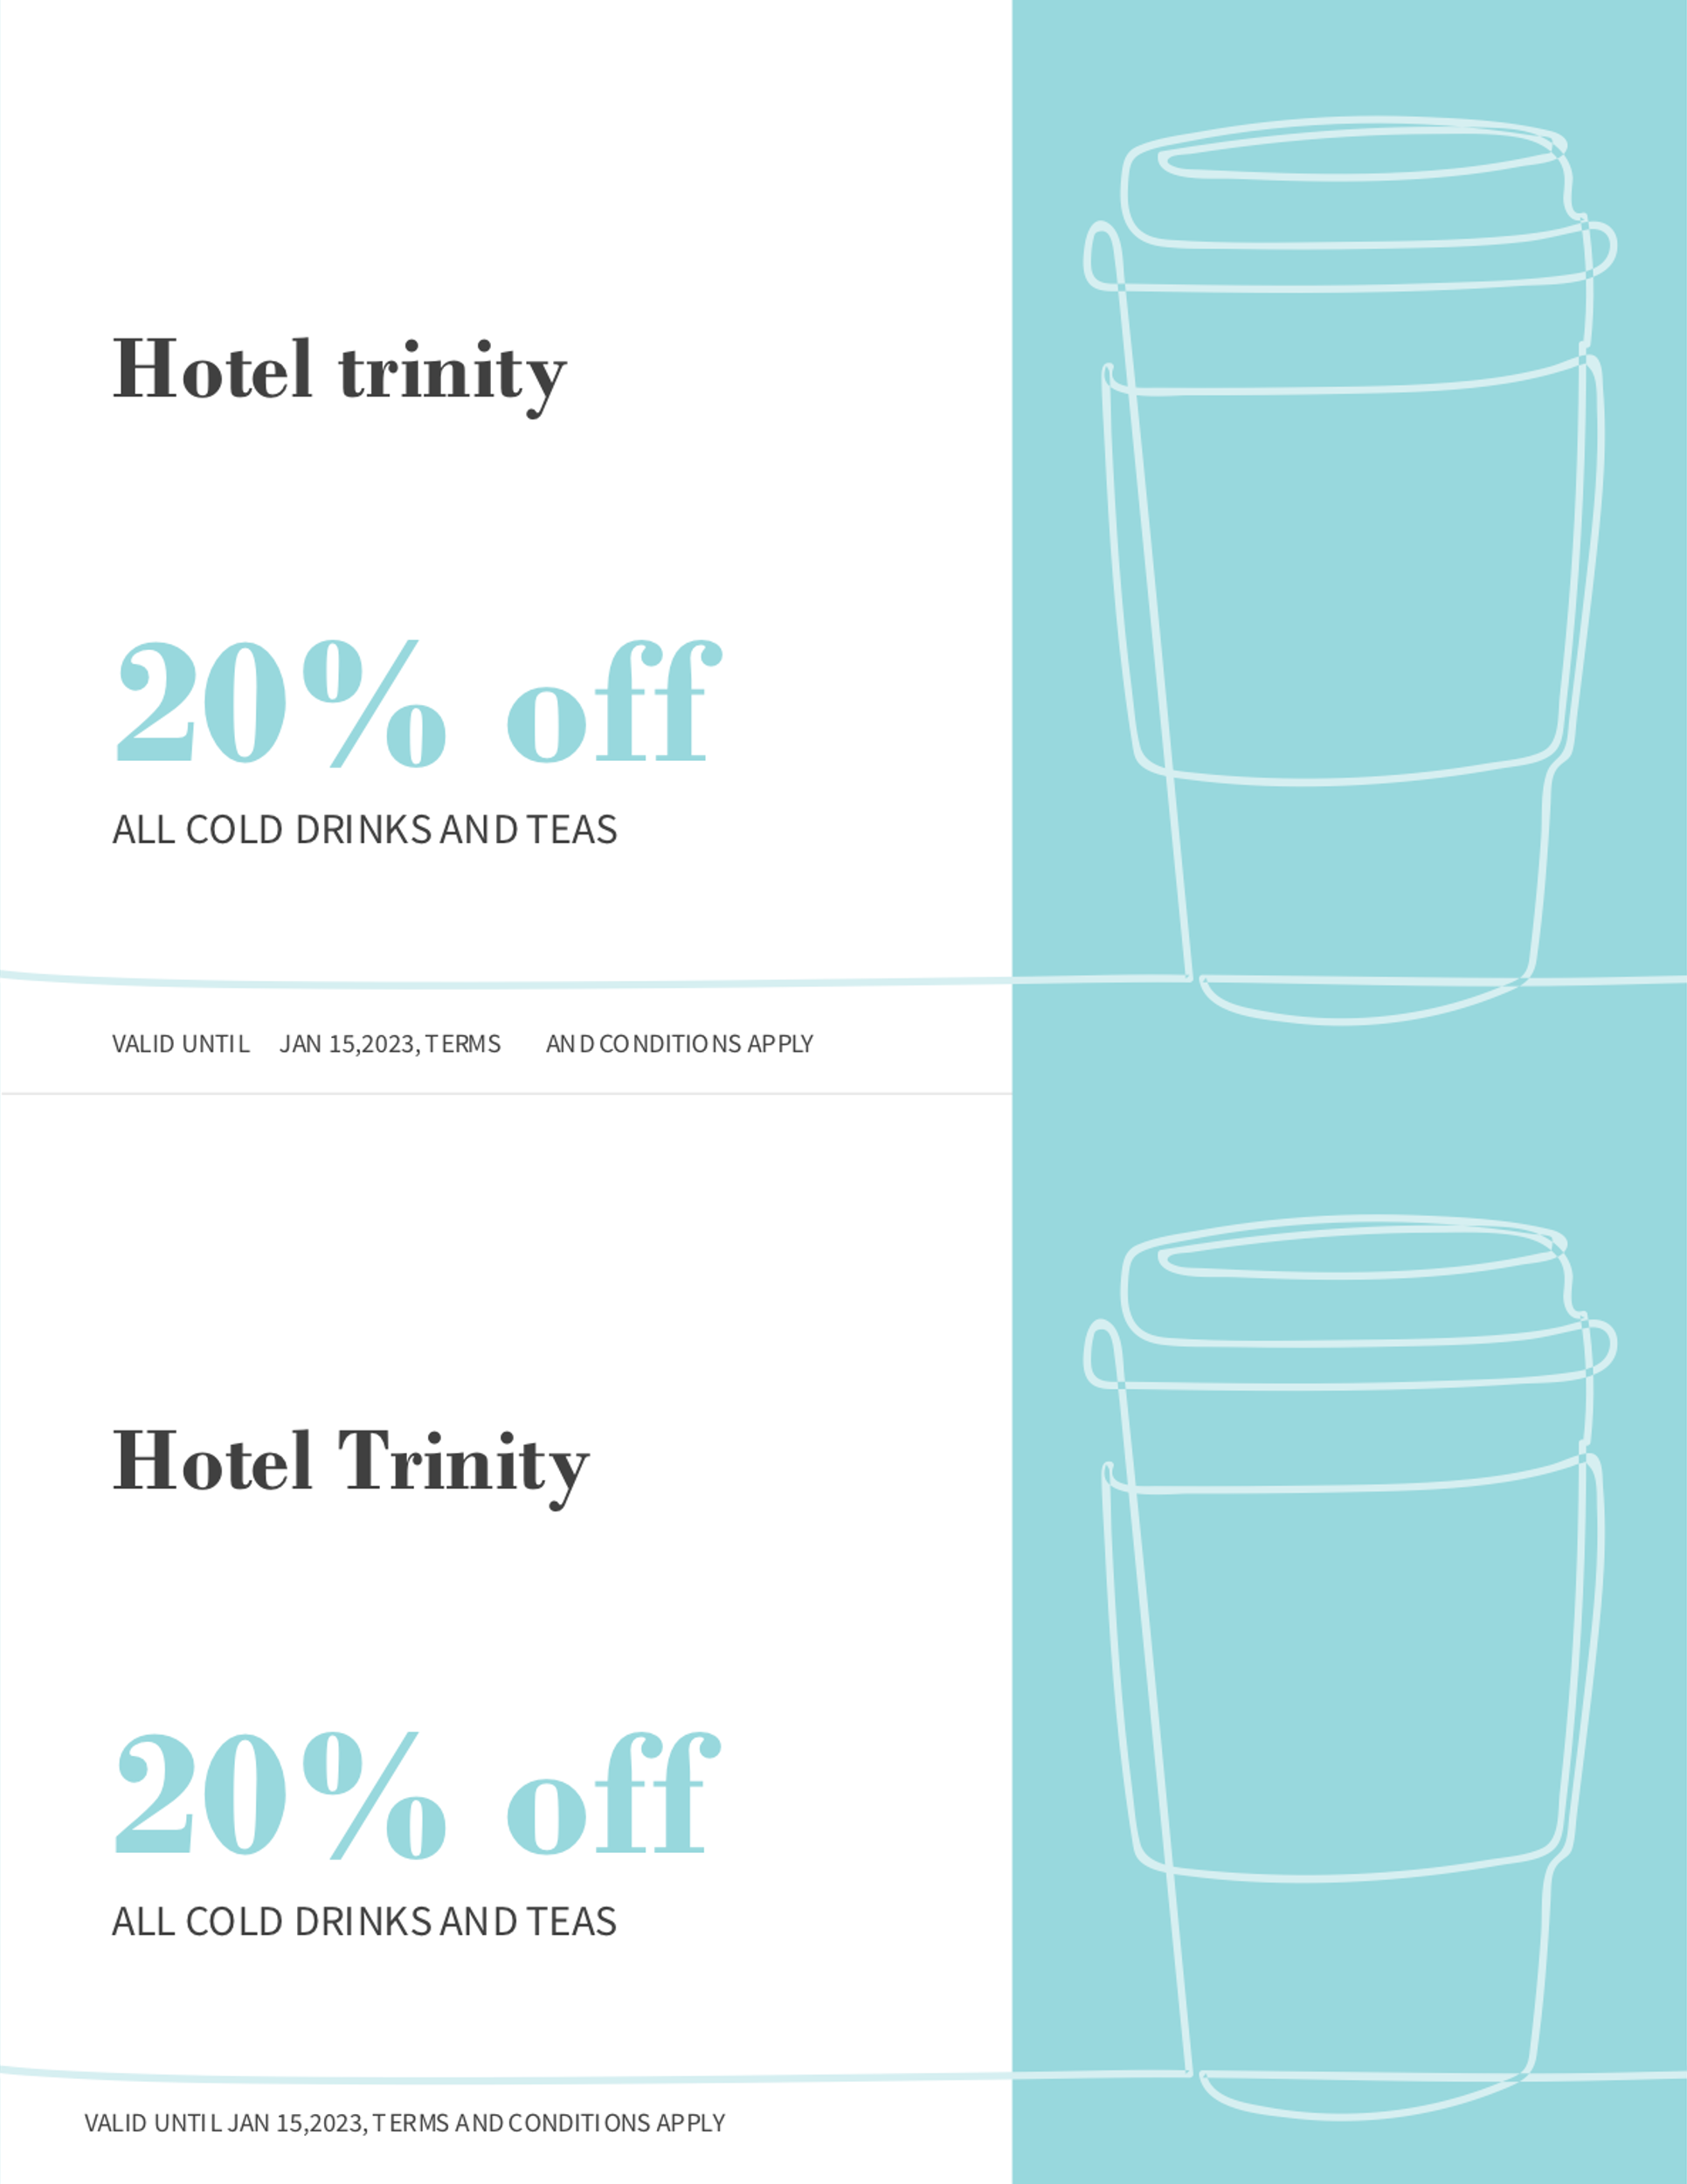
Beverage
Hot Chocolate – 5£
Espresso – 4£
Frappuccino – 6£
Hot Tea /Cold drinks - 2£
20% off on All cold drinks and teas until
Jan 15, 2023.

Conclusion:
Making a profitable menu requires tactics and strategies of menu engineering. A profitable fixed-price menu for the 4-star hotel, Hotel Trinity during the Christmas Season is made following such strategies. This menu is a static seasonal menu that will be the same all over the season.

Reference:
Krukowski, R.A., Eddings, K. and West, D.S., 2011. The children's menu assessment: development, evaluation, and relevance of a tool for evaluating children's menus. Journal of the American Dietetic Association, 111(6), pp.884-888.
Course, M., MENU FOR A BETTER ENVIRONMENT.
Wu, H.W. and Sturm, R., 2013. What's on the menu? A review of the energy and nutritional content of US chain restaurant menus. Public health nutrition, 16(1), pp.87-96.
Bowen, J.T. and Morris, A.J., 1995. Menu design: can menus sell. International Journal of Contemporary Hospitality Management.
Saraswati, N.K.A., Bagiastuti, N.K., Elistyawati, I.A. and Sudiarta, M., 2020. Menu Engineering on Main Course to Increase Sales. International Journal of Glocal Tourism, 1(1), pp.51-60.

