Literature Review

How neighbourhood teams working with vulnerable young people, to prevent them from becoming missing children, what is classed as a missing person and tackling anti-social behaviour within communities.

2.1 – Introduction
This literature review will evaluate and compare the research that has been conducted, which will detail what anti-social behaviour is and how this is impacting the community. It will also outline what local neighbourhood policing teams are facilitating to combat anti-social behaviour and how this can lead to vulnerable young people going missing and what adverse child experiences could be impacting these children to go missing. Examples will be shown from different authors who explain their opinions on how the police are working with partner agencies to address anti-social behaviour. There will also be reports that will detail what police forces are currently doing to protect the vulnerable members of the community and how anti-social behaviour can impact the individuals as well as the community. It will also detail what is classed as a missing person within the police and actions that are taken once a report has been made.
2.2- What is classified as a missing person for police?
In the UK, ‘missing’ refers to “anyone whose whereabouts cannot be established” who will be “considered as missing until located, and their well-being or otherwise confirmed” (Waring et al., 2023). A person reported as missing should be treated as a serious report as there is an element of risk. The person who initially reports a person as missing has a concern from the outset. The police then need to investigate, as to where this person has gone, how they have managed to make their whereabout unknown and the history surrounding them being reported missing. The college of policing state that the safeguarding of a vulnerable person is paramount, and a missing person report should be recognised as an opportunity to identify and address risk. Three key factors should be considered during the investigation of a missing person, these being, protecting those at risk from harm, to minimise the stress and remain professional and delivering updates to the family and prosecuting those who perpetrate harm when this is supported by evidence. (College of Policing, 2016).
Someone every 90 seconds in reported missing in the UK, many more go unreported. Missing people.org, is a charity where you can find out a little more about how the police investigate missing people and the tactics that are used to assist with the location of the person reported as missing, this charity also has a website that will offer details of possible signs of a young person before they go missing. They detail the risk of child exploitation and that organised crime groups target these vulnerable young children, and this is commonly known as county lines. (Missing People, n.d.)
Once a missing person is located there is a process officers need to complete called a prevention interview. This is within the missing person report which is completed to identify any risk that has occurred whilst missing. Several questions asked, these include, has anyone forced you to do anything you didn’t want to do? did you consume drugs or alcohol whilst missing? Where did you go and who did you meet. These questions are integral when it comes to completing returns with young people missing from care. The National Youth Advocacy Service (NYAS) stated that quality return/ prevention interview can more than halve the chances of that child going missing again and that communication is key. The young people that go missing who are in care are more than often put in a state of confusion and instability because professionals or carers haven’t made room for communication. (Embling, 2022). Neighbourhood teams and community support officers can assist in gathering further intelligence to submit into the system regarding these young children. Even though the main missing person report is the response officers, many young children become defensive and shut down the communication with these officers. This could be because of previous interactions where certain situations have led to that child being arrested by officers. The neighbourhood team and community officers are based within areas to engage with the community and due to the community officers having different powers from police officers, the young people are more likely to engage with them and inadvertently give those officers intelligence. This information is vital to obtain as one small price of information could lead to the safety and protection of that young person. It could also lead to investigations into county lines and looking at the bigger picture as to what activity that missing person is involved in whilst missing and identifying and possible offenders.

2.2b – What leads to children going missing?
There are several reasons as to why a child might go missing, however every time a child is reported missing there is a higher level of risk which needs to be explored. This could all start from children becoming involved with anti-social behaviour within the community. There is a serious threat to vulnerable young people in relation to organised crime groups who are targeting young people and this is exposing children to being criminally or sexual exploited.
It’s found that children in care, are at a higher risk of being reported missing. A report back in 2022, stated that over 1 in 8 children in care go missing every year compared to 1 in 200 for those who are not. Children in care who go missing or run away may be exposed to increase risk to criminal and sexual exploitation and being involved in ‘county lines’. In 2017 across the UK, 24% of all identified or suspected victims of trafficking were missing from care. (Embling, 2022)
The term ‘county lines’ is used to describe gangs and organised crime networks involved in exporting illegal drugs around the UK. These gangs will prey on the most vulnerable in the community, mainly children. Looking at some research conducted in a rural area of the UK for county lines being an impact with missing children, they found that 27% of the children reported missing were involved in county lines and in most cases these children were reported missing over five times or more. (Bonning and Cleaver, 2020)
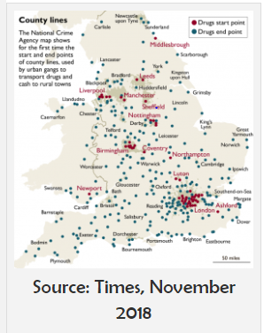(Harper, 2020)
This is a serious safety concern for police and the dedicated units, such as the public protection unit. This department focuses on the protection of all vulnerable people and placing protection measures for individuals.
Research conducted by Ravi Shankar, details the statistics on young people going missing and the impact that family life can have on that individual which can lead to episodes of being reported missing from home. It also detailed the number of theories of family dynamics that can have an impact on a child. The report focuses on a summary of these theories, these being psychosexual development, over many years psychoanalysts stressed the importance of early family experiences on children’s attitudes and behaviour. Another theory of psychosocial development, which is where children are active, curious explorers who seek to adapt to their environments. They also detail Watson’s Behaviourism, Banduras Social Cognitive Theory. (Shankar, 1 and Gadkar, 2015)

2.2c – What are ACES
Adverse childhood experiences was highlighted back in 1995, this was after a groundbreaking study conducted by the Centres for Disease Control and the Kaiser Permanente health care organisation in California. (Center on the Developing Child at Harvard University, n.d.). These are experiences that could be harmful to a person in a physical, mental, sexual or emotional nature. These are known as ACE’s . A report detailing the impacts of ACES, states, that in most cases of sexual abuse comes from within the home as its reported that many of the victims knew their offenders. Going through such a trauma can lead into adulthood and this can impact a person trying to get employment and dealing with day-to-day tasks. (Whitfield, 1998)
A child experiencing this form of abuse, they may not perform well in school and reported missing. This all interlinks to the safety of children and could be a reason why that child is going missing on a regular basis, it is vital that ALL authorities work together to identify these factors and then put tactics in place to support that young person. Research found that a small percentage of young children are reported missing, and the repeat missing children are teenagers, these teenagers have been found to live in care and have a history of family conflict. (Galiano López et al., 2021)
2.3 – What are neighbourhood teams doing to prevent anti-social behaviour
Neighbourhood teams across the country are taking a stand when it comes to anti-social behaviour and the impact this has on the community and the individuals involved in this form of behaviour. The introduction of neighbourhood policing teams back in 2005, which was rolled out nationally had an impact on the community, as these were dedicated teams to address the low-level issues and work with partner agencies to resolve issues before they become a permanent fixture in the area. The National Reassurance policing programme, aimed to reduce crime and the fear of crime to improve public confidence and engaging with communities. This was when the introduction of community support officers (PCSO), these officers were dedicated to engagement with members of the community but did not have the same powers as a sworn in police constable. (Longstaff et al., 2015)
The history of neighbourhood teams can date back to the early 1980’s, which lead to the Scarman report. This was a report that was created after the Brixton Riots in London in the early 1980’s. Within this report Lord Scarman detailed that the reason why the community lead towards these riots was through a breakdown in confidence between communities within Brixton and the police. He also detailed the good work that was being carried out by the police to prevent any further incidents such as this happening again in the future, he focused on the breakdown in communication between the police and the black and Asian community. Lord Scarman also made recommendations for the police service going forward and how to support the community and police by consent and the need for further training for officers and dealing with disorder within multiracial communities. (hansard.parliament.uk, n.d.)
The labour government came into power in 1997 and they wanted to focus on the crime and disorder within communities and hence created the pledge, ‘tough on crime, tough on the cause of crime’. They then adopted the crime and disorder act 1998. This act aimed to prevent crime and disorder while improving the criminal justice system. There were some key provisions within this act, and these include the introduction of anti-social behaviour orders (ASBO’s). These allow authorities to address anti-social behaviour by imposing restrictions on individuals, youth crime and disorder, the act introduced parenting orders, child safety orders, and local child curfew schemes and much more. (legislation.gov.uk, 1998).
Did the new legislation work? Looking at the below graph is details what the disorder rates were like prior and after the legislation was implemented.
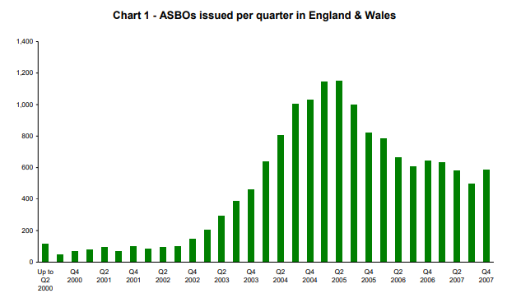
(Berman, 2009)

A report written by Glasgow University, investigated what Anti-social behaviour is and what the police and the home office were doing to try and address the issue. They also detail the different types of anti-social behaviour. Most people believe that this could be young children hanging around the local shop and being noisy, however there is more to it that just this element. Other forms of anti-social behaviour are, fly-tipping, abandoned vehicles, neighbour disputes, minor criminal damage, children setting fire to rubbish within the street, footballs being kicked against houses and the dumping of household objects, such as sofas and fridge freezers, this list is not exhausted. (Glasgow, 2012)
Looking at what the police are doing to combat anti-social behaviour and the prevention techniques that are currently in place to try and prevent missing episodes, many forces are working with partner agencies to address low level anti-social behaviour, the main agency forces are working together with is the community safety departments based within councils. These departments are made up of members of the council and local bodies who all work together with the local policing teams to address concerns within the community and to make them safer. These departments will assist with using a system known as the strike system. This is when a young person who is causing low level disorder will be given warning letters, there will be three letters within a 12-month period, if the behaviour continues then the young person and their family are invited to the police station and offered an early intervention clinic. This prevention policy was introduced by the Welsh Government and the Wellbeing of future generations act 2015, that placed responsibilities on local authorities to embed the early interventions with families to make this a way of working and how important it is to recognise how these principles are being embedded across public services and delivery going forward. (Welsh Government, 2017)
In 2023 the government reviewed the impact that the community safety partnerships were having across the county. They found that, when this new department which was introduced by the crime and disorder act 1998 to tackle anti-social behaviour, in 2021 they government published a review of the CSPs, they highlighted the importance of the joint working method, however they were not being used effectively as they could be. This then generated an action plan, and this was published in 2023. The action plan detailed a new framework for central government, police forces, local authorities, youth offending teams and housing authorities to work together to prevent ASB. The plan included strengthening the powers in the anti-social behaviour, crime, and policing act 2014. (GOV.UK, n.d.)
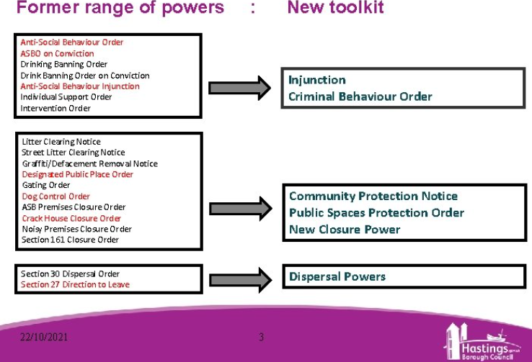
(slidetodoc.com, n.d.)
Gwent police, have a dedicated missing person unit. This unit consists of several police officers who review missing person reports daily. They then share information with the required social services within the council to highlight concerns they have and then act on any safety avenues. This could be discussing a new placement for that young person or interactions from a support worker to prevent the missing person going again.
Once a report is generated by police officers, the information is shared with the local authority’s social services department, information is also shared with the local school and this scheme is locally known at operation encompass. Operation encompass was established back in February 2011, even though operation encompass was designed to identify and support children who are being exposed to domestic violence within he home, this could also assist in why a child is going missing from the home and not attending school. This tool is another safeguarding product to prevent children being exposed to adverse child experiences. A report detailing the importance of how teachers can play a vital role in assisting the authorities with identifying ACE’s and communicating with these young children. It detailed that domestic violence and child protection is a complex, multifaceted area. It also detailed that being exposed to ACE’S can have long lasting effects into adulthood. (lloyd, 2018). Neighbourhood teams support this safeguarding element by attend regular meetings within schools, they updated with who are the regular missing children on patch and they are then tasked to engage with these young people when they see them out in the community to develop a better understanding of why these children are at risk and how the police can assist with safeguarding people.
Looking at statistics with possible links between anti-social behaviour and missing children. The media can portray an image of gangs of children in hooded tops hanging around local shops and causing intimidation to the community. Many local authorities along with the police have tried to tackle this behaviour with limited success. Could it be that once these children reach teenage years it’s too late, should interventions start earlier? This could reduce the cost to the police force and local authorities with managing these vulnerable children. (www.socsci.ox.ac.uk, n.d.)
Conclusion 2.4
Over the years you can see that police forces are using their powers to interact with young children to try and prevent anti-social behaviour and dedicated departments are being allocated within the forces to focus on the vulnerability for young children and them going missing. However more work needs to be carried out from an early age to identify adverse childhood experiences and to safeguard these young people and continued work with vulnerable families going forward.

Word count : 2739

Bibliography

Berman, G. (2009). Anti-social behaviour order statistics. [online] Available at: https://researchbriefings.files.parliament.uk/documents/SN03112/SN03112.pdf. Accessed on 20th June 2024.

Bonning, J. and Cleaver, K. (2020). ‘There is no “war on drugs”’: An investigation into county line drug networks from the perspective of a London borough. The Police Journal: Theory, Practice and Principles, [online] 94(4), p.0032258X2095668. doi: https://doi.org/10.1177/0032258x20956682 – Accessed on 26th June 2024.

Center on the Developing Child at Harvard University. (n.d.). What Are ACEs? And How Do They Relate to Toxic Stress? [online] Available at: https://developingchild.harvard.edu/resources/aces-and-toxic-stress-frequently-asked-questions/#:~:text=The%20term%20%E2%80%9CACEs%E2%80%9D%20is%20an%20acronym%20for Accessed on 11th July 2024.

College of Policing (2016). Missing persons. [online] College of Policing. Available at: https://www.college.police.uk/app/major-investigation-and-public-protection/missing-persons/missing-persons. – Accessed on 10th June 2024.

Embling, G. (2022). Missing the Point: Reducing the Risk of Children in Care going Missing • Government Events. [online] Government Events. Available at: https://www.governmentevents.co.uk/ge-insights/missing-the-point-reducing-the-risk-of-children-in-care-going-missing/#:~:text=A%20significant%20portion%20of%20children%20in%20care%20have Accessed on 20th June 2024.

Galiano López, C., Hunter, J., Davies, T. and Sidebottom, A. (2021). Further evidence on the extent and time course of repeat missing incidents involving children: A research note. The Police Journal: Theory, Practice and Principles, 96(1), p.0032258X2110529. doi: https://doi.org/10.1177/0032258x211052900 Accessed on 26th June 2024.

Glasgow , university (2012). Tackling Anti-social behaviour : A Critical Review . [online] https://eprints.gla.ac.uk. Available at: https://eprints.gla.ac.uk/50122/1/id50122.pdf - Accessed 10 Jun. 2024.
GOV.UK. (n.d.). Community safety partnerships review and antisocial behaviour powers: government response. [online] Available at: https://www.gov.uk/government/consultations/community-safety-partnerships-review-and-antisocial-behaviour-powers/outcome/community-safety-partnerships-review-and-antisocial-behaviour-powers-government-response. Accessed on 17th June 2024.

hansard.parliament.uk. (n.d.). The Scarman Report - Wednesday 25 November 1981 - Hansard - UK Parliament. [online] Available at: https://hansard.parliament.uk/Lords/1981-11-25/debates/008514e8-e688-4dfe-ba60-777fee95e3e5/TheScarmanReport. Accessed on 12th June 2024.
Harper, K. (2020). County Lines: what is it? what are the risks? How to be safe? [online] Billy’s Wish. Available at: https://www.billyswish.org.uk/county-lines-what-is-it-what-are-the-risks-how-to-be-safe/. Accessed on 26th June 2024.

legislation.gov.uk (1998). Crime and Disorder Act 1998. [online] Legislation.gov.uk. Available at: https://www.legislation.gov.uk/ukpga/1998/37/contents. Accessed on 12th June 2024.

lloyd, michele (2018). domestic violence and education: Examining the impact on domestic violence on young children . [online] fronttiriesin.org. Available at: https://www.frontiersin.org/journals/psychology/articles/10.3389/fpsyg.2018.02094/full - accessed on 20th June 2024.

Longstaff, A., Willer, J., Chapman, J., Czarnomski, S. and Graham, J. (2015). Neighbourhood policing: Past, present and future A review of the literature. [online] Available at: https://www.police-foundation.org.uk/wp-content/uploads/2017/06/neighbourhood_policing_past_present_future.pdf. – Accessed on 11th June 2024.

Missing People (n.d.). What is county lines and child criminal exploitation? [online] Missing People. Available at: https://www.missingpeople.org.uk/get-help/help-services/exploitation-and-county-lines/what-is-county-lines. Accessed on 10th June 2024.

Shankar, R., 1, B. and Gadkar, R. (2015). Family Factors and Runaway Missing Children: A Review of Theories and Research. International Journal of Management Research and Social Science (IJMRSS, [online] 2(4). Available at: https://irdp.info/journals/j2/volume2/IJMRSS_223.pdf - Accessed on 26th June 2024.

slidetodoc.com. (n.d.). ASB Crime Policing Act 2014 Overhauls whole system. [online] Available at: https://slidetodoc.com/asb-crime-policing-act-2014-overhauls-whole-system-2/ Accessed on 20th June 2024.
Waring, S., Fusco-Maguire, A., Bromley, C., Conway, B., Giles, S., Freya O’Brien and Monaghan, P. (2023). Examining the Impact of Dedicated Missing Person Teams on the Multiagency Response to Missing Children. Cambridge Journal of Evidence-Based Policing, 7(1). doi: https://doi.org/10.1007/s41887-023-00090-5 Accessed on 7th June 2024.

Welsh Government (2017). Families First Programme Guidance. [online] Available at: https://www.gov.wales/sites/default/files/publications/2019-07/families-first-guidance-for-local-authorities_0.pdf. Accessed on 25th of July 2024.

Whitfield, C. (1998). Adverse Childhood Experiences and Trauma. [online] Available at: https://citeseerx.ist.psu.edu/document?repid=rep1&type=pdf&doi=e0d8697f813b1f2fc4f543a01695c6a982e4028c. Accessed on 20th June 2024
www.socsci.ox.ac.uk. (n.d.). Reducing Child Antisocial behaviour in Britain. [online] Available at: https://www.socsci.ox.ac.uk/reducing-child-antisocial-behaviour-in-britain. Accessed on 26th June 2024

