Mia Maurice
2505028
LCHS4009
Professional development within health and social care.
Personal portfolio
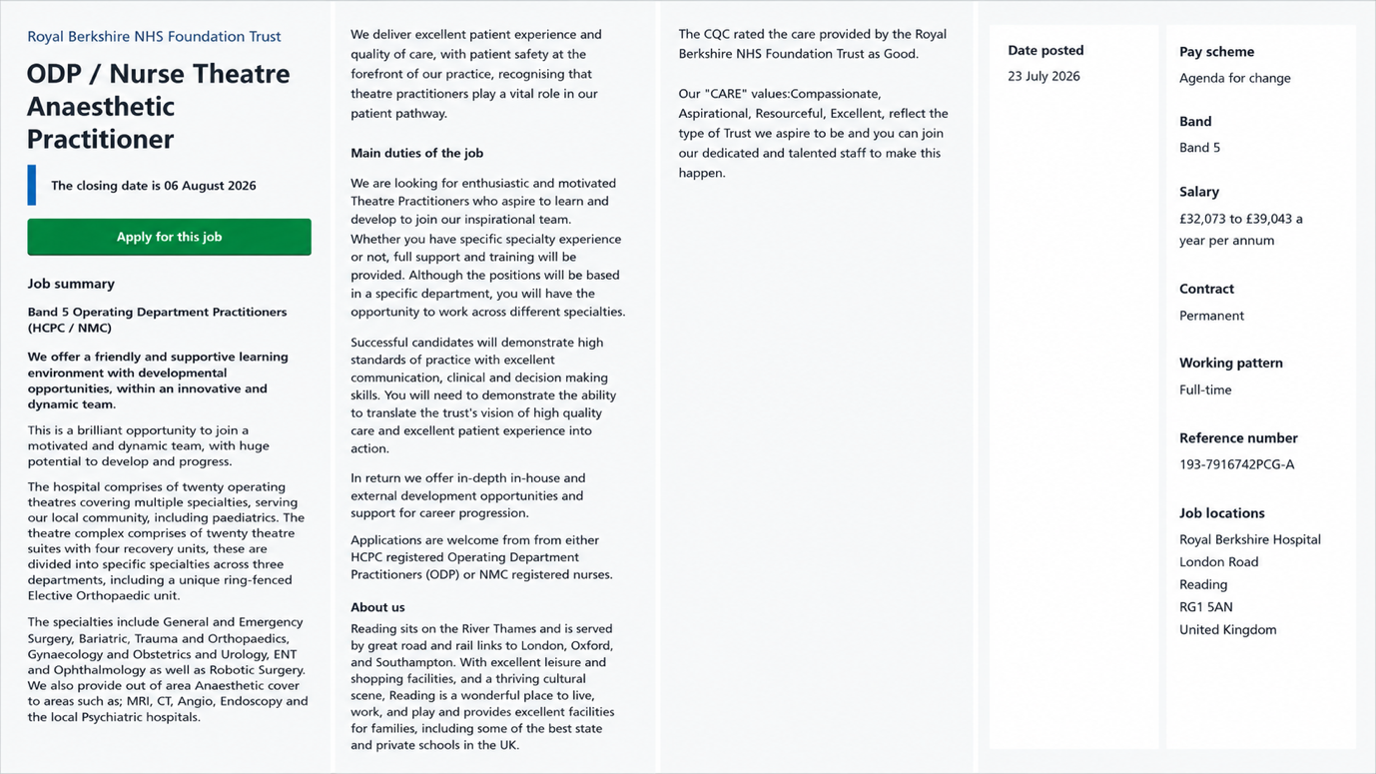

https://beta.jobs.nhs.uk/candidate/jobadvert/C9193-26-0485?keyword=welsh%20translators&language=en&page=52&skipPhraseSuggester=true
Summary
I am a dedicated, reliable, and highly motivated candidate with a strong academic background in Health and Social Care, having completed a Level 4 Certificate of Higher Education and a BTEC Extended Diploma. I demonstrate exceptional attention to detail, remain calm and resilient under pressure, and have a strong commitment to patient safety, patient dignity, and maintaining high standards of surgical hygiene. I am seeking the opportunity to apply my academic knowledge and practical skills within the role of Operating Department Practitioner, while continuing to develop my clinical expertise and contribute to the delivery of safe, high-quality patient care.
Experience
Day centre assistant / st albans (2023 – 2024)
- Assisting service users. With. Nutritional and hydration needs.
- Helping set up, run and supervise structured social, recreational and therapeutic activities.
- Preparing, cleaning and sanitising activity spaces, equipment and dining area.
Qualifications
Certificate of Higher Education (CertHE) in Health and Social Care (Level 4)
BTEC Level 3 Extended Diploma in Health and Social Care
BTEC Level 1/2 in Health and Social Care
Key skills
- Professional Accountability & Discipline
- High-Pressure Composure & Stress Management
- Meticulous Attention to Detail
- Active Listening & Clear Communication
- Safety Compliance
- Empathy
- Prioritization & Time Management:

Personal statement.
I am applying for the role of Operating Department Practitioner (Theatre Anaesthetic Practitioner) with the clear career objective of developing my career within operating department practice. Through completing my Level 4 Certificate of Higher Education and BTEC Extended Diploma in Health and Social Care, I have developed a strong foundation in clinical practice, patient-centred care, multidisciplinary working, and healthcare environments. I am excited about the opportunity to contribute to the delivery of high-quality patient care within your surgical team. My ambition to work within operating theatres stems from a deep interest in the critical phases of perioperative care, particularly anaesthesia, surgery, and post-operative recovery. Through my academic studies, I have developed a thorough understanding of the clinical protocols required to promote patient safety in acute healthcare environments. I have gained knowledge of infection prevention and control, sterilisation procedures, aseptic technique, maintaining sterile fields, and adhering to health and safety legislation that supports the safe management of patients undergoing anaesthesia and surgical procedures. I understand that working as a Theatre Anaesthetic Practitioner at the Royal Berkshire NHS Foundation Trust requires meticulous attention to detail, strict adherence to the Surgical Safety Checklist, and the ability to remain calm, focused, and professional in fast-paced, high-pressure environments. I recognise the importance of maintaining patient safety while supporting the multidisciplinary team throughout the perioperative journey. Beyond my academic knowledge, I possess the personal qualities and practical skills that align with the demands of this role. My greatest strength is my commitment to delivering compassionate, person-centred care, ensuring that patients feel safe, respected, and reassured during the pre-operative and induction stages of their care. My education has also strengthened my communication and active listening skills, enabling me to work effectively within multidisciplinary teams alongside anaesthetists, surgeons, registered nurses, Operating Department Practitioners, and theatre support staff. I am proactive, dependable, and accountable for my professional practice. I understand that working within an operating department requires physical stamina, mental resilience, adaptability, and the ability to remain composed under pressure. I maintain my own health and wellbeing through a structured fitness routine, enabling me to approach demanding clinical environments with energy, focus, and consistency. I am a quick learner who is eager to develop new technical skills and confident in following clinical guidance and protocols. I am committed to ensuring that anaesthetic rooms and theatre suites are prepared, stocked, and maintained to the highest standards, supporting the safe and efficient delivery of patient care. My primary objective is to bring my strong foundation in health and social care to your department while continuing to develop my knowledge of anaesthetic care, patient monitoring, airway management, and perioperative practice. I am committed to expanding my clinical expertise, contributing positively to your multidisciplinary team, and upholding the Trust's reputation for patient safety, dignity, and high-quality surgical outcomes. I believe this role represents the ideal next step in my professional journey, and I look forward to the opportunity to contribute to your team (College of Operating Department Practitioners ,2024).
- Strengths – I am compassionate and genuinely care about helping people during vulnerable moments in their lives. I have good communication and listening skills, which will help me work effectively. I am reliable, organised and work well apart of a team. I love to learn, take feedback and progress. I can remain calm under pressure and stay focused when completing tasks.
- Weaknesses – I sometimes lack confidence when entering new environments or doing unfamiliar tasks. I recognise that i need to improve on my maths skills to support safe medication calculations. I can overthink situations and worry about making mistakes, but this is something i can improve with experience. (HCPC, 2023).
- Opportunities – being an operating department practitioner can give opportunities to specialise in three areas, anaesthetics, surgery, or recovery as well as progression into education, leadership or advanced practice roles. Ongoing professional development will allow me to continue learning throughout the career (HCPC, 2023).
- Threats – the ODP profession is both academically and emotionally demanding so balancing work life and personal responsibilities would be challenging. Working in a high-pressure perioperative environment means that there is always a risk of stress and burnout. Shift work patterns like nights or weekends can impact mental wellbeing if not taken care (NHS Employers, 2022).

Goal | Actions to complete to achieve the goal | Support / resources needed | Target dates
Develop effective communication skills | - Practice active listening with anxious patients going into surgery.  - Adapt communication style when interacting with diverse patient groups and multidisciplinary teams.  - Request feedback from senior staff. | - Senior staff guidance.  - Communication workshops and practice.  - Multidisciplinary team feedback. | 2 years
Improve ability to work under pressure | - Learn and practice stress management and grounding techniques.  - Work on managing overthinking during a fast-paced situation.  - Gain hands on exposure to high pressure situations. | - Mindful and stress resources.  - Reflective practice logs. | 2 years
Build confidence | - Take active initiative in new clinical situations and unfamiliar tasks.  - Ask clarifying questions.  - Shadow and learn directly from experienced practitioners. | - Regular 1-1 supervision.  - Learning logs for tracking progress. | 2 years

Description
For my component 1 assessment, I delivered a presentation valuing the role of teamwork within health and social care settings. Following the assessment, my lecturer provided constructive feedback. They noted a while. I successfully covered the key foundational concepts I relied frequently on reading directly from my slides. Furthermore, the feedback highlighted that my discussion was largely descriptive regarding the importance of teamwork. To improve, I was advised to critically evaluate how teamwork directly influences professional practise, explore the advantages of challenges of applying teamwork models in diverse care settings, and rehearse more effectively to present independently.
Feelings
Before the presentation, I felt nervous about speaking in front of an audience, which led me to use my slides as a safety net. During the presentation, relying on my slide notes made me feel hesitant and constrained, limiting my ability to engage confidently with the audience. Receiving my lecturer’s feedback initially felt challenging; however, it helped me recognise how my anxiety had affected my delivery. Reflecting on this feedback, I now feel more motivated to build my confidence, move away from reading my slides verbatim, and engage more critically with theoretical analysis in future academic work.
Evaluation
There were both positive aspects and areas requiring development in my performance. On a positive note, I successfully introduced the key concepts and presented the topic in a clear and logical manner. However, my performance was limited by a heavy reliance on my presentation slides, which reduced eye contact and hindered natural engagement with the audience. In terms of content, I focused primarily on describing what teamwork is and why it is important, rather than critically examining how teamwork dynamics influence outcomes in professional practice. Recognising these areas for improvement is essential for developing both my professional communication skills and my academic ability to engage in critical analysis.
Analysis
Analysing my performance using Gibbs’ Reflective Cycle (Tarrant, 2013) revealed two key areas for development: my presentation delivery and the depth of my theoretical analysis. My reliance on the presentation slides stemmed from insufficient rehearsal and a lack of confidence in delivering the content independently. Presenting without relying on notes requires a thorough understanding of the subject, which can be developed through repeated practice using minimal prompts rather than reading from slides. In terms of content, I explained that healthcare delivery relies on multidisciplinary collaboration and effective communication; however, I did not critically evaluate how these principles are applied in practice. For example, I could have evaluated how effective teamwork contributes to improved communication, patient safety, decision-making, and the quality of care across different healthcare settings. Failing to critically analyse these practical applications meant that my presentation remained descriptive rather than analytical.
Conclusion
This experience demonstrated that an effective academic presentation requires both confident delivery and rigorous critical analysis. I learned that reading directly from presentation slides reduces audience engagement and that effective evaluation requires moving beyond surface-level summaries to critically examine how theory is applied within real-world health and social care settings. This reflection has reinforced the importance of developing both my presentation skills and my ability to apply theoretical concepts critically in future academic work.
Action plan
To improve my performance in future presentation assessments, I will implement a structured action plan. Firstly, I will improve my preparation and rehearsal by creating cue cards containing only key bullet points rather than full sentences. I will rehearse my presentation aloud multiple times to develop confidence and deliver the content more naturally and independently, as repeated practice has been shown to improve presentation skills and reduce anxiety (Vogel, 2018). Secondly, I will strengthen the depth of my critical analysis by evaluating theoretical models, considering their strengths, limitations, and their impact on service user outcomes. Developing critical thinking is essential for evidence-based practice and informed decision-making within health and social care (Cottrell, 2011). Finally, I will apply theoretical concepts to specific health and social care practice scenarios to demonstrate a deeper understanding of how theory informs professional practice and improves the quality of care.
References
College of Operating Department Practitioners (2024) Career development.
Available at: codp.org.uk Accessed: 15 July 2026).

Cottrell, S. (2011) Critical Thinking Skills: Developing Effective Analysis and Argument. 2nd edn. Basingstoke: Palgrave Macmillan. Available at: https://pdfyl.ertongbook.com/71/34138278.pdf [Accessed: 15 July 2026].
Peter Tarrant (2013) Reflective Practice and Professional Development. London: SAGE Publications Ltd. Available at: https://research-ebsco-com.uwtsd.idm.oclc.org/plink/05cc3175-ff55-3915-8015-f38aa35989bd (Accessed: 20 July 2026).
Health and Care Professions Council (2023) Standards of proficiency: Operating department practitioners. Available at: https://www.hcpc-uk.org (Accessed: 15 July 2026).

NHS Employers (2022) Health, wellbeing and staff support. Available at: https:// www.nhsemployers.org (Accessed: 20 July 2026).

Vogel, W. H. and Viale, P. H. (2018) 'Presenting With Confidence', Journal of the Advanced Practitioner in Oncology, 9(5), pp. 545–548. Available at: https://pmc.ncbi.nlm.nih.gov/articles/PMC6505544/ [Accessed: 20 July 2026].

