

Assessment 2 - Report on a Health Issue

LCHS 4008 Introduction to Public Health
Teacher name: Mumtaz Goolam
Student name: Rafaquat Ali
Student no: 2526587

Date:
Table of Contents
Introduction 3
Measuring and Monitoring Coronary Heart Disease 4
Controlling Coronary Heart Disease 5
Consequences for People in the Community 6
Health and Social Care Support Services 7
Conclusion 9
References 10

Introduction
Coronary heart disease, also known as CHD, is a disease where the blood vessels carrying blood to the heart are narrowed or obstructed. This normally occurs due to the accumulation of fatty substances within the arteries. This means that the heart gets less blood supply of oxygenated blood. The condition can lead to heart attacks and pains in the chest pain. Shortness of breath, tiredness, dizziness, sweating and pain in the arm, neck, jaw, back and stomach are the typical signs and symptoms. CHD is a significant health problem in all countries around the world and the leading cause of mortality, with approximately nine million deaths every year. CHD is estimated to affect 2.3 million individuals in the United Kingdom, and at least 66, 000 individuals succumb to the disease annually. These statistics indicate that CHD has a severe cost on individuals, families, communities and health and social care facilities.

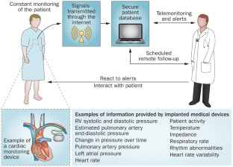
Measuring and Monitoring Coronary Heart Disease
Figure 1: Cardiac remote monitoring systems (Abraham et al., 2014)
There are several methods in place to measure and track coronary heart disease by health professionals and public health organisations. Mortality data is one of the important methods that indicates the number of individuals dying of CHD in a location over a given time. When one dies, the death certificate is registered with the cause of death. These records enable governments to know whether deaths are increasing or decreasing and also enable comparison between age, sex, region and social setups (Infante et al., 2020).
The other admissions made at hospitals pertain to chest pain, heart attacks, heart surgery and other heart conditions. These records indicate the frequency of the necessity of urgent or planned care. They assist in the planning of beds, staffing, clinics, and specialist units of the health services. The accident and emergency departments also give more details on sudden cases such as heart attacks, severe chest pains, among others.
CHD monitoring is done by general practitioners in the community. GP records consist of diagnoses, blood pressure, cholesterol, weight, smoking, diabetes, medicines, and family history. Periodic health examiner can be used to detect individuals at high risk before severe symptoms develop (Bae et al., 2021). An example is NHS health checks that might detect high blood pressure or cholesterol and provide early advice and treatment.
Population surveys can gather data on smoking, diet, exercise, alcohol, obesity and health care access. They demonstrate the prevalence of key factors contributing to risk as well as highlight the disparities within the communities. The findings can be used to investigate the correlations between lifestyle, living conditions and coronary heart disease.
There are also significant clinical tests. Blood tests determine cholesterol, blood sugar and evidence of heart damage. An electrocardiogram is a recording of the activity of the heart. A diagnosis can be confirmed by using exercise tests, heart scans and coronary angiography to determine the severity of the disease. Information regarding treatment, recovery, and survival can be obtained in disease registers and national audits. This enables the comparison of results between services, auditing the quality of care, and enhancing standards.

Controlling Coronary Heart Disease
Coronary heart disease is managed by its prevention, early identification, treatment and long-term follow-up. Prevention is highly significant as a great number of risk factors can be minimised. One of the leading causes of CHD is smoking, and by quitting smoking, one can greatly reduce the risk. Halt smoking facilities may offer guidance and counselling, along with drugs.
CHD can be prevented and controlled with the help of a healthy diet. It is recommended that people consume additional fruit, vegetables, wholegrains, and low-saturated-fat, low-salt, and low-added-sugar foods. Less salt decreases blood pressure. Saturated fat should be reduced to reduce bad cholesterol. Exercise is beneficial to the heart as it makes the heart stronger, maintains the right weight and helps manage blood pressure and blood sugar (Dibben et al., 2023).
Controlling weight is also significant. High chances of high blood pressure, diabetes and high cholesterol are at risk when one is overweight. With gradual changes, community weight-management programmes can assist people in making the changes. The consumption of alcohol is to be minimised since excessive alcohol consumption increases blood pressure and impairs health. Stress management and sufficient sleep can be beneficial to the heart as well.
CHD may require the use of medicines. Statins are taken to reduce cholesterol. Blood-thinning medications, e.g., aspirin in the right patients, can contribute to the possibility of harmful blood clots. Other medicines may reduce blood pressure, lessen chest pain and assist the heart to work better. Citizens need to learn to take their drugs and at what time. The treatment should be reviewed periodically to ensure it is effective and to deal with any adverse effects.
Some individuals need medical surgery. Angioplasty can open a constricted artery, and a stent can be placed to hold it open. Coronary artery bypass surgery opens up new pathways for blood to the heart. After a heart attack or operation, cardiac rehabilitation is important. It typically involves supervision, health teaching, emotional support, and dietary, smoking, and medication counselling (Wolf, 2021).
Wider action by the government and local services is also needed to control it. Individuals can be encouraged to make healthy choices by having clear food labels, healthier school food, safe walking pathways, parks and affordable leisure facilities. Knowledge of the signs of a heart attack and the necessity to seek emergency assistance can be enhanced by health education campaigns, which can allow people to do so, as they know what to expect. Secondhand smoke is also minimised by laws that limit smoking in open areas.

Consequences for People in the Community
CHD has the potential to impact any aspect of an individual. The physical effects can be exemplified by chest pain, shortness of breath, fatigue, weakness, and inability to walk or perform everyday activities. Some might not be able to work, drive, shop, cook or take care of themselves. Another one can be permanent damage to the heart, such as a heart attack, which can lead to heart failure or an irregular heartbeat.
The effect of the condition can also be severe emotionally. Patients can be scared of experiencing another heart attack or of death. Common effects following a major heart event are anxiety, low mood and depression. Other individuals lose hope and go without exercising, socialising or going out. This can make them lonelier and have poor living conditions (Su and Yu, 2021).
It also impacts families. Family members can also act as unpaid carers and assist with transportation, medications, bathing, eating, and schedules. The responsibilities involved in caring may lead to stress, exhaustion, and economic hardship. The roles of a family can shift when the individual with CHD is the primary earner/carer. There are also uncertainties about the health and future of the person by children and partners.
The community is broadly impacted. CHD may cause absence from work, retirement at an early age and loss of income. Employers can also lose talented employees and incur expenses due to employee shortages. The health and social care services should also offer emergency treatment, hospital services, medicines, rehabilitation, and long-term follow-up services.

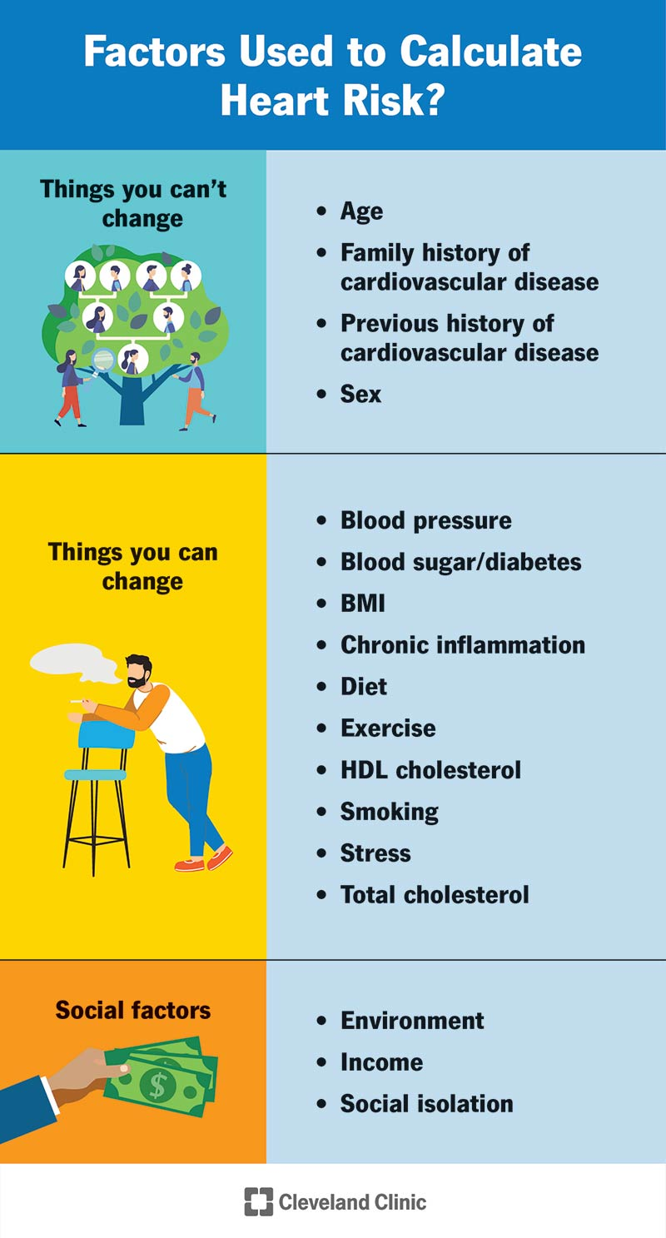
Health and Social Care Support Services
Figure 2: Cardiac risk calculator, sourced from Cleveland Clinic (2022)
Individuals with coronary heart disease can require the assistance of several services. General practitioners and practice nurses conduct regular check-ups, check on blood pressure and cholesterol, prescribe medication and offer lifestyle education. Pharmacists can interpret drugs, ensure that they are taken safely and assist individuals who experience issues with taking their medication with the right intake.
Heart doctors and specialist nurses expertly present their evaluation and care. They can schedule tests, medical examinations or surgery. Clear communication between the hospital and community services is very important after patients are discharged from the hospital. The individual ought to be informed of his/her diagnosis, his/her treatment, warning signs, medication and follow-ups.
One of the key support types is cardiac rehabilitation. The programmes assist individuals to heal safely and minimise the chances of heart events again. They offer physical activities, health education, nutrition, smoking cessation and stress management assistance. The rehabilitation process needs to be accommodating since some individuals can lack mobility, be tied up with care, language or travelling issues (Freak-Poli et al., 2023).
The health and physical ability of the person allow physiotherapists and exercise specialists to develop safe plans of activities. Occupational therapists can aid people who have difficulties in employment or daily activities. There may be a need for support with anxiety, depression or fear after a heart attack. This assistance can be in the form of counselling, talking therapies, peer support or community support groups.

Conclusion
Coronary heart disease is a severe disease, which is primarily caused by the narrowing or clogging of the arteries that supply the heart. It may cause chest pain, heart attacks, impairment, and even death. Death records, hospital records, GP records, health surveys, clinical tests, and national audits are used as measures to monitor the disease. It is treatable by means of healthier ways of living, earlier diagnoses, medications, surgery, and heart rehab. CHD has the potential to diminish self-reliance, harm emotional health, burden families, and create financial and social problems. Health and social care support is thus essential in providing effective care. The roles of GPs, nurses, cardiologists, pharmacists, rehabilitation teams, therapists, social workers, carers and community organisations are vital. The impact of coronary heart disease can be mitigated, and those individuals who are already affected enjoy a longer, healthier, safer and more independent life with prevention, early action, equal access to services and ongoing support.

References
Abraham, W.T., Stough, W.G., Piña, I.L., Linde, C., Borer, J.S., De Ferrari, G.M., Mehran, R., Stein, K.M., Vincent, A., Yadav, J.S. and Anker, S.D., 2014. Trials of implantable monitoring devices in heart failure: which design is optimal?. Nature Reviews Cardiology, 11(10), pp.576-585. https://doi.org/10.1038/nrcardio.2014.114
Bae, J.W., Woo, S.I., Lee, J., Park, S.D., Kwon, S.W., Choi, S.H., Yoon, G.S., Kim, M.S., Hwang, S.S. and Lee, W.K., 2021. mHealth interventions for lifestyle and risk factor modification in coronary heart disease: randomized controlled trial. JMIR mHealth and uHealth, 9(9), p.e29928. https://doi.org/10.2196/29928
Cleveland Clinic. “Cardiac Risk Calculator and Assessment.” Cleveland Clinic, 1 July 2022, https://my.clevelandclinic.org/health/articles/17085-heart-risk-factor-calculators.
Dibben, G.O., Faulkner, J., Oldridge, N., Rees, K., Thompson, D.R., Zwisler, A.D. and Taylor, R.S., 2023. Exercise-based cardiac rehabilitation for coronary heart disease: a meta-analysis. European heart journal, 44(6), pp.452-469. https://doi.org/10.1093/eurheartj/ehac747
Freak-Poli, R., Hu, J., Phyo, A.Z.Z. and Barker, S.F., 2023. Social isolation and social support influence health service utilisation and survival after a cardiovascular disease event: a systematic review. International Journal of Environmental Research and Public Health, 20(6), p.4853. https://doi.org/10.3390/ijerph20064853
Infante, T., Del Viscovo, L., De Rimini, M.L., Padula, S., Caso, P. and Napoli, C., 2020. Network medicine: a clinical approach for precision medicine and personalized therapy in coronary heart disease. Journal of Atherosclerosis and Thrombosis, 27(4), pp.279-302. https://doi.org/10.5551/jat.52407
Su, J.J. and Yu, D.S.F., 2021. Effects of a nurse-led eHealth cardiac rehabilitation programme on health outcomes of patients with coronary heart disease: a randomised controlled trial. International journal of nursing studies, 122, p.104040. https://doi.org/10.1016/j.ijnurstu.2021.104040
Wolf, S., 2021. The power of clan: influence of human relationships on heart disease. Routledge.

