Portfolio evidence of learning comprising of 4 separate items

MODULE : CREATIVITY AND VALUE CREATION
BMHP5014_BIRM

LECTURER : DR. AZORA HURD

STUDENT NUMBER : 1918145
NAME : SIMONA PASU
TABLE OF CONTENTS
Introduction 1
Task 2 2
Blog 2
Task 6 4
Letter to a potential funder 4
Task 7 6
Email to the interested party 6
Response to email 7
Task 8 8
Personal Development Plan (PDP) 8
Conclusion 9
References 10
Books and Journals 10
Online 10

Introduction
E-portfolio or electronic portfolio is the method that aims to connect and analyse the use of different tools and techniques better designed with the help of online mediums. The use of e-portfolio has increased rapidly in the health and social care sector. This is because it aims to reduce the complexity of the sector and helps them to develop effective policies to address the issues. The following report will discuss the importance of the e-portfolio and will provide evidence from the health and social care sector. The e-portfolio is based on different tasks that are designed for the applications of the health and social care sector. The following e-portfolio is based on a new project development plan and aims to identify the gap and its value in the health and social care sector.
The new project is based on-time implementation of the artificial intelligence into medical treatment and health policies. AI helps to keep the record of the patient’s data and tractor your health by reducing the effort of the workforce. Further, Due to the impact of the COVID-19 pandemic, the importance of AI has increased rapidly. The following report will provide a letter that is sent to the investors for the funding of the new project. Also, it will highlight emails sent to the investors and its response telling about the project and its activities. Lastly, the report will also analyse the use of the personal development plan in order to identify the skills and attributes involved in the project.
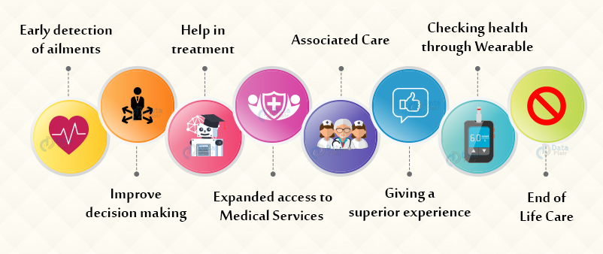
Figure 1: Role of AI in health and social care
(Source: Data Flair, 2021)

Task 2

Blog
Health and social care sector is one of the most important pillars of any country, as they aim to provide treatment to people and helps to maintain a healthy and sustainable life. The trends in the health and social care sector change continuously because they play a major role in promoting a healthy lifestyle and sustainable development. The idea and implementation of artificial intelligence in the health and social care sector is very beneficial for them, as it aims to increase productivity and empower them to treat and cure the patients. After the impact of the COVID-19 pandemic, the role of the health and social care sector has increased rapidly, and they had to face certain issues such as documentation policy, paperwork, advanced treatment, health record of the patients and many others. To reduce this complexity, artificial intelligence is one of the most important tools as it aims to add value and ensure creation in the health and social care sector (Panch et al., 2019).
Artificial intelligence helps to digitalise hospitals and brings the use of digital and online mediums to record documents and reduce paperwork. The idea of this plan also increases the productivity of the nation, as the health and social care sector contribute to the national and social economy of the country. Moreover, the idea of artificial intelligence also empowers the workforce and implements advanced equipment and machines for the treatment of patients. The medium used in this project is based on an online or digital medium, as artificial intelligence works on this platform and provides transparency into hospitals. Also, it promotes sustainable development and professionalism in the sector so that health and social care workers can easily complete their tasks and contribute to fighting the COVID-19 pandemic (Panesar, 2019).
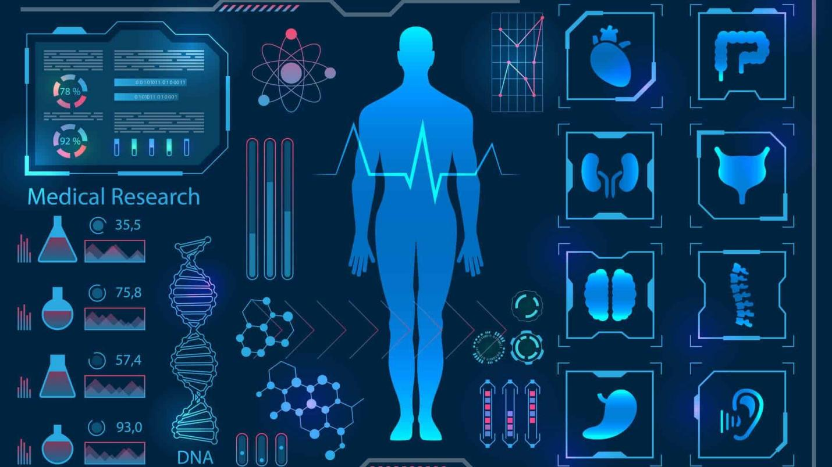
Figure 2: Identification of different diagnoses using AI in healthcare
(Source: Lotus Quality Assurance, 2021)
The e-learning material described form this helps the health and social care sector to implement this plan and treat the patients. For instance, the National Health Service of the UK had started to implement the policies of artificial intelligence in their hospitals. With the help of this, they have cured patients that are diagnosed with different diseases and also keep a record of their patients. Moreover, with the consideration of this policy, they had executed the paperless work to reduce their stress on paper findings. Other than this, there are more examples of the hospitals that are acquired this strategy and provided treatment to the patients. The advancement in machine learning and technological development enables the use of modern ways of decoding the diagnosis and developing vaccines for the disease (Bartoletti, 2019).

Task 6

Letter to a potential funder
To investor/bank,

XYZ

30th June 2021

ABC

Dear Sir/Madam,
I hope you are doing well. We have decided to start a new project campaign to ensure the use of artificial intelligence in the health and social care sector. The aim of this campaign is to provide advanced treatment in the tough time of the COVID-19 situation. I am writing this letter in order to gain your support for the successful execution of our new plan.
The use of artificial intelligence is important in hospitals as it aims to reduce complexity and provides enhanced technological development to treat patients. The idea is to use artificial intelligence to identify the diagnosis with the help of computerised programs and record them to a paperless digital framework. During the implementation of this program, there is one major problem, due to which this plan can face backlash. This problem can be addressed with your help, and it's my request to provide your help for the successful completion of this project. The problem is related to the funding and investment process. During the implementation of this process, a high amount of investment is required, and for that, we are looking for a funder or investor that can help us by Investing in the scheme.
This program is fruitful for future circumstances, as the use of artificial intelligence never gets outdated, and it aims to bring technological developments into the health and social care sector. Moreover, the scope of this program is reliable and flexible for the future also. It aims to promote sustainable development and ensures a healthy and hygienic environment in hospitals. The resources used in this, such as digital or online mediums, advanced computerised programs, changes in comparison to the COVID-19 pandemic and many others, are not easily available, and the cost of these are also high. Because of this factor, we are looking for an investor so that we can gather a sufficient amount of balance to successfully implement this program and ensure the use of technological developments to achieve higher growth. The use of this technique promotes sustainable development in future, as artificial intelligence helps to provide accurate results. Further, it reduces the impact of negative factors such as delay of reports, paperwork and documentation policy.
So, it’s my request that you please come forward and help us in this development program and provide us funds to implement the use of artificial intelligence. The details and other additional material are attached below.

Contact Number: **********

Yours faithfully

(Signature)

Task 7

Email to the interested party
To: abc@gmail.com

Subject: Involvement in the concept of your new project

Dear project manager
I am talking on behalf of my organisation, and we have heard about your project of the initiation of artificial intelligence in the health and social care sector. The concept developed by you is remarkable as it aims to bring a revolutionary change in this sector, and with the help of this, patients can get advanced treatment. The idea is interesting, and we have decided to participate with you in this development program actively. Our organisation had decided to involve you to implement AI in the health and social care sector. Also, we will provide funds for the execution of this plan and promote transparency in the plan.
We want to get more information about this project. Some of the things we want to know about this project are:
What is your target audience?
Which framework will you adopt to implement this program?
Will it bring effectiveness in the health and social care sector?
Is there involvement of other members also?
Other than this, our organisation will help you by providing a slogan and logo to this movement, and also aware people to actively participate. In this manner, the project can gain funds with the help of crowdfunding. We are waiting for your reply, and if there are any further questions or doubts, you can contact us with the following number. We are looking forward to working with you.

Contact number: **********

Thanks and regards

Response to email
To: xyz@gmail.com

Subject: Acceptance of the offer

Hello, we are glad to receive your email, and we are so happy to tell you that we had accepted your proposal and decided to make your organisation as a partner in the successful execution of this project. But, there are certain policies that you had to accept, and you have to certain details in order to become our partner. We are happy that you will provide us required funds, as the project is dealing with this issue. But, with your help, this issue can be addressed, and AI can be implemented easily without any problem.
The answers to your questions are:
Our target audience is the Covid-19 dedicated hospitals and implements AI in these hospitals so that they can gain the benefit of technological advancements.
The framework adopted in this is the digital transformation framework for paperless documentation policy.
With the consideration of AI, the health and social care sector can promote their medical diagnosis activity, which is essential for future development.
There is no involvement of others.

You can join our campaign from Monday, i.e., 5th July 2021. In reply to this email, please provide an outline of your skills sets and experience of your organisation and members that will participate with us. Also, provide a sample of the logo, slogan and other contact details to increase the communication process.

Thanks and regards

Task 8

Personal Development Plan (PDP)
 | Skills | Experience | Knowledge
Learning style | Use of Gibbs and Kolb reflective learning style to analyse my learning in the health and social care sector. | My experience is good, as I am employed in the hospital as nursing staff and had identified the use of AI (Jiang et al., 2017). | I have a high level of knowledge about artificial intelligence, and I am well-versed in the future impact of AI.
Leadership style | I have developed a situational leadership style, and it aims to change the style based on the situation. | Because of the hard-hit of the Covid-19 pandemic, I had changed my style and implemented new policies to tackle the changes. | I am well-versed with the role of leader in hospitals and also accomplished with the qualities of situational leadership style.
Personality | I am confident in my work and complete it within the given time. Also, I have developed different academic skills to gain knowledge (Pawar et al., 2020). | My experience in personality is related to a different diagnosis, as I have studied about different diseases. It reflects my personal development in the field of health and social care. | I have knowledge of different academic skills such as responsibility, integrity, problem-solving, stress and time-management and others, which had helped me to become successful.
Openness to work with others | I can easily communicate with others and understand their problems to provide the required treatment. | I have talked with different types of patients that are diagnosed with several diseases. Now, all are cured and are satisfied with the medical treatment provided to them and mental support. | I have knowledge of different diagnoses, and I have conducted a study on the Covid-19 virus also. Moreover, I am also well-versed with the types of treatment to be given to patients and the use of different machines to cure the patients (Davenport and Kalakota, 2019).

Conclusion
With the help of E-portfolio evidence, the above report had identified the aspects of a new project in the health and social care sector. The report had analysed a new plan that is to implement the use of artificial intelligence for medical treatment and record the status of a patient's health. It is concluded that during the implementation of this plan, one major problem is related to funding. But with the involvement of other organisations, this issue is addressed. The report had discussed a letter stating to an investor for funding. Moreover, a PDP is provided to analyse the skills.

References

Books and Journals
Bartoletti, I., 2019, June. AI in healthcare: Ethical and privacy challenges. In Conference on Artificial Intelligence in Medicine in Europe (pp. 7-10). Springer, Cham.
Davenport, T. and Kalakota, R., 2019. The potential for artificial intelligence in healthcare. Future healthcare journal, 6(2), p.94.
Jiang, F., Jiang, Y., Zhi, H., Dong, Y., Li, H., Ma, S., Wang, Y., Dong, Q., Shen, H. and Wang, Y., 2017. Artificial intelligence in healthcare: past, present and future. Stroke and vascular neurology, 2(4).
Panch, T., Mattie, H. and Celi, L.A., 2019. The “inconvenient truth” about AI in healthcare. NPJ digital medicine, 2(1), pp.1-3.
Panesar, A., 2019. Machine learning and AI for healthcare (pp. 1-73). Coventry, UK: Apress.
Pawar, U., O’Shea, D., Rea, S. and O’Reilly, R., 2020, June. Explainable ai in healthcare. In 2020 International Conference on Cyber Situational Awareness, Data Analytics and Assessment (CyberSA) (pp. 1-2). IEEE.

Online
Data Flair, 2021 [Online] [Accessed through] < https://data-flair.training/blogs/ai-in-healthcare-sector/> [Accessed on 30th June 2021]
Lotus Quality Assurance, 2021 [Online] [Accessed through] <https://www.lotus-qa.com/healthcare-ai-new-era/> [Accessed on 30th June 2021]

