Seeing is Believing: Cognition, Behaviour and the Brain (HPAN4012)

Selective Attention

A bit like the Multi-store model of memory, this topic looks at the flow of incoming sensory data and attempts to track its flow through possible cognitive mechanisms, mapping out a process which is consistent with the research data.
Selective attention is the first part of the cognitive process. We cannot pay equal attention to everything that is going on around us – attention has to be selective. Some stimuli are more likely to be attended to than others. For example, a sudden bang or flash will attract attention, regardless of what we are doing since it will be outside of the normal range of stimulation. In addition, a perceptual set may operate, for example, we may be more likely to tune into food related stimuli at the expense of others if we are hungry and we may be more likely to tune into some things than others, depending upon our past experience.
Some of the earliest research into past experience was done by Cherry (1953) who researched the Cocktail Party Effect. This effect suggests that you may be in a crowded room (such as a cocktail party) and be deep in conversation, yet when your name is mentioned on the other side of the room you have the ability to pick up on this and can immediately switch your attention and attempt to tune into what is being said about you.
Cherry was interested in the process by which this is possible. He used a technique known as Dichotic Listening to investigate this ability. Using headphones and a tape recording, he presented participants with different information to left and right ears simultaneously. Cherry then used a technique known as shadowing, whereby the participant had to shadow one of the messages by speaking it aloud as they heard it, so preventing them from learning anything about the second message. It was found that participants could determine whether the voice in the non-shadowed ear was male or female, high or low-pitched, but otherwise could report nothing about the content of the message.
Anne Treisman changed the language in the unattended ear from English into German and found that participants did not notice, also Morray (1959) repeated the same word up to 35 times , yet participants still did not notice. Another import finding from Cherry’s experiment was that participants’ could identify their own or their partners name in their unattended ear. Similarly, if someone shouted ‘attention’ or ‘listen’, then participants stopped shadowing and paid attention. To look at how psychologists have attempted to make sense of these findings, we have to consider the models of selective attention that have been proposed.

Models of Selective Attention

There are three major models:
- Broadbent’s Filter Model (1959)
- Treisman’s Attenuator Model (1964)
- Deutsch-Norman Pertinence Model (1963)

Broadbent’s Filter Model (1963)
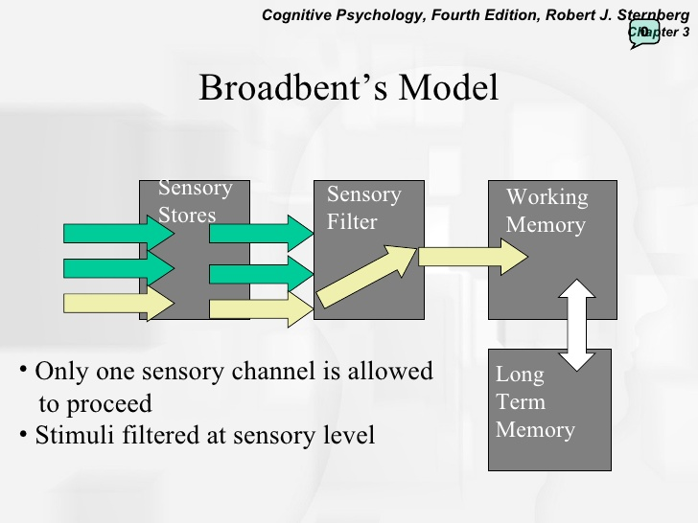
In this model, the Sensory Filter only allows some information to pass through. It selects from a mass of information only that which has the most relevance. Information from LTM can also give feedback to the filter so that it can change its bias. Any highly pertinent information will be picked up by the filter, which accounts for the Cocktail Party Effect and the ability to hear our name from across the other side of a room. Equally, the same is true if we are hungry – relevant information regarding food items will also make it through the filter. Once we have eaten, the bias of the filter will then change once more.
The bias of the filter can be affected by a number of things, such as motivation, perceptual set, and emotion. The filter also has a permanent bias towards novel stimuli, such as loud noises, which may be due to an obvious survival value. In addition, stimuli which are repetitive tend to get filtered out after a while – this process is called habituation.
Evaluation of Broadbent’s Filter Model
A big criticism with the model is that it is unable to explain the Cocktail Party Effect. How is it that your name, when spoken on the other side of the room, gets through the filter when it is not an intense or repeated sound?
Broadbent also suggests that participants can only attend to one channel at a time (the model proposes that parallel processing occurs before the filter, which is then reduced to serial processing immediately after the filter.)
For example, when numbers are presented to both ears simultaneously, as in the following example;

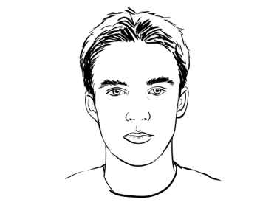
159
632

Participants typically report the digits in the order 632 159. This suggests a limited capacity for processing – they cannot process both numbers at the same time. There is a bottleneck somewhere in the system, preventing the simultaneous processing of both numbers. A process of queuing is apparent.
Gray & Wedderburn (1960) did a study which Broadbent’s model is unable to successfully explain;

6 JEC 9
OB 2 TIVE

According to Broadbent, when participants are asked to report the message heard in one ear, they should report ‘6 JEC 9’ or ‘OB 2 TIVE’. In fact, they reported ‘OBJECTIVE’. They could switch attention from channel to channel, as the perceived need for continuity arose, whereas the model suggests we can only attend to one channel at a time.
Furthermore, Norman (1969) found that if participants were stopped during shadowing they could reliably recall the last few words of the non-shadowed message, if they were asked within thirty seconds of being interrupted.
Another finding by Moray (1970) found participants previously given electric shocks paired with particular words appearing in the shadowed message, would exhibit an increase in Galvanic Skin Response (GSR) when these words then presented in the un-shadowed message. This was also found to hold true for acoustically similar words and synonyms (words with same meaning).
Overall, it would appear that Broadbent’s model with its suggestion of the filter acting like a bottleneck is too simplistic, perhaps this is a result of the bottleneck appearing too early in the process.

(Anne) Treisman’s Attenuator Model (1964)

The idea behind Broadbent’s model is that it was supposed to work on an all or nothing basis – either the message is attended to or it is not. Treisman’s model has greater flexibility. In her model all the sensory information is passed on, but only one of the messages is strong, while the others are reduced in strength, or attenuated.
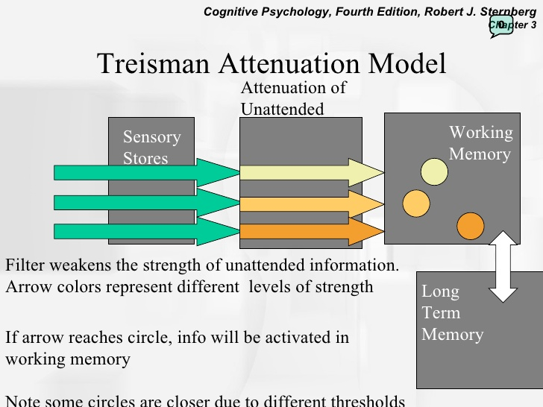

The idea is that only the words with the right characteristics pass into conscious awareness. Those not having the right characteristics do not, they get attenuated instead. All of the data arriving at the attenuator are passed on to a recognition network and analysed for meaning. From there, any vital messages that were not originally picked up can then pass into conscious awareness. Having passed into consciousness, such messages may alter the tuning of the filter, the idea being that the filter can then be retuned as interests change.
Unlike Broadbent, Treisman’s (1964) model can account for the ‘Cocktail Party Effect’ – it suggests we can tune into a message, even though we are not attending to it and then retune the selective filter. Furthermore, Treisman’s model accounts for the fact that we can attend to more than one channel at a time.

E.g. Treisman (1980);
Participants were given the following dichotic listening task;
Left ear: He felt somewhat ill window
Right ear: She sat looking out of the at ease
Participants had to shadow the message played to the right ear (preventing the left ear being listened to). Broadbent’s (1958) model would suggest that participants would repeat the message as played, but it was found that participants usually switched ears near the end of the message so that the sentence made sense (suggesting that messages are processed for meaning).
While Broadbent’s model has an early filter system, Treisman’s model suggests that the filter is a higher order mechanism which is able to process messages according to their meaning. However, as Solso (1979) points out, it is difficult to account for the decision making which allows for some information to pass through at the expense of others.

The Deutsch-Norman Late-selection Filter Model (AKA Pertinence Model)
[Deutsch & Deutsch (1963), refined by Norman (1969, 1976)]
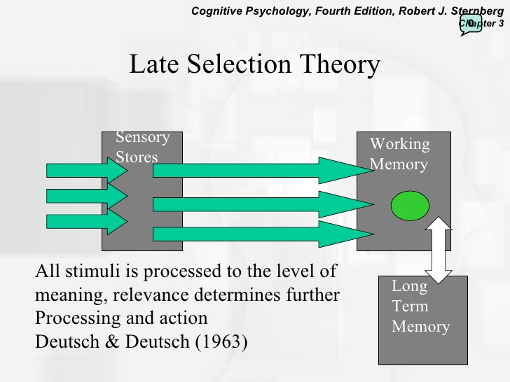
This model suggests that all the incoming sensory data gets analysed and whatever is pertinent or relevant to the current situation undergoes further analysis. For example, if driving a stretch of familiar road you might analyse the signs to the extent that you are aware they contain words and numbers. However, because they are not pertinent, once past a sign, you would not have a clue as to the road number, despite being aware that that were numbers on the sign.

Evaluation of this model
Two major issues;
- The idea that all incoming sensory data gets analysed, even to a limited extent, would seem to make this a very inefficient system. As Solso (1979) points out, this would mean analysing much that was irrelevant.

- There is not much experimental support for this model;
E.g. Treisman & Geffen’s (1967) dichotic listening experiment
Participants were given a shadowing task, being forced to attend to the message in one ear, while at the same time having to identify a target word which could occur in either ear. On hearing the target word, participants were required to make a noise by tapping. According to the Late-selection Filter Model (Pertinence Model) it should not matter in which ear the target word occurred – participants should be able to identify it without any problems.
In fact, it was found that participants were able to detect the target word 87% of the time when occurring in the shadowed ear, compared with only 8% of the time when it occurred in the non-shadowed ear. This result seems to lend support for Broadbent’s Filter Model, or, due to the fact that some non-shadowed words get through, Treisman’s Attenuator Model, whereas the Deutsch-Norman Model would have predicted a better result for the non-shadowed ear, since all incoming data should be analysed for meaning.
Deutsch & Norman (1967) claimed this was not a valid criticism of their model since participants had to shadow and tap for one message, but only tap for the other. It could be that this made shadowed words more pertinent than non-shadowed ones (shadowed target words had to be tapped as well as spoken, non-shadowed ones simply had to be tapped).
To address this criticism Treisman & Riley (1969) did a variation of the experiment where participants were told to stop shadowing as soon as a target word was detected in either message. It was found that participants detected 76% of target words which occurred in the shadowed ear compared with 33% for the non-shadowed ear. Although still problematic, this finding perhaps provides a little more support for Deutsch & Norman’s Late Selection Filter Model.

How the Models Operate – an example of the differences between the three models

Suppose a passenger asks a driver a question just as the driver is coming up to a junction. The reason for the driver not responding depends on your choice of model:
- Broadbent (Filter Model)
They did not even hear the question as they could only attend to the junction

- Treisman (Attenuator Model)
They received the less important message at an attenuated or reduced level. They may be able to remember it later

- Deutsch & Norman (Pertinence Model)
They can only respond to information that is pertinent to immediate needs. If the road signs are more important then, although they recognise the voice, they are unlikely to decode it further until they have dealt with the junction. Once that has been dealt with, then the question will be answered (both inputs enter the system)

Conclusion
It is difficult to obtain conclusive evidence for one particular theory, although it does appear that Broadbent’s model is overly simplistic. The lack of conclusive evidence points to the fact that selective attention is a very sophisticated process. It may be that the various models fail to take account of the different types of processing involved (e.g. visual, acoustic and semantic) and also the fact that this may sometimes occur serially and sometimes in parallel. Possibly, it is this lack of flexibility within the different models that explains why no single theory emerges as an obvious choice.
It is also worth pointing out that selective attention considers single channel models, whereas recent research into divided attention considers simultaneous processing of more than one channel. Research into this area will perhaps prove greater insight as to the sophisticated nature of the processes which underlie and are necessary to attention.

