  Component One: Student Journal (learning log) 750 words +/- 10%  Contribution to Overall Module Assessment: 25% | Student No: | Alexandru Ciprian Plaveti  2246419
 | Module Title: | Hotel Placement – Hotel Administration &  Front Office Operations.
 | Module Code: | BMIH4004
 | Lecturer: | Lisa-Marie Bassler
This component of the assessment shows the placement in the Premier Inn and a reflective journey there using Gibb’s reflection model.

Description: During my placement in the housekeeping department at Premier Inn, Chapel Bar, Nottingham City Centre, I was assigned various tasks. The placement allowed me to explore different areas of housekeeping. My responsibilities were to clean the rooms and prepare guest rooms. I also changed linens and maintained the overall cleanliness of the hotel. I have dealt with the guests whenever they needed something. In that placement, I had to make prompt decisions and behave professionally as it was an integral part of Premier Inn.

Feelings: I felt a range of emotions. I had to manage guest inquiries and handle the fact-paced check-ins and check-outs. Sometimes they presented challenges as well. Sometimes dealing with the inquiries from the guest was even challenging. There was always a pressure to maintain the high cleanliness standard of Premier Inn. In such a bustling place, the placement gave me an intense experience overall. But I always love to learn new things and adapt to new situations. So, this learning was quite enjoyable to me as well. I tried to enjoy the process and understand everything so that I could be a better professional. This professional attitude gave me an edge in dealing with situations.

Evaluation: In the front office area, I always tried to be smart and spontaneous with the guests. I tried to answer their question politely. Sometimes in urgent scenarios, I needed to take prompt actions to ensure that guests were feeling comfortable. As I needed to handle a variety of responsibilities, it helped me master the multi-tasking skill. I had to be very efficient with my time and work. It helped me to deal with difficult situations. When the guests were dissatisfied, I needed to adjust and take action to ensure comfort. It helped me increase my decision-making skills (Ninemeier, 2019). Also, my problem-solving skills have been developed. Conflict often arises when two persons or parties can’t reach a mutual ground. In my placement period, I have experienced it many times. During times of conflict, I tried to take an approach that ensured maximum outcome. I prioritised the objective of my workplace and the satisfaction of the guests. I believe that during the placement period, my effective communication skills have developed drastically. I appear as a smarter person now. I can deal with difficult situations and resolve conflicts more efficiently.

Analysis: When I think about my experience in Premier Inn, I find the huge learning opportunity I had. Every day I had new challenges to face and I needed to prepare myself to be able to take efficient action in any scenario. I believe that in any profession this skill will help me. I believe that my improved communication skills will help me do even better in my workplace. In this modern world, problem-solving is a vital skill. From this placement, I have got a good grip on problem-solving skills in this sector (Tyagi et al., 2024). I have also learned to organise my tasks so that I can complete them efficiently and set my priorities accordingly. This is another vital skill for professional success. So, I believe that this placement has equipped me with some valuable skills. Those skills will help me become a better professional and do well in life.

Conclusion: I experienced the pressure and thrill of working in a fast-paced environment, and it helped me grow as a person. This experience has helped me to understand the hospitality industry even more. This placement has shown me my shortcomings and skills. I will try to use this knowledge in my life in my continuous journey to develop myself. The hands-on experiences were invaluable. I have learned the importance of great service and the inner message of the hospitality industry. I have also gathered some ideas and feedback to improve my performance and work on the shortcomings.

Action Plan: I have created an action plan for me. It mostly incorporates my skill development journey and gaining expertise in other areas. In this action plan, I have incorporated multitasking, problem-solving, business communication and emotional intelligence skills.

My overall experience at the placement in Premier Inn was wonderful. The learning, development and excitement everything helped to make me a better person for my future.

Component Two
Contribution to Overall Module Assessment: 25%
Trip Advisor Review Response 150 words +/-10%
Positive review (T, 2024)
Melanie T wrote a review Jan 26
Great stay
Amazing stay! Stayed as part of a hen do for my friend so there was a decent amount of us and the staff (Jemma and Saff) were so friendly and helpful. The room was very clean, perfect size and a lovely bathroom. They also had great parking and breakfast options. Will stay again, thanks for all your help!
Date of stay: January 2024
Trip type: Travelled with friends.
Response:
Dear Melanie
Thank you for choosing Premier Inn and taking the time to share your experience here. We are glad to know that you had such an amazing time with us.
Our team is glad to help you. It's heartening to know that the cleanliness and size of your room, along with the quality of our parking and breakfast options, met your expectations. Our staff along with Jemma and Saff will continue this friendly behaviour and serve customers in future as well. Our staff are trained well to provide good service to our guests. We value the guests and we try to learn from our mistakes.
These kind words inspire us. We always try to provide the best for our guests. Your recognition motivates us. We would love to welcome you again to Premier Inn. Thank you for your feedback. Best wishes for you.
Regards
Premier Inn

Screenshot of referenced Trip Advisor review used:
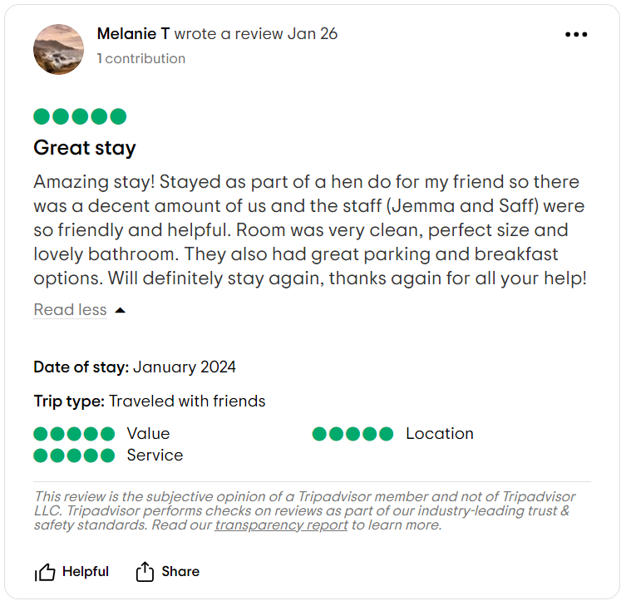
Letter of complaint response 500 words +/- 1-%
Dear Guest,
First, I want to express my sincere apology for the disappointment and dissatisfaction you felt while staying at Premier Inn. We appreciate your feedback. Such feedback helps us find out our shortcomings and work on them. In reality, it bothers us that the Premier Inn room failed to live as much as you expected. Your concerns about the limited facilities, cleanliness troubles, and noise are taken seriously. We've already begun doing a few matters to make it right.
We well know the problem with the cleanliness of our room. We have conducted a radical assessment of our cleaning strategies to ensure that all our rooms are clean and well-decorated. We have additionally made a few modifications to cope with the cleanliness issue. We have gone via some research as nicely. So, in the future, such issues never show up once more.
We understand the significance of a properly functioning wi-fi system. It's very treasured for us when a visitor chooses us for a higher revel in. We make an apology for any pain precipitated. We have already constant difficulty with Wi-fi. We can overview our education tactics for the housekeeping body of workers to make sure that each in-room facilities align with the booking info. That will offer the ultimate experience for our valued visitors. Your comments have brought on us to reevaluate our excellent manipulation measures. We will enforce additional schooling classes for our housework and protection group of workers to make sure good information on the specific requirements for Premier Plus rooms. We will set up a greater efficient device for ordinary maintenance exams on all our room facilities to save you similar problems within the Destiny. We will introduce a communication system to notify guests earlier of any recognised problems or renovation activities that might affect their stay. We are sorry for the customer support as well. We will pass for good sized training in customer service. We are thinking about some alternatives so that it will help reduce the noise degree. We have additionally devoted ourselves to a popular assembly to identify capacity issues. We apprehend the frustration those issues have brought on you. We need to guarantee you that your revel in isn't reflective of our typical widespread. We respect your willingness to provide such specified remarks.
To specific our sincere apologies, we would love to provide you a complimentary one-night time live in our Premier Plus room, making sure a much-advanced experience. This will permit us to expose the improvements we're making primarily based on your treasured insights. Please contact us immediately to arrange the information of your destiny stay.
Once more, we apologise for falling short of your expectations. We admire your know-how as we take instantaneous corrective measures.
Regards,
Premier Inn

Component Three:
Contribution to Overall Module Assessment: 50% (1000 words +/- 10%)
Writing in essay format

Introduction
Hotel administration and front office operations are always challenging experiences (Batabyal and Das, 2020). This essay considered the key skills incorporated with these two experiences and showed their impact on the understanding and development of key skills in hospitality management. The key skills discussed here are customer service skills, communication skills and organisational skills. All of them are significant. They help to make the guest experience better and establish the image of the hotel in a higher dimension. They also make the employees more efficient.
Key Skill 1 – Customer Service Skills
Customer service is significant in any industry that requires a connection with the customers. It works as the bridge between the customers and the company. Through customer service, the customers can avail of the services and learn more about the company (Kumar and Reinartz, 2019). In terms of the hospitality industry, the significance is even more. A guest comes in contact with the customer service at first. Customer service gives them the first impression of the hotel. Also, whenever they have any complaints or demands they contact the customer care service. So, customer service management cannot be emphasised less. There are many models in customer service. One of them is the Ritz-Carlton Model. This model emphasises prediction and proactive services (Deszczyński, 2021). Here the customer care service is supposed to predict the possible necessities and demands of the customer and serve them accordingly. Here the guests are served as per their necessity even before expressing. In Nordstrom Model - "Customer Comes First". This model is very powerful as it ensures that the guests are satisfied and makes it a priority (Krost, 2018). Such a strategy always helps the business to grow more and keep the customers coming as they are valued and respected here. Also, their problems are addressed promptly. In customer cases, service personalisation is very important (Tkalčič et al., 2018). It makes the customers feel special and enhances their overall experience. So, the customer care service needs to incorporate emotional intelligence in the training (Prentice, 2023). They also need to know about conflict resolution as it carries significance in dealing with guests. Empathy also plays a role in customer care service. Good customer care service can help to enhance the brand image and make people satisfied.
Key Skill 2 – Communication Skills

Communication is the key. The importance of communication skills cannot be emphasised less in front-office operations. The whole function of front office operation is based on communication. It incorporates the overall business communication with the customer from the business. Customer service works based on these communication skills. Proper communication skills can enhance the relationship with the guests. The guests expect a hotel to communicate properly and understand their needs without saying it out loud. Efficient communication can ensure this aspect. An efficient communicator can deal with difficult guests and work for the fulfilment of their needs (Holt et al., 2019). Communication helps to make the customer experience seamless. Communication is at the heart of hospitality. There are aspects of communication such as active listening. It helps to make the listener feel heard. When a guest is not able to articulate their needs, a good communicator can understand things even from the gestures of the guests. Communication involves both speaking and listening. Both need good training and practice (Ogunyemi et al., 2022). In the hospitality industry, the importance of having multilingual employees can be beneficial. So, communication skills can cater for a range of needs. This aspect of communication helps to understand non-verbal communication. Among the models of communication, the transactional model is significant. This model can be used in the hotel front office as some exchange of information happens there.
Key Skill 3 – Organisational Skills

In a front office, organisation skills work as the backbone. Organisational skills directly impact the performance of any hotel. With proper organisational skills, performance, collaboration and time efficiency increase (VOGLER, 2024). In the long run, these improvements affect the image of the hotel in front of the guests. No one likes to stay in a hotel that doesn’t give proper emphasis on the importance of time management and makes processes lengthier. Rather fast responses and quick considerate steps can make the guests trust hotel management and bring them back to the hotel again and again. Organisational skill in the front office helps to streamline the interaction with the guests (Wardley, 2024). It ensures that the check-in and check-out are prompt and don’t affect the experience of the stay. Time management theory for organisations discusses the importance of task categorisation based on urgency and importance. The Pareto principle says that 80% effects come from 20% causes. In organisational skills, it can be described as a focus management principle. Organisational skill needs to be adaptable and flexible so that they can incorporate the demand and service requirements of the changing world. The efficiency also depends on the task assignment and the training provided to the employees. So, it can be said that organisational skills are not limited to well-organised desks, they go beyond that and impact the overall experience of the customer.
Key Skill 4 – Problem-Solving Skills

Problem-solving skills are vital in modern life. Every day many problems arise. It's important to address the problem considering their depth and analysis. In front office operations, this problem-solving gets even more intense here, every guest is different and the way of dealing needs to be adapted as well. Also, when a guest faces any issue, he reports it to the front office. Front needs to assess the problem as well as make sure the solution satisfies the guest (Wagen & Goonetilleke, 2015). In the case of problem-solving, the first step is root cause analysis. Then open and clear communication is needed. The front office needs to have a full idea about the problems guests are facing. Sometimes different aspects of a problem analysis can help. After the analysis, decision-making is needed. This step sometimes involves communicating with proper personnel or offices. The front office needs to be equipped with proper knowledge and ideas about the potential problems and trained accordingly. In problem-solving, flexibility is important (Baytok et al., 2023). Also, a customer-centric approach in hospitality management can help to satisfy the customer's needs. While solving a problem it is also essential that the improvement is continuous and doesn’t involve only temporary measures.
Conclusion

Achieving the key skills can help front office operation employees become more efficient. It will help to enhance the brand image of the hotel in the long run. So, the investment in the skill development of the employees is a worthy investment for the hotel.

Reference List

Batabyal, D. and Das, D.K. (2020) Global trends, practices, and challenges in contemporary tourism and Hospitality Management. Hershey, PA: Business Science Reference.
Baytok, A. et al. (2023) Leadership approaches in global hospitality and tourism. Hershey, PA: Business Science Reference (an imprint of IGI Global).
Deszczyński, B. (2021) Firm competitive advantage through relationship management: A theory for successful sustainable growth. Cham, Germany: Springer International Publishing AG.
Holt, N. et al. (2019) Ebook: Psychology: The science of mind and behaviour, 4e. New York, NY: McGraw-Hill Education.
Krost, C. (2018) Marketing to millennials. Erscheinungsort nicht ermittelbar, US: LinkedIn.
Kumar, V. and Reinartz, W. (2019) Customer relationship management concept, strategy, and Tools. Berlin, Germany: Springer Berlin.
LHLee84 (2023) Disappointing premier plus upgrade - review of Premier Inn Nottingham City Centre (Chapel Bar) Hotel, Nottingham, England, Tripadvisor. Available at: https://www.tripadvisor.com/ShowUserReviews-g186356-d292536-r917205485-Premier_Inn_Nottingham_City_Centre_Chapel_Bar_hotel-Nottingham_Nottinghamshire_En.html?m=19905 (Accessed: 30 January 2024).
Ninemeier, J.D. (2019) Supervision in the hospitality industry. Chicago, IL: National Restaurant Association Solutions.
Ogunyemi, K., Ogunyemi, O. and Okoye, E. (2022a) Humanistic perspectives in hospitality and tourism, volume 1 excellence and professionalism in care. Cham, Germany: Springer International Publishing, Imprint: Palgrave Macmillan.
Ogunyemi, K., Ogunyemi, O. and Okoye, E. (2022b) Humanistic perspectives in hospitality and tourism, volume 1 excellence and professionalism in care. Cham, Germany: Springer International Publishing, Imprint: Palgrave Macmillan.
Prentice, C. (2023) Leveraging Emotional and artificial intelligence for organisational performance. Singapore, Singapore: Springer Verlag, Singapore.
T, M. (2024) Great Stay - review of premier in Nottingham city centre (chapel bar) hotel, Nottingham, England, Tripadvisor. Available at: https://www.tripadvisor.com/ShowUserReviews-g186356-d292536-r935623504-Premier_Inn_Nottingham_City_Centre_Chapel_Bar_hotel-Nottingham_Nottinghamshire_En.html?m=19905 (Accessed: 30 January 2024).
Tkalčič, M. et al. (2018) Emotions and personality in personalised services models, evaluation and applications. Cham, Germany: Springer International Publishing.
Tyagi, P. et al. (2024) Implementing sustainable development goals in the service sector. Hershey, Pennsylvania (701 E. Chocolate Avenue, Hershey, Pennsylvania: IGI Global.
VOGLER, A. (2024) Digital Management Practice: Mastering exponential change with collective and artificial intelligence E. S.l., Germany: SPRINGER GABLER.
Wagen, L.V. der and Goonetilleke, A. (2015) Hospitality management strategy and operations. NSW, Australia: Frenchs Forest.
Wardley, D. (2024) The vibrant organisation: The science of scaling enthusiasm to transform performance. Abingdon, Oxon: Routledge.

