Research Methods and Communication-A study of colour in the Animation
WEN XI
Swansea College of Art, UWTSD
1804976@student.uwtsd.ac.uk

- Introduction
Iridescent colours caused blindness.The sentence is from Tao Te Ching ( Laozi (traditional),4th century BC) , a Chinese classic text, which means the changing colours can disturb people's minds which can make people unable to calm down and in that way their visual attention cannot be concentrated.colour is one of the important factors of visual communication.From ancient to the present, the influence of colour on people's visual perception has been discussed all over the world.Just like Zelanski and Fisher has said in their books that “colour is perhaps the most powerful tool at the artist’s disposal.”(Zelanski & Fisher,2006)

Flowers and Trees ,which made in 1932 by Disney Studios and won the first Academy Award for Animated Short Subjects，which was the first animation to use the full-colour three-strip Technicolour process. After that, the animation on the screen has gradually began to become colourful.

With the advance of science and technology, the production of coloured animation has changed from the previous way like Celluloid animation to digital animation today . Nowadays, animation can better display their colours on the screen than 20 years ago .Meanwhile, with the in-depth studying of visual research included the perception mechanism in luminance and colour , imaging laws of retina and colour psychology, people begin using these kind of knowledge to help them to achieve the goal that is giving audience visual stimulation on the screen to attract audiences’ attention.

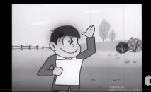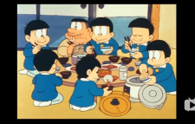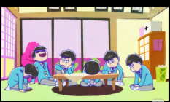
Figure 1: Osomatsu-san，three different edition from 1966 to 2018.
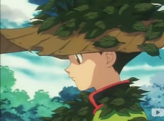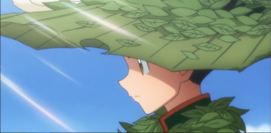
Figure 2:Hunter X Hunter ,two edition from 1999 to 2011.compared with the animation works of the past 20 years, we can clearly find that the contrast of colour in animation has changed greatly.

Animation is an expression of visual communication. A good animation should be able to attract audiences, and the picture design of the animation is one of the essential elements. colour can make strong impact of the animation design. Good colour match can make the audience fall in love at first sight.

colour and contrast are significant to visual perception. With the proper use of colour and contrast can help designer improve effectiveness and practicability of visual communication. Analyzing colour and colour contrast within the related vision theory can provide additional idea into how to use these design factors to create visual communication design.

colours vary in many different ways, including Hue,Saturation(chroma),hue,Lightness(value), Temperature.The factors that affect colour changes interact each other at the same time, and they are classified in these kind of names to facilitate recording.For instance,varying background luminance changed the relative saturation of the standard colours.(O'Connor,2013)

colour contrast is produced by these changes, such as brightness contrast, hue contrast, and so on.Control these relevant values, we can get a good picture effect.Even the Professional colourists (Hurkman,2010) need to correct global luminance and adjust global hue and saturation to make the film can attract the attention of the audience.Some professors are doing research in adjusting the overall colour and the tone of colour to change the film’s certain styles.They find that if work in this way,we could effectively models the horror genre, mysterious emotion .(Xue et al.2013)

This report aims to explore the approach about the colour contrast towards animation in the animate industry. It will cover the process of creating a colour contrast study to better understand and plan ahead how the strength of the hue,brightness combined can make the animation’s scenes be harmonious.

The report will also cover the expected outcome from the test.After achieved result,the research will analyze the data what we have got to draw a conclusion.

2. Project-specific research.
The design of character and scene of the animation can help animator make sure animation’s final presentation. Besides,colour contrast’s strength in picture can effectively impact the visual effect of animation. Under the whole operation in early-stage design, post-production and colour modulation, it can help picture’s colour contrast match the required style of picture. Meanwhile,colour matched harmoniously can effectively stimulate audience’s visual perception.
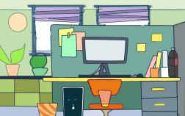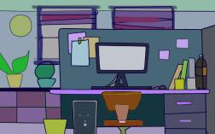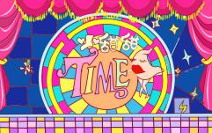
The early design sketches 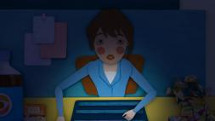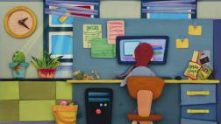 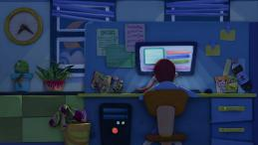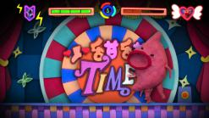
The final film’s screenshots
Figure 3: The early design sketches and the final film’s screenshots of a short advertising animation made by my team.The early-stage design and post-production aim at make the colour contrast of final scene in animation can provide a comfort range in visual perception to audience. On the stage of colour retouching, the post-production enhanced the colour contrast in virtual world to distinguish the virtual world from the real world in the animation plot.

This animated short film,Warm your stomach (XI,2016) ,tested the viewing effect produced by two kinds of colours in the same animation in a certain extent and combined two picture with different contrast into a comfort scope by adjusting which has enough strength of colour contrast to stimulate vision.

Figure 4 is a computer painting which imitated the style of stained glass window, using various colours and contrasted luminance.It show us that high-contrast picture can produce intensive stimulation to vision and give the pressure of visual.Because the background colour in this illustration is brighter than the foreground characters, it makes people's eyes have no center, and the vision is divergent.Meanwhile the brightness of the green is too bright, so that there is a sense of discomfort on the vision.As the result of that,people might give up watching this kind of illustration with longtime.If this intensive stimulation with high level apply in animation with flashing changing picture,people maybe occur cerebral spasm response.Almost 20 years ago，an animation named "Pokemon." has a plot about five seconds of flashing red light in the eyes of "Pikachu,".This plot made nearly 618 children had suffered "television epilepsy" . As the result ,even varying background luminance changed the relative saturation of the standard colours,we should use the strength of luminance in an appropriate way.
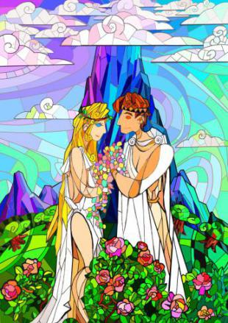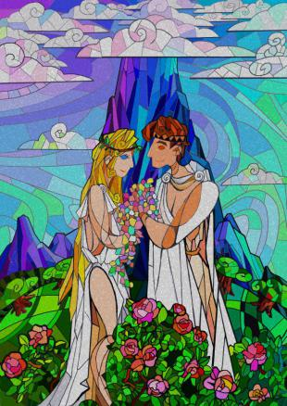
Figure 4: The case of using too strong colour contrast in the illustration.The image on the right decreases the brightness., so the visual pressure is much less.

The research in this project will centre on animation in recent years and make correlation analysis in picture’s colour contrast.Moreover,every creation is a summary of practicing experience. This report will follow from my previous experience in studying colour contrast in animation.

3.Proposed Methodology.
The core of the study is to explore the practice and seek a more comprehensive understanding of the formal structure of painting in practice.
Animation is a modern way to express visual communication, it is an art combined with audiovisual.This study is based on colour contrast in animation and find how can colour contrast do to enhance the audience's viewing experience. As the result the research methodology is about performative way rather than quantitative way.

Sullivan, G. talked about different analysis way in his book.“Quantitative studies is linear,iterative,and confirmatory,and qualitative studies is cyclical,emergent,and discovery oriented.Visual arts research,on the other hand,is dynamic,reflexive,and revelatory as creative and critical practices are used to shed new light on what is known and to consider the possibility of what is not.”(Sullivan,2005) Therefore, the art research and the art practice can not be separated..So the report will be based on my own practice, using the methods about doing the primary and secondary studies from animation works,artworks,literature and media review to analyze. so that we can get some feasible ways to provide more hypotheses for my future creation.

Practice-Based,this article will seek a reasonable way to use colour contrast to express emotion through reading relevant literature,research and doing the analysis of my own project. This report will try to provide animators some help to control the colour contrast in the animation and make summary and conclusion targeted on my practical work.

Japanese anime will be studied in detail to determine how best to approach controlling of the colour contrast of the animation screen.
This article based on analyzing the paper and related visual theory to practice mapping, seeking how to control the strength of the colour contrast to make picture’s ocular dominance and visual irritation live in harmony for promoting the own ability to control the picture design.

- Definition of proposed outcomes.
colour perception is a subjective feeling, and visual stimulation is an objective existence.colour and contrast play an important role in supporting aesthetics in animation picture design, attracting audience to watch and rendering story.colour contrast includes brightness contrast and tone contrast. Proper control of tone and brightness can control the colour contrast in animation, reduce visual pressure and attract audience's attention.
Good colour and contrast not only help to distinguish outline, detail and depth, but also help to attract and divert attention, so as to clearly depict the focus of the picture to be emphasized, such as roles or props. In this way, combined with the corresponding colour perception theory, the strategic use of colour and contrast can meet the needs of different styles in animation, and bring different kind of feelings to people. Through the design and arrangement of key information, colour and contrast can improve the effectiveness of visual communication design in animation.

Study the intensity of colour contrast for different animation styles, so that animation designers can refer to these conclusions for controlling the style they want. Based on current industry trends, it can be assumed that animations with strong colour contrast will enhance viewers' viewing experience better. Although it is not means that strong contrast will be the best style orientation of the animation, but this is a popular aesthetic trend.

The results of this paper may show that colour contrast studies have an important impact on emotional expression.Change the colour contrast can bring different kind of feelings to the viewer.Such a study would prove to be helpful for animators to create animations that are compatible with both popular and personal aesthetics. Moreover,to show how can contrast do to enhance the audience's viewing experience.

- References.
Books
Fisher, P., Zelanski, M. (2006). colour (5th ed.). NJ: Prentice Hall,Upper Saddle River.
Hurkman, A. (2011). colour correction handbook : Professional techniques for video and cinema. London: Peachpit : Pearson Education [distributor].Berkeley, Calif.
Sullivan, G. (2005). Art practice as research : Inquiry in the visual arts. London: SAGE.London

Journal Article
Gage, J. (2000). Colour and meaning : Art, science and symbolism.Thames & Hudson.London:
O'Connor, Z. (2015), Colour, contrast and gestalt theories of perception: The impact in contemporary visual communications design. colour Res. Appl., 40: 85-92.
Xue, S. et al. (2013) Learning and Applying colour Styles From Feature Films, Computer Graphics Forum, 32(7), pp. 255–264.
Albers, J. (1975). Interaction of colour (Revised paperbound ed.). London: Yale University Press,New Haven.

Works
Xi.W , Zhou.Z(2016)Warm your stomach

- BIBLIOGRAPHY
Books
Albers, J. (1975). Interaction of colour (Revised paperbound ed.). London: Yale University Press,New Haven.
Gage, J. (2000). Colour and meaning : Art, science and symbolism.Thames & Hudson.London.

Journal Article
Mulcahy, L. (2017). colour and Light. Stage Directions, 30(2), 20-21.
Monahan, R., & University of Wales Trinity Saint David, Swansea Faculty of Art Design. (2016). Drawing perception [thesis] : An analysis of the tectonics of drawing process and their influence on the structure of visual perception.
Vladusich, T. (2012). Simultaneous contrast and gamut relativity in achromatic colour perception. Vision Research, 69, 49-63.
Ekroll, Vebjørn. (2012). Basic Characteristics of Simultaneous colour Contrast Revisited. Psychological Science (0956-7976), 23(10), 1246-1256.

Online
Klein, Julian. “What is Artistic Research?” jar-online.net. https://doi.org/10.22501/jarnet.0004 (accessed [DATE]).

