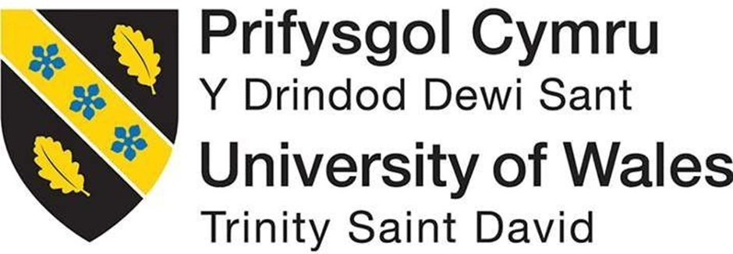

Organisation Management (ACMA4020)
‘How does your organisation manage organizational activities and performance’
Darrell Byrne
2420160
Degree Apprenticeship in Logistics and Supply Chain Management

Table of Contents
Introduction 3
Planning 4
Strategic objectives and plans of Tata Steel DUK&I 4
Operational plans to achieve strategic objectives 4
Planning approach 4
Corporate, competitive and functional strategies 5
Organising 6
Work Specialisation 6
Departmentalisation 6
Chain of command 6
Span of control and supervision 6
Degree of centralisation / decentralisation 7
Degree of formalisation 7
Leading 8
Leaderships styles at Tata Steel Distribution UK & Ireland 8
Controlling 9
Conclusion 10
References 11

Introduction
The effective management of organisational activities and performance is fundamental to achieving business success. Organisations must ensure that all internal processes, resources and people are aligned with strategic objectives to drive efficiency, productivity and innovation. According to Robbins and Coulter (2020). Management is defined as the process of coordinating work activities so that they are completed efficiently and effectively with and through other people. This is achieved through the application of four essential management functions: planning, organising, leading and controlling. These functions combined provide a structured framework for managing day-to-day operations as well as long-term goals.
In my organisation, this system is used to unite activities and monitor performance in all the departments. Strategic planning helps in establishing clear goal and setting priorities, whilst organising function helps in providing resources to the right areas and clearly defining jobs. Leadership plays a key role in motivating employees, encouraging team spirit and establishing a healthy organisational culture. Performance is monitored continuously through key performance indicators (KPI’s) frequent review meetings and feedback systems which enable prompt decision making and influences improvement.
Robbins and Coulter (2020) emphasise that effective performance management involves not only measuring outcomes but also enhancing the process and behaviours that lead to success. This essay will explore how these principles are applied within Tata Steel to manage activities and performance, supported by practical examples that reflect the integration of theory and practice in modern management.

Planning

Strategic objectives and plans of Tata Steel DUK&I
TSDUK&I aims to maintain leadership in the steel distribution market while enhancing sustainability and operational efficiency. One of the primary strategic objectives is to lead in providing sustainable steel solutions by reducing the environmental impact of its products and operations. The company also strives to offer superior customer service and high quality steel products tailored to various industries ranging from construction, automotive and manufacturing. To achieve these goals, Tata steel is investing in digital technologies such as SAP4Hanna, streamlining operations by consolidating assets and focussing on reducing carbon emissions by investing in low carbon steel production via an electric arc furnace instead of the current blast furnace configuration.

Operational plans to achieve strategic objectives
To achieve its strategic objectives TSDUK&I operational plans include improving its supply chain efficiency and leveraging advanced technologies to optimise inventory management and order fulfilment for instance, the company has implemented smart warehouse management systems such as SAP and just in time inventory techniques. The company also focuses on expanding its range of value-added services such as steel processing and technical support to further enhance customer satisfaction.

Planning approach
Tata Steel employs a combination of traditional objective setting and management by objectives. High-level strategic goals such as sustainability and market growth are broken down into specific departmental and individual targets. For example, sales teams are assigned specific revenue targets, while operational teams focus on improving production and delivery efficiency. Regular reviews and feedback ensure alignment with overall corporate objectives.

Corporate, competitive and functional strategies
Tata Steel’s corporate strategy focusses on sustainability and expanding its market footprint. Its competitive strategy is based on differentiation, offering services like custom steel processing and technical advice. The functional strategy includes enhancing digital capabilities, improving supply chain efficiency and upskilling employees to ensure operational excellence.

Organising

Work Specialisation
At TSDUK&I work specialisation is prominent across various departments to enhance efficiency and expertise. Employees are assigned specific tasks according to their skills and job roles. For example, the logistics team focusses on supply chain management, while the sales team handles customer relationships and marketing. This specialisation ensures that each employee can focus on core tasks thus improving productivity and quality.

Departmentalisation
TSDUK&I utilises functional departmentalisation to streamline its operations. Key departments include sales and marketing, operations, logistics, customer services and technical support. Each department focuses specific functions: the sales department manages customer interactions and sales targets, while the operations department oversees processing, the logistics department manages the inventory and distribution and the technical department focusses on technical and quality issues. This clear functional separation helps to improve efficiency within each area.

Chain of command
The chain of command within TSDUK&I follows a hierarchical structure. Senior management oversees the overall direction of the company, while middle managers and team leaders supervise individual functions. For instance, the Logistics manager reports to the Order Fulfilment Manager, ensuring clear lines of authority and accountability for decision making and operational execution.

Span of control and supervision
The company maintains a moderate span of control. Managers typically supervise 10-15 employees allowing for effective supervision and interaction. For example the logistics manager oversees the inventory and transport planning team, whilst the operational department manage the warehouse loaders. This structure provides adequate supervision while allowing managers to remain accessible to their teams.

Degree of centralisation / decentralisation
TSDUK&I practices a decentralised approach in decision making, particularly at a sales level, for example, sales managers have autonomy over sales strategies and customer interactions. However, centralised decisions are made at senior level, particularly for corporate strategies, investments and overall business decisions.

Degree of formalisation
The organisation follows a high degree of formalisation, with clearly defined policies, procedures and performance expectations. There are standardised processes for operations, inventory management and safety compliance. Employees undergo regular training to ensure adherence to these formalised practices, ensuring consistency and reducing operational risks.

Leading

Leaderships styles at TSDUK&I
At TSDUK&I the leaderships styles prevalent across various levels of management can be broadly categorised into transformational, transactional and democratic styles.
My line manager typically exhibits a democratic leadership style. This involves encouraging employee participation in decision making fostering a sense of inclusion and collaboration. For instance, in team meetings he often seeks input from team members on operational improvements and strategies. This participative approach helps in developing a sense of ownership and boosts team morale. Additionally, he often provides constructive feedback and offers opportunities for professional growth, which aligns with a transformational leadership style.
At the top management level, the company demonstrates a blend of transformational and transactional leadership styles. The leadership at this level tends to focus on long term vision, sustainability goals and innovation, with an emphasis on motivating employees through shared goals and values. For example, initiatives in green technologies reflect transformational leadership. On the other hand, top management also ensures the operational performance standards are met, which reflects transactional leadership by setting clear targets and using performance based rewards.
Both leaderships styles are generally effective. The democratic and transformational leaderships styles at the line management level contribute to a motivated and engaged workforce. However, top managements transactional approach could sometimes lead to an overemphasis on performance metrics rather than focussing on fostering a more adaptive and innovative culture.
To enhance effectiveness, both line managers and top management could incorporate more coaching and mentoring approaches to further support employee development and top management could integrate more open communication channels to ensure alignment with lower level teams.

Controlling
Corporate governance and compliance are essential for ensuring ethical conduct, accountability and long term sustainability in large organisations. Tata Steel UK which is a subsidiary of the Tata Group, operates under a well-defined governance framework aligned with the UK corporate governance code. The company is overseen by a board of directors and dedicated committees responsible for audit, safety and sustainability. These structures ensure transparency, regulatory compliance and strategic oversight. The organisation adheres to numerous legal and regulatory standards, including the UK companies act, GDPR and health and safety legislation enforced by the HSE. Regular training and internal audits help reinforce a strong compliance culture.
Tata Steel UK also demonstrates effective control across several operational domains. In terms of quality control the company follows ISO9001 standards and implements Total Quality Management (TQM) to ensure consistent product quality. Process improvements are driven by continuous feedback and performance monitoring. For information control the company uses secure digital systems and role based access, aligning with GDPR to protect sensitive personal and operational data.
Financial control is maintained through ERP systems such as SAP, routine audits and detailed budget reviews allowing for efficient resource management and risk mitigation. Workplace privacy is respected through clear policies on data monitoring and employee rights, ensuring compliance with the UK Data Protection Act.
Employee theft is addressed through strict access controls, inventory management, surveillance systems and an anonymous whistleblowing platform fostering a culture of accountability.
Through these practices Tata Steel UK upholds strong corporate governance and operational integrity.

Conclusion
The management of organisational activities and performance at TSDUK&I is guided by a structured framework that integrates strategic planning, effective organisation, leaderships and control mechanisms. Through a combination of strategic objectives, operational plans and leadership styles the company fosters a culture of collaboration and continuous improvement. The emphasis on work specialisation and departmentalisation allows for efficient management of resources, while decentralised decision making empowers managers to address local needs effectively. Additionally, the leadership approach of democratic and transformational styles at line management level supports employee motivation and engagement. However, there is room for further enhancement in fostering innovation and communication at the top management level.
By maintaining robust governance practices, such as quality control, financial oversight and workplace privacy, TSDUK&I ensures accountability and compliance, strengthening its overall operational integrity and long term sustainability, these practices are integral in driving the company’s competitive advantage and achieving its strategic goals.

References
Robbins, S.P. and Coulter, M., 2020. Management. 15th ed. Global Edition. Harlow: Pearson Education Limited

