REFERENCE SHEET FOR ACDA4011 CHEMISTRY OME
FINAL EXAM

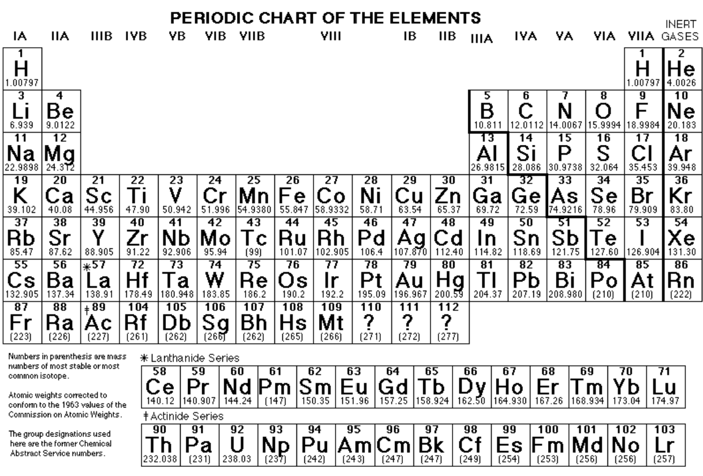

PHYSICAL CONSTANTS:
C = 3.0 x 10⁸ m/s (speed of light)
R_{H} = 3.29 x 10¹⁵ s⁻¹ (Rydberg constant)
h = 6.6 x 10⁻³⁴ Js (Plank’s constant)
e = 1.602 x 10⁻¹⁹ C (charge of electron)
1 amu = 1.66 x 10⁻²⁴ kg (atomic mass unit)
N_{A} = 6.02 x 10²³ Avogadro’s number
R = 0.0821 L-atm/mol-K gas constant
0 degC = 273 K
1 atm = 101.3 kPa = 101,325 Pa = 760 mm Hg = 760 torr = 14.7 lb/in2 (psi)

CDA4011 CHEMISTRY OME FINAL EXAM

NAME_____________________________________ DATE: May 12, 2022

SHOW ALL WORK. USE CORRECT UNITS AND SIGNIFICANT DIGITS. YOU MAY SHOW YOUR WORK ON THE BACK OF THE SHEET, BUT INDICATE YOUR ANSWER ON THE FRONT.
PERIODIC TABLE AND REFERENCE DATA CAN BE TORN OFF OF THE EXAM
THERE ARE 37 QUESTIONS, 100 POINTS TOTAL.

- (1p) An element with the valence electron configuration 3s²3p⁴ would most rapidly form an ion with what charge?
………………………………………………………………………………………………………………………………
- (2p) Draw two products of nitration of toluene.

- (3p) a) Give the total number of electrons in one NH₄⁺ ion. (Count ALL the electrons, not just the valence electrons) …………………..… …………………………………………………………………………..
b) Give the number of protons in one NH₄⁺ ion……………………………………………………………..
c) Give the number of nuclei in one NH₄⁺ ion……………….. ……………………………………………….
- (3p) The valence electron configuration of Fe³⁺ ion is:
- 3d⁶4s² b) 3d³4s²
- 3d⁶ d) 3d⁵
- 3d⁹4s²
- (2p) State whether each of the following molecules has a dipole moment. (Four answers are required)
- H₂S Yes / No
- CO₂ Yes / No
- O=C=S Yes / No
- F₂ Yes / No
- (1p) Which one of these orbitals does not exist:
- 4p b) 6s
c) 3f d) 5d e) 2p
- (3p) Classify the bonding in each of the following molecules as ionic, polar covalent, or non-polar covalent (no credit for the answer ‘covalent’).
- H₂O …………………………. ……………………………………………………………………………………………….
- N₂ ……………………………………. ……………………………………………………………………………………….
- CaO ……………….…………………………………………………………………………………………………………..
- (2p) In the molecule shown below, what is the value of the bond angle labelled A? What is the value of the bond angle labelled B?
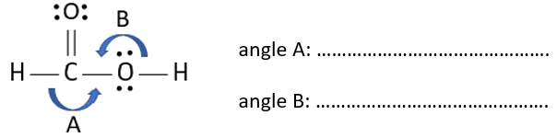

- (2p) Consider only the three elements: S, Se, Cl.
- Which one is most metallic? ……………….………………………………………………………………………
- Which one has the greatest electronegativity? ……………….………………………………………
- Which one has the highest ionisation energy? ……………….………………………………………
- Which one has the smallest atomic radius? ……………….……………………………………………………
- (4p) For each of the following molecules use words to describe its molecular shape (molecular geometry). Do not describe the electron pair geometry. Choose your answer from the following: linear, bent, square planar, trigonal planar, octahedral, trigonal pyramidal, square pyramidal, trigonal bipyramidal, T-shape, see-saw, tetrahedral, shapeless.
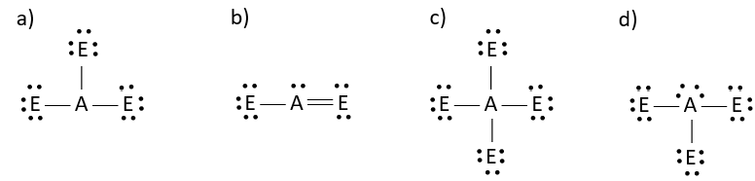
………………………. …. …………….…………… …………………..………. ………………………….
……………………………. …………………………… ……………………………. …………………………..
- (4p) For each of the molecules in question 10 give the bond angle or angles. If the angle is a bit less than a certain value, you must state it.
- molecule a ……………………………………………………………………………………………………………
- molecule b ………………… ………………………………………………………………………………………
- molecule c ……………….……………………………………………………………………………………………
- molecule d …….……………………………………………………………………………………………………
- (2p) a) Circle the compound that has a higher boiling point, H₂O or H₂S.
b) Which kind of intermolecular force is responsible for the higher boiling point you picked in part (a)? …………………………… ……………………………………………………………………………………….
- (4p) Complete and balance these reactions:
- …….V₂O₅ + …….H₂ …….V₂O₃ + …….H₂O (redox!)

- …….C₆H₁₂O₆ + …….O₂ …….CO₂ + …….H₂O

- (1p) Find the net ionic reaction for the following process:
2 CuSO₄ (aq) + Mg (s) +H₂O (l) 2 MgSO₄ (aq) + Cu₂O (s) + H₂ (g)
……………………………………………………………………………………………………..………………………………
………………………………………………………………………………………………………………………………………
………………………………………………………………………………………………………………………………………
- (2p) Consider only the following: 1) London dispersion attractions between two small molecules, 2) the O-H bond in a water molecule, 3) hydrogen bonding between two water molecules.
- Which one of the three is the strongest interaction? ……………………………. ……………..
- Which one of the three is the weakest interaction? …………………. …………………………..
- (1p) For which two gases are the rates of effusion 2:1 ?
- He and O₂ b) Ne and Kr
c) N₂ and Ar d) H2 and He
e ) O₂ and CH₄
- (1p) Which process is endothermic:
- vaporisation b) solidification
c ) condensation d) freezing
- all are exothermic
- (6p) Draw the Lewis electron dot structure for each of the following:
- SF₄ b) CO₃²⁻

c ) C₂H₂ d) H₃O⁺

- (1p) What is the oxidation number of Mn in KMnO₄?
…………………………………………………………………………………………………………………………………….
- (4p) Give the formula of each of these:
- Magnesium bicarbonate………………………………………………………………………………………
- Ammonium nitrate …………………………..……………………………………………………………………
- Silicone tetrabromide …………………………………………………………………………………………...
- Copper (II) phosphate ………………………….………………………………………………………………..
- (2p) Name these:
- C₃O₂ …………………………………..……………………………………………………………………………………….
- Ag₃N ………………………..………………………………………………………………………………………………….
- (4p) Consider the phase diagram for substance R:
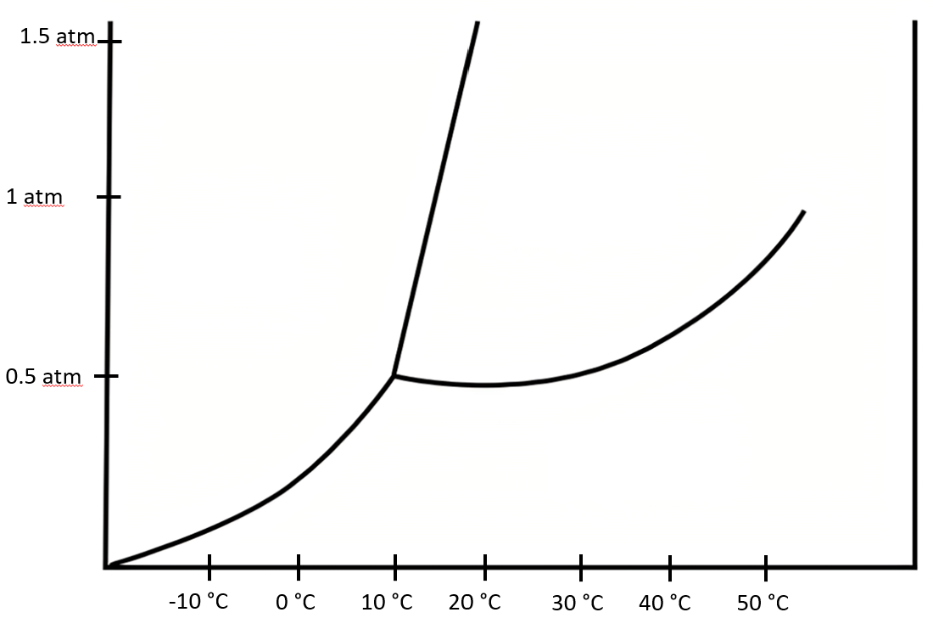
- At 10 degC and 0.1 atm, is R a solid, a liquid or a gas? ……………………………………………..
- Does the melting point of R increase, decrease or stay the same as the pressure is increased? …………………..……………………………………………………………………….……………..…..
- What is the vapour pressure of liquid R at 30 degC? …… ……………………………………………..
- What is the temperature of the normal boiling point of R?........ …………………………………

- (3p) A student adds 20.0 mL of water to an empty graduated cylinder. Then she drops 65.0 g of a solid piece of metal into the water, and the level of the top of the water rises to 35.0 mL. Find the density of the metal.
- 4.33 g/cm³
- 1.86 g/cm³
- 3.25 g/cm³
- 1.18 g/cm³
- 0.231 g/cm³

- (3p) An electron in a certain molecule has an energy of 2.0 x 10⁻¹⁸ J. If this electron emits a photon of frequency 8.0 x 10¹⁴ s-1, find the new energy of the electron.
- 5.3 x 10⁻¹⁹ J
- 2.5 x 10⁻¹⁸ J
- 6.4 x 10⁻¹⁸ J
- 1.1 x 10⁻¹⁹ J
- 6.0 x 10⁻²³ J

- (3p) What mass of Zn (65.4 g/mol) will react with 280 mL of 3.00 M HCl (aq) according to the following equation: Zn (s) + 2 HCl (aq) Zn(Cl)₂ (aq) + H₂ (g).
- 86.2 g
- 54.9 g
- 40.1 g
- 27.5 g
- 13.7 g

- (3pt) An ideal gas at 300 K and 2.00 atm pressure in a 4000 cm³ container has its pressure increased to 5.00 atm and its volume increased to 6000 cm³. What is the final temperature?
- 80 K
- 1125 K
- 640 K
- 4500 K
- 820 K

- (3p) Balance the following equation in acidic solution using the lowest possible integers.
Cl₂ (aq) + H₂S (aq) S (s) + Cl⁻ (aq)

- (3p) Given these ΔHº values
2 H₂ (g) + O₂ (g) 2 H₂O (l) ΔHº = -576 kJ
C (s) + O₂ (g) CO₂ (g) ΔHº = -394 kJ
2 C₂H₂ (g) + 5O₂ (g) 4 CO₂ (g) + 2H2O (l) ΔHº = -2600 kJ
Find ΔHº for 2 C (s) + H₂ (g) C₂H₂ (g).
- -3570 kJ
- 812 kJ
- 224 kJ
- 1918 kJ
- 465 kJ

- (3p) Find the number of oxygen atoms in 25 g CO₂.
- 2
- B) 9.4 x 10⁻²⁵
- 6.8 x 10²³
- 5.3 x 10²⁴
- 1.2 x 10²³

- (3p) Determine the Celsius temperature of 2.49 moles of gas contained in a 1.0 L vessel at a pressure of 143 kPa.
- - 266 degC
- – 622 degC
- 622 degC
- 266 degC
- 133 degC

- (3p) Find the mass of O₂ that will react with 22 g of C₃H₈ to form CO₂ and H₂O.
- 20 g
- 40 g
- 80 g
- 120 g
- 160 g

- (3 p) Given these bond energies in kJ/mol: (C – C) = 348, (C = C) = 614, (H – C) = 413, (H – H) = 436, (O = O) = 495, (C – O) = 396, (C = O) = 799, (O – H) = 463, estimate ΔHº for the following reaction: 2 C₂H₆ (g) + 7 O₂ (g) 4 CO₂ (g) + 6 H₂O (g).
- -2831 kJ
- 2831 kJ
- -2364 kJ
- 2364 kJ
- -2548 kJ
- 2548 kJ

- (3p) For the reaction N₂ + 3 H₂ 2 NH₃, suppose 14 g of N₂ and 8.0 g of H₂ are present at the start of the reaction. At the end of the reaction, which one of the following will remain unreacted.
- 3.0 g of H₂
- 1.0 g N₂
- 6.0 g H₂
- 4.0 g N₂
- 5.0 g H₂

- (3p) If a solution of sucrose, C₁₂H₂₂O_{11,} has a molarity of 0.245 M, how many millilitres of solution are needed to obtain 50.0 g of sucrose? (molar mass of sucrose is 342.3g/mol).
- 158 mL
- 456 mL
- 596 mL
- 784 mL
- 224 mL.

- (3p) What is the mole fraction of water in water-ethanol solution that is 54% water by mass (ethanol C₂H₅OH, molar mass 46.0 g/mol).
- 0.25
- 0.33
- 0.46
- 0.67
- 0.75

- (3p) A mixture containing 2.0 mol CH₄ (g), 4.5 mol of O₂ (g) and 3.5 mol of Ne (g) exerts a total pressure of 0.80 atm. What is the partial pressure of the CH₄ (g)?
- 0.16 atm
- 0.40 atm
- 0.64 atm
- 0.80 atm
- 0.32 atm

- (3p) The density of 1.95 M solution of KBr in water is 1.16 g/mL. Find the molality of this solution. The molar mass of KBr is 119.0 g/mol. (Hint: take a convenient amount of solution such as one litre or 1 kg or one handful).
- 1.44 mol/kg
- 1.86 mol/kg
- 1.95 mol/kg
- 2.10 mol/kg
- 2.31 mol/kg

