For completion by the student:
Student Name: Alberto Alessandro Berio

Student University Email: 1907991@students.utwsd.ac.uk
Module code: HPCA7009  Module title: Skyscapes | Student ID number:  1907991 |  |  | Educational support needs:  Yes/No
Assignment title:

Assignment due date: August, 16th, 2020
This assignment is for the 1st 2nd 3rd 4th 5th 6th module of the degree
I confirm that this is my original work and that I have adhered to the University policy on plagiarism.
Signed ……………………………………………………………
Email submission:if you are submitting this form via email, please tick this box □
(as a substitute for your signature) to confirm that you agree to the above declaration.
Assignment Mark

1st Marker’s Provisional mark

2nd Marker’s/Moderator’s provisional mark

External Examiner’s mark (if relevant)

Final Mark

NB. All marks are provisional until confirmed by the Final Examination Board.

For completion by Marker 1 :
Comments:
Marker’s signature: |  |  | Date:
For completion by Marker 2/Moderator:

Comments:

Marker’s Signature: |  | Date:
External Examiner’s comments (if relevant)

External Examiner’s Signature: |  | Date:

The Sacred Cistern: Possible Astronomical Orientations At The Minoan Ruins of Chamaizi, Crete

Word Count: 3788

Introduction

This research project aims to study possible astronomical orientations at the Minoan ruins of Chamaizi, in the hinterlands of eastern Crete (35°10’3.67”N, 26° 1’6.75”E). Blomberg and Henriksson proposed two archaeoastronomical alignments at the site’s entranceways, who emphasized its uniqueness as the only location in their Minoan survey to harbor sunset alignments. The objective of this research is to analyze azimuthal orientations of the site’s inner walls and compare them with regional mythological, iconographic, and ethnohistoric evidence from the Minoan and the later Mycenaean and Greek cultures. While intentionality is difficult to determine, this paper presents new evidence that azimuthal bearings of some inner walls appear to have been oriented toward the declination of significant celestial events, stars, and possibly constellations, which were depicted in Minoan glyptic iconography (Appendix, Table 1). The significance of these orientations may have been preserved in ancient Greek myths, culture, and traditions.

Literature Review

Near the Bay of Sitia, Chamaizi crowns a flattened knoll as the imminent construction in the surrounding farmlands. Chamaizi has attracted attention as the only oval-shaped Minoan construction discovered so far. Davras observed that, ‘The oval form is not caused by the space available on the crown of the hill: there is enough solid bedrock, leaving a good margin before dropping downhill’. The presence of ‘pithos fragments, loomweights, whetsones, querns, and pestles’ suggest domestic activities associated with a house. Artifacts, such as the ‘Chamaizi pots’ indicate high ranking individuals inhabited the location, while their style suggests cultic ceremonies. According to Arthur Evans, the vases and other objects found there are characteristic of the MM I period (ca. 2000 bce). This implies that it was concurrent with the famed palace of Knossos. Chamaizi’s function is still debated by archaeologists, with some suggesting a fortress, while the presence of a few terra-cotta figurines, similar but fewer in number to those from peak sanctuaries, has suggested a domestic sanctuary or at least a domestic shrine. After extensive research, photographs of the votive figurines were not located by the author.

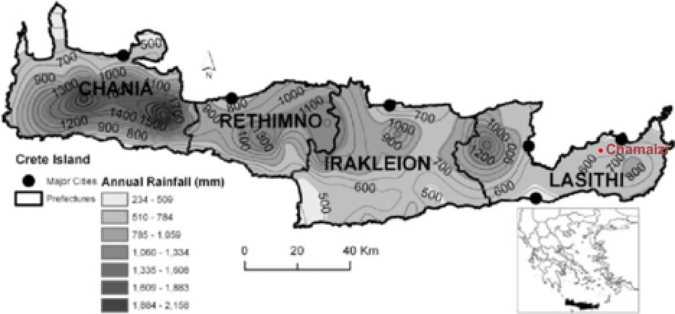
Figure 1. The island of Crete and mean annual precipitation.

Meteorological studies indicate that Sitia is located in one of the driest regions of Crete with a mean annual precipitation of around 600mm (fig. 1). The absence of a natural source of water, and the discovery of a drain which poured out overflows adjacent to the southern entrance, confirmed the identification of the cistern. As suggested by Marinatos, the centrality of the cistern, the ‘symbolic nucleus’ accessible from all rooms and entrances, emphasizes its importance to the dwellers. He further conjectured that Chamaizi was linked to a high-ranking individual whose function was connected to the water cistern and who organized feasting and ritual activities.
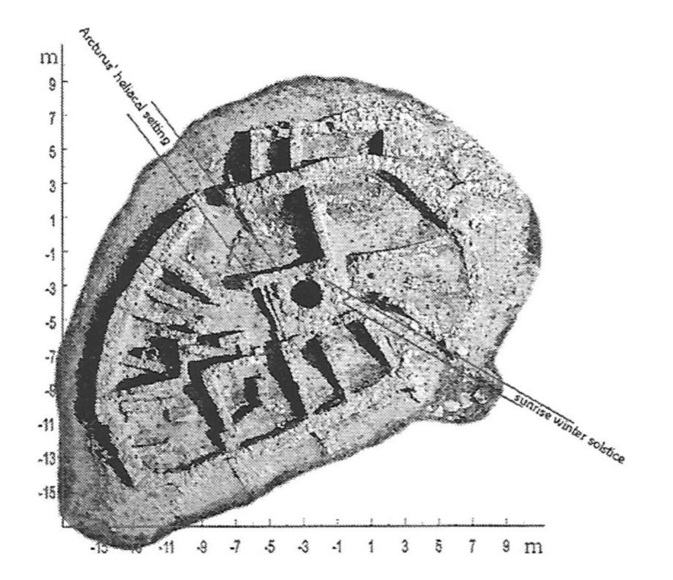
Figure 2. The orientations according to Bloomberg of Chamaizi to sunrise at winter solstice and the heliacal setting of Arcturus at the beginning of the Middle Bronze Age.

Blomberg and Henriksson have suggested that the ruins of Chamaizi contain astronomical alignments (fig. 2): ‘The main entrance was orientated to sunrise on the morning of the winter solstice in the early Middle Minoan period (ca. 2000 bce) and the door on the northern side framed the heliacal setting of Arcturus in the same period.’ To locate Chamaizi within the Minoan skyscape, the question of the origins of the Greek celestial map and its possible inheritance from an archaic past must be considered. Schaefer argued that, ‘no evidence for the old Greek constellations has been found in Minoan Crete or elsewhere before the first millennium b.c.’ and that ‘the lack of all constellations other than the obvious Orion and Big Bear from Hesiod and Homer argues that these were unknown to the early Greeks and Myceneans.’ Although Minoan hieroglyphic and Linear A writing systems remain undeciphered, their religion and culture are traceable through the later Mycenaean and Greek civilizations. As Nilsson writes, ‘It would be an impossible standpoint to deny any connexion between the religion of the pre-Greek inhabitants of Greece and Greek religion.’ It has even been proposed that the Greek constellations described by Eudoxus and by Aratus may have been created around 2800 bce by a sailing culture around the latitude of 36°, near that of Syria or Crete. Although, Schaefer disagrees with these dates and latitudes.
According to Blomberg and Henriksson, an earlier entrance on the northwestern side, later closed, was oriented to the heliacal setting of Arcturus. They believe it was a significant star in Minoan calendrical astronomy, serving as a marker for the sailing season. Kyriakidis outlines the importance of the stars to ancient sailors:

‘But did the Minoans classify their stars into constellations? The evidence is very limited. We would rather formulate the question in a different way. Did the Minoans need to know the stars? The answer to that question is surely yes. Any seafaring and trading nation needs to be able to read the stars. Minoan Crete, one of the main regional sea powers of its time, would have classified the stars into constellations to act as mnemonic devices.’

Setting aside the debate of when and where the Greek constellations originated, as Kyriakidis suggests, the Minoan ‘thalassocracy’, dependent on stellar navigation, would have by necessity employed constellations.
Kyriakidis then discusses how the Minoan lapidary tradition where ‘people appear to be floating and not standing on the ground has caught the imagination of some Minoan scholars and has prompted much speculation on what they represent and what the implications are for Minoan religion.’ Marinatos and Nilsson held the view they represented generic ‘divine epiphanies from the sky’. In later Mycenaean rings, these ‘floating figures’ occupy the same upper registers as the sun, moon, and stars. Kyriakidis then proposes that the unidentified floating icons often depicted on Minoan seals, ‘may also represent other stellar bodies (i.e., constellations).’ For example, he interprets the hair of the floating person on Minoan seals as Corona Borealis. The constellation was known as the Northern Wreath to the ancient Greeks who identified it with the myth of the Minoan princess, Ariadne. This proposition links a Minoan glyptic symbol with a Greek constellation, whose myth was set in Bronze Age Crete.

Methodology

The virtual fieldwork undertaken involved measuring the azimuthal bearings of Chamaizi on Google satellite imagery which were then inputted into Stellarium software, set to 2000 bce at the site’s latitude and longitude (fig. 3). The location’s horizon landscape profile (generated via HeyWhatsThat.com) was also imported into Stellarium to determine the correct altitude of rising and setting celestial luminaries within the landscape. The architectural uniqueness of Chamaizi could be a limiting factor for this analysis, for as Ruggles writes, quoting Belmonte ‘[…]unique interpretations for undue types of monuments are scientifically untestable.’ Fortunately, though, comparable orientations have been documented by Blomberg and Henriksson’s extensive work at other Minoan sites. Also, while astronomically oriented inner walls without obvious sight-lines to the horizon might seem unusual, Blomberg and Henriksson have proposed a similar analysis at the Minoan site of Petsophas, where all of the original inner walls of the site were orientated to major celestial events, with emphasis on the helical rising and setting of Arcturus. Because of project scope, the orientations found for other inner walls will not be discussed in this paper. Also, due to the fact that HeyWhatsThat landscape profiles are prone to error, in situ fieldwork will be needed to validate these preliminary results.
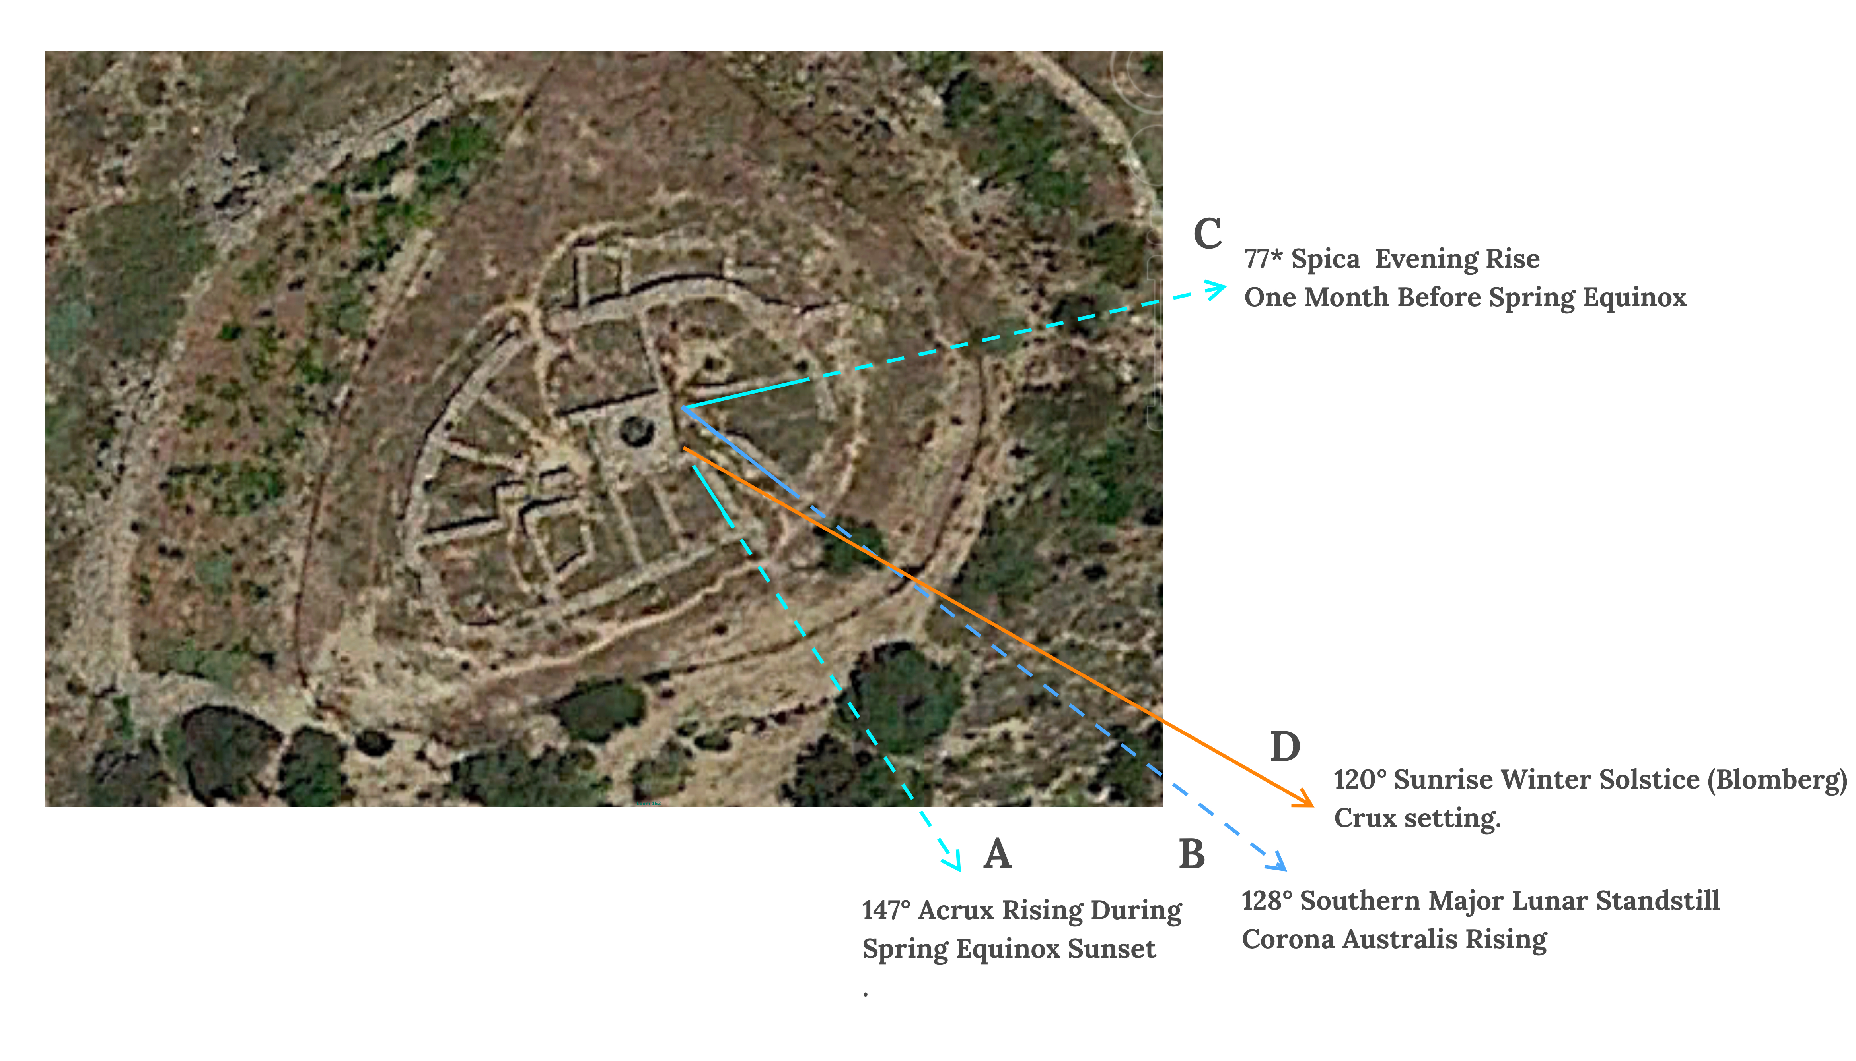
Figure 3. Orientations of Chamaizi’s inner walls.

The Spike of Wheat

The ancient Greeks employed the risings and settings of constellations as seasonal markers, as recorded by Hippocrates who marked various points of the year by the Pleiades and Arcturus. A similar tradition may have been observed at Chamaizi. The azimuth of wall (C) was oriented toward the theoretical declination for the evening rise of Spica, the brightest star in Virgo circa 2000 bce. Spica’s Latin name means ‘spike’ for the ear of wheat held by Virgo, as widely reproduced in Graeco-Roman zodiacal imagery. It can also be found in Mesopotamian traditions, as evidenced by the Mul.Apin star tables, which equate Virgo (The Furrow), with the goddess Šala and her ‘ear of grain’.
Spica’s evening rise occurred one month before the Spring Equinox. Blomberg and Henriksson have also documented sunrise alignments marking precisely one month before the equinoxes at Knossos, Juktas, Phaistos, Gournia, Malia, Valypethro, and Tylissos. A parallel can possibly be drawn with Haloa, the ancient Greek festival of Demeter in mid-winter. Håland explained the significance of this time of year to Greek farmers: ‘If only a small percentage of the seeds have sprouted by January, it is unlikely that the crop will be a good one.’ Therefore, Spica’s evening rise was well situated to have functioned as an agricultural marker for the Minoans, forecasting the season’s harvest. In addition, the fact that wall (C) adjoined the storage room, where harvest grains were kept, it can be conjectured that the alignment’s harvest symbology could have been transferred to the house’s space syntax.

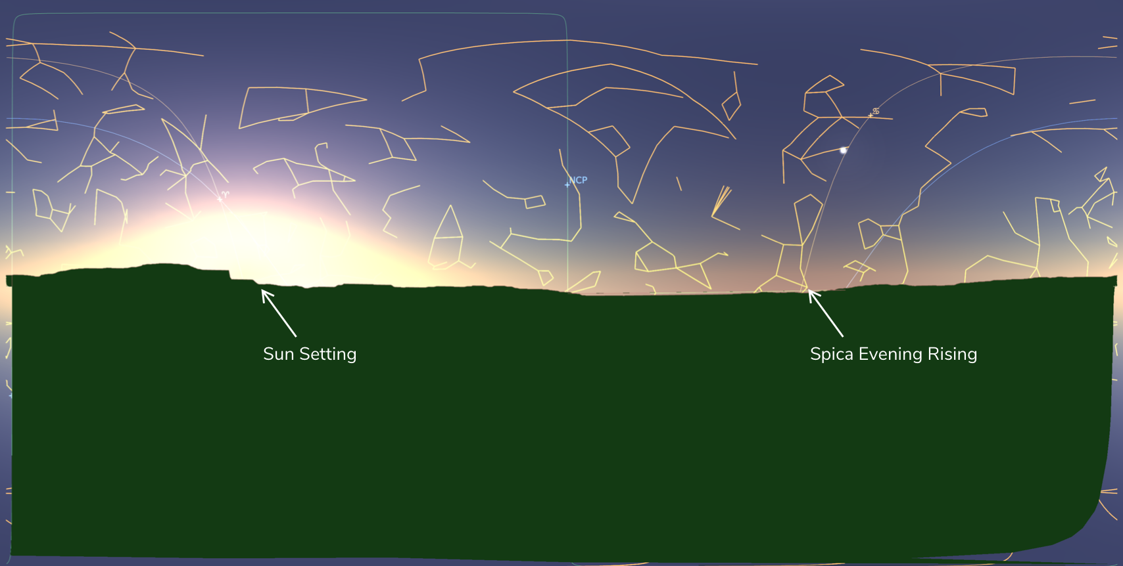
Chart 1. Spica’s evening rising at Chamaizi ca. 2000 bce, one month before Spring Equinox.

While Virgo is unconfirmed as a Minoan constellation, it can be observed that the evening rise of Spica happened as half of Virgo’s ‘body’ was below the horizon (chart 1, above). A Minoan seal depicts a goddess emerging from the earth, while a suppliant, holding her by the arm, appears to be inspecting the young crops beneath his feet as might have been done mid-Winter (fig. 4). Evans suggests: ‘It is the Spring Goddess arising out of the earth, and the poppy-heads she holds in her hand, besides being emblems of fertility, may also in their soporific quality bear a certain allusion to her winter sleep.’ He equated this goddess with the Greek Persephone, who rose from the underworld bearing poppies, drawing a parallel to a terra-cotta relief from Magna Graecia that depicts a chthonic Persephone holding both poppies, lilies, and ears of barley (fig. 5).

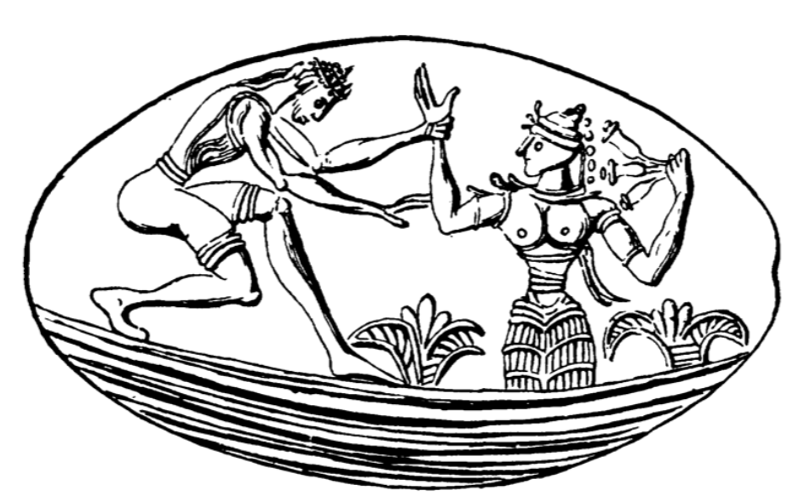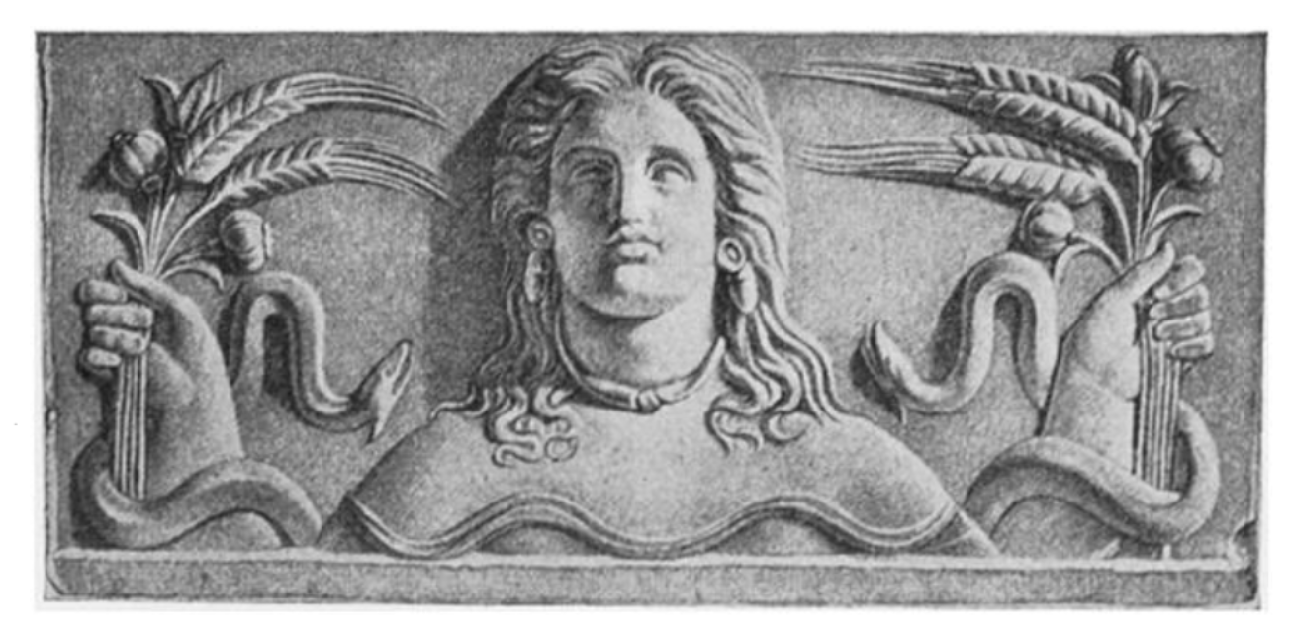
Figure 4. Spring Goddess rising from ground. Figure 5. Persephone rising from ground, holding poppy-capsules, lilies, ears of barley, with snakes on either side. Terracota relief, Magna Graecia.

In the Eleusinian mysteries, associated with the cults of Demeter and Persephone, sheaves of wheat were conferred upon initiates, confirming the object’s sacrosanct status in Hellenic times. Kyriakidis highlights that one of the most common ‘floating items’ on Minoan gems is indeed the spike of wheat, which ‘despite its abstract character and varied position has a stable basic form and texture, always at the upper center of the entire depiction’, perhaps indicative of a celestial identity (fig. 6). Therefore, Chamaizi’s orientation to the evening rise of Spica lends weight to Kyriakidis’ notion that the glyptic ‘floating objects’ represented stars, since as the evidence suggests, the celestial ‘floating wheat’ iconography could be related to Spica, the ‘ear of grain’.
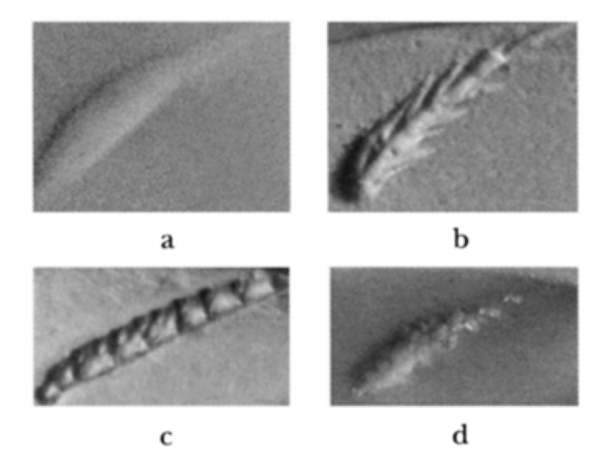
Figure 6. Examples of floating ‘spikes’ (detail): a, plain (second Kalvyia ring); b, wheat-like (Vapheio ring); c, beanpod-like (Isotapa ring); d, cloud-like (Sellopoulo ring)

Topocosm of The Minoan Skyscape

A diagrammatic analysis of a class of 8 oval Minoan seals indicates possible mimicry of the original elliptical circumference of Chamaizi’s outer wall (fig.’s 6, 7). The sanctity of this shape may be attested in Minoan seals that depict a sacred oval stone, the baetyl with the ‘floating’ wheat above (fig. 8). The Minoan baetyl finds a parallel in the Greek tradition of the omphalos stone, meaning ‘navel’, placed in temples throughout Greece. Despite being a sui generis example of this type of Minoan construction, this analysis suggests that the site’s architecture contains archetypal geometry of special significance to the Minoans.

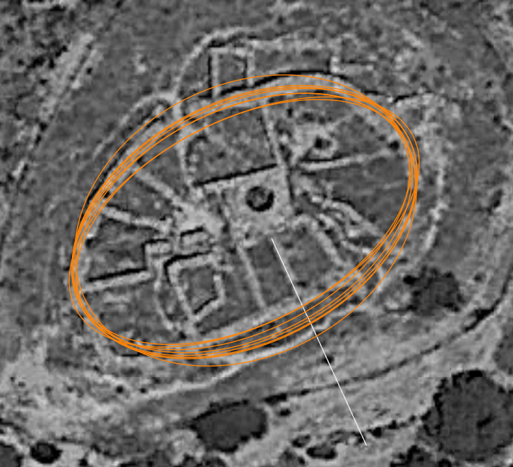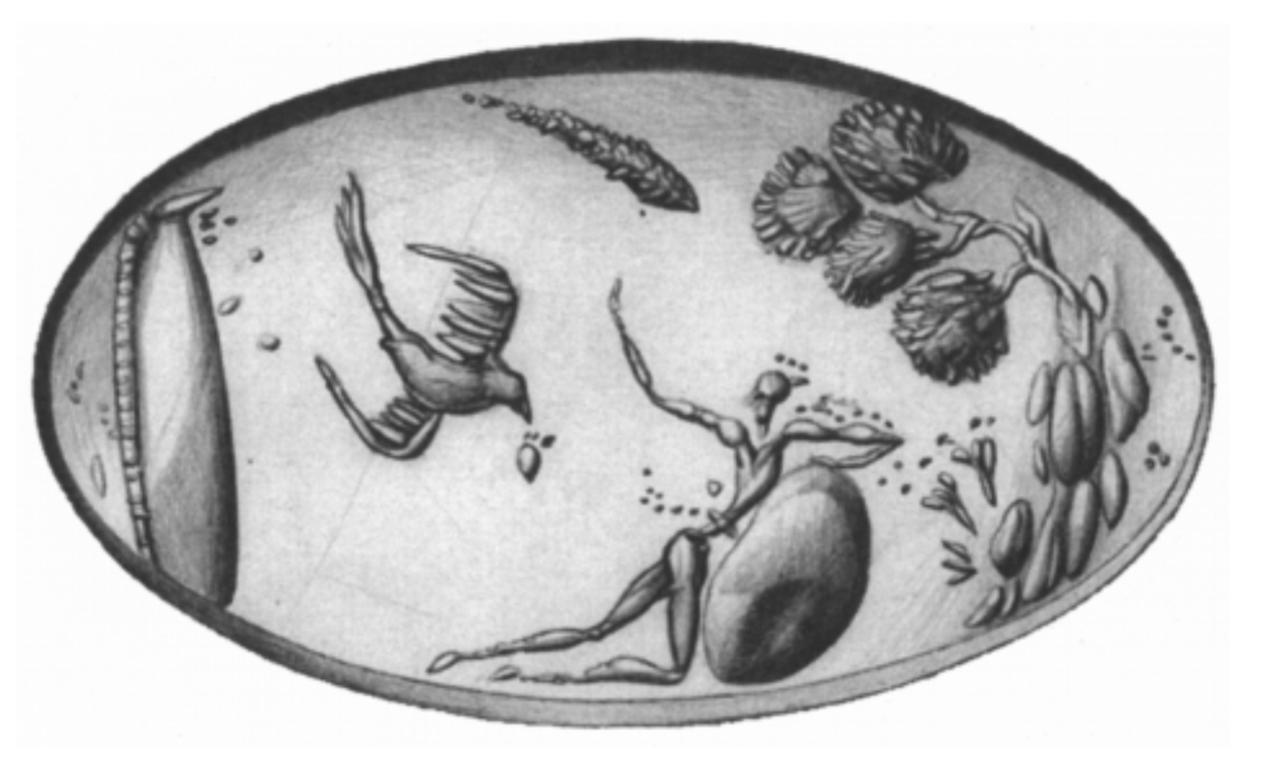

Figure 6. Superimposed outlines of 8 oval Minoan seals. Figure 7. Outlines overlaid on Chamaizi’s elliptical outer walls. Figure 8. Ring. Selopoulo. CMS Archives IIS - 1034.

The astronomical measurements indicate that wall (B) was aimed at the southern major lunar standstill at the time of Chamaizi’s construction. Henriksson and Blomberg also found alignments to the southern major lunar standstill in the Minoan palace of Zakros. Coincidentally, wall (B)’s azimuth also pointed at the declination of Corona Australis, the Greek southern laurel wreath constellation. Although it is difficult to prove intentionality, the elliptical shape of Chamaizi’s northern outer walls coincides with the ovoid contours of the Corona Australis constellation (fig. 9). This starry wreath, στεφανώ, was often associated with Apollo, however, Artemis also had the epithet, Daphnaia, meaning ‘of the laurels’.

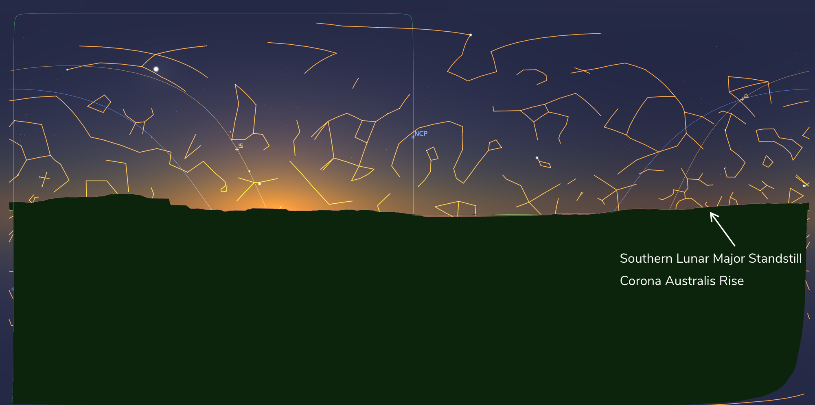
Chart 2. Corona Australis rising at the declination of the southern major lunar standstill as seen from Chamaizi, ca. 2000 bce.

The virgin huntress and lunar goddess, Artemis, was worshiped in the region of Chamaizi, as the local Britomartis. Flinterman cites Sporn, who identifies Dictynna, syncretized with Britomartis, as wearing wreaths made of Dittany, an herb used to ease childbirth. Hesichus and Diodorus both mention Britomartis, whose name, according to Nilsson, is possibly a ‘scanty remain of the Minoan language’ and who was worshipped in eastern Crete (where Chamaizi and Zakros are located). Solinus' folk etymology cites Britomartis’ name as meaning virgo dulcis, or ‘sweet virgin’. Eventually, the deity was demoted to nymph status, although she was said to be ‘the most loved’ of Artemis. Britomartis, like Artemis, was identified with the moon, as evidenced by her link with the lunar Aeginetan Aphaea, and also by some coins of the Roman empire depicting Dictynna, with the crescent. As such, the hypothesis that Chamaizi was purposefully orientated to and mirrored Corona Australis, marking the southern major lunar standstill, is reinforced by the shape’s replication in Minoan art. It is also historically evidenced by local cults to a Cretan Artemis, a lunar goddess, associated with wells and purification, and who was later depicted wearing wreaths.

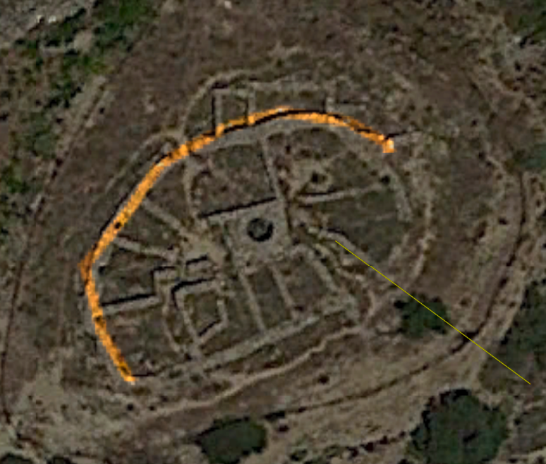
Figure 9. Corona Australis constellation outline overlaid on Chamaizi’s outer wall.

The Minoan Mother Goddess

According to Marinatos, ‘that a powerful goddess of nature was the chief deity of the Minoans[…] has never been seriously questioned,’ and whose character revolves around ‘fertility and motherhood’. Flinterman suggests Dictynna may have in fact assisted in childbirth, further attested by her aforementioned wreath. Furthermore, the Amnissos cave, near Knossos, has been historically identified with the cave of Eileithyia, the Greek goddess of birth. Sherds were found there from the ‘oldest times to the Roman days’, and was mentioned by Homer as being sacred to the goddess. Nilsson, however, discounts this identification of the cave with the goddess. He does however propose that the philological evidence points to a pre-Greek origin to Eileithyia. He elucidates the syncretization of Artemis and Eileithyia, who also protected sacred wells:

‘In her function of Λοχια she is parallel to Eileithyia and is often surnamed thus, Artemis Eileithyia, especially in Boeotia. Eileithyia appears, however, also as a goddess in her own right, and so far as her cults and her functions are known, she is always the goddess of childbirth, except at Paros where she was a healing goddess and had a sacred well.’

Despite being the virgin huntress of classical mythology, Artemis, was also a nature goddess and ‘mistress of the animals’ justifying her function as goddess of childbirth.
The ancient Greeks identified the central hearth of their homes with the virginal goddess Hestia, where newborn babies were often carried around, as a homecoming ritual. A similar notion of a house embedded with sacred feminine architecture may have been present in Chamaizi. It can be proposed that Chamaizi’s oval floor plan and its centralized cistern are visually evocative of a bare breast or the Omphallic ‘navel’ stone, which may have symbolized the Minoan mother goddess, whose purification rites were associated with marriage and childbirth. The Omphalos stone, and perhaps by extension the Minoan baetyl, was mythopoetically linked to fertility when Rhea tricked Cronus into believing a stone swaddled in clothes was his son Zeus, which he promptly swallowed.
Chamaizi is located in Sitia, where according to the oft-quoted legend, Dictaean Zeus was born in a cave on the unidentified mountain of Dikte, hidden away from Cronus. There, the infant god, ‘was fed with the milk of the goat Amalthea[…] more often said to be a nymph who nursed Zeus’. The role of Dictynna/Britomartis as kourotrophos of Zeus is attested from regional coins dating from Hadrian’s reign, which depict the goddess holding an infant. The Greek mytheme of the Cretan divine suckling is further evoked by a myriad of bare-breasted Minoan goddesses depicted on figurines and frescoes. The famous faience deity, though heavily reconstructed, is a well-suited example, whose most striking feature, according to Marinatos, ‘is the deep décolletage which leaves the breasts exposed’ (fig. 10).

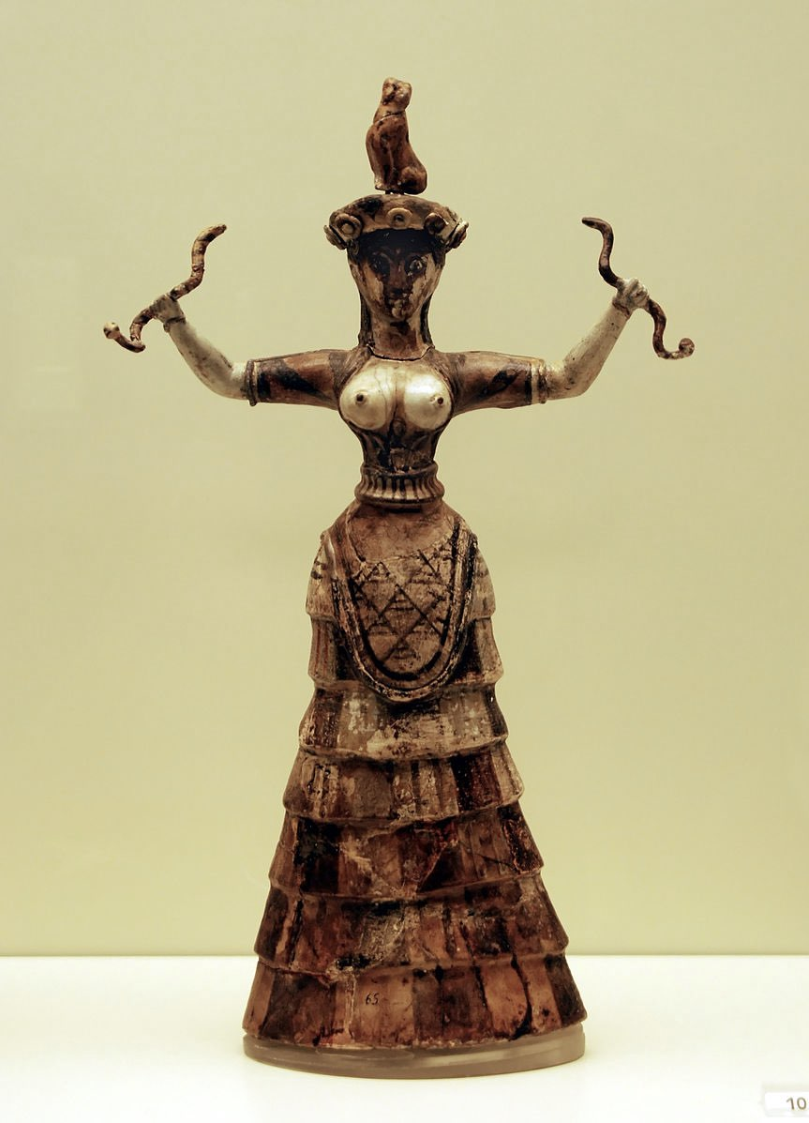
Figure 10. Faience figurines of the Snake Goddess. Heraklion Archaeological Museum. Photograph by AlMare 2008.

Traditionally, the location of this primeval Cretan myth was associated with the cave of Psychro, which according to Nilsson, ‘was frequented down to the geometric age, and the memory of its fame still lingers on in the verses of Hesiod.’ However, Nilsson suggests that ‘Psychro is not the Dictaean cave; the latter must be sought for in the district of Sitia’. Therefore, the region of Chamaizi contained one of the fundamental myths of ancient Greece, the pilgrimage-worthy site of where Zeus Kretagenes was nurtured. The site’s morphology, combined with astronomical alignments, and regional myths of divine nursing lend credibility to the speculation that it was a cistern sacred to the Minoan birthing goddess that metonymically collected and distributed water, her life-giving nourishment for the arid farmlands.

The Hieros Gamos

Given the dry climate of Sitia and the presence of votive figurines, it can be postulated that Chamaizi could have been the locus of rainmaking and fertility rituals revolving around its cistern. Marinatos’ ‘high-ranking individual’ may have been a priestess performing purification ceremonies associated with marriage and birth. This interpretation is bolstered by the fact that water sources such as spring were sacred to nymphs and the cult of Artemis, and were used for the pre-nuptial baths that purified maidens. Flinterman cites Sporn who posited that Dictynna was patroness not just of hunters and fishermen, but also of marriageable girls. Modern Greece still maintains the tradition of sprinkling newly-wed girls with water, to induce fertility in them.
The Greek myth of Danaë may offer insights into Chamaizi’s conceivable identification with Minoan marriage rituals. After hearing a prophecy from the Oracle of Delphi that his daughter, Danaë, would one day kill him, King Acrisius imprisoned her in a windowless tower with only a skylight reminiscent of Chamaizi itself. However, raging with lust, Zeus visited her in the form of golden rain, which streamed in through the skylight and into her womb, apparently through her ‘navel’ as depicted in a bell-krater (fig. 11). Thus, the celebrated Greek hero, Perseus, was conceived. Håland explains, ‘The idea that the Sky God impregnates the Earth Goddess through rain is expressed in several sources (cf. Aesch. Fr. 25 [44]) and in the ceremonial formula, “rain, conceive”.’ This mystical incantation was chanted during the rites of Eleusis to the Corn Mother, Demeter, in a hieros gamos, or sacred marriage, between heaven and earth, after which water was poured out ritualistically. This archaic belief system can perhaps be encapsulated by the ancient Egyptian word mw 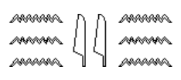, which meant ‘water, rain and semen’.

Figure 11. Ancient Boeotian bell-krater showing Zeus impregnating Danaë in the form of a shower of gold, circa 450-425 BC, Louvre Museum. Photograph by Marie-Lan Nguyen (2011).

It can be surmised that this nuptial symbology may have been embedded into the orientations of Chamaizi’s main entrance walls. The azimuthal direction of wall (A) pointed toward the evening rise of Acrux, in the Southern Cross constellation (Chart 3). The rising of Crux coincided with the Spring Equinox sunset when the path of the sun and moon themselves ‘crossed’. Blomberg and Henriksson’s measurements throughout Crete also confirm that the Minoans observed the equinoxes. Furthermore, during the Winter Solstice sunrise as seen from the main entrance, Crux would set in the opposite horizon (Chart 4). Therefore, the constellation of Crux, if recognized by the Minoans, was well situated to have been a liminal marker announcing both the Spring Equinox and the Winter Solstice in Bronze Age Crete.

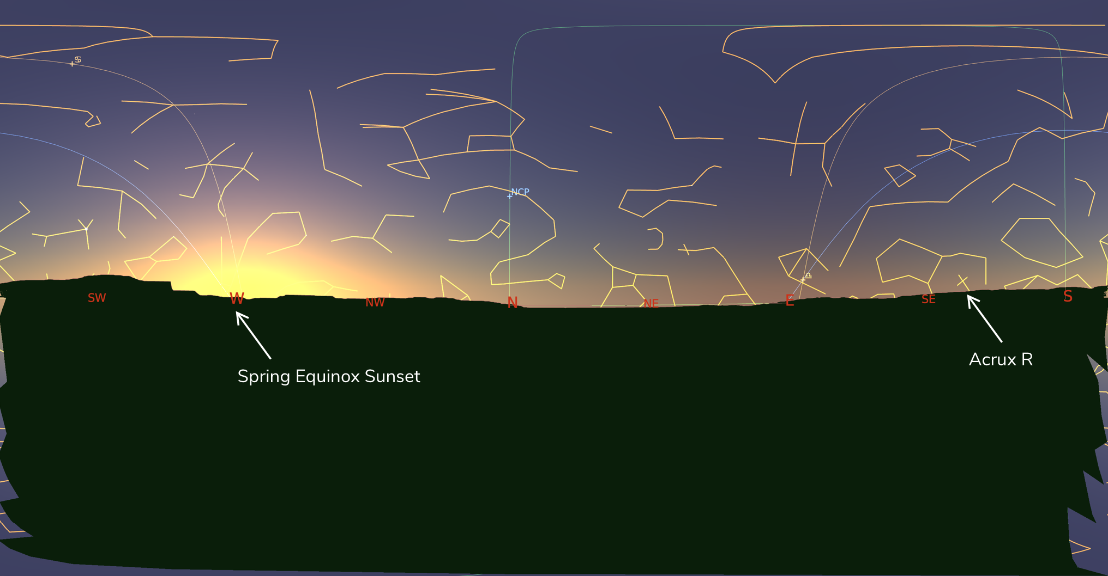
Chart 3. Acrux rising during Spring Equinox sunset, ca. 2000 bce. The sun was at nautical twilight.
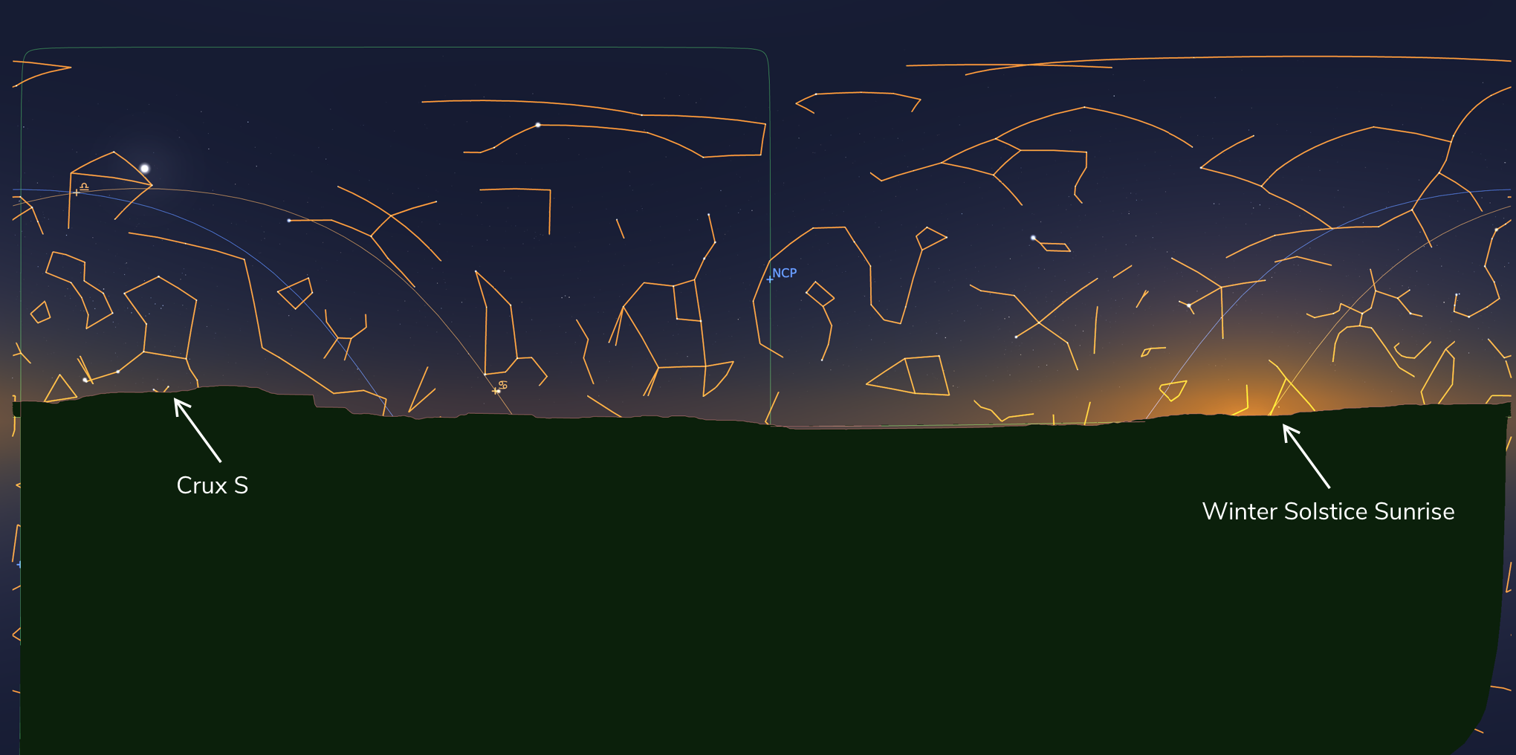
Chart 4. Crux setting during Winter Solstice sunrise at Chamaizi, ca. 2000 bce.

Crux, as a seasonal marker embedded in the orientations of Chamaizi, may provide an astronomical interpretation for a Minoan glyptic motif. The encircled cross is a common image in Minoan seals, where sometimes it takes the form of a solar wheel. An example is engraved on a Mycenean ring where dog-headed Minoan Genii offer libations to a goddess, canopied by a solar wheel, a crescent moon, and the ‘floating’ spikes of wheat (fig. 12). Nilsson is skeptical of interpreting these seals purely on religious connotations of the cross:

‘Thus it is very doubtful if the star-like and rayed hieroglyphic signs, similar to the designs treated here, represent the sun or stars… No evidence can be deduced from the circumstances of their discovery to show that these crosses were more than pieces of jewelry and if any; deeper significance is to be ascribed to them, it must be demonstrated by other evidence that the cross was a religious symbol.’

The Minoan cruciform motif would have been an ideal semantic representation of the equinoxes, when daylight and sunlight were equally divided. This symbol finds a celestial metaphor in the fortuitous location of the asterism, Crux, as a nocturnal marker for the seasons in Minoan Crete.

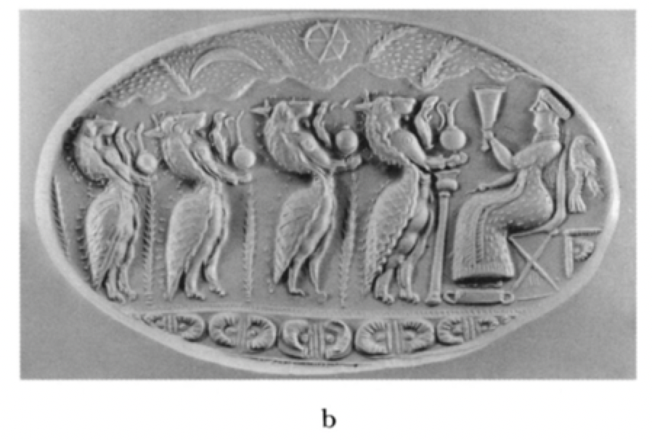
Figure 12. The sun, moon, and stars on Tiryns ring (CMS l [Xenaki-Sakellariou 1964], no. 179)

The equinox itself can be envisioned as the union of the sun and moon, ‘crossing' each other in their heavenly dance. In Near Eastern societies, the hieros gamos was celebrated during the autumnal equinox, and it is believed that Aegean cultures practiced similar ceremonies until at least 1400 bce. Strabo records that Persian kings would marry their wives at the beginning of the vernal equinox. In some parts of modern Greece, around the spring equinox, a ‘mock wedding’ is celebrated on Clean Monday. Chamaizi’s main entrance may have incorporated a similar conjugal symbology. The construction embedded a solar solstitial alignment while Crux set, a lunar alignment at Corona Australis’s declination, and a spring equinox alignment while Crux rose. This potential cosmological trinity evokes the hieros gamos, the solar male as the rain god with the lunar female as the well, giving birth to life-sustaining Spring.

Conclusion

The orientations to Spica’s evening rise and the southern major lunar standstill are consistent with lunar identifications of Artemis/Britomartis and the ‘floating wheat’ glyptic iconography. Chamaizi's archetypal oval-shaped floor plan, mirroring the curvature of Corona Australis, combined with its centralized cistern finds correspondences with the Greek myths of Cretan Zeus’ nursing in Sitia. The lunisolar and equinoctial alignments, perhaps emblemized as the solar cross, are consistent with ancient Greek pre-nuptial traditions, which were propitiated with water libations at the springs, wells, and baths sacred to Artemis.
Appendix

Wall | Azimuth | Star | Azimuth | Altitude | Declination | Seasonal Marker
A | 147° | Acrux (α Cru) Rising | 148°53’ | 2°54’ | -42°07’ | Spring Equinox Sunset
B | 128° | γ CrA Rising | 130° | 2°35’ | -30°32’ | Southern Major Lunar Standstill
C | 77° | Spica (α Vir) Evening Rising | 77°28’ | 0° | +10°31’ | One Month Before Spring Equinox

Table 2. Astronomical Alignments Chamaizi, Crete (35°10’3.67”N, 26° 1’6.75”E), 2000 bce

Door | Azimuth | Seasonal Marker | Star | Azimuth | Altitude | Declination
D | 119.8° | Sunrise Winter Solstice is at -6° alt and occurs at 119.8° as Cru Sets | δ Cru Morning Set | 213°38’ | 5°58’ | -37°57’

Table 2. Astronomical Alignments Chamaizi, Crete (35°10’3.67”N, 26° 1’6.75”E), 2000 bce

Primary Sources

Apollodorus, The Library (W. Heinemann; G. P. Putnam's sons: London New York,, 1921).

Callimachus, Lycophron, Aratus, A. W. Mair, and G. R. Mair, Callimachus and Lycophron (W. Heinemann; G.P. Putnam's sons: London, New York,, 1921).

Homer, The Odyssey (Harvard University Press: Cambridge, MA, 1919).

Hunger, H., and D. Pingree, Mul.Apin. An Astronomical Compendium in Cuneiform (Horn: Verlag Ferdinand Berger & Söhne, 1989).

Jones, William Henry Samuel, Hippocrates: With an English Translation (Harvard University Press, 1952).

Solinus, C Julius, Bartolinus Atriensis, and Giacomo Britannico, De Mirabilibus Mundi (Andreas Portilia, 1983)

Jones, Horace Leonard, and John Robert Sitlington Sterrett, Strabo. The Geography of Strabo (W. Heinemann; G. P. Putnam's sons: London, New York,, 1917).

Wycherley, Richard Ernest, Pausanias Description of Greece (Harvard University Press, 1918).

Secondary Sources

Barrie, Thomas. ‘Sacred Domesticities: The Ontology of Home.’ In Architecture, Culture, and Spirituality Symposium. 2001.

Blomberg, Mary, and Göran Henriksson, ‘Evidence for the Minoan Origins of Stellar Navigation in the Aegean’: (1999).

Blomberg, Mary, and Göran Henriksson, 'Minoan Astronomy', Handbook of Archaeoastronomy and Ethnoastronomy: (2015), 1431.

Blomberg, Mary, and Göran Henriksson, 'The Function of the Minoan Oval House at Chamaizi', British Archaeological Reports-International series, 1647: (2007), 15-18.

Burkert, Walter, Greek Religion (Harvard University Press, 1985).

Davaras, C, 'The Oval House at Chamaizi Reconsidered', Athens Annals of Archaeology, 5: (1972), 283-88.

Dietrich, Bernard Clive, The Origins of Greek Religion (Bristol Phoenix Press, 2004).

Evans, Arthur, 'The Palace of Minos at Knossos, I. 1928', The Palace of Minos at Knossos: (1921).

Evans, Arthur, ''The Ring of Nestor': A Glimpse into the Minoan after-World and a Sepulchral Treasure of Gold Signet-Rings and Bead-Seals from Thisbê, Boeotia', Journal of Hellenic Studies: (1925), 1-75.

Flinterman, Jaap-Jan. 'Apollonius Ascension.' in, Theios Sophistès (Brill, 2009).

Håland, Evy Johanne, 'The Life-Giving Spring: Water in Greek Religion, Ancient and Modern, a Comparison', Proteus, 26: (2009), 45-54.

Håland, Evy Johanne, 'Rituals of Magical Rain-Making in Modern and Ancient Greece: A Comparative Approach', Cosmos: The Journal of the Traditional Cosmology Society, 17: (2005), 197-251.

Håland, Evy Johanne, Rituals of Death and Dying in Modern and Ancient Greece: Writing History from a Female Perspective (Cambridge Scholars Publishing, 2014).

Håland, Evy Johanne. '“Take, Skamandros, My Virginity”: Ideas of Water in Connection with Rites of Passage in Greece, Modern and Ancient.' in, The Nature and Function of Water, Baths, Bathing and Hygiene from Antiquity through the Renaissance (Brill, 2009).

Koehl, Robert B. "The ‘Sacred Marriage’in Minoan Religion and Ritual." In Potnia: Deities and religion in the Aegean Bronze Age, Proceedings of the 8th International Aegean Conference, 237-43. 2001.

Kyriakidis, Evangelos, 'Unidentified Floating Objects on Minoan Seals', American Journal of Archaeology: (2005), 137-54.

Lenuzza, Valeria, '" The Whole Is a Freak": A Reassessment of the Spatial Organization of the Oval House at Chamaizi, Siteia', Hesperia Supplements, 44: (2011), 59-70.

Marinatos, Nanno, Minoan Religion: Ritual, Image, and Symbol (University of South Carolina Press, 1993).

Nilsson, Martin Persson, The Minoan-Mycenaean Religion and Its Survival in Greek Religion (Biblo & Tannen Publishers, 1971).

Nowicki, Krzysztof, 'When the House Becomes a Fortress', Hesperia Supplements, 44: (2011), 349-65.

Poursat, Jean-Claude, 'Cult Activity at Malia in the Protopalatial Period', Hesperia Supplements, 42: (2009), 71-78.

Rogers, J. H., 'Origins of the Ancient Constellations: Ii. The Mediterranean Traditions', Journal of the British Astronomical Association, 108: (1998), p.79-89.

Ruggles, Clive L. N., 'Pushing Back the Frontiers or Still Running around the Same Circles? ‘Interpretative Archaeoastronomy’ Thirty Years On', Proceedings of the International Astronomical Union, 7: (2011), 1-18.

Schaeffer, Bradley E., 'The Origin of the Greek Constellations', Scientific American: (2006), 96 - 101.

Smith, William, Dictionary of Greek and Roman Biography and Mythology (CC Little and J. Brown, 1849).

Stevens, Kathryn. 2013. ''Šala (Goddess)'', Oracc and the UK Higher Education Academy. http://oracc.museum.upenn.edu/amgg/listofdeities/ala/.

Tzoraki, O, M Kritsotakis, and E Baltas, 'Spatial Water Use Efficiency Index Towards Resource Sustainability: Application in the Island of Crete, Greece', International Journal of Water Resources Development, 31: (2015), 669-81.

Mary Blomberg and Göran Henriksson, 'The Function of the Minoan Oval House at Chamaizi', British Archaeological Reports-International series, 1647: (2007), p. 17
Lenuzza, Valeria, '" The Whole Is a Freak": A Reassessment of the Spatial Organization of the Oval House at Chamaizi, Siteia', Hesperia Supplements, 44: (2011), p. 49; and Nanno Marinatos, Minoan Religion: Ritual, Image, and Symbol (University of South Carolina Press, 1993) p. 113
Lenuzza, ‘Whole’, p. 60
Lenuzza, ‘Whole’, p. 63; and Jean-Claude Poursat, 'Cult Activity at Malia in the Protopalatial Period', Hesperia Supplements, 42: (2009), p. 76
Arthur Evans, 'The Palace of Minos at Knossos, I. 1928', The Palace of Minos at Knossos: (1921), p. 147
Evans, ‘Palace’, p. 148
Krzysztof Nowicki, 'When the House Becomes a Fortress', Hesperia Supplements, 44: (2011), p. 354; Blomberg, ‘Function, p. 15; and Lenuzza, ‘Whole’, p. 64
O. Tzoraki, M Kritsotakis, and E Baltas, 'Spatial Water Use Efficiency Index Towards Resource Sustainability: Application in the Island of Crete, Greece', International Journal of Water Resources Development, 31: (2015), p. 673
Lenuzza, ‘Whole’, p. 59, 66; and C. Davaras, 'The Oval House at Chamaizi Reconsidered', Athens Annals of Archaeology, 5: (1972), p. 287
Nanno Marinatos, Minoan Religion: Ritual, Image, and Symbol (University of South Carolina Press, 1993), p. 113
Marinatos, Minoan, p. 113
Blomberg, ‘Function’, p. 16
Blomberg, ‘Function’, p. 15
Martin Persson Nilsson, The Minoan-Mycenaean Religion and Its Survival in Greek Religion (Biblo & Tannen Publishers, 1971), p. 2
J. H. Rogers, 'Origins of the Ancient Constellations: II. The Mediterranean Traditions', Journal of the British Astronomical Association, 108: (1998), p.79
Bradley E. Schaeffer, 'The Origin of the Greek Constellations', Scientific American: (2006), p. 96
Blomberg, ‘Function, p. 16, 17
Blomberg, ‘Function, p. 16, 17
Evangelos Kyriakidis, 'Unidentified Floating Objects on Minoan Seals', American Journal of Archaeology: (2005), p. 150
Kyriakidis, ‘Unidentified’, p. 143
Kyriakidis, ‘Unidentified’, p. 144
Kyriakidis, ‘Unidentified’, p. 148
Kyriakidis, ‘Unidentified’, p. 149
Kyriakidis, ‘Unidentified’, p. 152
Clive L. N. Ruggles, 'Pushing Back the Frontiers or Still Running around the Same Circles? ‘Interpretative Archaeoastronomy’ Thirty Years On', Proceedings of the International Astronomical Union, 7: (2011), p. 10
Mary Blomberg, and Göran Henriksson, 'Minoan Astronomy', Handbook of Archaeoastronomy and Ethnoastronomy: (2015), p. 1434
Mary Blomberg and Göran Henriksson, 'Evidence for the Minoan Origins of Stellar Navigation in the Aegean': (1999), p. 76
William Henry Samuel Jones, Hippocrates: With an English Translation (Harvard University Press, 1952), On the Regimen, 3.68.2
Kathryn Stevens, 2013. ‘Šala (Goddess)’, Oracc and the UK Higher Education Academy. http://oracc.museum.upenn.edu/amgg/listofdeities/ala/ ; and Mul-Apin, Tablet I line 52
Blomberg, ‘Minoan’, p. 1434
Evy Johanne Håland, 'Rituals of Magical Rain-Making in Modern and Ancient Greece: A Comparative Approach', Cosmos: The Journal of the Traditional Cosmology Society, 17: (2005), p. 207
Arthur Evans, ''The Ring of Nestor': A Glimpse into the Minoan after-World and a Sepulchral Treasure of Gold Signet-Rings and Bead-Seals from Thisbê, Boeotia', Journal of Hellenic Studies: (1925), p. 16
Evans, 'Nestor', p. 16
Evans, ‘Nestor’, p. 15
Bernard Clive Dietrich, The Origins of Greek Religion (Bristol Phoenix Press, 2004), p. 169, 170
Kyriakidis, ‘Unidentified’, p. 140
Kyriakidis, ‘Unidentified’, p. 140
Blomberg, ‘Minoan’, p. 1434
Richard Ernest Wycherley, Pausanias Description of Greece (Harvard University Press, 1918), Pausanias III. 24. § 6
Jaap-Jan Flinterman. 'Apollonius Ascension.' in, Theios Sophistès (Brill, 2009). p, 243, footnote 79
Nilsson, Religion, p. 439, 440
C. Julius Solinus, Bartolinus Atriensis, and Giacomo Britannico, De Mirabilibus Mundi (Andreas Portilia, 1983), IX.8.
Callimachus, Lycophron, Aratus, A. W. Mair, and G. R. Mair, Callimachus and Lycophron (W. Heinemann; G.P. Putnam's sons: London, New York,, 1921), Hymn 3 to Artemis 190-1
William Smith, Dictionary of Greek and Roman Biography and Mythology (CC Little and J. Brown, 1849), B.9.britomartis
Marinatos, ‘Ritual’, p. 147, 165
Flinterman. 'Apollonius', p. 243
Nilsson, Religion, p. 395; and Homer, Odyssey, 19.188
Nilsson, Religion, p. 395
Nilsson, Religion, p. 449
Nilsson, Religion, p. 446
Nilsson, Religion, p. 446
Thomas Barrie, ‘Sacred Domesticities: The Ontology of Home.' In Architecture, Culture, and Spirituality Symposium. 2001. p. 65
Nilsson, Religion, p. 394
Flinterman. 'Apollonius', p. 244
Marinatos, ‘Ritual’, p. 141
Nilsson, Religion, p. 394
Nilsson, Religion, p. 393
Evy Johanne Håland, '“Take, Skamandros, My Virginity”: Ideas of Water in Connection with Rites of Passage in Greece, Modern and Ancient.' in, The Nature and Function of Water, Baths, Bathing and Hygiene from Antiquity through the Renaissance (Brill, 2009). p. 129, 132
Flinterman. 'Apollonius', p. 243, 244
Håland, ‘Rain-Making’, p. 242
Pseudo-Apollodorus, Bibliotheca, 2.26 and 2.34
Håland, 'Rain-Making', p. 240
Håland, ‘Rain-Making', p. 206
Blomberg, ‘Minoan’, p. 1434
Nilsson, Religion, p. 365
Robert B. Koehl, ‘The “Sacred Marriage” in Minoan Religion and Ritual.’ In Potnia: Deities and religion in the Aegean Bronze Age, Proceedings of the 8th International Aegean Conference, 237-43. 2001, p. 237
Horace Leonard Jones and John Robert Sitlington Sterrett, Strabo. The Geography of Strabo (W. Heinemann; G. P. Putnam's sons: London, New York,, 1917), Book XV. Chapter III. 17
Evy Johanne Håland, Rituals of Death and Dying in Modern and Ancient Greece: Writing History from a Female Perspective (Cambridge Scholars Publishing, 2014), p. 185

