Report for Corporate Social Responsibility in the Public Sector Assignment 2 2020 – Global CSR



May 2020

MODULE NAME: Corporate Social Responsibility in the Public Sector Name: Samuel Lockley
Student Number: 1704902

Table of Contents

1 Executive Summary………………………………………………………………………………………………………………………1
2. Introduction………………………………………………………………………………………………………………………………….2
2.1 What is Poverty………………………………………………………………………………………………………………………..2-4
3.0 U.N Goals…………………………………………………………………………………………………………………………………….5
3.1 Goal Initiatives…………………………………………………………………………………………………………………………….5
3.1.1 Universal Basic Income………………………………………………………………………………………………………….5-8
3.1.2 Bolsa Familia………………………………………………………………………………………………………………………...8-9
3.1.3 3.1.3 Post 2015 Analysis: Sweden and Brazil……………………………………………………………………..9-10
3.2 Corporate Social Responsibilities, Theory and Application……………………………………………………11-12
4. Conclusion……………………………………………………………………………………………………………………………………13
4.1 Recommendations……………………………………………………………………………………………………..………………13
5. References………….………………………………………………………………………………………………………………….14-19

List of Figures

Figure 2.1: Maslow’s Hierachy of Needs……………………………………………………………………….3
Figure 2.2: The Poverty Trap………………………………………………………………………………………….4
Figure 3.1: improvements in financial wellbeing……………………………………………………….6
Figure 3.2: Brazil gpd………………….………………………………………………………………………………..9
figure 3.3: Sweden GPD…………………………………………………………………………………………………10
Figure 3.4 the triple bottom line……………………………………………………………………………….1o
figure 3.5 Carroll’s pyramid……………………………………………………………………………………….11

- Executive Summary
In 2015 the UN convened and presented a revised list of goals, 17 to be precise, which was meant to be an improvement on their Millennium Development Goals. Poverty being the main point of discussion for the report, suffers from the issue of ambiguity. Wherein how it is defined is dependent on the country where it is situated as one country may perceive poverty as someone earning under $5 an hour or another simply as when someone is unable to afford basic needs. The UN however has defined absolute poverty as living off $1 or less a day. There have been several initiatives to attempt to tackle poverty however such as Sweden’s universal basic income or Brazils Bolsa Familia or Family Allowance. Both these initiatives are born from the same desire to help struggling families by ensuring that they received an amount of money to help them. These two countries are of very different economic states, with Sweden being a highly developed country and Brazil being one that is less developed than most. Despite this it would appear that the system implemented by Brazil was significantly more successful than that of Sweden’s, reasons behind this could be down to the running period that both initiatives have had differ significantly and that Brazil also included stipulations to receive funding in that any children must receive appropriate vaccinations and attend school. When looking at corporate social responsibility in regard to these two initiatives however, it is difficult to judge the overall intentions of the governments that implemented them, whether they felt it was the right thing to do or simply something that had to be done in order to maintain economic stability in the long term. Overall, it would appear that Brazil is on the right track in terms of tackling its levels of poverty, yet it seems that it’s a much more difficult endeavour for developed countries to stamp out poverty.

2.0 Introduction
In an attempt to tackle the many problems the world faces, the UN has devised a strategy to achieve 17 goals by 2030 (United Nations, 2020). These goals consist of eliminating poverty (General, 2014), eradicating hunger, ensuring that everyone has access to sufficient health care (Norheim, et al, 2015, Costanza, et al, 2016), quality education, clean water and sanitation, affordable and clean energy, increased economic growth, as well as infrastructure and industry in countries that require it (Colglazier, 2015). They also want to ensure all genders and sexual orientations are treated equally and ensure all inequality is reduced as much as possible (Women, U.N, 2018, Doyle, Stiglitz, 2014.). They are also pushing for action to be taken to slow climate change, improve habitability for animals both on land and sea (Lynch, et al, 2017), as well as put in place strong and fair justice systems. They want to bring as many prominent people, countries, and organisations on board as possible to encourage others to help with these initiatives (Jomo, et al, 2016). The objective of tackling worldwide poverty will be the primary focus for this report.
The UN had previously established what were known as the Millennium Development Goals which consisted of eight goals (Five Talents, 2019). The reason for the adaption to the 17 goal strategy was to expand on the existing objectives, remove those that had been achieved and revise those that were not feasible within the time frame they had set themselves (Galatsides, 2015, Maurice, 2015).

2.1 What is Poverty?
There is not consensus on what the definition of poverty is. Poverty, or in this instance relative poverty, can be considered the lack of material wealth, or ability to buy essentials by the populace of a country (Lewis, 1969, Hulme, Shepherd, 2003). However, as noted by Foster and Shorrocks (1988) there is an issue in determining whether someone can be considered in poverty as it is difficult to determine how much a person needs to lack in order to be considered impoverished. There is a second term, given to those who not only lack material wealth but also access to the essentials. This is referred to as absolute poverty which by UN standards are those living on under $1 an hour but may be different depending on the country (Foster, 1998, Ravallion, et al, 1991). Hopefully, through the U.N’s goal, a clear line will determine when someone falls into relative poverty or absolute poverty.

A prime example of what would need to be met in terms of poverty can be seen by considering Maslow’s Hierarchy of Needs (Maslow, Lewis, 1987).
Figure 2.1: Maslow’s Hierarchy of Needs
It is the initial two layers of the diagram that need to be tackled in order to help resolve the issue of poverty as these will help the individual form a foundation to attain further needs.
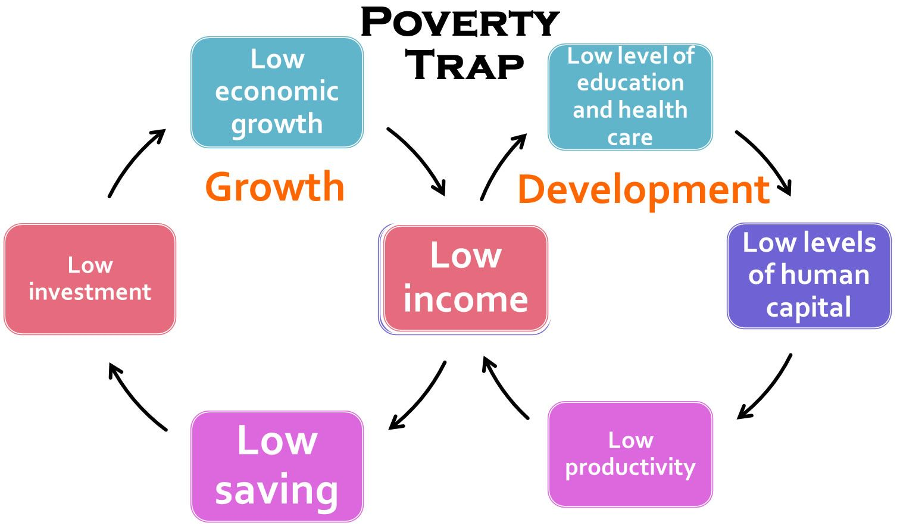
Another purpose of the initiative would be to break the Poverty Trap, where individuals are trapped in a cycle of poverty due to the initial issue of having a low income and do not have the funds to gain a better education or new skills in order to achieve better paying jobs (Barham, et al, 1995, Sachs, et al, 2004, Whitehead, et al, 2001). There are already plans in place to attempt to break the poverty trap in an area by stimulating the local economy, or providing financial relief on a temporary basis (Sachs, et al, 2004, Whitehead, et al, 2001). The issue with this, however, is that if these plans fail then those in poverty become too heavily reliant on government aid and so the trap tightens its grip, making it harder to break the cycle (Addison, 2008).
Figure 2.2: The Poverty Trap

3.0 U.N Goals
Since the issue of tackling poverty is such a major undertaking, it has been broken down into several individual goals that they hope to achieve by 2030. One goal, to eliminate absolute poverty completely by 2030, was changed from solving all poverty by 2030 as this was deemed too large a scale. Despite this, it is believed that there will still be levels of absolute poverty by 2030 based on current projections (United Nations, 2019). Another such goal is to ensure that everyone has access to a social security system if they so need (United Nations, 2020). This goal in particular will be a major discussion point for the report.

3.1 Goal Initiatives
Many initiatives have been suggested to attempt to tackle the goal of reducing poverty levels. This is because it is considered such a major issue on a global scale thus a response on such a level was needed in order to combat it. These goals exist in both lesser developed countries such as Brazil and more developed countries such as Sweden. This is because poverty exists regardless of how developed a country may be albeit the classification of what classifies as poverty may differ (Atkinson, 1991, Spencley, Meyer, 2012).

3.1.1 Universal Basic Income
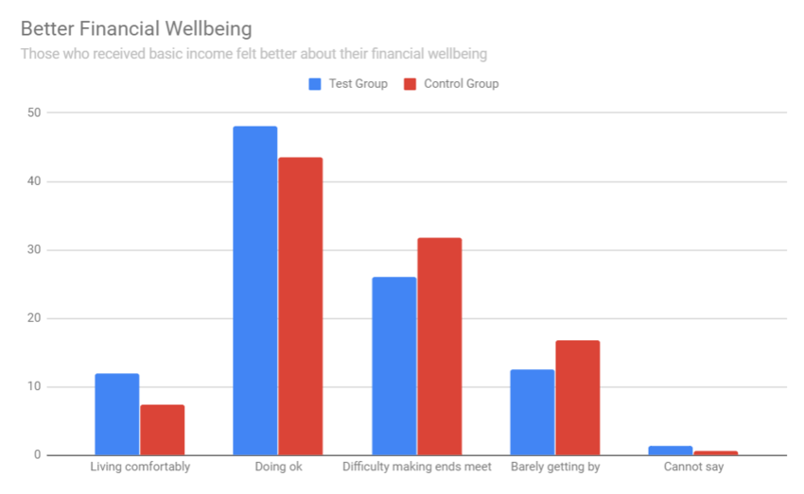
Universal Basic Income, where every person in a country receives a regular sum of money regardless of their employment status, has been an idea proposed for some time as a potential solution to poverty (Lansley, Reed, 2019). Some countries such as Canada and Sweden have been performing tests to gain a better understanding as to how viable it would be to maintain, as well as its true benefits (World Economic Forum, 2019). While the UN itself has been transparent, Sweden has not. This is because Sweden only considers people to be in poverty if they fall within the category of absolute rather than relative poverty. Because of this, it has been identified through independent studies that Sweden’s levels of poverty are significantly higher than has been reported (Hallerod, 1995, Behrendt, 2018). This sort of initiative would be backed by their corresponding government department that deal with social security, such as the Ministry of Health and Social Affairs for Sweden (2020), the Social Security Agency (2020) for the US, or the Department of Work and Pensions (2020) in the UK. While the experiment in Sweden, executed by the Ministry of Health and Social Affairs (Government Offices of Sweden, 2020), did not show an increase in employment levels, it did not seem to discourage people from working. In addition, overall levels of stress have reduced, while measures of financial and health wellbeing have risen (Andersson, 2019). During the study there were a randomised sample of 2000 participants who would receive the monthly payments over the course of 2 years (Lee, 2018). In the graph below it can be seen that those who were receiving government aid during this trial period, represented in blue, were marginally better off in terms of their financial well being in that they were able to afford their basic needs more easily.
Figure 3.1: Improvements in Financial Wellbeing
Some argue that in its current state, a UBI will not be enough to eliminate poverty outright (Sage, Diamond, 2017), with arguments such as the suggestion that this sort of solution leads to those on UBI without a job being considered social outcasts. This sort of behaviour is evident in UK society as far as the benefits system is concerned, where sections of the public sees those in receipt of such as being undeserving (Moffitt, 1983, Poverty and Social Exclusion, 2020) as well as other beliefs such as it being an easy opportunity for fraudulent claims. The major argument against this sort of solution is the question of how it will be funded, whether it be through the introduction of even more taxes on top of income tax such as a wealth or carbon tax (Van Parijs, 2004). There are those who of course still have hope for UBI being a potential solution to poverty as it allows people to maintain a level of dignity and have access to their basic needs (Reed, Lansley, 2016). The argument that UBI alone is unable to resolve all problems relating to poverty has merit, as was noted in the Sweden study employment levels did not rise. This could be attributed to the Poverty Trap where, despite having been given enough to satisfy their basic needs, people do not have the financial capabilities to break out of this cycle (Pick, Weiss, Sirkin, 2010, Lund et al, 2011). The reasoning behind why there was not more positive results from the testing of UBI is that the sample may not have been large enough to be effective at determining an accurate level of success. Another such potential issue is that the timeframe in which the test was conducted over was too short, funding had been offered by Kela (2020), the social security agency for Finland however it was declined.
If UBI were to work however it would meet the criteria for the UN’s target of having implemented social protection measures and systems that will be beneficial for all (United Nations, 2020). Even if not an outright solution to poverty UBI can at least curb the levels of poverty that may exist in countries that choose to implement it. A prime example might be as a temporary measure during events such as the recent Covid-19 outbreak which has left people out of work for long periods of time leaving them without a household income (World Health Organization, 2020), or natural disasters that might leave people homeless such as hurricanes, floods, and earthquakes (Fothergill , Peek, 2004, Karim, Noy, 2016, Carter, et al, 2008).

3.1.2 Bolsa Familia
Brazil has its own welfare system, which is not toi dissimilar to the more widely discussed universal basic income known as Bolsa Familia (Family Allowance), also referred to as Happy Families (Paes-Sousa, Vaitsam, 2014). This initiative is run by the Brazilian government (Presidency of the Republic of Brazil, 2020) with a keen interest from the World Bank (The World Bank, 2007). The purpose of this program is to ensure that families have enough to get by with the stipulation that if they have children as part of the family they must ensure they attend school and receive vaccinations (Dias, Passos, 2014). The fact they are incentivising to ensure that children are getting educated and receive appropriate health care means that this initiative, albeit in a small part, helps aid some of the other U.N goals.
During the first year of implementing Bolsa Familia alone, there was a reduction of 27% in the levels of poverty in Brazil (Brandao, et al, 2007) and aided in lowering the international levels of absolute poverty from 13% to just 3% in 2015 (Ravallion, 2011, The World Bank, 2015). It could be hypothesised that the reasoning behind why this initiative is so much more successful than that of the universal basic income approach used elsewhere is how such initiatives are perceived in each of these countries. In countries such as Sweden and the UK it has already been discussed that there are high levels of disdain for those who rely on government aid (Contini, Richiardi, 2012), whereas in countries like Brazil that social stigma does not exist or there is a lesser extent of it. Another reason as to why it has been so successful is the fact that it has managed to reach and aid over 13million of Brazils almost 200milion people (Shei, et al, 2014).There is an issue with regards to transparency however, as due to the vast scale of the project, there have been issues in ensuring that all those that benefited from it were registered. as well as a level of uncertainty over the improvements it made in terms of health and education (Hall, 2008, Soares, et al, 2010). Bolsa Familia also shares a common issue with Universal Basic Income and that is the Poverty Trap. Despite the financial aid that the people of Brazil receive there is a high chance of them falling back into poverty due to their being heavily reliant on government aid should that funding suddenly stop.

3.1.3 Post 2015 Analysis: Sweden and Brazil
When looking at both countries post introduction of the revised goals by the UN it would appear that there have been great improvements with regarding Brazils economic standing in terms of its GDP. However it is unclear if this is indeed the result of the implementation of the aforementioned goals or if it is simply a slow recovery from a crash in prior years (Pastor, Wise, 2015, Leahy, et al, 2014).
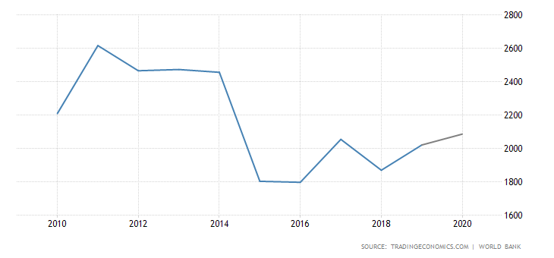
Figure 3.2: Brazil GDP
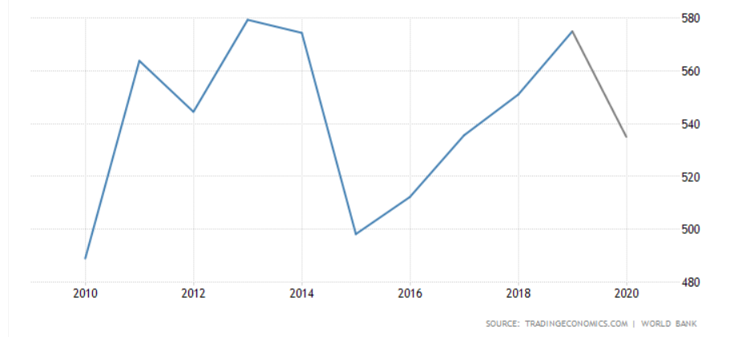
Much like with Brazil, Sweden shows a significant level of growth during the years following the 2015 changes, however, also like brazil, this occurs immediately after a significant decline and thus could just be attributed to a natural level of recovery.
Figure 3.3: Sweden GDP
3.2 Corporate Social Responsibilities Theories and Application
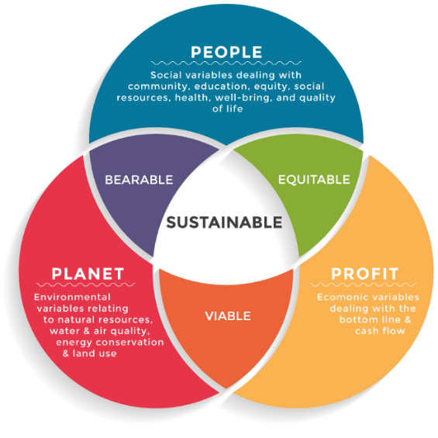
When attempting to evaluate tackling poverty using corporate social responsibility, it can be difficult to judge where they fall. Using the triple bottom line theory in relation to the above initiatives it is evident that the primary focus is on that of people (Henriques, 2009), however, there is little or no focus on the environment or any sort of profit that the triple bottom line is made up of, and therefore cannot be considered sustainable. It could be argued that the profit comes not from immediate financial income but the longer-term gain of helping the people the programs focus on to gain long-term employment and giving back to the country in the form of taxes.
Figure 3.4: The Triple Bottom Line
Another Such model that could be applied in this situation is that of Carroll’s Pyramid (Carroll, 2016). Using Carroll’s Pyramid, it can be argued that the governments that issue these programs can either be being philanthropic, or simply focusing on economic gain, both of which fall on opposite ends of how socially responsible they can be. As was briefly mentioned it could be construed as a government act simply to improve the countries’ economic situation in the long term, or it could indeed be an attempt to reach out to those in need. When looking at it from an individual perspective however, those receiving government aid are unlikely to be choosing the ethical options such as free range produce over those produced in less desirable conditions, as they are more likely to go for the option that is more affordable.
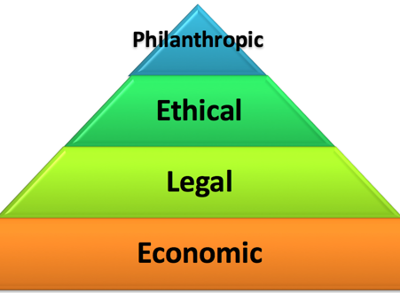
Figure 3.5: Carroll’s Pyramid

4.0 Conclusion
Overall, UBI requires more time invested into developing it, perhaps even take inspiration from Brazils variation, however social stigma may still get in the way of it bearing fruit. It can also be said that a system may work for one country’s society, such as Brazil and its Bolsa Familia, whereas it may have little or a negative impact on another in terms of the marginal difference Universal Basic Income produced in Sweden. When put under scrutiny in terms of CSR, it is difficult to judge whether these methods of tackling poverty lead to a socially responsible result. There may in fact be other avenues in which poverty could be tackled, be it through adapting an already existing approach, or taking an entirely new one.

4.1 Recommendations
It would be advisable, that before attempting to delve deeper into the prospect of UBI, that a solution for the poverty cycle is also devised and put into place alongside it. This is because such attempts will prove fruitless as they would inevitably fall back into the cycle. It would also be worthwhile to attempt to address the negative stigma placed on these sorts of benefit systems in countries where there is a low tolerance of those who rely on monetary aid. This would reassure those who require the extra help to seek it rather than be fearful of public opinion. It may even be wise to pull back focus on the goal of eliminating poverty, at least in already developed countries, in the hope that the solution might be located elsewhere, perhaps in solving one of their other goals set for 2030 they will also find a way in which to solve poverty. The reasoning behind this is that poverty in terms of the U.N goals seems be closely linked to so many of the others. If poverty can be thought of as a dying tree and the other goals are considered the branches then perhaps in healing the branches there may be a positive inward effect on the internal matters, in this instance poverty.

5.0 References
Addison, T., 2008. Debt relief: The development and poverty impact. In Development Finance in the Global Economy (pp. 216-235). Palgrave Macmillan, London.
Alcock, P., 1997. Understanding poverty. Macmillan International Higher Education.
Andersson, J.O., 2019. Will Finland be first to introduce a basic income.
Andress, H.J. and Lohmann, H. eds., 2008. The working poor in Europe: Employment, poverty and globalisation. Edward Elgar Publishing.
Anwar, T. and Qureshi, S.K., 2002. Trends in absolute poverty in Pakistan: 1990-91 and 2001. The Pakistan Development Review, pp.859-878.
Atkinson, A.B., 1991. Comparing poverty rates internationally: lessons from recent studies in developed countries. The World Bank Economic Review, 5(1), pp.3-21.
Barham, V., Boadway, R., Marchand, M. and Pestieau, P., 1995. Education and the poverty trap. European Economic Review, 39(7), pp.1257-1275.
Behrendt, C., 2018. At the Margins of the Welfare State: Social Assistance and the Alleviation of Poverty in Germany, Sweden and the United Kingdom
Brandao, e. a., 2007. O material jornalístico produzido pelo Estadão é protegido por lei. As regras têm como objetivo proteger o investimento feito pelo Estadão na qualidade constante de seu jornalismo. Para compartilhar este conteúdo, utilize o link: https://economia.estadao.. [Online] Available at: https://economia.estadao.com.br/noticias/geral,miseria-no-brasil-cai-27-7-no-1-mandato-de-lula,54881 [Accessed 24 04 2020].
Buck, D. and Jabbal, J., 2014. Tackling poverty: making more of the NHS in England. London: King’s Fund.
Carroll, A.B., 2016. Carroll’s pyramid of CSR: taking another look. International journal of corporate social responsibility, 1(1), p.3.
Carter, M.R., Little, P.D., Mogues, T. and Negatu, W., 2008. Poverty traps and natural disasters in Ethiopia and Honduras. In Social Protection for the Poor and Poorest (pp. 85-118). Palgrave Macmillan, London.
Colglazier, W., 2015. Sustainable development agenda: 2030. Science, 349(6252), pp.1048-1050.
Contini, D. and Richiardi, M.G., 2012. Reconsidering the effect of welfare stigma on unemployment. Journal of Economic Behavior & Organization, 84(1), pp.229-244.
Costanza, R., Daly, L., Fioramonti, L., Giovannini, E., Kubiszewski, I., Mortensen, L.F.,
Department of Work and Pension, 2020. Organisations. [Online]
Available at: https://www.gov.uk/government/organisations/department-for-work-pensions
[Accessed 04 04 2020].
Dias, R.M.D.S.B. and Passos, I.C.F., 2014. The implementation of the bolsa-família (family allowance) program at a local level: the experience of the city of Divinópolis/Minas Gerais, Brazil. Pesquisas e Práticas Psicossociais, 9(2), pp.156-172.

Doyle, M.W. and Stiglitz, J.E., 2014. Eliminating extreme inequality: A sustainable development goal, 2015–2030. Ethics & International Affairs, 28(1), pp.5-13.
Five Talents, 2019. UN's Millenium Development Goals. [Online]
Available at: https://www.fivetalents.org.uk/un-sustainable-development-goals?gclid=Cj0KCQjw7qn1BRDqARIsAKMbHDa08zOMie5jUFDXLKig971t55RztJ9Vd02bnjEf7Dg97sWnY6Lf7-UaAgtAEALw_wcB
[Accessed 30 04 2020].
Foster, J.E. and Shorrocks, A.F., 1988. Poverty orderings. Econometrica: Journal of the Econometric Society, pp.173-177.
Foster, J.E., 1998. Absolute versus relative poverty. The American economic review, 88(2), pp.335-341.
Fothergill, A. and Peek, L.A., 2004. Poverty and disasters in the United States: A review of recent sociological findings. Natural hazards, 32(1), pp.89-110.
Galatsidas, A., 2015. Sustainable development goals: changing the world in 17 steps-interactive. The Guardian Global development. Posted Monday, 19.
General, U.S., 2014. The road to dignity by 2030: ending poverty, transforming all lives and protecting the planet. Synthesis report of the Secretary-General on the post-2015 sustainable development agenda. New York: UN.
Government Offices of Sweden, 2020. Ministry of Health and Social Affairs. [Online]
Available at: https://www.government.se/government-of-sweden/ministry-of-health-and-social-affairs/
[Accessed 02 04 2020].
Hall, A., 2008. Brazil's Bolsa Família: A double‐edged sword?. Development and change, 39(5), pp.799-822.
Halleröd, B., 1995. The truly poor: direct and indirect consensual measurement of poverty in Sweden. Journal of European Social Policy, 5(2), pp.111-129.
Hulme, D. and Shepherd, A., 2003. Conceptualizing chronic poverty. World development, 31(3), pp.403-423.
Jomo, K.S., Chowdhury, A., Sharma, K. and Platz, D., 2016. Public-Private Partnerships and the 2030 Agenda for Sustainable Development.
Karim, A. and Noy, I., 2016. Poverty and natural disasters—a qualitative survey of the empirical literature. The Singapore Economic Review, 61(01), p.1640001.
Kirby, P., 2006. Vulnerability and Violence: the impact of globalisation. Ann Arbor, MI: Pluto.
Lansley, S. and Reed, H., 2019. Basic Income for all: From desirability to feasibility. Compass: London, UK.
Leahy, S., Levy Carciente, S., Stanley, H.E. and Kenett, D.Y., 2014. Structure and dynamics of the brazilian stock market: A correlation analysis. Eugene and Kenett, Dror Y., Structure and Dynamics of the Brazilian Stock Market: A Correlation Analysis (August 23, 2014).
Lee, S., 2018. Attitudes toward universal basic income and welfare state in Europe: A research note. Basic Income Studies, 13(1).
Lewis, O., 1969. The culture of poverty. Anthropological realities: Readings in the science of culture.
Lund, C., De Silva, M., Plagerson, S., Cooper, S., Chisholm, D., Das, J., Knapp, M. and Patel, V., 2011. Poverty and mental disorders: breaking the cycle in low-income and middle-income countries. The lancet, 378(9801), pp.1502-1514.
Lynch, A.J., Cowx, I.G., Fluet-Chouinard, E., Glaser, S.M., Phang, S.C., Beard, T.D., Bower, S.D., Brooks, J.L., Bunnell, D.B., Claussen, J.E. and Cooke, S.J., 2017. Inland fisheries–invisible but integral to the UN Sustainable Development Agenda for ending poverty by 2030. Global Environmental Change, 47, pp.167-173.
Maslow, A. and Lewis, K.J., 1987. Maslow's hierarchy of needs. Salenger Incorporated, 14, p.987.
Maurice, J., 2015. UN set to change the world with new development goals. The Lancet, 386(9999), pp.1121-1124.
Ministry of Health and Social Affairs, 2020. Government Offices of Sweden. [Online]
Available at: https://www.government.se/government-of-sweden/ministry-of-health-and-social-affairs/
[Accessed 04 04 2020].
Moffitt, R., 1983. An economic model of welfare stigma. The American Economic Review, 73(5), pp.1023-1035.
Norheim, O.F., Jha, P., Admasu, K., Godal, T., Hum, R.J., Kruk, M.E., Gómez-Dantés, O., Mathers, C.D., Pan, H., Sepúlveda, J. and Suraweera, W., 2015. Avoiding 40% of the premature deaths in each country, 2010–30: review of national mortality trends to help quantify the UN Sustainable Development Goal for health. The Lancet, 385(9964), pp.239-252.
Paes-Sousa, R. and Vaitsman, J., 2014. The Zero Hunger and Brazil without Extreme Poverty programs: a step forward in Brazilian social protection policy. Ciência & Saúde Coletiva, 19, pp.4351-4360.
Pastor, M. and Wise, C., 2015. Good-bye financial crash, hello financial eclecticism: Latin American responses to the 2008–09 global financial crisis. Journal of International Money and Finance, 52, pp.200-217.
Pick, S., de Weiss, S.P. and Sirkin, J., 2010. Breaking the poverty cycle: The human basis for sustainable development. Oxford University Press, USA.
Pickett, K.E., Ragnarsdottir, K.V., De Vogli, R. and Wilkinson, R., 2016. Modelling and measuring sustainable wellbeing in connection with the UN Sustainable Development Goals. Ecological Economics, 130, pp.350-355.
Poverty and Social Exclusion, 2020. Benefit system riddled with ‘stigma’. [Online]
Available at: https://www.poverty.ac.uk/report-benefits-attitudes/benefit-system-riddled-%E2%80%98stigma%E2%80%99
[Accessed 02 04 2020].
Presidency of the Republic of Brazil, 2020. [Online]
Available at: http://www.brazil.gov.br/@@search?Subject%3Alist=Happy%20Child%20Programme
[Accessed 24 04 2020].
Ravallion, M., Datt, G. and Van De Walle, D., 1991. Quantifying absolute poverty in the developing world. Review of Income and Wealth, 37(4), pp.345-361
Ravallion, M., 2011. A comparative perspective on poverty reduction in Brazil, China, and India. The World Bank Research Observer, 26(1), pp.71-104.
Sachs, J., McArthur, J.W., Schmidt-Traub, G., Kruk, M., Bahadur, C., Faye, M. and McCord, G., 2004. Ending Africa's poverty trap. Brookings papers on economic activity, 2004(1), pp.117-240.
Sage, D. and Diamond, P., 2017. Europe's New Social Reality: The Case Against Universal Basic Income.
Shei, A., Costa, F., Reis, M.G. and Ko, A.I., 2014. The impact of Brazil’s Bolsa Família conditional cash transfer program on children’s health care utilization and health outcomes. BMC international health and human rights, 14(1), p.10.
Smith, R., 1997. Doctors can reduce the harmful effects of poverty.
Spenceley, A. and Meyer, D., 2012. Tourism and poverty reduction: Theory and practice in less economically developed countries. Journal of Sustainable Tourism, 20(3), pp.297-317.
Social Security Agency, 2020. Social Security. [Online]
Available at: https://www.ssa.gov/
[Accessed 04 04 2020].
The World Bank, 2007. Bolsa Família: Changing the Lives of Millions in Brazil. [Online]
Available at: https://www.worldbank.org/en/news/feature/2007/08/22/bolsa-familia-changing-the-lives-of-millions-in-brazil
[Accessed 24 04 2020].
The World Bank, 2015. Global Poverty Line Update. [Online]
Available at: https://www.worldbank.org/en/topic/poverty/brief/global-poverty-line-faq
[Accessed 24 04 2020].
Roy, S., 1997. Globalisation, structural change and poverty: Some conceptual and policy issues. Economic and political weekly, pp.2117-2135.
United Nations, 2019. PROGRESS OF GOAL 1 IN 2019. [Online]
Available at: https://sustainabledevelopment.un.org/sdg1
[Accessed 04 04 2020].
United Nations, 2020. Goal 1: End poverty in all its forms everywhere. [Online]
Available at: https://www.un.org/sustainabledevelopment/poverty/
[Accessed 15 04 2020].
United Nations, 2020. Sustainable Development Goals. [Online]
Available at: https://sustainabledevelopment.un.org/?menu=1300
[Accessed 31 03 2020].
Van Parijs, P., 2004. Basic income: a simple and powerful idea for the twenty-first century. Politics & Society, 32(1), pp.7-39.
Whitehead, M., Dahlgren, G. and Evans, T., 2001. Equity and health sector reforms: can low-income countries escape the medical poverty trap?. The Lancet, 358(9284), pp.833-836.
World Health Organization, 2020. Coronavirus disease 2019 (COVID-19): situation report, 67.
Women, U.N., 2018. Turning promises into action: Gender equality in the 2030 Agenda for Sustainable Development. UN Women.
World Economic Forum, 2019. The results of Finland’s basic income experiment are in. Is it working?. [Online]
Available at: https://www.weforum.org/agenda/2019/02/the-results-finlands-universal-basic-income-experiment-are-in-is-it-working/
[Accessed 02 04 2020].
World Trade Organization, 2015. Fifth Global Review of Aid for Trade: “Reducing Trade Costs for Inclusive, Sustainable Growth”. [Online]
Available at: https://www.wto.org/english/tratop_e/devel_e/a4t_e/global_review15prog_e/global_review15prog_e.htm
[Accessed 04 04 2020].

