

Title- Marketing management assessment 1

Student name: Akashdeep singh

Student ID : 2239847

Programme :MBA- Master of Business Administration

Module : Marketing Management

Module code : LCMB7001

Lecturer name : Tushara Balendran

Date : 30/08/2023

Table of content

1 Introduction……………………………………………………………………………………………3
  - Mission and vision statements of Samsung………………………………………….3
  - Communication channels at Samsung………………………………………………….3
  - Integrated marketing communication tools used…………………………………4
  - Key Recommendations for Samsung …………………………………………………..5
- Branding …………………………………………………………………………………………….6
  - brand equity ………………………………………………………………………………………7
  - Keller’s Brand equity model……………………………………………………………….7
  - Advantages of keller’s model for Samsung ………………………………………..9
  - Disadvantages of keller’s model for Samsung ……………………………………9
- Customer journey mapping ……………………………………………………………….10
  - Different types of customer journey map used by Samsung ………………11
  - Advantages of customer journey map………………………………………………..11
  - Disadvantage of customer journey map …………………………………………….12
  - Customer touchpoints ……………………………………………………………………….13
- Total Engagement model……………………………………………………………………14
- Recommendations and conclusion……………………………………………………..15
- References ………………………………………………………………………………………..16

- Introduction

Samsung is one of the world's leading electronics businesses, and it shares many similarities with Apple in terms of creativity and hard work. The business was established in South Korea in 1938, and it has since developed into a worldwide corporation that manufactures a variety of gadgets, including cellphones, televisions, and home appliances. Like its rival Apple, Samsung has always been dedicated to innovation and thinking beyond the box. The company's motto, "Imagine the Possibilities," embodies its conviction that innovation has the potential to advance society and open up new opportunities. When it comes to emerging technologies like flexible displays, 5G connectivity, and artificial intelligence, Samsung has continuously been at the vanguard (Wikipedia, 2023).
Samsung's dedication to research and development is one of its greatest assets. The business makes significant annual R&D investments, which has helped it stay on top of emerging technology. Samsung is renowned for its state-of-the-art research facilities and labs, which are manned by some of the best brains in the business. The success of Samsung has also been significantly influenced by its management. Former Samsung Group chairman Lee Kun-hee, who has since passed away, was a visionary manager who turned the business into a major force on the international stage. Samsung rose to the top of the electronics market under his direction, and today its goods are offered in more than 80 nations worldwide. Lee Jae-yong, his successor, is equally dedicated to advancing Samsung and carrying on its tradition of innovation and quality. Samsung is dedicated to creativity, diligence, and the ability to think creatively beyond the box (Samsung, 2023). These principles have contributed to Samsung's rise to one of the most renowned and prosperous electronics manufacturers in the world.

  - Mission and vision statement of Samsung

The company's motto is "Inspire the World, Create the Future." This declaration demonstrates Samsung's dedication to being a business that offers cutting-edge technology and goods that improve people's lives and the wider world. The company's mission is "Together for Tomorrow! Enabling People." In order to create a better future for everyone, Samsung announces its intention to work in partnership with its clients, business associates, and communities. Samsung wants to help individuals reach their full potential by giving them access to state-of-the-art tools and technology. Overall, Samsung's mission and vision statements demonstrate the company's commitment to fostering innovation and teamwork in order to improve the world (Samsung, 2023).

  - Communication channels at Samsung

Samsung communicates with its stakeholders using a range of channels, including social media sites like Twitter, Facebook, Instagram, and LinkedIn. Additionally, the business uses email, newsletters, and promotional emails to interact with its clients, business partners, and staff members. The website of Samsung acts as a platform for customer service, including details on repairs and troubleshooting. In order to publicise new goods and alliances, the corporation also sends press releases, which are sent to media sources and published on its website. Samsung provides customer assistance via a variety of channels, including live chat, email, phone, and social media. The business exhibits its goods at trade-shows and other events to meet with clients, partners, and industry experts, foster connections, and spread its brand message. 2017 (Samsung Group)

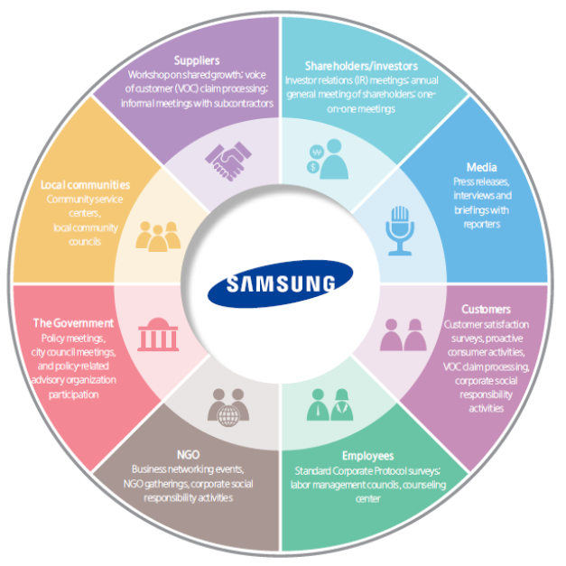
Figure 1: Communication Channels at Samsung (Samsung Group, 2017)

  - Integrated marketing communication and tools used
Samsung has an integrated marketing communication strategy to make sure that its communication activities are consistent and successful. To reach its target audience, the business blends a number of channels, including advertising, public relations, sales promotion, personal selling, and direct marketing (Tsai, 2005).
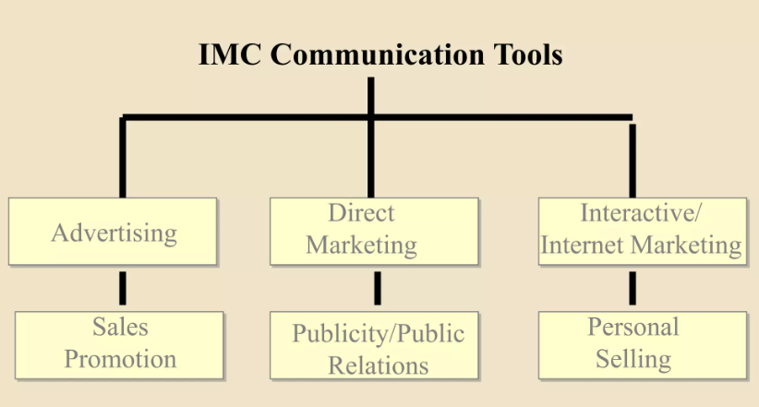
Figure 2: IMC Tools (Juska, 2021)

  - Key Recommendations for Samsung
Samsung is renowned for utilising a premium pricing approach for its high-end products, making them unaffordable for many customers. The demands of customers with low and moderate incomes are met by Samsung's greater selection of goods at various price points, which includes mid-range and budget smartphones. This helps the business to increase its market share and consumer base. Samsung has placed a strong emphasis on innovation, including the inclusion of fresh features and technology in its products, to set them apart from low-cost knockoffs. Additionally, Samsung provides its clients with customisation choices, such as unique phone covers and themes, which may be added on for an additional fee (Harwood, 2015).
Samsung may also appeal to the elderly by emphasising phone features created especially for them, such as bigger displays, user-friendly interfaces, and accessibility capabilities. This may be accomplished by running focused marketing efforts in publications, on television, and in other mediums that appeal to this audience. Samsung may also utilise guerilla marketing strategies to provide clients fresh and unexpected experiences while raising awareness of the company. Pop-up stores, interactive displays, and other innovative marketing activities that involve customers and create buzz might be included in this. In order to improve the perception of its brand and employee morale, Samsung can also promote its corporate social responsibility (CSR) efforts through a variety of platforms. Samsung may draw clients that value social responsibility and build a favourable reputation for the firm by demonstrating its dedication to sustainability, community participation, and ethical business practises (Gnewuch, 2017).
- Online

Augmented reality (AR) :Launch an AR application that allows customers to virtually explore and engage with Samsung's newest products in a lifelike manner.

Virtual Product Experience: Through the AR app, let consumers imagine the characteristics, functions, and advantages of items, creating a distinctive and captivating experience.

Virtual "Try Before You Buy": Allow customers to virtually "test out" devices in order to assist them in making educated decisions about purchases and to promote a sense of ownership.

Gamification Elements: To increase user participation and engagement, use gamification by adding challenges, tests, or awards to the AR app.

Live AR Events: Hold live AR events where professionals present items, respond to inquiries, and give demos in real-time to increase client engagement.

- Offline

Experiential Pop-Up Stores: Open transient physical shops in busy regions to generate awareness about Samsung's goods.

Select Strategic places: To increase foot traffic, pick prime places like shopping centres, city centres, or well-attended events.

Interactive Experience Zones: Create areas within the pop-up shops where customers can interact with the newest gadgets and devices from Samsung.

Virtual Reality (VR) Engagement: Use VR technology to provide immersive experiences that let customers virtually examine product features.

Interactive Displays: Install interactive displays that dynamically highlight the features and advantages of Samsung goods.

Set up expert workshops and tech demos led by in-store professionals to inform clients about product features and usability.

2 Branding

Samsung is a reputable company in the industry, known for its cutting-edge goods and services. The business has a well-known brand that stands for its dedication to excellence and innovation. The name Samsung is made up of the company's name, logo, and other distinguishing features that make it simple for customers to recognise its goods. Samsung has a high brand value, which raises the value of its products. Samsung is viewed by customers as a premium brand that offers top-notch goods and services. The brand value of the business is based on a history of technical innovation, excellence, and dependability (Ramiz, 2014).

The goal of Samsung's branding strategy is to build a deep emotional bond with its audience. The brand of the business represents this dedication to client happiness, and its goods are created to satisfy the requirements and objectives of its clients. Samsung's reputation for quality, innovation, and customer happiness enables the corporation to set its goods apart from those of its rivals. Because of the popularity of the Samsung brand, people are prepared to pay more for the quality and dependability it represents. This allows the corporation to command a higher price for its products. Additionally, Samsung's brand name gives the business a competitive edge in the market since it encourages consumer loyalty and preference for its products over those of its rivals.
2.1 Brand Equity
Samsung is known for creating creative and high-quality goods, such as smartphones, TVs, and home appliances. Strong customer recognition of and faith in the firm and its goods serve as indicators of Samsung's brand equity. The brand has a devoted following because of its associations with dependability, technical innovation, and stylish appearance. In order to further promote its brand, Samsung has also made significant marketing investments, such as sponsorships of important sporting events and celebrity endorsements. Over the years, the firm has been able to retain and increase its brand equity because to its focus on providing a quality customer experience. Overall, Samsung's brand equity is a benefit to the business, allowing it to stand out from rivals and retain a significant position in the worldwide market (Diputra, 2021).
2.2. Keller’s Brand Equity Model
Keller's brand equity model is a framework for developing powerful brands that includes four main elements: brand salience, brand performance, brand imagery, and brand judgments/feelings/resonance (Jing, 2014).
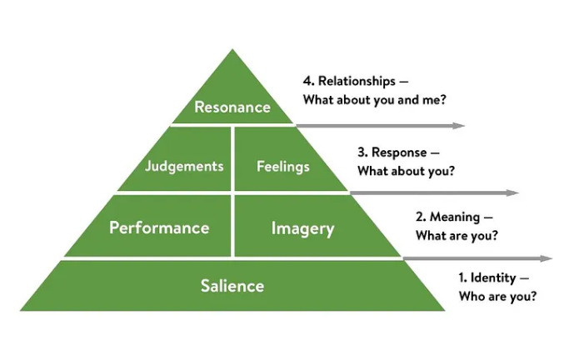
Figure 3: Keller’s Brand Equity Model (Jing, 2014)
Brand Salience: This refers to a brand's capacity to spring to mind when a buyer thinks about a product category. The capacity of the Samsung brand to come to consumers' minds first when they consider electronics, cellphones, home appliances, and other related items is known as brand salience (Yoo, 2001).
Brand Performance: This relates to how well a brand satisfies the practical requirements of its target market. Delivering high-quality products with cutting-edge features, such as the newest smartphone technology or cutting-edge home appliance improvements, is what Samsung defines as brand performance (Yoo, 2001).
Brand Imagery: This relates to the intangible elements of a brand that induce a specific picture or perception in the minds of consumers. Design, beauty, and innovation are all part of Samsung's brand imagery. The brand imagery that customers identify with Samsung reflects the company's efforts to position itself as a pioneer in design and technological innovation (Yoo, 2001).
Brand Judgments/Feelings/Resonance: This speaks to the loyalties and attachments that consumers feel towards a brand as well as their emotional connections with it. Customer happiness, loyalty, and advocacy are just a few examples of the elements that go into Samsung brand judgements, sentiments, and resonance. Customers' emotional ties to the brand are a result of the company's significant investments in delivering a pleasant customer experience and developing a devoted client base (Yoo, 2001).
Samsung has made investments in each of these four crucial components to develop a strong and recognisable brand, and Keller's brand equity model overall offers a thorough framework for creating and managing great brands. In order to build a brand that is associated with innovation, quality, and customer pleasure, Samsung focused on brand salience, brand performance, brand imaging, and brand judgments/feelings/resonance.
2.3 Advantages of keller’s Brand equity model for samsung
Framework in its entirety: Keller's brand equity model offers a thorough framework that enables Samsung to pinpoint the essential elements that lead to the development of brand equity (Tsordia, 2018).
Customer-focused strategy: The approach places a significant emphasis on how consumers view the brand, which is essential for Samsung to create and preserve a positive brand image (Tsordia, 2018).
Takes both practical and emotional considerations into account: The approach acknowledges that consumers link brands with both functional and emotional qualities, and it assists Samsung in developing a brand identity that connects with consumers on both an emotional and a functional level.
Provides precise instructions: The model offers Samsung specific rules for creating a brand identity that is consistent throughout all marketing initiatives, which helps to increase brand awareness and client loyalty.
2.4. Disadvantages of Keller's Brand Equity Model for Samsung
Limited scope: The model's primary areas of focus are brand perception and consumer behaviour, which may not accurately depict Samsung's total marketing efforts and results (Tsordia, 2018).
Lack of flexibility: The model could not be flexible enough for Samsung to adjust to shifting consumer preferences or market conditions over time (Tsordia, 2018).
Complexity: The approach may be complicated and challenging to put into practise, particularly for smaller enterprises with less resources (Tsordia, 2018).

Over reliance on marketing: If other elements, such as product quality and customer service, are subpar, building a strong brand may not be possible (Tsordia, 2018), as the model heavily emphasises marketing activities.

3 Customer Journey Mapping

A customer journey map is a graphic depiction of a customer's interaction with a business from beginning to end. By recognising and assessing the customer's numerous encounters with the business, such as website visits, social media interactions, in-store experiences, and customer service interactions, it is possible to comprehend their perspective (Batra, 2017).

The following phases would normally be included in a customer journey map for Samsung:

Awareness: Customers learn about Samsung's products and services at this stage using a variety of marketing channels, including advertising, social media, and word-of-mouth (Batra, 2017).

Consideration: Once consumers are aware of Samsung, they begin to take its goods and services into account. They might do their homework online, evaluate rival products, read reviews, or go to a Samsung store (Batra, 2017).

Purchase: At this point, clients decide whether to buy Samsung's goods or services. They might buy anything from a third-party vendor, shop in-person, or do it online (Batra, 2017).

Post-purchase: Following the purchase of Samsung goods or services, customers assess their overall satisfaction and offer feedback. For Samsung to keep its clients and foster loyalty, this phase is essential (Batra, 2017).
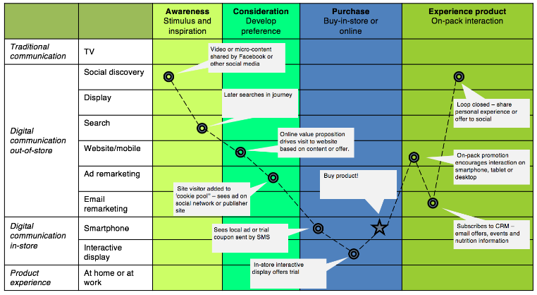
Loyalty: This phase encapsulates Samsung's commitment to its clients over the long term. consumers are more likely to become devoted and repeat consumers if they are pleased with Samsung's goods and services
. Figure 4: Customer Journey Mapping stages (Batra, 2017)

3.1. Different types of customer journey used by Samsung

Current-State Journey Map: Using all the touchpoints and interactions that consumers have with Samsung before, during, and after a purchase, this sort of map depicts the current customer journey of Samsung's clients. The map aids in locating problem regions for clients as well as locations where improvements may be made (Mele, 2021).
Future-State Journey Map: This form of map projects the customer experience for Samsung in the future, taking into account shifting consumer tastes and behaviour as well as emerging technology. The map can assist Samsung in foreseeing client wants and creating plans to satisfy those needs (Mele, 2021).
Day-In-The-Life Journey Map: This kind of map is centred on the normal day of a Samsung client, covering all the touchpoints and interactions that consumers have with Samsung throughout the day. The map enables Samsung to better comprehend how its goods and services integrate into the everyday lives of its clients and to spot possibilities to improve the client experience (Mele, 2021).
Service Blueprint: This sort of map examines the internal processes and systems that support the customer journey. It covers all of the procedures that Samsung personnel follow in order to provide goods and services to clients, in addition to the equipment, resources, and tools they make use of. The map can assist Samsung in locating places where it can enhance efficiency, save expenses, and streamline procedures (Mele, 2021).
Persona-built Journey Map: This style of map is built on fictionalised depictions of various client categories known as customer personas. The map demonstrates how each persona engages with Samsung's goods and services and aids Samsung in customising its advertising, messaging, and customer care to various clientele groups (Mele, 2021).
3.2 Advantages of customer journey mapping
• Better Understanding of Customer requirements: By outlining the whole customer journey, Samsung can better comprehend the requirements and preferences of its customers at each point. The product, service, and customer experience may all be improved with the use of this expertise.
• Identify Challenges and Pain Points: Journey mapping aids in identifying the difficulties and pain points customers have when using Samsung's goods and services. This aids Samsung in enhancing those areas and offering clients better options.
• Goal Alignment: Journey mapping aids in coordinating corporate objectives with client objectives. Samsung is able to develop a customer-focused business strategy because to this synergy.
• Boost Customer Retention: Samsung can boost customer retention, loyalty, and advocacy by offering a better customer experience.
3.3. Disadvantages of Customer Journey Mapping
• Time Consuming: Journey mapping can take a lot of time, especially if Samsung's customer journey is complicated. Delays and increased expenses might come from this.
• Expensive: Customer journey mapping calls for staff, money, and other resources. To make the mapping process effective, Samsung could need to recruit outside experts or make technological investments.
• Inaccurate Data: Accurate data and insights are essential to journey mapping. The mapping process could not produce the expected results if the data is erroneous or lacking.
• Limited Applicability: Journey mapping is only applicable to the experiences of current clients. It could not take into account the wants and preferences of prospective customers who haven't used Samsung's goods or services yet.

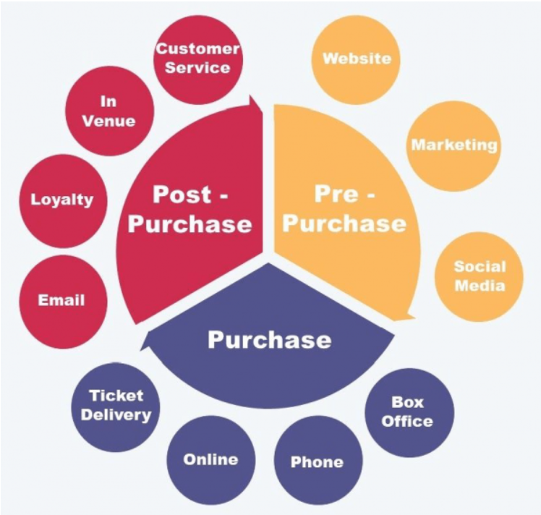
3.4. Customer Touchpoints
Figure 5: Customer Touchpoints (D'Esopo, 2009)
Pre-purchase touchpoints are encounters that a customer has with a company or brand prior to completing a purchase. Some of the pre-purchase touchpoints for Samsung include:
• Advertising: To advertise its goods and attract potential customers, Samsung employs a variety of advertising channels, including TV commercials, web ads, and billboards (Roggeveen, 2020).
• Website and social media: Customers may learn more about Samsung's goods, including specs, reviews, and price, on the company's website and through its social media platforms (Roggeveen, 2020).
• Retail outlets: According to Roggeveen (2020), Samsung has a network of outlets where customers can see and touch things in person, get help from salespeople, and make purchases
• Customer service: To help consumers with their questions and problems, Samsung provides a variety of customer support channels, including phone, email, live chat, and social media.

Post-purchase touchpoints are interactions a consumer has with a business or brand following a transaction (Roggeveen, 2020). Some of the post-purchase touchpoints for Samsung include:

• After-sales service: To ensure customer happiness and loyalty, Samsung offers after-sales services such repairs, warranty claims, and replacement of damaged goods.

• Customer input: In order to improve its offers and customer experience, Samsung asks for feedback on its goods and services from its customers.

• Social media: Samsung interacts with consumers on social media to respond to queries and concerns. The actual transaction or buying procedure is referred to as the purchase touchpoint.

• Online stores: The firm offers online shops where customers may buy its items directly.

• Retail outlets: Samsung has a network of retail locations where customers may make in-person purchases.

• Payment choices: To make shopping easier for customers, Samsung offers a number of payment alternatives, including credit cards, debit cards, and mobile payments.

4. Total Engagement model

Samsung uses a framework called the Total Engagement Model to interact with clients at every point of their journey. It wants to interact with its clients and develop enduring bonds with them (Jayasingh, 2015). The Total Engagement Model concentrates on many elements that support this goal:

Customer value proposition: Innovation and quality are what make Samsung stand out from the competition. The business is renowned for bringing cutting-edge technology and offering premium goods that satisfy the demands and tastes of customers. This distinctive value offer sets Samsung apart from its rivals and aids in building a devoted consumer base.

Branding: The goal of Samsung's branding is to connect emotionally with its audience. The brand's messaging demonstrates the company's dedication to innovation, quality, and client pleasure. The logo and name of Samsung, along with other branding components, are essential to building brand identification and awareness (Iblasi, 2016).

Internal culture elements: The culture of Samsung is centred on delivering a happy and collaborative work environment that appreciates human resources. The company's staff rules, training, and development programmes all reflect this culture. Customer service and experiences may improve with a happy and engaged team.

Customer service: Samsung is dedicated to provide top-notch customer service. This entails meeting or surpassing customer expectations, providing goods and services on schedule, and promptly and effectively resolving any problems or challenges clients might have. The goal of Samsung's customer experience strategy is to increase customer loyalty and trust. By concentrating on these elements, Samsung may develop a Total Engagement Model that aids the business in engaging with clients at all touchpoints, cultivating a sense of loyalty, and eventually raising long-term revenues. Working as a team and consistently enhancing the customer experience via innovation and quality are the keys to establishing this synergy (Iblasi, 2016).

5. Recommendations and Conclusion

To sum up, businesses should take into account the following suggestions in order to develop creative marketing strategies and efficiently manage the client journey: To guarantee that customers' expectations are satisfied across their entire interaction with the company, place more emphasis on the customer journey than simply certain touchpoints. Use a whole engagement model that highlights the benefits of customer engagement and satisfaction, as well as the essential components of branding, corporate culture, and customer experience. Create a thorough framework for constructing brand equity, producing pleasant brand experiences, and encouraging brand loyalty by incorporating Keller's Brand Equity Model into the Total Engagement Model. Make strategic decisions based on these insights by using a data-driven strategy to track and assess brand equity and customer satisfaction indicators.

In conclusion, companies can develop creative marketing strategies and successfully manage the customer journey to meet the expectations of both present and future stakeholders by adopting a holistic approach to the customer journey, prioritising customer engagement and satisfaction, and using models like the Total Engagement Model and Keller's Brand Equity Model.

6. References
Batra, M., 2017. Customer experience-an emerging frontier in customer service excellence. In Competition Forum. American Society for Competitiveness., 15(1), pp. 198-207.
D'Esopo, M., 2009. Mapping the Customer's Experience Through Brand Design. Design Management Review, 20(4), pp. 38-47.
Diputra, I., 2021. The influence of product quality, brand image, brand trust on customer satisfaction and loyalty.. American International Journal of Business Management (AIJBM), 4(1), pp. 25-34.
Gelder, V., 2005. The new imperatives for global branding: Strategy, creativity and leadership. Journal of Brand Management, 12(5), pp. 395-404.
Gnewuch, U., 2017. Towards Designing Cooperative and Social Conversational Agents for Customer Service, s.l.: In ICIS.
Harwood, T., 2015. An investigation into gamification as a customer engagement experience environment., s.l.: Journal of Services Marketing.
Iblasi, W., 2016. The impact of social media as a marketing tool on purchasing decisions (Case study on SAMSUNG for electrical home appliances).. International Journal of Managerial Studies and Research, 4(1), pp. 14-28.
Jayasingh, S., 2015. Customer engagement factors in facebook brand pages.. Asian Social Science, 11(26), p. 19.
Jing, Z., 2014. The relationship of brand equity dimensions: A case study of Samsung brand in Thailand.. European Journal of Business and Management, 6(16), pp. 182-189.
Juska, J., 2021. Integrated marketing communication: advertising and promotion in a digital world. s.l.:Routledge.
Mele, C., 2021. The millennial customer journey: a Phygital mapping of emotional, behavioural, and social experiences. Journal of Consumer Marketing..
Ramiz, M., 2014. The comparative analysis of the factors effecting brand loyalty towards Samsung products.. Journal of Sociological Research, 5(1), pp. 327-349.
Reason, B., 2015. Service design for business: A practical guide to optimizing the customer experience., s.l.: John WIley & Sons.
Roggeveen, A., 2020. Customer-interfacing retail technologies in 2020 & beyond: An integrative framework and research directions.. Journal of Retailing, 96(3), pp. 299-309.
Samsung Group, 2017. Samsung - Company Report, s.l.: Business Research Methodology.
Samsung, 2023. Our Mission & Values. [Online]
Available at: https://www.samsung.com/levant/about-us/company-info/
[Accessed 10 April 2023].
Samsung, 2023. Taking the lead in tech innovation. [Online]
Available at: https://www.samsung.com/us/aboutsamsung/
[Accessed 10 April 2023].
Tsai, S.-p., 2005. Integrated marketing as management of holistic consumer experience.. Business Horizons, 48(5), pp. 431-441.
Tsordia, c., 2018. The influence of sport sponsorship on brand equity and purchase behavior.. Journal of Strategic Marketing, 26(1), pp. 85-105.
Wikipedia, 2023. Samsung. [Online]
Available at: https://en.wikipedia.org/wiki/Samsung
[Accessed 10 April 2023].
Yoo, B., 2001. Developing and validating a multidimensional consumer-based brand equity scale. Journal of business research, 52(1), pp. 1-14.

