Eleanor Coster
1815668

Data Analysis

This section contains the results of a study conducted to’ answer the research question: ‘How effective is communication between the Police, Fire and Ambulance Services at terrorist attacks in contemporary Britain?’ This section also includes discussion that the analysis conducted was consistent with the literature reviews and methodology and how the research ties back to the research questions. In addition to this, this section will also include sample demographics, using tables and charts to complement the summary. Google Forms was used to help analyse 249 individual responses in order to discover specific themes in this section. Google forms was the chosen method of data collection because it allowed a range of standard, multiple choice, check boxes, liner scales and open ended questions to be incorporated into the questionnaire. This method also allowed information to be shared with the participants at the beginning of the questionnaire stating why the study was being conducted and any ethical considerations. Google forms automatically saves answers in the response tab, showing the summary of graphs and lists of answers giving as much detail as necessary. Even though no personal data was collected, Google forms was chosen due to the safety element and responses can only be accessed through a google account log in. This questionnaire consisted of 19 questions, with the majority being closed and was sent out via a web link. This allowed for a wide range of participants to be contacted, quickly and efficiently in order for them to have easy access to the questionnaire. The online questionnaire is primarily quantitative, although there were 3 questions which were open ended which resulted in a small amount of qualitative data collection, therefore allowing participants to provide their own views and opinions on the area of study.
As ‘Demographic, ‘Communication’ and ‘Training’ were identified as key themes throughout both the questionnaire and responses (open and closed), the responses will be discussed in this order and can be viewed in the appropriate appendices.
Theme one, the demographics, links questions 1, 2, 3 and 4. This allows data to be grouped together in relation to the number of participants there were from each service, how long they have served for, what rank they are and if they have worked for more than one service before. Demographics play a vital role in the analysis of the data as it required a wide range of respondents across all three services, as well as a wide range of experience to increase the validity of the results. This was achieved by sharing the questionnaire across a number of different platforms, which allowed it to be accessed by the appropriate target audience. The platforms used were internal mail boxes, social media (some closed emergency services pages) and sharing the link amongst colleagues on shift. In total 249 responses were received as broken down below. Raw data is given in appendix 1. All three emergency services are represented relatively equally in the sample, with 97 (39.4%) Police, 87 (35.4%) Ambulance, 60 (24.4%) Fire and with 2 (0.8) preferring not to say. The total years of experience vary between services and individuals, with the majority of participants having between 0-5 years of experience representing 35.1% (61 participants) and 24.6% of the sample size having 21+ years of experience. This shows a vast range of experience from questionnaire responders from all three services have taken the time to complete the questionnaire allowing for more detailed and reliable data to be collected. As well as this, 39 or (15.7%) of participants stated that they have worked for more than one of the emergency service meaning that 207 participants (83.5%) have only ever worked for one service, leaving 0.8% of the participants preferring not to say.
Theme 2, relating to communication links the majority of questions from the questionnaire together creating the main theme of the study. Questions 5, 6 , 7, 8a/b, 9, 10, 13, 14, 15, 16, and 17 all relate to communication, whether that be communication methods, how effective communication is currently between services and if participants feel communication can be improved. The majority of participants who answered question 4 (83.5%) stated that they have not worked for more than one emergency service, where as 15.7% stated they have. This links into question 5 (appendix 2), as 47.6% of participants who answered yes to question 4, stated that this benefitted them when communicating with other services at joint incidents. This data supports the consideration that participants feel they communicate better with other services if they have a working understanding of other roles and knowledge of their needs and priorities at calls. Questions 6 and 13 (appendix 3, and appendix 4) provide data in relation to participants communicating with other services at a joint emergency service scenes and how effective this communication was, 98% of participants stated that they have personally communicated with another emergency service with only 2% saying they have not. This shows all levels of service members communicate at scenes, with 92.9% of communication being face to face and that experience does not impact on participating in varying communication. The vast majority of respondents (42.3%) to question 13 (appendix 4) stated that they feel communication was good when they interacted with other services. However, 33.9% of participants felt communication was average and similarly, 14.1% felt that communication was poor or very poor. These percentages appear quite worrying, as although the majority of participants feel communication is good currently between services, a vast amount of respondents feel communication is not as effective as it should be. Question 9 (appendix 5) also supports this data as 39.4% of participants stated that they have been involved in a joint emergency service incident where due to poor communication between services an error/misunderstanding has occurred. This supports the findings of (The Kerslake Report, 2017) as it argues “it was a combination of poor communication and poor procedures” that lead to failures. This has also been supported in the literature review section. Questions 15 and 16 (appendix 6 and appendix 7) relate to multi-agency reviews after incidents and if there were any specific communication concerns brought up between services, of which 88 participants have been involved in a multi-agency review post incident with 44 of these stating that concerns around communication were brought up.

The final theme discussed is around ‘Training’ which is an important element to include within the questionnaire as it is essential requirement for all staff of all levels. Of the 249 responses received, 42.5% had received no training in relation to multi-agency communication. Although the JESSIP principle exists, it appears that many are unaware of it, or how it can benefit day to day communication, which will in turn contribute to the break down in communication at any incident. Of those who had received any kind of training on communication within their role there was a large split between the forms of training received with workshop style learning and online learning combined receiving 61.8% of the responses with only 22.9% of participants stating that they had received practical/drill style training on communication. A few responses in question 11b (appendix 8) stated that they had received ‘all of the above’, but this was only 8 of the participants who had stated that they had received any form of training.
Question 12 and question 19 (appendix 9 and appendix 10) strongly suggests that communication can be improved by means of training, as over 88% of participants stated that additional or more comprehensive training between emergency services is necessary (question 12) and again over 88% of participants stating that they would benefit from joint emergency services training days which would be face to face (question 19) as a method of this training being delivered. From the open question feedback received, the common responses were focussed around the need to increase confidence in multi-agency communication, understanding of other emergency services methods of communication as well as industry specific language, awareness, knowledge and appreciation of the varying styles of communication between services. One participant stated that “Understanding the working strategy from other services around specific incidents would benefit my knowledge of how to collaborate more effectively with joint services...”. This also supports the findings of a published document (Crown copyright, 2006) who stated that further steps need to be taken “including commissioning a review of training needs, to promote a better understanding by responders of the roles and responsibilities…”. This also supports the data collected and findings in the literature review.
This research question was developed due to the apparent lack of communication between Police, Fire and Ambulance at terrorist attacks, and as a whole, the findings of this study have supported this. The literature reviewed allowed opportunity to site what literature was already available, as well as highlighting gaps in the research which could be filled with reliable data. In relation to training it has become apparent that having an understanding of what other services do, provides a better understanding of communication. Nearly all those who have worked from another emergency services stated that it benefitted them with knowledge, communication and understanding, this has been supported in questions 4 and 5. As the data collection progressed, it became apparent that the majority of participants felt that communication was good between services. This is one area which goes against the initial study outcome as it indicates that communication is good enough and members of all three services feel happy and content with the standard of communication between them. However, there is still a large amount of participants who feel communication was poor, which has been evidenced in question 13. Analysing data from question 8a which confirmed that most people communicated face to face, and data from question 11a which stated that most people received training online or workshop format (as opposed to scenario/drill training)fully support the feedback from question 19 which has suggested that multi-agency, ‘in person’ training days was going to be the most effective way to improve communication training, and therefore communication at incidents, as this is a more realistic way of delivering training.
(1677)

Bibliography:
Crown Copyright, 2006, Addressing lessons from the emergency response to the 7 July 2005 London bombings, What we learned and what we are doing about it, 22 September 2006, pg.20, viewed 1st October 2021. https://jesip.org.uk/uploads/media/incident_reports_and_inquiries/Addressing%20Lessons%20from%20London%207th%20July%202005%20Bombings.pdf

The Kerslake Report, An independent review into the preparedness for, and emergency response to, the Manchester Arena attack on 22nd May 2017, The major areas of learning, pg.8, viewed on 22nd September 2021. https://www.jesip.org.uk/uploads/media/Documents%20Products/Kerslake_Report_Manchester_Are.pdf

Appendix:

Appendix one
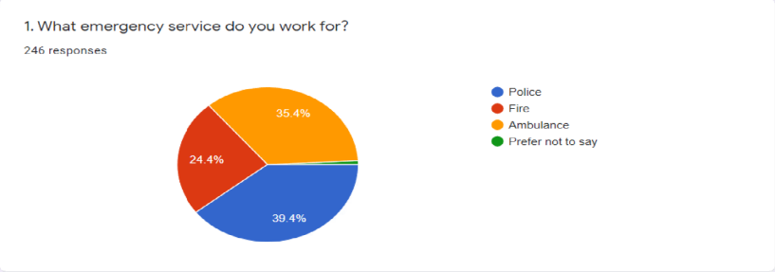
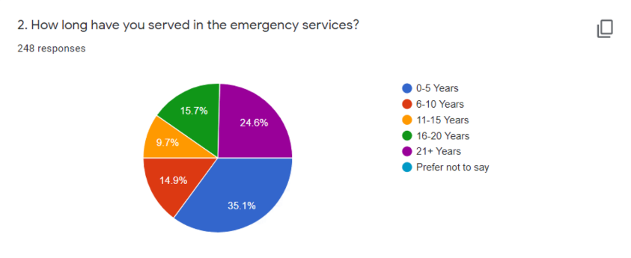
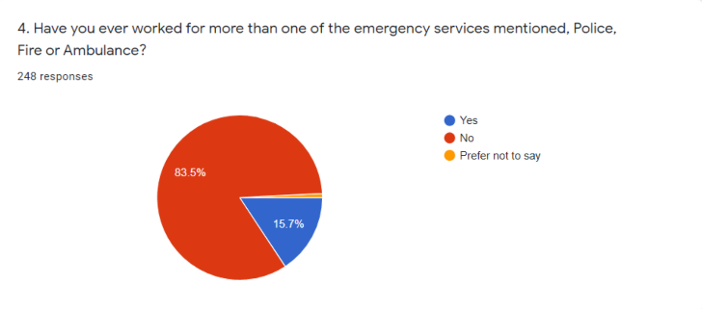

Appendix 2
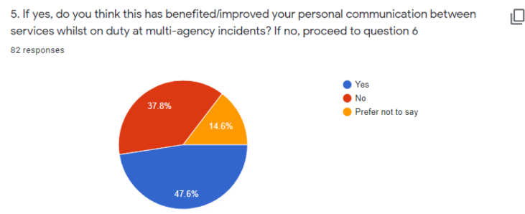

Appendix 3
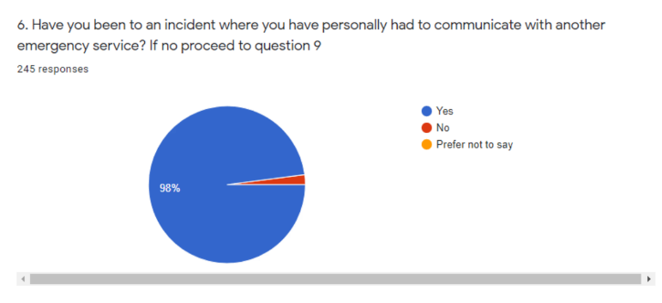

Appendix 4
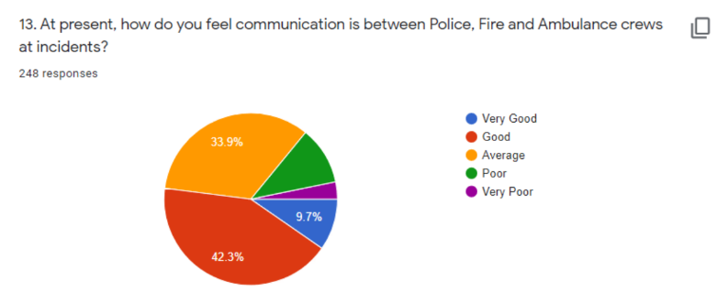

Appendix 5
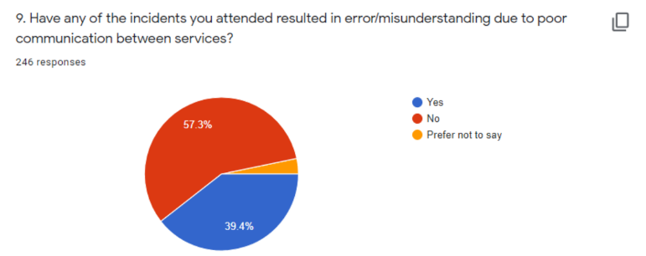

Appendix 6
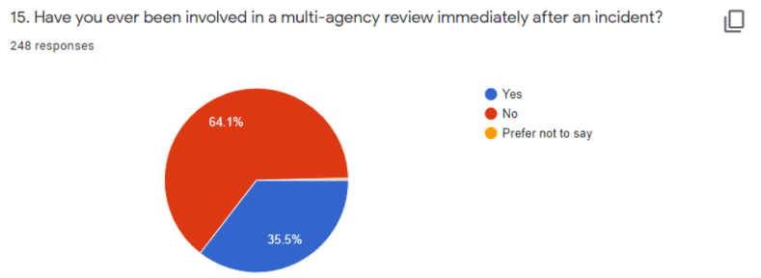
Appendix 7
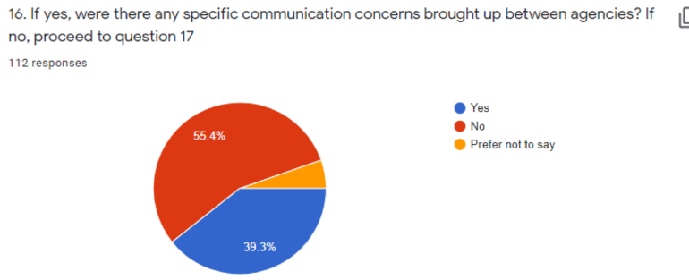
Appendix 8
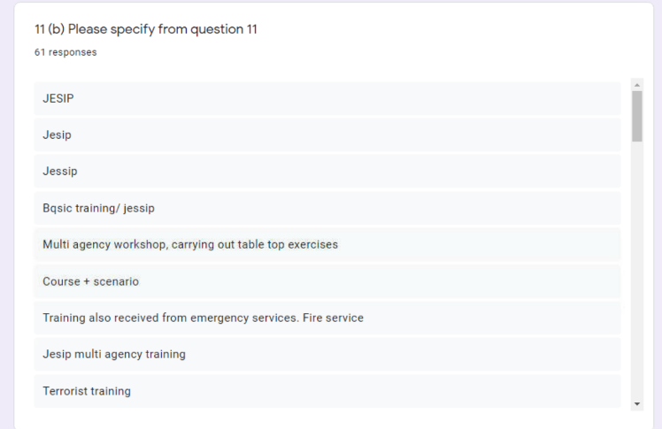
Appendix 9
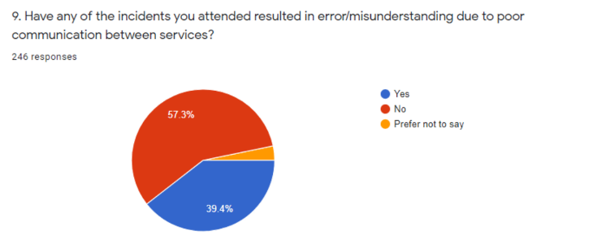

Appendix 10
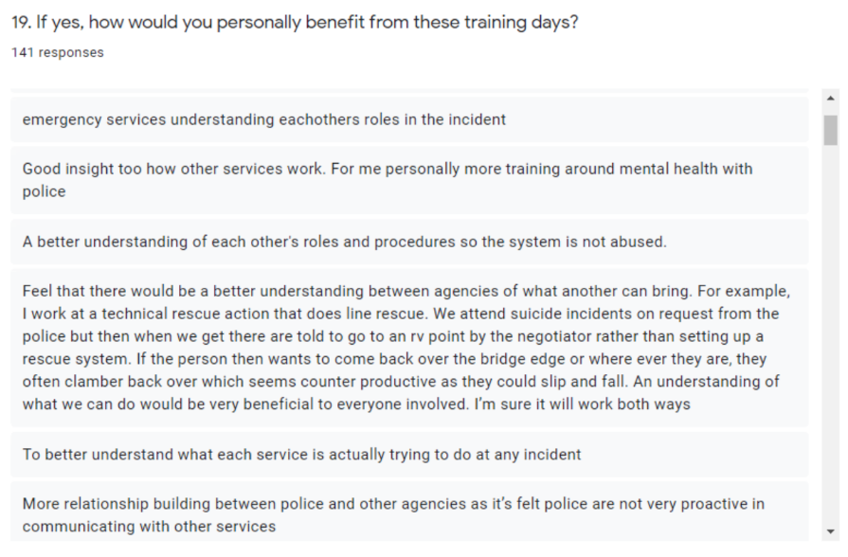

Appendix 11


