Gabe Morris
Carmarthen Business School
Contemporary Manageent Approaches Assessment One (BMSP4013)
Lecturer: Glenn Behenna

A Study of the Samsung Organisation

Introduction

This report is about the organisation Samsung. In this report I will attempt to analyse its organisational structure. In order to do so I will look at many different areas in relation to organisational structure. For example, Samsung’s organisational context, approaches to organisation and management, work and satisfaction and lastly perception and communication.

Organisation Background

Samsung is a company that originated in South Korea and was founded by Lee Byung-Chull on the 1st of March in 1938 (Peter Bondarenko, no date). The company started out as a grocery store and has changed dramatically over the years it’s been in operation. In the beginning, Samsung’s operations were store andselling grocery goods, and exporting them to China. Later, after the Korean war ended in 1953 (EisenhowerLibrary, no date) Lee Byung-Chull decided to expand the business into textiles (P.B, no date).

It first expanded into what it’s known for today, technology, with the production of black and white televisions in 1969 (P.B, no date). The company has since expanded tremendously and is now one of the most well-known technology companies globally.

Samsung’s Organisational Structure

An organisational structure is an important element of every successful business, that allows them to operate efficiently and smoothly. Having a clear structure for an organisation will assist in its every-day operation and also in the decision-making process (Allaya Cooks-Campbell, 2022).

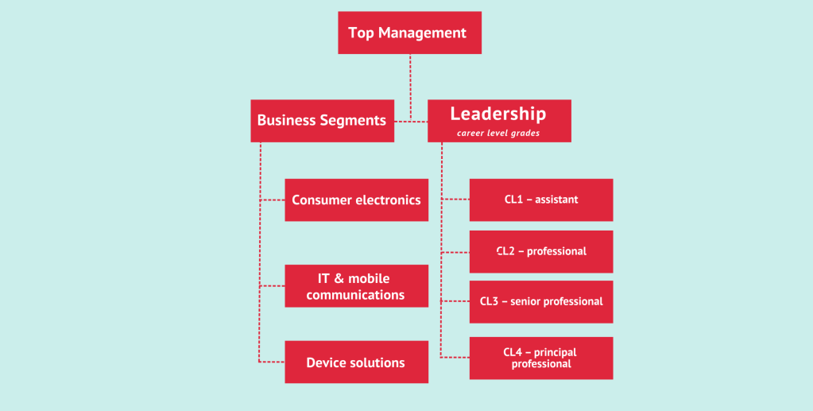
FourWeekMBA (2022)

Above is a diagram of Samsung’s organisational structure from the website FourWeekMBA (2022). The website states that Samsung has adopted a product-type divisional organizational structure. This is where business operations and resources are grouped, determined by the different types of products the business is selling. The diagram shows three examples of product categories Samsung has in their organisational structure. These being consumer electronics, IT & mobile communications, and device solutions.

Samsung’s decision to structure themselves in this way is predominantly down to the wide range of different goods they provide. Structuring in this way is advantageous to them, because by separating different products into different divisions they can specialise in their large variety of products (nibusinessinfo, no date). This is a very positive thing, because it gives each product division a better opportunity to be successful individually, because there will be a focus on solely that product type. More focus on each product type individually will lead to a better understanding of the needs of customers, better knowledge of industries, and an more understanding of the market they’re selling in (nibusinessinfo, no date). They will also be able to adapt to changes in the market/industry much faster, with a higher chance of success.

Approaches to Organisational Management

Before studying Samsung’s approach to management, I want to take a look at the three main management theories that are most well known. These are the theories by theorists; Max Weber, Frederick Taylor and Henry Fayol (OCC, 2017).

These three theorists were active during the industrial revolution. They came to action with the growing abundance of factory jobs, because such jobs were unknown to most people, and the management of factories was something no one had experience with, to the scale it grew to. Differently to before, large numbers of individuals were having to work along side each other, as part of a system. They were also having to work with machinery. Conversation was sparked about how companies should go about managing these people, as it was an unusual circumstance for the time. Many wondered how these factories should be managed, so that they were as efficient and organised as possible.

The first theorist, Max Weber believed in a straightforward way of management, that focused on accomplishing tasks and goals in the most efficient way possible. To do this he instructed that companies should be giving their workers strict guidelines and instructions, so that they were doing exactly what was necessary. In his opinion, this would be the best way of managing a large group of people, because all members of the workforce are solely focusing on their part of the process. He also believed in strict rules on hiring and firing employees, to ensure that the process didn’t lose efficiency.

Frederick Taylor contributed to the discussions with his belief that all tasks should be done in the one ‘correct way’. This being the most efficient way. He believed that if all workers are doing their jobs exactly as instructed then their work will completed as quickly as possible, making the process as a whole more efficient. Taylor devoted time to what he referred to as ‘time and motion studies’. These studies were to find the total time and number of motions each action and ultimately, task should take to reach completion.

Theorist Henry Fayol had a different focus. His aim was to instruct the way that the managers themselves should go about their duties. He said that good managers should be able to plan, organise, command, coordinate and control.

Samsung Approach to Management

Finding information about the approach Samsung takes to managing its employees proved quite difficult. However, I was able to find an interview by McKinsey Quarterly (2020) with Won-Pyo Hong, which shared some insight into his approach to management. Won-Pyo Hong is the CEO of Samsung’s information and communications technology arm. In response to a question about the future technological innovations of the company, he talked about how the company uses automation, and is improving in that area. He said the purpose of the automation was to increase efficiency, but not only for the sake of the company itself. It's true that an increase in efficiency will benefit the company greatly and will especially help with the labour laws in South Korea, which limit an employee to work a maximum of 52 hours a week. The automation will help make sure the employees can complete their work within their given hours. Won-Pyo Hong continued, stating that this doesn’t mean employees will be given a lot more tasks to complete. He talked about how the fact that employees will finish their work faster than scheduled, will mean they have time to spend on courses that will aid them in completing the more difficult and complicated tasks. This is also beneficial to the employees, because it means they have an opportunity to improve their knowledge and skills.
Looking at what Won-Pyo Hong stated in the interview, I find some similarity in the beliefs of Max Weber. It seems that the focus of both is to complete tasks as efficiently as possible. This is apparent in the introduction of automation in the workplace, so that employees are able to complete tasks quicker.
Their approach is quite different to that of Frederick Taylor, who believed that things should be done in the ‘one right way’, but considering the inclusion of automation the workers might be coming close to working in the perfect way, in the company’s eyes. Of course, this is because the automation will support them along the path that Samsung has laid out, and will ensure tasks are completed in the way Samsung desires.

Motivation, Satisfaction and Culture
“The three motivators are affiliation, achievement and power.”. This is the theory of McClelland and the belief of Samsung Electronics (MySamsungMyLife, 2013).
Affiliation refers to the relationship between the employees, which Samsung say they work hard to ensure, because they provide a good environment for their workers. They also say that many of the workers have said their co-workers “have an excellent culture”, which shows that most of the workers are motivated to work (MySamsungMyLife).
According to the theory, another motivation for workers is achievement (MySamsungMyLife, 2013). Samsung, being a very successful company, has achieved many things over the years, and has even won awards. The company’s belief is that these achievements are another motivator for the employees, because they want the company to do well, they feel they are a part of the company’s success, and that they have contributed to the world in that regard.
The final motivator according to the theory is power. Just like many companies, Samsung motivates its workers by promoting the ones that show hard work and commitment. They state that they give equal opportunities to all, regardless of gender or disability.

Perception and Communication
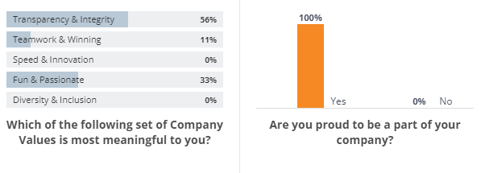
Samsung – Comparably (no date)
The statistics above are the results of a short survey that was made by Samsung for its employees. The existence of the survey is proof that Samsung is attempting to improve employee experience, and is trying to listen to their opinions.
The first question shown asks what, of the company’s values, is the most meaningful to the worker personally. We can see that no employees answered ‘Speed & Innovation’, likely because that is more important for the company itself. There was also 0% responses with ‘Diversity & Inclusion’.
Regardless, the important part to note about these results is that they are split. This is proof of differing opinions, perceptions and ideals among the employees. The following question asked about their happiness at the company, receiving 100% ‘yes’. This is proof that, despite the employees having different perceptions, they are all happy to be working at Samsung. This likely means that Samsung has taken actions to accommodate different types of people.

Conclusion
The purpose of this report was to study Samsung as an organisation, its structure and its approaches. Looking at the information I’ve found, it seems Samsung is an organisation that prides itself in its efficiency, but also in its relationships with employees. Despite being a highly successful company, that is a part of many peoples everyday lives today, its clear they have many goals that aren’t directly tied with the business’ financial gain.
Word Count: 1623
References

Peter Bondarenko, P.B. (no date). Samsung https://www.britannica.com/topic/Samsung-Electronics

EisenhowerLibrary (no date). Korean War https://www.eisenhowerlibrary.gov/research/online-documents/korean-war#:~:text=On%20July%2027%2C%201953%2C%20seven,II%20at%20the%2038th%20parallel.
FourWeekMBA (no date). What is Samsung’s Organisational Structure? https://fourweekmba.com/samsung-organizational-structure/#:~:text=Key%20takeaways%3A-,Samsung%20has%20a%20product-type%20divisional%20organizational%20structure%20where%20products,What%20is%20this%3F&text=Samsung%20consists%20of%20three%20product,mobile%20communications%2C%20and%20device%20solutions.
Allaya Cooks-Campbell A.C. (2022) Organizational structure: Your guide to configuring and growing teams https://www.betterup.com/blog/organizational-structure#:~:text=Organizational%20structures%20are%20important%20because,can%20make%20better%20decisions%20faster.
nibusinessinfo (no date). Business Organisational structure https://www.nibusinessinfo.co.uk/content/organisational-structure-product#:~:text=What%20is%20a%20product-based,the%20customers%20they%20deal%20with
Organisation Communication Channel (2017) Classical Management Theory https://youtu.be/d1jOwD-CTLI
McKinsey Quarterly (2020) How the CEO of Samsung SDS sets a course for ‘humble and speedy’ https://www.mckinsey.com/featured-insights/asia-pacific/how-the-ceo-of-samsung-sds-sets-a-course-for-humble-and-speedy
MySamsungMyLife (2013) Motivation https://mysamsungmylife.wordpress.com/motivation/#:~:text=The%20three%20motivators%20are%20affiliation,McClelland%20theory%20it%27s%20called%20affiliation.
Samsung - Comparably (no date) Samsung Employee Engagement https://www.comparably.com/companies/samsung/employee-engagement

