
University of Wales Trinity Saint David
School of Engineering
BEng Advanced Manufacturing Operations
Thomas Hughes
1909575
Major Project ACMA6013

Major Project: End of Line Washroom Improvement Project

Abstract
The project's initial assessment based on the Final Clean equipment controls indicated that it was straightforward. The business believed that if the temperature deviated outside the specified range, the wash tank timers would pause and restart upon returning to the specified range, thus ensuring the absence of product risk associated with temperature deviations.
However, subsequent investigations revealed that the wash controls behave differently and do not perform in accordance with the Qualification documents; additionally, the process-related documentation are old and outdated and fails to provide employees with the clear instruction required for such a critical activity.
Rework and scrap related with the final clean lines are extremely high, having surpassed the £1,000,000 mark in Q1 of 2022 alone; such volumes are unsustainable for any business. More importantly, the high volume of defects is affecting employee performance and well-being. The goal of this project is to investigate all aspects of the process, identify root cause(s), and implement corrective actions to eliminate or greatly reduce recurrence of the temperature falling out of specification.

Acknowledgement
I would like to express my sincere gratitude to those who have made significant contributions to my degree apprenticeship program at the University of Wales Trinity Saint David (UWTSD). Firstly, I extend my heartfelt appreciation to my wife, Rebecca, for her support throughout the program. Juggling the responsibilities of caring for our four children and providing me with the necessary space to concentrate on my studies was not an easy feat. I am deeply grateful for her sacrifices and support.
Secondly, I would like to express my gratitude to Zimmer Biomet for providing me with the opportunity to pursue this esteemed qualification and for their continued support. I am particularly grateful to my line manager, Anthony Harrison, who provided me with invaluable support and guidance throughout my studies. Additionally, I would like to acknowledge the support and camaraderie of my colleagues, Andrew Chick and Stuart Jones, who embarked on this journey alongside me.
Thirdly, I would like to thank the staff at UWTSD for their patience and support throughout this program. Studying amidst the COVID-19 pandemic presented numerous challenges, but the dedication and commitment of the staff members in delivering quality education remained committed. I would like to extend special thanks to Andrew Thorne, my supervisor, for his support, including traveling for face-to-face meetings at the workplace and conducting virtual meetings over Teams.

Declaration of Authenticity
‘This thesis is the result of the author’s original research. It has been composed by the author and has not been previously submitted for examination which has led to the award of a degree.’

Signed: Date:

Contents
1 Abstract 2
2 Acknowledgement 3
3 Declaration of Authenticity 3
4 Contents 4
5 List of Figures 7
6 List of Tables 8
7 Literature review 9
7.1 Cost of Poor Quality (COPQ) 9
7.2 Costs of Preventing Poor Quality 10
7.3 Internal Costs of Poor Quality 10
7.4 External Costs of Poor Quality 11
7.5 Hidden Costs of Poor Quality 12
8 Introduction 14
8.1 Zimmer Biomet 14
8.2 Zimmer Biomet Bridgend Manufacturing Plant 15
8.3 Background of The Project 17
8.4 Aims & Objectives 17
8.5 Timing Plan 18
9 Introduction To The Corrective and Preventative Action Process. 18
9.1 CAPA Definition 18
9.2 Zimmer Biomet Quality Management System EtQ 19
9.3 Zimmer Biomet CAPA Process 19
9.3.1 Initiation 20
9.3.2 Containment 20
9.3.3 Investigation & Root Cause 20
9.3.4 Action Implementation 21
9.3.5 Verification of Effectiveness (VoE) 21
10 Introduction to the Final Cleaning process. 22
11 CAPA Project - CA-06458 24
11.1 Initiation 24
11.1.1 Background 24
11.1.2 Problem Statement 24
11.1.3 Risk Scoring 24
11.2 Containment 25
11.2.1 Process Containment 25
11.2.2 Product Containment 25
11.3 Investigation & Root Cause 26
11.3.1 Investigation Plan 27
11.3.2 Investigation results 27
11.3.3 Review validation documents for temperature impacts on part cleanliness. 27
11.3.4 Investigate the Final Clean line 1& 2 equipment controls to understand how they operate during out-of-specification temperature events. 27
11.3.5 Investigate how operators conduct the daily process monitoring. 30
11.3.6 Summarise all non-conformances relating to the final clean lines. 31
11.3.7 Analyse Scrap/Rework data for wash line defect trends. 31
11.3.8 Review Process Failure Mode Effect and Criticality Analysis (PFMECA) 37
11.4 Root cause analysis 37
11.4.1 Cause and Effect Diagram 38
11.4.2 5 Why’s 40
12 Zimmer Biomet Case Study 42
12.1 Zimmer Biomet Bridgend - Cost of Poor Quality 2022. 42
12.2 Employee Survey 42
12.3 Survey Conclusion. 46
12.4 Implementation plan 47
13 Action Implementation 48
13.1 Interim Control 48
13.2 Simplification of Documentation 50
13.3 Process Failure Mode Effect Criticality Analysis (PFMECA) 51
13.4 Process Monitoring Form Design 52
13.5 Business Case For Ultrasonic Upgrade 54
13.6 Dissemination of information 55
13.6.1 Action plan approval 55
13.7 Verification of effectiveness (VoE) 55
13.7.1 VoE Plan 56
13.7.2 VoE Result 57
13.7.3 Final risk summary 60
14 Results 60
14.1 Rework Reduction 60
14.2 Improved productivity 62
14.3 Improved Sustainability 62
14.4 Improved Employee Moral & Wellbeing 63
15 Discussion and conclusions 65
16 Recommended further work – Final Clean 2 Upgrade 65
16.1 Purpose 65
16.2 Benefits 66
17 References 67

List of Figures

Figure 1 - Zimmer Biomet Guiding Principles 14
Figure 2 - Zimmer Biomet, Bridgend Plant. 15
Figure 3 - Examples of the Taperloc & G7 Hip Implant Family 15
Figure 4 - Examples of the Oxford Partial Knee Implant 16
Figure 5 - G7 Acetabular Process Flow 16
Figure 6 - CAPA-06458 Gantt Chart 18
Figure 7 - CAPA Process Flow 19
Figure 8 - Final Clean Line Current State Drawing 23
Figure 9 – Pie Chart – Bridgend Site Total Scrap 32
Figure 10-Pie Chart – Bridgend Site Total Rework 33
Figure 11 – Scrap Pareto Analysis for Reason codes 34
Figure 12 - Scrap Caused by Exceeded Process Time 35
Figure 13 – Rework Pareto Analysis for Reason Codes 35
Figure 14 - Out of Specification Rework Analysis 36
Figure 15 - Ishikawa Diagram 38
Figure 16 - SonoCheck Vial 40
Figure 17 - 5 Why's relating to Ultrasonic Failures 41
Figure 18 - Employee Survey Question 1 Result 43
Figure 19 - Employee Survey Question 2 Result 43
Figure 20 - Employee Survey Question 3 Result 44
Figure 21 - Employee Survey Question 4 Result 44
Figure 22 - Employee Survey Question 5 Result 45
Figure 23 - Employee Survey Question 6 Result 45
Figure 24 - Employee Survey Question 7 Result 46
Figure 25 - Employee Survey Question 8 Result 46
Figure 26 - Inline Heater Control Panel 48
Figure 27 - Interim Control Log Sheet 49
Figure 28 - New Installation of Audible Alarm To The Control Panel 50
Figure 29 - Final Clean Process Monitoring Log Revision 13 52
Figure 30 - Final Clean Process Monitoring Log Revision 14 53
Figure 31 - Verification of Effectiveness Results 59
Figure 32 - Verification of Effectiveness Results 59
Figure 33 - Verification of Effectiveness Results 60
Figure 34 - Out of Specification Rework Reduction 61
Figure 35 - Productivity Performance 62
Figure 36 - Project Close Employee Question 1 63
Figure 37 - - Project Close Question 2 64
Figure 38 - Project Close Question 3 64
Figure 39 - NexTgen Ultrasonic Trending Example 65

List of Tables
Table 1 - Final Clean Process Settings 23
Table 2 - CAPA Risk Guidance 25
Table 3 - Final Clean Test and Frequency. 30
Table 4 - Top 2 Causing Work Centres Qty vs Cost 32
Table 5 – Ishikawa Ranking Results 40
Table 6 - Zimmer Biomet 2022 COPQ Results 42
Table 7 - Control Panel Decision Table 49
Table 8 - Sampling Plan Statistical Table for 95% Confidence / 95% Reliability 56
Table 9 - Verification of Effectiveness Results 58

Introduction

Zimmer Biomet
Zimmer Biomet is a global medical device company that designs, manufactures, and markets orthopaedic and musculoskeletal medical devices and related products. The company's products are used in a wide range of medical procedures, including joint replacement, spine surgery, dental implants, and sports medicine.
Zimmer Biomet was formed in 2015 through the merger of Zimmer Holdings, Inc. and Biomet, Inc. The company is headquartered in Warsaw, Indiana, USA, and has operations in more than 25 countries worldwide. Zimmer Biomet employs over 20,000 people globally and serves healthcare professionals and patients in more than 100 countries.
Zimmer Biomet's product portfolio includes joint reconstruction devices such as knee, hip, and shoulder implants, as well as bone cement and related surgical tools. The company also offers a range of spine and dental implants, along with trauma and orthobiologic products.
Zimmer Biomet is committed to improving the quality of life for patients through the development of innovative medical technologies and products. The company is also focused on delivering value to healthcare providers and driving positive healthcare outcomes through its products and services. (Zimmer-Biomet, 2022)
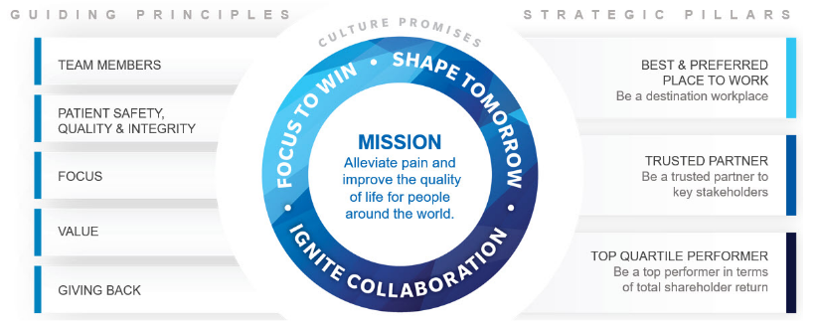
Figure 1 - Zimmer Biomet Guiding Principles

Zimmer Biomet Bridgend Manufacturing Plant
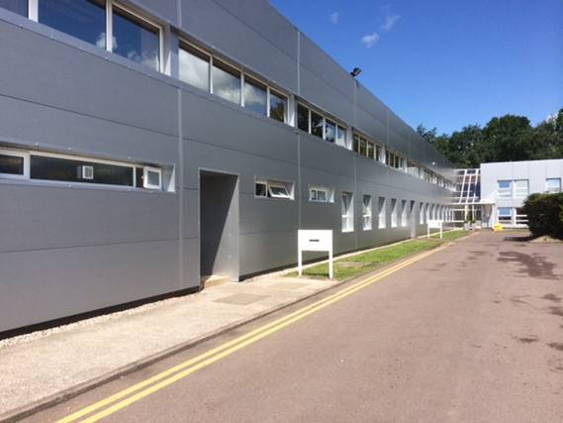
Figure 2 - Zimmer Biomet, Bridgend Plant.
The plant is located at Waterton Industrial Estate, Bridgend, and it is one of Zimmer Biomet's largest facilities in Europe. The Bridgend plant produces a wide range of medical devices and implants, predominantly specialising in knee and hip replacements. The facility is fortunate to manufacture 3 of the most popular branded implants within the Zimmer Biomet corporation, the G7 and Taperloc hip family, and the Oxford Partial Knee. All three account for 80% of the overall sales at the Bridgend plant and are distributed to healthcare providers throughout Europe and other regions around the world.
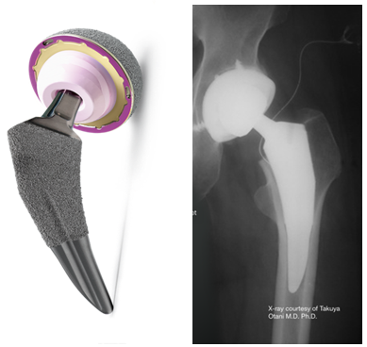
Figure 3 - Examples of the Taperloc & G7 Hip Implant Family
(Zimmer-Biomet, 2022)
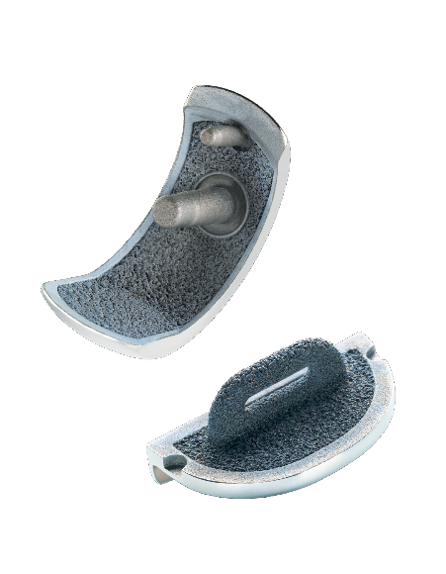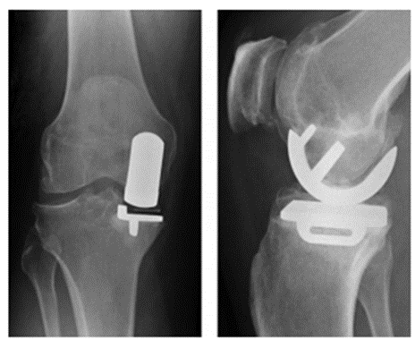

Figure 4 - Examples of the Oxford Partial Knee Implant
(Zimmer-Biomet, 2022)
The facility has a workforce of over 600 employees and is committed to maintaining high standards of quality, safety, and sustainability in its operations. The plant has implemented various environmental initiatives to reduce its carbon footprint and promote sustainability, including a waste reduction program and the installation of solar panels to generate renewable energy. The facility is one of few that has the capability of introducing new product development all the way through to manufacturing of raw material through to washing, packing & distributing directly to the customer.
The Manufacturing plant is split in to three sections, Machining, coatings, and End of Line(EOL). The process flow below shows the route of a G7 Acetabular shell through the site, highlighted in blue is the machining area, Porous coating in green and finally EOL in orange. This paper will focus solely on the EOL area, in particular the final cleaning process.
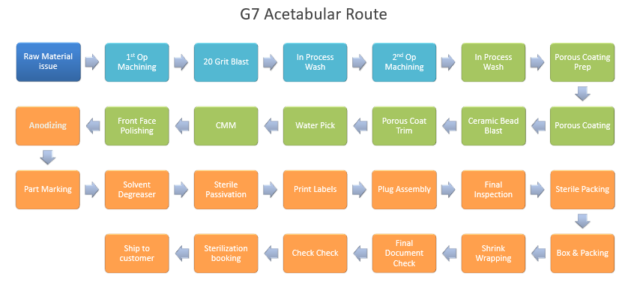
Figure 5 - G7 Acetabular Process Flow

Background of The Project
This independent project relates a number of repeat non-conformances for temperature being out of specification relating to the End of Line Final Clean lines, which is costing the business by having extended downtime and additional cost of rework. 3 events in a short period caused for action to be taken, project CA-06458 was initiated to investigate, identify root cause(s) and provide actions to eliminate or greatly reduce recurrence. CA standing for Corrective action, is part of the Corrective and Preventative Action (CAPA) sub system which are documented and controlled within the EtQ Reliance (Quality Management) System.
The project was believed to be straight forward however, following a thorough investigation many anomalies were identified within the process, in particular what we believed to be the wash line controls thus, throwing question the cleanliness of product and possible impact to the end customer, furthermore the project identified many other failures pertaining to the wash which is having more of an impact on the business than issues relating to temperature.
This paper sets out to explain to work carried out throughout the process all the way to the project being final approved by the Operations and Quality Directors.

Aims & Objectives

Aim
This dissertation aims to address the issue of non-conformances relating to the final clean lines of the manufacturing process, specifically temperature which is resulting in decreased Right First Time (RFT) rates and increased costs due to scrap and rework.

Objectives
- Critically Analyse the validation/qualification documents referring to the Final Clean Lines.
- Identify the root cause(s) of non-conformances in the final clean lines of the manufacturing process related to temperature.
- Analyse process risk
- Propose and implement improvements to the documentation ensuring that the process is easier to follow, more robust, and less prone to errors or non-conformances.
- Reduce costs associated with scrap and rework by implementing the corrective action plan.
- Verify that the changes made are effective.

Timing Plan
Figure 6 provides a snapshot of the Gantt chart used to represent project activities, critical paths and timelines, assisting project managers to plan, schedule, and track project progress. Gantt charts are frequently used in many sectors to help with project planning and management. (Verzuh, 2019)
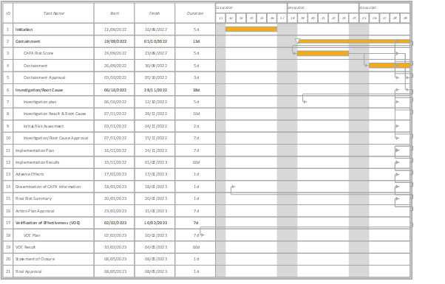
Figure 6 - CAPA-06458 Gantt Chart

CAPA Process.

CAPA Definition
CAPA stands for Corrective and Preventive Action. It is a systematic approach used to identify, investigate, and resolve problems or issues that arise within an organisation's processes, products, or services.
Corrective action involves addressing an existing problem or nonconformance, such as a customer complaint, process failure, or quality issue. The goal of corrective action is to eliminate the root cause of the problem and prevent its recurrence. Preventive action, on the other hand, is taken to prevent problems or nonconformities from occurring in the first place. This involves identifying potential issues or risks and taking proactive measures to address them before they lead to problems. CAPA’s are a critical component of quality management system within Zimmer Biomet. By implementing an effective CAPA process, organisations can improve their products and services, reduce costs, increase efficiency, and enhance customer satisfaction.

Zimmer Biomet Quality Management System EtQ
EtQ is a software company that provides a Quality Management System (QMS) to assist businesses in managing compliance, mitigating risk, and improving quality. The EtQ QMS System is a comprehensive solution for quality management activities such as document control, corrective and preventative action (CAPA), audit management, risk management, and supplier management.

Zimmer Biomet CAPA Process
The CAPA process must be followed to the letter with each phase needing approval from the CAPA owners Department Manager as well as approvals from the Quality Systems Manager and CAPA coordinator.
Managed within the EtQ QMS system, each CAPA is broken down in to the following 5 phases. Figure Shows the process flow with each section of the CAPA.
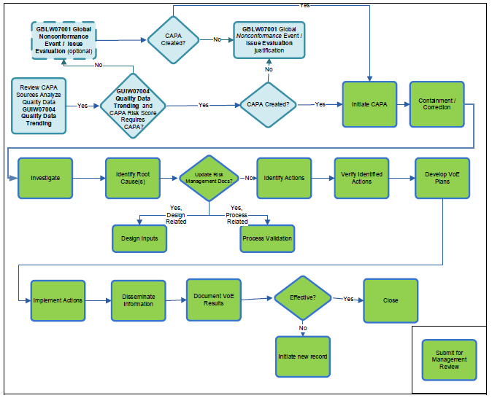
Figure 7 - CAPA Process Flow

Initiation
As part of the initiation, it is decided whether the CAPA is a Corrective action or Preventative action, the owner and approvers are chosen and the Problem statement of the issue is also defined.

Containment
The Containment Phase of the CAPA process must be completed within 10 business days of the CAPA record's creation. This phase involves identifying and implementing initial corrective actions to address the nonconformance, assigning a CAPA/SCAR Risk Score, and documenting the rationale behind the risk score. If the product is impacted or potentially impacted, a product risk management assessment should be carried out. Any necessary containment actions must be identified and documented in the relevant fields, with the Containment Date recorded as the last date of the containment activities. While corrections may be implemented after routing the CAPA record for Containment Approval, an Investigation Plan should be established, with an expected investigation complete date recorded.
The CAPA risk score is determined within this phase, to determine the CAPA risk score, the CAPA risk score procedure is consulted. The guidelines and examples for determining CAPA risk score may vary from site to site and are not exhaustive. The severity and occurrence of the risk are covered by the examples provided within the procedure, and further clarification for the occurrence may be needed using the guidelines for probable, occasional, and remote/limited in nature. It is important to provide objective evidence justifying how the non-conformance/potential non-conformance aligns with the risk of the issue.

Investigation & Root Cause
During the Root Cause/Action Plan phase, the investigator aims to identify and analyse the root cause(s) of a nonconformity or potential nonconformity. To facilitate the investigation, relevant background information is provided, and past data is analysed. Various root cause analysis tools may be employed, and the results are thoroughly documented. In addition, the investigator is responsible for identifying and discussing any issues that may impact other sites, as well as conducting risk assessments and containment efforts as required. The investigator must clearly record the root cause and likely cause, along with the systemic and technical analytical codes. To address the identified issues, an implementation plan is developed, with each action item linked to its corresponding root cause.

Action Implementation
The Implementation Phase of the CAPA involves describing the actions outlined in the Implementation Plan and providing justification for any incomplete items. It is important to ensure that corrective and preventive actions do not compromise regulatory requirements or the safety and performance of the product, and to disseminate CAPA information to those responsible for product quality. A Risk Summary is created based on the actions taken, and the need to update risk management documentation should be considered. The Verification of Effectiveness (VoE) Plan should be reviewed and revised as necessary before submitting the record to CAPA Approvers for approval.

Verification of Effectiveness (VoE)
To ensure that the corrective and preventive actions taken are effective and do not have any adverse effects, it is crucial to establish and document a Verification of Effectiveness (VoE) Plan. This plan will include specific, measurable criteria linked to the problem statement, root cause, and corrective or preventive action. Statistical methodology will be employed when possible to determine the VoE sampling plan, which will also be documented within the CAPA.
Additionally, the expected VoE date based on the required actions should be established and recorded, and all relevant supporting documentation should be attached to the CAPA record. Once completed, the record must be submitted to the CAPA Approvers for final approval and closure is deemed effective.

Introduction to the Final Cleaning process.
The final clean and biologic upgrade process starts by running the parts through a vapour degreaser (VD). The VD submerges the components into boiling solvent while applying ultrasonic agitation. More ultrasonic agitation is applied when the parts enter the rinse tank, before being raised into a solvent vapour zone and finally dried before exiting the machine.
Final Clean lines 1&2 are automatic multi-stage clean and passivation systems. The process is used for surface preparation to remove processing surface contaminants including aluminium oxide grit blast; aluminium oxide dust; glass bead dust; cutting oils; polishing compounds and general surface contaminants. The process contains 16 stages which include an a detergent clean, acid biologic upgrade step, rinsing and drying.
All components are placed in carriers which are fitted to bespoke holding fixtures and operator loaded at the start of the process. The pick and place conveyor moves the carrier through the various stages of the wash system in accordance with the selected process parameters before depositing on an outfeed conveyor.

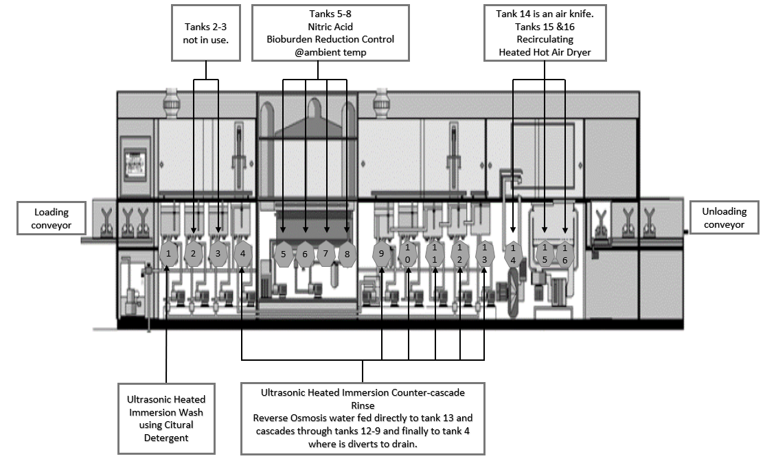
Figure 8 provides current state drawing of FC2 showing (from left to right) the loading conveyer, tanks 1-4, acid back section 5-8, tanks 9-13, air knife step 14, the dryers 15-16 and the reject or unload conveyors. Table 1 provides the process settings of each Final clean.
Figure 8 - Final Clean Line Current State Drawing
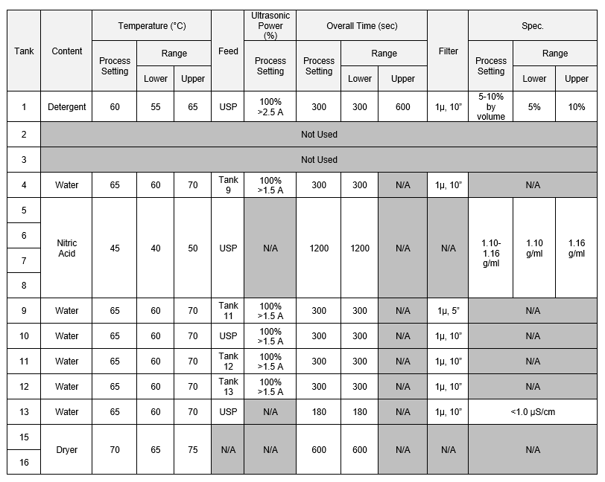
Table 1 - Final Clean Process Settings
(Hughes, 2023)

Literature review

Cost of Poor Quality (COPQ)
Over the years, many scholars and organisations have been interested in the cost of poor quality, with countless studies revealing its negative impact on businesses. We will look at the many expenses associated with poor quality and how organisations might decrease or eliminate them in this research review. The cost of rework, which entails repairing errors or mistakes in products or services, is one of the most significant costs of poor quality. According to an American Society for Quality study, rework expenses can range from 15% to 40% of total operating costs for many organisations (ASQ, 2020). This cost can be particularly significant in industries such as manufacturing, where defective products can result in recalls or legal action, further adding to the overall cost of poor quality.
Another cost of poor quality is the cost of warranty claims, which can be substantial for Organisations that produce products that are prone to defects. According to a study by the National Bureau of Economic Research, the cost of warranty claims can account for up to 2.5% of total revenue for some businesses (Bloom, et al., 2019). Additionally, warranty claims can damage a company's reputation and lead to a loss of customer trust. The cost of poor quality can also include the cost of lost business due to dissatisfied customers. Research has shown that dissatisfied customers are more likely to share their negative experiences with others, resulting in lost sales and revenue for the Organisation (Heskett, et al., 1990). Furthermore, poor quality can lead to a decline in customer loyalty, which can have long-term negative effects on the Organisation's profitability. In addition to these direct costs, poor quality can also result in indirect costs such as reduced employee morale and productivity. A study by the International Journal of Quality and Reliability Management found that poor quality can lead to increased stress, job dissatisfaction, and turnover among employees (Sila, et al., 2017). These indirect costs can further add to the overall cost of poor quality for Organisations. To reduce or eliminate the cost of poor quality, Organisations can implement quality management systems such as Total Quality Management (TQM) or Six Sigma. These systems focus on improving processes and reducing defects, ultimately leading to improved product and service quality. Additionally, Organisations can implement customer feedback mechanisms to identify areas for improvement and address customer complaints promptly.
In conclusion, poor quality can result in significant costs for Organisations, including the cost of rework, warranty claims, lost business, and reduced employee morale and productivity. However, by implementing quality management systems and focusing on continuous improvement, Organisations can reduce or eliminate these costs, ultimately leading to improved profitability and customer satisfaction.

Costs of Preventing Poor Quality
Effective prevention of poor quality is essential for businesses to maintain high levels of customer satisfaction and avoid costly errors. This can be achieved through a variety of methods, including quality planning, education and training, design reviews, supplier reviews and selection, quality system audits, process planning and control, product modifications, and equipment upgrades.

Quality planning, according to Crosby, is a proactive approach that entails recognising prospective quality issues before they occur and taking steps to prevent them from occurring. Employee education and training are crucial to ensuring that they have the necessary skills and knowledge to do their tasks appropriately, hence lowering the likelihood of errors and defects (Oakland, 2014). Design reviews are an essential component of a successful quality management system that can aid in the prevention of costly faults (Gryna & Juran, 2000). It is vital to choose the correct suppliers to ensure that items satisfy quality standards (Ishikawa, 1985). Quality system audits are an integral component of a good quality management system that can aid in the prevention of costly defects (Feigenbaum, 1991). Process planning and control are a key component of a successful quality management system that can assist avoid costly defects from occurring (Shewhart, 1931). Product modifications can improve quality or lower costs, and they are an important part of an effective quality management system (Taguchi, 1986) . Finally, equipment modifications can increase product quality and are required for a successful quality management system.

Internal Costs of Poor Quality
Internal costs of poor quality can have a significant impact on a company's bottom line, affecting profitability and customer satisfaction. Such costs include in-process scrap and rework, troubleshooting and repairing, design changes, inventory required to support poor process yields and rejected lots, and re-inspection/retest of reworked items. In-process scrap and rework refer to materials that do not meet the company's quality standards and need to be reworked or scrapped, which can significantly increase production costs (Oakland, 2014). Troubleshooting and repairing also incur additional costs, including labour, materials, and lost productivity, as a result of failed products or systems (Crosby, 1978).
Design changes can be costly and time-consuming, as they often require a complete overhaul of production processes and may involve additional training and resources (Gryna & Juran, 2000). The inventory required to support poor process yields and rejected lots can also be significant, tying up resources that could be used elsewhere in the company (Ishikawa, 1985).
Re-inspection/retest of reworked items is another cost of poor quality that can significantly impact a company's bottom line. This involves retesting or inspecting products that have already been reworked, resulting in additional labour, materials, and lost productivity (Feigenbaum, 1991). To reduce internal costs of poor quality, companies must focus on improving quality throughout the production process and implementing effective quality control measures. This includes identifying potential quality issues early on, investing in employee training and education, and regularly reviewing and updating quality management systems (Taguchi, 1986).

External Costs of Poor Quality
Poor quality can have a substantial impact on a company's customer satisfaction, reputation, and profitability. Sales returns and allowances, replacing defective products, service level agreement fines, complaint management, product recalls/legal claims, lost clients and opportunities, downgrading, and customer complaint processing are all examples of external costs associated with poor quality.
Sales returns and allowances relate to the costs experienced by companies when customers return or request refunds for products that do not match their quality requirements (Hendricks & Singhal, 2003)(Hendricks & Singhal, 2003). Replacing defective products also incurs additional costs for businesses, such as the cost of making and transporting replacement products, as well as income lost due to the defective products (Simchi-Levi, et al., 2003).
Another external cost of poor quality is service level agreement penalties, which can be imposed on businesses that fail to fulfil the agreed-upon service levels with their consumers (Dean & Bowen, 1994). Companies incur additional costs as a result of complaint handling, such as the cost of researching and resolving customer complaints, as well as paying customers for any losses suffered (Bitner, et al., 1990).
Product recalls and legal claims can have a substantial influence on a company's bottom line, as they incur costs for collecting and replacing defective products, as well as legal fees and potential damages (Mitra & Golder, 2006). Missed clients and opportunities are also substantial external costs of poor quality, as they can result in income loss and reputation damage (Fornell, et al., 1996). Downgrading is lowering the price of defective products in order to sell them, which can have a considerable impact on a company's profitability (Deming, 1986). Finally, the processing of customer complaints may incur additional costs, such as the cost of researching and resolving complaints, as well as the cost of paying customers for any losses incurred (Wilson, et al., 2016). Companies must focus on increasing quality throughout the manufacturing process, investing in customer service and complaint management, and employing effective quality control procedures to reduce the external costs of poor quality (Hendricks & Vinod, 2003).

Hidden Costs of Poor Quality
The hidden costs of poor quality in Organisations are significant and can be detrimental to their success. Poor quality can result in lost revenue, decreased customer satisfaction, decreased employee morale, increased rework, and increased warranty costs, among other things. While the visible costs of poor quality, such as scrap and rework costs, are relatively easy to identify and measure, the hidden costs can be much more difficult to identify and quantify. One study found that the hidden costs of poor quality could be as much as 15-20% of an Organisation's total revenue (Ahire, et al., 1996). Other studies have shown that the costs of poor quality can be up to ten times the visible costs (Chowdhury, 2013). These hidden costs can include lost sales due to dissatisfied customers, lost customers due to poor quality products or services, increased employee turnover, and increased training costs.
Organisations that fail to address poor quality not only suffer financial losses but also experience decreased employee morale and increased turnover rates. A study by the American Society for Quality found that employees who work in Organisations that prioritise quality management are more satisfied and less likely to leave their jobs (Goetsch & Davies, 2015). In contrast, employees who work in Organisations with poor quality management practices are more likely to experience stress, burnout, and dissatisfaction, leading to increased turnover rates and decreased productivity. Effective quality management practices can help Organisations reduce the hidden costs of poor quality. By implementing quality management systems, Organisations can identify and address quality issues before they become major problems. Quality management systems can also help Organisations reduce rework, increase customer satisfaction, and improve employee morale.
In conclusion, the hidden costs of poor quality can have a significant impact on an Organisation's success. These costs can be difficult to identify and quantify but can be reduced through effective quality management practices. Organisations that prioritise quality management can reap the benefits of increased customer satisfaction, decreased employee turnover rates, and increased revenue. It is important for companies to understand what they need to do to reduce their overall cost of quality. This will help them improve their business processes and operations, which ultimately lead to better profitability. The worst type of cost out of these four categories of the cost of poor quality is the external failure costs. Organisations should make their best effort to reduce the external failure cost. Spending more on prevention and appraisal costs usually leads to a reduction in internal and external failure costs.

CAPA Project - CA-06458

CAPA Initiation

Background
The Final Clean lines at the Bridgend plant are critical to the manufacturing process, as all products manufactured on site must pass through these washes. As a result, this process has become the most constrained work centre on site. However, there is a significant issue with rework associated with the Final Clean lines, which puts strain on the business due to the high volume of rework required. As a result, the business has had to change the shift pattern of the washroom team to 24/7 to mitigate this risk, incurring an additional cost of £465,000 in staff wages alone. This increased cost is not sustainable and could threaten the company's competitiveness within the corporation.

Problem Statement
The current process monitoring form used for the final clean wash of sterile implant products has a recurring issue with the accuracy of temperature recordings in the wash tanks. This issue poses a serious risk to the quality of the final product and could lead to severe consequences for both the Organisation and its customers.
On September 5th, 2022, during routine monitoring, an operator recorded a temperature of 56°C for Tank 4 of Final Clean 1, which is below the specification of 65°C which has a tolerance of ±5°C. A review of the QMS system revealed three additional out of specification occurrences against the Final Clean lines located in the End of Line area of the Bridgend site. To address this issue, CAPA CA-06458 has been initiated to evaluate associated risks, identify the root cause, develop and implement corrective actions, and establish preventive measures to prevent recurrence.

Risk Scoring
Referring to internal risk scoring documents, the issues relating to the problem statement fell under the High-risk category for ‘Out of tolerance/specification (accepting NC parts) and parts released to the field where there are a lack of adequate equipment controls or controls in place but not followed’. (Paro, 2022)
This occurred due to a portion of the product not being properly contained during previous events, resulting in products being shipped and having to be recalled. Product recalls can have a significant impact on how a company is perceived and hence can be detrimental to the business's reputation.

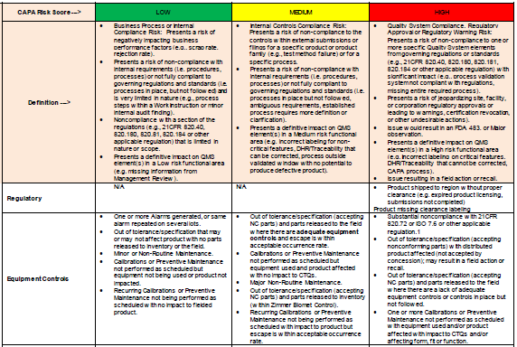
Table 2 - CAPA Risk Guidance
(Paro, 2022)

Containment

Process Containment
After examining the process specification, it states that the machine controls would stop the tank's time if the temperature deviated from the defined specification. This action guaranteed that the minimal validated time of 300 seconds was satisfied for every batch. As a result, it was concluded that no process containment was necessary at that time however, this was later proven to be incorrect during investigations.

Product Containment
Product containment had already been evaluated within the previous events, due diligence had to be taken and a review of each event was undertaken. The events all differed, for first event the temperature of 71˚c was recorded for tank 9.
Despite the temperature in tank 9 being higher than the specified temperature, it does not result in any negative effects on the product. This is supported by the following justification:
The higher temperature is proven to enhance the rinsing process and effectively eliminate any remaining contaminants from the parts as proven within Final clean Performance Qualification (PQ) protocol, the PQ protocol did not include any higher temperature challenge conditions, as it indicates that increased temperature will lead to better reduction of bioburden. Since all the washed parts were made of metal, there would be no impact on their dimensions. Therefore, despite the 1°c difference from the specified temperature, there was no risk to the product.
For the other events that had been raised for this CAPA the temperatures fell under the bottom tolerance of 60˚c, and temperatures of 56˚c & 58˚c were recorded during routine daily checks.
Final Clean Installation Qualification (IQ) protocol provided written evidence that the equipment has been validated to stop if the temperature goes out of spec, and an alarm will present on the HMI screen, the timer will only recommence once the temperature is back within specification. Furthermore, validation study Performance Qualification (PQ) protocol includes challenge conditions at a lower temperature of 55˚c, providing documented evidence that temperatures as low as 55˚c will clean the parts and remove process contaminants.
Therefore, despite product being processed at 56˚c & 58˚c, there is no risk to the product.
According to the rationale provided in the three instances, it was determined that no product containment was required at this stage of the project.

Investigation & Root Cause
Without a doubt, the investigation phase is critical in the project, as poor evaluation of the issue can result in identifying the incorrect root cause(s) and carrying out ineffective actions. The investigation strategy aimed to examine several parts of the process as well as the effects of nonconformances on employees. The subsequent investigation plan attempted to investigate the cause of the tanks failing to meet specifications and whether the scope should be expanded to include other aspects associated to final clean lines and non-conformances.

Investigation Plan

- Review validation documents for temperature impacts on part cleanliness.
- Investigate equipment controls to understand how they operate during out-of-specification temperature events.
- Investigate how Operators conduct the daily process monitoring.
- Summarise all non-conformances relating to the final clean lines.
- Analyse Scrap/Rework data for wash line defect trends.
- Review the Process Failure Mode Effect and Criticality Analysis (PFMECA) document.
- Conduct root cause analysis based on information acquired from tasks 1-6.
- Conduct employee survey.

Investigation results

Review validation documents for temperature impacts on part cleanliness.
The validation documents determined the following effects of lower and higher temperatures on the cleanliness of the parts.
The challenge conditions in the Operational Qualification (OQ) Report provide documented evidence that rinse tanks were adjusted to a lower temperature of 55˚c to give evidence that water at this temperature can clean product and satisfy the applicable pass criteria.
The OQ report did not look at challenge conditions of higher temperatures as it states that increased temperature will improve the ability to reduce bioburden.

Investigate equipment controls to understand how they operate during out-of-specification temperature events.
Investigations have revealed that there are differences in the actual controls governing Final Clean 1 (FC1) and Final Clean 2 (FC2). If the temperature falls out of specification at any moment, FC2 will alarm and pause; the timer will resume when the tank temperature returns to specification, delivering the right clean time while staying within the required temperature range, as per the qualification documents
Upon investigation of FC1, several anomalies were discovered in the process. Specifically, FC1 is designed to pause only during start-up, and in the event that the temperature falls outside of the specified range at any other point in the process, the timer in each tank will not stop and will continue to process the product. The identified anomalies in the process of FC1, which prevent the timer from stopping when the temperature falls outside of the specified range, not only pose a risk to product by allowing processing outside of the validated set point but also raise doubts about the validity of the justification given for past out of specification events associated with FC1.
The above information prompts further investigation into the amount of time batches spend in each tank.

Tank 1, which contains the Citural cleaning detergent, is an Ultrasonic Heated Immersion Wash tank. Due to the poor risibility of Citural, elevated cytotoxicity levels have been previously linked to it. To prevent issues, any product left in the tank for more than 600 seconds must be scrapped. As a result, Tank 1 is the only tank that is monitored, and after a batch completes a full cycle, the Operator scans the batch number, which returns the time it spent in the tank. If the time is greater than 600 seconds, it will appear in red, indicating that the batch must be placed on hold and scrapped
Subsequent review of the records of Tank 1 time found a number of historical undertime events that fall outside the minimum validated state of <240 seconds, that were not identified nor highlighted to operators by the software.
The process time in tanks is measured by both final clean lines and includes an overall time in tank 1 which is then recorded in a Structured Query Language (SQL) database via a bridge PC between the wash Programmable Logic Controller (PLC) and the network database location. The SQL data is then presented in an Excel format, the Excel form has access to tank 1 time data since February 2020 when the form was first introduced.
Tank time data was recorded in an archived SQL database from 17th of July 2019 to 20th of October 2019, after which a networking issue resulted in no data being retained until 14th of February 2020. From that date, the data has been captured and presented in accordance with various document revisions, these revisions have only impacted the way the data is presented and not the underlying PLC or SQL database. However, it was found that only overtime in tank 1 was being monitored and no detection mechanism was in place for undertime, despite the availability of data. As part of a system revision in 2019 the PLC was modified to allow Tank 1 immersion time to be logged by addition of extra data tags. Review of the documents show that undertime occurs at a frequency that is unlikely to have been detected due to the sample size used in the validation.

Optimal Technologies (OEM) were engaged to support and visited site on 27-28th of September 2022 to conduct investigation into the issue. No obvious reason could be found despite a code review and running the system continuously with blank baskets to simulate production. The undertime event was witnessed once after 60 cycles but the PLC logic showed that the condition for a process to move on was not met (time had not completed). However, the tank was unlatched allowing the robot logic to pick up and move the cycle to next stage. This is counter to the programme intent, but no root cause was established.

Examination of the frequency and timing of the undertime event does not reveal any underlying triggers or patterns based on time, soft patterns, loadings or other external factors. Currently it is understood that the undertime event is linked to the changes to introduce tank priority and overall time control as part of the system update and revalidation in July 2019. This is indicated because the changes introduced at this time affected how the PLC program prioritises available cycles to be processed by the pick-and-place robot. These program changes were performed by the OEM Optimal Technologies, but with the machine in-situ and as an add-on to the original PLC program.

Analysis for FC1 shows that there are no data points for tank 1 time below the minimum validation requirement of <240 seconds per the UKF0753 Excel log. The PLC changes that were made on FC1 for tank time do not appear to have had the same effect although it should be noted the machines FC1 and FC2 are not the same build standard.

After the investigation into undertime in tank1, the parts in scope were classified into three groups based on the duration of undertime:
  - Batches undertime outside of the validated state and where no data is available for <240 seconds - Qty = 13,406 parts
  - Batches undertime within the validated state >240 and <300 seconds - Qty = 127 parts
  - Batches undertime outside of the validated state <240 seconds and no Vapour Degreaser Boil Tank Ultrasonic - Qty = 1440 parts

Batches in the first group were deemed acceptable, based on the validation of the Vapour Degreasers which established that the cleanliness of parts prior to Final Clean process are already within the cleanliness requirements.

Batches that have been through an undertime event, but within the validated state of >240 seconds per group 2 are covered by an approved Concession based on the challenge conditions within the qualification documents.

For the third group, an Engineering cleaning study will be required as currently there is no information available to justify product concession. The SQL and excel software was immediately updated to capture both under and overtime in tank 1.

Investigate how operators conduct the daily process monitoring.
To determine whether timing, plant state, or other circumstances can alter the water temperature, the process was reviewed with the Operators and subject matter expert (SME) with conclusions described below. The daily process monitoring of all final cleans are captured on the daily form, the checks that are to be captured are described below:
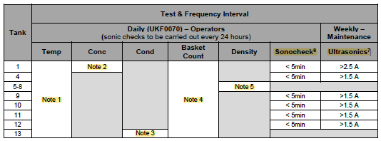
Table 3 - Final Clean Test and Frequency.
Note 1: Tank temperatures to be taken directly from the optimal equipment control panel display.
Note 2: Refractometer Check for Citural Cleaning Detergent.
Note 3: Conductivity value displayed on the monitoring unit on the optimal line above the tank.
Note 4: Basket count taken directly from the HMI
Note 5: Nitric Acid Density Test Method and/or Nitric Acid Adjustment taken with a hydrometer.
Note 6: Sonocheck Vial Test Ultrasonic Monitoring Check.
Note 7: Ultrasonic Generator PPM Procedure to be performed weekly by the maintenance team.

According to the table, acid tests are conducted twice during each shift, and ultrasonic checks are performed daily. These checks necessitate the activation of the manual mode of the wash, which results in the deactivation of the tank heaters. If manual mode is used for extended periods, it may cause a decrease in temperature. This may occur when repeat testing is conducted or when the chemical needs to be replenished to bring it within the guard band range.
However, the current procedures do not provide clear guidelines on the order in which temperature checks should be performed, and there is no standard for operators to follow. Interviews with operators have revealed that they conduct the checks in different orders, increasing the likelihood of an out-of-specification (OOS) temperature being recorded.

Summarise all non-conformances relating to the final clean lines.
A review of the QMS system discovered 16 recorded instances of non-conformances (NC) pertaining to the Final Clean lines. These NCs occurred over a period of 5 years and were related to various issues. However, action was taken on 4 occasions within a 2-month period, which led to the initiation of the project described in this paper. a summary of the non-conformances can be found below.

- 63% of the NC are relating to FC1 (Optimal 1)
- 37% of the NC are relating to FC2 (Optimal 2)
- Out of the 16 NCs, 60% are relating to temperature issues.
- 40% of the total NCs are relating to Ultrasonic failures.
- On 3 occasions operators have written out of spec temperature readings without knowingly doing so.

Analyse Scrap/Rework data for wash line defect trends.
2022 Scrap Analysis
Scrap and rework are significant issues encountered at the Bridgend site, with the root causes predominantly located at the beginning and end of the manufacturing process. A pie chart has been presented to provide a graphical representation of the overall scrap rate at the Bridgend plant. The work centre that contributes the most significant scrap rate is the Index R200, which is a G7 Shell CNC machining cell. The extremely tight tolerances required in this area are responsible for the majority of scrap generated. However, for the purposes of this analysis, we will focus solely on the Final Clean lines, specifically the Sterile Passivation Ultrasonic Clean process. This work centre comprises Final Clean 1 and Final Clean 2 and is the second-highest contributor to scrap at the Bridgend facility.
It is important to note that when a product is scrapped at the Final Clean stage, the value lost is far higher than when it occurs at the R200 due to the extensive value addition from various manufacturing areas such as blasting, plasma coating, and polishing. A tabulated summary of the total number of pieces scrapped for each work centre and the corresponding production value lost has been presented for reference.
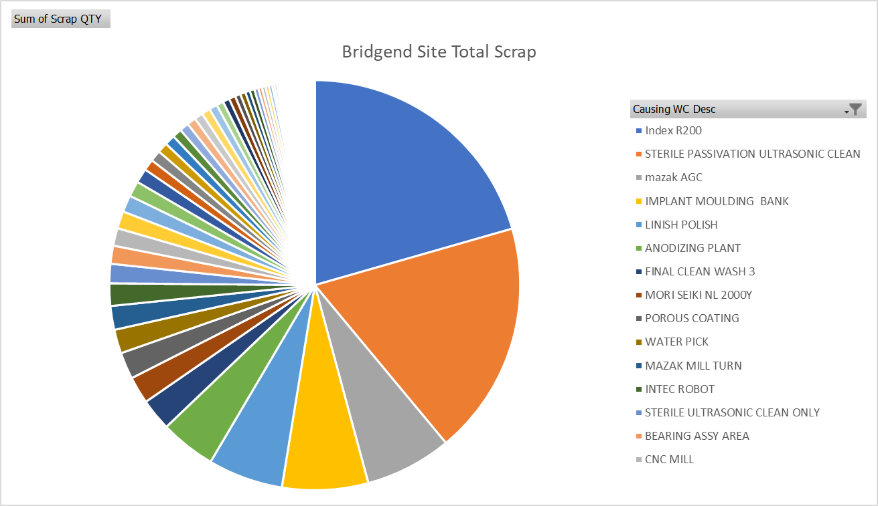
Figure 9 – Pie Chart – Bridgend Site Total Scrap
Row Labels | Sum of Scrap QTY | Sum of Scrap Value
Index R200 | 11376 | £1,333,525
STERILE PASSIVATION ULTRASONIC CLEAN | 10194 | £744,055
Table 4 - Top 2 Causing Work Centres Qty vs Cost

2022 Rework Analysis
The analysis of the 2022 rework data reveals that the Final Clean Lines pose a significant issue for the Bridgend site. Specifically, the Final Clean Lines work centre has the highest rework rate across the entire site, with 12,828 reworked units. Although it is possible to sell reworked products for profit, excessive rework in manufacturing can also be harmful to the environment. Reworking damaged products can result in higher energy usage, waste generation, and emissions. This has the potential to contribute to pollution, resource shortages, and climate change. Decreasing rework in manufacturing can result in considerable environmental benefits such as lower energy usage, greenhouse gas emissions, and waste generation (Golinska, et al., 2015). As a result, it is critical for businesses to address the environmental implications of rework and implement methods to reduce it, such as enhancing quality control and optimising manufacturing processes.

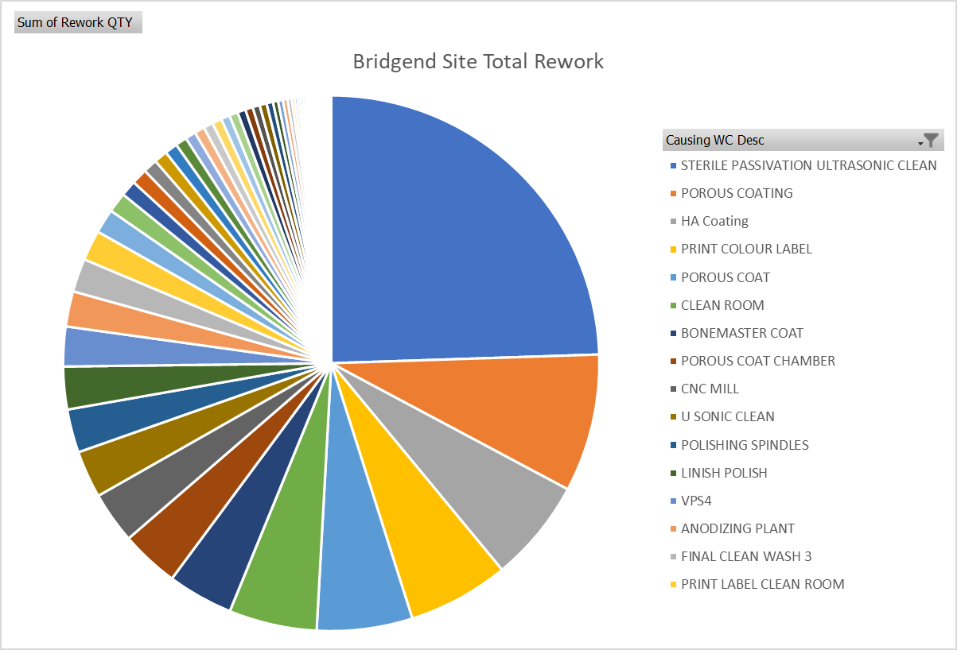
Figure 10-Pie Chart – Bridgend Site Total Rework

Scrap Pareto of the Final Clean Line
Pareto analysis is a widely used tool in quality management for identifying and prioritising the causes of problems in various industries. It is named after the economist Vilfredo Pareto, who first noted the unequal distribution of wealth in society. The Pareto principle, also known as the 80/20 rule, suggests that roughly 80% of effects come from 20% of causes.
Using Pareto analysis, we can analyse the scrap data for the work centre "Sterile Passivation Ultrasonic Clean" as follows:
- CC-Exceeded Process Time: (7223/8924) * 100 = 80.9%
- SC-Exceeded Process Time: (667/8924) * 100 = 7.5%
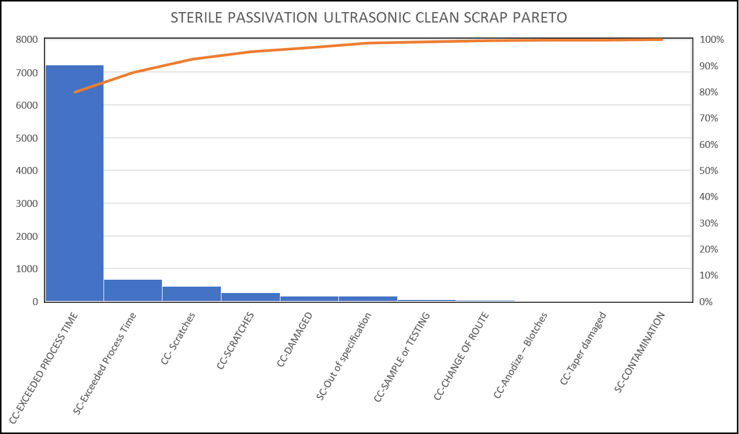
Figure 11 – Scrap Pareto Analysis for Reason codes
From the above analysis, we can conclude that the two main causes of scrap at the Sterile Passivation Ultrasonic Clean work centre are CC-Exceeded Process Time and SC-Exceeded Process Time, which are for the same issue and together account for almost 89% of the total scrap. The issue of exceeding the process time limit in Tank 1 has been a longstanding concern, as previously discussed in this paper, when a wash basket surpasses the designated 600-second time limit, it is categorised as overtime, leading to the scrapping of all the products within the basket. Despite the well-known reasons behind this issue, they have been ignored, and resolving it would necessitate a lengthy and expensive revalidation process. Additionally, the downtime incurred would only leave Final Clean 3, which lacks the capacity to meet customer demand. Consequently, the business has accepted the existence of exceeded process time as an unavoidable circumstance, at least for the time being.
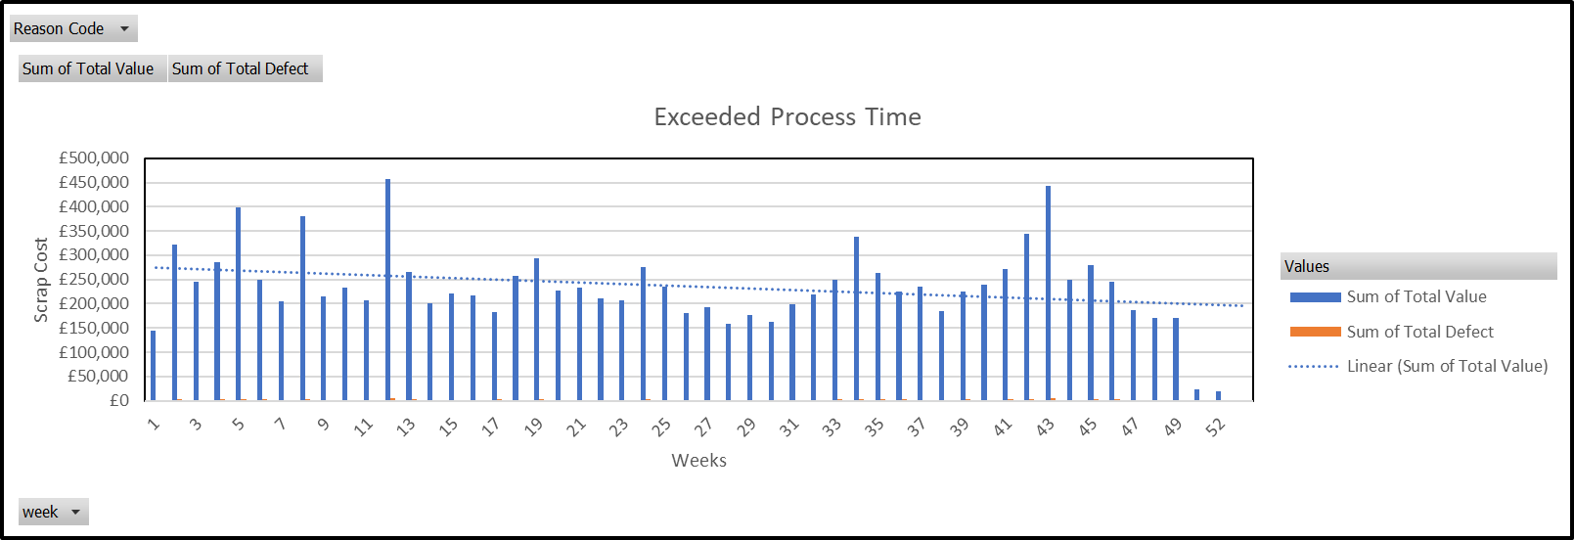
Figure 12 - Scrap Caused by Exceeded Process Time

Rework Pareto of The Final Clean Lines

According to the Pareto analysis, "SC-Out of specification" is the predominant cause of rework, contributing to the majority of the total rework quantity, which has contributed to 8840 part or 69% of the total rework amount.
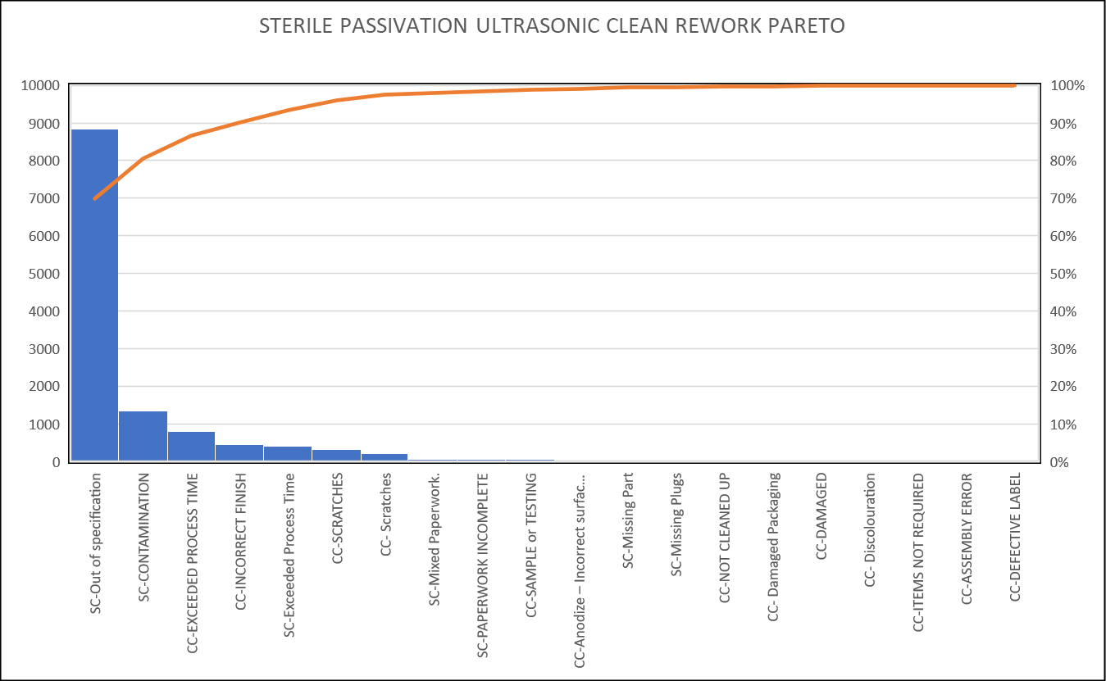
Figure 13 – Rework Pareto Analysis for Reason Codes
Therefore, it is imperative that the company focuses its efforts on addressing this issue to minimise rework and improve the overall manufacturing process. However, to tackle the issue of "SC-Out of specification," the company must first determine the underlying cause of the problem. The current data system for processing scrap and rework does not have sufficient reason codes to pinpoint the root cause. In 2022, the primary factors leading to rework in the washes were either temperature-related issues or failures in ultrasonic processes. As "SC-Out of specification" is the only code used, additional analysis is necessary to identify the specific causes of rework and develop targeted solutions.

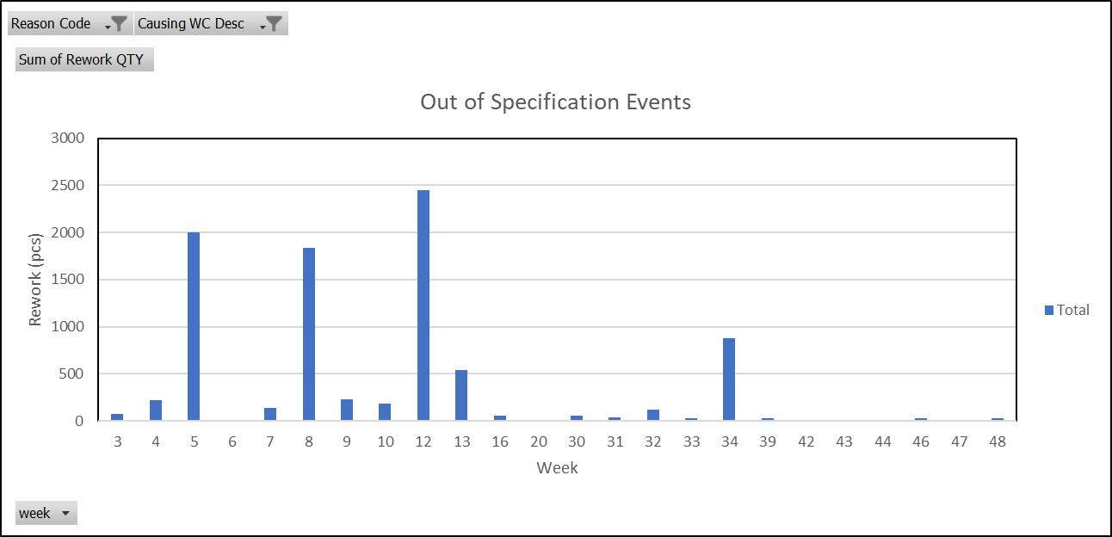
Figure 14 - Out of Specification Rework Analysis
A review of the Maintenance SAP data revealed a direct correlation to individual events that occurred during each week; almost every spike per week had a reason relating to temperature or Ultrasonic failure, where temperature issues were identified, the majority of which were related to the In-line heater tripping or issues with the chiller.
Four of the sixteen events were caused by ultrasonic failures, while the remaining occurrences were caused by temperature issues, eight of which were caused by problems with the in-line heater.

Table 5 - Maintenance Notification Data

Review Process Failure Mode Effect and Criticality Analysis (PFMECA)
During this investigation a review of the PFMECA took place to evaluate the potential impact of varying temperatures on the product. PFMECA 00018 Rev.2, which was last revised in 2015, was found to be inadequate in capturing a significant number of failure modes pertaining to the wash line. While the document identifies "Incorrect tank temperature" as a potential failure mode, the associated effects are limited to "Residual cleaning agent not removed from component," and do not offer a comprehensive understanding of the risks associated with low or high temperatures. Additionally, none of the recent failure modes identified during the investigation are documented with the PFMECA. Considering the critical nature of the document with respect to the process, it is evident that the information presented in PFMECA00018 is insufficient to meet the requisite standards of precision and comprehensiveness that are expected of a PFMECA for a critical process.

Root cause analysis
Root cause analysis is significant because it assists in identifying the fundamental causes of issues and incidents rather than simply treating the symptoms. Organisations can prevent future instances of similar problems and enhance overall performance by identifying and resolving the root cause. It has been stated that root cause analysis assists businesses in improving their safety, quality, and productivity, while also lowering costs and increasing customer satisfaction.

Cause and Effect Diagram
A cross-functional team comprised of Operations, Ops Engineering, Ops QA, Validation, Maintenance, and washroom operators conducted root cause analysis based on the information acquired from the investigation.
The RCA was split in to two sections, the first addressing the problem statement of the CAPA, however during the investigation phase other non-conformances relating the washes have become just as critical as the initial problem statement. Data shows that the ultrasonics have become a serious concern and is costing the business in many ways.
The 5M Plus Diagram is basically an Ishikawa diagram managed within the QMS system, this diagram will be used to detail the causes and effects of repeat issue of out of spec temperature recorded on the daily Process Monitoring Log. A cross functional team have been selected to be involved within the meeting, this would ensure that all causes and effects could be captured which will aid in deep diving to the correct root cause. Figure 15 provides the details highlighted the causes and effects of the issue
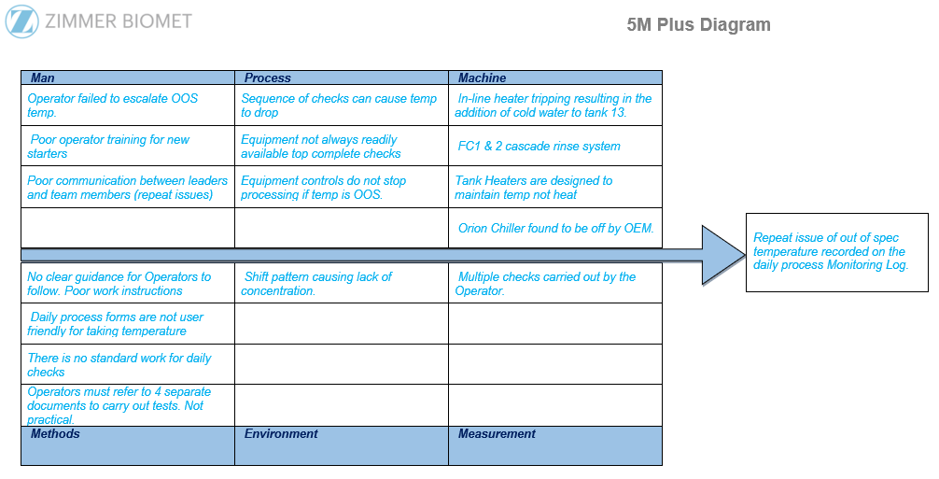
Figure 15 - Ishikawa Diagram
Several causes were identified during the meeting which could potentially affect the tank temperatures, each of which was ranked as shown in table. To eliminate or greatly reduce future recurrence improvements would need to be made to the process and captured within the CAPA.
Based on the cause-and-effect diagram, it was found that the primary cause of the issue with the inline heater tripping and resulting in the addition of cold water to the tank 13 cascade system, it was observed that the inadequate procedure relating to the process was the primary cause of the problem, which was evident from the feedback provided by the operators. They reported that the procedures were poorly written and lacked sufficient guidance, and that there were too many documents to manage efficiently, thereby leading to longer processing times and adversely affecting training. Furthermore, the confusion among operators regarding each tank's specifications has led to errors on the Form. Although there were other factors that were ranked, their priority may be lower. For instance, while shift patterns could contribute to errors being made, they are considered part of the day-to-day routine and are not considered a priority for the time being.

Potential Cause(s) | Rank | Assessment
Inline heater tripping, resulting in the addition of cold water to the tank 13 cascade system. | 1 | - Investigation by the OEM identified that the chiller unit was turned off, water flowing through the inline heater is higher than usual causing it to trip.  - Resulting in cold water being added to tank 13, thus reducing the water temperature in the tank.  - Individual tank heaters are designed to maintain temp not heat.
Inadequate Procedures | 2 | - Manual mode selected for Sonic/Acid checks, when in Manual mode the tanks will not heat, causing them to go under temperature.  - No instruction of time to check or what sequence the checks are to be completed. There is a requirement to turn the wash in to manual mode which in turn switches off the inline heaters.  - PS no 113 provides instruction for the user to take the temperature reading, however, the instructions could be clearer as all other checks have their own Work Instructions.
Poor overall understanding of the checks as detailed within UKF0070 | 3 | - Not all Operators have complete understanding of the escalation process when the Temperature goes OOS. Specification is written on the UKF form and OOS temperatures are still being documented.
Equipment not readily available | 4 | - Various equipment is needed to complete daily checks, if all equipment is not available it can cause delays, which can lead to the temp falling if in manual mode.
Too many work instructions to follow | 5 | - 4 separate work instructions make it difficult to follow.  - Also leading to poor training and critical information being missed.
Tank heaters may not be adequate | 6 | - Temp rarely goes OOS suggesting the heaters are adequate at maintaining the required temperature.
Shift pattern - Tiredness causing lack of concentration. | 7 | - Following a review of previous NC’s errors have been made across multiple shift patterns.
Table 6 – Ishikawa Ranking Results

5 Why’s
Following information extracted for the scrap and rework data a 5 Why’s was carried out to understand the root cause of why we’re seeing so many Ultrasonic test failures.
Background of the sonic check:
The Medical Device Directive 93/42/EEC stipulates that medical equipment used for the cleaning & disinfecting of surgical instruments must be validated & quality assured. The SonoCheck is made up of a small vial containing an indicator solution and a number of glass nuclei beads that, when subjected to the appropriate cavitation forces within an Ultrasonic washer, cause a colour shift in the vial solution. The vials are unobtrusive and simple to use and provide quick, objective results. (Anon., 2023)
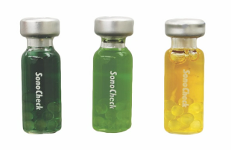
Figure 16 - SonoCheck Vial
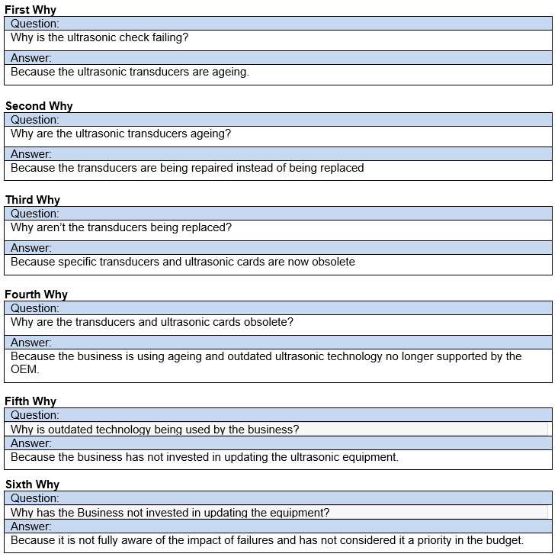
Figure 17 - 5 Why's relating to Ultrasonic Failures
5 Why’s conclusion.
Although the main factor of the Ultrasonics failing is due to the transducers, the business is aware the equipment is out dated and have accepted the risk previously. However, following quantification of the impact of scrap and rework the business has to choose to invest in upgrading the Ultrasonics.
Although the current Sonocheck Vial test provides a conclusive pass/fail, they do not offer any monitoring of ultrasonic performance or degradation, additionally the business is spending £100,000 per annum on testing Vials for both washes, furthermore the test method is also causing 1 hours down time each day to conduct the test which leads to Operator inefficiency and a loss in capacity.

Zimmer Biomet Case Study

Zimmer Biomet Bridgend - Cost of Poor Quality 2022.
The table provides a breakdown of the total scrap for 2022 across various value streams. The largest contributor to scrap was Shells G7, which accounted for £2,226,284. Other significant contributors include Oxford Fems & Trays (£843,487), Stems (£573,403), and Mouldroom (£214,521). The remaining value streams, including Vanguard Femorals, Plastics, LPS, Shells Non G7, Heads, SPS, STAAY & Extremities, and Semi Finished, accounted for smaller amounts of scrap, ranging from £2,138 to £137,807. The grand total of scrap for all value streams in 2022 was £4,295,196.
Table 7 - Zimmer Biomet 2022 COPQ Results

Employee Survey
Zimmer Biomet like other large businesses suffer with impact of COPQ within the work place, to gain a better understanding on its impact on the business a survey was created and delivered to Operators from the End of Line area. The survey asked 45 participants about their experiences surrounding COPQ.
The following are the key findings:
- 31% (14 out of 45) of respondents report weekly stress or irritation as a result of scrap and rework, whereas 22% (10 out of 45) report it on an hourly basis. The majority of the frustration is from having to complete additional paperwork each time a product must be held, as well as additional procedures on both the clocking machine and a hold ticket for each non-conformance. Operators said that all they want to do is ‘come in and do their job’, however, poor processes prevent them from doing so, resulting in frustration rather than stress.
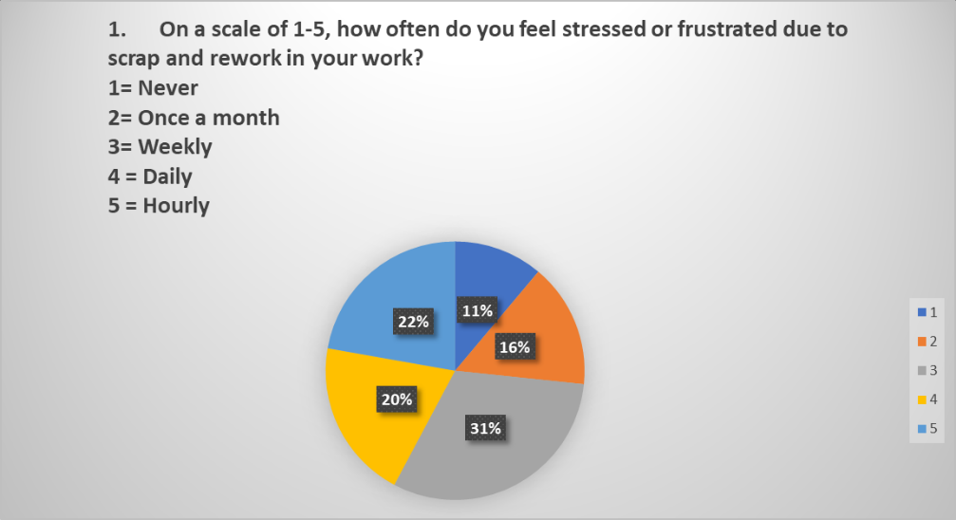
Figure 18 - Employee Survey Question 1 Result
- The productivity of a significant number of participants was reported to be heavily influenced by scrap and rework, with 47% (21 out of 45) indicating high impact while only a mere 4% (2 out of 45) reported no impact. This is primarily attributed to the need to reprocess defective products, resulting in zero standard time for each reworked operation, thereby causing Operators to lose out on the time they had initially put in. Consequently, this leads to reduction in productivity.
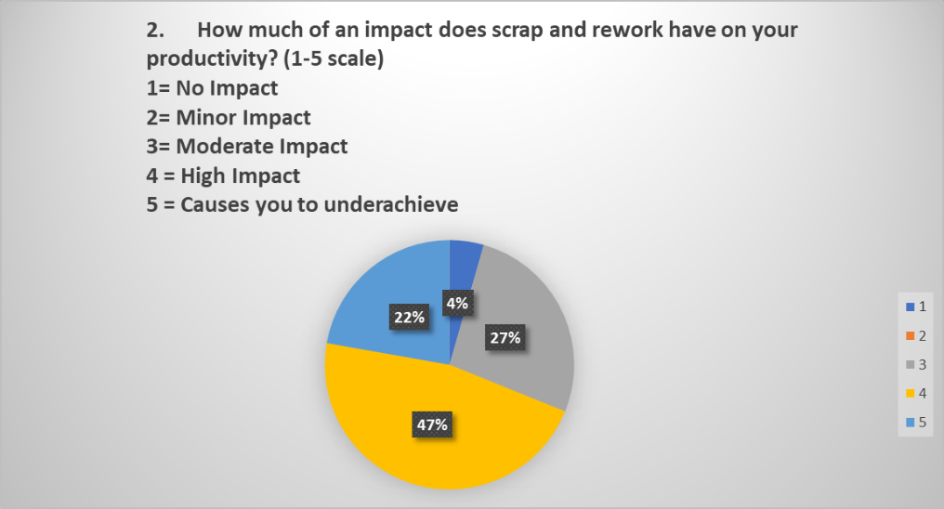
Figure 19 - Employee Survey Question 2 Result
- According to the survey results, a significant proportion of the participants, 69% (31 out of 45), expressed moderate to high confidence in their capacity to mitigate scrap and rework in their workplace, while the remainder had either slight or no confidence in this regard. It should be noted that those with low confidence were primarily new to the company, having been employed for less than a year. This outcome indicates that the Operators possess commendable process awareness, which the company should acknowledge and not overlook.
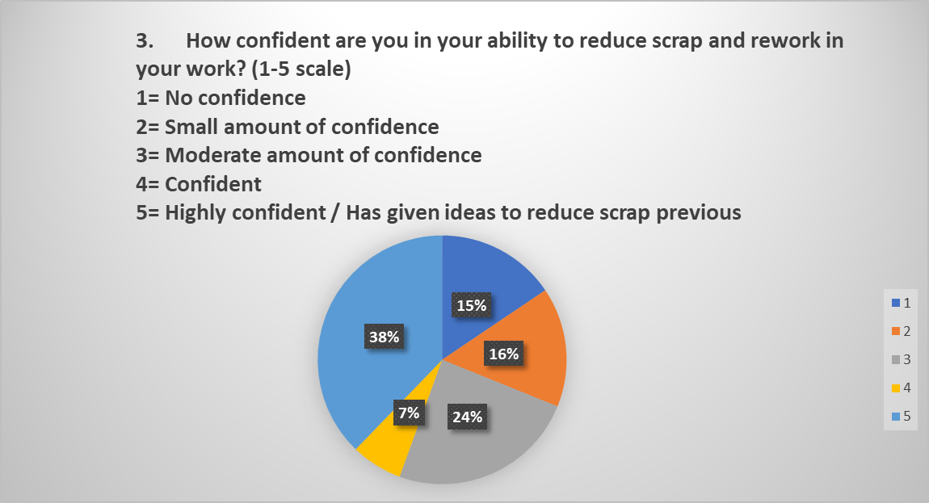
Figure 20 - Employee Survey Question 3 Result
- A significant number of participants, 58% (26 out of 45), reported daily management help in addressing and minimising scrap and rework. In comparison, only 4% (2 out of 45) claimed to receive no assistance. This result is positive for the business since it indicates that the Operators feel supported by their individual line managers. However, other comments suggested that the support department lacked the appropriate effort to address such problems, which contributed to the elevated rejection rates.

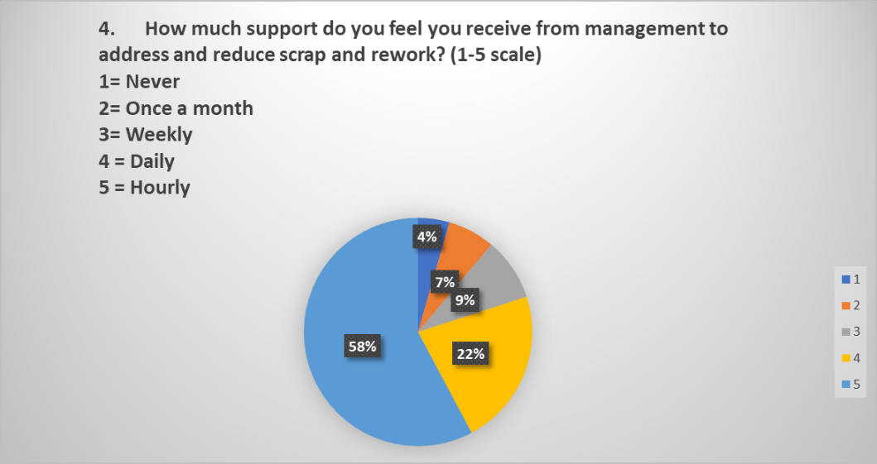
Figure 21 - Employee Survey Question 4 Result
- The survey results revealed that an overwhelming majority of the participants, accounting for 95%, reported facing scrap and rework issues on a daily or weekly basis, with none reporting encountering such issues hourly or never having to deal with them. This is corroborated by the current rejection rate of the business, and the Operators have observed a progressive increase in these occurrences. This is a cause for concern for the business, as it indicates that the processes are out of control.
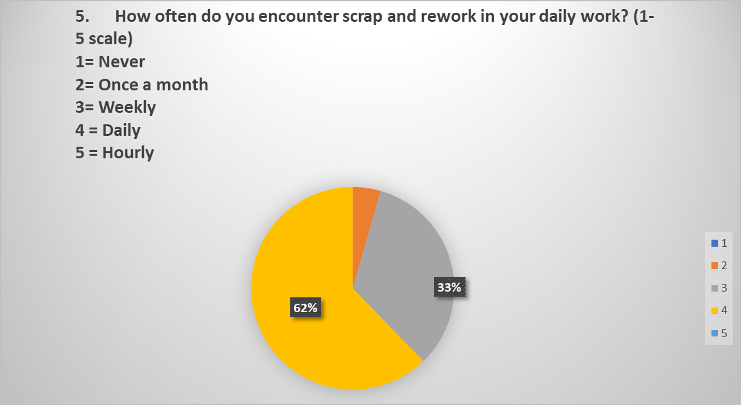
Figure 22 - Employee Survey Question 5 Result
- More than two-thirds of the participants expressed scepticism that any significant steps would be taken as a result of this survey. Corporate surveys are conducted annually, but little constructive action is taken. While some view this survey as merely a ‘Tick box exercise’, many remain optimistic that meaningful measures will be implemented, particularly since the survey targets realistic questioning. Some Operators have already witnessed progress within the area since the project was launched, such as the work carried out with the Interim control pertaining to the in-line heater.

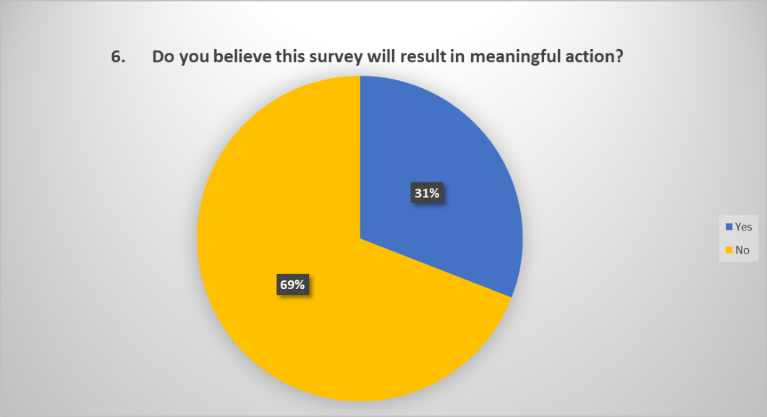
Figure 23 - Employee Survey Question 6 Result
- The survey's most alarming finding is that 78% of participants stated they have never been asked to assist with scrap reduction, despite a high proportion feeling they have the confidence to support in scrap reduction. This is a knowledge base that should be utilised, but evidently, it is not. The key to reducing defects lies in working with the shop floor staff, who are the true subject matter experts. The business should take note of this and involve Operators more actively in scrap reduction initiatives.
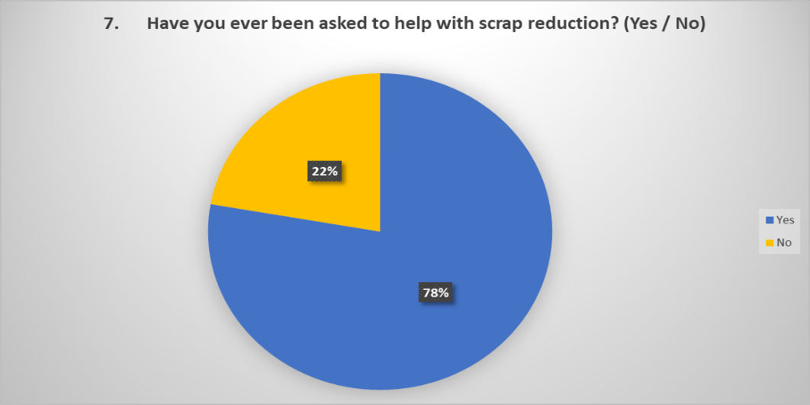
Figure 24 - Employee Survey Question 7 Result
- 82% employees who took the survey feel the lack the support and resources to maintain quality standards, most comments relate to ageing equipment and a lack of investment throughout the site.
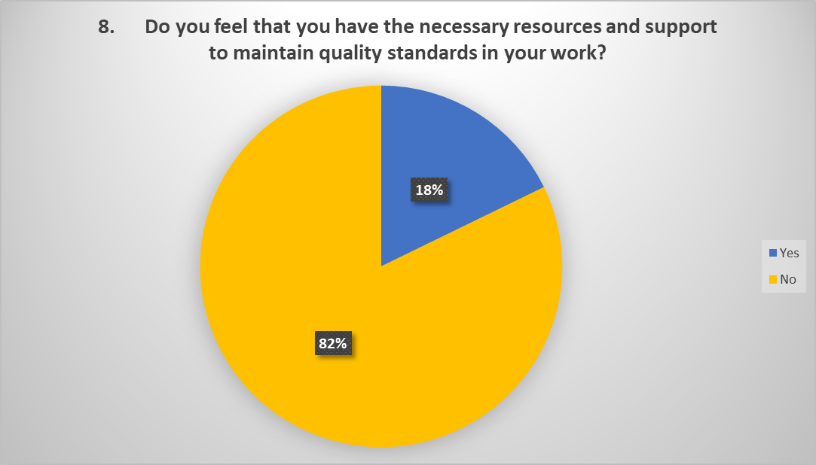
Figure 25 - Employee Survey Question 8 Result

Survey Conclusion.
According to the survey results, scrap and rework are a serious issue affecting the productivity and well-being of its employees. This may have an adverse effect on the quality of the company's products or services. Employees' differing levels of confidence in reducing scrap and rework suggests a need for extra training or resources. The fact that some employees do not believe they have the resources and support they need to maintain high quality standards in their job indicates a need for improved communication and collaboration between employees and management.
To address these concerns, the organisation should consider introducing scrap and rework reduction solutions, such as process improvements or improved quality control measures. Additionally, the organisation could provide employees with extra training and resources to boost their confidence in decreasing scrap and rework. According to the survey results, management support is essential, thus the organisation may need to ensure that staff feel appropriately supported in their attempts to reduce scrap and rework. Finally, the organisation should take the survey results seriously and make a concerted effort to address the difficulties raised by employees in order to foster a happy work atmosphere and uphold high quality standards.

Implementation plan
The investigation plan revealed numerous process-related issues that significantly complicated the Corrective and Preventive Action (CAPA) process. Upon discovering an issue related to the in-line heater, the Quality team stopped the wash process for a second time until it could be demonstrated that the risk was manageable. This was the first step taken to enable Production to resume. The decision to take this action was made at the last minute on a Friday, which necessitated spending the entire weekend developing an Interim control and form to monitor the process as a temporary measure until long-term engineering solutions could be identified to eliminate the need for manual, non-productive checks.

Based on the investigation's findings, additional measures were developed to address the underlying causes and other factors identified in the CAPA. This implementation plan outlines all of the actions taken to eliminate or significantly reduce the likelihood of the root cause recurring.
- Create Interim Control for the additional monitoring on the In-line heater
- Upgrade In-Line heater
- Simplify the work instructions
- Update PFMECA
- Update the Process Specification
- Reconfigure the daily monitoring to limit operator errors when taking the temperature.
- Review business case for Ultrasonic Upgrade.
- Review possibilities of engineering the Interim control out.
- Create and deliver training for all updates captures within the project

Action Implementation

Interim Control
Interim controls (IC) are temporary procedures used in Zimmer Biomet to manage quality issues or non-conformance until a permanent solution can be introduced.
Interim controls are often employed as a short-term solution to solve quality issues while a permanent solution, such as altering the production process, strengthening quality control methods, or resolving supplier quality issues, is developed and implemented. Interim measures can be only be withdrawn once the permanent solution is in place.
The In-line heater has been the cause to Out of Specification events against the final clean lines, as a temporary solution Interim Control (IC 0047) was created to provide additional control measures surrounding the In-line heater. At this point the Final Clean line was placed on stop by the Quality Director until additional control measures were introduced, IC 0047 required for a Quality Technician to check that the in-line heater was in Operational mode, this check was to be carried out every 2 hours to limit the scope if further issues were identified. Due to the impracticality of this check and the impact on the workload of the Technicians I was under pressure to come up with a solution to quickly remove the IC however, to do this we had to identify upgrades that would allow us to do this. The following actions took place to provide further control measures.
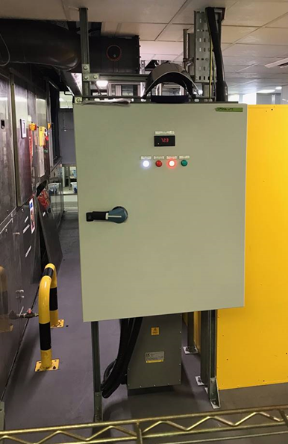
Figure 26 - Inline Heater Control Panel
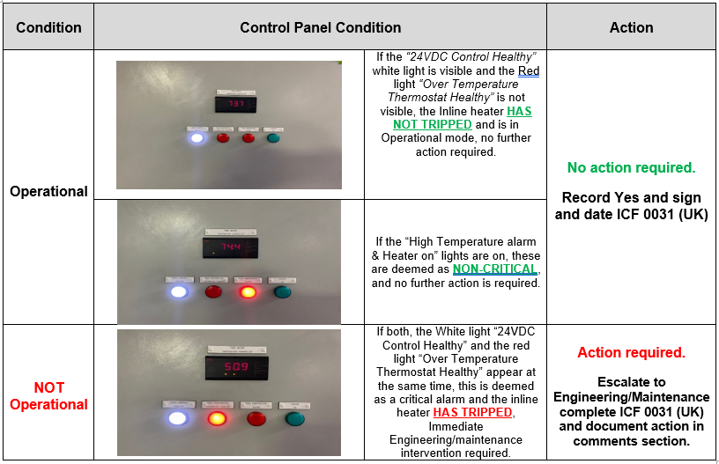
Table 8 - Control Panel Decision Table
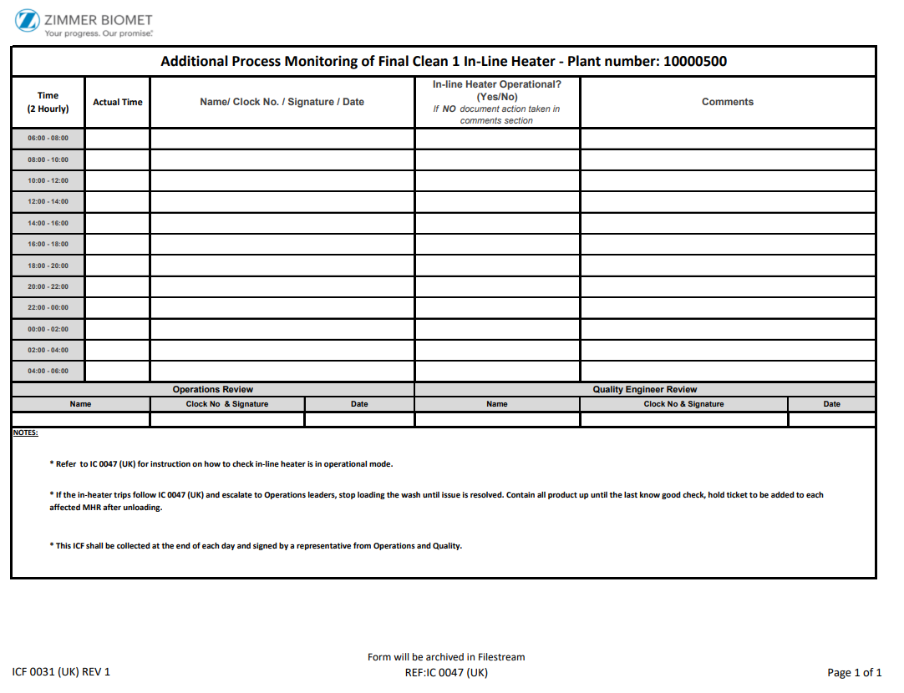
Figure 27 - Interim Control Log Sheet
- Service and replace the Chiller
Although root cause points towards the In-line heater, the OEM identified faults with the Water plant chiller system, if the incoming temperature is too hot, it causes the in-line heater to trip, therefore allowing cold water to enter the system, causing tank temperatures to fall under limit.
- Modifying the parameters
A slight amendment to the inlet and outlet parameters allowed for an improved water temperature being fed to the in-line heater, this improved two areas, the changes brought less demand on the in-line heater but also regulated the temperature better which in turn would reduce the chances of the in-line heater tripping out.
- Alarm Installation
Previously there was no alarm to notify the operator, hence why the Operators did not recognise that cold water was being fed to the tanks. Working alongside the OEM we arranged for an audible and visible alarm to sound once the in-line heater had tripped. This would provide an early alarm to allow the team to react efficiently and attempt to resolve before the wash fell out of spec.
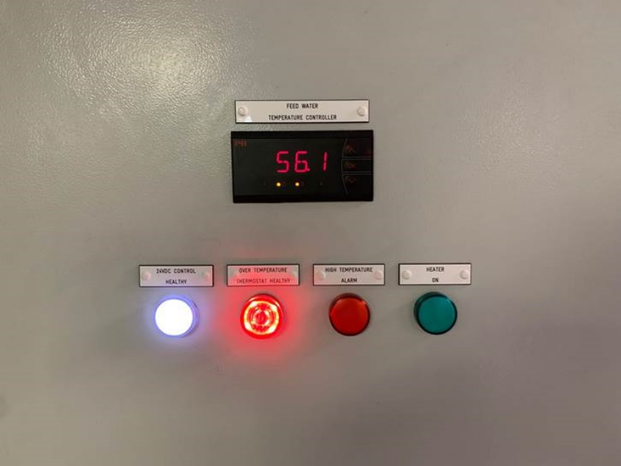
Figure 28 - New Installation of Audible Alarm To The Control Panel
- Obsolete IC 0047
The interim control remained in place for a total of 4months, although improvements had been made to the In-line heater

Simplification of Documentation
During root cause analysis we identified that there was no clear standards or sequence in which the daily process monitoring took place by the Operators, further investigation of the process and people identified a lack of and poor instructions for the Operators to follow.
There are 5 separate Documents for the Operators to follow which are neither linked in any way, the Process Spec contains basic instructions of how to take other checks however, there is no clear guidance in which sequence the checks should be carried out.
The 5 separate documents are:
- PS no 113 - Final Cleaning and Biological Upgrade of Sterile Implant Products
- I001050 – Refractometer Testing of Chemical Concentration
- I001052 – Nitric Acid Density Test Method
- I001053 – Final Wash Chemical, Filter Change and Nitric Acid Procedure
- I001054 – Sonocheck Test Ultrasonic Monitoring Check
The lack of instructions and standards are not only contributing to out of specifications against the Final cleans, but they’re also having a detrimental effect on training. During conversations with the team, each Operator demonstrated how they complete the checks differently, not only can this lead to mistakes it is also a safety and compliance risk, some operators were not following the work instruction safety which could lead to serious harm when dealing with nitric acid.
To improve consistency, safety and training - a review of the above documents took place with the aim in creating a singular document for the process checks.
Instead of having to switch back and forth between various papers, a new single document I001843 - Final Cleaning of Sterile Implant Products - Process Monitoring Procedure was developed to outline the steps to be taken to carry out each test and in what sequence, making it significantly more user friendly. In addition to the previous checks, this document captured the checks required for the In- line heater and provided explicit instructions on the escalation process if the In-line heater was to alarm, thus allowing us to obsolete the Interim control. The Furthermore, it allows us to obsolete the other documents meaning less documents within the QMS system which is a Goal and Objective of the site for 2023.

Process Failure Mode Effect Criticality Analysis (PFMECA)
A PFMECA (Process Failure Mode Effects and Criticality Analysis) document is an essential tool for identifying potential failure modes in a process and prioritising corrective actions based on their severity. In the case of the sterile wash process, it is critical to ensure that the process is effective in eliminating all contaminants to maintain sterility.
However, the initial PFMECA document for the sterile wash process was only 10 lines long, which was inadequate to capture all the potential failure modes relating to the wash. Previous investigations had identified many issues that could lead to contamination and sterility breaches, which were not included in the document. Therefore, it was necessary to update the document to ensure that all the critical failure modes were addressed.
To achieve this, a cross-functional team was assembled, which included members from various departments, including quality, production, engineering, validation and maintenance. The team reviewed the previous investigations and conducted a thorough analysis of the process to identify all the potential failure modes relating to the wash.
The team then updated the PFMECA document which included a template update to capture all the identified failure modes and prioritise the corrective actions needed to address them. With this updated document, the sterile wash process can now be executed with confidence that all potential failure modes have been identified and addressed, ensuring the maintenance of sterility. Refer to appendix 1 for the final document

Process Monitoring Form Design
Documented previously within the is paper, non-conformances relating to the wash have been caused by Operator errors, this includes writing the wrong temperature specification for a specific tank. Operators are honest and state that some do not remember the specification for each tank as the temperature ranges based on its contents, to look at what the temperature for each tank is they have to revert to the Process Specification which can be time consuming giving they have targets to achieve, and whilst this is a requirement, efforts should be made to simplify the form to ensure the operators have everything they need to complete the task correctly and efficiently.
Figure provides an example of the previous revision whilst figure shows the new for which was created and introduced to the process.
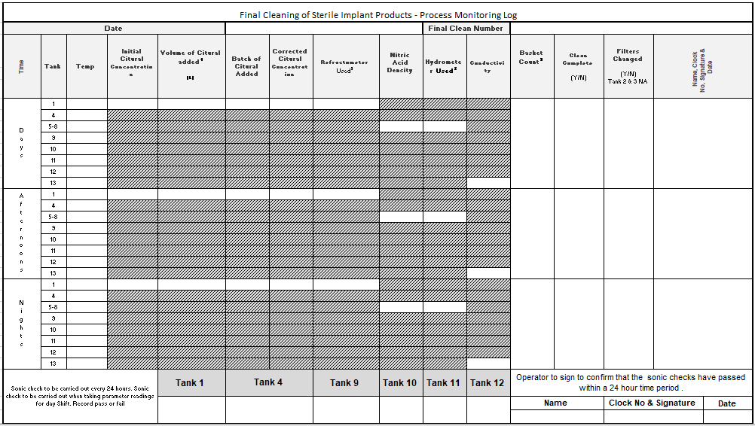
Figure 29 - Final Clean Process Monitoring Log Revision 13
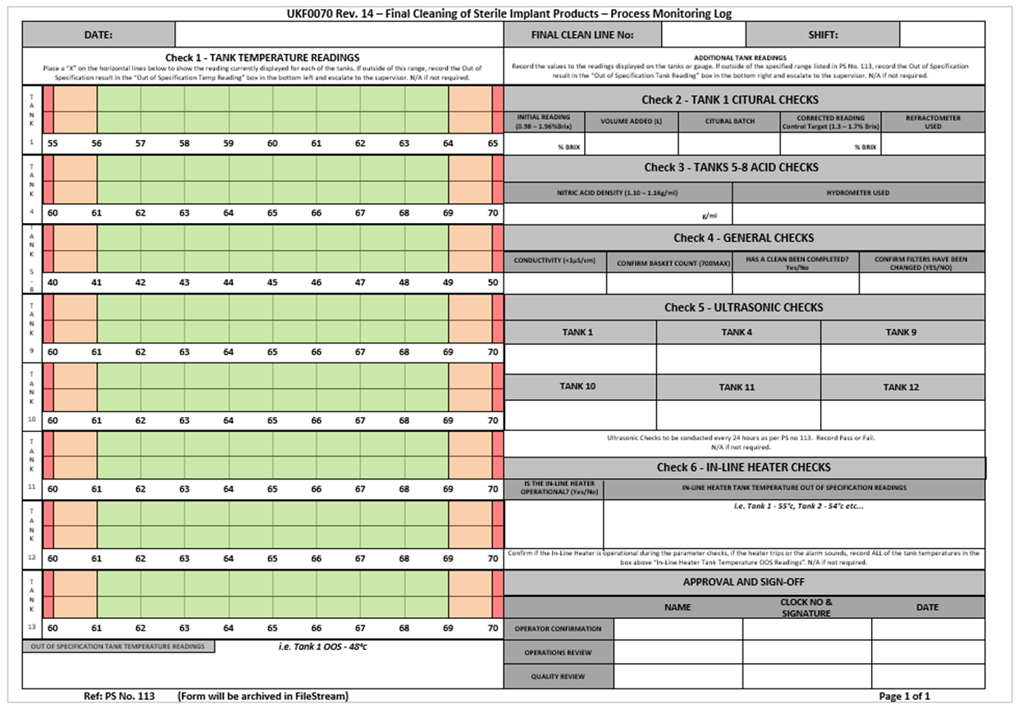
Figure 30 - Final Clean Process Monitoring Log Revision 14
The changes to the form were made directly from feedback from Operators, all of the checks are critical to the process so have to remain however, how they’re documented or how the operators interact with the form should be decided by the team themselves, based on feedback from the team the following changes/improvements have been made to the process monitoring log:
- Template change.
According to the feedback provided by the team, the boxes allocated for each check were deemed too diminutive, thereby causing certain members of the team to perceive the recorded values as illegible. As the operations have now transitioned to a 24/7 schedule, rendering the afternoon shift check redundant, the opportunity was taken to consolidate the form into a single document for each check. This alteration resulted in two improvements. Firstly, it enabled the team to allocate larger boxes, and subsequently, to focus on the temperature with greater precision. Secondly, each form shall be subject to immediate review and sign off following its use, thus facilitating the prompt identification and rectification of any potential errors. In contrast, under the previous protocol, the forms were not reviewed until 24 hours later, which impeded the early detection of errors and expanded the scope of potential consequences.
- Temperature.
The new layout presents a clear specification of the temperature range for each tank, removing the requirement to review the Process Spec. The temperature range is now colour-coded to indicate whether it falls within the top, middle or bottom spec. Instead of writing the temperature value for each tank, an ‘x’ is now used to indicate the corresponding temperature. This change aims to prevent the inadvertent recording of an incorrect temperature value. In case the temperature falls outside the specified range, a new box has been added at the bottom of the form to indicate this. By doing so, the importance of escalating the issue immediately is emphasised, which was not emphasised previously. This is particularly significant as any delay in identifying an issue could lead to adverse impacts on more product.
- Specifications / Guard Banding added.
In cases where a check requires a specification, the specification and its corresponding value have been provided to the user. This modification has been introduced to eliminate the possibility of users mistakenly recording incorrect values. The Cultural concentration is highly likely to fluctuate within a short period of time. Therefore, guard banding has been introduced to control the specification range. Despite the upper and lower ranges for Citural concentration being between 0.98 to 1.96 %Brix, a control target of 1.3 to 1.7% Brix has been introduced to govern the specification and restrict any potential out-of-specification events.
- In-Line Heater Check
The final step towards making the Interim control redundant was to incorporate the in-line heater check into the existing standard monitoring process. However, instead of conducting the check every 2 hours, it will be performed once during each shift by the Operator. Additionally, an alarm will sound in the event of the in-line heater tripping for any reason, enabling Operators to take necessary action. To further improve the process, Operators have been provided with an additional box and instructions to record the temperature of each tank immediately in the event of the in-line heater tripping. This reading will then become the last known good reading, and if the temperature falls outside the specified range, it will limit the impact on the overall amount of product.

Business Case For Ultrasonic Upgrade

Dissemination of information
Work Instruction I001843 Rev.1 - Final Cleaning of Sterile Implant Products – Process Monitoring Procedure, was disseminated to all trained washroom operators via UKF0690 Rev.2 OJT Training & iLearn,
A presentation on the changes made to UKF0070 Rev.14 and background of the CAPA was provided to all available washroom operators.

Action plan approval

Verification of effectiveness (VoE)
Verification of effectiveness is a crucial aspect of the corrective and preventive actions (CAPA) process within the medical device industry. It involves validating that the implemented corrective action has successfully addressed the underlying cause of nonconformities, thereby preventing their recurrence. This is a vital step in ensuring the safety and efficacy of medical devices, as it helps to mitigate the risks associated with product failures and noncompliance with regulatory requirements. (Wernle & Paro, 2022)

In accordance with ISO 13485:2016, medical device manufacturers are required to validate the effectiveness of their corrective actions and document the results. This ensures that the CAPA process is effective in addressing the root cause of nonconformities and preventing their recurrence, thereby improving the quality and safety of medical devices. (Standardization, 2016)
The VoE is completed within 2 stages, the VoE plan is assembled immediately prior to completion of all actions, following the specified timeframe the plan is carried out and the results are documented before routing to final approval.
The VoE plan and results must fulfil procedural and regulatory criteria and may be audited; the type of plan generated will depend on the type of issue related to the CAPA; for this CAPA, the chosen VoE plan will be based on the 'Statistical Sample VoE' as defined in the global VoE procedure.
To develop a statistical sampling plan for a CAPA, first conduct a risk assessment to evaluate the level of risk associated with the CAPA. The CAPA risk score is determined to be Medium as per (Paro, 2022)
It is critical to justify the sample size and time period chosen, as well as to specify whether the sample size is the actual or minimal number of records necessary. Patient risk versus quality system risk, direct influence on patient safety, process capability, and process variability are all factors to consider when deciding sample size.

The next stage is to set the sample size and acceptability parameters based on the intended Lot Tolerance Percent Defective (LTPD) level, as well as the desired confidence and reliability levels. This entails determining an acceptable sample size and acceptance criteria for the population of records being reviewed using statistical tables as defined within the global procedure and shown in table &. (Wernle & Paro, 2022)
Where,
- AQL = Acceptable Quality Level
- n = mean
- a = significance level
- r = correlation coefficient
- LTPD - Lot Tolerance Percent Defective
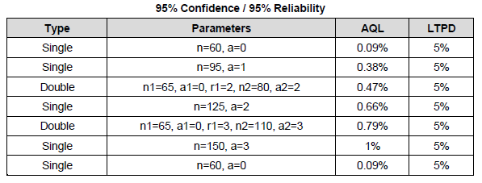
Table 9 - Sampling Plan Statistical Table for 95% Confidence / 95% Reliability
(Wernle & Paro, 2022)

VoE Plan
Therefore the following VoE plan was set to verify the effectiveness of the implemented changes. Internal process monitoring form UKF0070 captures all checks pertaining to the Final cleans, therefore will capture any non-conformance relating to the washes.
After a 3 month period, 60 UKF0070 forms will be randomly retrieved from archive and reviewed. The AQL for the VoE is zero failure, all 60 forms retrieved must be 100% conforming to the local procedures, any nonconformances without the expected escalation will result in the VoE failing. In the event of a failure, the CAPA is deemed ineffective and would therefore start from the beginning.
The following instructions are provided for the reviewer:
- Pull 60 UKF0070 forms from archive for review.
- Examine each UKF0070 form, checking that all temperature checks are within specification as described within the process spec. If values are out of specification, ensure that operators have taken appropriate action and escalated to their leader.
- Document findings on a signed memo for VoE evidence.
The sampling plan rationale is as follows:
Based on table a sample size of 60 UKF0070 forms will be reviewed to provide a 95% confidence level and 95% reliability as. The rationale for this sample size and confidence intervals is that the CAPA risk is medium. It is estimated that in a 3-month period, there would be sufficient samples of records to review and verify effectiveness. For example, from the 1st of September 2022 – 1st of December 2022, there were 92 samples available.
All UKF0070 forms must be correct and comply with the relevant procedures in order for the VoE to be deemed effective.

VoE Result
The VoE, which was carried out between February 13th and April 10th, 2023, randomly selected and reviewed 60 UKF0070 forms from the archive, concluded that all temperature values were recorded correctly and within specification, and all other process monitoring checks were confirmed to be within specification, as evidenced by Table 1 and figures 1-7. This demonstrates that the implemented actions were successful and therefore the CAPA was deemed effective.

Table 10 - Verification of Effectiveness Results

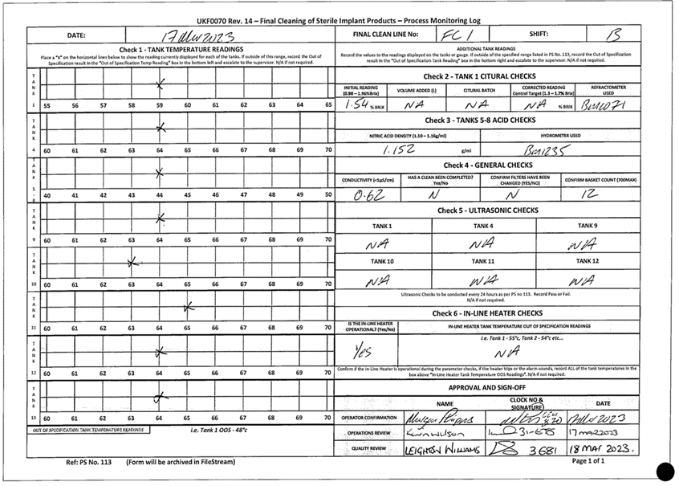
Figure 31 - Verification of Effectiveness Results

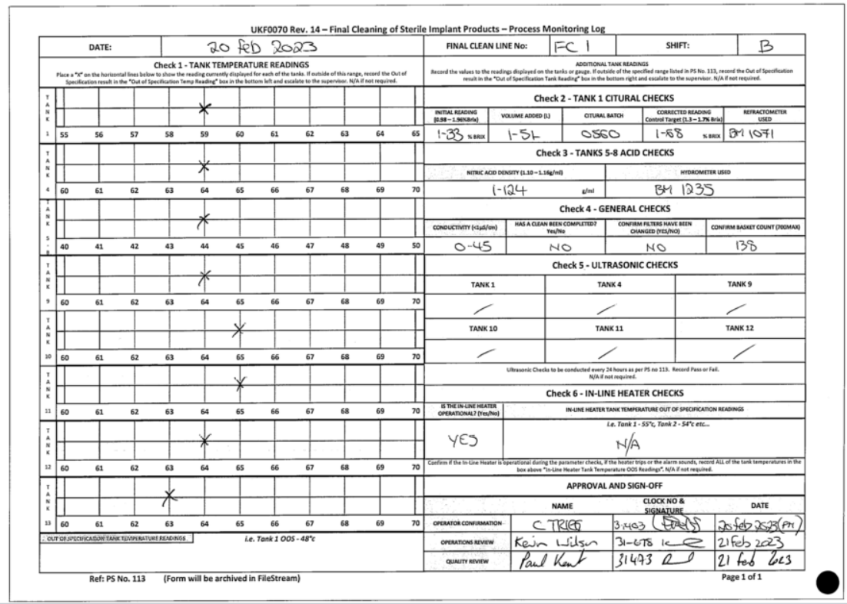
Figure 33 - Verification of Effectiveness Results

Final risk summary
The identified corrective actions have implemented sufficient controls to reduce the occurrence of out of spec temperatures being recorded on UKF0070 without the appropriate escalation, as demonstrated in the supporting evidence provided within the VoE, all other risks have been assessed through the new PFMECA. Therefore, as per (Paro, 2022), the final risk has been reduced to low.

Results

Rework Reduction
The project's improvements have resulted in significant benefits for the business, particularly in the form of a significant reduction in rework. As evidenced by the graph in the Figure 22, from the beginning of 2022 until May 2023, there has been a clear downward trend in the amount of product reworked. Since the implementation plan was put in place, only £35,640 worth of product has been reworked, compared to £816,723 prior. This is a clear indication that the changes made to the documentation and processes have resulted in substantial cost savings. Moreover, there have been zero non-conformances relating to temperature since the changes were implemented.
While the in-line heater has tripped twice due to mechanical failures, the new alarm and audible alert systems have allowed the Operators to respond quickly and limit the impact to only a few batches, as opposed to entire shifts rework as previously experienced.
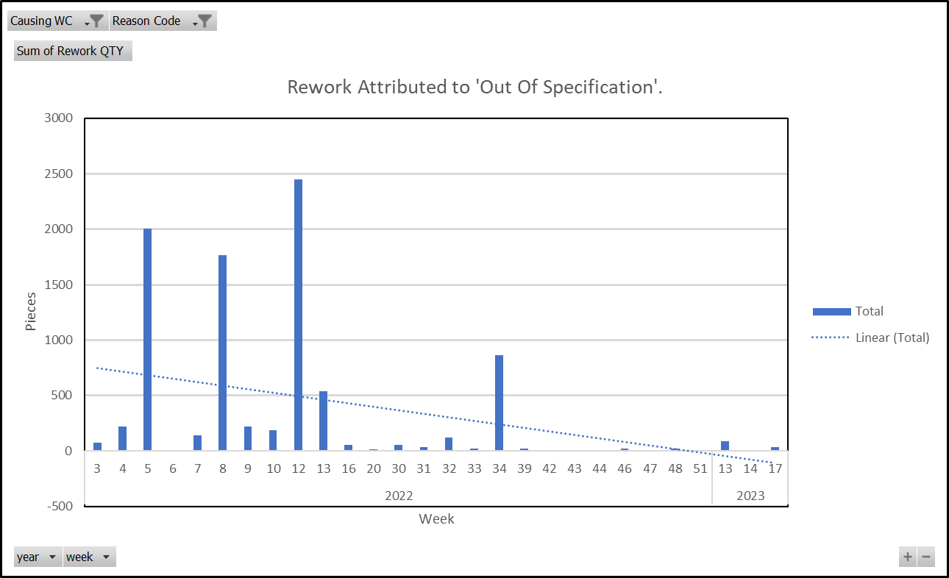
Figure 34 - Out of Specification Rework Reduction
Table 11 - Total Out of Specification Rework Jan 2022 - May 2023

Improved productivity
The high level of rework has a direct impact on Operator performance, as they only receive standard time for any product manufactured on the first attempt. When they have to rework a product, the time spent on rework is lost, resulting in reduced productivity. For instance, if an Operator works a full shift on rework, they will have a productivity rate of 0% for that shift. Additionally, most Operators book downtime to show managers that they are working on rework, which explains why downtime hours also increase when rework is high.

Figure 34 provides clear evidence that since the level of rework has reduced, the area performance for washes has become more stable, consistently achieving above the 85% target. In fact, they achieved their highest percentage on record at 90.7%
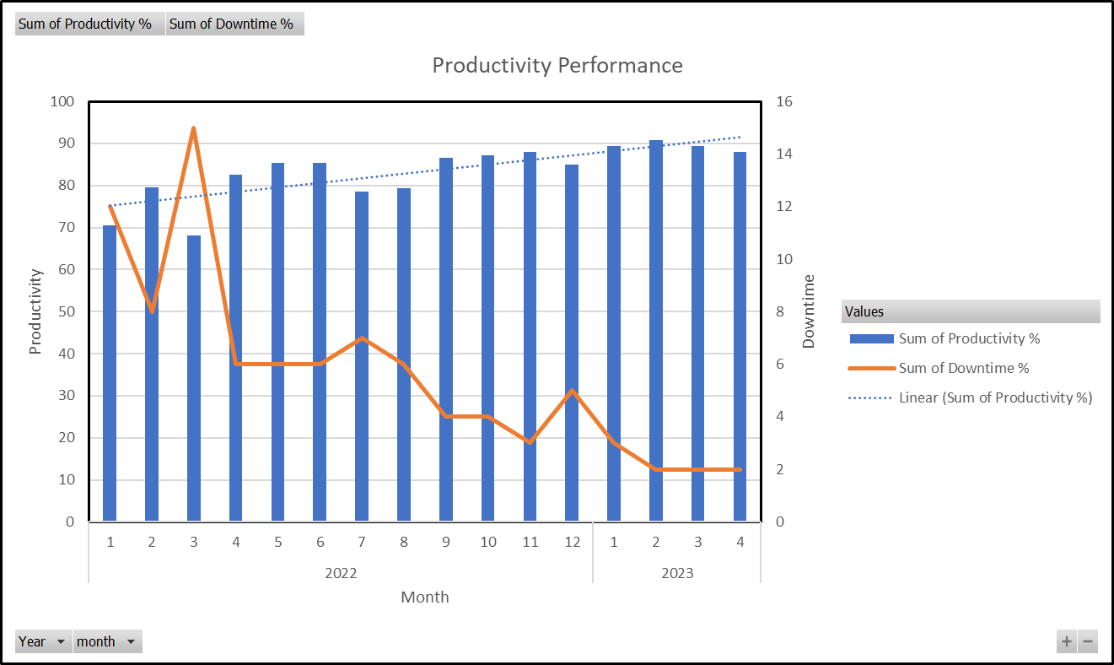
Figure 35 - Productivity Performance

Improved Sustainability
The improvements relating to this project have had a positive impact on the company’s key performance indicators, which in turn make the business more profitable, cheaper to run and become more competitive. High rework volumes have not allowed us to commit to accepting increased volume in fear of being unreliable, current data suggests that the process is far more reliable which will allow them to commit to increased loadings, this will help become a trusted partner within the Zimmer Biomet corporation and help build a sustainable plant in our local area.

Improved Employee Moral & Wellbeing
Based on the Employee survey results as shown in chapter 12.2, Operators moral and well being is impacted due to high rework and defects, they feel strongly towards the impact it is having on their performance which is shown evident in the productivity decrease when out of specification events occur.
A follow up questionnaire also demonstrates that the changes made throughout the Project will seek to improve the employee moral.
A study by Bakker, et al., (2008) found that employee engagement, which is linked to employee happiness, was found to be positively associated to job performance and organisational commitment. The results of this question indicates that the empoyees feel more engaded and will therfore perform and a higher level that previously. 87% of the employees question felt a part of the project with 42% believing they had a high involement throughout.

Figure 36 - Project Close Employee Question 1
The responses to the following questions indicate that the Operator is happier as a result of less rework. 87% believe the project has had a beneficial impact on their daily job. With only 2% responding negatively.

Figure 37 - - Project Close Question 2
The adjustments achieved through simplicity of documentation, template changes and less rework have allowed the business to favourably impact the employee’s health and wellbeing. While improvements are being made, some long-serving employees have responded negatively to changes in process and procedures. 78% of respondents believe the changes will have a positive impact, while 7% believe it would have a negative impact.

Figure 38 - Project Close Question 3

Conclusion

- Summarise the key findings of the study
- Explicitly answer the research question(s) and address the research aims
- Inform the reader of the study’s main contributions
- Discuss any limitations or weaknesses of the study
- Present recommendations for future research

The project aimed to address the issue of non-conformances in the final clean lines of the manufacturing process, specifically relating to temperature, which had resulted in significant costs due to scrap and rework. Literature surrounding COPQ highlights the impact is has on organisations, stating that Organisations that fail to address poor quality not only suffer financial losses but also experience decreased employee morale and increased staff turnover rates. A study by the American Society for Quality found that employees who work in Organisations that prioritise quality management are more satisfied and less likely to leave their jobs (Goetsch & Davies, 2015), This was evident during the employee survey which concluded that high defect rates are having a significant negative impact on employee performance and wellbeing.
The investigation revealed numerous gaps win the process that significantly complicated the Corrective and Preventive Action (CAPA) process, the equipment controls were not performing as described within the qualification documents, throwing question into the risk to product as well batches being processed undertime not highlighted to the Operators when unloading the wash. Further analysis of the process identified that the work instructions and supporting process documentation were found to be inadequate for such a critical process.
The severity of the issues identified within the process meant the enginn
The implementation plan involved a critical analysis and investigation of the process to identify the root cause, and establish corrective actions to provide reliability and robustness to the process.
The implementation plan resulted in significant benefits for the business, particularly in the form of a significant reduction in rework and improved productivity.
The changes made to the documentation and processes have resulted in substantial cost savings, and there have been zero non-conformances relating to temperature since the changes were implemented. The project's success can be attributed to a combination of upgrading equipment, simplifying work instructions, updating process specifications, and reconfiguring daily monitoring to limit operator errors.

Recommended Further Work

Long Term – Upgrade Ultrasonic Generators

Purpose
The business has decided that they can no longer sustain the level of scrap and rework as highlighted within this paper, therefore it is taking the opportunity to upgrade Final clean 2 in line with the newly validated Final Clean 3 (FC3), this work has already commenced and Final Clean 2 was taken out of Operation in January 2023 where it will remain down for 6 months during it’s upgrade, once upgraded the plan is the decommission Final Clean 1 which since its age does not have the capability to be upgraded.
The work due to be completed on Final Clean 2 is as follows:
Generator Upgrade - Ultrasonic generators will be upgraded with modern NexTgen 1500 Ultrasonic Generator unit that allow for additional data and controls to be measured and recorded. This will provide demonstrated assurance during cleaning that ultrasonic performance during the process is achieved at all times. 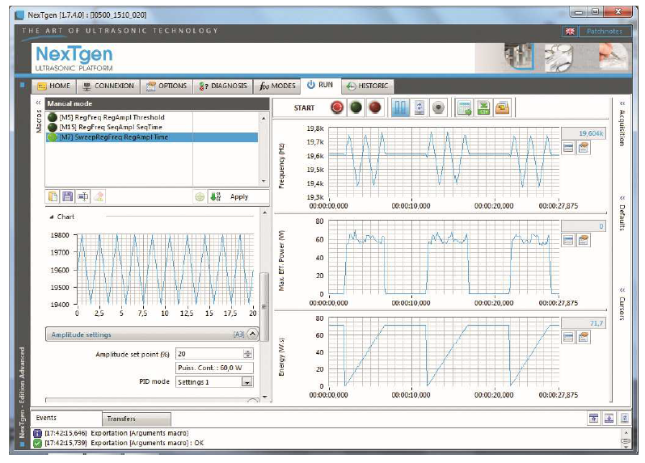
Figure 39 - NexTgen Ultrasonic Trending Example

- FC3 Equivalence – The wash will be set up and programmed to run an equivalent process to that of FC3. This includes:
    - Transfer over to CIP100 cleaning detergent.
    - Pipe Mods - Pipes will be modified as required to achieve the desired water flow and tank order.
    - Install temperature sensors to each tank and link them to the PLC.
    - Align all alarms and I/Os for Ultrasonic monitoring general alarm and high/low temperature alarms.

Benefits
The upgrade of FC2 will provide the business with a huge number of benefits such as:
- Scrap Reduction.
As noted earlier, Exceeded process time cost the business £610,000 in scrap in 2022 alone, the upgrade is replacing the current cleaning detergent Citural for CIP100, CIP100 provides improved risibility and has been validated to allow product to remain in the tank for up to 900 seconds. Data suggests that only 2% of batches exceed 900 seconds. If we receive similar performance when upgraded this could yield scrap reduction of £597,800 in the first year.
- Rework Reduction.
In 2020 8840 pieces were reworked due to temperature and Ultrasonic failures, this is 11.3 days worth of lost capacity. The value of product relating to the 8840pcs adds up to £825,715 whilst this product was realised in the end, if processed right first time the business could’ve benefited by increasing loadings.
- Reduction In Manual Testing
By upgrading the Ultrasonics and temperature alarms there will be no requirement to complete most of the Process Monitoring, the Tank temperatures
- Reduction In Water and Energy Usage.

References
Ahire, S. L., Golhar, D. Y. & Waller, M. A., 1996. Decision Sciences. Development and Validation of TQM Implementation Constructs, 27(1), pp. 23-56.
Anon., 2023. Minerva Stericlean Limited. [Online]
Available at: https://www.minervastericlean.co.uk/sonocheck.html#:~:text=The%20SonoCheck%20consists%20of%20a,change%20in%20the%20vial%20solution.&text=during%20the%20wash%20process%20and%20provide%20rapid%2C%20objective%20results.
[Accessed 27th January 2023].
ASQ, 2020. ASQ. [Online]
Available at: https://asq.org/quality-resources/cost-of-quality
[Accessed 15 January 2023].
Bakker, A., Schaufeli, W. B., Leiter, M. P. & Taris, T. W., 2008. Journal of Organizational Behavior. Work engagement: An emerging concept in occupational health psychology. Work & Stress., 22(3), pp. 187-200.
Bitner, M. J., Booms, B. H. & Tetreault, M. S., 1990. The Service encounter: Diagnosing Favorable and Unfavorable Incidents.. Journal of Marketing, , 54(1), pp. 71-84.
Bloom, N., Guvenen, F., Mihaylov, E. & Jaimovich, N., 2019. National Bureau of Economic Research. [Online]
Available at: https://www.nber.org/papers/w25779
[Accessed 20 February 2023].
Chowdhury, S., 2013. The power of LEO: The hidden secret of staggering profitability.. 1 ed. Boca Raton: CRC Press.
Crosby, P., 1978. Quality Is Free: The Art of Making Quality Certain. 1st ed. New York: McGraw-Hill Education.
Dean, J. W. & Bowen, D. E., 1994. Management Theory and Total Quality: Improving Research and Practice through Theory Development. The Academy of Management Review, 19(3), pp. 392-418.
Deming, W. E., 1986. Out of the crisis.. 2nd ed. Massachusetts: The MIT Press.
Feigenbaum, A. V., 1991. Total Quality Control. Volume 1 ed. New York: McGraw-Hill.
Fornell, C. et al., 1996. The American Customer Satisfaction Index: Nature, Purpose, and Findings. Journal of Marketing, 60(4), pp. 7-18.
Goetsch, D. & Davies, S., 2015. Quality Management for Organizational Excellence: Introduction to Total Quality. 8th ed. New York: Pearson.
Golinska, P., Kosacka, M., Mierzwiak, R. & Werner-Lewandowska, K., 2015. Grey Decision Making as a tool for the classification of the sustainability level of remanufacturing companies. Journal of Cleaner Production, 105(1), pp. 28-40.
Gryna, F. M. & Juran, J. M., 2000. Quality Planning and Analysis: From Product Development Through Use. 4th ed. New York: McGraw Hill.
Hendricks, K. & Singhal, V. R., 2003. The Effect of Supply Chain Disruptions on Long-term Shareholder Value, Profitability, and Share Price Volatility. Production and Operations Management, 12(3), pp. 313-333.
Hendricks, K. & Vinod, R. S., 2003. The effect of supply chain disruptions on long-term shareholder value, profit margin, and shareholder equity.. Journal of Operations Management, 21(5), pp. 544-560.
Heskett, J. L. et al., 1990. Putting the service-profit chain to work.. Harvard Business Review, 68, 68(4), pp. 164-174.
Hughes, T., 2023. PS No 113 - Final Cleaning and Biological Upgrade of Sterile Implant Products. 21st ed. Bridgend: Zimmer Biomet.
Ishikawa, K., 1985. What is total quality control? The Japanese way.. 1st ed. New Jersey: Prentice Hall.
Mitra, D. & Golder, P. N., 2006. How Does Objective Quality Affect Perceived Quality? Short-term Effects, Long-term Effects, and Asymmetries.. Marketing Science, 25(3), pp. 230-247.
Oakland, J. S., 2014. Total quality management and operational excellence. Text with cases. 4th ed. New York: Routledge.
Paro, S., 2022. GUIW7005 - Global CAPA Risk Guidance. 2nd ed. Geneva: Zimmer Biomet.
Shewhart, W. A., 1931. Economic Control of Quality of Manufactured Product. 1st ed. New York: D. Van Nostrand Company..
Sila, I., Ebrahimpour, M. & Birkholz, C., 2017. The cost of poor quality: Evidence from the service industry.. International Journal of Quality and Reliability Management., 34(3), pp. 381-399.
Simchi-Levi, D., Kaminsky, P. & Simchi-Levi, E., 2003. Designing and Managing the Supply Chain. 2nd ed. New York: McGraw-Hill.
Standardization, I. O. f., 2016. iso.org. [Online]
Available at: https://www.iso.org/obp/ui/#iso:std:iso:13485:ed-3:v1:en
[Accessed 17 April 2023].
Taguchi, G., 1986. Introduction to Quality Engineering: Designing Quality into Products and Processes.. 1st ed. New York: Quality Resources.
Wernle, A. & Paro, S., 2022. GUIW07006 - Global CAPA Verification of Effectiveness (VoE) Guidance. 2nd ed. Geneva: Zimmer Biomet.
Wilson, A., Zeithaml, V., Mary, B. J. & Gremler, D. D., 2016. Services Marketing: Integrating Customer Focus Across the Firm: Integrating Customer Focus Across the Firm. 3rd ed. New York: McGraw-Hill.

