 | University of Wales  Trinity Saint David
Programme | BA Business management
Module code | LCBB4002
Unit tittle | Community Engagement
Lecturer | Molly Jack
Student name | Silviya Lazarova
Student ID | 1916917

Reflective evaluation
(Course work part B)

Date: 22/05/2020

Table of Contents
Introduction 3
1. Reflective Evaluation 4
1.1. Reflection on CW1 4
2. Theories of learning styles and reflective cycle 6
2.1. Kolb’s theory of learning 7
2.2. Gibbs’ reflective cycle 9
Conclusion 9
References 11

Introduction

This reflection is designed to follow the process of preparing a report on a task that requires business analysis and clarifying concepts related to the importance of the workforce for an organization. This is a free relief report, which is entirely formed in the opinion of the author himself. In general, this work should express a personal opinion and tell about personal feelings and impressions.
The purpose of this work is to trace what knowledge the author had, as well as what knowledge he/she acquired while making the analysis, as well as the difficulties that the author encounters while doing the work. At the same time, this process of acquiring knowledge and skills will be related to theories known to science, which the author finds to be confirmed by what he/she had experienced during the process of making the analytical report.

Reflective Evaluation

The reflective questions are usually questions that the author or reader of a work meet while completing the job or reading the job of someone else. They are usually personal and express feelings, which could differ from author to reader. The reflective evaluation at the end of a process of some educative or practical experience is necessary, because it clear the usefulness and
“Reflective questions are raised at every stage of the practice to guide further appropriate steps. It is also important to undertake specific evaluation at the end for a range of reasons such as learning, improvement, funding, agency, professional, accountability and so on” (Pawar & Anscombe, 2015).
People live in communities in which they build relationships with the rest of the society. They build themselves and thrive in the context of supportive relationships that are cohesive or destroyed by the dominant economic, political and social forces in their society. The personal reflection on each of the events, which in some way affects the individual, outlines the personal path in which this event was overcome, as well as the personal issues that arose during this period. It also defines the personal gains for the individual expressed in the acquisition of knowledge, skills and experience, which can be permanent and useful, and could become base for gaining new knowledge and skills, or use them as advantages in future.

Reflection on CW1

Course work one was a big challenge for me and I had to do many researches to overcome them. That was because I have never been involved in such activities and haven’t gained any similar skills. The completing of the job was connected with reading many articles, most of which had their single reason to be written, as well as they had their single angle of view, due to which it was difficult to find an objective explanation of the subjects of my questions.
For a start, I was aware that I was choosing a difficult topic, but I hoped that this would be a reason to gain more valuable knowledge and experience. I believed that the skills I would acquire while performing a difficult task would be much better and more valuable than if I had chosen something easy.
The first challenge was finding relevant and at the same time valuable information about the business I have chosen for conducting the environmental analysis. The lack of useful enough information turned out to be a big problem and it took a long time to find it. In the course of my work, I have found that the chosen business has a serious political dispute with the US government and the American business community, of which it is accused of serving China's military interests, using the technology and nature of its business to do so (Hamilton, 2020).
This fact disappointed me a lot, because that was the reason why I could not find valuable information. In other words, there was a lot of information, but not valuable enough to be confirmed by value references. What I realized at the time was based on the fact that the Google search engine was owned by an American business that has power over the world, and would naturally be influenced by the policy measures taken in this case by the US government, no matter that these allegations are not yet provable. Moreover, that the Google has already confirmed that they will no longer be supplying software and services to Huawei, which situation has started one year ago (O'Flaherty, 2019).
No matter all of the problems and challenges I have met, I was already committed and dedicated to continue with the job. Moreover, that the situation I am experiencing now, could happen again in my future life, so I could not give up now, but should use it to gain skills.
One of the difficult parts of the environmental analysis was that I could not relay on today’s not yet provable accusations like a fact, because it could change tomorrow, so my analysis could turn wrong. For that purpose, I had to analysis the current status as required without making too extreme recommendations, but limiting my answers only up to personal opinions related to clearing of the problem.
For the most part, business analysis was very difficult for me due to the fact that it was my first time doing this job. At the same time, however, I was very happy with every victory achieved, with every successful step, as well as with every novelty that turned into useful knowledge and acquired skills for me.
There are many new things, that I have learned during the process of completing the tasks of the report, such as techniques of analysis, reasons for analysing a business situation, role of the analysis, importance of the analysis, as well as usefulness of the analysis. While learning how to do SWOT analysis, I first tried to do individual SWOT analysis of myself and the result was amazing. This is a great tool, that could be used for many reasons, not only for business.
Later when I reached to the discussion regarding the human resources and their importance for the organizations, I was remained about my personal SWOT analysis. I realised that I have been trained in a few of the organisations where I have worked and that I have never realised that these trainings are in my benefit, because later on I have used them while performing my duties in another organisation. I also, realised that the company that have trained me has spent for my training and have lost me then to another business of its competitors. No matter how I feel about them losing me, I am happy that the previous trainings have became basement for getting higher in my career.
Having gained some more knowledge and experience makes me feel the usedness of it immediately. The skills though, require more repeatable work on the same or similar tasks. This is because this work is specific and requires quite a lot of attention, as well as much more training than just one read or one try, i.e. it needs practice.
The practice also causes the acquisition of more knowledge related to details that would not be noticed by one experience. Rereading my work, I now find that many things could be done differently and better. At the same time, questions are being formed that I want to find the answer to. This lets me know that developing a skill in an area requires a cross-cutting process of repetitive actions.

Theories of learning styles and reflective cycle

There are many learning theories, such as behavioural learning theories, cognitive learning theories, developmental theory of learning, humanistic theory of learning, constructivism theories of learning, experiential learning theories, etc. Most appropriate theory that could be employed for analysing adults’ model of development seems to be the Experiential Learning Theory (ELT). This is a model that provides a way to examine how people learn, grow, and develop.
“The theory is called experiential learning to emphasize the central role that experience plays in the learning process, an emphasis that distinguishes ELT from other learning theories. The term experiential is used therefore to differentiate ELT both from cognitive learning theories, which emphasize cognition over effect, and behavioural learning theories, which deny any role for subjective experience in the learning process” (Sternberg & Zhang, 2001).

Kolb’s theory of learning

The Kolb’s experiential theory of learning styles came first into my mind, while trying to define what kind of learner I am according to my style. Due to the similarity, Kolb’s theory is believed to be built and expanded upon the theory of personality developed by Carl Jung (1922), who had focused on the way people interact and adapt to the world (Cherry, 2020).
Still, all theories differ in many ways, otherwise they could not be identified as theories. However, the theory caught my attention because it is an experiential theory, and I think that it is related to my case (gaining experience by completing tasks), so that I could try to define my way of learning according to his theory.
Kolb though, has developed Experiential Learning Theory (ELT), which consists of Experiential Learning Styles (ELS) and Experiential Learning Cycle (ELC).
Kolb’s learning cycle contains four stages of learning cycle, in which cycle a learner goes through all of the stages during the process of learning. During this process though, a learner can be defined as belonging to one of the four learning styles Kolb has described.
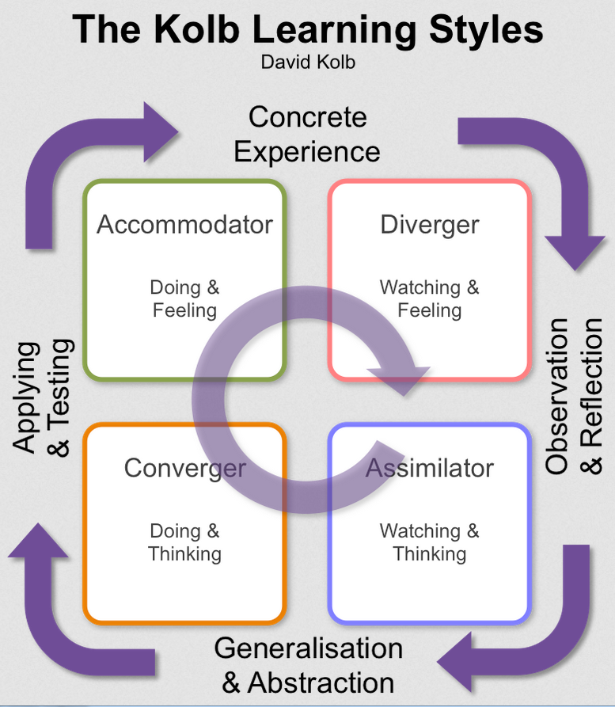
Figure 1. Kolb learning Styles. Source: (Pocketbook, 2015)
Concrete experience, Reflective observation, Abstract conceptualisation and Active experimentation is how Kolb has defined the four stages of the learning cycle. A short explanation is necessary, so that after that the learning styles can be defined easier.
Concrete experience - encountering a new experience that helps creating an opportunity for learning (Gruber, 2015).
Reflective observation - reflecting on personal experience before trying to make any judgements (Gruber, 2015).
Abstract conceptualisation - developing theories in order to explain their experience, or creating concepts that they can apply in future (Gruber, 2015).
Active experimentation - applying what have been learned in the experience, to another similar or same situation (Gruber, 2015).
There are four recognised by Kolb learning styles, which are a result of the qualities people have, and which are defined but the stages standing in both of their sides, as shown on the Figure1 above.
The ‘converger’ – because this means that the people with this learning style are highly skilled of applying ideas in practice, and have dominant abilities in the areas of active experimentation and abstract conceptualisation, I can recognise myself as partly ‘converger’, which though doesn’t define my style exactly.
The ‘diverger’ – Defined as having abilities in Concrete Experience and Reflective Observation, this style appears like opposite of the ‘converger’. This though also makes me describe my style as partly ‘diverger’ especially because that means people with this style are emotional and creative, also they enjoy brainstorming, so that they can generate ideas. Still, not everything describing this style suits me.
The assimilator – A style that define people whose skills are spread between the areas of Reflective Observation and Abstract Conceptualization and their greatest strengths is understanding and creating theoretical models. Also, they are not greatly concerned to practically apply theories, but they are more interested in abstract ideas than in people. This style describes me much more than the previous two, which can be seen even in the reflective notes made above.
The accommodator – A style describing people, which are the greatest risk-takers out of all other styles is a bit too contrasting with my personality. I can say that this is quite not my style, because I cannot accept that it is acceptable to do something if there is not a 100% promise it will succeed, especially of it is involving people’s life.
So, after describing the four Kolb’s learning styles, I recognised myself in the style of the assimilator.

Gibbs’ reflective cycle

Developed by Graham Gibbs back in 1988, this theory aims to give a structure of learning by experiencing. It consists of six stages that could be shortly presented as follow:
- “Description of the experience
- Feelings and thoughts about the experience
- Evaluation of the experience, both good and bad
- Analysis to make sense of the situation
- Conclusion about what you learned and what you could have done differently
- Action plan for how you would deal with similar situations in the future, or general changes you might find appropriate” (Reflection toolkit, 2019).
This is just one more model of reflection that is a bit more detailed and focuses on the process of gaining experience. It is a model that explore different ways of doing things and promote self-improvement.

Conclusion

This reflective evaluation was following the model of Gibbs’ learning cycle. The stages of this learning cycle are completely followed by the reflection on the conducted analysis in course work one and have been extremely helpful for the building of the reflective evaluation. However, there are other theories that apply for this work and one of them, the Kolb’s model of learning was also discussed. Overall, this reflection has completed its aim.

References
Cherry, K., 2020. Kolb's Theory of Learning Styles. [Online]
Available at: https://www.verywellmind.com/kolbs-learning-styles-2795155
[Accessed 21 May 2020].
Gruber, G., 2015. Explorance; I Do and I Understand’ – Kolb’s Experiential Learning Theory Explained. [Online]
Available at: https://explorance.com/blog/i-do-and-i-understand-kolbs-experiential-learning-theory-explained/
[Accessed 21 May 2020].
Hamilton, I. A., 2020. The US says Huawei has been spying through 'back doors' designed for law enforcement — which is what the US has been pressuring tech companies to do for years. [Online]
Available at: https://www.businessinsider.com/us-accuses-huawei-of-spying-through-law-enforcement-backdoors-2020-2
[Accessed 21 May 2020].
O'Flaherty, K., 2019. Forbes; Google Is Cutting Huawei's Android Access: Here's What It Means (Updated). [Online]
Available at: https://www.forbes.com/sites/kateoflahertyuk/2019/05/20/google-is-cutting-huaweis-android-access-heres-what-it-means/#5e19ced67bc8
[Accessed May 2020 2020].
Pawar, M. & Anscombe, B., 2015. Reflective Social Work Practice: Thinking, Doing and Being. First ed. Port Melbourne: Cambridge University Press.
Pocketbook, 2015. Pocketbook; The Kolb Learning Styles. [Online]
Available at: https://www.pocketbook.co.uk/blog/2017/02/07/david-kolb-experiential-learning/kolb-learning-styles/
[Accessed 21 May 2020].
Reflection toolkit, 2019. The UOE; Gibbs' reflective cycle. [Online]
Available at: https://www.ed.ac.uk/reflection/reflectors-toolkit/reflecting-on-experience/gibbs-reflective-cycle
[Accessed 21 may 2020].
Sternberg, R. J. & Zhang, L.-f., 2001. Perspectives on Thinking, Learning, and Cognitive Styles. First ed. London: Routledge.

