

BMHP5015_BIRM – BUILDING YOUR PERSONAL BRAND FOR SUSTAINABLE EMPLOYMENT
Component 1

Student Name: EHIS TESSY MASADEY
Student Number: 2244813

Task 1: Personal Brand
Personal branding refers to my ability to consciously creates a professional personal where their skills, interests, and capability are easily identifiable (Szántó and Radácsi, 2023). For me this would involve, showcasing my principles and how I would like my professional life to be seen, has been empathetic, ethical and person-centred mental health practitioner.
Similarly, personal branding provides those who may consider hiring me with an understanding of what my personal values, skills and identity are in a professional context. This is especially true in the workplace (Korzh and Estima, 2022). I want to be seen as a reflective and empathetic practitioner who is aware of their own feelings and equipped to provide support for clients experiencing mental health distress. All of this is acutely relevant in mental health where establishing trust, communication and emotional intelligence support safe practice (NHS England, 2023).
My best traits are my ability to listen, be sensitive to others and be reflective of my behaviour and growth. I believe my personal brand needs refining if I really want to continue on to work in mental health after graduation. According to NHS England (2023), continuous professional development and reflective practice are essential for developing a resilient and capable health and social care workforce.
This could mean continuing my use of reflective learning, continuing mental health training, or working on developing a professional LinkedIn profile that accurately reflects my values and aims. I feel that through participation in these activities, I will be able to position myself as a credible, self-aware and motivated mental health professional.

Task 2 – Network Map and Rationale
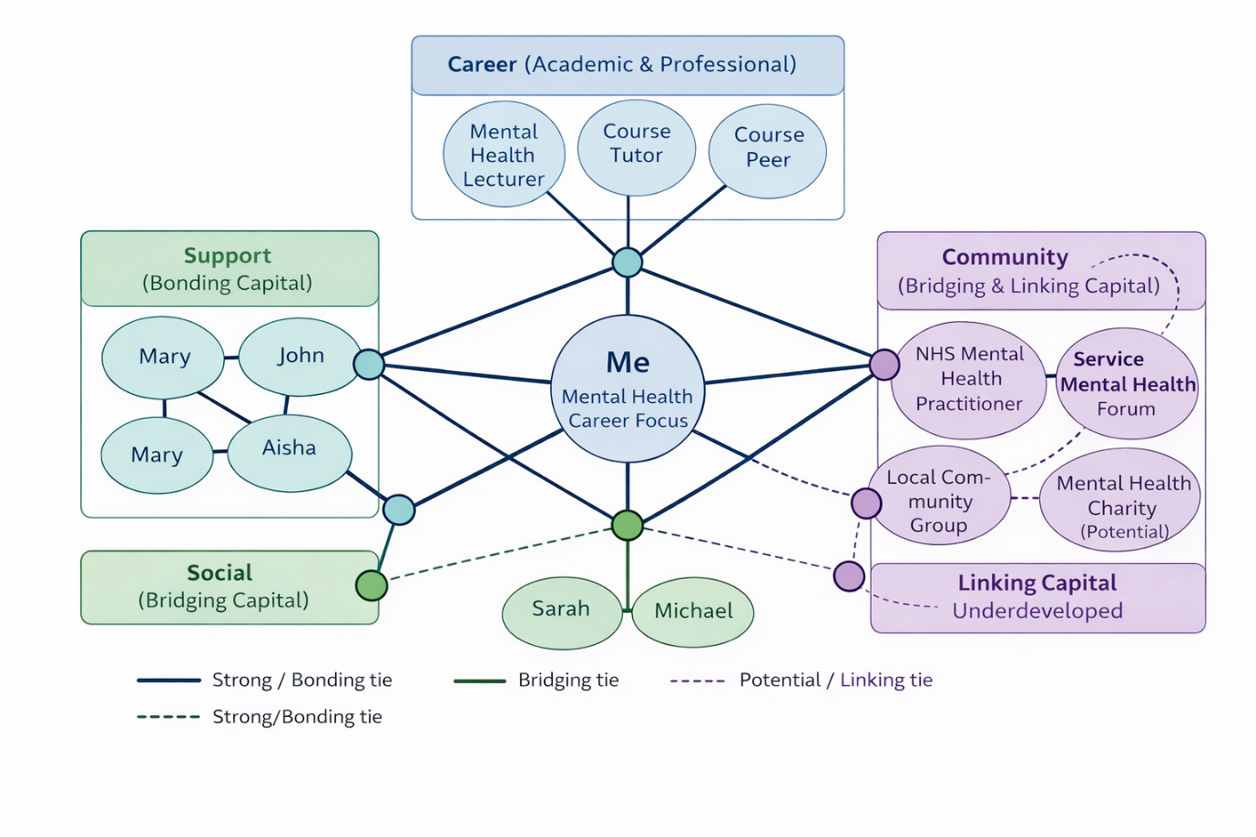
I have drawn my most up to date network map, illustrating my centrality within my network, the various networks influencing my academic, personal and professional development around a mental health career. My close family, specifically my mother, siblings and father have supported and provided stability to my emotional well-being. They are often defined as strong social bonds that offer comfort, trust and personal support during stressful or challenging times.
The people I consider to be part of my career network are my course tutor, mental health lecturers and peers from my Health and Social Care course. They provide academic support, feedback and learning. While these are important links, I have only weak ones. Most of these links are only within the bounds of the university, but my own social network also overlaps the same region a little, due to friends or peers who are likewise interested in the academic subjects.
Besides the university, I have a network in my community: I do not get as involved with community organizations or online mental health forums. These are weaker bridging ties, involving people with whom I have weaker acquaintances, as opposed to those in my school or social circles. Further, my linking social capital is weak, as I have little direct contact with senior or management mental health practitioners, such as NHS employees or service managers.
Overall, my network is hybrid: It has relatively dense bonding ties weakly developed as bridging and linking ties (Putnam, 2000). I need to tighten bonds in bridging ties through volunteering and networking events and in linking ties through interactions with professionals in the mental health services. This referral network has improved my access to professional advice, mentorship, and potentially future employment (Bourdieu, 1986).

Task 3 – Blog
Title: The Growing Mental Health Crisis Among Young Adults in the UK
Target Audience: University Students and Young Adults
In the UK‚ mental health disorders in young adults have considerably increased․ In particular‚ university students experience increased levels of anxiety‚ depression and stress due to demands of university life‚ finances and incoming transitions (Auerbach et al., 2018; Thorley, 2017). NHS Digital (2023) has reported that demand for mental health services within young people has considerably increased over the past five years; this has placed further pressure on NHS services․
Long waiting times for treatment are common‚ and young adults do not always have timely access to therapy or specialist services (Royal College of Psychiatrists, 2021). Symptoms may worsen and the person may become further isolated from the support and services available․ Despite campaigns‚ stigma against mental health problems may prevent people accessing services early on (Clement et al., 2015).
Digital mental health services‚ like online therapy services and NHS talking therapy services‚ have increased considerably to make access easier‚ but are limited by some who lack internet access or a private space to speak about their mental health․
Since then, higher education institutions have taken more responsibility for student mental health via counselling services‚ wellbeing workshops and peer support networks‚ and called for more funding and policy support in those areas to ensure lasting change․
The problems around mental health in young people could be solved by improving funding‚ reducing waiting times‚ improving early intervention and reducing stigma․ We could also help each other by prioritising self-care‚ seeking help when we need it and having conversations that help to destigmatise mental health issues․
Mental health support should be timely‚ compassionate‚ and accessible to everyone‚ not a privilege‚ nor an afterthought․

Task 4 – NHS Equality, Diversity and Inclusion Quiz
1. What is the primary goal of the NHS Equality, Diversity and Inclusion Improvement Plan?
This strategy outlines the commitments to create a fair and inclusive NHS workforce and to create an NHS in which staff from diverse backgrounds feel valued and supported․
2. How does the NHS EDI Improvement Plan propose to tackle the gender pay gap?
The plan seeks to reduce the pay gap between the genders by improving transparency‚ reviewing recruitment and promotion practices‚ and increasing‌ the number of women in senior positions․
3. What is meant by the term ‘intersectionality’?
Intersectionality is also described as how different aspects of a person's identity (for example race‚ gender and disability) combine to create different modes of discrimination and privilege․
4. Why is it important for the NHS to create a psychologically safe work environment?
This creates an environment where staff are able to raise concerns‚ report discriminatory behaviour and input new ideas without fear of blame or repercussions‚ leading to improved patient safety and employee wellbeing․
5. How does the NHS EDI Improvement Plan suggest improving the experience of internationally recruited staff?
Improve induction schemes‚ mentoring and career progression opportunities for internationally recruited staff‚ ensuring equity in career opportunities․
6. What role does leadership play in advancing EDI objectives?
Leaders can role model inclusivity‚ hold organizations accountable to their commitments and embed equality in their workforce plans․
7. Identify one way the NHS EDI Improvement Plan aims to reduce health inequalities within the workforce.
A suggested remedy is to increase the number of underrepresented groups in decision-making positions․
8. Why does the NHS emphasise collecting and analysing data on protected characteristics?
The data collected allows the NHS to better understand inequalities‚ monitor progress and deliver evidence․
9. How can flexible working policies contribute to equality and inclusion?
This might help support staff with caring responsibilities‚ disabilities‚ or health issues‚ helping to achieve work-life balance and reduce inequality․
10. What is one strategy to combat bullying and harassment?
The NHS recommends clear reporting systems‚ zero-tolerance and accountable leaders to tackle bullying and harassment․

Task 5 – A Letter to Yourself
Dear Younger Me‚
You were a person who was overwhelmed‚ not knowing what to do․ Overwhelmed by academic pressure‚ anxiety and self-doubt‚ and this was back when you thought strength meant pushing on without allowing yourself to feel anything․ You told yourself that it's better to endure alone․ But emotional intelligence starts with recognising and accepting how you feel․
You would be more aware that being under stress doesn't mean you're weak‚ it means you need help․ You would learn to become better at controlling your emotions‚ rather than blocking them‚ so to respond rather than be numb under pressure․ Emotional intelligence refers to the ability to recognise‚ understand and appropriately express emotions․
In these situations you grew gradually more resilient: you kept showing up to classes and consulting and taking advice‚ thinking about the experience even when things were becoming increasingly challenging․ Resilience‚ the ability to adapt well to adversity‚ is a mindset you could have adopted sooner to reach a kinder place with yourself․
Asking for support from friends‚ family or tutors was important and not a sign of failure․ Learning to manage coping strategies‚ find a sense of balance and practice reflective thinking would have improved your confidence earlier on․
Though they have been painful‚ those experiences have led me to become the empathetic‚ introspective and resilient person I am becoming․ Trust the process‚ you are stronger than you realise․
With compassion‚
Your Future Self

Task 6 – Gantt Chart
Career Goal: Become a Mental Health Practitioner within the NHS (2026-2027)
Task / Activity | Mar–May | May–June | July–Sep | Oct–Dec | Jan –Mar | Apr–July | Aug–Oct | Oct–Dec | Milestone
Complete Degree |  |  |  |  |  |  |  |  | Graduation
Develop LinkedIn Profile |  |  |  |  |  |  |  |  | Profile Completed
Research NHS Roles |  |  |  |  |  |  |  |  | Role List Created
Volunteer in Mental Health Setting |  |  |  |  |  |  |  |  | 6 Months Experience
Attend CPD Workshops |  |  |  |  |  |  |  |  | 2 Certifications
Apply for NHS Band 3/4 Roles |  |  |  |  |  |  |  |  | Interview Secured
Seek Professional Mentor |  |  |  |  |  |  |  |  | Mentorship Established
Interview Preparation |  |  |  |  |  |  |  |  | Interview Confidence
Secure Employment |  |  |  |  |  |  |  |  | Job Offer
Continue CPD & Reflective Practice |  |  |  |  |  |  |  |  | Ongoing Development

Figure 1: The diagram below is a Gantt chart that shows how I plan to become a Mental Health Practitioner within the NHS over the course of 2 years․ The first 6 months will involve finishing my studies‚ then going through the process of developing a professional identity․ These foundations support employability readiness․
In stage two (Months Jun-Dec) the focus is on participation e․g․ through volunteering and professional development workshops to develop bridging and linking social capital‚ professional knowledge‚ and confidence․
In the third phase (Months Jan-Jun)‚ the applicant makes applications to NHS Band 3 or 4 jobs‚ arranges mentorship‚ and prepares for the interviews which take place alongside the applications․
In the final stage (Months Jun-Dec) the focus is on getting a job and CPD․ Reflective practice and CPD will also happen throughout the whole process․
This Gantt chart breaks down my long-term goal into measurable milestones that allow for structured progression‚ accountability‚ and adaptability‚ turning a general career aspiration into specific measurable objectives that are time-bound and achievable․

Task 7 – Making Changes: Report
Introduction
I am a care home manager and would introduce a digital care planning system to replace paper-based systems․ This would improve record keeping accuracy‚ communication‚ regulatory compliance and improve systems and processes in the service․
Planning the Change
Utilising Lewin's (1951) Change Model‚ unfreezing would involve discussing the need for a change‚ addressing the impact of outdated paperwork and inspections․ The change stage would involve training and one-to-one support to raise staff understanding of the new policy․ The refreezing stage involves incorporating the digital documents into regular workflow routines with feedback loops․
As Kotter (1996) highlights‚ building a coalition and creating urgency are very important․ I would include senior carers and team leaders early on to act as change champions․
Skills Required
Key skills include leadership‚ communication skills‚ emotional intelligence and conflict resolution‚ all of which are essential when addressing resistance and gaining stakeholder engagement․
Barriers and Solutions
Obstacles include fears around staff buy-in‚ technology‚ and time constraints․ I would overcome them by showing empathy‚ running structured training sessions‚ and celebrating small wins․ Clear communications and visible leadership support help sustain morale․
Conclusion
With the use of structured change models and staff involvement‚ the digital care planning system is expected to improve efficiency‚ safety and quality of care․
Task 8 ‚ Self-Reflection
I will use Gibbs' (1988) Reflective Cycle and discuss my learning experience throughout this module․
Description
This module was about personal branding‚ networking‚ emotional intelligence and change management․ I had not realised the importance of actively and purposefully developing my personal brand․
Feelings
The initial stages were hard as I struggled with understanding what my brand was and assessing my network‚ but once I grasped those concepts, I became more self-assured and confident about my brand․
Evaluation
Thus‚ I can be said to have mostly bonding social capital and little bridging or linking capital‚ with strong empathy and reflection‚ but little self-confidence in professional areas outside the academic world․
Analysis
I also learnt how employability is about more than skills and experience‚ how it requires an awareness of identity‚ networks and adaptability‚ an understanding of social capital (Putnam‚ 2000) and the workplace․ Studying change management also increased my awareness of leadership․
Conclusion
This module has made me more aware of myself and made my career in mental health clearer․
Action Plan
I will continue to extend my professional networks and engage in CPD and reflective practice to build my resilience and professional identity․

References
Auerbach, R.P., Mortier, P., Bruffaerts, R., Alonso, J., Benjet, C., Cuijpers, P., Demyttenaere, K., Ebert, D.D., Green, J.G. and Hasking, P. (2018) ‘WHO World Mental Health Surveys International College Student Project: prevalence and distribution of mental disorders’, Journal of Abnormal Psychology, 127(7), pp. 623–638.
Bourdieu, P. (1986) ‘The forms of capital’, in Richardson, J. (ed.) Handbook of Theory and Research for the Sociology of Education. New York: Greenwood, pp. 241–258.
Clement, S., Schauman, O., Graham, T., Maggioni, F., Evans-Lacko, S., Bezborodovs, N., Morgan, C., Rüsch, N., Brown, J.S.L. and Thornicroft, G. (2015) ‘What is the impact of mental health-related stigma on help-seeking? A systematic review of quantitative and qualitative studies’, Psychological Medicine, 45(1), pp. 11–27.
Gibbs, G. (1988) Learning by Doing: A Guide to Teaching and Learning Methods. Oxford: Oxford Polytechnic.
Korzh, A. and Estima, A., 2022. The Power of Storytelling as a marketing tool in personal branding. International Journal of Business Innovation, 1(2), p.e28957.
Kotter, J.P. (1996) Leading Change. Boston: Harvard Business School Press.
Lewin, K. (1951) Field Theory in Social Science. New York: Harper & Row.
NHS Digital (2023) Mental Health of Children and Young People in England. Available at: https://digital.nhs.uk (Accessed: 19 February 2026).
NHS England (2023) The NHS People Plan. London: NHS England.
Putnam, R.D. (2000) Bowling Alone: The Collapse and Revival of American Community. New York: Simon & Schuster.
Royal College of Psychiatrists (2021) Mental health services for young people: Access and waiting times. London: RCPsych.
Szántó, P. and Radácsi, L., 2023. Defining personal brand, personal branding and personal brand equity. Prosperitas, 10(3), pp.1-11.
Thorley, C. (2017) Not by degrees: Improving student mental health in the UK’s universities. London: Institute for Public Policy Research.

