Module Code: LCCB4005
Module Title: The Global Business Environment
Assignment Number: Assignment 1
Assignment Title: Environmental Analysis of Automobile Industry

Table of Contents
Introduction 3
SWOT analysis 3
Pestel analysis 5
Porter’s five forces 6
Value chain analysis 8
Recommendations 9
Conclusion 10
References 11

Introduction
Environmental analysis includes internal as well as external factors that influence the business performance of an organisation. This analysis is essential for every organisation which helps to make decisions and achieve competitive advantages more effectively. The chosen automobile company for this assignment is Jaguar Land Rover from the automobile industry of the UK. Jaguar Land Rover is a well-known multinational automobile company that produces luxurious and sports vehicles. The following section has analysed the internal environment and external environment through SWOT analysis, Pestle analysis, Porter’s five forces and value chain analysis for Jaguar. Recommendations are also provided to enhance all over the performance of the organisation and in conclusion, this assignment also summarises the findings of the learning process of the company from this industry.

SWOT analysis
Strength  - Jaguar is one of the most popular and well-known brands in the automobile manufacturing industry.  - The company is also well known for its expertise level. They have an extremely skilled workforce which helps them to produce such luxurious cars.  - The company belongs to a niche category therefore it is not easy to give competition from a new brand.  - The loyalty and trust among customers is also a positive advantage for the brand to hold its position in the market (Jaguarlandrover, 2021a).  - The company shares a high brand value which helps them to recall their brand in terms of promotion. | Weakness  - The company has a good product range but in comparison with their competitors, they lack this aspect. However, they need to focus on this area.  - The brand is popular in certain countries and still needs to work on increasing its popularity in other countries.  - Jaguar is facing a reliability and quality issue currently (Nagaraj, 2021).
Opportunity  - The company is emerging as a result in the future there is an opportunity to target new markets as well.  - As most of the competitive brands are focusing on hybrid technologies thus Jaguar also can focus on this area to seek awareness of customers by enhancing the overall quality of their cars.  - In the UK, the Environment Protection Act, 1990 is regulated (Legislation, 2021). Thus, Jaguar has the opportunity to follow the regulations for protecting the environment and reducing CO2 emissions.  - The disposable income of UK citizens is always high and currently, it is measured as 197620.31 GBP million (Tradingeconomics, 2021). Thus, it can be stated Jaguar has the opportunity to increase their sales from the UK and generate profit more effectively. | Threat  - A strong competition always exists with Audi, Porsche, BMW, Aston Martin and others (Owler, 2021). Thus, it is difficult for Jaguar to stay in the competition and hold its position in the market.  - In the UK financial instability is already observed which includes inflation rate or recession (O'Neill, 2021). As a result, people spend less thus it can be a threat for Jaguar to generate profit.  - COVID-19 is another threat that increases the prices of raw materials and eventually impacts the cost of production.
Table 1: SWOT analysis of Jaguar
(Source: Self-developed)

Pestel analysis
Political | - The UK is politically strong and the government is also stable which helps every organisation to grow more effectively and rum the business.  - Brexit uncertainty adversely impacted the trades of the UK.
Economic | - The inflation rate of the country has been reduced in 2020 and measured 0.85% (O'Neill, 2021). Reduction in inflation rate leads to fewer expenses of customers thus it creates an adverse impact on the organisation.  - Brexit created a barrier to economic development in the country.
Social | - Disposable income of the people in the UK is always high and currently, it is 197620.31 GBP million (Tradingeconomics, 2021). Thus, it is beneficial for Jaguar to generate more profit.  - Vehicle sales in the UK have declined due to COVID-19 and it is measured at 2 million in 2020 which is much less than the previous year (Wagner, 2021). Hence, sales of Jaguar also have declined.
Technological | - The UK is technologically advanced which is beneficial for Jaguar as well.  - Currently, modern vehicles use Autonomous Emergency Braking, 360 Degree cameras and others. Jaguar has the opportunity to use such techniques as well.  - Due to COVID-19 technology use has been increased a lot which is beneficial for the companies to attract customers online as well.
Environmental | - Greenhouse gas emissions have increased by 6% through transports in 2017 (Gov, 2019).  - In the UK, Environmental Protection Act 1990 is regulated (Legislation, 2021b). Jaguar also has to follow the legislation and they also have initiation to reduce CO2 emission and greenhouse emission in the UK (Jaguarlandrover, 2021a).
Legal | - Equality Act 2010 is regulated within the UK to maintain equality within organisations and all employees get equal benefits in every sector (Legislation, 2021).  - In the automobile industry, all the legislation is as follows as other industries of the UK. Jaguar has to follow all the legislation to provide equal benefit to their employees, avoid discrimination and avoid unavoidable circumstances.
Table 2: Pestel analysis
(Source: Self-developed)

Porter’s five forces
Porter's five forces are conducted to evaluate competitive advantages and determine profit potentials in the market (Padraig, 2017). Five factors of Jaguar illustrated in the following section,
Threats of new entrants
As Jaguar is popular and provides high-quality vehicles thus there are no chances of coming threat from new entrants. By utilising the cost advantage, Jaguar can easily fight with new entrants (Jaguarlandrover, 2021a). Due to its innovation, Jaguar has the option to differentiate its vehicles from new entrants. Thus, threats of new entrants are low for Jaguar.
Threats of substitutes
A Lesser number of substitute products are available in the automobile industry of the UK and they earn very little. Therefore, in this context also threats of substitute products for Jaguar are low.
Bargaining power of suppliers
A huge number of suppliers are available in the UK automobile industry thus they do not have the power to bargain. Switching cost in terms of suppliers is very less as well. In order to maintain quality, Jaguar can switch their suppliers at any point in time (Jaguarlandrover, 2021a). The cost of raw material is less which is beneficial for Jaguar. Multiple supply chains can be maintained for different regions. Therefore, it can be stated that the bargaining power of suppliers is low for Jaguar.
Bargaining power of buyers
Quality matters for the buyers and in this context the purchasing frequency is less. Customers prefer to purchase vehicles based on their quality as a result in this context it can be stated that they do not price sensitive. Thus, the bargaining power of customers is low for Jaguar.
Rivalry among competitors
Competition in the automobile industry of the UK is high as there are multiple competitors available for Jaguar. Competitive brands such as Audi, BMW can capture the market at any time by providing more quality vehicles (Owler, 2021). The brands also can apply better competitive strategies to seek awareness of customers. Thus, it can be also stated that rivalry among competitors is high for Jaguar.
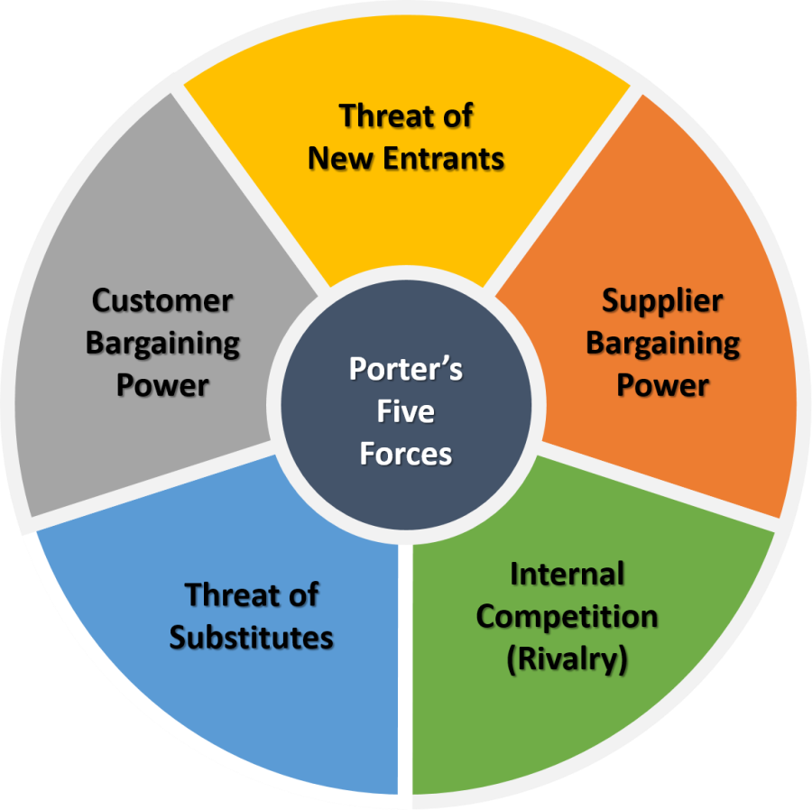
Figure 1: Porter’s five forces
(Source: Influenced by Padraig, 2017)

Value chain analysis
Value chain analysis is a framework used to evaluate all the activities done by a company and the opportunities that lie within it (Jones et al. 2019). The following section has conducted a Value chain analysis for Jaguar,
Primary activities
Operations
The operation of Jaguar includes manufacturing and services. In this context, Jaguar has an expert workforce who works to produce high-quality vehicles and sales personnel provide excellent services as well (Jaguarlandrover, 2021a). The company has exceptional technical assistance who provides after services to their customers.
Inbound logistics
The company provides excellent inputs to produce quality-maintained vehicles to maintain their standard. Their logistics department provides high-quality services to reduce any damages. The company spent £3 on product innovation (Jaguarlandrover, 2021b).
Outbound logistics
In terms of vehicle delivery, the company focuses to ship without any damage and also deliver customers' cars within a limited time frame. They maintain flexible delivery capabilities and the order process is also effective (Jaguarlandrover, 2021a).
Service
The company has highly skilled workers who provide excellent services after purchasing as well. Repairing and maintenance are also tackled by the teams efficiently. The company employed around 38,000 people supporting their retailers (Jaguarlandrover, 2021b). Jaguar provides services while communicating with customers through the test drive, after product booking manufacturing done by the people, after manufacturing all the vehicles checked by the quality checker or technicians, then it gets delivered by their people and also after purchasing services included.
Marketing and sales
The company tries to maintain a two-way communication process with their customers (Jaguarlandrover, 2021a). The exceptionally focus on their advertising and promotional activities to create brand awareness and create a brand image in the industry. Coordination within all the departments can be seen.
Secondary activities
Human resource management
The HR department of the company focuses on their employees' well being and provides rewards to produce high productivity. Training is given time by time to develop employees' knowledge and skills which eventually produce high-quality vehicles and services (Jaguar, 2021).
Firm infrastructure
The company operates globally thus they have to maintain more than one infrastructure for their manufacturing and retailing. The database is maintained through their firms to maintain effective marketing communication and advanced technologies used in information systems.
Technology development
Innovation is always seen at Jaguar by using advanced technologies. The company produces new vehicles within a certain period and new features are always incorporated in the vehicles through the development of systems.
Procurement
Jaguar effectively replaces parts of vehicles with high-quality raw materials and they maintain reliability to satisfy their customers by ensuring quick delivery of cars.
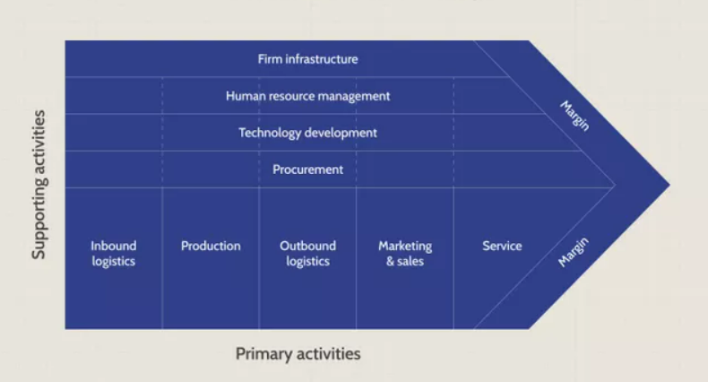
Figure 2: Value chain analysis
(Source: Influenced by Jones et al. 2019)

Recommendations
Jaguar has to analyse its internal and external environment along with competitors' analysis. After facilitating environment analysis, it is required to focus on their innovation process and quality maintenance as currently, they are facing such issues. Competitors such as Audi, BMW always maintain their quality thus, in order to hold the position in the industry, Jaguar also has to focus on their quality. The company can contact their suppliers to ensure better quality material which can be used to maintain their quality of vehicles. Marketing communication done by other competitive brands is exceptionally attractive which includes Social media advertisement, Television advertisement, Celebrity endorsement, and also influence through Bloggers. The company can also enhance their promotional activities to create brand awareness more effectively. Training and development play a significant role in enhancing workforce capabilities. In this context, initiatives have been seen by the company but still, they need to focus more on this area. The company has to identify the requirements of their employees and solve them as soon as possible so that employees feel motivated and deliver high-quality performance. The UK is technologically advanced therefore Jaguar has the opportunity to deal with such advanced technologies to achieve competitive advantages. In terms of achieving competitive advantages the company also needs to maintain their cost structure which can help them retain its value by achieving competitive success in the automobile industry.

Conclusion
From this environment analysis assignment, it has been understood that environment analysis is necessary in taking decisions. In order to evaluate internal factors for the company SWOT analysis has been done. Through SWOT analysis strengths and drawbacks have been identified properly and they have to work more effectively. In terms of the external environment, Pestel analysis has been done. Through all the factors of the country, the impact has been observed on the Jaguar. Due to COVID-19 sales of Jaguar have fallen and an adverse impact has been identified. Porter's five forces have been conducted to analyse the competitive advantages for the company and along with value chain analysis also has been. After evaluating all the factors through the frameworks, viable recommendations have been provided as well to enhance the capabilities of Jaguar. Hence, it can be stated that Environment analysis is important for every company to stay competitive and generate revenue.

References
Gov. 2019. Road transport and air emissions - Office for National Statistics. [online] Ons.gov.uk. Available at: <https://www.ons.gov.uk/economy/environmentalaccounts/articles/roadtransportandairemissions/2019-09-16> [Accessed 8 December 2021].
Jaguar. 2021. Jaguar Training and Development. [online] Training.jaguar.com. Available at: <https://training.jaguar.com/login.aspx> [Accessed 9 December 2021].
Jaguarlandrover. 2021a. 2021 JAGUAR LAND ROVER AUTOMOTIVE PLC | JLR Corporate Website. [online] Jaguarlandrover.com. Available at: <https://www.jaguarlandrover.com/annual-report-2021> [Accessed 8 December 2021].
Jaguarlandrover. 2021b. About Jaguar Land Rover | Jaguar Land Rover Apprenticeship Programme. [online] Jaguarlandroverretailerapprenticeships.co.uk. Available at: <https://www.jaguarlandroverretailerapprenticeships.co.uk/about-jaguar-land-rover> [Accessed 9 December 2021].
Jones, L., Demirkaya, M. and Bethmann, E., 2019. Global value chain analysis: concepts and approaches. J. Int'l Com. & Econ., p.1.
Legislation. 2021. Equality Act 2010. [online] Legislation.gov.uk. Available at: <https://www.legislation.gov.uk/ukpga/2010/15/contents> [Accessed 8 December 2021].
Legislation. 2021a. Environmental Protection Act 1990. [online] Legislation.gov.uk. Available at: <https://www.legislation.gov.uk/ukpga/1990/43/contents> [Accessed 8 December 2021].
Nagaraj, R., 2021. Jaguar Land Rover promises to resolve its reliability issues | Team-BHP. [online] Team-BHP.com. Available at: <https://www.team-bhp.com/news/jaguar-land-rover-promises-resolve-its-reliability-issues> [Accessed 8 December 2021].
O'Neill, A., 2021. United Kingdom - Inflation rate 2026 | Statista. [online] Statista. Available at: <https://www.statista.com/statistics/270384/inflation-rate-in-the-united-kingdom/> [Accessed 8 December 2021].
Owler. 2021. Jaguar Land Rover Limited's Competitors. [online] Owler. Available at: <https://www.owler.com/company/jaguar> [Accessed 8 December 2021].
Padraig, B., 2017. An Analysis of Michael E. Porter’s Competitive Strategy: Techniques for Analyzing Industries and Competitors. Macat Library.
Tradingeconomics. 2021. United Kingdom Households Disposable Income | 2021 Data | 2022 Forecast. [online] Tradingeconomics.com. Available at: <https://tradingeconomics.com/united-kingdom/disposable-personal-income#:~:text=Disposable%20Personal%20Income%20in%20the%20United%20Kingdom%20averaged%20197620.31%20GBP,the%20first%20quarter%20of%201955.> [Accessed 8 December 2021].
Wagner, I., 2021. Vehicle sales: United Kingdom | Statista. [online] Statista. Available at: <https://www.statista.com/statistics/265959/vehicle-sales-in-the-uk/> [Accessed 8 December 2021].

