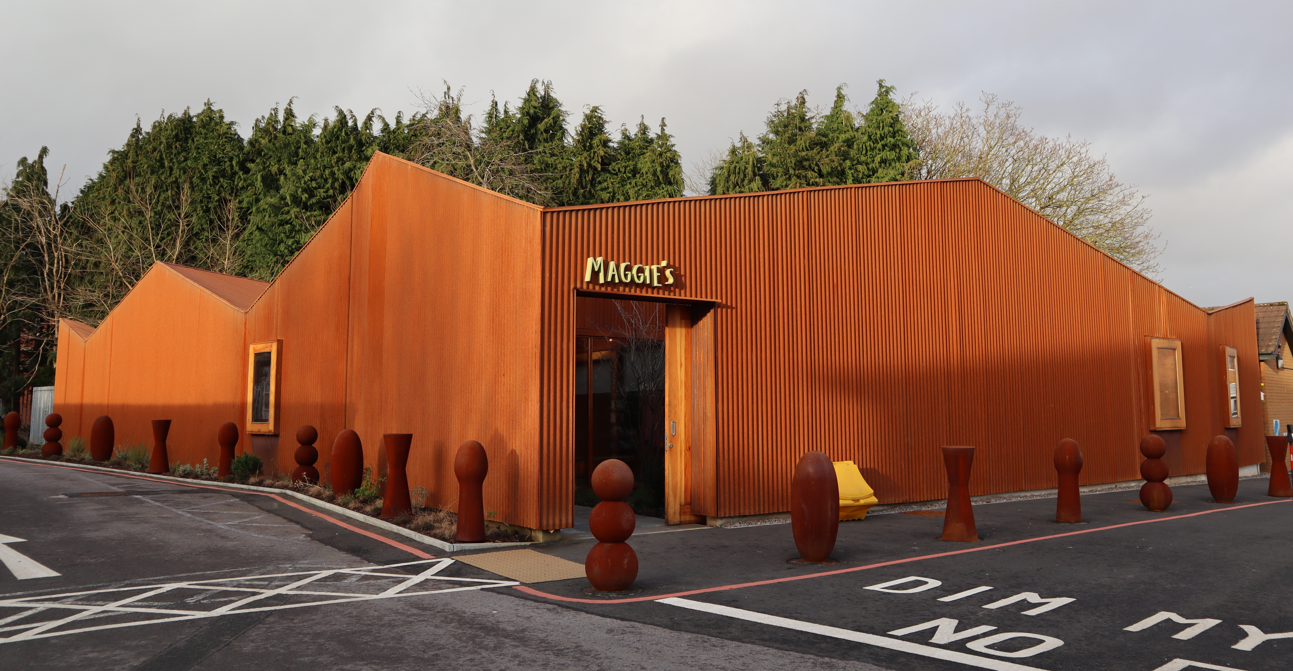  How can architecture affect wellbeing?  With Particular Reference to Maggie Centres | Chloe Knight  BSc Architecture, Built and Natural Environment Dissertation Module Code: M6X01986

Abstract
This dissertation will discuss how architecture can affect people’s wellbeing. It will discover and analyse the key design features that can affect the atmosphere in a building and in turn impact and improve someone’s wellbeing. The information collected will help enhance our knowledge on improving wellbeing through architecture and what steps to take when designing a building to support this. This will also help design buildings around the users while still producing innovative designs.
The primary research collected will help define the term ‘wellbeing’, producing a statement and a base for the rest of my research and analysis. The information collected will discuss companies that have discovered ways to measure a person’s wellbeing. I will also give a brief description of several wellbeing centres, what their aims are as a charity and where architecture is a major aspect in their support.
The secondary research will be based on five Maggie centres; Manchester, Merseyside, Nottingham, Cardiff and Swansea. I will collect information about their location, design, layout and how they overcame any restrictions. As well as this, I will also be visiting each centre and personally experiencing the buildings atmosphere and daily routine. After this I will conduct interviews with the architects and employees of three of the five centres. Through this research I wish to gain an understanding of the design, arrangement and aims of each centre; knowing which features produce the best improvement for a visitor’s wellbeing and where that design feature was planned.
The research will be conducted by collecting data from online articles from architectural journals, books written about the centres and the Maggie’s webpage and resources. In addition, I will collect data through personal investigations by visiting the centres and interviewing the architects and employees who have a personal connection to the centres. I will then compare each centre with each other and the primary research; highlighting important features and concepts in the designs and buildings.
I am hoping to achieve an understanding of wellbeing and how Maggie centres are designed to focus around the users. I hope to discover key design features that have been used numerous times and how they impact and improve people’s wellbeing. So that I may incorporate some of these features in buildings I may design in the future.

Table of Contents
Abstract 1
Figure table 3
Acknowledgments 4
Introduction 5
Background to Maggie Centres 5
Chapter 1: Literature review 7
Chapter 2: Methodology 11
Chapter 3: Studies and discussions 13
Case Study 1: Nottingham Maggie centre 13
Analysis related to the well criteria: 14
Chapter 2: Merseyside Maggie centre 14
Analysis related to the well criteria: 15
Chapter 3: Manchester Maggie Centre (More intensive research was conducted into this case study) 16
Interview/questionnaire data from the architect/s: 17
Interview/questionnaire data from the employee/s: 18
Analysis related to the well criteria: 18
Chapter 4: Swansea Maggie Centre (More intensive research was attempted into this case study) 19
Analysis related to the well criteria: 20
Chapter 5: Cardiff Maggie Centre (More intensive research was conducted into this case study) 21
Interview/questionnaire data from the architect/s: 22
Interview/questionnaire data from the employee/s: 23
Analysis related to the well criteria: 23
Chapter 5: Review of the methodology and findings 24
Conclusion 25
Appendices 29
Appendix 1: The Warwick-Edinburgh Mental Wellbeing Scale 29
Appendix 2:The Maggie centre brief 29
Appendix 3: Pilot Results 32
Harvard Referencing 34
Bibliology 36
Statement regarding copyright 37

Figure table
 |  | Page References
Figure 1 | Edinburgh Maggie Centre
Figure 2 | Manchester Maggie centre concept sketches
Figure 3 | Priory Hospital Glasgow
Figure 4 | Priory Hospital Chelmsford
Figure 5 | Priory Hospital Altrincham
Figure 6 | Southdown Princess Royal Hospital
Figure 7 | Southdown Worthing Hospital
Figure 8 | Southdown The Bedale
Figure 9 | WELL Criteria icons
Figure 10 | Nottingham Maggie centre
Figure 11 | Nottingham Maggie centre first floor plan
Figure 12 | Nottingham Maggie centre ground floor plan
Figure 13 | Nottingham Maggie centre Small private room
Figure 14 | Nottingham Maggie centre kitchen-diner
Figure 15 | Nottingham Maggie centre Balconies projecting into the trees
Figure 16 | Merseyside Maggie Centre
Figure 17 | Merseyside Maggie Centre floor plan
Figure 18 | Merseyside Maggie Centre entrance area
Figure 19 | Merseyside Maggie Centre kitchen-diner
Figure 20 | Merseyside Maggie Centre London dresser/ nature box
Figure 21 | London dresser in 2012
Figure 22 | Merseyside Maggie Centre view from Wirral fields to the ‘nature box’
Figure 23 | Manchester Maggie centre
Figure 24 | Manchester Maggie centre concept model
Figure 25 | Manchester Maggie centre floor plan
Figure 26 | Manchester Maggie centre green house space
Figure 27 | Manchester Maggie centre large ‘activity’ room
Figure 28 | Manchester Maggie centre kitchen-diner
Figure 29 | Manchester Maggie centre Mezzanine floor
Figure 30 | Swansea Maggie centre
Figure 31 | Swansea Maggie centre floor plans
Figure 32 | Swansea Maggie centre landscape plan
Figure 33 | Swansea Maggie centre entrance area
Figure 34 | Swansea Maggie centre large ‘wing’ rooms
Figure 35 | Swansea Maggie centre kitchen -diner
Figure 36 | Swansea Maggie centre cluster of seats
Figure 37 | Swansea Maggie centre garden, fruit and vegetable patch
Figure 38 | Swansea Maggie centre rooflight in the atrium space
Figure 39 | Cardiff Maggie centre
Figure 40 | Cardiff Maggie centre entrance courtyard
Figure 41 | Cardiff Maggie centre floor plan
Figure 42 | Cardiff Maggie centre kitchen-diner
Figure 43 | Cardiff Maggie centre large activity room
Figure 44 | Cardiff Maggie centre private room
Figure 45 | Cardiff Maggie centre the cwtch
Figure 46 | Cardiff Maggie centre garden space

Acknowledgments

Introduction
This dissertation investigated the topic of wellbeing in architecture, and how buildings were designed to focus around the users and form an atmosphere to enhance their wellbeing. The research covers why wellbeing centres are designed the way they are and what the important features are that impact and improve someone’s wellbeing.
By researching a number of organisations that focus on people’s wellbeing; I found a ‘wellbeing criteria’ for buildings. These criteria were aimed at a range of different scale buildings from: office blocks, home design and wellbeing centres. These centres were focused on supporting a range of problems and issues. There were numerous centres across the country that support people through: bereavement, medical issues, health and mental problems.
I chose to focus my research into the Maggie’s organisation as it is a well-known company that prides itself on an innovative architecture and design in the wellbeing centres and their impact on people in need. Their centres are a free service that supplies advice and support for everyone affected by cancer.

Background to Maggie Centres
Maggie’s is an organisation that offers free support and advice to people with cancer, and their families and friends. Situated on the same sites as NHS hospitals, Maggie centres are slowly being built across the country, the first one being in Edinburgh in 1996. The centres follow the same ideas about care, that Maggie Keswick Jencks originally set up.
Maggie Keswicks Jencks was born in 1941, and spent most of her life writing, gardening and designing. With her father, they founded the Holywood trust (south west Scotland) and the Keswick foundation (Hong Kong), which are support groups for disadvantaged and vulnerable people. She designed numerous gardens and interior spaces during her career. Maggie was only 47 when she was first diagnosed with breast cancer and five years later, in 1993, was told that it had returned and that she only had a few months to live. After she was moved to a windowless corridor where her husband and her had to process the news. They discussed the benefits of a place where people affected by cancer could go; that was somewhere better than the hospital environment that she had experienced. (Maggie’s 2014)
Determined, she joined an advanced chemotherapy trial which helped her live for a while longer. During this time, Maggie worked closely with her husband, Charles Jencks, and her medical team, to develop a new approach to cancer care for people suffering in the future. Maggie and Charles believed that people could live better with cancer; to do this the patients, families and friends needed more information about the medical treatment, stress reducing strategies, psychological support and having the ability to meet people in a similar situation as them. Pushing these beliefs forward, the Maggie’s organisation was born.

As stated before, the first Maggie centre was built in Edinburgh, which was designed by Richard Murphy, a close friend of the Jencks. The centre is placed in the same hospital complex that Maggie herself had most of her treatments. The centre has a strong domestic feel about it; similar in size to a typical Scottish cabin with colour themes that are bright and lively yet homely. (C. Jencks 2011)
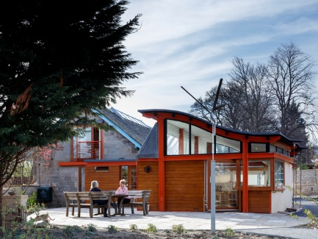
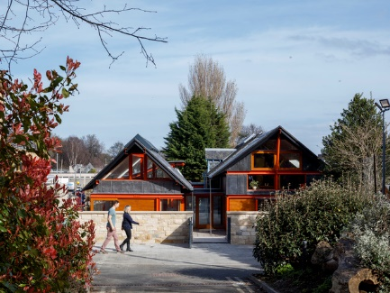
This centre was the only building that had direct input from Maggie herself. Through the buildings design and construction, Maggie create a brief which she wanted the next wellbeing centres to follow. The brief was developed with the progress of the Edinburgh centre; features that worked well she kept, and features that didn’t she scraped. This building was a pivotal moment which started off the Maggie’s organisation, which inspired all subsequent centres from then on.
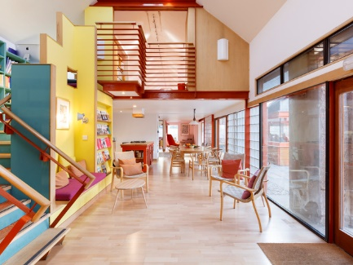
The brief stated that the centres needed to be comprised of; a kitchen, a dining table, large and small support rooms, clusters of seats scattered around, bathrooms, quiet areas for sleeping and a centre space, all surrounded by a well-thought-out garden space. When built the centres were then supplied with professional staff to help out day to day and professionals that put-on classes, creating a more social and active environment.
Before the Edinburgh Maggie centre was built, much like with all the other centre locations, there only stood the hospital complex; supplying the needed treatments and medication for their patients. Mental support and advise was given but at a minimal level due to lack of funding. The help given was very institutionalised and impersonal, including the surroundings. This didn’t create the separation needed between treatment and mental care, making patients feel trapped and suffocated.
Figure 1: Edinburgh Maggie centre. http://www.richardmurphyarchitects.com/viewItem.php?id=2452 (Accessed 11 May 2020)

Maggie noticed this when she was given treatment, the medical help given was remarkable, but the mental wellbeing support was limited. Due to the lack of funding the hospitals received, increasing the wellbeing support wasn’t at the top of the list; the hospital needed an organisation that was self-funded and more directed towards wellbeing.
“People should not lose the joy of living in the fear of dying” (Maggie Jencks 1995)
The Maggie centres excelled because it was clear from the very beginning that the public needed wellbeing centres like Maggie’s; the centres built first were used constantly and there were large requests for more across the country. As well as that, the centres were self-funded; the funding used to maintain and build each centre was raised through donations from visitors, the public, families affected or large corporations that wanted to help.
As each Maggie centre was very ‘complex’, the budget used on the actual design and build was flexible and classed as ‘infinite’. Whereas the maintenance and cleaning budget needed to be as economical as possible, as they were no full-time staff for specific jobs. (Maggie’s 2020)

After Maggie died, Charles carried on Maggie’s dream. He asked close architect friends to help; such as, for example: Page/Park, Frank Gehry, Zaha Hadid and Richard Rogers. The architects that designed the first centres helped expand and start of the Maggie’s organisation. The most recent architects and designers were chosen by the Maggie organisation; they were judged on their past work, and then trusted to create an exceptional building. Maggie’s tried to put minimal restriction on the architects as they wanted them to be as free as they could with the design.

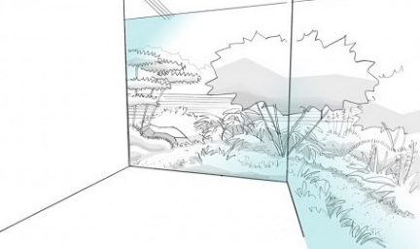
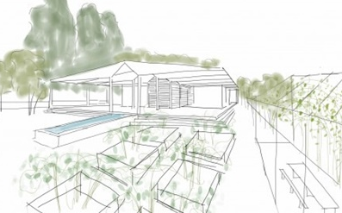
“We need our buildings to feel safe and welcoming. They need to be small, and domestic in scale. On the other hand, these little buildings should not pat you on the head, patronise you by being too cosy. They should rise to the occasion, just as you, the person needing help, is having to rise to the occasion of one of the most difficult challenges any of us is likely to have to face. At the very least they should raise your spirits.” (Maggie’s 2020)
Each architect was given a simple brief, with the requirements Maggie, herself, thought was important to include in a wellness centre. The brief was extremely open, with no requested room measurements or specific design features allowing architects to have freedom in the design. The only requirements were the room types, such as: a large room for exercise, kitchen-diner offices.
Figure 2: first sketches of Norman Foster's Manchester Maggie’s centre. https://www.architectsjournal.co.uk/home/revealed-first-sketches-of-norman-fosters-manchester-maggies-centre/8652469.article (Accessed 11 May 2020)

Chapter 1: Literature review
“The definition of Wellbeing was the state of being comfortable, healthy or happy” (Oxford dictionary). These three descriptive words were personal to the individuals; making wellbeing different for everyone.
I researched the meaning of wellbeing and the main principles that could affect and improve our wellbeing. There were a number of articles and organisations that stated that they had collected their own research into wellbeing and had formed their own definition which was more personal to the individuals.
The mental health foundation was a support group that supplied therapy and treatment to people suffering with mental health. The organisation’s focus was on improving people’s wellbeing permanently, their aim was to get to the core of people’s problems and tackle the issues from there. However, the company understood that wellbeing was very subjective, and having the ability to measure an individual’s wellbeing, analysing the results and supplying treatment specifically for them, would solve the matter. The organisation’s researchers created a way to measure wellbeing through the “Warwick-Edinburgh Mental Wellbeing Scale (WEMWBS)”. (Mental Health foundation 2012)
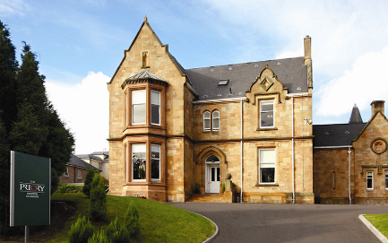
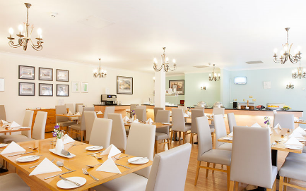
An article published in 2007 written by numerous researchers, discussed their investigation into the different definitions of wellbeing and how a good or bad state of wellbeing differs from person to person. The article stated that different factors play a role in someone’s wellbeing, some of those factors being: physical heath, physical activity and social interaction. External conditions such as: income, housing, life and stress, as well as internal conditions such as: optimism, resilience and self-esteem, also play a big role in defining wellbeing. The research developed a way of measuring wellbeing through the “Warwick-Edinburgh Mental Wellbeing Scale (WEMWBS)”. The WEMWBS was a scale of 14 positively worded phrases, such as ‘I’ve been feeling optimistic about the future’ or ‘I’ve been interested in new things’, that were responded to by the participate. They would choose between five categories that responded to the phrases that best describe how they were feeling. Which were then combined together to create a score between 14 and 70; the higher the score, the better mental wellbeing the person had, according to the test. (R. Tennant, 2007) (See appendix A)
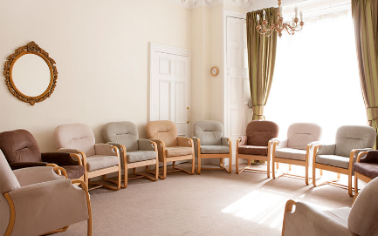
There were numerous wellbeing centres and organisations that used wellbeing tests or questionnaires like that, that could help focus the support given to a person’s specific needs. Depending on what purposes the wellbeing centres or organisations were aimed to improve, the support and advice given had to be appropriate.
Figure 3: Priory Hospital Glasgow. https://www.priorygroup.com/locations/priory-hospital-glasgow (Accessed 20 March 2020)

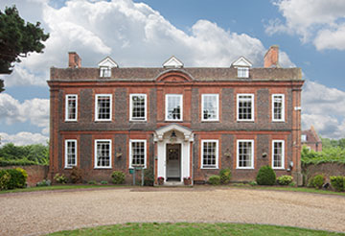
‘Priory’ was a wellbeing organisation that had a number of centres situated across the country. They focused on Alcohol, drug and other addiction rehabilitation, as well as mental health and eating disorder support. Priory offered individual and group therapy sessions available at a range of times; available for even the busiest person. They also supplied additional therapy packages, which were unique to each patient. The price for the sessions depended on the patients’ needs and age which were worked out after the first initial call or visit.
Figure 4: Priory Hospital Altrincham. https://www.priorygroup.com/locations/priory-hospital-altrincham (Accessed 20 March 2020)
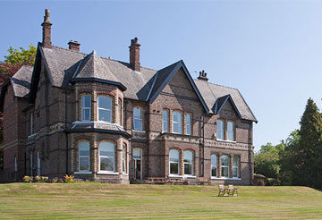
Priory clinics were located across the country; the companies ‘hospitals’ were renovated stately homes or manor houses. Even though they didn’t produce much focus on the buildings, they were designed to have a welcoming and homely feel. This was done so their patients feel safe and comfortable; the high-end houses made the patients feel worthy and enjoy going there. Examples of their centres were: the priory hospital Glasgow which consisted of two stunning Georgian villas, Priory hospital Chelmsford which was situated in a beautiful 19th centre grade II listed building and Priory hospital Altrincham which was set in a large manor house. All the facilities were supplied with numerous private and group therapy rooms and large gardens surround them. (Priory Group 2020)
Figure 5: Priory Hospital Chelmsford. https://www.priorygroup.com/locations/priory-hospital-chelmsford (Accessed 20 March 2020)

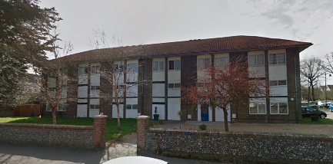
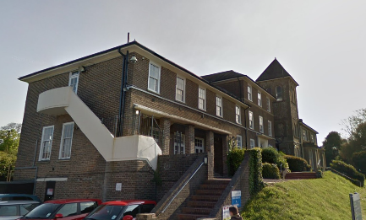
‘Southdown’ was another wellbeing group; the helped support people in the Sussex area. Southdown was split into three units. The community support service division, which provided support for mental health recovery, employment and peer problems. The second unit was the housing division, which acted as a landlord for the community, supplying safe houses to vulnerable people. Lastly, the learning disability division offered living and community support for people with learning difficulties.
Figure 6: Southdown Princess Royal Hospital. https://www.sussexpartnership.nhs.uk/location-southdown (Accessed 16 March 2020)
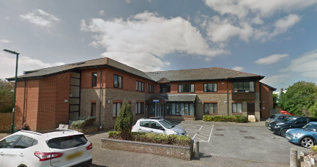
These support divisions were situated in wellbeing centres across the Sussex area, supporting as many people as they could. Unlike the priory group, the sites that the centres were located at weren’t renovated high end buildings, they were designed similar to a hospital complex. Southdown didn’t use architecture and design to impact people’s wellbeing as much; the hospital buildings were relatively new but to cut down on building costs the design and materiality weren’t innovative. The development of the buildings followed a similar layout and design to hospitals with several private rooms coming off long corridors with large group rooms available. Other examples of their centres were: The Princess Royal Hospital, Worthing Hospital and the Bedale Centre. These centres were built in the city or town centres for easy access for the community. (Sussex Partnership NHS 2014)
Figure 8: Southdown the bedale centre. https://www.sussexpartnership.nhs.uk/location-bedale-centre#location-map-844 (Accessed 16 March 2020)

Figure 7: Southdown Worthing Hospital. https://www.sussexpartnership.nhs.uk/location-worthing-hospital#location-panorama-456 (Accessed 16 March 2020)

A variable that needed to be considered was that both Priory and Southdown supplies accommodation at their clinics, therefore the long corridors design were inevitable. Due to the companies having accommodation provisions, the buildings also had to follow different building regulation, such as for example, temperature in the rooms, acoustic levels and induvial bathrooms. Whereas Maggie doesn’t provide accommodation, and were only open during the day, therefore the centre designs had more flexibility.

Similar to the research from the mental health foundation, the company ‘Well certified’ was a corporation that evaluates buildings on their effect on Wellbeing. Launched in 2014, the WELL standard was an accreditation for buildings, interior spaces and communities which validated the effectiveness and improvement of wellbeing to the buildings.
Their website had a list of different factors that buildings must consider and include to be ‘Well Certified’; these factors being, air, water, nourishment, light, movement, thermal comfort, sounds, material, mind, community and innovation. Within each factor there were lists of different points and features to consider in a building. These points depend on what purpose the building had; such as an office block would have different recommendation than a hospital or wellbeing centre. These factors were created by the organisation through their own research; they collect data and information from literature on environmental health and behavioural factors. Additionally, they consider scientific and medical research around wellbeing. Their peer review process comprises of three phases; scientific, practitioner and medical review. (International WELL building Institute 2019)
The Well Certified factors were aimed towards all-purpose buildings; dwellings and commercial buildings. Looking into each factor, I selected and summarised the points that related to wellbeing centres or to buildings that had a similar purpose.

The ’air’ factor states that the air quality had to be ‘at its best’, meaning the air inside the building had to be kept at a high quality and fresh. Air pollution from the construction of the building and surrounding buildings must be controlled. When a building was mechanically ventilated, the air vent filters installed in the building need to be changed several times before opening to the public to avoid the toxins going back into the air. However, if the building was naturally ventilated, having a flow of fresh air through the building, the air will be of the correct quality. Naturally ventilation spaces would only work if the air outside was clean and not polluted; if the outside air wasn’t good quality, natural ventilation wasn’t an option. Another point that was mentioned was the heating of the building, however as the comfortable temperature for certain people can differ, being able to control rooms differently was suggested.
The ‘Light’ factor related not only to natural and artificial light but to the intensity of light in set places. Maximising the amounts of natural light into a space was important, as having the ability to see outside, and having the sunlight coming into a space improves peoples mental health and creates a positive and light environment. However, controlling that light was important, the intensity of light in certain places needed to be correct to avoid glare and eye strain. These could be regulated by using curtains, shutters or designing the building in a certain orientation to reduce to sun from the south. Another option was to use a solar shading device that minimise sun light at set times of the day.

The ‘sound’ factor related to the exposure to loud, continuous noises, such as traffic or other external noise; this could cause sleep disturbance, hypertension and a drop in personal mental wellbeing. This also referred to noises internally such as other people talking or moving; noise travelling from room to room which would cause people to feel exposed, ruining the effect of certain areas being ‘private’. To avoid these problems sounds barriers were used, which was accomplished by adding sound absorbent materials in the partition walls to avoid noise travelling from room to room. Another technique which was used was sound masking, which was when music or natural noises (such as birds chirping) were used to hide the noises from other rooms. Listening to music or natural noises could also improve certain people’s wellbeing as well.


For the ‘movement’ factor, it suggested that appropriate physical activity/exercise breaks should be offered to visitors to the building. These activities should differ depending on the people in the building; some examples were: yoga, Thai chi, stretching or walking. Moving is good for circulation and joints; which in turn improves physical wellbeing. These activity sessions also created social groups, allowing a space where people could interact with others, improving mental wellbeing.


The ‘mind/nature’ factor encouraged wellbeing centres to include access to nature within the building, this could be done directly or indirectly. Direct connection could be made through plants, water, light and views of nature. Having outdoor areas if possible, where visitors could interact with the surroundings or bringing plants and water features inside. Indirect connection could be done using natural materials, patterns, colours and images, throughout the layout of the building. Mirroring the placement of natural elements from the outside. Having natural surroundings was a change from the manmade rigid environment which people were used to; having that change helped people create a separation, allowing them to feel at peace and calm in these areas.

The ‘innovation’ factor stated that the building should have a positive impact on the occupants or the general public, either through the current requirements listed above, or in a new way that related to health and wellbeing. The building needed to follow building regulations to be safe by law but thinking outside of the box and creating designs that were adaptable to the individuals.
Figure 9: WELL criteria icons. https://www.wellcertified.com/certification/v2/ (Accessed 11 May 2020)
(The icons above were sourced from WELL certified, the icons were used a number of times through the report)

Chapter 2: Methodology
As mentioned above in the literature review the first part of the primary research considered the definition of the word Wellbeing and how to maximise this when designing a building for the 21st Century. This helped create a base for my understanding and produced a statement and description to refer back to when researching and comparing wellbeing centres. Research was collected from articles and books written about the topic; a number of the sources defined wellbeing through their personal research and formed a way to measure peoples wellbeing using their data. One of the main online sources that helped define wellbeing in architecture was the Well-Certified organisation; a group of specialists who used their personal research to define wellbeing, which they have collected through a range of environmental sources and behaviour articles. The company created criteria for producing effective wellbeing centres and helping architects and designers to focus buildings around the users. These criteria refer to each human sense, explaining how a building needs to be designed to reach the certification desired; this was explained fully in the literature review.
The research from Well Certified into the human senses had been the main driver throughout this study on architecture and wellbeing due to the clear definitions. This had enabled an objective comparison of each building. During the research it was apparent that several architects who had designed past centres had also used Well Certified as a reference when creating design concepts.
After consideration of several Wellbeing organisations, the Maggie’s organisation was chosen for further investigation as its regarded as exceptional for its architecture and its impact and improvement on visitor’s wellbeing. Research included understanding the founder (Maggie), the original aims of the company, and the first Maggie centre constructed as described.
Information was collected on how the company was run, who funded the centres, how the architects were chosen and what their given architectural brief was. To collect this research, I read and analysed a number of online articles and books linked to the company ‘Maggie’s’; any questions that were left unanswered, were later resolved through the interviews with the architects and employees.
Next, I started to investigate the impact the centres had on the visitors and how they evolved over the years, this demonstrated why the centres were needed and how they worked to improve the wellbeing of the visitors. Completing the base research helped me to understand whether Maggie centres were designed using the same or similar criteria as the Well Certified organisation, or whether they had a different approach. Maggie’s was based around personal preference, creating spaces that could be adapted to anyone’s desired ‘wellbeing’ place; to support this I considered the design brief they presented to the architects. The design brief specified room types and a simple layout but other than that, the brief was open to the architect’s interpretation. (See appendix B)
I analysed five of the twenty Maggie centres: Manchester, Nottingham, Merseyside, Swansea and Cardiff. The centres were chosen because of their vicinity to my University and hometown. These five buildings had several variables being: locations, site sizes, budget and design concepts, this also included the employees hired to work at each centre. This was kept in mind when comparing them, as they are all classed as wellbeing centres and designed to the same brief.
To collect research into the individual Maggie centres I started by reading books, articles and architectural journals focused around the design of the buildings and how the different features were aimed at affecting the visitor’s wellbeing in the centres. This gave me an understanding of how the centres worked overall but to expand my knowledge, I visited each one personally in order to make my own observations in relation to the wellbeing criteria during the tours. I experienced the centres design and day to day staff routines in person which helped me understand the change of atmosphere and the experience Maggie’s offers to the visitors when they enter. I observed how the visitors got involved with activities that were offered and how certain spaces were used in each centre. I also observed how the employees interacted with the visitors and how they focused on the wellbeing and the life of each person who entered. After visiting each one, I analysed the similarities and differences between the centres and how they related back to the original Maggie design brief and the human senses criteria from Well Certified.
For the next phase of my research I conducted a more extensive investigation into three Maggie centres: Manchester, Swansea and Cardiff. This was due to personal preference, as I believed these buildings had the most innovative designs, and I found it interesting how the architects designed round the constrictions. I sent out emails to the architects and a range of employees from each of the centres. I explained the topic of my dissertation briefly and asked whether they would be available for a thirty-minute interview about the centre and wellbeing. If the recipients were busy, they also had an option to answer a small questionnaire that I attached, with five questions expanding on the information I research at the start. (See appendix C)
To test the questionnaire and interview questions before sending them out to the set people, carried out a pilot test. This is where I rehearsed my interview questions with a volunteer and noted down their answers. As they weren't in a wellbeing centre, I asked the volunteer questions about their university and study space instead. This test helped me see whether my questions were interpreted correctly and whether I received the information and results about the design that I needed. (See appendix D)

A number of questions were similar to evoke different answers from the recipients, some of the similar questions being: ‘what do you enjoy about the centre?’ And ‘what architectural design features do you think are most important?’. When writing these questions, I considered the people I would be asking, the architect would more than likely answer with a more ‘architectural’ referencing, whereas the employees wouldn’t. I wanted to try and collect data about the centres that were both architectural and not, so I needed to provoke these answers.
The same questions were asked to all participates so when analysing the answers, I could compare them; this way I could see if any of the design features were experienced in the same way by the visitors that the architect had intended. If features were mentioned more than once and had a correlation through the answers, I would know that those features produced the strongest impact on people. Collecting opinions from the designers of the centres and the people who work there every day would give me a personal insight into the concept of the building and how efficient it was.

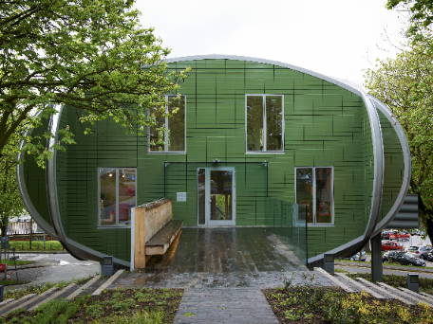
Chapter 3: Studies and discussions

Case Study 1: Nottingham Maggie centre
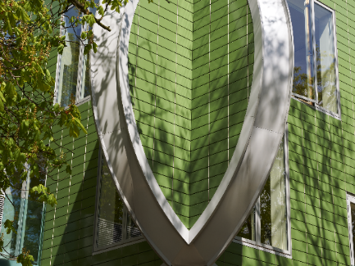
Nottingham’s Maggie Centre was built inside the Nottingham University Hospital complex, located to the north of the city centre. The site that was allocated had a lot of constraints; the area was situated in the middle of the complex, surrounded on all sides by the hospital. The chosen site was to the west of the main hospital building, on a small plot of land with a steep incline, surrounded by trees and greenery. Creating a separation between the Maggie centre and the hospital was an important design objective. The architect needed to avoid a direct view towards the hospital and reduce the possibility of being overlooked. Due to it being part of the Hospital, there was a large amount of shared parking surrounding the site, which was a positive.
Figure10: Figure 10: Nottingham Maggie centre. https://www.maggies.org/our-centres/maggies-nottingham/architecture-and-design/ (Accessed 11 November 2019)

Piers Goughs was the architect who designed the centre, with assistance from the famous interior designer, Paul Smith. The centre opened on the 2nd of November 2011. (A Frearson 2011) The centre consists of four oval walls, crossing through each other to create a square shape internally. All four walls are clad with green tiles that are aligned with each other and the openings, such as doors and windows. To respond to the restrictions of privacy and the steep topography on the site, the public areas were situated on the first floor and above. The ground floor was used as a basement for storage and the centre held the kitchen diner. This design feature raised the users into the trees, out of sight from the hospital and helped create a secluded area for visitors to escape reality for a while.

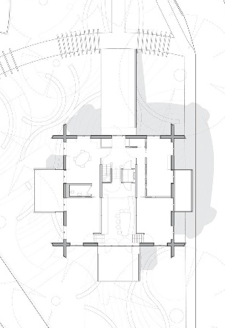
This green block sat above the ground floor, clad in a corrugated steel, designed to allow plants to grow. This feature created the illusion of the centre floating within the trees. The large windows and balconies project into the trees to form a strong connection with the surroundings and help visitors engage more with nature.
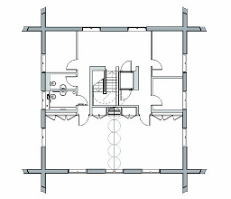
As people walk towards the entrance of the Maggie centre, they have the sense of climbing up into a tree house. Walking through the trees and into the green building, the centre seemed to open up. When entering the building, you could easily see straight down into the kitchen-diner area, normally filled with visitors chatting, which right away created a friendly and comfortable environment. To the left were the offices, with larger and smaller rooms for different interactions with visitors, these rooms were scattered throughout the first floor, all the way up to the top floor. Each room either had a floor to ceiling window or balcony doors, opening up into the surrounding nature. The balconies were minimalist; built out of natural wood and sticking out ‘randomly’ from the building, mirroring the tree branches around. Once you walk up the stairs from the first floor, the second and third floors open up which highlighted the large roof light window that drew light down through the centre. The centres symmetrical facades created a peaceful environment and with the combination of the brightly mismatch décor formed a fun and energetic atmosphere inside.
Figure 11: Nottingham Maggie centre first floor plan. https://www.archdaily.com/254535/maggies-nottingham-czwg-architects/562006ffe58ecec3c40001d9-maggies-nottingham-czwg-architects-plan-02?next_project=yes (Accessed 10 May 2020)

Figure 12: Nottingham Maggie centre ground floor plan. https://www.archdaily.com/254535/maggies-nottingham-czwg-architects/56200748e58ece6d440001cd-maggies-nottingham-czwg-architects-plan-03?next_project=yes (Accessed 10 May 2020)

Analysis related to the wellbeing criteria:
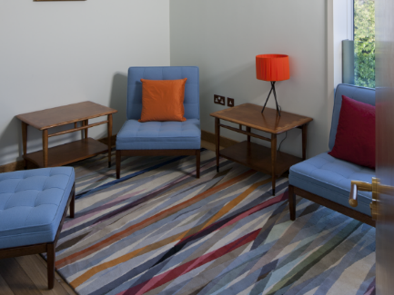
Air: To create a domestic feel with the design of the Maggie centre, each room is isolated by partition walls. Doing this allows the rooms to be cut off from each other and the heating and cooling of each room can work independently. This allows the activity rooms located at the back of the centre to be cooler, and the private rooms and office located at the front of the centre to be warmer. As well as this, each room either has a floor to ceiling window or French doors that open on to a balcony. This allows a free flow of air through each room if the room gets too hot and needs to be purged.
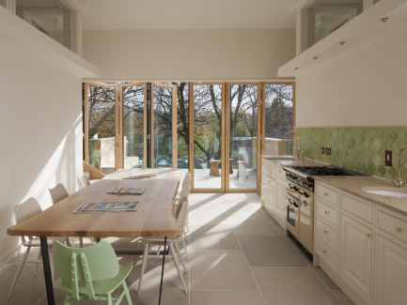
Light: This design has responded to its surrounding perfectly, secluding the building from the hospital but still preserving the amount of natural light into the centre. The floor to ceiling windows and balcony doors allows light into each room, whereas the roof light window floods light down into the centre of the building.
Figure 13: Nottingham Maggie centre small private room. https://www.maggies.org/our-centres/maggies-nottingham/architecture-and-design/ (Accessed 11 November 2019)
Sound: Reducing the number of open spaces helps control the noise travel through the centre; each room felt completely separate and private, allowing visitors to talk openly about their feelings. The kitchen-diner, which is the social hub of the centre, is located on the ground floor, reducing noise travelling from room to room.
Figure 14: Nottingham Maggie centre kitchen-diner. https://www.maggies.org/our-centres/maggies-nottingham/architecture-and-design/ (Accessed 11 November 2019)
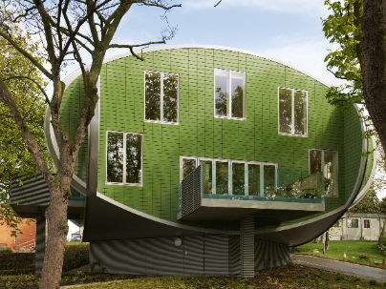
Movement: This centre supplies numerous activities sessions weekly due to the two larger rooms. The two large rooms are separated by a bifold wall that can open to join them for large groups.
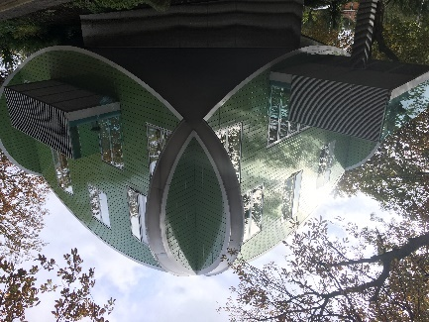
Mind/ nature: As the site didn’t provide space for a garden, the centre is designed in the trees, allowing visitors to feel submerged in nature. To mirror the branch projecting from the surrounding trees, the balconies project out of the centre ‘randomly’. This helps formed a strong direct connection with nature.

Innovation: As you enter the building on the first floor, you can see straight down into the kitchen-diner, where groups of visitors and employees sit and talk. This creates an instant feeling of joy and fun. The friendly and energetic atmosphere is carried through the centre, helped by the colourful artwork by Paul Smith.
Figure 15: Nottingham Maggie centre balconies projecting into the surrounding trees. https://www.maggies.org/our-centres/maggies-nottingham/architecture-and-design/ (Accessed 11 November 2019)

Case Study 2: Merseyside Maggie centre
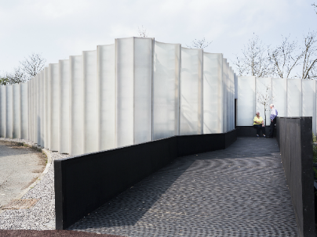
Merseyside Maggie centre was a temporary centre that sat to the west of the Clatterbridge hospital complex, next to the cancer centre. It opened for previews on the 9ths of June 2014 and then fully opened to the public on the 23rd of June 2014. (NHS foundation trust 2014) The centre had its own private car parking, as well as shared car parking areas scattered around the hospital. Unfortunately, almost all of the facades looked straight at the hospital, making it difficult to create a private secluded space. The only good view overlooked the Wirral farming fields to the North east of the site.
Figure 16: Merseyside Maggie centre. https://www.maggies.org/our-centres/maggies-merseyside/architecture-and-design/ (Accessed 09 November 2019)
Carmody Groake was the architect for the Merseyside Maggie centre, creating a design that overcame all of the restraints and enhanced the positives on the site. As this Maggie centre was temporary the funding was minimal. To reduce costs the centre was formed of seven existing structures, which were then “enclosed by a singular envelope of fibre glass panels” formed to create a curving installation around the centre. (Maggie’s 2006)

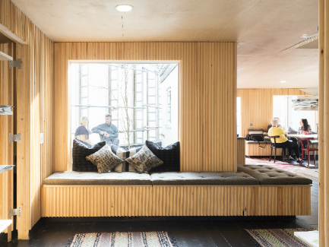
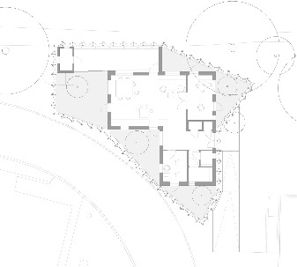
The fibre glass panels were used to isolate the building, making the centre and visitors separate from the hospital. However, even though the structure was partially transparent it reduced the amount of natural light allowed into the building, so to combat this, small courtyards were formed to the south of the building. These spaces allowed outdoor seating, a connection with the natural environment and allowing light into the centre. The only facade that wasn’t screened by the fibre glass was the ‘London Dresser’ structure, commissioned for the 2012 London Olympics. The ‘London dresser’ was originally designed as “a large-scale cabinet displaying small scale buildings”. (Studio of cinematic architecture 2012) Inside the cabinet were seats crafted to look like small scale model buildings. By day the seats were arranged to form social gathering spaces and by night the seats were placed back inside to create an interactive showcase. As people walked past, the buildings would momentarily be illuminated for people to look in.
Figure 17: Merseyside Maggie centre floor plan. https://architizer.com/idea/1125052/ (Accessed 10 May 2020)
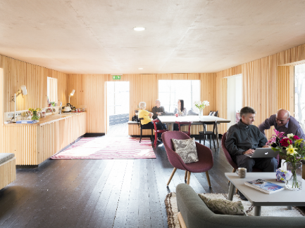
After the london dresser was dontated to Maggie’s it was transformed to a nature box, taking advantage of the beautiful views over the Wirral farming fields that expand over miles. The north east side of the centre, where the structure was located, had been allowed to be swallowed by the surrounding greenery, encasing the ‘London dresser’, so it felt like the users were part of nature.
Figure 18: Merseyside Maggie centre entrance area. https://www.maggies.org/our-centres/maggies-merseyside/architecture-and-design/ (Accessed 09 November 2019)
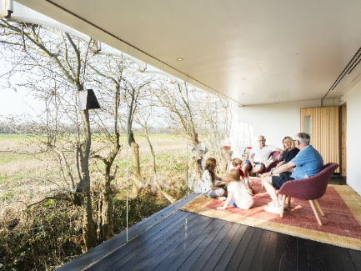
Internally, the walls of the centre mirrored the curved effect of the installation, reducing any chance of echoing in the large space and formed a connection with the exterior. Copying the other centres, there was a small reception area; where unsure visitors could observe the centre before entering. The offices sat to the left with a number of private rooms and a small bookcase was placed right in front to draw visitors into the centre. The kitchen-diner opens up in the heart in the centre, where a large cluster of soft chairs for relaxing and socialising are supplied. Branching off the main space is the ‘London Dresser’ for group sessions, and a private room for more personal conversations. The other two doors lead off the kitchen to the small courtyards, where you could sit and enjoy the fresh air on a nice day.
Figure 19: Merseyside Maggie centre kitchen-diner. https://www.maggies.org/our-centres/maggies-merseyside/architecture-and-design/ (Accessed 09 November 2019)
The atmosphere in the centre, which was busy and energetic, still accommodated visitors that wanted to be alone in a quiet space. The visitors and employees had formed strong relationships and act like a family.
Figure 20: Merseyside Maggie centre London dresser/Nature box. https://www.maggies.org/our-centres/maggies-merseyside/architecture-and-design/ (Accessed 09 November 2019)

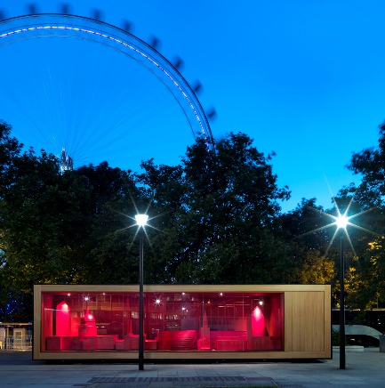
Analysis related to the wellbeing criteria:
Air: Due to the Merseyside Maggie centre having the majority of the rooms being sperate from the main space by partition walls, the temperature of those rooms can be easily controlled. Each room has its own thermostat to control the heating and cooling in the room. The London dresser can be at a cooler temperature for the activities, the large group therapy room can be warmer for comfort and the small private rooms can be at staggered temperatures for the visitor’s needs.
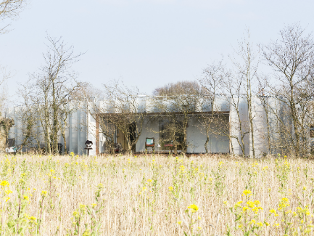
Light: As mentioned before, the views around most of the centre look directly into the hospital complex, so to avoid this view, the structure is surrounded by fibre glass panels. These panels are partially transparent, still allowing natural light into the courtyards and windows. The centre has a light colour palette, reflecting the light deeper into the main spaces.
Figure 21: The London Dresser. www.studioofcinematicarchitecture.com/londondresser (Accessed 15th May)
Sound: As previously stated, all the walls in the centre are clad in curved timber strips to mirror the installation that surrounds the building. This effect helps to not only reduce echoing in the open space but reduce sound penetration from room to room. The small intimate rooms are on the opposite side to the main space, creating rooms that are completely private.
Figure 22: Merseyside Maggie centre view from the Wirral fields to the ‘nature box’. https://www.maggies.org/our-centres/maggies-merseyside/architecture-and-design/ (Accessed 09 November 2019)
Movement: The ‘Londoner Dresser’ is used for a number of group activities; this space holds activities such as yoga sessions, knit and knatter groups and group therapy, which run every other day. These sessions are for anyone who would like to join, encouraging the visitors to interact and socialise with both the employees and the other visitors. The community atmosphere in the Merseyside Maggie’s is prominent.
Mind/Nature: The London dresser forms a nature box, looking over the Wirral fields to the north east of the site. This nature box is allowed to be swallowed by the surrounding greenery forming a direct connection with nature. The small amounts of greenery situated in the courtyards also support this.
The interiors of the centre form an indirect connection with nature; the walls, kitchen cupboards and benches are cladded in concaved timber strips. This change in theme creates a vast difference from the surrounding concrete buildings and grey palette.
Innovation: Even though the site and budget had so many constraints, the Merseyside Maggie centre still creates a feeling of a home away from home. Allowing people to step away from their everyday life, into a supporting community. The centre is used daily with numerous activities going on at the same time, creating an energetic and playful space.

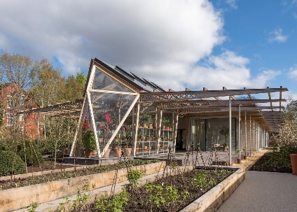
Case Study 3: Manchester Maggie Centre (More intensive research was conducted into this case study)
The Manchester Maggie centre was located to the south of the city centre. The site was situated next to Manchester cancer research centre at Christies Hospital, with the Christies staff parking on the east side and the research complex on the north side. Domestic housing surrounds the other sides. Due to this, the noise levels and privacy were a big restraint when designing the wellbeing centre.
Figure 23: Manchester Maggie centre. https://www.dezeen.com/2016/04/27/norman-foster-partners-maggies-centre-cancer-care-manchester-england/ (Accessed 09 November 2019)

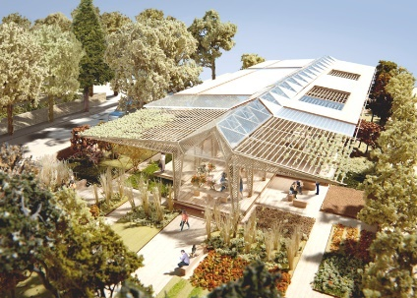
The centre, which was opened in April 2016, was designed by Foster + Partners, with help from a landscape architect, Dan Pearson. The extra focus on the garden and exterior helped create a strong connection with the environment. The building combined a flower filled greenhouse and a timber porch; the glass panels sat simply between the timber lattice columns becoming almost invisible, this created a smooth connection with its surroundings. To reduce noise levels and overlooking, large trees and bushes were planted around, which also helped create a magical and peaceful space. The building was surrounded with small courtyards relating to the different spaces in the building, as well as deep canopies for visitors to enjoy fresh air whatever the weather. There was minimal public parking around the centre, so visitors were allowed to park on the street that sat perpendicular to the site.
Figure 24: Manchester Maggie centre concept model. https://www.architectsjournal.co.uk/news/foster-wins-planning-for-manchester-maggies-centre/8661397.article (Accessed 09 November 2019)

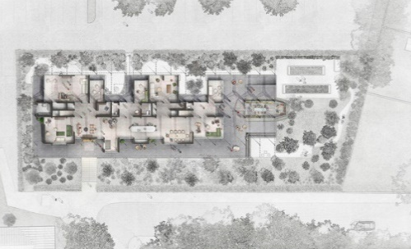
As the site was thin and long, the centre was designed in such a way to maximise the space. With a long centre space extending almost the length of the site, providing space for a kitchen-diner, and two hanging wood burners surrounded by chairs this created social spaces for the visitors. More private and secluded rooms were situated under the wings, with a mezzanine floor forming more rooms. The mezzanine floor helped to create more space while retaining the double high space in the centre of the building. The low height at the eaves also helped keep the building at a similar height to the surround dwellings.
Everything in the centre was designed to bring a sense of nature; between the interior palette incorporating natural woods and tactile fabrics, and the numerous rooms filled with indoor plants. After walking down, the length of the centre, at the end sat the greenhouse and an outside plot for visitors to grow their own fruit and vegetables.
Figure 25: Manchester Maggie centre floor plan. https://www.archdaily.com/786370/maggies-cancer-centre-manchester-foster-plus-partners/59774d3eb22e38d07f0003e8-maggies-cancer-centre-manchester-foster-plus-partners-ground-floor-plan-color?next_project=no (Accessed 09 November 2019)
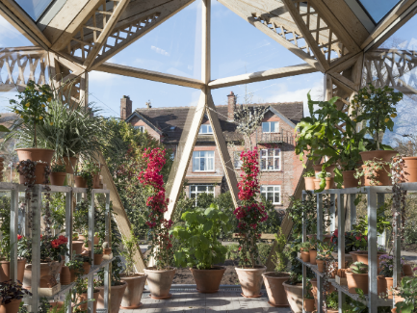
Having a mixture of larger, smaller, social and private areas, the building always seemed full of people doing their own thing. The clusters of bespoke furniture either surrounded the floating wood burners or sat quietly in the corners, with larger windows opening up to the beautiful landscaping.
The exterior and interior design of the centre evoked a peaceful and quiet environment, where the connection with nature and people was clearly visible. Throughout the year the Manchester Maggie centre is a beautiful place to be.
Figure 26: Manchester Maggie centre green house space. https://www.maggies.org/our-centres/maggies-manchester/architecture-and-design/ (Accessed 09 November 2019)

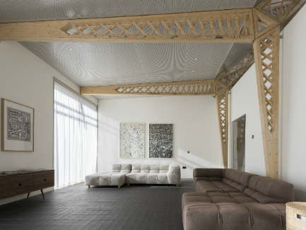
Interview/questionnaire data from the architect/s:
I interviewed the architect director of the Manchester Maggie centre, Darron Haylock; he stated that he was a strong believer that architecture can improve wellbeing in people and in the past has designed a number of buildings focused around this. During the interview the architect discussed several design features that were implemented to impact upon the visitor’s senses.
Figure 27: Manchester Maggie centre large activity room. https://www.maggies.org/our-centres/maggies-manchester/architecture-and-design/ (Accessed 09 November 2019)

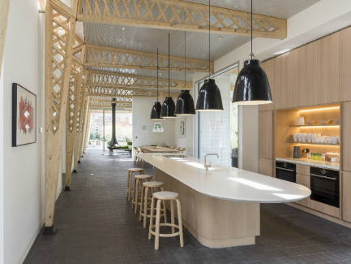
The main senses touched upon were light and mind. He stated that the Manchester Maggie centre was designed to maximize the volume of natural light into the space by using large windows, as that was something important to him personally. He believed creating a space that was naturally lit and ventilated helps lowers stress and anxiety levels and increase positivity in the visitors. A space that is naturally lit rather than artificially lit helps stimulate visitors senses and improves mental wellbeing.
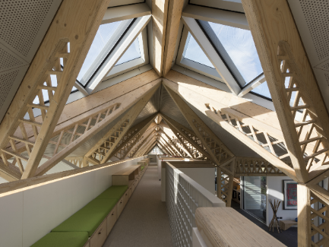
As well as allowing light into the building, he stated the large windows formed a connection with the garden surrounding the centre. This combined with having a number of indoor plants, water features and a natural material interior, created a strong connection with nature, letting visitors feel immersed and relaxed. This also formed a contrast to their normal institutional atmosphere, giving people an escape.
Figure 28: Manchester Maggie centre kitchen-diner. https://www.maggies.org/our-centres/maggies-manchester/architecture-and-design/ (Accessed 09 November 2019)

After doing research into wellbeing, the architect had noted that someone’s feel and touch becomes very sensitive after chemotherapy, therefore designing surfaces and surroundings warm to touch was important. Therefore, other than the glass panels of the external walls, everything is a soft wood, from the structure to the dinner room table and handrails.
Figure 29: Manchester Maggie centre mezzanine floor. https://www.maggies.org/our-centres/maggies-manchester/architecture-and-design/ (Accessed 09 November 2019)
“It’s little small things like that, that make a huge difference.” Architect director of the Manchester Maggie centre.
Throughout the interview the architect stated that the centre was designed and run to be flexible when it comes to treating the visitors. That creating a comfortable space depends on the visitor’s mood, meaning if a space is adaptable the building can support a wider range of people. The centre was designed around people and their needs, reducing stress wherever possible.
“People use the building differently, contrary to the way we designed it, which is great.”
(See appendix E)

Interview/questionnaire data from the employee/s:
One completed questionnaire I received from the manager of the Manchester Maggie centre, expressed very similar views around the design features and purposes, highlighting that the methods that the architect utilised in the design positively impacted the users in this wellbeing centre
The employee repeated that the soft wood structure and connection with the natural materials was enjoyed and impacted the visitors and other employees at the centre. With this and the volumes of natural light; these features created a beautiful, airy and uplifting space.
(See appendix F)

Analysis related to the wellbeing criteria:
Air: As the building is nearly fully glazed, the natural ventilation plan had been developed along with the design; the pitched glass roof holds 14 triangular windows that automatically open when the centres internal temperature goes over the set comfort temperature. The windows are angled in a way where they can be open without letting in rain during the rainy months. This keeps the centre at a comfortable temperature and allows fresh air to flow through the centre all year round.
Light: The Manchester Maggie centre has maximised the amount of natural light; having a minimal number of solid walls allows light to travel deep into the centre. Rooms such as the library and bathrooms are situated on the north side of the building as they don’t need as much light, whereas the main centres space is completely lit by the sunlight.
Sound: The gardens around the centre have been designed to absorb surrounding noises, by having large dense trees and bushes on the perimeter. The creates a peaceful atmosphere outside in the garden and inside the centre. Internally, the centre has been designed in a way where the busier rooms were cut off from the main space with partition walls. The large open space is kept at a low noise level, which is supported by the absence of a doorbell and crowd of visitors.
Movement: Such as in the other centres, large rooms are used for group activities; keeping the visitors moving and forming communities in the centre. In addition, the Manchester Maggie centre supplies areas in the garden and in the ‘greenhouse’ for visitors to plant and grow any flowers, fruits or vegetables they please. These spaces help visitors who don’t have gardens or the equipment, get involved with nature. This creates a range of hobbies for visitors to get involved in and committed to.
Mind/Nature: The Manchester Maggie centre is designed around nature, forming clear connections with its surroundings. As the building sits surrounded by trees and greenery, the glazed walls, indoor plants and interior design make the centre feel like the nature outside is growing into it. The cross hatched timber beams encourage plants to grow up them, swallowing the centre in the garden.
Innovation: The Manchester Maggie centre creates a range of spaces for the visitors: large rooms for group activities or discussion’s for visitors to catchup and gossip with each other, quiet spaces for visitors to sit or sleep if they need time to themselves and a range of activities to help form communities and families inside the centre. These communities and friendships expand out of the centres, into the lives of each visitor.

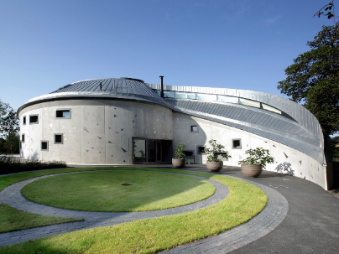
Case Study 4: Swansea Maggie Centre (More intensive research was planned for this case study but could not be undertaken)
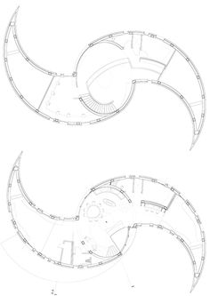
The Swansea Maggie centre was located South west of Swansea, between the Mumbles and the city centre. The centre was raised above the rest of the hospitals complex, with the north of the centre backing into Singleton park. Access could be given on foot, through Singleton park on a path surrounded by trees, or by car through the hospital, up a small windy road where the centre could be seen through the trees. The given site was an open space surrounding by woods, however access to the site was a constraint as the road leading up to the building was narrow and steep. This problem was difficult to combat, so parking was available at the bottom and the top of the road.
Figure 30: Swansea Maggie centre. https://www.maggies.org/our-centres/maggies-swansea/architecture-and-design/ (Accessed 10 November 2019)

The Swansea Maggie centre was designed by Kisho Kurokawe and was one of the first 'Maggie's' Cancer support centres to be built in the UK through the organisation. After the death of the architect, the centre opened on the 19th of December 2011. The centre was designed in a swirling structure, mirroring the cosmic whirlpool of the milky way; evoking an inspirational and uplifting feeling. The wings finished at points, joining the east and the west, following the sun as it raised and set, bringing a sense of calm and tranquillity to all that visited. (A. Frearson, 2011)
Figure 31: Swansea Maggie centre floor plans. http://sabrinaysl-bsarchi-e-portfolio.blogspot.com/2013/12/architectural-studio-2-1126-lecturer.html (Accessed 10 May 2020)
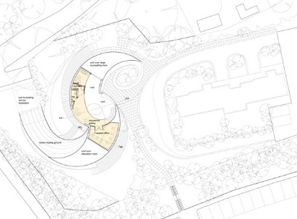
The interiors balanced the sense of calming through simple beige wall colouring and an easy flow through the building with the feeling of being welcoming and friendly with bright coloured soft furnishings and social areas. The two wings were fitted with benches that follow the seam of the curved walls, rotated shelving with hidden storage behind and specially placed windows to allow natural light in but still creating the feeling of privacy. Pocket doors at the base of the wings were fitted so the area could be isolated from the main space creating a peaceful area for group and individual discussions.
The main space consisted of a kitchen and dining table for larger groups, a wood burning fire ‘hanging’ off centre and small clusters of chairs for smaller groups, with the oculus window in the roof, dragging light into the space. The larger windows were positioned on the west side of the building, focusing on the best views on the site and increasing the amount of natural light coming into the building.
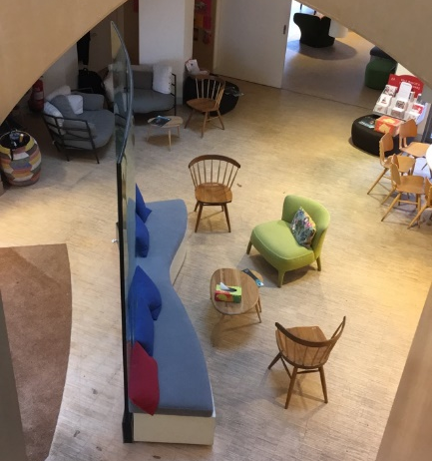
The landscaping and building were designed and developed together as the architect wanted everything to be in unison and correlate with each other. The paths swirl round, parallel to the centre, forming a garden space for fruit and vegetables with a centre point just left of the entrance. A dry-stone wall with built in seating was constructed a couple of years after, framing the garden space. The trees neighbouring were cut back slightly to expose to surrounding views, while still keeping the centre hidden in its peaceful paradise. As hospital parking can be difficult and stressful, a private carpark was included on the site, forming easier access to the centre.
Figure 32: Swansea Maggie centre landscape plan. https://www.roberthirschfield.com/projects/culture-and-community/maggies/ (Accessed 10 May 2020)
Unfortunately, I was unable to receive any response from the architect or employees of the Swansea Maggie centre at this time.
Figure 33: Swansea Maggie centre entrance area. Knight, C. (Accessed 10 May 2020)

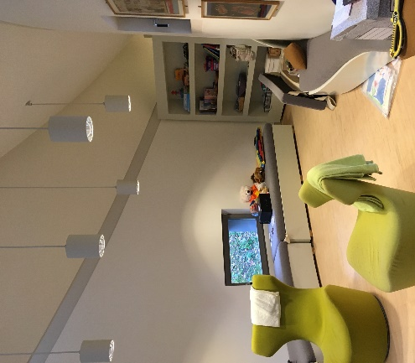
Analysis related to the wellbeing criteria:
Air: As discussed before, the Maggie centres are designed to allow each room to be heated and cooled independently, allowing visitors to adjust the temperature to suit them. In the Swansea Maggie centre, the sliding doors situated at the two main rooms in the wings can be opened allowing free flow of air through the centre. In addition to this, the entrance door and bifold doors, situated opposite each other, can be opened up to create a large indoor and outdoor space during sunny and warm months.
Figure 34: Swansea Maggie centre large ‘wing’ room. Knight, C. (Accessed 10 May 2020)
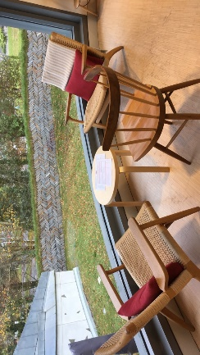
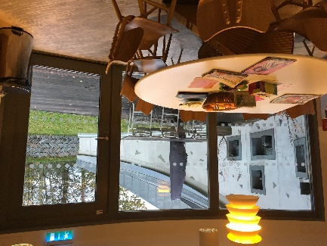
Light: The centres orientation is also designed to maximise the amount of natural light into the centre. Due to the centre being raised on a platform, views to the hospital are minimal, so larger windows are situated on the southside, creating views across the back garden and Swansea. The roof light drags light deep into the centre, and the white walls help exaggerate this.
Figure 35: Swansea Maggie centre cluster of seats. Knight, C. (Accessed 10 May 2020)

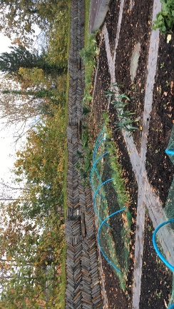
Sound: As mentioned above, sliding doors are used to open up the centre allow free flow of air and people. However, the sliding doors don’t block all sound travelling from room to room. To avoid visitors from being overheard other visitors, families and friends are asked by the employees to sit further away. There are numerous clusters of seating around the centre, allowing families and friends to sit in comfort while waiting.
Figure 36: Swansea Maggie centre cluster of seats. Knight, C. (Accessed 10 May 2020)

Movement: Due to the shape of the centre, the large activity and discussion rooms are located downstairs in the wings and the small private rooms are located on the first floor. The wings height and area make these rooms perfect for a group of 20 people in each room, to do a range of activities, such as for example Thai chai, yoga or meditation.
Figure 37: Swansea Maggie centre garden, fruit and vegetable patch. Knight, C. (Accessed 10 May 2020)
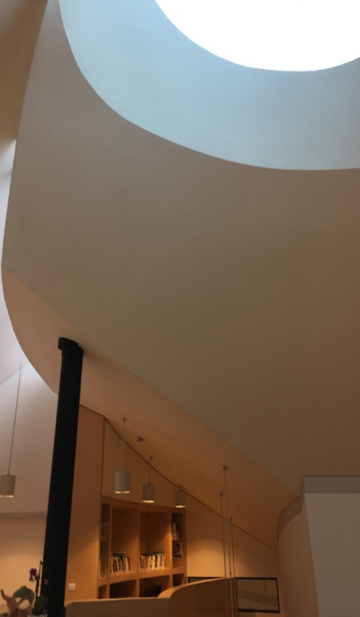
Mind/Nature: The Swansea Maggie centre has a strong connection with nature; the garden spaces and outdoor seating allows visitors to get involved with their surrounding and supplies people with gardening therapy if they do have a garden at home. The surround area around the centre is a mixer of garden space for growing flower, fruit and vegetables, and a wooded area leading into singleton park; creating green spaces for any preference the visitors might have.

Innovation: When visiting the centre, it became clear that their focus was children, whether it was a child suffering or that someone from the family was. The centre offers group discussions and activities aimed towards children, helping them open up about the topic and showing them that others are going through the same thing. There are also private therapy sessions where the child can discuss their emotions or ask for advice privately without their families; this once again encourages those visiting to open up on the topic.
Figure 38: Swansea Maggie centre rooflight in the atrium space. Knight, C (Accessed 10 May 2020)

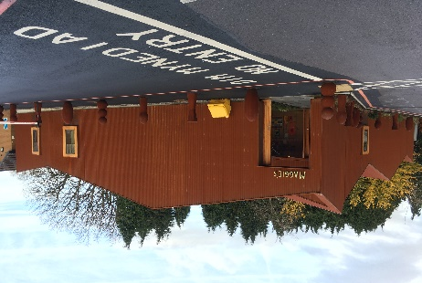
Chapter 5: Cardiff Maggie Centre (More intensive research was conducted into this case study)
The Cardiff Maggie centre was located to the north west of the city centre; situated in the Velindre University NHS Trust complex. The centre shared parking and was an easy walk from the main entrance of the hospital, creating an easy flow of people.
Figure 39: Cardiff Maggie centre. Knight, C. (Accessed 10 May 2020)

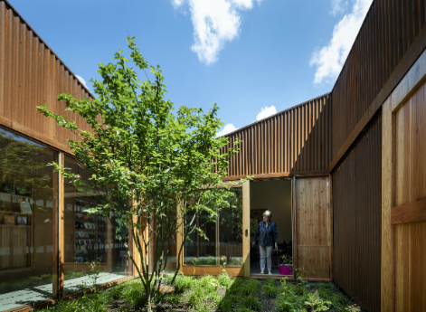
The Cardiff Maggie centre, which was opened in early 2019, was designed by Dow Jones architects. They concentrated on natural light, open but quiet spaces, and social areas. Creating a space that felt familiar, as “familiarity is a common word in briefs for care environments” quoted for Dow Jones Architects from their book ‘Maggie’s Cardiff: Art, Architecture, Landscape’. (Dow Jones Architects 2019)
Figure 40: Cardiff Maggie centre entrance courtyard. https://www.maggies.org/our-centres/maggies-cardiff/architecture-and-design/ (Accessed 10 May 2020)

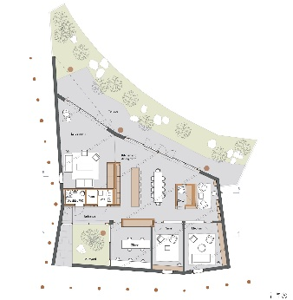
The south and west facades addressed the hospital complex; to create a feeling of privacy and the separation from the hospital, the Corten steel clad wall had a minimal number of windows. Whereas backing into the wooded area, the north diagonal face was almost all glazed, maximising the natural views of the forest and the amount of natural light let into the building. The buildings angled roof and the rusty, wrinkled steel cladding, mirrors the shape, colour and texture of the local mountains; responding strongly to the areas character. The red colouring of the centre also made it stand out and easy to spot from afar.

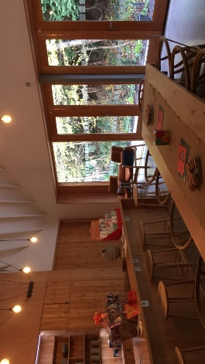
As you entered the centre, you walked through the initial opening into a small courtyard surrounded by glazed walls that overlook the reception area. This feature formed a feeling of welcoming and comfort. After walking through the door, you were greeted by a small library filled with self-help books and information leaflets, naturally lit by the large south facing window, looking back into the courtyard. Looking down into the centre, you could catch glimpses of the kitchen, dining and quiet spaces, giving a chance for unsure visitors to examine their surroundings before making the decision to enter.
Figure 42: Cardiff Maggie centre kitchen-diner. https://www.maggies.org/our-centres/maggies-cardiff/architecture-and-design/ (Accessed 10 May 2020)
Figure 41: Cardiff Maggie centre floor plan. https://www.dezeen.com/2019/05/12/maggies-cardiff-dow-jones-architects-maggies-centre/#/ (Accessed 10 May 2020)
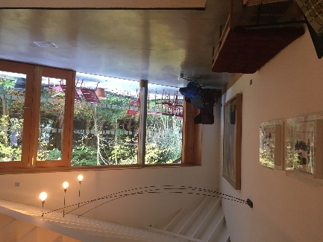
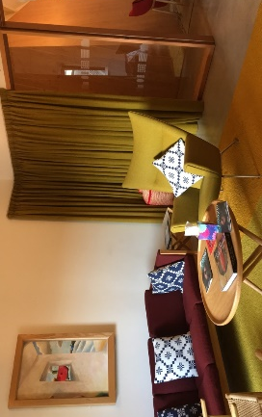
The main space consisted of a kitchen and dining area for social groups, small clusters of chairs for smaller groups and at the heart of the centre the cwtch formed a small intimate cave. (A cwtch is a small enclosed space) Off the main area were offices for the employees, two separate rooms for private classes, a larger space to the back for group activities, such as Thai chai and a small patio looking back into the forest to the north. Each space had an open feeling, with either large openings or with glazed walls, but still having the ability to make them separate with sliding doors and curtains.
Figure 43: Cardiff Maggie centre large activity room. Knight, C. (Accessed 10 May 2020)
The atmosphere in the centre was a homely feeling, with each employee and visitor being part of the family.

Interview/questionnaire data from the architect/s:
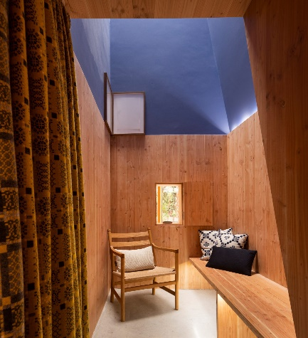
I received an answered questionnaire from the architect director of the Cardiff Maggie centre, who discussed how they responded to the ‘Maggie’s architectural brief’ and what features were most important to them.
Figure 44: Cardiff Maggie centre private room. Knight, C. (Accessed 10 May 2020)
They discussed the courtyard, being the first point of contact, and therefore important as it needed to be intense and a contrast to the hospital complex that surrounded the centre. The focus here was to take peoples mind from where they had just been and concentrate on where they were going. Once inside the entrance art pieces at the end of the building would pull the visitors in further where they could then see the floor to ceiling windows out to the garden.
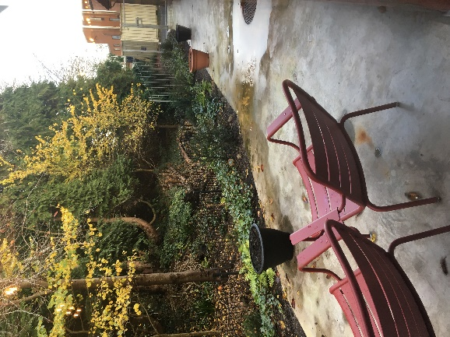
The architect stated that the combination of the angled roof, the natural light coming in from the glazed wall, and the view into the garden helped to draw people into the heart of the centre. They wanted to tell a story through the journey, helping visitors flow into the centre easily, avoiding any barriers or hesitation where they might change their mind.
Figure 45: Cardiff Maggie centre the cwtch. https://www.maggies.org/our-centres/maggies-cardiff/architecture-and-design/ (Accessed 10 May 2020)
Another point stated by the architect, was the desire to create varied atmospheres in the rooms, for the different people who needed support. The atmospheres created were: energetic social rooms for group activities, private concealed rooms for discussions and advice on problems, and the cwtch creating an isolated room for a person to sleep or to be with their thoughts in the quiet and looking at the clouds. Recognising these different needs made the centre more adaptable for the visitors and helped everyone improve their wellbeing.
(See appendix G)
Figure 46: Cardiff Maggie centre garden space. Knight, C. (Accessed 10 May 2020)

Interview/questionnaire data from the employee/s:
I interviewed two employees of the Cardiff Maggie centre, who after working with Maggie’s believe that architecture and interior design can impact upon a person’s wellbeing. They mainly discussed the effects on people’s mind, in reference to the interior design and the connection with natural light and nature.
One employee stated that their favourite aspect in the centre would be the soft furnishings, chairs and decorations, as they were all handmade and well thought out. Everything had a purpose and was positioned to enhance this. The Cardiff Maggie centre is designed and filled with several locally sourced objects.
One of the local materials used was the melin trewynt wool, sourced from Pembrokeshire, Maggie’s has used this wool to create the curtains, pillows and blankets. According to the employees, a number of visitors recognised the wool right away. Having the ability to recognise something in an unknown place helped new visitors to feel more comfortable quicker, as they had a common connection and felt grounded. As well as the wool, all the pottery on show was handmade by a local ceramicist, Lisa Kreigal, who works at Cardiff university teaching ceramics. These also created recognisable objects. The employees stated that the local objects helped to start conversation between visitors as they discussed the surroundings.
The centre’s large table allowed visitors to sit around with others drinking tea and exchanging stories and experiences. This helped create a social circle and allowed people to talk openly or come to terms with problems with others who understood. The employee also noted that visitor’s check-up and care for each other like a family.
Due to the centre being relatively new, certain aspects weren’t fully finished. The garden had been a feature that they had been working on, ready for the spring and summer. The garden runs along the glass facade and there was a small courtyard at the entrance, which helped enhance the connection with nature, already formed by the interior materials and layout.
(See appendix H)

Analysis related to the well criteria:
Air: Similar to the other centres, each room in the Cardiff Maggie centre has their own thermoset, allowing visitors to control the temperature to their liking. Heavy wool curtains can be used to cover the glazing, helping keep the heat in longer. As well as this, due to the orientation and layout of the centre, during especially hot days, the south windows and north bifold door can open up and purge hot air.

Light: Due to the South and West facades of the building facing the hospital complex and to avoid the view of the hospital and the chances of being overlooked, the centre had been designed with minimal windows on those sides. To combat the minimal light entering from here, the majority of the north-east side had been glazed, forming a beautiful view into the garden and wooded area behind the centre. Natural light was allowed through the small windows on the southside, and glazed walls allowed the light to travel deeper into the centre. A roof light was used in the Cwtch to create a uniquely light space, completely private and isolated from the world.

Sound: To reduce noise transfer, all rooms are able to be cut off from the main space, creating numerous private rooms. During the activity’s sessions, noise can be heard between the kitchen-dinner in the main space and the activities rooms, to combat this, large wool rugs are used to absorb some of the floor vibrations.

Movement: The Cardiff Maggie much like another Maggie centres, has a large open space for group sessions, this backs into the glazed northside, allowing views into the small yet beautiful garden. The large room is used for relaxation sessions for the visitors, Cardiff Maggie’s holds group activities, such as Thai chai and yoga for visitors of the centre. This allows the visitors to get out of the house/ hospital, keep active and make friends.

Mind/nature: The lack of garden space and nature around the site has made making a direct connection to nature difficult. Therefore, the architect forms strong connections indirectly. This is done through the internal clad, kitchen counter, dining table, and chairs being handmade out of timber. On top of this, the cultural connection to welsh heritage is strong; through the local wool curtains, rugs and blankets, the handmade bowls and plates and the local hand painted artwork around the centre.

Innovation: From first-hand experience, the activity sessions helps create a community inside the centre, where friends can meet up, tell stories about their life or ask for advice between them. The social gathering that happen before and after the sessions, helps form friendship between the visitors and employees. The visitors care for one another, allowing their friendship to reach out further than the centre walls. The atmosphere inside the centre is very much like a family.

Chapter 5: Review of the methodology and findings
I received a response from the manager of the Swansea Maggie centre stating that they were unable to help as it was a busy time. No response was received from the architect of the centre as well. This made further analysis of the Swansea centre difficult. Therefore, I was only able to collect more extensive research from the two other centres, Manchester and Cardiff, where I gained either a face to face interview, responses to my questionnaire or an answered questionnaire based around the set topics.
Comparing these two centres was acceptable as they had had responded similarly to certain criteria. It was interesting to compare how different architects could design features encompassing different constraints, locations and area available, while still producing a similar atmosphere and affecting the same senses.
After collecting the interview and questionnaire responses from the architects and employees for both Manchester and Cardiff I compared their opinions against one another. This was to highlight the common features or senses that were important through the design; with reference to the well certified points and descriptions. After this, I then compared the results from the architects and employees with the key features that were highlighted through my personal research; from visiting the centres and architectural articles focused on the centres.
I then started to compare all five Maggie centres, combining the results from all the sources, a correlation between several design features and senses were identified. These common design features were then analysed in all the centres to identify how the architect had responded to the original design brief. Maximising the amount of natural light into a building and creating a space in the visitor’s mind that feels separate from their normal life being achieved through connections with nature was one of the main design features. These features were based on the well certified research and were shared between the centres.
As the centres had different constraints and locations, these features had to be adapted to the particular Maggie centre. Natural light and connectivity in nature is easy to achieve when a building has room for a garden and received south sun light. Analysis of these Maggie centres shows that good architectural design could still achieve natural light and connectivity even when there were minimal outside space and available south sun light. These architects helped create a spectrum of features that could be used in a large number of buildings; helping other architects design buildings specific to the user and their wellbeing.
After visiting the centres and interviewing the employees, it had come to my attention that my investigation had a number of variables. It would be unfair to compare the centres I had visited in terms of which were better equipped or had a superior design to improve someone’s wellbeing as each centre has a different location, restraints, budget and designer. The centres also depended heavily on the people who worked there, suppling help and advice throughout the day. However, I do personally believe that each centre had complete focus on improving their visitor’s wellbeing, the employees daily work and forming a welcoming place to come when people are at their worse time.
Due to the corona virus outbreak, I was unable to visit the Maggie centres again to collect any last-minute information and take my own photos. I had not re-contacted the Swansea Maggie centre to collect any additional results. In some cases, I had to use official photos from the Maggie’s organisation and architectural online articles.
As a response to the outbreak the Maggie centres have closed temporarily for safety of the visitors and employees, however after looking on their website I can see that the employees are still supplying help and advice through phone and video calls. Even though they are unable to place their visitors in a tranquil space, they are still trying to support people’s wellbeing and helping them think more positively. Through every adversity the employees and volunteers at the Maggie’s organisation will do everything in their power to support their visitors and anyone who needs someone to talk to.

Conclusion
During the investigation into wellbeing and wellbeing in architecture, it became clear that a ‘good state of wellbeing’ and a ‘place that evoked a good state of wellbeing’ differs from person to person, this was stated numerous times by the mental health foundation. They understood that wellbeing was subjective. Supporting someone through a difficult time and improving their wellbeing would only be possible if specialists could measure what state of wellbeing a person was at and what the core of the problem was. Wellbeing was defined as a state of comfort and happiness; personal to the individual. Wellbeing centres needed to create spaces that were adaptable, so that a ‘comfortable and ‘happy’ place was provide for all the visitors. The Well certified research supplied criteria for buildings, which help rate them on their effectiveness towards wellbeing.
After comparing all the research and data from Well certified and the five Maggie centres, I noticed the designs had similarities and differences following the wellbeing criteria. The similarities were the same throughout most of the centres I researched. These criteria were: Air, Sound, Movement and innovation.

Air: Both Manchester and Cardiff Maggie centres can be naturally ventilated, with large windows and doors on the external and internal walls, opening up to create a follow of fresh air through the buildings. In addition to this every room in both centres had thermoset to control the temperature in that set room. This allowed rooms to be at different temperatures across the centre.
Even though Nottingham, Merseyside and Swansea Maggie centres could be naturally ventilated, they mainly relay on the centre being mechanically ventilation as its more effective, due to the large number for separated rooms. However, similar to manchester and Cardiff Maggie centres, all the rooms have temperature control.

Sound: All the Maggie centres are designed with large busy rooms for group discussions and activities, as well as smaller private rooms for intimate discussions and allowing space for someone to sit with their own thoughts. Sound is considered in all of the designs reducing noise travelling from room to room by including partition walls and heavy insulated materials (such as curtains), to avoid chances of overhearing conversations. These design features are used in all five of the Maggie centres I’ve visited. Nottingham, Swansea and Manchester have separated to different rooms on to different floors, whereas, for the smaller centres have been design with the nosier rooms situated across the centre from the private rooms. These features are aimed to reduce as much noise transfer as they can.
An extra note for the Manchester Maggie centre, was the consideration of noise. The centre is designed to allow space for discussions and group activities but still allowing quiet and private areas. The noise levels are so well controlled that visitors who want a quiet moment to themselves could achieve this even in the main area.

Movement: The centres were designed to have a large room that could fit 20 visitors in during each activity session. All the centres supply a range of activities, for example: Thai chai, yoga, and meditation. These sessions are picked to allow anyone, with any level of movement and energy, to get involved. Nottingham, Manchester and Swansea have several large activities rooms, to allow different sessions to run at the same time. Due to the size Cardiff and Merseyside, they have only been designed with one activity room, however they have numerous clusters of seats and areas from groups of visitors to carry out fewer active sessions, such as kit and knatter.

Innovation: The architecture behind the Maggie centres are exceptional and inventive. The five Maggie centres I’ve researched and visited are designed at such a high standard to create places that are beautiful and make people want to visit. The communities in each centre are energetic and friendly, filled with families and friends that form bonds with each other.
Something I noticed in my visit to the Cardiff Maggie centre, after each activities the visitors and employees would gather round the dinner table for a snack or a cup of tea and chat. These discussions would be about a range of topics, such as: the activities they had just done, family life, experiences and stories. These discussions were personal and created a family like atmosphere between each visitor and employee. The centre felt like a home.

However, the five Maggie centres had a number of differences, by following the same wellbeing criteria. These differences show how, against the restrictions of each site, the architects were still able to produce design that followed the criteria and impact upon people’s wellbeing. These criteria were: light, in terms of allowing natural light into a space, as well as mind/nature, in terms of having either a direct or indirect connection with nature.

During my data collection, it was made very clear that allowing the maximum amount of natural light into a building was the main driver in the design for the Manchester Maggie centre. The design of the centre consists of three of the facades: the East, south and west, being almost completely glazed with large glass panels sitting between the timber structure. On top of this, the roof was formed from triangular windows. These features allowed natural light into the building all day long, during every season. The main problem with this feature was overheating from solar gain, this was reduced through the east and west facades including deep canopies extending out over the porches. To purge the building if it got too hot, the triangular windows on the roof would open allowing the hot air out.
Other centres, such as Swansea and Nottingham have also been designed to maximise the amounts of natural light into the centres. Similar to the centre in Manchester, the Swansea Maggie centre has been designed in a specific orientation, with the larger windows situated on the south southside. This design feature didn’t have any problems as the better views were on the south side of the site. Whereas Nottingham had a major constraint with avoiding views over the hospital; designing the centre in the trees allowed every room to have a floor to ceiling windows or bifold doors leading on to balconies without overlooking the hospital. In addition, similar to the Manchester centre’s glass roof, both Swansea and Nottingham have one large roof light windows, dragging light into the centre of the building.
The Merseyside Maggie centre had a major problem avoiding overlooking the hospital complex as it surrounded all most all of the facades. To combat this issue and to keep costs low, partially transparent fibre glass panel surrounded the structure. Due to the panels being partially transparent, it eliminates the view of the hospital be still allow natural light into the courtyards and building.
In the Cardiff Maggie centre, there didn’t seem to be such a focus on natural light in the original research. However, the questionnaire completed by the architect states that the use of natural light was considered and was a large part of the centres design. The natural light that was allowed into the centre space from the northside was included to encourage visitors to walk deeper into the centre, persuading them to look out of the large bifold doors at the small beautiful garden that backed into a wooded area behind. Glazing the south side of the building would maximize the natural light into the spaces however these windows would overlook the hospital complex. Therefore, small windows were used to reduce this direct view but still allowing enough light into the spaces. This in turn created a bright area for visitor to come into for group and individual therapy; a bight colourful space that was used to help those in the sessions think more positively and happy.
The cwtch, was concealed in the centre of the main area; a small timber clad space that receives tunnelled natural light from the window in the roof. This created an area away from other visitors which was secluded and safe, while still forming a connection with the outside and nature.

The Manchester Maggie centre had representation for both direct and indirect connections with nature. The largely glazed facades mentioned earlier helped create a direct connection with nature. The centre was designed to have a garden wrapping round from the east to the west. On one side of the garden there are large trees, decorative bushes and flowers with a water feature running through it. The other side had a fruit and vegetable planter, where guests could plant what they desired. In between these areas sat a green house, an extension from the centre; once again where visitors could plant and grow what they wanted. These areas create attractive views for visitor to see through the windows as well as giving them the ability to get involved with nature by planting their own. This was extremely beneficial for visitors who either lived at the hospital or didn't have their own garden at home.
The centre also created an indirect bond with nature, helping produce that connectivity in the colder winter months when access to the garden was limited. This bond to nature was formed by exposing timber frame structure internally and externally, as well as matching the same timber material with the furnishing throughout the centre, producing a warm and soothing atmosphere. These features helped the visitors feel welcomed and accepted by nature and was continued with the use of indoor plants and nature walls situated to the south of the building.
Similarly, Swansea Maggie centre has direct connection with nature as the centre has been supplied with a large garden wrapping round the building, with a drystone wall built around the perimeter forming outdoor seating. The garden has large open spaces for activities, and a large fruit and vegetable plot from visitors to plant what they desire. In addition to that, the centre back into singleton park, allowing visitors to go for a walk around the park on nice days.
Both the centres in Nottingham and Merseyside have been designed with direct connection to nature without garden space. Even though the enters don’t have a garden, they have been orientated and designed to enhance the beautiful views around them. Nottingham Maggie centre has numerous balconies project into the surround trees, allowing visitors to feel submerge in nature, while looking over Nottingham. The Merseyside Maggie centre, as well as having numerous courtyards where greenery has been allowed to grow into and round, the London dresser has been transformed into a nature box. This nature box holds group activities and discussions while overlooking the beautiful Wirral fields. The trees and bushes around the nature box have been allowed to grow around it, making the visitors in the structure feel like they are part of nature.

Due to the lack of natural views around the site, the Cardiff Maggie centre was limited in direct connections with nature. On the north side, a small garden backing into a wooded area was visible, with a timber porch allowing outdoor seating. The porch was also home to some potted plants which were cared for by the centre’s gardener.
To combat this the architect maximised the amount of indirect connection with nature and the welsh heritage. The centre was internally clad with timber panels; this material and texture was then mirrored through the furnishings. This formed surfaces that were soft and warm to touch. On top of that, the designers included curtains, blankets and some wall decorations that were crafted out of Melin Trewynt, which is local welsh wool. Additionally, the mugs, bowls and plates were handmade by a local ceramicist and the paintings scattered around the centre were by a local artist. These features were intentionally placed to be recognizable to the visitors, forming ice breakers in new conversations. This made the visitors feel more at home and comfortable.

To conclude, after comparing these centres, when designing a building focused around a user’s wellbeing, consider allowing large amounts of natural light into spaces where synthetic light would be used. Lighting a space naturally helps users feel more positive. In addition, forming a connection with nature, whether that would be directly or indirectly is important to help place visitors in a positive frame of mind. The range of environment produce separation from the hospital or their homes for the visitors, allowing them to have well needed break from day to day challenges. On top of all of this, it was clear throughout the centres, that creating a range of spaces with different lighting, views, temperature and area, allowed visitors to decide where they wanted to go. Forming adaptable rooms and spaces for everyone, the visitors can situate themselves in an atmosphere/room that is their personal safe haven and improves their wellbeing.

Appendix A: The Warwick-Edinburgh Mental Wellbeing Scale
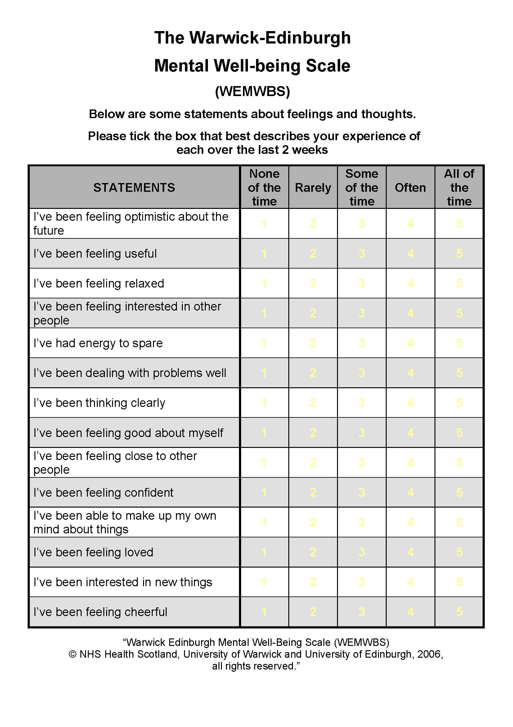

Appendix B: The Maggie centre brief
Spatial Requirements | Design | Aesthetics
Entrance | The entrance should be welcoming and obvious; without being intimidating.  The door should not be draughty; a lobby space with places to hang brollies and coats.  There should preferably be a place for a relative or friend to sit, with a small bookshelf.  From here there should be east access to most of the building layout. | The space created form a ‘pause’ space, where newcomers can assess the buildings atmosphere and activity, without having to fully commit.  The first impression must be encouraging.
Office | There should be three main workstations, with six small ones with generous storage space for stationary.  There also should be space for a photocopier, printer, server etc. Each of the main stations should have a telephone, computer point, a shelf and draws. | The office space doesn’t need to be in an obvious place, but it should be positioned next to the entrance, so members of staff working can spot visitors entering the centre  Should be noted, there should not be a reception desk.
Kitchen | This space should be large enough for: a large table to seat about 12, a ‘fairly’ large kitchen island with additional seating, and an extra counter space for food and drinks.  Ideally there should be two dishwashers, a large fridge, one and a half sinks, oven and a hob. | This area is usually the main hub of the building, with the extra spaces, essential for nutrition workshops.  Visitors should be able to work round the tables easily, encouraging people to help themselves to the equipment and resources.
Computer Desk | Two computer areas are needed for visitors to access online information. | The areas should be shouting distance from the offices, for if users are in need of help.  The areas also don’t have to be side to side, just easily visible and comfortable.
Notice Board | There should be a visible notice board, which will include fundraising information and a programme timetable. | The notice board should be visible but simple and not too ‘in your face’.  Preferably near the entrance for newcomers to check out.
Library | This space should fit a couple of shelves for books, leaflets and booklets with needed information for visitors. Surrounded by a range of different seating; in a quiet and semi-private space.  The space could also be integrated in the ‘pause’ space. | This space should be comfortable with natural light or windows with views.  The books should be easy to find, and at a reasonable height.
Sitting rooms | There should be three main seating rooms, which can ‘open up’ to the main centre but can also be ‘shut off’ depending on how they are used.  The first space is normally used for relaxation groups and class, should as: thai chi, yoga or meetings. This space should be large enough for 12 people lying down with stage of folding chairs and equipment.  The second space will need to be a medium to large sized rooms, used for workshops and group sessions. It needs to be supplied with a table and seating for 12 people, either permeant or easy to assemble and store.  The third space can be smaller, used for counselling sessions for up to 12 people. With comfortable furniture and a fireplace to create a friendly atmosphere. | The centre would also benefit if the two biggest rooms are formed off the main hub space, which can be opened up during fundraiser days.  The rooms do not have to be completely soundproof, but the noise should be buffered as much as possible. That way each room can control the atmosphere they want, and no visitors are worried about being overheard in their sessions.
Consultation Rooms | In the centre there should be a number of them scattered around. One of the rooms should be able to fit a treatment bed, and they should all be soundproof and private when in use. | These rooms should be simple but comfortable, with windows looking out on the nature and the sky.  It should also be noted, these rooms should be positions so passer byers can look in.
Toilets | The two toilets should have washbasins, mirrors and bookshelf.  The rooms should be large enough for disabled access or to bring a chair in. | The rooms should be soundproof, private enough to cry.  The must be clean and never have gaps under the doors.
Retreat | If able, a small quiet space, for people to have a rest or a lie down would be nice.
Views in and out | It is important for most rooms and spaces to have large windows, to maximise the amount of natural like and to form a strong connection with the outside and nature.  If possible, an outdoor space (even a small planted courtyard) would be good.  Allowing people to exit out of as many internal spaces as possible. | The strong connection with outside is important as nature place a strong factor in feeling refreshed and free.  However, avoiding being too open the people feel watched or unprotected.  The nature, such as trees, are also important because they create privacy which is needed in many rooms.
Parking | If able, parking is needed, with disabled spots near the centre. | Available private parking near the centre, reduces stress when visiting, allowing people to come and go with ease.
Overall design | The designs ethos should be domestic, maximising the amount of natural light and avoiding looking like a hospital. | Creating a space which is completely different from the hospital makes people feel more comfortable.  Allowing them to have a break from the continuous hospital environment.
Maggie’s Architecture and landscape brief (REFERENCE)

Appendix C: Questionnaire and interview questions
Interview Questions:

- Do you think architecture can improve people’s wellbeing? If so how?

- What do you enjoy about the Manchester Maggie Centre?

- Whats architectural design features do you think is most important?

- Do you think that adds to the improvement of people’s wellbeing?

- Would you change anything about the (Manchester) Maggie centre? If so, what and why?

- Are there any aspects of the building that contribute to your enjoyment, sense of wellbeing?

Appendix D: Pilot Results
Questionnaire:
- Do you think architecture can improve people’s wellbeing? If so how?
I think it can because buildings are what we spend every minute of the day in and therefore it affects us even though we may not realise. For example, I think that having windows in a space is one of the most important things, however, often overlooked until you contrast this with a space with no natural sunlight or view out of the building. I think this is important as it not only puts you in context of the work around you, you can see out and others can see in, but also allows for a small element of nature to come in.
- What do you enjoy about the university/ study room?
I really like how our studio is really open planned as it allows for collaboration and open-ness between all the students. There’s plenty of work and posters always on display in the centre of the room and there are ample amounts of large windows allowing a lot of natural light into the space. All the walls and ceiling are painted white which, I think, works really well in a studio space as it makes the work stand out.
- What architectural design features do you think are most important?
For wellbeing, I think that the most important thing is the use of materials and the amount of windows that allow natural light into the building.
- How do you think these add to the improvement of people’s wellbeing?
The materials are important as the more earthly these are, the more they hint toward nature, the more you feel in touch with it. I think the amount/size of windows again is really important as it makes you feel connected with the outside space. Unconsciously telling you the time of the day, what the outside world is doing, breaking your cycle with something out of your control.
- Would you change anything about the university/ study room? If so, what and why?
If I could change anything, I would add concertina partition walls rather than having the curtains as these are really good to create an open plan, adaptive studio, however, it means that the noise levels can be disturbing at times especially when there is a studio session and a lecture going on at the same time.
- Are there any aspects of the building that contribute to your enjoyment, sense of wellbeing?

I think that the amount of large windows lining both sides of the studio, combined with the white walls and ceilings, it makes everyone in the studio feel brighter and happier. Alongside this, I also think that the open planned nature of the studio makes people converse and collaborate, boosting my social and mental wellbeing as well as enjoyment while studying.

Appendix E: Manchester Maggie centre Architect interview

Architect director of Manchester Maggie centre, Darron Haylock
- Do you think architecture can improve people’s wellbeing? If so how?
"100%, absolutely."
"it’s very much a trend at the moment, or vogue. There's a standard called the well standard (well certified), it focuses on the wellbeing of the occupant in a building. So, to ensure or to guide architects and design teams to design a building which is putting the people at its focus. SO, things like improving natural ventilation, improving views and stimulations, connections with biophilia and so forth. All those things. It’s similar to BREEAM, how you would rate a building to a sustainability point of view but the well standards rates buildings on how well they put the occupants at its focus and how they look after the occupants"
"There's a lot of research that says about if the occupants are stimulated and they have more fresh air, their productivity increases. Which is focused on the commercial point of view but from a Maggie's point of view 100%, the quality of the architecture has a direct influence or impact on their wellbeing of their occupants. Not only the ones who are affected by cancer but those who work and volunteer"
"So it’s not just about the ones who try and seek help or recovery, some people go to Maggie's for escapism, it’s all about creating a sense of place and a sense of home, it’s like a second home for some people, so without a shadow of a doubt, architecture can improve the wellbeing of somebody"

- What do you enjoy about the Manchester Maggie Centre?
"I could send hours thinking about this, there's not one singular thing I could point out on the project. I think I must say the people there are great, the volunteers, the staff are fantastic and without them the building wouldn't function the way that it does. I think that sometimes you forget about the importance of those people and those volunteers."
"What I like about the project, I like the use of timber, the fact that timber is a very warm material. I like that we expressed the structure, made the structure apart of the architecture and focus of the building. The large connections to the outside with the large windows that overhang the veranda. But the glass house is a special space, it’s a unique space. It’s a celebration of the building, in some respects, because you walk through the building and that is the last thing you naturally come to. I think it’s a very successful space, I enjoy going in there, and coral who is the gardener there is doing an amazing job. The garden, all those things add to the experience and the joy of being there. “
"So, I think it’s a lot of things, natural day light, openness, the connectivity. Lots of things I enjoy. If I can find an excuse to go back, and if I have time I like to go back to the Maggie, it’s a treat. And over the years I've become friends with the staff and just going there just to show someone around. I would spend all day there."

- Whats architectural design features do you think is most important?
"Again, I dont think it’s a partial design feature, I think it’s the feeling that important, and that can range from the having a sense of place or sense of being, which is related to how comfortable people would be in a space. Those spaces can range for intermate spaces to large open spaces. It depends on the occupant’s mood and what they are trying to achieve."
"If it achieves what it needs to then it’s a successful space."
"I think connection to the outside, natural daylight is important. “
"We design a hospital in bath, over 10 years ago now, one of the things we worked hard to achieve was natural daylight in an operating theatre. To our mind and to our research, it hadn't really been done before, must operating theatres in various hospitals for a number of reasons were boxes with no day light. We thought it was important, obviously the patients are anaesthetise so they are conscience, but the doctors and the surgeons, we thought it was really important that they had a connection to outside because their stress levels, their anxiety levels, their wellbeing is important to the success of the operation. If the doctors relaxed, the patients relaxed, the recovery rate is increased. Also, the quality of daylight is so much better than artificial light. “
"So, one feature, visual connection to the outside, daylight, and landscape, trees and greenery, that would be my key feature"

- Do you think that adds to the improvement of people’s wellbeing?
"Absolutely. I think we've covered that, it’s that connection. There's a lot of research from the well standard, and I'm sure there's a lot of research backing them up on why they are encouraging designers to design buildings that have these features-built in."
- Would you change anything about the (Manchester) Maggie centre? If so, what and why?
"We really didn't have many restrictions, and I think sometimes restriction informs the architecture."
"I will say the restrictions were the site, we were given a site by the hospital which we didn't like, so we justified why we should go to this site (the one it’s on now) but then again the site still had some restrictions. It was a long thin site, it informed the configuration of the building, in terms of the location of the garden on the south side. So, we worked with those restrictions, they had created the sense of place really. Connection with the environment, the connection with the neighbourhood. Context"
"Well we did change something; we changed a couple of things. And credit to Maggie's they supported us on this. We had some handrails on the stairs which were metal, and it wasn't right, everything else you touched was different, was timber, so we changed those to handrails to timber. Its little small things like that, that made a huge difference. The warmth of that material was very important, certainly when you are affected by cancer your feel and touch are very sensitive, after a lot of chemotherapy your touch is very important to you. So, the idea of touching something warm as you walk up the stairs was important, and it was the right thing to do. “
"We added a few more planters in the garden, that's about it really. I think it’s important that the staff, volunteers and regular visitors actually grow with the centre, so there's enough space and things for them to work on (in the garden and in the green space). Adding these bits, we didn't really change, they just evolved."

- Are there any aspects of the building that contribute to your enjoyment, sense of wellbeing?
"personal preference is the connection to the outside, one thing we learnt from other Maggie centres, the one particular in Nottingham. The staff room (office space) was actually a room, and what they were say was that it was too disconnected from the rest of the centre, so that if there was a quiet time, when the staff or admin team would go and do some work, they would go into that room, but then they would have their backs to people as they arrive. There was a sense of disconnection. So, we learnt from that, we had a space which was on top of the spin, in the centre, which they have a visual connection to the entrance, and the surrounding. So that they can go up there and do some admit but have awareness to everything else."
"So, there's no sound or bell on the door when people arrive, because they dont need that; they are in the same space but also elevated in a different position. Behind them also they have visual into the consultation rooms."
"so those consultation rooms are used for people to just go and have a sleep. Every time we go there, the team, just talk about how people use the building differently, unexpectedly the way we designed it, which is great."
"I remember a story, a lady (who visited) could sleep at home, it was just stressful for her, so basically she uses to just come to the centres for a sleep. She felt more relaxed and it was a change in environment, so she use to go into one for the consultation rooms, when it wasn't prep booked, lie down on one of the sofas, pull a blanket over her and have a few hours’ sleep. But having the glass on top of their meant that they (the employees) could keep an eye on her with disrupting her."
" the centre is there to provide support, which is different to different people. “

Appendix F: Manchester Maggie centre Employees questionnaire

Manager of Manchester Maggie centre
Questionnaire:
- Do you think architecture can improve people’s wellbeing? If so how?
Definitely, many people who walk through our door say they feel less stressed as soon as they step into the building. Lots of natural light and a beautiful space make you feel happier in work as opposed to an old-fashioned office space with strip lighting and small windows

- What do you enjoy about the (Manchester) centre?
The light and airiness of the space. The garden surrounding the centre and the many plants inside too. The softness of the wooden structure and the connection with natural materials

- What architectural design features do you think are most important?
Light and space

- How do you think these add to the improvement of people’s wellbeing?
Uplifting

- Would you change anything about the (Manchester) Maggie centre? If so, what and why?
N/A

- Are there any aspects of the building that contribute to your enjoyment, sense of wellbeing?
N/A

Appendix G: Cardiff Maggie centre Architect questionnaire (a questionnaire Dow Jones Architects emailed responding the questions about the topic)

[Architecture & Culture] Interview with Dow Jones Architects
about "Maggie’s Cardiff"

- This month's theme is ‘Healthcare’. Can you tell me what Healthcare facilities you think? What do you consider the most important when designing Healthcare facilities?
I think the most important thing to remember when designing healthcare buildings is that you are dealing with people, and making buildings for people. Most healthcare buildings in the UK are designed to very prescriptive codes and are understood purely as a functional question. This de-humanises the experience and makes you feel that you are being processed, and not cared for. Most people are at healthcare buildings because there is something wrong, and that this puts them in a delicate state of mind. Remembering this is really important.

- Designing Maggie’s centers is global project realized today by numerous architects. I want to hear what you felt when you participated in the project as architect.
Maggie’s have built up a portfolio of amazing buildings by amazing architects, and so when they rang and asked if would like to do one it was a dream come true. The director of Maggie’s had been at a party at The Garden Museum, which we designed in central London, and liked it so much she asked us to design a building for Maggie’s. It was a great privilege and also slightly daunting to be joining such a select and celebrated group of architects, but the Maggie’s team are wonderful and the process was a real pleasure.

- This project is intended to be used for the next 10 years. Did you have any special consideration for this building?
The hospital where our centre is located is planning to move to a new building. However, this project is still in the very early stages of planning and might also never happen. We initially looked at options of making a building that we could move to the new site, but decided instead to make a building that would cost less to make than a typical Maggie’s centre, and that when the hospital does move, our building could be re-used as a nursery school, or community centre or even a pub – so the idea is the building is permanent but Maggie’s occupation of it is ‘interim’.

- It is very interesting that your design motif is a vernacular welsh architecture. Why did you use the motif? Does it have any meaning?
We are very interested in making buildings that respond to their context, and always look for something to connect to in our designs. The landscape and the form of local building is very specific in this part of Wales, and it gave us a way into thinking about what a contemporary Welsh architecture could be like. The form and material relate to local domestic traditions, but also to the industrial past of the area – where a lot of the mines and industrial buildings were clad with corrugated steel sheet. This makes the building familiar, but the way we have designed and detailed the building also makes it different. We want our buildings to be familiar but questioning – same but different.

- We want to hear more about your design philosophy, and how you applied the philosophy to this project?
We are very interested in ideas about place, and place making, and how architecture relates to culture through the act of making. We are interested in why people used what they did to make buildings, how they differentiated buildings for ritual and buildings for everyday uses, and how this relates to where the buildings are located. We often describe this as ‘an idea about construction’, which for us connects culture to making through the medium of ideas. Obviously there is a trap here, which could end up in the creation simply of vernacular building – and not architecture – so an idea about construction looks to change and adapt tradition through the introduction a degree of ‘same’ and ‘difference’. So in Maggie’s, the idea of the form is trying to turn the image of the industrial shed into an the local mountains through repetition of the form. The use of the corrugated steel for both the walls and roof with seamless junctions makes the building look familiar but also strange, demanding a closer look and an engagement with it.

We are also interested in an idea about narrative in architecture, and how this relates to movement around a building. So rather than adopt a modernist understanding of flow as the way people move through a building, we like to think about how a narrative can be unfolded as you move around. So at Maggie’s the narrative is about nature – as the opposite of the bleak car-park location for the building. The first point of contact with the building is the small entrance courtyard – which is densely planted and has a central tree. This small but intense dose of nature takes your mind off the place where you have just been, slows you down and relaxes you. On entering the front door you turn to the right, and see at the end of the building a painting which establishes an long view through the building and draws you in. Then you encounter the main kitchen room, where the geometry of the roof, natural light, and the view of the trees behind the building draw you into the heart of the building. So the narrative journey talks you from car park to nature via art and natural light.

- We are looking forward to the role of this project. Did you have any memorable experience during the design process? And If you have anything to add, you are more than welcome to do so.
At the heart of the building is a room called the CWTCH, this is a Welsh word which means to cuddle, but it also means a small space. In traditional welsh houses the space underneath the stairs, or the little corner by the fireplace would be called the cwtch. We have made a cwtch - which is the smallest, but tallest room in the building, and has a rooflight and a tiny window to look at the garden – so you can go in and lie on the day-bed and watch the clouds pass by, and be with your thoughts or a friend, and enjoy the quiet. Maggie’s really liked this idea because what they provide as an organization is both a physical and emotional cwtch.

- In conclusion, could you tell us about your dream and aspirations as an architect?
We are lucky in that we have had a wide range of very different buildings to design and have worked with a wide range of really interesting people. The model for architectural practice in the UK these days is becoming more and more specialized, and practices end up being pigeon-holed into just designing housing, or schools, or industrial buildings, or hospitals. So we dream of carrying on doing what we are doing – but we do also dream of doing it on a larger scale and doing more of it.

Appendix H: Cardiff Maggie centre Employee interview

Maggie centre Cardiff employees

Interview Questions:

- Do you think architecture can improve people’s wellbeing? If so how?
"Just by being here really, seeing people walk through the door obviously from the outside you can’t really see it inside so when you come in you can see the glass but not Whats ahead of you. So, a lot of people first come in they are quite nervous, apprehensive and scared, and if they haven't been on the website or seen photos, they dont actually know what they are coming into and what is looks like inside. So, as we've seen so many times that as soon as people come in the door, of course it’s the welcoming things they get from the volunteers usually, but the building itself, provides such a sense of calm for them." Person 1
"that's the overwhelming word used; I've actually asked specifically a few people today 'what did you feel when you first came in?' And they send calming, a lot of people come here in turmoil, so this building defiantly. SO, to answer your question, it can really influence people’s moods and everything really. Yeah defiantly. " Person 2
"We see that on a daily basis, especially on a first visit. Saying that even visitors that have been here before and know what they are coming into, and are quite familiar, if they've had bad news or a bad day, 99% they live in a better place than when they came in." Person 1
" there's so much thought gone into the building, even like the furniture, it just all goes together" Person 2

- What do you enjoy about the Manchester Maggie Centre?
"everything" Person 1 & 2
" my favourite aspect would have to be the soft furnishings, the chairs, the chairs around the table, all being handmade"
"It’s just knowing that everything is so well thought-out, it’s not all slung together, every last chair, every last rug, is so well thought out, it’s all got a purpose, it’s not just there because it looks pretty, it provides warmth and comfort, things or safety"
"I have had comments of people saying immediately they recognise the Mellon trugwint wool, all the woven curtains are all from there. As it’s a well-known west walen wool mill. That also very comforting, its locally sourced. They do get as locally as possible. The paintings as well 'Osman' (a local artist). I had a visitor the recognised his work, and was going on about each painting"
"we do have some people that come in and really engage with things like that, and then others that just come in and just love the feel of it"
"In a hospital you would have signs above doors and thing, whereas here you dont, it’s like a home almost"

- Whats architectural design features do you think is most important?
"The function of the Maggie is not to be clinical in anyway, so an important feature is not to have any signage, and not to be like clinical like in the hospital, and so to Maggie's I've seen have taken this on board too"
"and of course, the garden, as Maggie herself was a garden design, every Maggie's has a garden, it’s a little be of land but in the spring out there will look lovely"
"I like the shape of it (the building), I know it was the shape they were given but I love that its small then some of the others but they've made very good use of the space and shape"
"Having rooms going of it, makes the space feel quite central, and the high ceiling"
" the high ceilings makes the space feel bigger"

- Do you think that adds to the improvement of people’s wellbeing?
"Yes, the features do add to people’s wellbeing"
"all the details come together"

- Would you change anything about the (Manchester) Maggie centre? If so, what and why?
"the only thing, which isn't really practical, we could have more storage"
"It can be quite noise, when they are trying to do a relaxation session, the concrete flooring just echoes, maybe adding a rug might absorb some of the noise"
"we have lot of relaxation sessions in there (the large room), and if there is any noise in here (the main centre room) you can hear everything, it’s a bit of a problems"
"As pretty as the doors and windows are into the garden, it can be quite problematic over the winter the doors can become quite stiff because obviously the wood expands or freezes"
"But it is manageable"
"minor things you would get with a new building"
"Can’t have a hose pipe, hospital rules/ laws?"

- Are there any aspects of the building that contribute to your enjoyment, sense of wellbeing?
"(the family like atmosphere) has a lot to do with having a huge table in the centre, so people can come out and sit around the table for tea or coffee. After I while people are exchanging stories and emails, it works really well"
"it’s nice to watch that group, if someone doesnt come one week, everyone's like 'where blah blah, are they alright' like they check up on each other which has been amazing"
"the cwach is really nice, its designed like a chimmy"
"it’s a lovely place to work, it benefits are wellbeing too"

Bibliography

Astbury, J. (2018) ‘Health and Wellbeing: A therapeutic setting, Architects Journal, 14 June 2018, p. 58-66

Dow Jones Architects. (2019) Maggie’s Cardiff: Art, Architecture, Landscape. Dow Jones Architects.

Frearson, A. (2016) ‘Norman Foster’s timber-framed Maggie’s Centre opens in his hometown of Manchester’, Dezeen, 27 April 2016. Available at: https://www.dezeen.com/2016/04/27/norman-foster-partners-maggies-centre-cancer-care-manchester-england/ (Accessed 10 December 2019)

Frearson, A. (2014) ‘Maggie’s Merseyside by Carmody Groarke features a fluted façade’, Dezeen, 04 July 2014. Available at: https://www.dezeen.com/2014/07/04/maggies-merseyside-carmody-groarke/ (Accessed 28 December 2019)

Frearson, A. (2011) ‘Maggie’s Nottingham by CZWG and Paul Smith photographed by Michael Whelan’, Dezeen, 04 November 2011. Available at: https://www.dezeen.com/2011/11/04/maggies-nottingham-by-czwg-and-paul-smith-photographed-by-michael-whelan/ (Accessed 12 December 2019)

Frearson, A. (2011) ‘Maggie’s South West Wales by Kisho Kurokawa and Garbers & James’, Dezeen, 28 November 2011. Available at: https://www.dezeen.com/2011/11/28/maggie’s-south-west-wales-by-kisho-kurokawa-and-garbers-james/ (Accessed 20 December 2019)

Griffiths, A. (2019) ‘Ridged roofline at Maggie’s Cardiff recalls outline of Welsh mountains’, Dezeen, 12 Ma 2019. Available at: https://www.dezeen.com/2019/05/12/maggies-cardiff-dow-jones-architects-maggies-centre/ (Accessed 16 December 2019)

Guner, A. (2018) ‘Evaluation of quality components in architectural design of healthcare buildings’ Online Journal of Art and Design, Vol 6 Issue 4, October 2018. Available at: https://www.researchgate.net/publication/332380812_Evaluation_of_Quality_Components_in_Architectural_Design_of_Healthcare_Buildings (Accessed 22 September 2019)

Hildebrand, G. (1999) Origins of architectural pleasure. 2nd edn. University of California Press

International WELL Building Institute (2019) WELL Certified. Available at: https://www.wellcertified.com/certification/v2/ (Accessed 23 November 2019)

Jencks, C. (2010) The Architecture of Hope. 1st edn. London: Frances Lincoln Limited

Maggie’s (2019) Architecture and Design – Cardiff. Available at: https://www.maggies.org/our-centres/maggies-cardiff/architecture-and-design/ (Accessed 09 November 2019)

Maggie’s (2016) Architecture and Design – Manchester. Available at: https://www.maggies.org/our-centres/maggies-manchester/ (Accessed 09 November 2019)

Maggie’s (2012) Architecture and Design – Merseyside. Available at: https://www.maggies.org/our-centres/maggies-merseyside/ (Accessed 09 November 2019)

Maggie’s (2011) Architecture and Design – Nottingham. Available at: https://www.maggies.org/our-centres/maggies-nottingham/ (Accessed 11 November 2019)

Maggie’s (2011) Architecture and Design – Swansea. Available at: https://www.maggies.org/our-centres/maggies-swansea/ (Accessed 10 November 2019)

Maggie’s (2001) Architecture and Design – Edinburgh. Available at: https://www.maggies.org/our-centres/maggies-edinburgh/ (Accessed 15 February 2020)

Maggie’s (2020) Maggie’s Architecture and Landscape Brief. Available at: https://maggies-staging.s3.amazonaws.com/media/filer_public/e0/3e/e03e8b60-ecc7-4ec7-95a1-18d9f9c4e7c9/maggies_architecturalbrief_2015.pdf (Accessed 12 December 2019)

National Health Service (NHS) Health Scotland, University of Warwick and University of Edinburgh (2006) Warwick Edinburgh Mental Well-Being Scale (WEMWBS). Available at: https://static-content.springer.com/esm/art%3A10.1186%2F1477-7525-5-63/MediaObjects/12955_2007_394_MOESM1_ESM.pdf (Accessed: 07 October 2019)

New Economic Foundation. (2015) ‘What is wellbeing, how can we measure it and how can we support people to improve it’, Mental Health Foundation, 20 July 2015. Available at: https://www.mentalhealth.org.uk/blog/what-wellbeing-how-can-we-measure-it-and-how-can-we-support-people-improve-it (Accessed 10 October 2019)

Peterman, A and Pohlmeyer, A. (2014) ‘Design for subjective wellbeing in interior architecture’ Designing and Planning the Built Environment for Human Well-Being, p. 206-218

Priory Group (2020) Flexible outpatient treatment at priory wellbeing centres. Available at: https://www.priorygroup.com/wellbeing-centres (Accessed 15 March 2020)

Priory Group (2020) Priory Hospital Glasgow. Available at: https://www.priorygroup.com/locations/priory-hospital-glasgow (Accessed 20 March 2020)

Priory Group (2020) Priory Hospital Chelmsford. Available at: https://www.priorygroup.com/locations/priory-hospital-chelmsford (Accessed 20 March 2020)

Priory Group (2020) Priory Hospital Altrincham. Available at: https://www.priorygroup.com/locations/priory-hospital-altrincham (Accessed 20 March 2020)

Priory Private Healthcare (2020) Priory’s outpatient therapy packages. Available at: https://www.priorygroup.com/media/594393/priory-healthcare-outpatient-therapy-packages.pdf (Accessed 16 March 2020)

Seixas Lopes, D. (2015) Melancholy and Architecture. 1st edn. Zürich: Parks Books

Steemers, K. (2019) ‘Architecture for wellbeing and health’ Daylight, 23 July 2019. Available at: thedaylightsite.com/architecture-for-well-being-and-health/ (Accessed 18 September 2019)

Stewart-Brown, S. (2018) ‘The Warwick-Edinburgh Mental Health Wellbeing Scale – WEMWBS’, Warwick Medical School [blog], 12 September 2018. Available at: https://warwick.ac.uk/fac/sci/med/research/platform/wemwbs/ (Accessed 15 October 2019)

Studio of cinematic architecture (2012) The London Dresser. Available at: http://www.studioofcinematicarchitecture.com/londondresser (Accessed 18 April 2020)

Sussex Partnership NHS (2014) Southdown- Our purpose and values. Available at: https://www.southdown.org/about-us/our-purpose-and-values (Accessed 15 March 2020)

Tennant, R., Hiller, L., Fishwick, R. (2007) ‘The Warwick-Edinburgh Mental Well-being Scale (WEMWBS): development and UK validation’, Health Qual Life Outcomes, p 63.

The Maggie Keswick Jencks Cancer Caring Centre Trust (1993) Maggie’s. Available at: https://www.maggies.org/about-us/how-maggies-works/our-story/ (Accessed 09 November 2019)

Williams, F. (2019) ‘Restorative power: Dow Jones’ new Maggie’s Centre in Cardiff’, Architects Journal, 14 June 2019, p. 18-30 (Accessed 29 December 2019)

Wilson, R. (2018) ‘Health and Wellbeing: Handled with care’, Architects Journal, 14 June 2018, p. 22-28

Declaration doc Back

Statement regarding copyright

