Module Name: Digital Skills for Personal and Professional Growth (BMSW4008)
Student Name: Chahir Bentrad
Student ID: 2223851
Name of lecturer: Phillipa Fitzgerald
E-Portfolio

Table of Contents
Introduction 1
Task 1: Questionnaire Analysis 1
Task 2: Website and Marketing Materials 4
Task 3: The Importance of Microsoft Excel in the Digital Era 10
Task 4: Video Script 13
Conclusion 14

Introduction
These days success hinges on your ability to know the market research, financial planning, branding, and digital presence. The development of EcoPure Essentials, an eco-friendly personal care brand, through the applications of essential business strategies, is showcased on this portfolio while completing Managing Enterprise. They represent structured work on what tasks to do for identifying the market needs, dealing with the data, designing an appealing presentation of the brand, and a projected result in terms of financial performance through the digital tools.

Task 1: Questionnaire Analysis
Market research is very important in how you understand what customers like, their behaviour, expectations. I built a questionnaire of 10 well-crafted questions aimed at potential customers with Microsoft Forms to gather valuable insights for them to have a business idea. The class was provided with a questionnaire to which responses were collected and analysed to identify key trends and patterns. This analysis examines three of the most important questions that resulted in valuable results but only with the help of corresponding graphs generated using Microsoft Forms. They will help reinforce the business idea to better position it on the market (Bala & Verma, 2018).
Selected Questions and Key Findings
1. What factors influence your decision to purchase a product/service?
In this question, the aim was to understand the priority factors that drive the customers' purchasing decisions (Gupta, 2020). The response was categorised as price, quality, brand reputation, convenience and customer reviews. Affordability was seen as the most important factor influencing consumers’ buying behaviour; 45 per cent of respondents considered affordability to be an integral part. The second most significant factor was quality: 30% of respondents agreed to well-made products over cost alone. 15 per cent and 10 per cent of responses in each of Social Proof and Brand Credibility were for brand reputation and customer reviews respectively.
The implications from these findings indicate that businesses should not sacrifice product quality in applying competitive pricing strategies (Bencsik, 2016). Price-sensitive customers can be attracted by offering discounts, bundles or value-for-money products but with good quality to build trust and loyalty (Blazheska, et al., 2020). Secondly, with the help of positive customer reviews showcased on the site, in the form of Testimonials, the nature of the product or service, you can leverage influencer marketing as well as social media engagement to keep your potential buyers interested and gain credibility in order for them to choose the product or service.
2. How often do you purchase products/services in this category?
It helps to know how frequently are purchases made so you know the amount of demand such onsite services potentially have and how much that market might expand (Burgess, et al., 2017). The findings further suggested that 25% of participants spend every week suggesting a group of regular consumers who rely on products to be available. Among the customers who were able to plan their expenditure time-wise and are thus labelled the largest spender group (sales of about 50 per cent), however, were those who buy essentially every month. Lucky 20% of respondents are occasional buyers, who buy products as needed or on festive occasions, and 5% of respondents practically never buy particular products.
These insights indicate that businesses should brace themselves for implementing targeted promotional campaigns specific to the most frequent purchasing frequency (Byrd, 2021). Because most of the customers make purchases monthly, it is advantageous for businesses to introduce subscription sales and loyalty programmes leading to repeat purchases and periodic seasonal sales.
3. What is your preferred shopping method? (Online vs. In-Store vs. Hybrid)
Technology has changed consumer shopping preferences dramatically and so has the market dynamism (Chaffey & Ellis-Chadwick, 2019). The findings from the questionnaire indicate that 50% of the respondents prefer online shopping because it is convenient and easy to compare prices and customer reviews. And for that, 25 per cent still prefer in-store shopping, since they miss the chance to see, touch or try products before purchase. The final 50% favour a hybrid method by getting insights from online browsing but making purchases in the stores for more flexibility.
This is by far becoming the key idea which is essential for businesses to have an online presence. Companies need to develop an e-commerce platform that is user-friendly, has seamless navigation, secure payment options and efficient delivery services to cater to a big percentage of the customers who prefer online shopping. Also, businesses should not disregard in-store shoppers, physical outlets should offer special product demonstrations, exceptional customer service, and in-store promotions (Dadwal, 2019).
Visual Representation of Findings
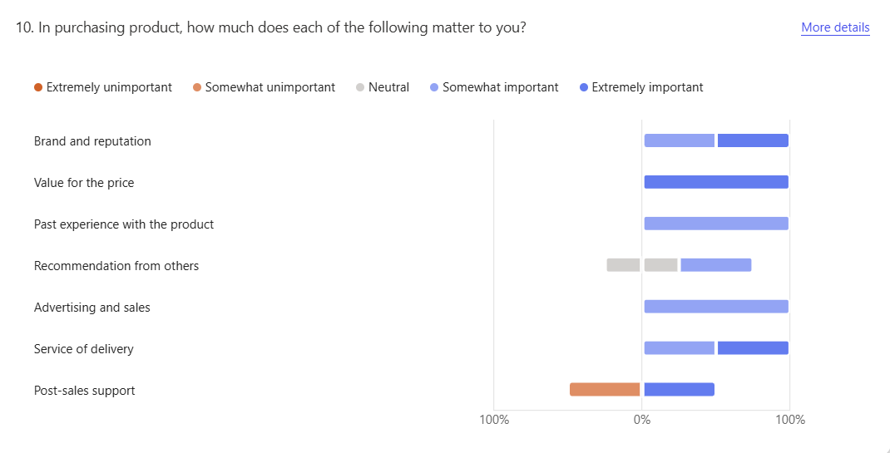
Figure 1: Microsoft Forms Questionnaire Results First Graph
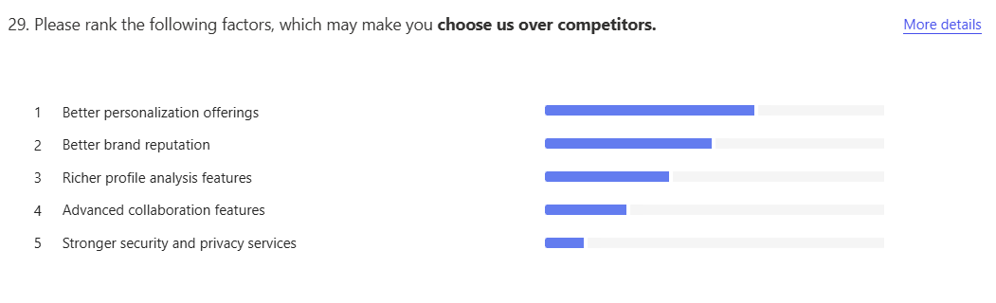
Figure 2: Microsoft Forms Questionnaire Results second Graph
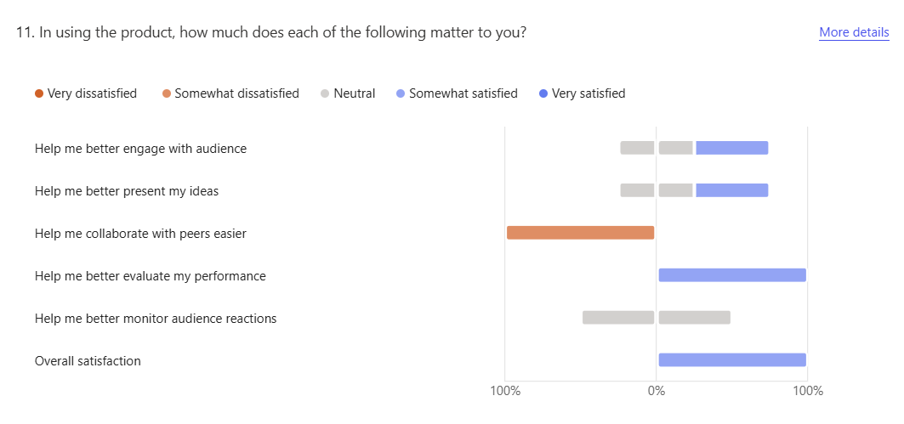
Figure 3: Microsoft Forms Questionnaire Results Third Graph
Business Strategy Adjustments
The questionnaire analysis was very useful regarding customer behaviour and preferences. It is deduced from the data that price and quality are the most important determinants in purchasing decisions and it implies that businesses should always strike a perfect balance between what is affordable and what is of high standards (Ganesan & Gopalsamy, 2022). Moreover, the monthly purchasing pattern revealed that retail should have retention strategies that include personalized marketing campaigns, membership discounts, and reward programs to entice repeat customers (Ghorbani, et al., 2021).

Task 2: Website and Marketing Materials
Introduction
Great marketing and a good presence on the web are very important for any business to succeed. The questionnaire conducted before gave us insights into how they behave, and what their preferences and expectations are (Blazheska, et al., 2020). Here, I used the information acquired to draft a two-page site on Weebly and created marketing materials in Canva to promote the business. In this document, we take a look at how questions found within the questionnaire were applied to the design and content of both elements (segmentation, content strategy, visual appeal, and SEO).
Segmentation: Identifying and Targeting Key Audience Groups
As per the questionnaire, customer purchases are driven by price and quality. These findings are thereby used to inform the website and marketing materials, which focus on affordability, but do not sacrifice quality (Ibrahim & Ganeshbabu, 2018). It features competitive models for pricing offers, limited offers, and value-for-money deals to persuade price-sensitive customers. It also provides reinforcement to the product quality with testimonials, certifications and detailed descriptions.
Website Design: Enhancing User Experience and Engagement
It was also aimed at being simple, functional and engaging. A compelling headline on the homepage introduces the business and clearly conveys the business's value (Kamal, 2016). So, both the customer testimonials and the brand’s mission, and core values section on the homepage are very prominently displayed.
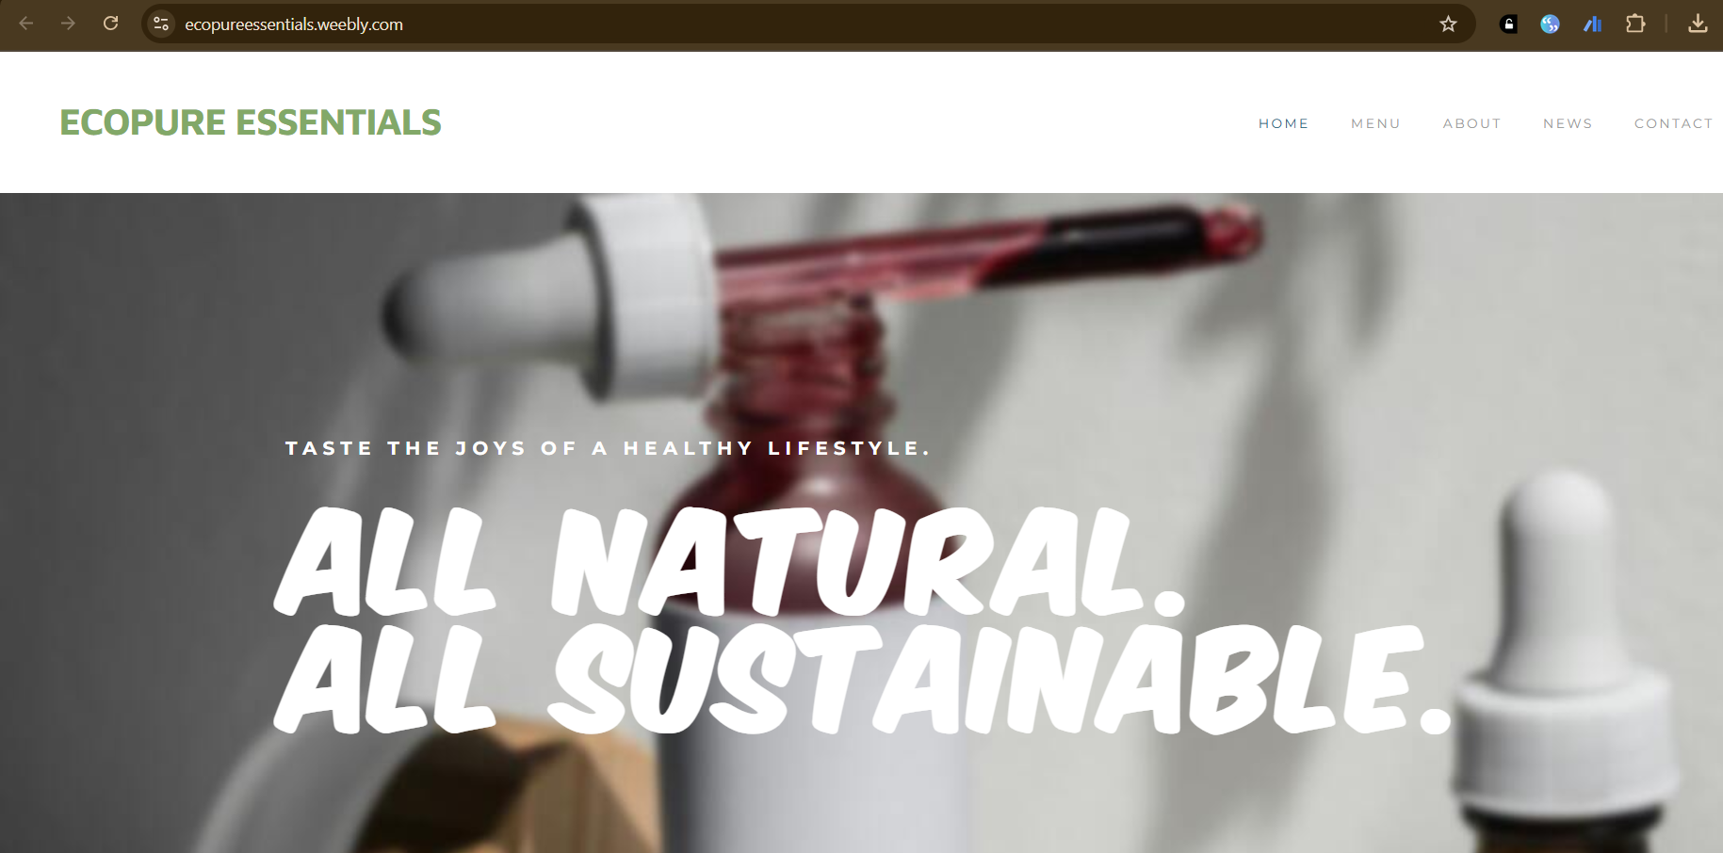
Figure 4: First page of The Website
This approach also provides a clean, modern, and very appealing look to the website, avoiding clutter (Kotane, et al., 2019). Based on consumer psychology, the colour scheme was chosen and has shades of trust, and reliability. The readability of the font is prioritised to make sure the people will be able to take the information (Madan & Rosca, 2022). The menu allows users to easily jump and explore from products to the brand and contact customer support because of the menu sections based on clear labels.
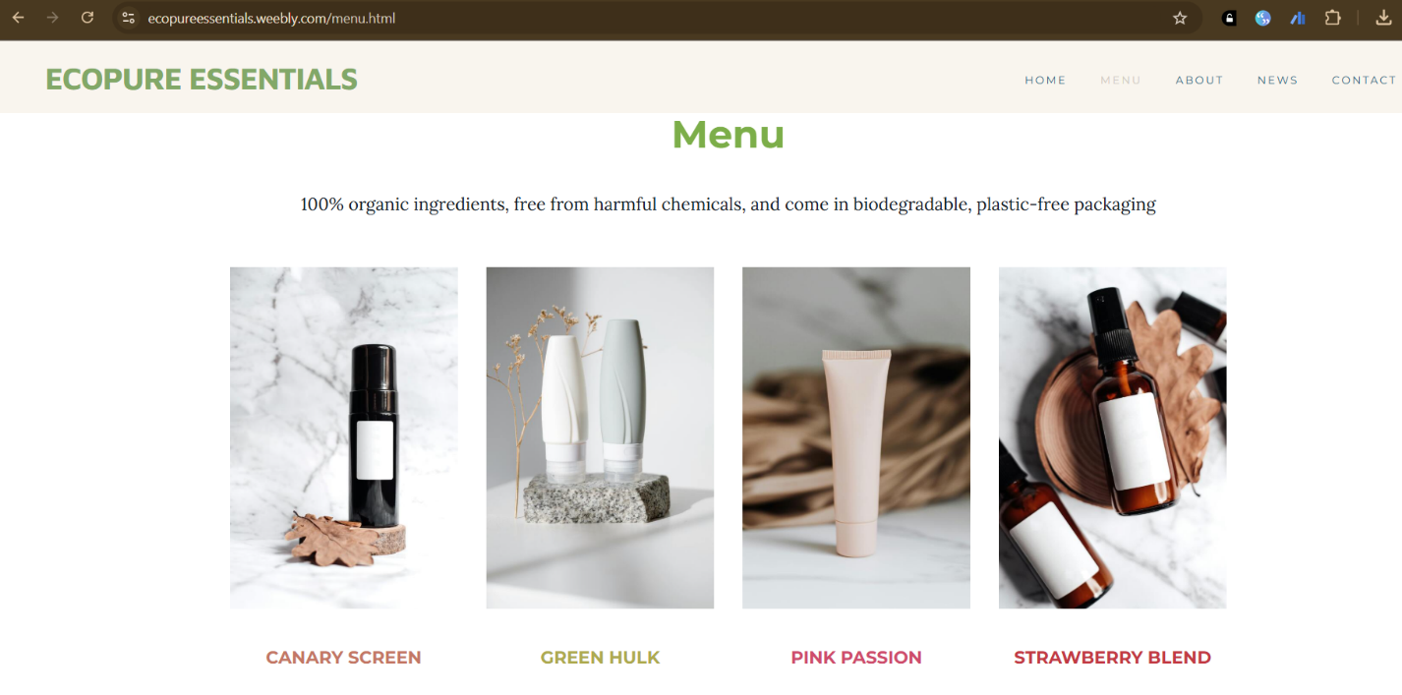
Figure 5: Second page of The Website
The second page explains detailed product descriptions and sharing information about how to buy from them is quite fast and easy (Malar, 2016). The website itself is streamlined with no more than 5 steps in the checkout process since convenience was identified as the key factor in consumer decision-making.
Marketing Materials: Capturing Attention and Driving Engagement
Canva is used to design marketing materials such as social media posts, brochures and digital advertisements. Based on the answers to the questionnaire, each piece was made to suit the audience.

Figure 6: Marketing Material made with Canva
Additionally, respondents want to buy goods online and therefore most of the marketing materials are dedicated to digital platforms like Instagram, Facebook, and Google Ads. It has visuals filled with high-quality images of products with nice prices and attractive call-to-action phrases to encourage instant engagement (Morzhyna, et al., 2019).

Figure 7: Marketing Material made using Canva
Among the key takeaways from the questionnaire was how brand reputation would lead the customer to purchase. The marketing materials with the customer testimonials, trust badges, and industry certifications will help to build credibility. The brand’s authenticity is reinforced through social proof added into digital ads by showing real customer experiences.
SEO Strategy: Maximizing Online Visibility
This gave meaningful organic traffic to the site, and an SEO strategy was developed towards the website. It emerged from the findings of the questionnaire that these customers use particular keywords while searching for products online. Using these keywords, they were strategically placed in the website’s content like; product descriptions, meta titles and blog articles (Blazheska, et al., 2020). More of the website is likely to appear in the search results of the search engines when the content on the website is aligned with the intent of the consumer.
Also, the website includes a page of informative blogs, since respondents stated that they were worried about trustiness and credibility. The blog consists of articles that address common customer queries, and give out expert advice and industry insights. In addition to building the business as a leader in their field, this content helps to increase website ranking on the basis of the search engines because it keeps the site fresh and valuable.
Incorporating Visual Appeal: Enhancing Brand Recognition
According to the questionnaire, customers are willing to praise visually appealing content. The website and the marketing materials are designed in such a way to reflect this preference by using high-quality imagery, professional design elements and a cohesive brand identity (Dadwal, 2019). Having the same colours, fonts, and logos on all your platforms, helps in brand recognition, this makes your brand stronger and it will leave a visual impression on the clients.
I crafted social media images with dynamic, simple messaging by using their creative design tools using Canvas design tools. The layout of each post is structured, to allow for the right key information to be conveyed (Ganesan & Gopalsamy, 2022). Moreover, the marketing materials also have infographics that simplify difficult information, making it more digestible for possible customers.
Additionally, video marketing is very important as it captures the attention of the audience. Video is created of short promotional videos that emphasise the unique selling point of the business based on customer feedback from the questionnaire. To leverage across all possible platforms these videos are integrated into the website, sent through social media and included in digital advertisements.
Conclusion: Leveraging Data-Driven Insights for Success
The questionnaire analysis allowed us to think of how we want the website to look and how the content should be expressed, hence it served as an invaluable source of inspiration in terms of design and in terms of the website and marketing materials. The business was able to develop a targeted approach which helps the given value of brand loyalty for the market by understanding customer preferences, purchasing behaviour and shopping habits (Ibrahim & Ganeshbabu, 2018).
This website was designed keeping the customer in mind his easy navigation, adding trustability elements and easy shopping itself. To appeal to the consumers’ expectations, marketing materials were created with compelling visuals, social proof, and engaging digital content (Chaffey & Ellis-Chadwick, 2019).
In the end, this data-driven approach can enable the business to capture, sympathise and keep the customer in. However, the business can keep improving its strategies by continuously analysing customer feedback and market trends.

Task 3: The Importance of Microsoft Excel in the Digital Era
Data Management and Organization
Excel is one of the most fundamental Excel advantages allowing it to keep and manage data well (Pinto & Pinto, 2020). Despite its structured grid layout that facilitates putting in, sorting and grouping large amounts of information, interfaces such as Fitbit have gained popularity. It is the conveniences of formulas and functions allowing automatic calculations and data manipulation that cut down human errors and improve accuracy significantly (Reedy & Parker, 2018). Excel is used in businesses to keep track of inventory, customer database, and list of sales and expenses.
Another powerhouse included in Excel is the pivot table, which helps ensure that users can take advantage of datasets that are large and reorganise and summarise them to uncover patterns and insights that might otherwise be too difficult to find (Sandhu, 2020). With the use of these functionalities, businesses can enhance efficiency and capture relevant data from them, helping them to record necessary as well as structured data for the smooth running of operations.
Financial Planning and Analysis
Finance, in particular, is known to need a tool such as Excel to budget, forecast and plan financially (Soltanifar, et al., 2021). Whether you are a small business or have a huge inventory, you utilise Excel to keep track of income, monitor expenses, and foresee your future money-making and spending ability. This allows financial analysis to be done without any human intervention and therefore it is accurate.
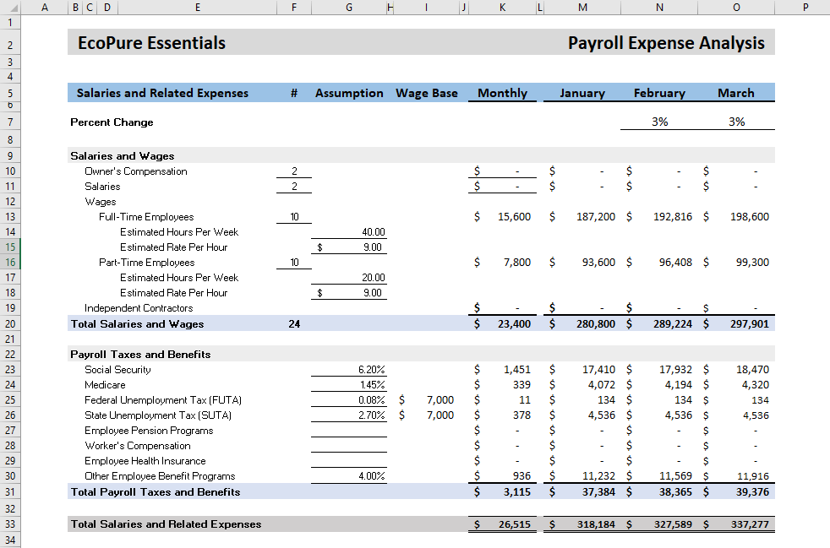
Figure 8: Financial Projections using MS Excel
Making financial projections is a definite plus for small businesses, and Excel is one of the best ways to do just that. Profit prediction over time can be set up by entrepreneurs using spreadsheets with column headers like months and input actual income and expenses to get a project of profitability (Bencsik, 2016). Basic formulas like sum and subtraction can be applied to total income, total expenses, net profit or loss. This enables the business owners to assess the sustainability of their operations and make strategic changes as per their sustainability.
Data Visualization and Reporting
Data visualisation statistics for complex datasets require the use of Excel’s charting functionality and graphing capabilities. Making raw numbers into bar charts, line charts, and pie charts, Excel helps the user identify trends and patterns at a glance. Most useful in business environments where managers want to make quick and presentable decisions based on reports and guide their strategy with concise and appealing visuals.
For example, businesses can set up bar charts to check monthly income versus monthly expense costs so that the managers can identify high-profit times and where they need to cut costs (Reedy & Parker, 2018). In the same way, the sales team can use Excel-generated graphs to monitor revenue growth and determine market demand for different products.
Automation and Productivity Enhancement
Excel automation capabilities have a big contribution to workplace productivity and efficiency. Being able to generate invoices, create reports and update financial statements is one of the reasons why businesses use Excel’s built-in macros and the VBA (Visual Basic for applications) programming language to automate simple repetitive tasks (Pinto & Pinto, 2020). Automation helps by handing the workers to do higher tasks rather than to do the dirty work.
Also, Excel’s collaboration tools, including sharing via Microsoft OneDrive OR Google Sheets integration allow multiple users to work on the same spreadsheet simultaneously. This contributes to the formation of teamwork and allows business processes to be executed in a manner that avoids thereof it cases delays due to version control. The ability to have better communication and coordination within the organisation increases only because of real-time updates and shared access.
Excel in Business Decision-Making
Today, the success of the business depends on the resort to data-driven decision-making. Excel is an analytical tool provided by Excel to businesses that help them make their decisions based on empirical evidence (Paulus & Nijstad, 2003). Businesses have a tool that goes through statistical analysis, scenario modelling and forecasting functions so they can predict future trends and create strategic plans to stay competitive.
For instance, to identify the correlation of one variable to the other, businesses resort to Excel’s regression analysis, in order to know the behaviour of the customers and market trends. Sensitivity analysis is used by financial analysts to determine how changes in variables like interest rates or production costs would affect the profitability of a company (Nabieva, 2021). Such insights give them the means to take preventative actions to keep risks at minimal levels or to exploit opportunities.
Excel’s Relevance in the Digital Era
Due to technological advancement, Excel is still an important aspect of the digital world. Being an integral part of modern operations, a person could not have another software tool that is as much flexible and compatible as QuickBooks (Malar, 2016). Now, Excel is being used in sophisticated data analytics and predictive modelling, as the AI and machine learning age has come along.
Furthermore, Excel has become more workable today in light of its cloud-based features as well as its compatibility with big data platforms (Madan & Rosca, 2022). Companies which use business intelligence tools such as Power BI connect Excel datasets to get more insights and become more capable of making better decisions. As an essential tool, Excel is not just about traditional spreadsheet functions but also takes part in digital transformation that a business needs to create to make it an existing one in a competitive market.

Task 4: Video Script
Instructions
Task 4 requires a simple script that expresses the brand's message. The script should be 3 minutes and highlight the brand's USPs. Business ideals like sustainability, product quality, and customer pleasure must be reflected in the script. The script should interest viewers and reveal the brand's values and goals. After scripting, shoot the video. The video presenter should identify themselves and briefly describe the brand. The video's tone should start here. The presenter must appear at the start of the video, but not throughout. The film should then show the product, its features, and customer reviews. To enhance audience trust and credibility, offer favourable reviews or real-life instances of how the product has helped.
Video storytelling should emphasise visual and emotional appeal. Narrative framework, emotional connection, and real-life testimonies will make the video memorable. Presenting the product as a solution to the audience's problems is crucial. To make viewers relate to the brand's mission and values, the video should leverage emotional appeal. Lastly, the video will be edited for clarity and flow. Adobe Premiere and other easy-to-use video editors can keep videos entertaining. Add background music, text overlays, or other visuals to improve the video. After editing, upload the video to YouTube. Then share the video URL in the e-portfolio.

Conclusion
As a result of this endeavour, a well-defined business plan for EcoPure Essentials has been written outlining research, forecasting of financials, strategic marketing and so forth. This questionnaire analysis also proved to be valuable in terms of understanding consumers’ behaviour and contributed to creating an appropriate brand presence online and promotional materials. Assessment of the project’s feasibility through the financial projections guaranteed sustainable growth. Moreover, the website, marketing materials and brand video created, have also done well in establishing a powerful and inspiring brand identity which is in line with environmentally conscious consumers.

References
Bala, M. & Verma, D., 2018. A critical review of digital marketing. International Journal of Management, IT and Engineering, Volume 8, p. 321–339.
Bencsik, A., 2016. Knowledge management initiatives and strategies in small and medium enterprises. s.l.:IGI Global.
Blazheska, D., Ristovska, N. & Gramatnikovski, S., 2020. The impact of digital trends on marketing. UTMS Journal of Economics, Volume 11, p. 48–58.
Burgess, J., Poell, T. & Marwick, A. E., 2017. The SAGE handbook of social media.
Byrd, L. S., 2021. Cultivating Entrepreneurial Changemakers Through Digital Media Education. s.l.:IGI Global.
Chaffey, D. & Ellis-Chadwick, F., 2019. Digital marketing. s.l.:Pearson uk.
Dadwal, S. S., 2019. Handbook of research on innovations in technology and marketing for the connected consumer. s.l.:IGI Global.
Ganesan, S. & Gopalsamy, S., 2022. Marketing 5.0: Digital marketing trends analysis. Digital business and E-commerce management, Volume 141.
Ghorbani, Z. et al., 2021. Trends and patterns in digital marketing research: bibliometric analysis. Journal of Marketing Analytics, p. 1–15.
Gupta, N., 2020. Digital marketing: Trends, opportunities, and challenges. Asian Journal of Management, Volume 11, p. 434–440.
Ibrahim, S. S. & Ganeshbabu, P., 2018. A study on the impact of social media marketing trends on digital marketing. Shanlax International Journal of Management, Volume 6, p. 120–125.
Kamal, Y., 2016. Study of trends in digital marketing and evolution of digital marketing strategies. International Journal of Engineering Science, Volume 6, p. 5300–5302.
Kotane, I., Znotina, D. & Hushko, S., 2019. Assessment of trends in the application of digital marketing. Scientific Journal of Polonia University, Volume 33, p. 28–35.
Madan, A. & Rosca, M. I., 2022. Current trends in digital marketing communication. Journal of Marketing Research and Case Studies, Volume 2022, p. 1–13.
Malar, P. J. M. A. J., 2016. Innovative digital marketing trends 2016. s.l., s.n., p. 4550–4556.
Morzhyna, A., Oliinichenko, M. & Postykina, Y., 2019. Modern trends in digital marketing.
Nabieva, N. M., 2021. DIGITAL MARKETING: CURRENT TRENDS IN DEVELOPMENT.. Theoretical & Applied Science, p. 333–340.
Paulus, P. B. & Nijstad, B. A., 2003. Group creativity: Innovation through collaboration. s.l.:Oxford University Press.
Pinto, F. M. & Guarda, T., 2020. Digital Marketing Strategies and Models for CompetitiveBusiness.. s.l.:IGI Global..
Pinto, F. M. & Pinto, C. C., 2020. Country Marketing Strategy: A Low-Cost Digital Marketing Proposal for Cabo Verde. In: Digital Marketing Strategies and Models for Competitive Business. s.l.:IGI Global, p. 131–159.
Reedy, K. & Parker, J., 2018. Digital literacy unpacked. s.l.:Facet.
Sandhu, K., 2020. Digital Transformation and Innovative Services for Business and Learning. s.l.:IGI Global.
Soltanifar, M., Hughes, M. & Göcke, L., 2021. Digital entrepreneurship: Impact on business and society. s.l.:Springer Nature.

