Elis Edwards
EDW22862836
HND Applied Computing
Computer Architecture and Operating Systems

Contents
1. Introduction 3
2.Key Functions of General Operating Systems 3
3. Use of Windows CLI Commands 5
4. Use of Linux OS CLI Commands 8
5. Use of Windows OS Scripts 10
6. Use of Linux OS Scripts 13
7. Conclusion 17
8. References 17

1. Introduction
This report explores key topics related to general purpose Operating Systems, including the roles and functionalities of common OS platforms such as Windows and Linux, through research, command line and scripting this report will document the use of command line interface tools and scripting languages in managing systems. The final section of this report will also showcase my engagement with certified learning content provided by Cisco Networking Academy.

2.Key Functions of General Operating Systems
Operating Systems (OS) are essential software designed to manage hardware and software resources on all devices. Microsoft Windows, macOS and Linux are all examples of platforms that provide application execution, user interaction and resource coordination.
To go further into detail here are some of the primary functions that an OS deals with and includes:
Process Management – The OS handles the creation, scheduling and termination of all of its processing. It ensures that the CPU usage is efficient and allows for process communication and also synchronisation. For instance, in Linux the kernel uses a scheduler to decide which process it runs next and in Windows task manager allows the user to monitor and end processes. Having efficient process management is essential for multi-tasking and optimal resource allocation.
File System Management – Similar to process management the OS deals with data storage, access permissions and directory structures. This also includes file operations such as the creation of files, reading of files, writing and also the deletion of files. Tools like chmod on Linux and Windows explorer help manage files.
Memory Management – The OS controls and coordinates the use of RAM throughout the various applications being carried out, this means it manages the allocation and deallocation as needed. Techniques such as paging and segmentation are commonly used as stated by William Stallings in Chapter 7 of Operating Systems: Internals and Design Principles, 9e.
Device Management – Through device drivers the OS will manage its input and output devices such as the keyboard and mouse and enables its communication between hardware and software applications. Windows device manager or commands such as lspci on linux can provide visibility into device status.
User Interface – General Purpose OSs will come with a Graphical User Interface also known as a GUI and Command Line interface as previously mentioned. This is done for user interaction with windows offering a GUI through file explorer and a CLI through PowerShell, whilst Linux provide a range of support.
Security and Access Control – OS security includes features like firewalls, encryption, antivirus and access controls to ensure safety of the system and of its users data. In Linux security frameworks such as AppArmor and SELinux enforce access control policies that restrict access controls of programs and system resources. Windows on the other hand uses tools such as windows defender for real time malware protection and BitLocker for disk encryption. Additionally windows also offer group policy settings to enforce policies across networks, this would usually be used within most businesses to ensure each group has access to only what they need to ensure their work is complete.
Networking support – OSs manage network interfaces and protocols. Commands like ipconfig in Windows and Linux help discover and resolve networking issues. As well as this tools such as tracert and traceroute assist in identifying network path issues. There are also tools for diagnostics, firewalls and service management which play key roles in ensuring secure networking environments.
Comparing the core features of Windows, Linux and MacOS
Each system shows strengths and weaknesses depending on the context in which it is used I shall list below all the best environments and uses for each OS.
Windows
Windows is the most widely used OS for personal computers. It offers compatibility with hardware and software making it the most dominant OS for desktop environments. As well as this Windows provides great support for third party applications making it so useful for at home use, gaming, and productivity. The GUI is very user friendly and easy to use and compatibility advantages for home users and businesses make this OS a must in the market for general use.
Linux
Linux is preferred in server environments and for professional development. It offers plenty of customisation, and being open source, it provides for great flexibility for developers and administrators. There are several desktop environments to chose from making it versatile for different use cases. Linux is also known to be less vulnerable to malware, which makes it more attractive for security conscious environments. The CLI in Linux allows for efficient management making it a preferred choice for server management and development tasks.
MacOS
Mac is developed by Apple and is known for its seamless integration with all of Apple’s Hardware and software. It is mostly used in creative fields such as graphic design, video editing and music production due to its powerful software suite. This OS offers a hybrid experience combing the easy-to-use GUI and powerful CLI tools for more advanced users. It is considered to be a very stable OS with good security features whilst being a closed ecosystem it still provides a good user experience that many prefer for their choice of work.
Each Operating system has a different system design with there being something for everyone especially in different work environments, overall I feel Windows being more GUI driven and ease of use allows for it to be the perfect OS for day to day use whilst Linux and Mac have great use for more specific tasks and environments with more efficiency and control and the CLI tools available.

3. Use of Windows CLI Commands
The windows Command Line Interface includes tools like command prompt and powershell, each are essential for a range of tasks here are examples of some with a description of their use.
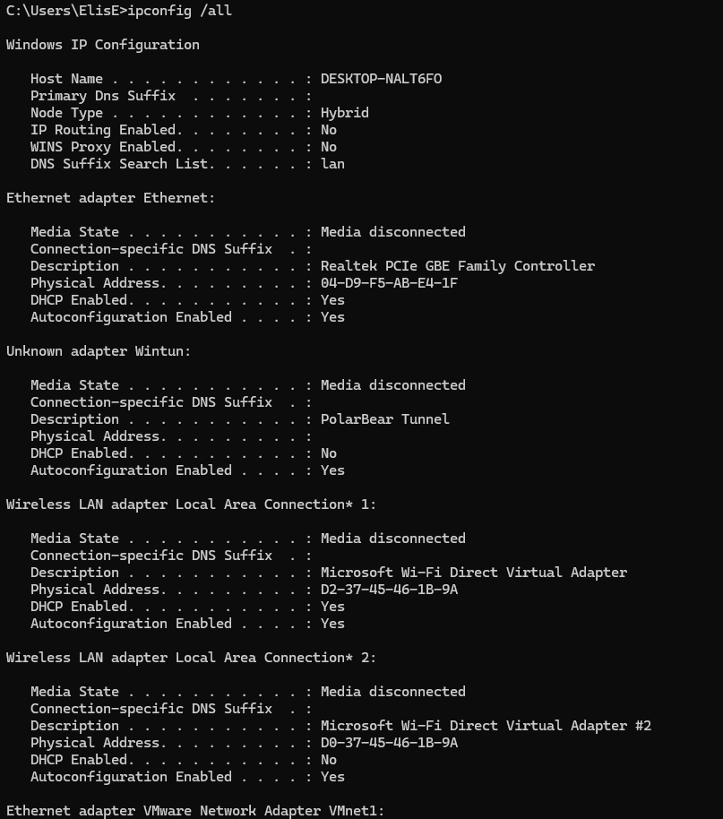
ipconfig /all – This displays all network adapter details including IP, DNS and Mac addresses

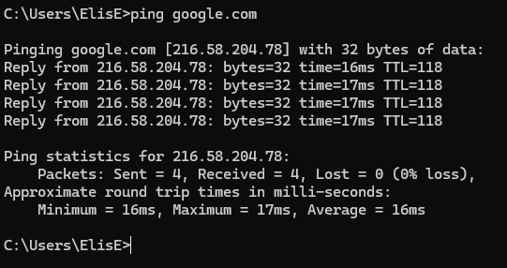
Ping google.com - Pinging a website tests connectivity and latency in this example above I used Google’s server as an example
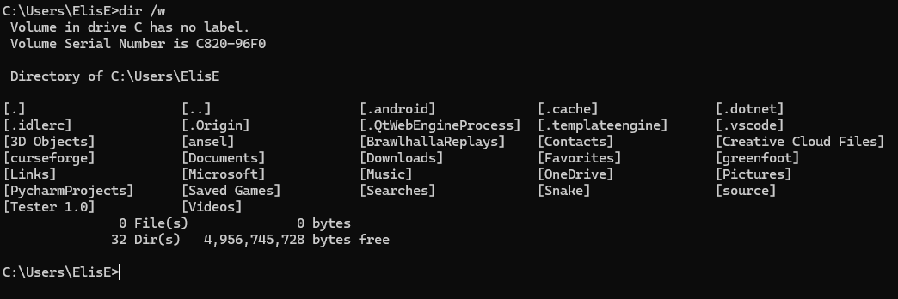
dir /w – Lists directory contents in a wide format, this is useful for a quick overview of multiple files without additional details.
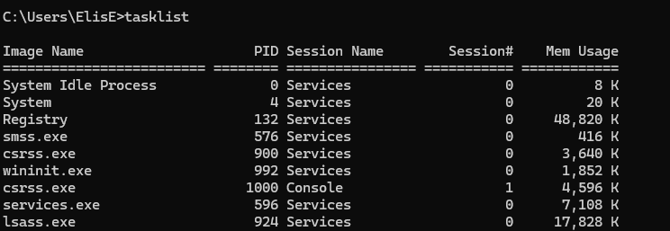
tasklist – this command lists all running processes along with how much memory they are using.
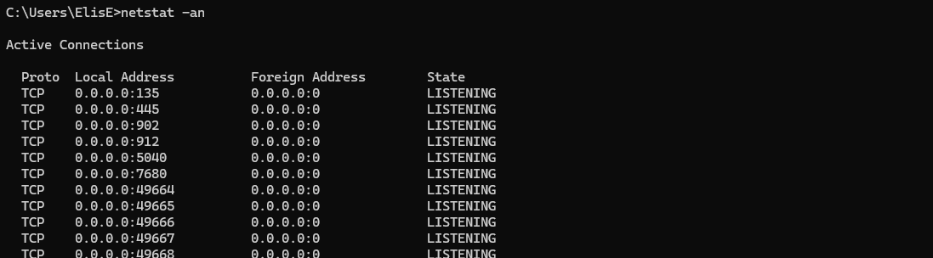
netstat –an – this shows active network connections and ports on which the computer is listening, this can identify open ports and unauthorised access.
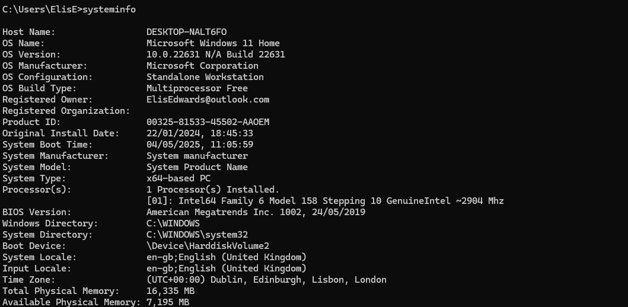
systeminfo – This will show a complete summary of the system configuration which includes OS version, hardware specs and installed hotfixes.
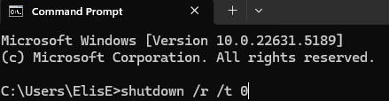
shutdown /r /t 0 – this command forces an immediate restart of the system, mostly used in remote management tasks and scripts.
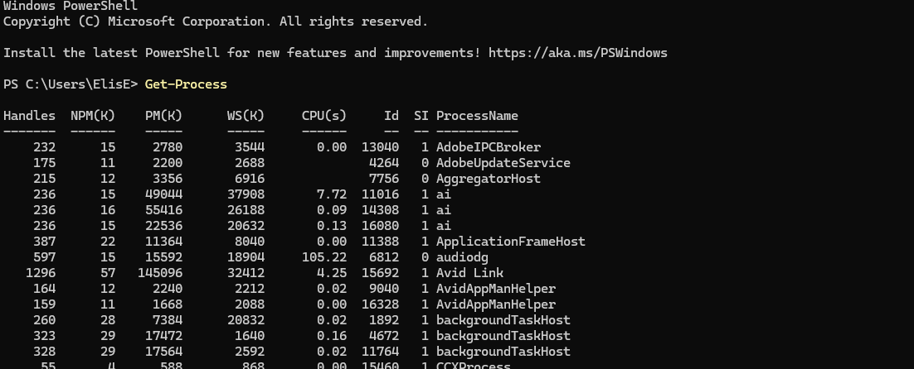
Get-process – In PowerShell this lists all currently running processes with their IDs and CPU usage, this provides much more detail than the tasklist command.
These command line tools are fundamental for system administration. They support diagnostics, system configuration and helping admins maintain secure and stable windows environments on the server.

4. Use of Linux OS CLI Commands
Linux relies heavily on command line tools for everyday administration. Below are some commonly used commands with screenshots.
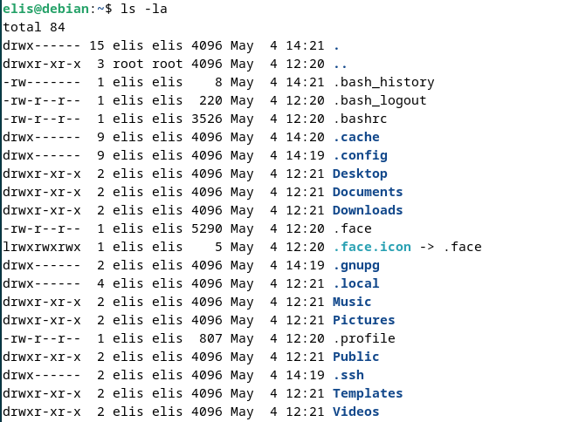
ls -la – this lists all files including hidden ones in a long format.
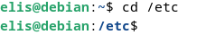
cd /etc – this changes the directory to /etc.
cp file1.txt /home/user/ – Copies file to user’s home directory.
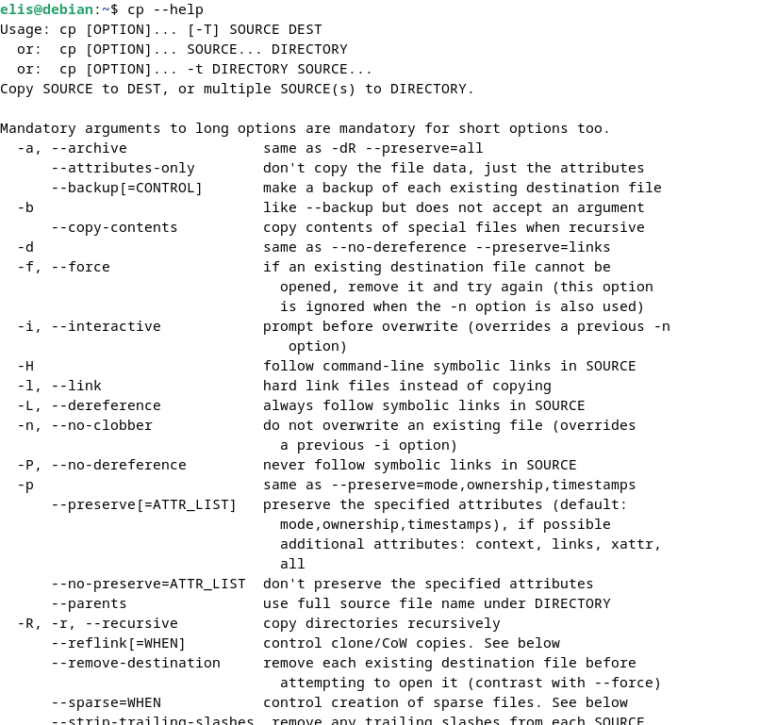
cp –help – list of all commands to help the user.
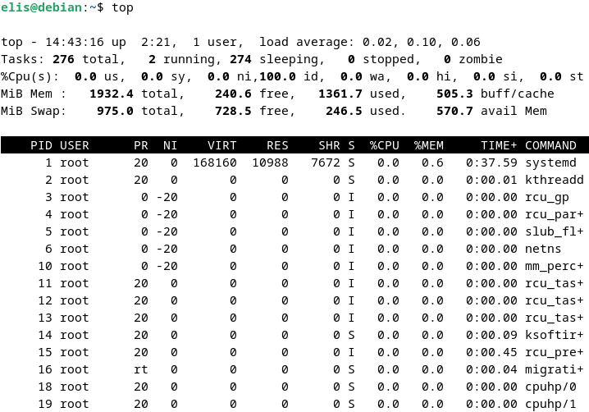
top – Live monitoring of all the systems processes.
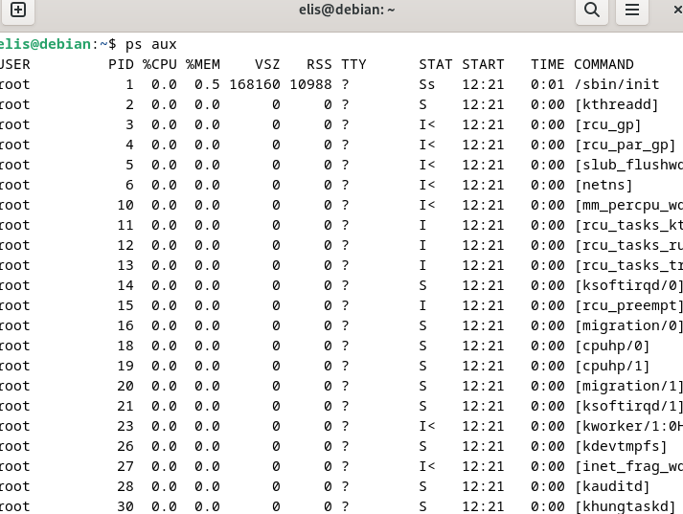
ps aux – Detailed list of all running processes.
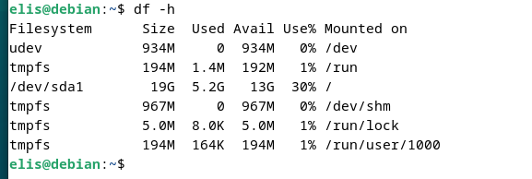
df – h – Shows disk space usage in a readable format.

5. Use of Windows OS Scripts
Windows Powershell scripting enables automation of complex administrative tasks here are 10 examples and what task they do:
1. List Installed Programs
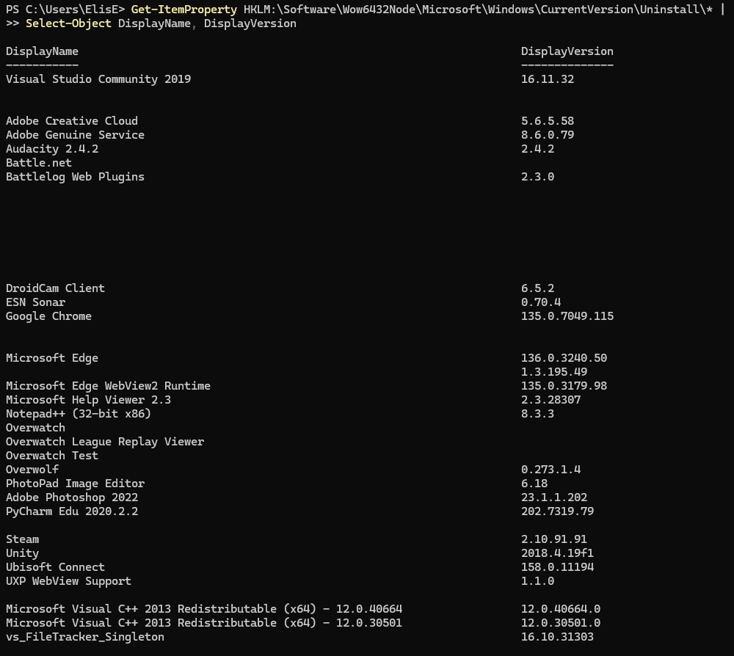
This script lists all installed programs and their versions from the windows registry.
2. Check for Windows Updates
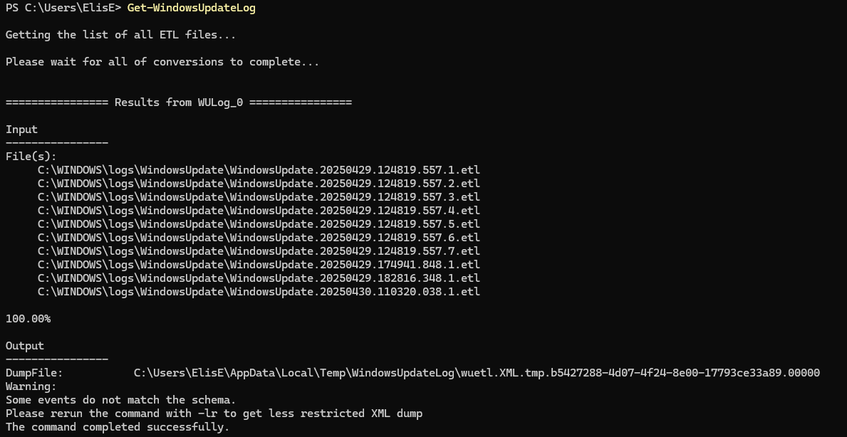
Generates a windows update log file that can be analysed for update activity or errors.
3. Monitor CPU Usage
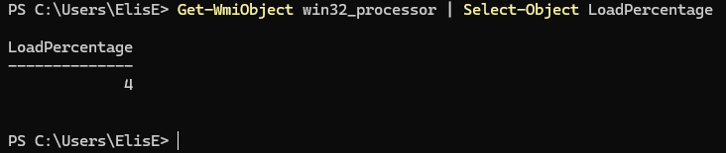
Returns the CPU usage load as a percentage.
4. Find Large Files
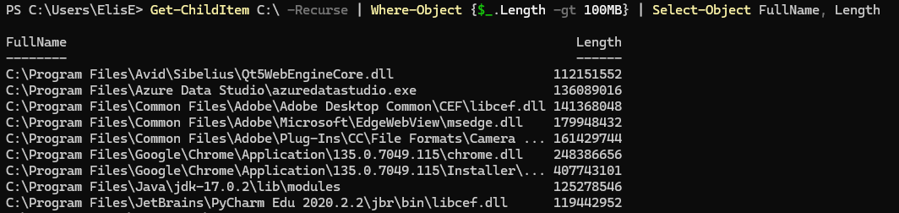
Scans the C drive for files larger than 100mb and displays their paths and sizes.
5. Backup Files
Copies all contents of one directory to another, this is useful for data backups.
6. Start a Process
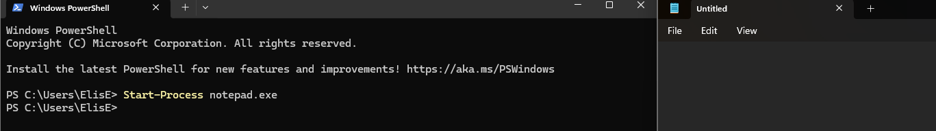
Launches notepad or any other application specified.
7. Check Running Services
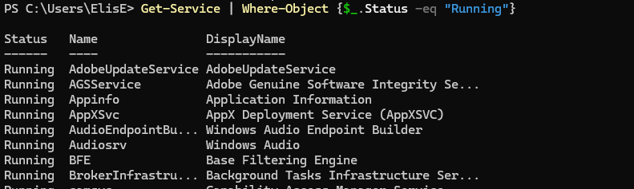
Lists all currently running services on the system.
8. Export System Info
This will export system information into a text file called report on the c drive.
9. Network adapter configuration
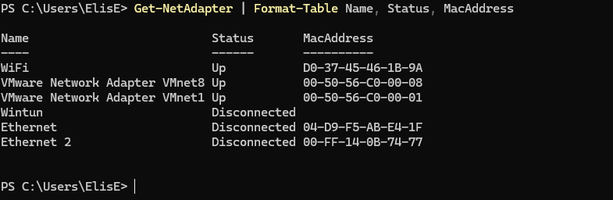
Displays all network adapter names, status and mac addresses in a table format.

6. Use of Linux OS Scripts
Bash scripts offer automation capabilities for Linux environments, here are some examples:
1. Check Uptime
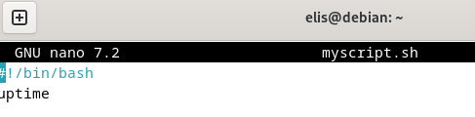
This shows how long your computer has been on without restarting and how many users are logged in.
2. Show Disk Usage
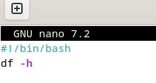
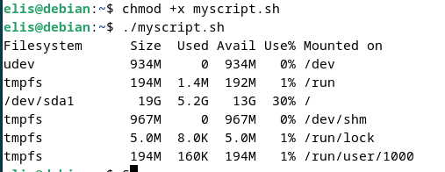

Displays how much storage space has been used and free on each disk, -h means human readable to help the user understand
3. Show memory usage
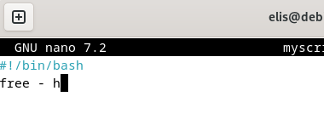
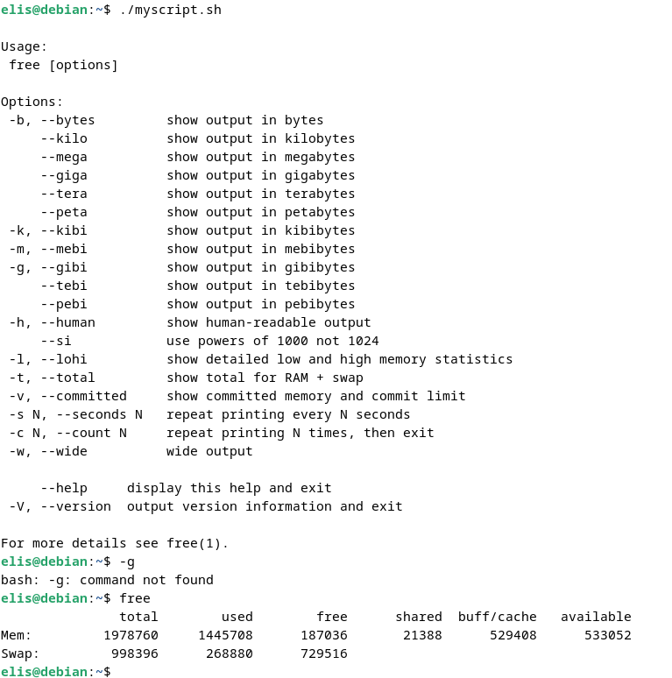
This shows how much ram is being used with options on size of output.
4. Show logged in users
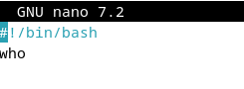
Lists all users currently logged in and from where.
5. Backup Home folder
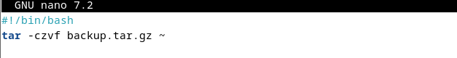
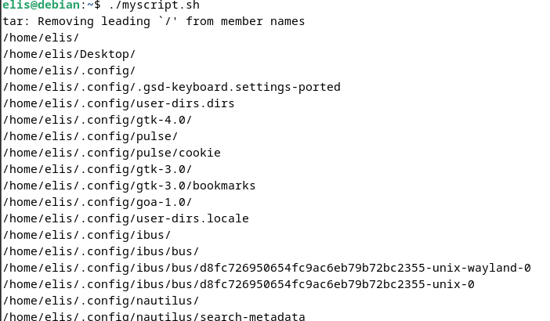
This creates a compressed back up file of your home directory this includes your files and settings.
6. Check internet connection

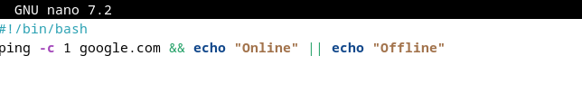
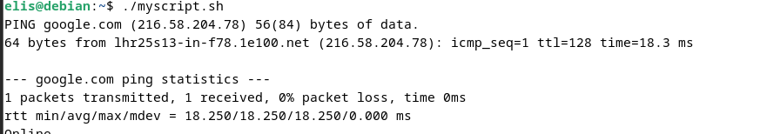
Sends one signal to google if it gets a reply, it prints online if not It prints offline.
7. Top 5 memory using processes
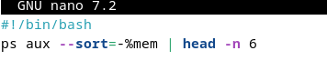
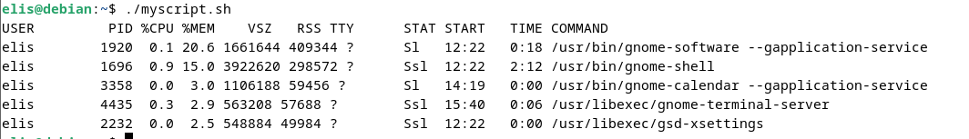
This command lists running programs sorted by how much memory they use.
8. Empty Trash
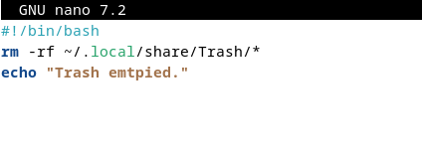
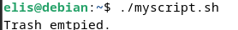
Deletes everything in your trash and shows a confirmation message.
9. 30 second countdown
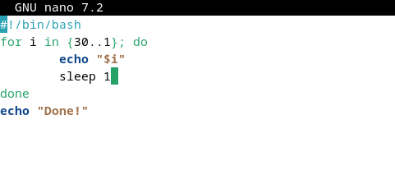
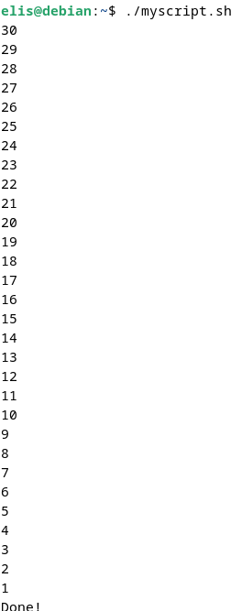
Counts down from 30 to 1 waiting 1 second each time then prints done!

7. Conclusion
This report has examined the fundamental roles and practical implementation of general purpose operating system focusing on Windows and Linux environments. Key OS functions such as memory management process control and device handling are vital for system performance. Through hands on research and exploration of both windows and Linux CLI commands, I demonstrated how these tools can be used for system configuration diagnostics and file management. Finally by engaging with a certified online course from Cisco Networking Academy I was able to enhance my understanding and knowledge on the subject. This report reflects continuous learning which is essential for IT professionals working with diverse operating systems.

8. References
William Stallings, 2017, Operating Systems: Internals and Design Principles, Available at: https://www.youseficlass.ir/wp-content/uploads/2023/07/William_Stallings_Operating_Systems_Internals_and_Design_Principles_watermark.pdf (Accessed on 03/05/2025)
Mark Russinovich + David Solomon + Alex Ionescu, 2017, Windows Internals, Available at: https://repo.zenk-security.com/Linux%20et%20systemes%20d.exploitations/Windows%20Internals%20Part%201_6th%20Edition.pdf (Accessed 03/05/2025)
Ubunutu, Year Unknown, The Linux command line for beginners, Available at: https://ubuntu.com/tutorials/command-line-for-beginners#1-overview (Accessed on 03/05/2025)

