
Name of Student: Ohikhuare Irogho
Student ID: 2128365
Name of Lecturer: Dr Oluwadamilola Tayo
Course Title: Quality Assurance and Service Improvements
Module Code: LCHS7006_LON
Assessment Topic: Root Causes and Policy Issues Affecting Healthcare Quality
Case Study: Shrewsbury and Telford Hospital NHS Trust Maternity Scandal

1.0 Introduction
The quality of healthcare is an essential part of the successful health and social care system, which supports patient safety, clinical effectiveness, and person-centred care (Donabedian, 2005; WHO, 2021). Failures in healthcare delivery can result in serious patient injury and, in most cases, may be symptoms of systemic failures in governance, workforce capacity, and organisational culture as opposed to individual errors (Van Cott, 2018; Higham and Vincent, 2020). The Shrewsbury and Telford Hospital NHS Trust maternity scandal is one of the largest patient safety failures in the United Kingdom, which underlines the ongoing gaps in the quality management and services enhancement (Ockenden, 2022).
The Ockenden Review (2022), which was conducted independently, reviewed more than 1,400 cases of maternity care occurring between 2000 and 2019 and found common cases of preventable maternal and infant injury. Among the main problems were failures in fetal monitoring, a delay in the escalation of clinical issues, and insufficient staff training, which led to poor clinical outcomes (Ockenden, 2022). The lack of organisational learning about past events and inefficient clinical governance systems further contributed to these failures, showing systemic breakdowns in quality assurance processes (Martin-Delgado et al., 2020). Moreover, the organisational culture with fear of blame and ineffective communication deterred the staff from voicing their concerns, which further undermined patient safety (Higham and Vincent, 2020).
The importance of the given case is supported by the national and international policy frameworks aimed at enhancing the quality of healthcare and its safety. According to the NHS Patient Safety Strategy, an active safety culture, the ongoing learning process, and system-wide enhancement are necessary (Department of Health and Social Care, 2019). Correspondingly, the need to enhance healthcare systems to minimise preventable harm is emphasised by the World Health Organisation (WHO) in its Global Patient Safety Action Plan (2021). Nevertheless, the continuation of the failures of the Shrewsbury and Telford scenario suggests that the policy formulation and its practical application have a disconnect, which creates a crucial issue of accountability and regulatory controls (Ockenden, 2022). This highlights a gap between national policy expectations and frontline practice, suggesting that policy alone is insufficient without effective enforcement mechanisms.
The purpose of this report is to critically examine the underlying causes of quality failures at the Shrewsbury and Telford Hospital NHS Trust using the recognised theoretical models, the Donabedian Model (Donabedian, 2005), the Fishbone Diagram (Ranhotra, 2022), and the 5 Whys method (NHS Improvement, 2018). It will also assess critically how policy and organisational factors contribute to service delivery and examine the broader impact on healthcare quality, efficiency and equity. Lastly, the report will make evidence-based recommendations based on quality improvement methodologies, including PDSA, Lean, and Six Sigma, to facilitate sustainable service improvement and avoid similar failures from happening again (Carayon et al., 2020).
2.0 Conceptualising Healthcare Quality and Theoretical Frameworks.
A multidimensional concept, healthcare quality includes safety, effectiveness, patient-centeredness, timeliness, efficiency, and equity (WHO, 2021; Institute of Medicine, 2001). High-quality care involves having strong systems that combine structural capacity, good processes, and good patient outcomes. One of the most prominent models that has been used to assess the quality of healthcare is the Donabedian Model, which divides healthcare quality into structure, process and outcome (Donabedian, 2005). However, this approach is limited because it presents healthcare quality as a linear relationship and does not fully capture the complexity of healthcare systems.
In the case of the Shrewsbury and Telford Hospital NHS Trust, the structural deficiencies were manifested in the following way: the deficit in the level of staffing, the lack of training in cardiotocography (CTG) interpretation, and the lack of organisational resources (Ockenden, 2022). All these structural flaws had a severe effect on care processes, which included ineffective fetal monitoring, slow escalation of complications, and poor clinical decision-making (Ockenden, 2022; NHS Improvement, 2018). As a result, negative results were noted, such as preventable maternal and neonatal mortality, which demonstrates a direct connection between structural deficiencies and patient injuries (Ockenden, 2022). This indicates a direct relationship between structural deficiencies and patient harm, reinforcing the importance of system-level interventions.

(Shropshire Live, 2025)
2.1 The Donabedian Model
Although the Donabedian Model provides a structured framework for classifying healthcare quality issues, however, it adopts a linear perspective, which limits its ability to capture the complexity of healthcare systems (Creighton, 2023; McCullough et al., 2023; Endeshaw, 2021). Human factors, organisational culture, and system dynamics are not well considered in the model, but they are important determinants of patient safety (Higham and Vincent, 2020). Hence, this model might not provide the overall picture of systemic failures and therefore requires the incorporation of other theoretical perspectives. However, applying the Donabedian model to the Shrewsbury and Telford hospital NHS Trust maternity scandal several issues occurred, such as structural issues, process issues and outcome issues. Structural issues involve Staffing levels and training, Leadership and governance failures, Inadequate facilities and resources and organizational culture, the process issues in Shrewsbury and Telford hospital NHS Trust scandals were Inadequate clinical practice and protocols, failure to escalate and address concerns, lacks of collaboration between doctors, nurses midwives and other specialists, poor documentation and communication and failure learn from past incidents. Moreover, the outcome observed in Shrewsbury and Telford hospital NHS Trust scandals are patient harm and mortality, long-term psychological and emotional consequences for patients and families, damage to patient trust and reputations, and legal and financial consequences. Finally, it has been revealed how failures at each level contributed to the whole crises at Shrewsbury and Telford hospital NHS Trust maternity scandal. Addressing these issues in a holistic manner is important for preventing similar incidents in the nearest future.
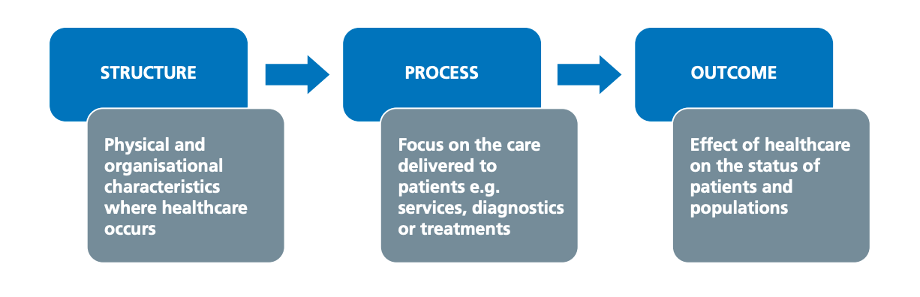
(Creighton, 2023)
2.2 The Swiss Cheese Model
The Swiss Cheese Model provides a systems-based explanation of failure. In contrast to the Donabedian Model, it highlights how multiple layers of defence can fail simultaneously. In the case of Shrewsbury and Telford, all these safety barriers, such as clinical guidelines, staff training, supervision, and incident reporting systems, collaborated to permit the adverse events to take place (Ockenden, 2022; Carayon et al., 2020). Such a model supports the idea that the failures in healthcare can hardly be connected with individual negligence but are caused by the systemic vulnerabilities rooted in the organisational structures (Van Cott, 2018; Satriyanto et al., 2024).
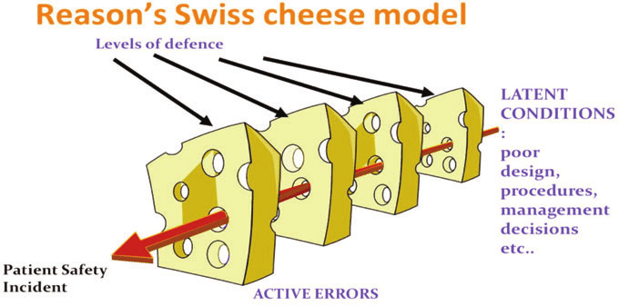
(Carthey, 2022)
However, the Swiss Cheese Model is limited because it presupposes comparatively stagnant layers of defence and fails to reflect the dynamic and adaptive nature of healthcare systems, where interactions between people and technology and organisational aspects are in constant flux (Carayon et al., 2020; Hollnagel, 2018). Thus, the model can be used to conceptualise the error pathways, but it needs to be implemented in conjunction with more dynamic models to gain a complete understanding of the complex healthcare setting. In contrast to the Donabedian Model, this framework provides a more dynamic explanation of how multiple system failures interact.

2.3 Root Cause Analysis of Quality Failures
Root Cause Analysis (RCA) is a core element of quality improvement in healthcare, which seeks to define the root of adverse events and avoid them (Hibbert et al., 2018). RCA in the Shrewsbury and Telford case demonstrated a variety of systemic failures, such as workforce shortage, insufficient staff training, leadership failures, and inefficient incident reporting systems (Ockenden, 2022; Martin-Delgado et al., 2020). These results demonstrate that patient safety events are multifaceted and that a systems approach to analysis should be used.
Fishbone Diagram (Ranhotra, 2022) is a systematic approach to classifying such root causes into major areas of concern like people, processes, environment, equipment, and policy. Issues related to the workforce were especially salient, as the workforce was understaffed and poorly trained in making clinical decisions (Ockenden, 2022; Royal College of Midwives, 2020). Delays in the process of identifying and reporting complications were also process-related failures, which showed the weaknesses of clinical protocols and communication systems (NHS Improvement, 2018). These problems were further intensified by environmental pressures, including workload and resource deficiencies, and the lack of effectiveness of clinical interventions was caused by deficiencies in equipment and monitoring systems (Ockenden, 2022).
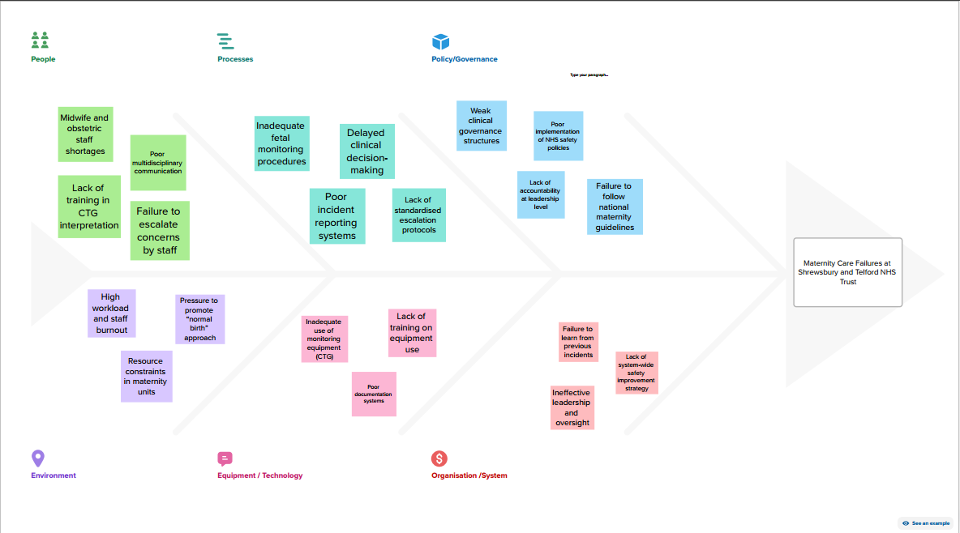
Fishbone Analysis of Maternity Failures (Ranhotra, 2022)
Organisational culture became a key aspect that contributed to these failures. The culture of fear of blame and a top-down decision-making process suppressed the desire of the staff to raise issues and to question unsafe practices (Higham and Vincent, 2020; Francis, 2013). This is consistent with the general evidence that psychological safety is critical to successful incident reporting and organisational learning (Edmondson, 2018). These problems were also perpetuated by policy-related factors, such as a lack of regulatory control and effectiveness in applying national safety strategies (Department of Health and Social Care, 2019; Ockenden, 2022).
The use of the 5 Whys technique gives additional information on the root causes of these failures. As an example, the delays in escalation happened due to the failure of staff to intervene at the right moment; this was caused by a lack of confidence and training, which were caused by the lack of organisational support and discouraging culture (Ockenden, 2022; Higham and Vincent, 2020). This cyclical process suggests that root causes can be highly entrenched in organisational systems and cannot be resolved by superficial interventions alone.
Regardless of its popularity, RCA has been accused of its inability to bring about sustainable improvement since organisations frequently do not introduce changes suggested by the tool or track their consequences (Martin-Delgado et al., 2020; Domer et al., 2021). As seen in the Shrewsbury and Telford case, the repeated attacks witnessed even after investigations had been carried out before show that the organisational learning failed, and more vigorous implementation strategies are necessary.
3.0 Policy and System-Level Influences on Service Quality
Policy frameworks help to define standards, guidelines, and accountability mechanisms, which are crucial in shaping healthcare quality (WHO, 2021). The NHS Patient Safety Strategy (Department of Health and Social Care, 2019) in the UK targets patient safety by means of building a culture of learning, improved reporting and system-wide enhancement measures. In a similar manner, the Ockenden Report (2022) also offers certain recommendations on how the maternity services can be enhanced, such as enhancing governance, training, and workforce capacity.
Nevertheless, the case of Shrewsbury and Telford reveals a huge disconnect between the formulation and execution of policies. Although well-established policy frameworks were in place, flaws continued to occur over a long period, which implies the inefficiency of the enforcement, monitoring, and organisational responsibility (Ockenden, 2022; Leape, 2021). Regulatory bodies like the Care Quality Commission (CQC) are important in guaranteeing adherence to quality standards, but the fact that this case was not intervened in a timely manner suggests a lack of effectiveness and control in regulation (Higham and Vincent, 2020).
The Global Patient Safety Action Plan (2021) by the WHO highlights the need to reinforce health care systems to minimise preventable harm on an international level. Though these structures are useful guidelines, however, their implementation and organisational commitment are based on the local contexts, which were evidently deficient in this instance (WHO, 2021; Domer et al., 2021). This underscores the necessity to have better alignment between policy and practice, and better accountability and performance monitoring mechanisms.
Moreover, healthcare reforms that focus on enhancing the level of efficiency and cost reduction can also unwillingly lead to quality failures unless well-coordinated. The example is that the NHS has already been associated with staffing shortages and resource pressures, which have led to workload pressures and diminished safe care delivery capacity (NHS Resolution, 2020; Royal College of Midwives, 2020). This highlights the need to look at the larger policy landscape when examining issues of healthcare quality.
4.0 Strategic Analysis Using SWOT
SWOT analysis is a strategic tool of assessment of internal and external forces that affect the organisational performance (Gürel and Tat, 2017). The national clinical guidelines, the availability of a qualified workforce, and policy frameworks designed to enhance patient safety were internal strengths of the case of Shrewsbury and Telford (Department of Health and Social Care, 2019). These strengths have given a background of providing high-quality care but were not properly exploited because of system weaknesses.
Staffing issues, lack of training, deficient leadership, and dysfunctional governance structures were some of the main weaknesses that led to the continuous occurrence of quality failures (Ockenden, 2022; Francis, 2013). The absence of organisational learning and the inability to implement the recommendations of the past studies worsened these weaknesses (Martin-Delgado et al., 2020).
The areas of improvement may be the implementation of digital health technologies, the development of better training programmes, and the introduction of national policy recommendations to make the situation with patient safety better (WHO, 2021; Carayon et al., 2020). Moreover, patient safety is now given more attention both nationally and internationally, and this is an opportunity to align healthcare organisations' practices with best evidence.
These opportunities, however, are offset by external threats such as financial constraints, growing demand for maternity services and workforce burnout that may limit the ability to change (NHS Resolution, 2020; Royal College of Midwives, 2020). These dangers emphasise the value of planning and resource distribution towards attaining sustainable progress in healthcare quality.
Although SWOT analysis is helpful in determining the major factors that affect the performance of an organisation, however, it is criticised as a descriptive tool that is not analytical enough (Gürel and Tat, 2017). Thus, it must be utilised together with other analytical tools to offer a more detailed insight into organisational issues.
5.0 Impact on Healthcare Quality, Efficiency, and Equity
The shortcomings of the case of Shrewsbury and Telford had far-reaching consequences in various areas of healthcare quality. Regarding safety, the failure to give timely and proper care led to preventable maternal and neonatal injuries, which constituted a serious violation of patient safety (Ockenden, 2022). The inability to follow evidence-based clinical guidelines and neglect of patient-centred care (poor communication and patient involvement in the decision-making process) undermined effectiveness and eroded patient-centred care (WHO, 2021; Institute of Medicine, 2001).
Efficiency-wise, such failures led to significant financial losses, such as litigation and compensation settlements, and the diversion of resources to frontline services (NHS Resolution, 2020). Also, employee burnout and elevated turnover rates decreased organisational performance and ability to provide high-quality care even further (Higham and Vincent, 2020; Royal College of Midwives, 2020).
It has a great impact on equity, too, since disparity in the quality of maternity care may result in uneven access to safe care, especially in vulnerable populations (WHO, 2021). There is evidence that healthcare disparities are frequently compounded by systemic failures, which means that specific actions need to be taken to provide equal access to high-quality care (Marmot et al., 2020).
6.0 Recommendations
The case of the Shrewsbury and Telford Hospital NHS Trust has shown that organisational culture, ineffective governance of the institution, workforce constraints, and inefficiency in the implementation of safety policies were all systemic failures leading to maternity care failures (Ockenden, 2022). To solve these problems, a concerted evidence-based intervention is needed with well-established quality improvement methodologies to be used to guarantee long-term improvement of services.
One of the main suggestions is the enhancement of workforce capacity and clinical training. According to the Ockenden Review (2022), insufficient training in cardiotocography (CTG) interpretation and a shortage of staff were listed as the main factors for poor clinical outcomes. To enhance clinical competence and patient safety, it is critical to increase the number of midwives to patients and use mandatory and standardised training programmes (Royal College of Midwives, 2020). This is in line with the structural aspect of the Donabedian Model that insists on adequate resources and staffing in the provision of high-quality care (Donabedian, 2005). Nonetheless, it is not enough to increase the level of staffing; but professional development and competency evaluation should become an integral aspect of organisational practice to guarantee a long-term improvement (Carayon et al., 2020).
The Plan-Do-Study-Act (PDSA) cycle must be embraced to make the implementation effective. Audits and performance data should be used to identify workforce gaps and training needs in the planning phase (Institute for Healthcare Improvement, 2020). Then, the intervention can be piloted in maternity units, and the performance of staff and patient outcomes is evaluated. Successful strategies should subsequently be scaled across the organisation. This cyclic approach facilitates ongoing learning and allows organisations to change interventions depending on the real-world results.
The second-best practice is the creation of a positive safety culture promoting transparency and learning. In the case study, it was identified that an unhealthy blame culture prevented employees from voicing concerns, which contributed to recurring failures (Higham and Vincent, 2020). A psychologically safe environment is thus necessary to enhance patient safety (Edmondson, 2018). According to the NHS Patient Safety Strategy, organisations ought to adopt well-structured incident reporting systems, which encourage learning instead of punishment (Department of Health and Social Care, 2019). Nevertheless, cultural change is a complex process that needs robust leadership, employee involvement, and long-term dedication to change (Gopee & Galloway, 2017).
Also essential in solving the identified delays in the escalation and the communication failures identified in the case is process improvement. The LEAN methodology can be utilised to make care pathways smoother, eliminate inefficiencies, and enhance multidisciplinary team coordination (Kovacevic et al., 2016; Hallam and Contreras, 2018). As an illustration, the timeliness and patient outcomes can be improved by standardising escalation procedures and minimising unnecessary delays. Nevertheless, Lean methodologies should be implemented with caution since they prioritise efficiency at the expense of human and relational components of care (Domer et al., 2021; Hallam and Contreras, 2018). Thus, Lean needs to be combined with more comprehensive quality improvement initiatives to balance the approach.
Moreover, the implementation of Six Sigma approaches can be used to promote the minimisation of variation and clinical practice errors. Six Sigma relies on data-driven strategies to enhance process consistency and care delivery reliability (Antony et al., 2019). This in the maternity services can be done through the analysis of trends in clinical mistakes and the establishment of standardised procedures to minimise the variation. Although efficient, Six Sigma demands substantial organisational investment in training and data systems, which might become a challenge in resource-restricted settings (Samanta and Gurumurthy, 2023).
Lastly, sustainable improvement should be through strengthening governance and effective policy implementation. The inaction on the past recommendations in the case of Shrewsbury and Telford Hospital NHS Trust raises concerns about flaws in the process of accountability and oversight (Ockenden, 2022). Healthcare organisations are encouraged to develop robust governance systems, such as frequent audits, performance checks, and accountability lines (Leape, 2021). There should also be increased efforts by the regulatory bodies to enforce obedience to safety standards hence governance systems should transcend compliance and foster a culture of ongoing improvement to bring about long-term change (Gopee & Galloway, 2017).
In general, these recommendations are a thorough plan of how to enhance the quality of healthcare, but their effectiveness hinges on the impactful implementation, commitment of the leadership, and constant assessment. It is important to solve the systemic problems with combined quality improvement strategies to avoid similar failures and provide safe, effective, and patient-centred care.
7.0 Conclusion
In conclusion, the maternity scandal at the Shrewsbury and Telford Hospital NHS Trust serves as an example of the impact of the lack of quality and safety in healthcare facilities. In the analysis, it is revealed that insufficiency of organisational structure, clinical process, and governance mechanisms has all played a role in the negative maternal and neonatal outcomes (Ockenden, 2022). Multifactorial root causes of these failures were comprehensively understood by using theoretical models, i.e., the Donabedian Model, Fishbone Diagram, and the 5 Whys technique, which revealed the interconnection between workforce limitations, ineffective leadership, and organisational culture (Donabedian, 2005; Ranhotra, 2022; Higham and Vincent, 2020).
Moreover, the analysis of policy frameworks demonstrated that there is a great discrepancy between the national safety strategies and their implementation in the practical healthcare organisations, which raises the question of accountability and regulatory effectiveness (DHSC, 2019; WHO, 2021). The results highlight the necessity of a combination of policy and strong leadership, good governance, and a culture of continuous learning.

The recommendations suggested with the help of the quality improvement methodologies, including PDSA, Lean, and Six Sigma, offer a systematic way of solving these systemic problems and encouraging sustainable change in the service (Carayon et al., 2020). Finally, to enhance the quality of healthcare, a systems-based approach should be prioritised and based on patient safety, organisational learning, and evidence-based practice to avoid the repeat of such failures.

8.0 References
Antony, J., Sony, M., Dempsey, M., Brennan, A. and Farrington, T. (2019). ‘An evaluation into the limitations and emerging trends of Six Sigma’, International Journal of Lean Six Sigma, 10(2), pp. 445–458. Available at: https://doi.org/10.1108/IJLSS-07-2018-0074
Carayon, P., Wooldridge, A., Hoonakker, P., Hundt, A.S. and Kelly, M.M. (2020). ‘SEIPS 3.0: Human-centered design of the patient journey for patient safety’, Applied Ergonomics, 84, p. 103033. Available at: https://doi.org/10.1016/j.apergo.2019.103033
Carthey, J. (2022). Understanding safety in healthcare: The system evolution, erosion and enhancement model. Available at: https://www.researchgate.net (Accessed: 5 March 2026).
Creighton, S. (2023). Avedis Donabedian: The Donabedian Model of Care. Available at: https://blog.lifeqisystem.com (Accessed: 5 March 2026).
Department of Health and Social Care DHSC (2019). The NHS Patient Safety Strategy: Safer culture, safer systems, safer patients. Available at: https://www.england.nhs.uk/patient-safety/the-nhs-patient-safety-strategy/ (Accessed: 5 March 2026).
Domer, G., Gallagher, T. M., Shahabzada, S., Sotherland, J., Paul, E. N., Kumar, K. N., & Kaur, P. (2021). Patient safety: preventing patient harm and building capacity for patient safety. In Contemporary Topics in Patient Safety-Volume 1. IntechOpen.
Donabedian, A. (2005). ‘Evaluating the quality of medical care’, The Milbank Quarterly, 83(4), pp. 691–729. Available at: https://doi.org/10.1111/j.1468-0009.2005.00397.x
Edmondson, A. C. (2018). The fearless organization: Creating psychological safety in the workplace for learning, innovation, and growth. John Wiley & Sons.
Endeshaw, B. (2021). Healthcare service quality-measurement models: a review. Journal of Health Research, 35(2), 106-117.
Francis, R. (2013). Report of the Mid Staffordshire NHS Foundation Trust Public Inquiry. Available at: https://www.gov.uk/government/publications/report-of-the-mid-staffordshire-nhs-foundation-trust-public-inquiry (Accessed: 5 March 2026).
Gopee, N., & Galloway, J. (2017). Leadership and management in healthcare.
Gürel, E., & Tat, M. (2017). SWOT analysis: A theoretical review. Journal of International Social Research, 10(51).
Hallam, C. R., & Contreras, C. (2018). Lean healthcare: scale, scope and sustainability. International journal of health care quality assurance, 31(7), 684-696.
Hibbert, P. D., Thomas, M. J., Deakin, A., Runciman, W. B., Braithwaite, J., Lomax, S., & Fraser, C. (2018). Are root cause analyses recommendations effective and sustainable? An observational study. International Journal for Quality in Health Care, 30(2), 124-131.
Higham, H. and Vincent, C. (2020). ‘Human error and patient safety’, in Textbook of Patient Safety and Clinical Risk Management. Available at: https://doi.org/10.1007/978-3-030-59403-9_3
Hollnagel, E. (2018). Safety-I and safety-II: the past and future of safety management. CRC press.
Institute for Healthcare Improvement (2020). Science of Improvement: Testing Changes. Available at: http://www.ihi.org/resources/Pages/HowtoImprove/ScienceofImprovementTestingChanges.aspx (Accessed: 5 March 2026).
Institute of Medicine (2001). Crossing the Quality Chasm: A New Health System for the 21st Century. Available at: https://www.ncbi.nlm.nih.gov/books/NBK222274/
Kovacevic, M., Jovicic, M., Djapan, M., & Zivanovic-Macuzic, I. (2016). Lean thinking in healthcare: Review of implementation results. International Journal for Quality Research, 10(1), 219.
Leape, L. L. (2021). Making healthcare safe: the story of the patient safety movement (p. 450). Springer Nature.
Marmot, M., Allen, J., Boyce, T., Goldblatt, P. and Morrison, J. (2020). Health Equity in England: The Marmot Review 10 Years On. Available at: https://www.health.org.uk/publications/reports/the-marmot-review-10-years-on (Accessed: 5 March 2026).
Martin-Delgado, J., Martinez-Garcia, A., Aranaz, J., Valencia-Martin, J., Mira, J. and Torijano-Casalengua, M. (2020). ‘How much of root cause analysis translates into improved patient safety’, BMJ Open, 10(2). Available at: https://doi.org/10.1136/bmjopen-2019-033626
McCullough, K., Andrew, L., Genoni, A., Dunham, M., Whitehead, L., & Porock, D. (2023). An examination of primary health care nursing service evaluation using the Donabedian model: A systematic review. Research in nursing & health, 46(1), 159-176.
NHS Improvement (2018). Patient Safety Incident Response Framework. Available at: https://www.england.nhs.uk/patient-safety/patient-safety-incident-response-framework/ (Accessed: 5 March 2026).
NHS Resolution (2020). Annual Report and Accounts 2019/20. Available at: https://resolution.nhs.uk/resources/annual-report-and-accounts-2019-20/ (Accessed: 5 March 2026).
Ockenden, D. (2022). Final Report of the Independent Maternity Review of Shrewsbury and Telford Hospital NHS Trust. Available at: https://www.gov.uk/government/publications/final-report-of-the-ockenden-review (Accessed: 5 March 2026).
Ranhotra, A. (2022). Fishbone diagram (Ishikawa diagram). Available at: https://www.linkedin.com (Accessed: 5 March 2026).
Reason, J. (2000). ‘Human error: models and management’, BMJ, 320(7237), pp. 768–770. Available at: https://www.bmj.com/content/320/7237/768
Royal College of Midwives (2020). State of Maternity Services Report. Available at: https://www.rcm.org.uk/publications (Accessed: 5 March 2026).
Samanta, A. K., G, V., & Gurumurthy, A. (2023). Implementing lean six sigma in health care: a review of case studies. International Journal of Lean Six Sigma, 14(1), 158-189.
Satriyanto, M. D., Sayidah, N., & Ady, S. U. (2024). Patient Safety Determinants in Surgical Settings: A Literature Review. Dinasti International Journal of Management Science (DIJMS), 5(3).
Shropshire Live, (2025). Shrewsbury and Telford Hospital NHS Trust named in national maternity investigation. Available at: https://www.shropshirelive.com (Accessed: 5 March 2026).
Van Cott, H. (2018). Human errors: Their causes and reduction. In Human error in medicine (pp. 53-65). CRC Press.
World Health Organization (2021) Global Patient Safety Action Plan 2021–2030. Available at: https://www.who.int/publications/i/item/9789240032705 (Accessed: 5 March 2026).

