Michael Reeves Materials Assignment 1905430 29/04/21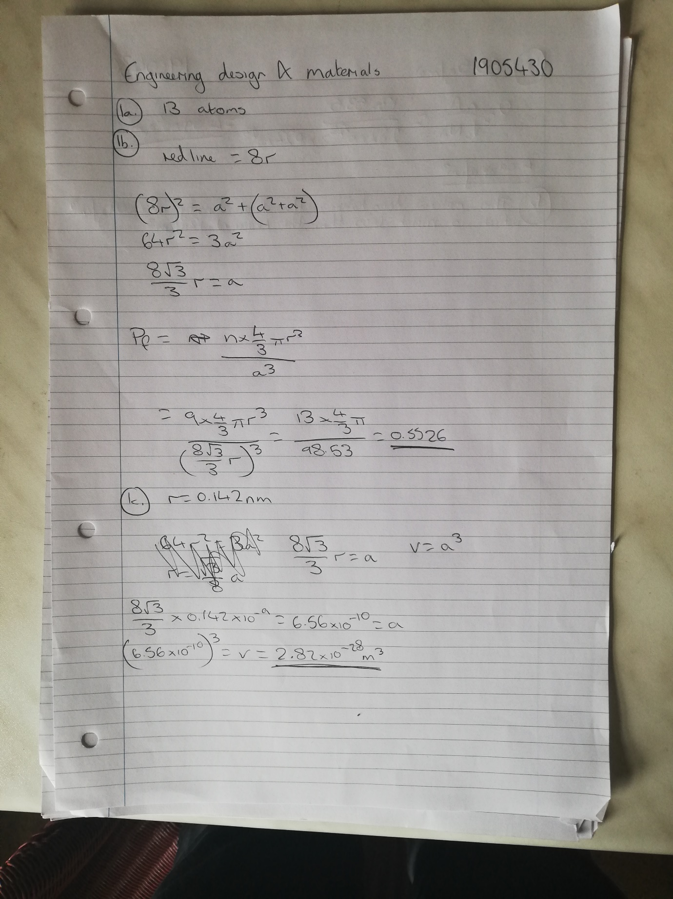
Michael Reeves Materials Assignment 1905430 29/04/21
Michael Reeves Materials Assignment 1905430 29/04/21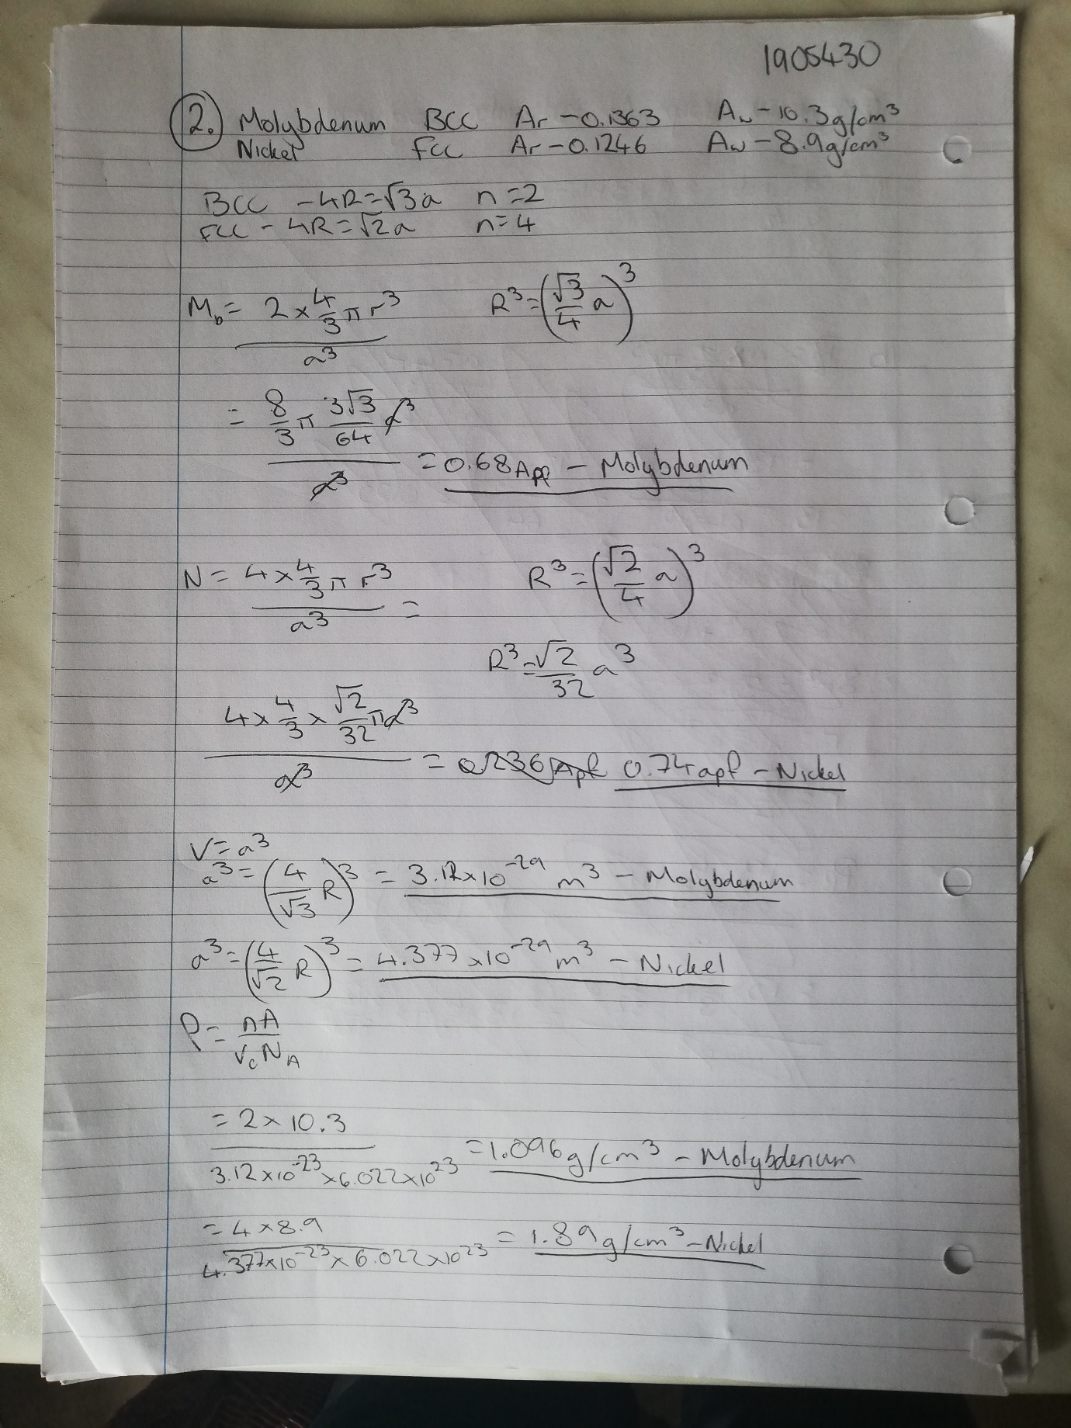
Michael Reeves Materials Assignment 1905430 29/04/21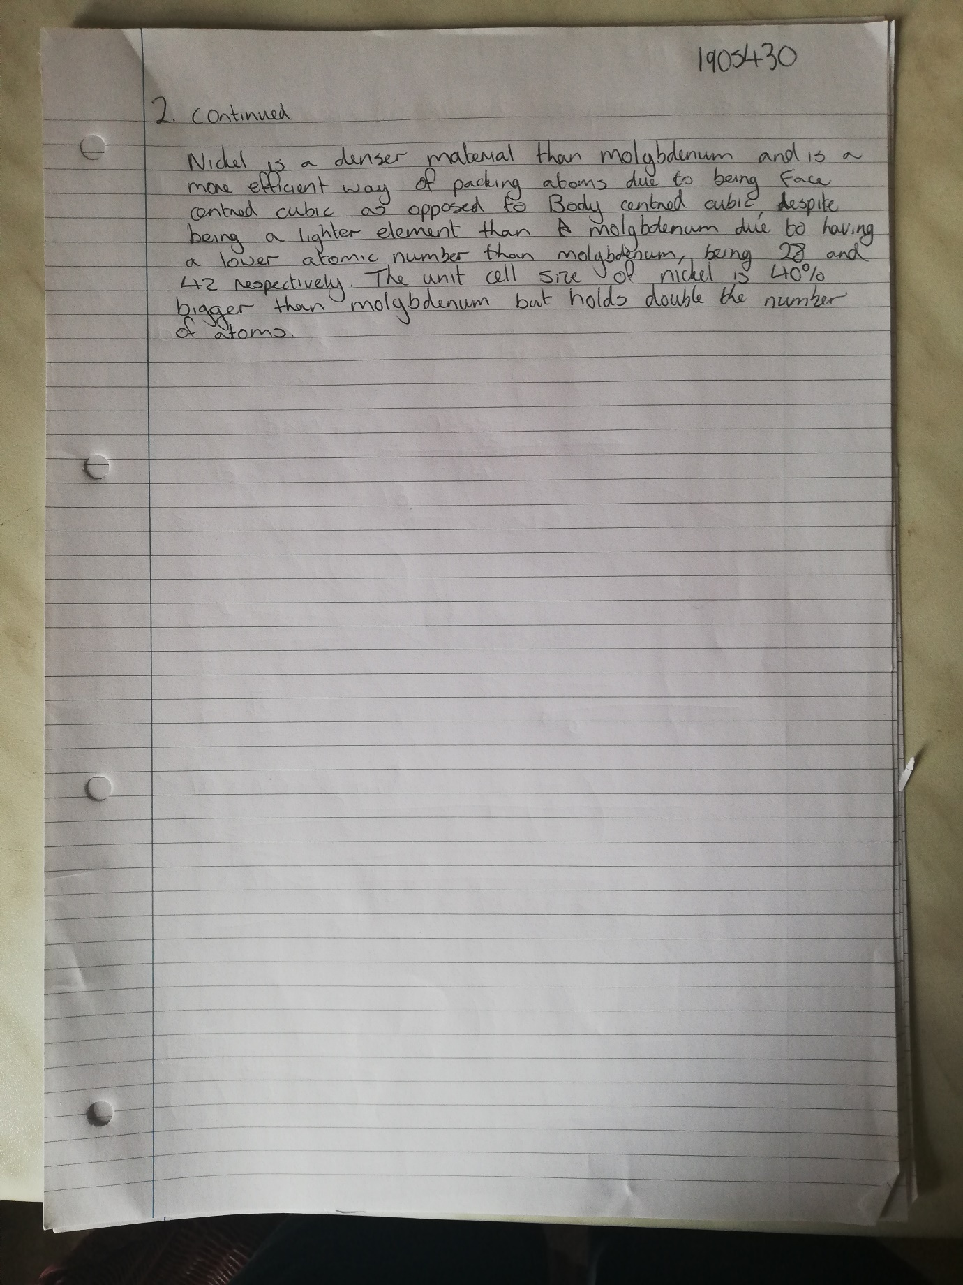
Michael Reeves Materials Assignment 1905430 29/04/21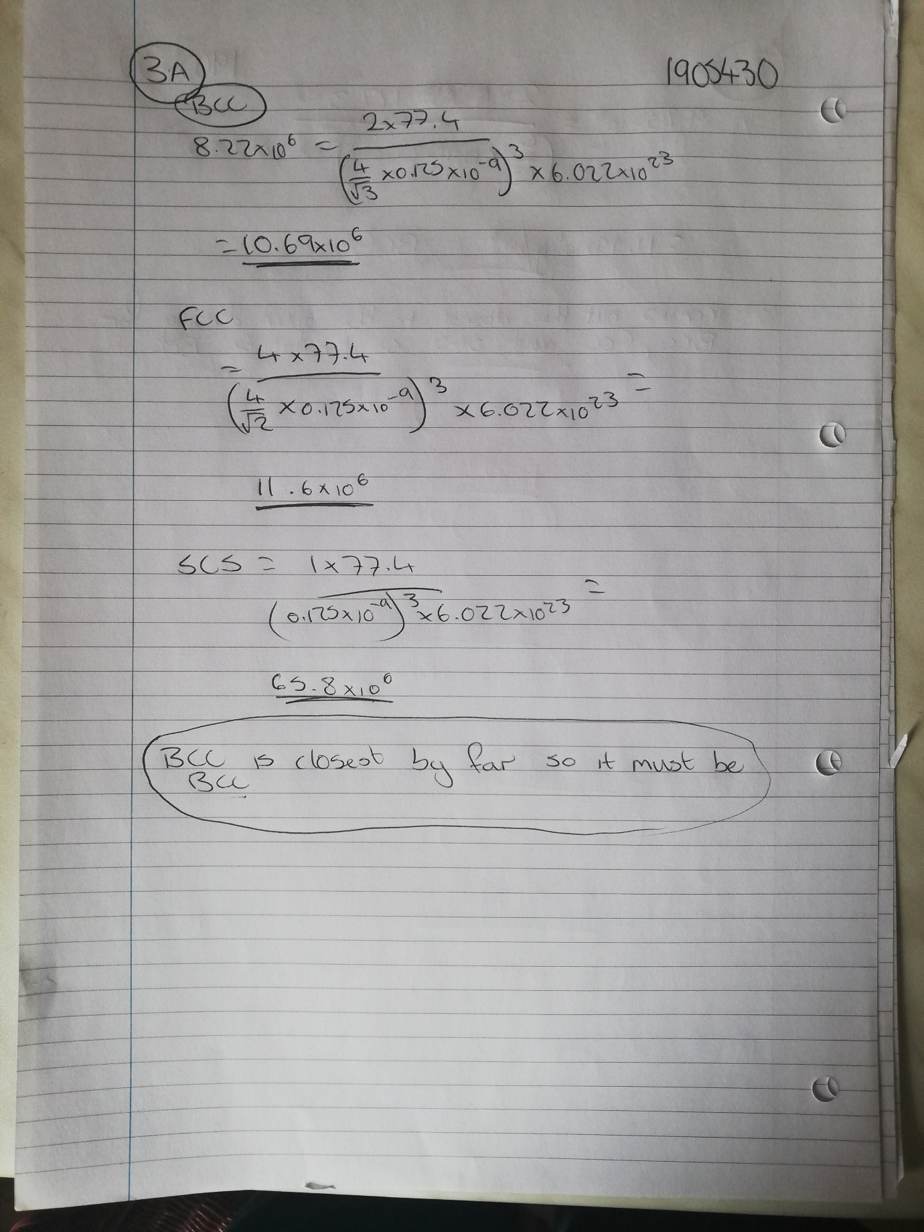
Michael Reeves Materials Assignment 1905430 29/04/21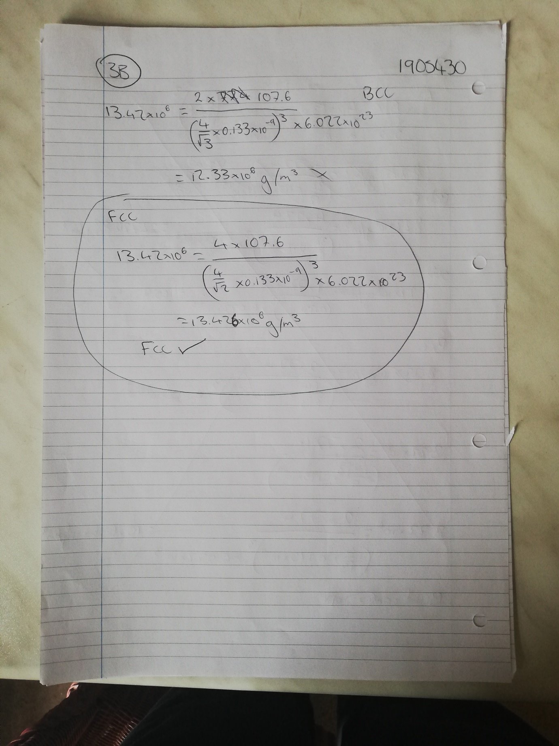
Michael Reeves Materials Assignment 1905430 29/04/21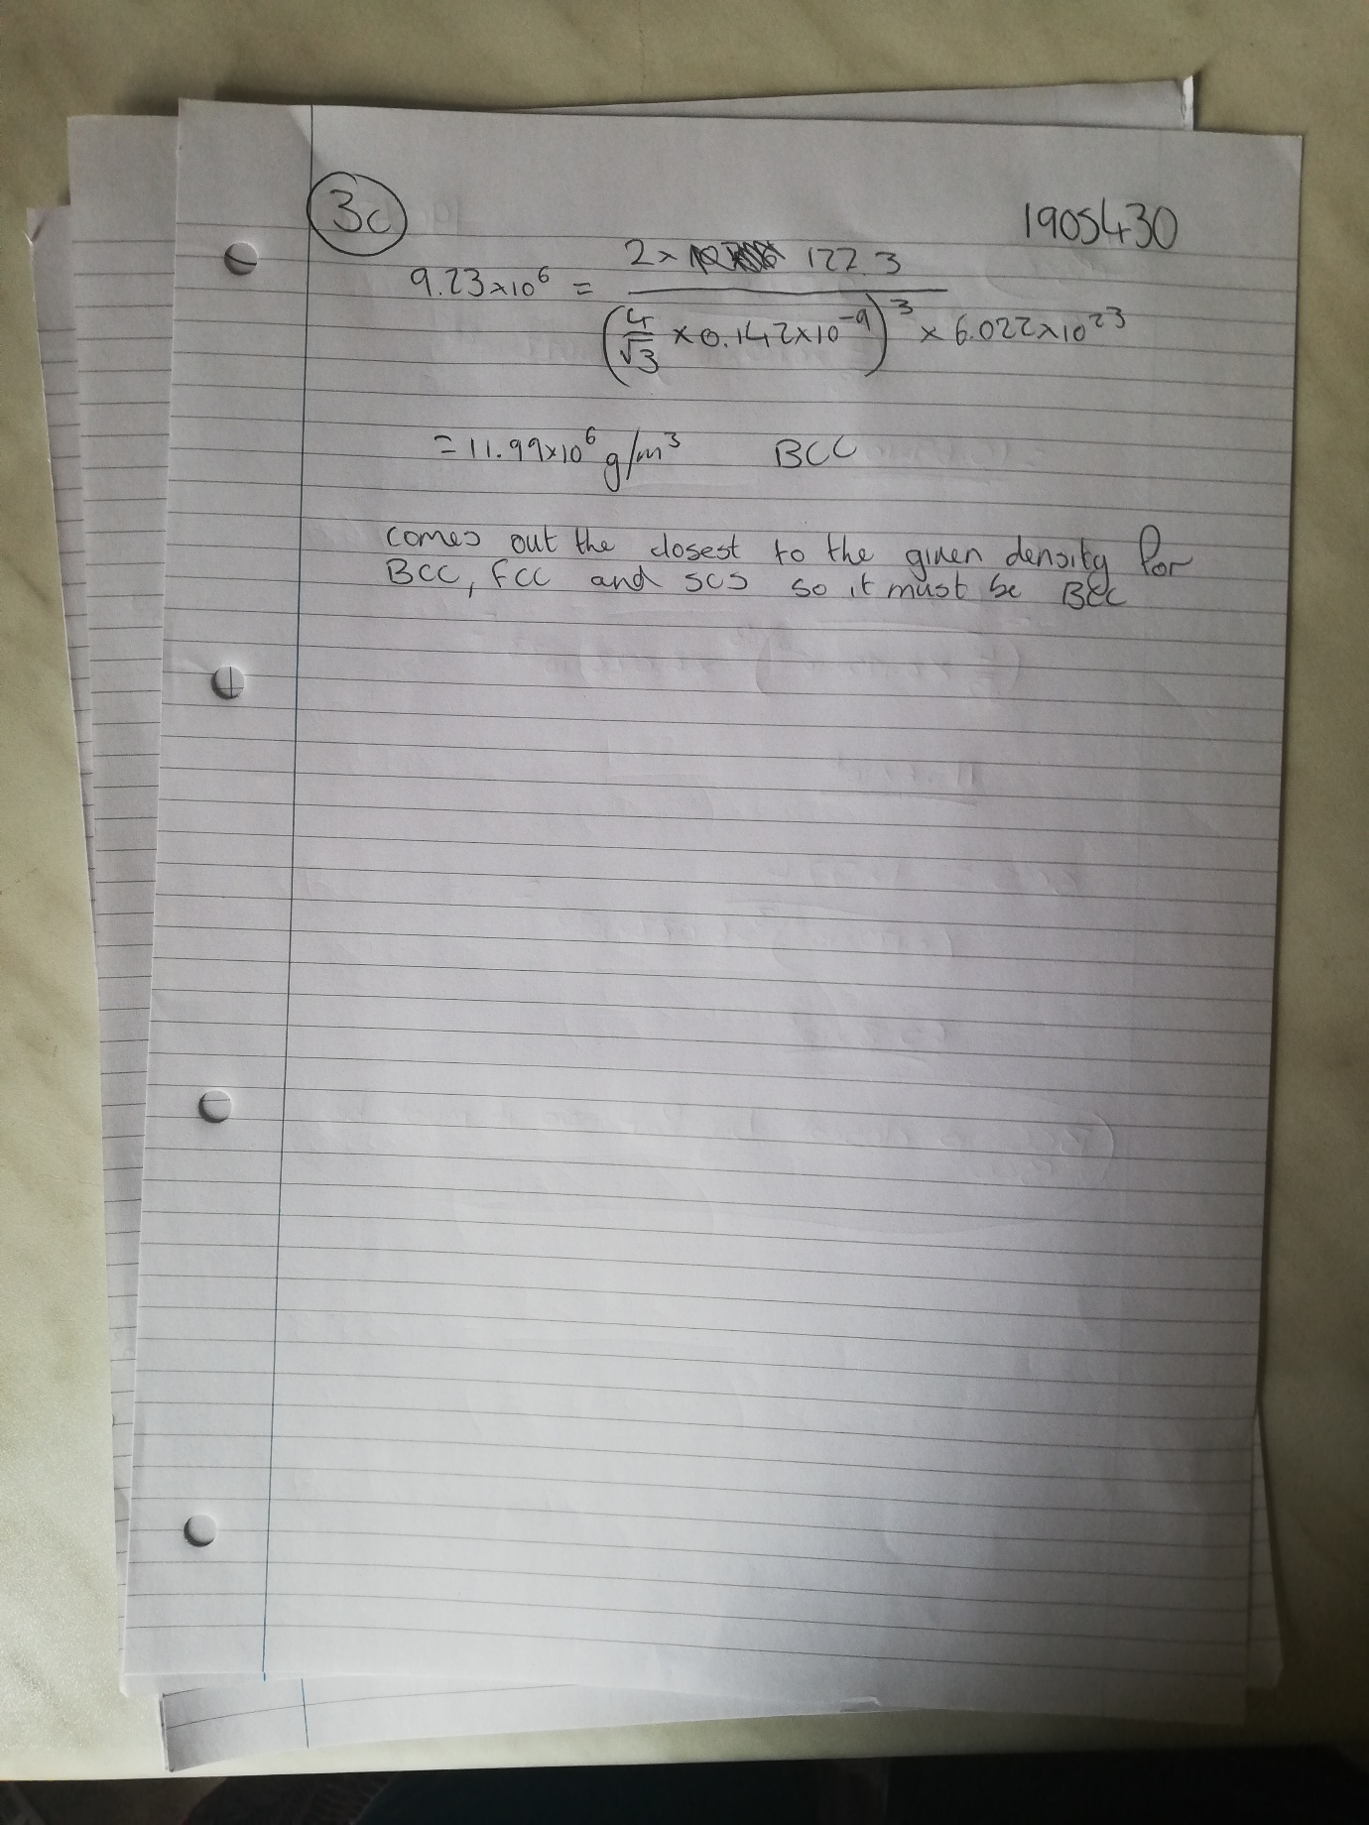
Michael Reeves Materials Assignment 1905430 29/04/21
Michael Reeves Materials Assignment 1905430 29/04/21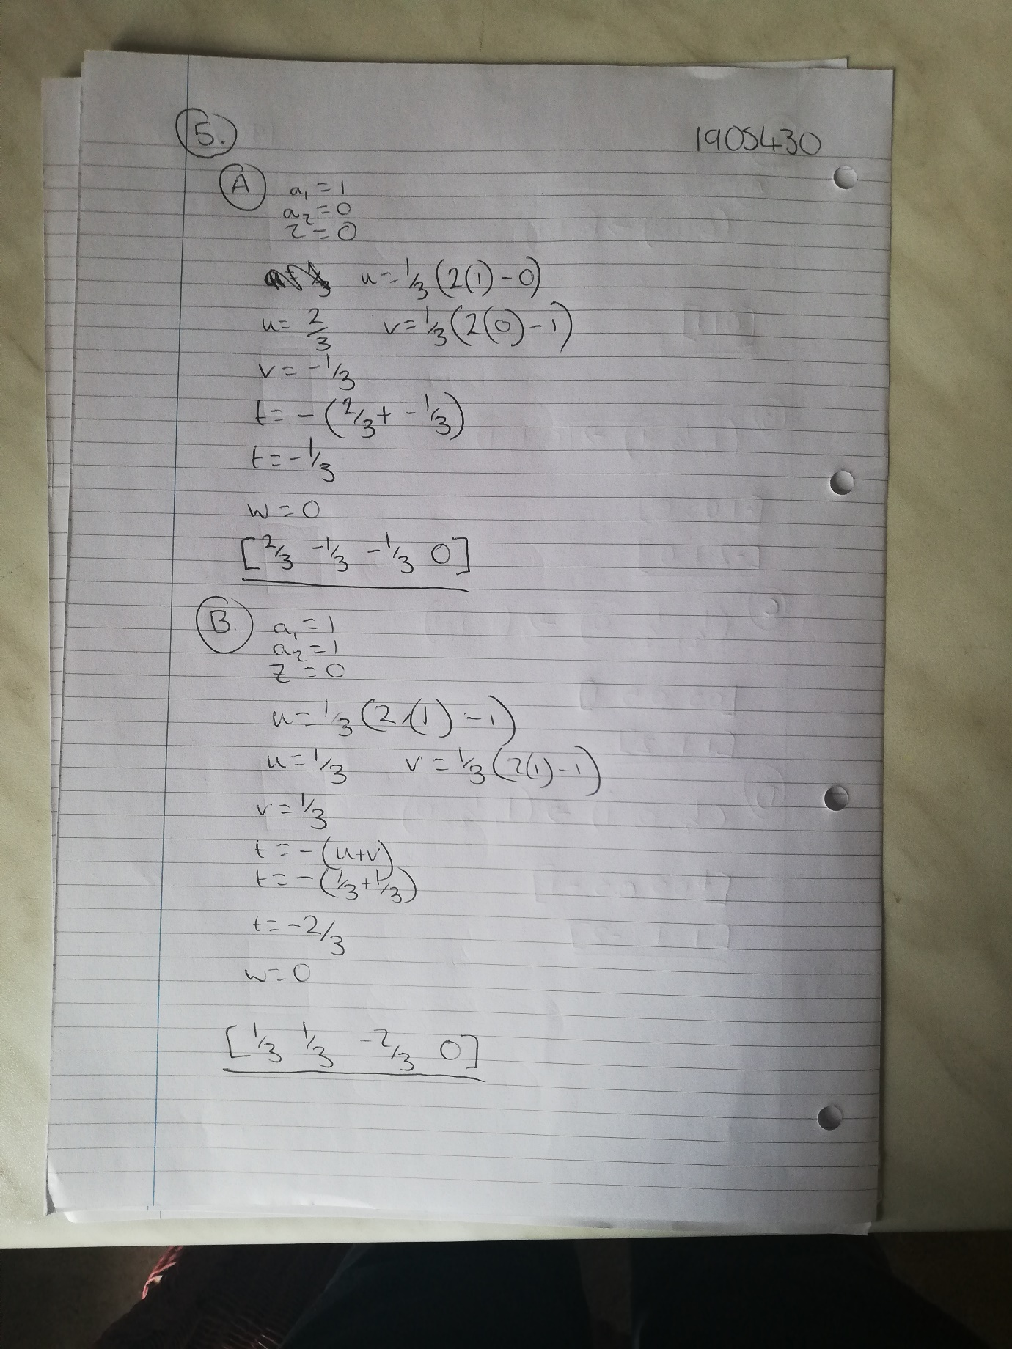
Michael Reeves Materials Assignment 1905430 29/04/21

Michael Reeves Materials Assignment 1905430 29/04/21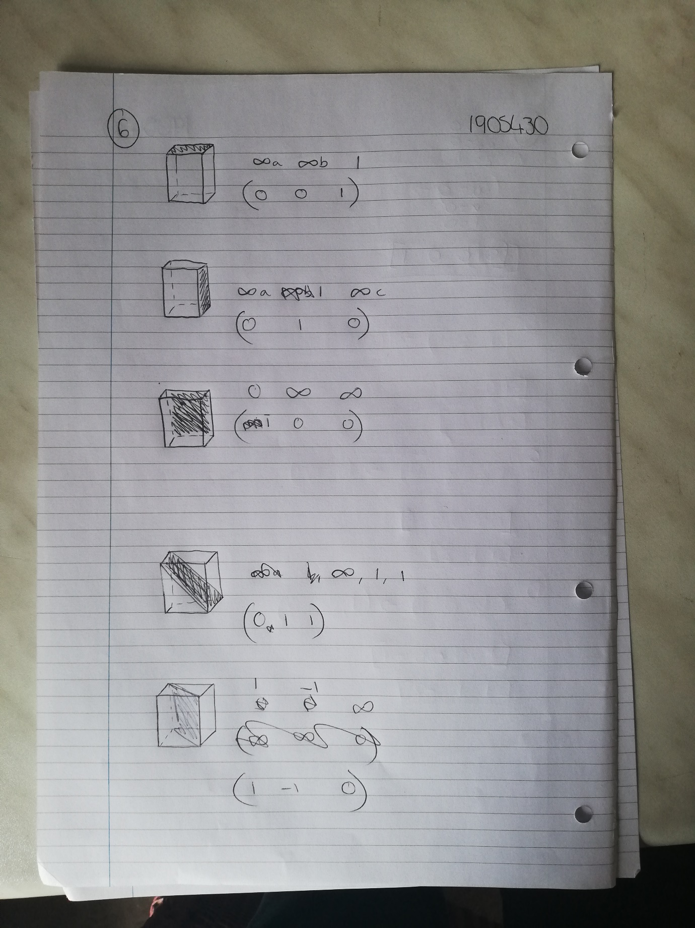 Michael Reeves Materials Assignment 1905430 29/04/21

