Ma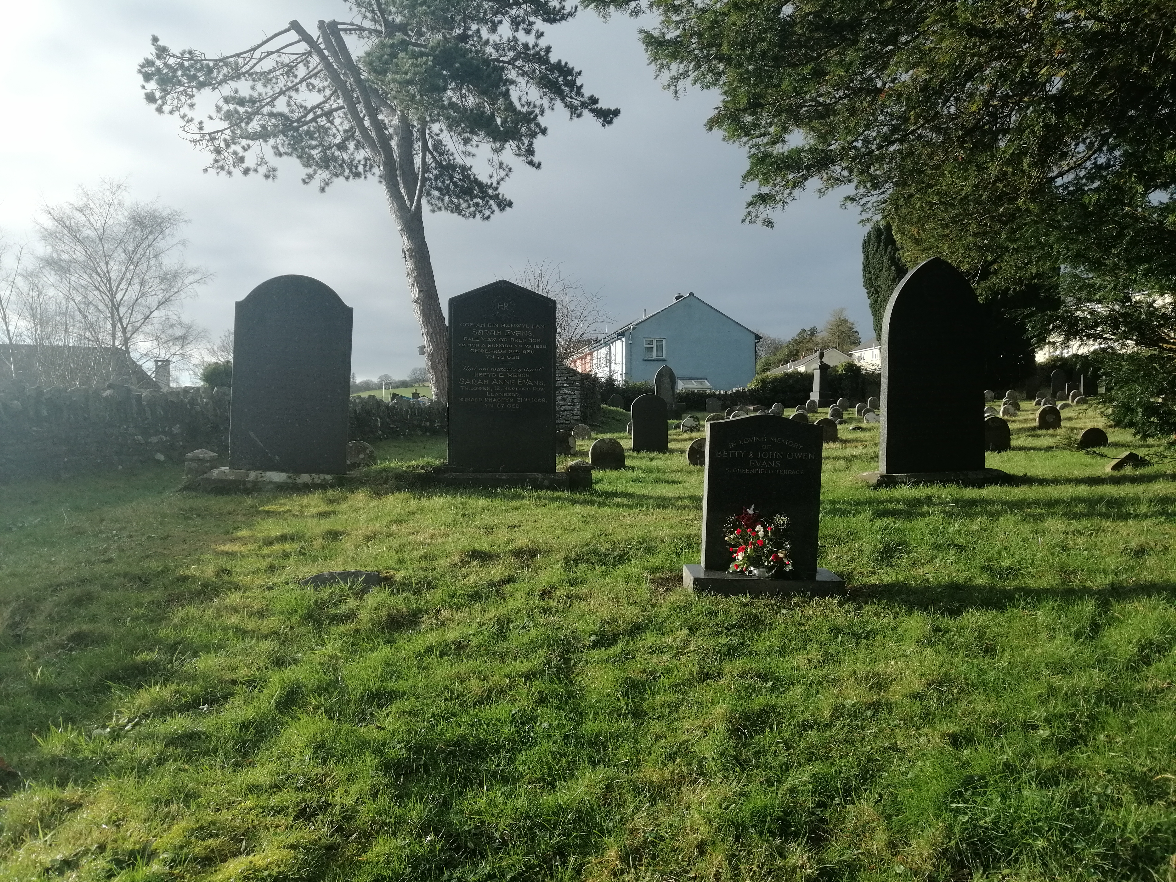tthew French

Lampeter st peters graveyard survey report

Code key
Type of monument
Plinth = 1
Headstone = 2
Bed =3
Table =4
style of grave
Art deco = a
Gothic = b
Modern = c
language
Welsh = w
English = e
English and Welsh = &
Other Languages = o
Shape of headstone if present
Cross
Obelisk
urn
urn covered
classic headstone
Pointed top headstone
Flat top headstone
raised middle headstone
Bed
Material
granite
slate
marble
This is the compilation of the data I have collected from the Lampeter St Peters graveyard
Type of grave | frequency
2ceClassicGranite | 9
2bwPointedSlate | 4
1beCrossGranite | 2
1bwCoveredGranite | 2
2aeFlatMarble | 2
2awRaisedMarble | 2
2bePointedGranite | 2
2ceClassicMarble | 2
2coRaisedMarble | 2
2cwClassicGranite | 2
2cwFlatGranite | 2
1beObeliskGranite | 1
1beObeliskMarble | 1
1beUrnGranite | 1
2aeFlatGranite | 1
2aeRaisedMarble | 1
2aoFlatSlate | 1
2b&ClassicSlate | 1
2beClassicSlate | 1
2bePointedSlate | 1
2bePointedMarble | 1
2bwClassicSlate | 1
2bwPointedMarble | 1
2bwPointedGranite | 1
2bwFlatGranite | 1
2c&ClassicGranite | 1
2ceClassicSlate | 1
2cwPointedSlate | 1
2cwPointedMarble | 1
3beBedSlate | 1

As we can see the largest style grave surveyed was gothic at 46% followed by modern graves at 40% and art deco coming in last with 14%
In this particular graveyard the largest language is English with the majority of graves having it as the only language on the stone.

Zone A
19 of the graves surveyed were in zone A, All the graves surveyed here are dating between 1865 and 1976 with graves mainly around the turn of the 20th century. 12 of the graves surveyed are purely in Welsh, 6 only in English and one that had both English and Welsh inscriptions. This zone also contained the graves of the Lampeter workhouse workers which are hidden by the placement of trees and other graves.
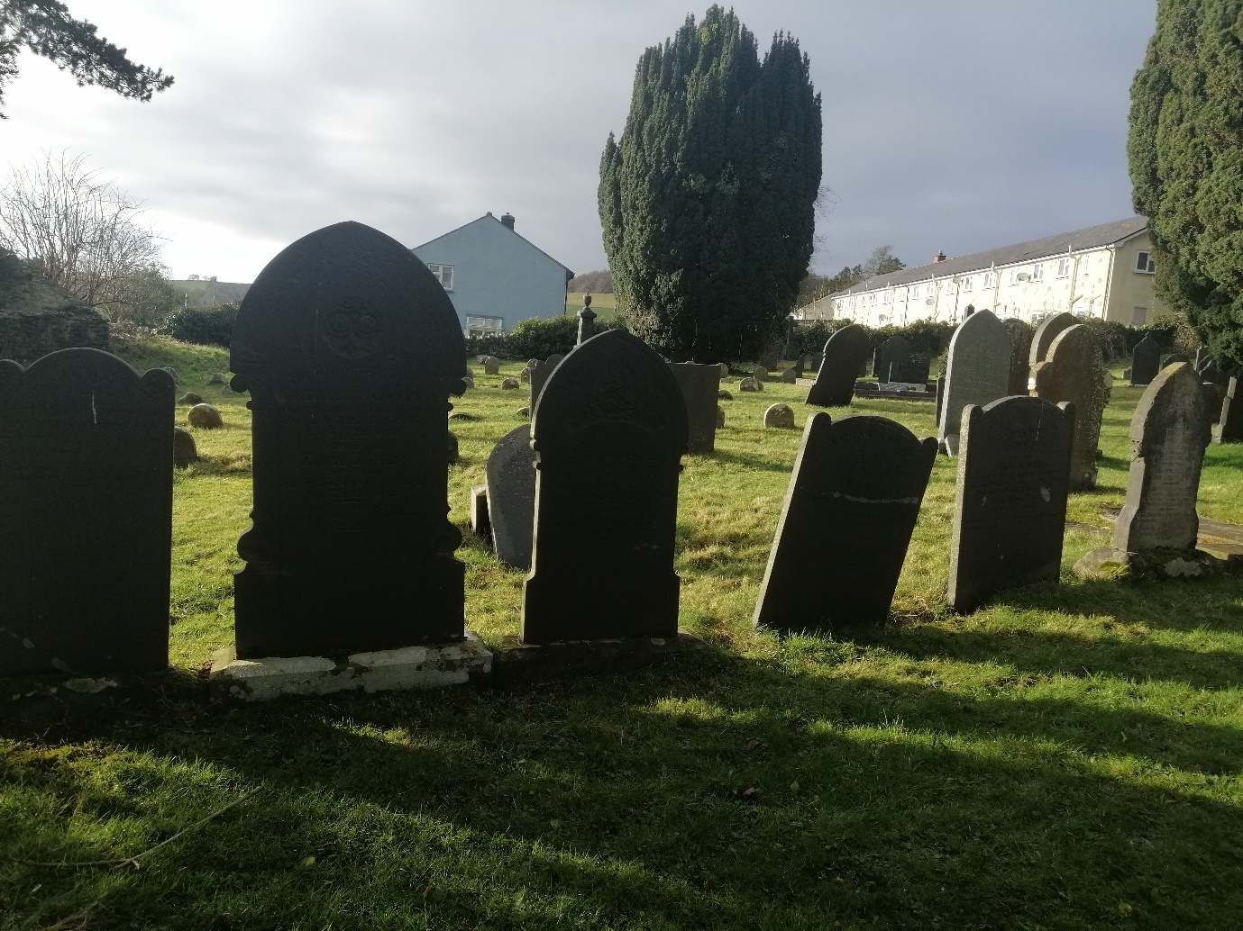
Most of the gravestones in this area were different and had personalised inscriptions to the people buried there.

Zone B
11 of the graves surveyed were in zone B which has the site of the old church in it marked out on the site plan. The oldest grave surveyed in this area was from 1817 the oldest I surveyed in the graveyard. 3 of the graves in zone B were in Welsh, 7 were in English and the remaining grave had both Welsh and English inscriptions. What is interesting about the zone B graves tended to be plinth graves more often then other places surveyed particularly around the site of the old church. The site of the old church (pictured bellow) is incredibly close to the church and near the path these are very visible graves, I believe because of this these graves are owned by more affluent people could afford the plots on the site of the old church right next to the path. Graves in this zone tend to be from the mid to late 1800s
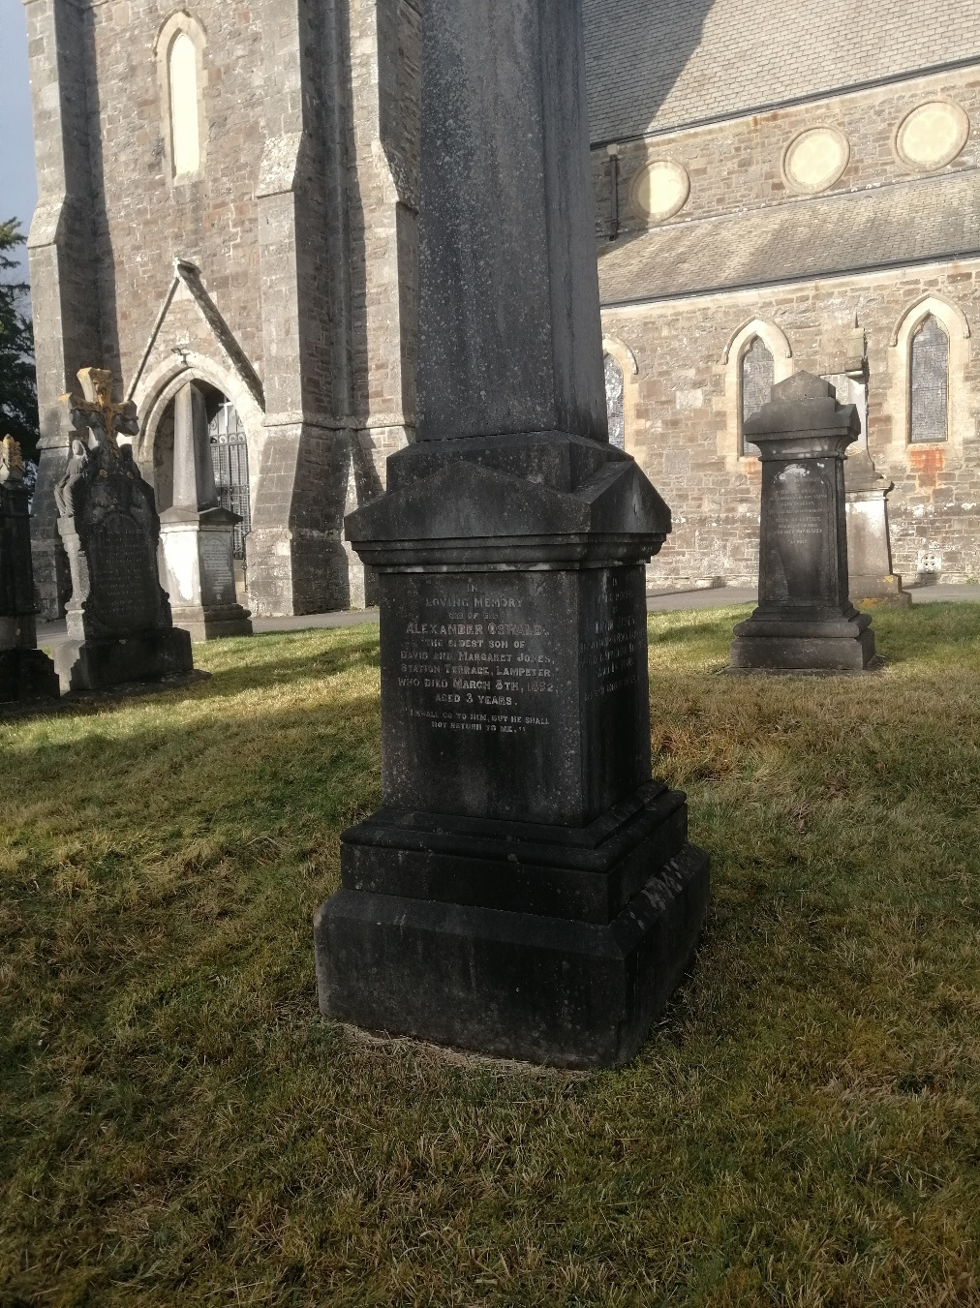

Zone C
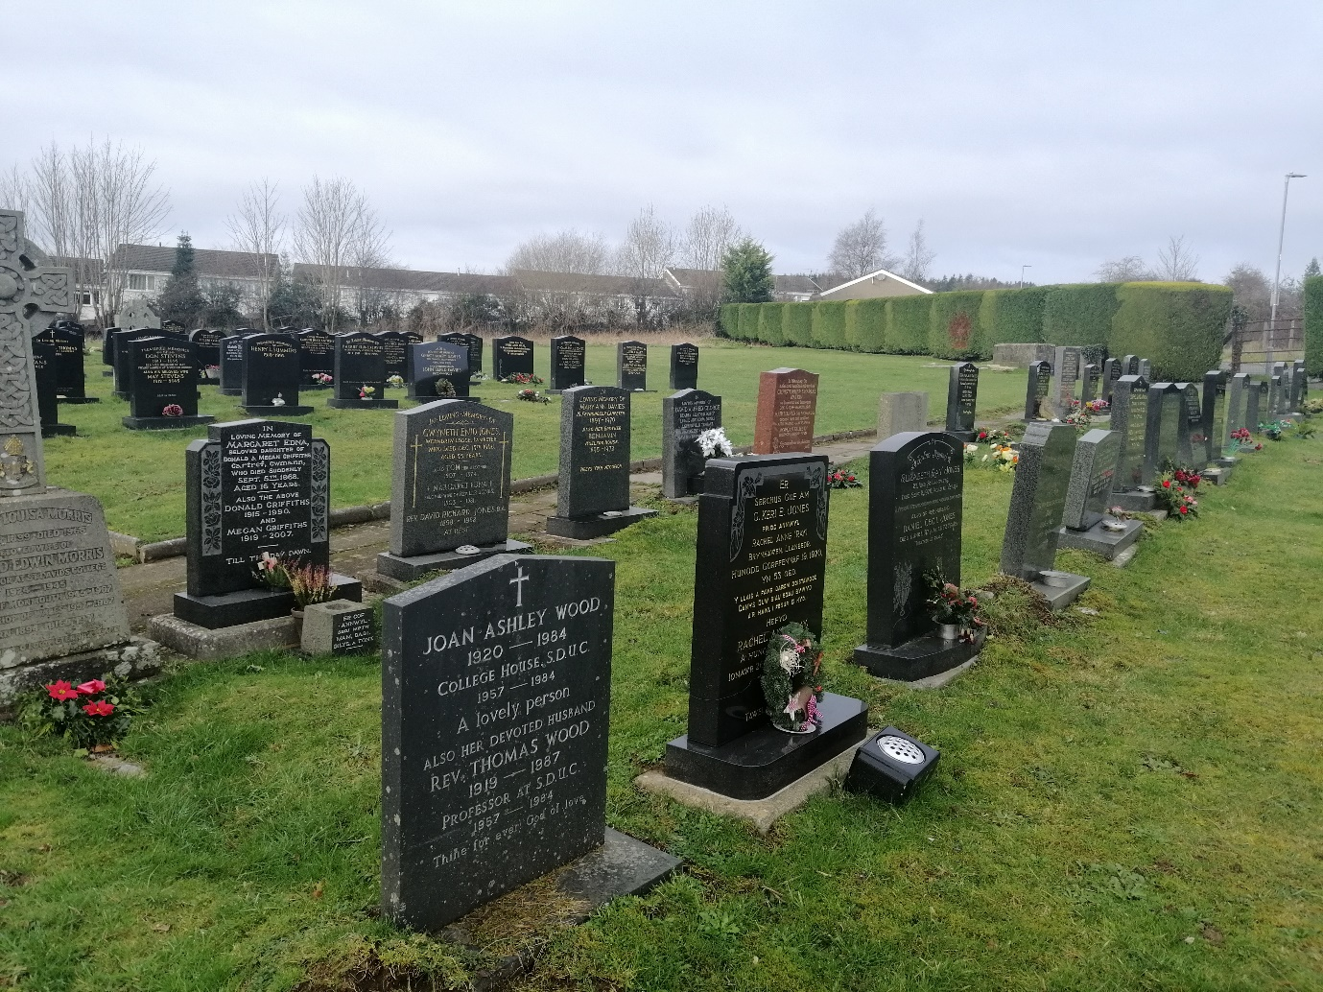
Zone C is interesting as it shows a change in the way society perceives death. The graves get more uniform with only a few graves standing out. Welsh appears on 3 of the surveyed graves while English was on 14 of the graves. This is also when languages other than English and Welsh start to appear in the survey with 3 polish graves.
In this zone whilst still presenting religious text language and symbolism it appears much less frequently. The Office for National Statistics suggests that 35% of people living in towns such as Lampeter are not religious (ONS, 2019) 65% of the graves therefore statistically should belong to religious people however the people are choosing to no to add religious inscriptions instead tending to focus on the relationships of the deceased.

What does that data tell us?
First of all, I think it important to consider that most of us will leave one last mark on the world, our gravestone. As such gravestones are more then just slabs of stone, they are important markers of people’s lives representing them for years after. The size and shape of grave monuments tells a lot about the views of the society which placed the body there. Particularly, the difference between regular headstones and plinth graves are that plinth graves are far grander. A plinth headstone on clearstreammonumentscosts.com from $2600 compared to around $480 and above for a regular headstone. (clear stream monuments, 2010) The price difference means that the plinths are exclusive to a higher more affluent class. In Zone A, 15% of the headstones were plinths. which Compared to zone B where this was 40% shows the more affluent groups of people from the mid to late 1800s congregate closer to the church and in areas closer to the path

Bibliography
Great Britain, The Office For National Statistics. (2019) Dataset Population characteristics research tables available at https://www.ons.gov.uk/peoplepopulationandcommunity/populationandmigration/populationestimates/datasets/populationcharacteristicsresearchtables (accessed: 21 jan 2020)
Obelisk Monuments, Obelisk Headstones Gravestones, https://clearstreammonuments.com/memorials/obelisk_monuments_headstones.php?cat=23 (accessed: 22 jan 2020)

