
Rotna Begum


STUDENT NUMBER/ NAME | Rotna Begum (2421635)
MODULE CODE | LCLM 5005
MODULE TITLE | Organisational Culture
LECTURER NAME | Taonga Kaonga Sobrere Snithers
ASSIGNMENT TITLE | Organisation Culture  Component 1 Individual Report 3000 words

Contents
List of Abbreviations 1
Executive Summary 2
1. Introduction and the NHS Context 2
2. Theoretical Framework 3
3. How Culture Influences Structure and Decision-Making 4
3.1 Influence on Structure 4
3.2 Application of Handy’s Cultural Types to NHS Functionality 4
A mechanistic national hierarchy sits above organic frontline teams 5
Four professional ladders feed shared clinical departments 6
3.3 Influence on Decision-Making 6
4. Identifying the Prevailing Culture 7
4.1 Schein’s Three Levels 7
4.2 Handy’s Cultural Types 7
4.3 Hofstede’s Dimensions 7
4.4 The Four Traits Model 8
4.5 Synthesis 8
5. Leveraging Culture to Adapt to the External Environment 8
5.1 The General Environment (PESTEL) 8
5.2. The Task Environment……………………………………………………………….9
5.3 Environmental Uncertainty 9
5.4 Adaptation Mechanisms 10
5.5 Evaluation 10
6. A Critical Assessment Enabler or Barrier 10
7. Impact on Performance and Recommendations 11
7.1 Impact of Culture on Performance 11
7.2 Recommendations 12
7.3 Limitations 12
8. Conclusion 11
References 12,13
Abbreviations List

BMA – British Medical Association
CQC – Care Quality Commission
DHSC – Department of Health and Social Care
GMC – General Medical Council
NHS – National Health Service
NMC – Nursing and Midwifery Council
RCN – Royal College of Nursing

EXECUTIVE SUMMARY
The NHS in England possesses a strong, mission-driven public-service culture that supports operations in high-uncertainty environments. However, this culture becomes a barrier when rigid hierarchy, blame, and target pressures stifle candour and local adaptation. Applying Mullins and Christy (2016), culture is viewed as the implicit shared assumptions shaping NHS structure, decisions, behaviour, and performance. Key findings include:
- Structure and Decisions - Clinical professionalism, public governance, and risk aversion yield a large, hierarchical, rule-bound structure, splitting decisions between autonomous clinicians and accountable managers (Ham, 2014; Mannion and Davies, 2018).
- Prevailing Culture - A role culture overlaid with a strong professional person culture among clinicians, united by a powerful public mission (Handy, 1993; Dixon-Woods et al., 2014).
- Adaptation - A shared mission enabled rapid crisis response during COVID-19, but routine adaptation remains constrained by structural and political factors (Royal College of Physicians, 2021).
- Enabler vs. Barrier - Culture acts as a conditional enabler. It sustains staff commitment and service reliability, but inquiries reveal it can foster blame, deference, and poor practice (Francis, 2013; Ockenden, 2022).
- Recommendations: Prioritise compassionate leadership, psychological safety, devolved decision-making, and routine culture measurement (West et al., 2017; NHS England, 2023).
1. INTRODUCTION AND THE NHS CONTEXT
Founded in 1948 to provide comprehensive carefree at the point of use, the NHS in England employs over a million staff across primary, community, mental health, and hospital services, accountable to Parliament via the Department of Health and Social Care (DHSC) (NHS England, 2023).
The NHS serves as a critical case for organizational culture analysis due to three factors:
- Codified Mission - Values set out in the NHS Constitution, such as compassion, respect, and quality care (DHSC, 2023).
- Professional Subcultures - Coexisting identities across doctors, nurses, managers, and support staff (Dixon-Woods et al., 2014).
- External Drivers - Continuous political, financial, technological, and statutory changes, such as the Health and Care Act 2022 establishing Integrated Care Systems (UK Parliament, 2022).
Scope and Structure - This report focuses exclusively on NHS England. Section 2 outlines the theoretical framework; Section 3 evaluates culture’s impact on structure and decisions; Section 4 identifies the prevailing culture; Section 5 analyses external adaptation; Section 6 assesses culture as a barrier or enabler; and Section 7 evaluates performance and delivers recommendations

2. THEORETICAL FRAMEWORK

Mullins and Christy (2016) present culture as a pervasive, implicit force within organisations like the NHS. Expressed through shared clinical values, operational rules, and symbols, it shapes workplace behaviour more strongly than formal policies.

Four core arguments frame this report.
•Culture and structure are interdependent: NHS structural hierarchies reflect core values surrounding clinical authority, public governance, and risk control.
•Culture is multi-faceted: It is shaped by medical history, political leadership, complex patient care, technology, and external regulation.
•Culture creates advantage or inertia: Shared dedication binds staff to patient care yet deeply embedded cultural norms can resist structural reform.
•Culture changes slowly: Cultural shifts cannot simply be imposed by management; they require systematic alignment across administrative and clinical boundaries (Mullins and Christy, 2016).

Table 1. Applied Analytical Frameworks Applied to the NHS.

Model | Purpose in NHS Context | Report Section
Schein’s Three Levels (Schein and Schein, 2016) | Explores NHS artefacts (uniforms, badges), espoused values (NHS Constitution), and core implicit assumptions (patient safety first). | Section 5
Handy’s Cultural Types (Handy, 1993) | Evaluates how Power, Role, Task, and Person cultures coexist within administrative and clinical NHS domains. | Section 5
Hofstede’s Dimensions (Hofstede, 2011) | Examines national societal values, such as low power distance and uncertainty avoidance, driving NHS operational norms. | Section 5
Four Traits Model (Denison, 1990) | Assesses involvement, consistency, adaptability, and mission across NHS trust performance. | Sections 5, 6, 8
PESTEL & Task Environment (Johnson, Whittington and Scholes, 2020) | Maps external environmental uncertainty, statutory changes, funding pressures, and demographic shifts. | Section 6
Mechanistic vs. Organic Structures (Burns and Stalker, 1961) | Evaluates structural fit between rigid administrative governance and adaptable frontline emergency care. | Sections 4, 6
The fundamental test applied throughout this report is the fit between culture and environment. Stable environments favour formal, structured cultures, whereas complex, high-uncertainty healthcare environments require flexible, adaptive, and learning-oriented cultures (Burns and Stalker, 1961; Mullins and Christy, 2016).
3. HOW CULTURE INFLUENCES STRUCTURE AND DECISION-MAKING
Culture shapes NHS structure and decision-making through professional identity, public accountability, and mission focus, while risk aversion influences choices at all levels.

3.1 INFLUENCE ON STRUCTURE
Professional Identity - As a professional bureaucracy, standardized clinical training and professional norms guide daily work rather than direct management. Expert clinical authority creates established professional hierarchies (consultants, registrars, ward sisters) in distinct operational silos (Dixon-Woods et al., 2014).
Public Accountability - Operating on public funds under Parliamentary and CQC oversight, administrative culture prioritises compliance, auditing, and standardization. Aligned with Handy’s (1993) Role Culture, this yields rigid hierarchies and national targets (Ham, 2014).
Mission and Purpose - The belief that patient care comes first provides cohesion across fragmented trusts and integrated care systems, supporting multidisciplinary teams (MDTs) (West et al., 2017).
3.2 APPLICATION OF HANDY’S CULTURAL TYPES TO NHS FUNCTIONALITY.
Handy’s (1993) four cultural types illustrate how different operational styles coexist within the NHS.

- Role Culture - Administrative governance, compliance, and finance.
- Person Culture - Autonomous clinical specialists operating under professional registration.
- Task Culture - Multidisciplinary teams, emergency response, and crisis groups.
- Power Culture - Centralised control during national crises or restructures.
The NHS is a hybrid: mechanistic in governance, organic in frontline care. This creates ongoing tension between managerial compliance and clinical autonomy (Mannion and Davies, 2018).
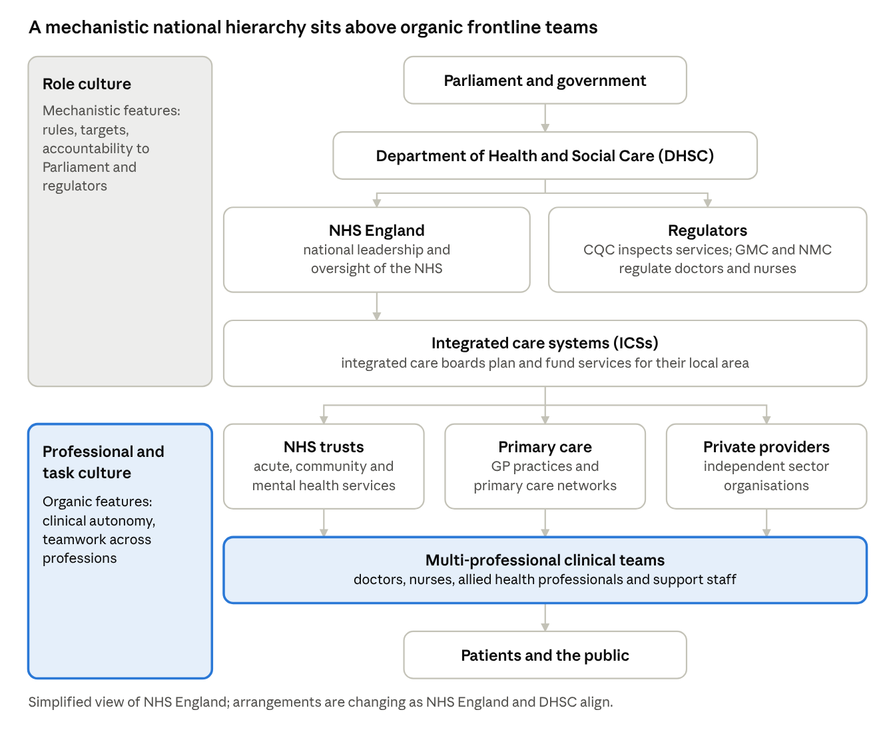
Mission creates cohesion. The shared belief that patient care comes first holds a large, fragmented organisation together and underpins multidisciplinary working. Without this shared purpose, the fragmentation across trusts, professions and sectors would be far harder to manage.

Figure 1. A mechanistic national hierarchy sits above organic frontline teams. (Adegbite, 2026, Slides 11, 19 & 20).
National and system tiers form a mechanistic, role-culture hierarchy, frontline clinical teams work in a more organic, professional pattern.

The structure is a hybrid mechanistic in governance and finance, organic in frontline clinical teams. This supports the argument that structure follows values, but creates tension, managers expect compliance and uniformity, while clinicians expect autonomy.

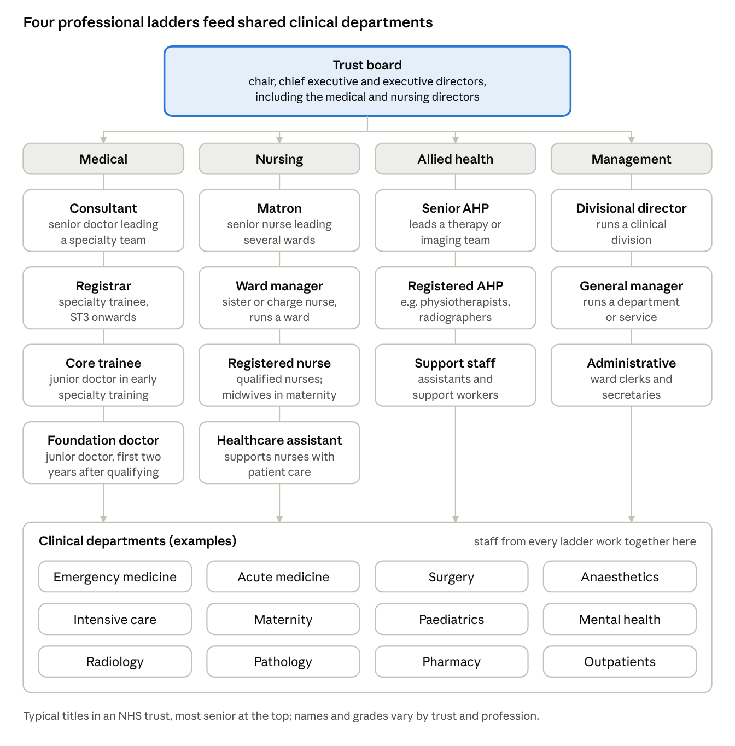
Figure 2. Four professional ladders feed shared clinical departments. (Adegbite, 2026, Slides 11, 19 & 20).

Each profession has its own career ladder, but all work together in shared departments and is divisional, which helps explain the professional subcultures and silos discussed in Section 5.

3.3 INFLUENCE ON DECISION-MAKING

Clinical decisions are decentralised and guided by NICE protocols, whereas operational and financial decisions are centralised around targets and budgets. Risk aversion encourages defensive practice. Inquiries (Francis, 2013; Berwick, 2013; Kirkup, 2015; Ockenden, 2022) show how prioritizing targets and reputation over openness compromises patient safety, prompting reforms like Freedom to Speak Up guardians.

4. IDENTIFYING THE PREVAILING CULTURE
Mullins and Christy stress diagnosing culture through several lenses, four of which are applied here. The prevailing culture is a role culture overlaid on a strong professional (person) culture, bound by an unusually powerful sense of mission.

4.1. Table 2. Schein’s three levels (Schein, 2010)
Level | NHS evidence
Artefacts | Uniforms and grade hierarchy; ward rounds and handovers; targets and CQC ratings; the NHS Constitution Freedom to Speak Up guardians’ protocols
Espoused values | Compassion, respect and dignity, quality of care, (everyone counts)
Basic assumptions | The patient comes first clinicians are the legitimate experts the NHS must not fail mistakes are professionally and reputationally dangerous
The gap between levels explains much of the difficulty. Espoused values are compassionate and open, but assumptions about expertise, reputation and blame can undermine them, the pattern described in the Francis and Ockenden reviews (Schein, 2010).

4.2 HANDY’S CULTURAL TYPES OF THE 4 CULTURES
The NHS uses all 4 cultures.
- Role culture (management and governance): formal rules, grades, procedures and defined authority (Handy, 1993).
- Person culture (clinicians) authority rests on professional expertise, and many clinicians identify more with their profession than their employer.
- Task culture (multidisciplinary teams) found in specialist teams, major incident response and pathway redesign.
- Power culture (limited) present only in pockets, such as dominant individual leaders or consultants.
Together these types show why the NHS resists a single description managers and clinicians often operate under different cultural logics, which explains recurring friction over targets, autonomy and priorities.

4.3 HOFSTEDE’S DIMENSIONS

Hofstede’s framework describes national culture, so approximate UK scores serve only as a prompt (Hofstede et al., 2010). Power distance is low nationally yet noticeably high within the NHS because of professional hierarchy and deference to seniority. Uncertainty avoidance is low nationally but high institutionally because of rules, protocols and risk management. Individualism is high nationally, offset by a collective ethos of public service. The gap shows that organisational culture is not simply a copy of national culture.

4.4 TABLE 3 - THE FOUR TRAITS MODEL (DENISON, 1990)

Trait | NHS assessment
Mission | Very strong. Shared purpose is the NHS’s greatest cultural asset
Consistency | Moderate. Shared core values, but variation between trusts, professions and teams
Involvement | Mixed. Strong local teamwork, but uneven staff voice, particularly for junior, support and minority-ethnic staff
Adaptability | Variable. High in crises, slow in routine reform

4.5 SYNTHESIS
The four lenses agree, the NHS is a mission-led role culture with a powerful professional subculture. It is a federation of subcultures rather than a single culture, as Mullins and Christy would expect of a large organisation. The diagnosis rests on published evidence rather than primary data, so culture will vary between individual trusts.
5.LEVERAGING CULTURE TO ADAPT TO THE EXTERNAL ENVIRONMENT
The NHS adapts rapidly when its mission is urgent, but slowly when constrained by structure and politics.

5.1 Table 4 -The General Environment (PESTEL)

Factor | Key NHS Influences | Cultural Implication
Political | Government priorities, frequent reorganisations, statutory changes (Health and Care Act 2022), intense public scrutiny (UK Parliament, 2022; Ham, 2023). | Reinforces compliance and political sensitivity; frequent structural restructurings cause widespread change fatigue (Dixon-Woods et al., 2014; Ham, 2023).
Economic | Constrained real-terms funding, high inflation, rising operational costs, ongoing pay disputes (The King's Fund, 2023). | Resource pressure intensifies focus on short-term efficiency targets and reduces operational slack for staff learning and innovation (Mannion and Davies, 2018).
Social | Ageing population, multi-morbidity and long-term conditions, health inequalities, rising public expectations (NHS England, 2023). | Reinforces core NHS mission and equity values; creates cultural frustration as escalating patient demand continuously outstrips capacity (West et al., 2017).
Technological | Electronic patient records, digital platforms (NHS App), AI diagnostics, remote consultation models (Department of Health and Social Care, 2022). | Requires openness to innovation; however, legacy systems, fragmented infrastructure, and institutional risk aversion slow technology adoption (Royal College of Physicians, 2021).
Environmental | Pandemic risks, climate change commitments (Net Zero NHS), aging physical estate condition (NHS England, 2020; Royal College of Physicians, 2021). | Requires long-term, systems-wide thinking and sustainable operational practices across all healthcare services (NHS England, 2020).
Legal | Health and Care Act 2022, Equality Act 2010, Care Quality Commission (CQC) regulation, data protection laws (UK Parliament, 2010; UK Parliament, 2022). | Reinforces a strictly rule-based, cautious, and highly accountable compliance culture (Francis, 2013; Ham, 2023).

5.2. THE TASK ENVIRONMENT & 5.3 UNCERTAINTY

Conflicting stakeholder demands (DHSC, CQC, GMC, NMC, unions, BMA, RCN, private providers) require balancing political control, professional autonomy, and public expectations. High environmental uncertainty requires organic flexibility, yet rigid mechanistic features create persistent structural tension. (See appendix page for abbreviations).

5.4 ADAPTATION MECHANISMS

Cultural levers mediate between national policy mandates and frontline realities. Adaptation relies heavily on mission mobilisation, where shared public-service values enabled rapid crisis response, staff redeployment, and mass vaccination during COVID-19 (Royal College of Physicians, 2021). Furthermore, regulatory learning utilizes post-inquiry tools, such as Freedom to Speak Up guardians and CQC frameworks, to embed safety and candour into daily practice (Francis, 2013; Berwick, 2013). Finally, driving system integration across Integrated Care Systems requires overcoming professional silos to foster collaborative, cross-boundary care delivery (Mullins and Christy, 2016; West et al., 2017). Aligning these cultural levers ensures sustainable organizational adaptation.

5.5 EVALUATION
Adaptability (Denison, 1990) is strongest during crises and weakest in routine reform (Dixon-Woods et al., 2014). Structural reorganisations often alter administrative frameworks without transforming underlying workplace culture (Ham, 2014; Mullins and Christy, 2016). Adaptation relies heavily on staff goodwill rather than system design (West et al., 2017).

6. TABLE 5 - A CRITICAL ASSESSMENT – ENABLER OR BARRIER

Furthermore, the dual nature of NHS culture highlights the critical tension between standardization and clinical autonomy. While centralized rules and performance targets provide essential public accountability, an over-reliance on rigid compliance risks fostering defensive practice, risk aversion, and institutional silence (Francis, 2013; Ham, 2014). To transform culture from a conditional enabler into a sustainable driver of excellence, leadership must balance governance requirements with local empowerment. Fostering open dialogue and active psychological safety enables staff to challenge unsafe practices without fear of reprisal, directly converting professional commitment into measurable improvements in quality of care (Berwick, 2013; West et al., 2017).

Culture works as an enabler when | Culture works as a barrier when
Mission and compassion motivate discretionary effort, as in crisis response | Hierarchy and deference discourage junior and minority staff from speaking up (Francis, 2013; Ockenden, 2022)
Professional norms and protocols sustain high-reliability practice | Blame and fear of scrutiny encourage concealment rather than learning (Berwick, 2013)
Shared values give coherence across a very large, diverse workforce | Silos obstruct integrated care, and targets reward compliance over improvement
Accountability mechanisms (CQC, audit, professional regulation) protect patients | Workload and burnout erode compassion and drive staff to leave

These effects coexist within single organisations, the same trust can show exemplary teamwork on one ward and defensive silence on another, which is why leadership and local context matter so much.
Three arguments support the conditional-enabler judgement.

Fit with the environment- High-uncertainty environments need organic, adaptive cultures. Mission and teamwork provide adaptiveness, but role-culture features pull the other way, so the culture is partly aligned and partly misaligned with its context.

Evidence of both outcomes- The same organisation delivered the Covid vaccination programme at pace and, elsewhere, failed to act on repeated safety warnings. This variation supports Mullins and Christy’s view that subcultures differ in effectiveness.

The cost of strength- A strong mission can normalise overwork (“we always cope”) or make criticism feel disloyal. Schein (2010) warns that strong cultures can hide dysfunctional assumptions.

Culture is therefore neither the problem nor the solution but an amplifier of good or poor leadership. Improvement should strengthen the enabling elements (mission, professionalism) while deliberately changing the assumptions that create barriers (hierarchy, blame, silos).

7. IMPACT ON PERFORMANCE AND RECOMMENDATIONS
7.1 IMPACT OF CULTURE ON PERFORMANCE
Patient Safety - Good safety culture correlates with lower mortality, whereas blame cultures lead to harm (Francis, 2013; Berwick, 2013; Dixon-Woods et al., 2014; West et al., 2002; West and Dawson, 2012).
Workforce - Bullying and poor voice lower engagement and increase turnover, eroding team stability and raising recruitment costs.
Productivity - Strong mission supports reliability, but low adaptability limits innovation.
7.2 RECOMMENDATIONS

Compassionate Leadership - Train leaders in inclusion and listening; track voice via staff surveys (Schein, 2010; West et al., 2014).
Just Culture - Implement non-punitive incident learning and strengthen Freedom to Speak Up (Edmondson, 1999; Berwick, 2013).
Local Adaptation - Devolve operational choices to frontline teams and streamline processes (Burns and Stalker, 1961; Denison, 1990).
Break Silos - Use cross-professional training and joint ICS objectives (Mullins and Christy, 2016; Schein, 2010).
Inclusion & Metrics - Act on WRES data, address burnout, and report culture metrics to the board (Kotter and Heskett, 1992; Mullins and Christy, 2016).

7.3 LIMITATIONS
Because this report is short, I could not research this deeper. Also, the findings are general guidelines because they use published reports instead of direct interviews or staff surveys. National framework scores are only used as background ideas. Finally, published NHS articles often just tell people what they want to hear.

8. CONCLUSION
Applying Mullins and Christy (2016), the NHS shows how culture, structure, decision-making and environment interact. A mission-led, professional and rule-bound culture produces a hybrid structure and a distinctive pattern of decisions. Schein, Handy, Hofstede and the four traits model together identify a role culture overlaid on a strong professional culture, with a very strong mission. Because the environment is highly uncertain, the NHS needs an adaptive culture; it adapts impressively in crises but unevenly in routine reform. Culture is therefore a conditional enabler, becoming a barrier when hierarchy, blame and silos suppress voice and learning. Prioritising compassionate leadership, psychological safety, local involvement and routine culture measurement would strengthen its advantages while reducing the risks. The central lesson is that structural reform alone is unlikely to succeed unless it also addresses the assumptions beneath it.
REFERENCES LIST

- Mullins, L.J. and Christy, G. (2016) Management and Organisational Behaviour. 11th edn. Harlow: Pearson Education Limited.
- Ham, C. (2014) Reforming the NHS from Within: Beyond Management, Governance and Regulation. London: The King's Fund.
- Mannion, R. and Davies, H.T. (2018) ‘Understanding organisational culture for healthcare quality improvement’, BMJ, 363, p. k4907.
- Handy, C. (1993) Understanding Organizations. 4th edn. London: Penguin Books.
- Dixon-Woods, M., Baker, R., Charles, K., Dawson, J., Jerzembek, G., Martin, G., McCarthy, I., McKee, L., Sevdalis, N., West, M. and Willars, J. (2014) ‘Culture and behaviour in the English National Health Service: overview of lessons from a large multimodal study’, BMJ Quality & Safety, 23(2), pp. 106–115.
- Royal College of Physicians (2021) Lessons Learned from the NHS Response to COVID-19. London: RCP.
- Francis, R. (2013) Report of the Mid Staffordshire NHS Foundation Trust Public Inquiry. HC 906. London: The Stationery Office.
- Ockenden, D. (2022) Findings, Conclusions and Lessons from the Independent Review of Maternity Services at the Shrewsbury and Telford Hospital NHS Trust. HC 1218. London: House of Commons.
- West, M., Eckert, R., Collins, B. and Chowla, R. (2017) Caring to Change: How Compassionate Leadership Will Transform Health and Care. London: The King's Fund.
- NHS England (2023) NHS Long Term Workforce Plan. London: NHS England.
- Department of Health and Social Care (2023) The NHS Constitution for England. London: DHSC. Available at: https://www.gov.uk/government/publications/the-nhs-constitution-for-england (Accessed: 21 October 2026).
- UK Parliament (2022) Health and Care Act 2022. c. 31. London: The Stationery Office.
- Schein, E.H. and Schein, P.A. (2016) Organizational Culture and Leadership. 5th edn. Hoboken, NJ: John Wiley & Sons.
- Hofstede, G. (2011) ‘Dimensionalizing cultures: The Hofstede model in context’, Online Readings in Psychology and Culture, 2(1), pp. 1–26.
- Denison, D.R. (1990) Corporate Culture and Organizational Effectiveness. New York: John Wiley & Sons.
- Johnson, G., Whittington, R. and Scholes, K. (2020) Exploring Strategy: Text and Cases. 12th edn. Harlow: Pearson Education.
- Burns, T. and Stalker, G.M. (1961) The Management of Innovation. London: Tavistock Publications.
- Mintzberg, H. (1979) The Structuring of Organizations. Englewood Cliffs, NJ: Prentice-Hall.
- Adegbite (2026) Organisational Culture [Lecture slides]. LCLM 5005, Slides 11, 19 & 20.
- Berwick, D. (2013) A Promise to Learn: A Commitment to Act. Improving the Safety of Patients in England. London: Department of Health.
- Kirkup, B. (2015) The Report of the Morecambe Bay Investigation. London: The Stationery Office.
- Schein, E.H. (2010) Organizational Culture and Leadership. 4th edn. San Francisco: Jossey-Bass.
- Hofstede, G., Hofstede, G.J. and Minkov, M. (2010) Cultures and Organizations: Software of the Mind. 3rd edn. New York: McGraw-Hill.
- Ham, C. (2023) The NHS under the Conservative Governments 2010–2023: A Critical Appraisal. London: The King's Fund.
- The King's Fund (2023) NHS Funding and Spending: Key Facts. London: The King's Fund.
- Department of Health and Social Care (2022) A Plan for Digital Health and Social Care. London: DHSC. Available at: https://www.gov.uk/government/publications/a-plan-for-digital-health-and-social-care (Accessed: 21 October 2026).
- NHS England (2020) Delivering a ‘Net Zero’ National Health Service. London: NHS England.
- UK Parliament (2010) Equality Act 2010. c. 15. London: The Stationery Office.
- West, M.A., Borrill, C., Dawson, J., Brodbeck, F., Shapiro, D.A. and Haward, B. (2002) ‘The link between the management of employees and patient mortality in acute hospitals’, International Journal of Human Resource Management, 13(8), pp. 1299–1310.
- West, M.A. and Dawson, J.F. (2012) Employee Engagement and NHS Performance. London: The King’s Fund.
- West, M., Eckert, R., Steward, K. and Pasmore, B. (2014) Developing Collective Leadership for Health Care. London: The King’s Fund.
- Edmondson, A. (1999) ‘Psychological safety and learning behavior in work teams’, Administrative Science Quarterly, 44(2), pp. 350–383.
- Kotter, J.P. and Heskett, J.L. (1992) Corporate Culture and Performance. New York: Free Press.

