

Module Title: | Dissertation
Module Code: | LCMB7020_LON
Course: | MBA HUMAN RESOURCE MANAGEMENT
Dissertation Topic: | The Impact of HRM Practices on Equal Employment Opportunities and Service Performance of Private-Sector Employees – Accenture PLC
Lecturer: | Dr. Jaya Gopalkrishnan

Master’s Degrees by Examination and Dissertation
Declaration Form.
1. This work has not previously been accepted in substance for any degree and is not being concurrently submitted in candidature for any degree.
Signed : 
Date : 14/06/2023

2. This dissertation is being submitted in partial fulfilment of the requirements for the degree of Master in Business Administration.
Signed :
Date : 14/06/2023
3. This dissertation is the result of my own independent work/investigation, except where otherwise stated.
Other sources are acknowledged by footnotes giving explicit references.
A bibliography is appended.
Signed candidate :
Date: 14/06/2023

4. I hereby give consent for my dissertation, if accepted, to be available for photocopying, inter- library loan, and for deposit in the University’s digital repository
Signed (candidate) :
Date : 14/06/2023

Supervisor’s Declaration.
I am satisfied that this work is the result of the student’s own efforts.
Signed :
Date:

University of Wales: Trinity Saint David
E-Thesis Deposit Agreement

Details of the Work
I would like to deposit the following item in the digital repository maintained by the University, and/or in any other repository authorized for use by the University:

Title: The Impact of HRM Practices on Equal Employment Opportunities and Service Performance of Private-Sector Employees – Accenture PLC

This item is a product of my own research endeavours and is covered by the agreement below in which the item is referred to as “the Work”. It is identical in content to that deposited in the Learning Resources Centre, subject to point 4 below.
I agree that the University of Wales: Trinity Saint David may electronically store, copy or translate the Work to any approved medium or format for the purpose of future preservation and accessibility. The University is not under any obligation to reproduce or display the Work in the same formats or resolutions in which it was originally deposited.
UW: TSD Digital Repository
I understand that work deposited in the digital repository will be accessible to a wide variety of people and institutions, including automated agents and search engines via the World Wide Web.
I understand that once the Work is deposited, the item and its metadata may be incorporated into public access catalogues or services, such as national databases of electronic theses.

I agree as follows:
- That I am the author or have the authority of the author/s to make this agreement and do hereby give the University of Wales: Trinity Saint David the right to make available the Work in the way described above.
- That the electronic copy of the Work deposited in the digital repository and covered by this agreement, is identical in content to the paper copy of the Work.
- That I have exercised reasonable care to ensure that the Work is original, and to the best of my knowledge, does not breach any laws including those relating to defamation, libel and copyright.
- That I have, in instances where the intellectual property of other authors or copyright holders is included in the Work, gained explicit permission for the inclusion of that material in the Work, and in the electronic form of the Work as accessed through the open access digital repository, or that I have identified and removed that material for which adequate permission has not been obtained and which will be inaccessible via the digital repository
- That University of Wales: Trinity Saint David does not hold any obligation to take legal action on behalf of the Depositor, or other rights holders, in the event of a breach of intellectual property rights, or any other right, in the material deposited.
- That I undertake to indemnify the University of Wales: Trinity Saint David against all actions, suits, proceedings, claims, demands and costs occasioned by the University in consequence of any breach of this agreement

Signature :
Date : 14/06/2023

Abstract
Background
In modern times, most private companies have been facing instability, and therefore, to manage the issue, the HRM of such companies have been trying to treat their workers in an equal manner. When each of the workers of the same level of competency and skill has gained an equal level of scope, there has been a positive generating culture in the organisation, which has led the organisation to profitable growth.
Aim and Objectives
The basic cause for carrying out this investigation is to analyse the influence of HRM processes on service productivity and equal employment opportunities for staff in private firms across the globe. The case of Accenture has been considered to conduct the investigation. The main objectives that are created in this study are such as the prominence of HRM on service productivity and “equal employment opportunity”, the challenges HRM faced to integrate equal employment scopes and the strategies integrated by HRM of Accenture for providing equal opportunities.
Methodology
In this investigation, both qualitative and quantitative data has been garnered with the help of interview and survey. In the interview, 30 employees of Accenture participated, and in the survey, 120 workers have been contributed. Then the data was assessed with “thematic analysis” and “the SPSS tool”.
Results
The findings of both qualitative and quantitative information led to the realisation that, with the integration of “equal employment opportunity”, the reputation of Accenture has improved, and through such a superior reputation, the company has been able to recruit top talents and has been able to retain their clients.

Acknowledgement
I like to convey my deepest appreciation to my supervisor Dr Jaya Gopalkrishnan for guiding and providing feedback throughout this study.
I am indebted to my colleagues and friends who supported me and assist me in gathering prerequisites for my study. Finally, I am grateful to my family for helping me complete my education and supporting me throughout the journey.
Your Signature:
Date:14/06/2023

Table of Contents
Chapter 1: Introduction 11
1.1 Chapter Introduction 11
1.2 Research Background 11
1.3 Research Problem 13
1.4 Research Rationale 13
1.5 Research Aim and Objectives 14
1.6 Research Questions 15
1.7 Research Structure 15
1.8 Research Significance 16
1.9 Chapter Conclusion 16
Chapter 2: Literature Review 18
2.1 Overview 18
2.2 Importance of HRM on Service Performance in Terms of Equal Employment for Employees 18
2.3 Challenges of HRM to Create Equal Opportunities for Employees 20
2.4 Harvard HRM Model 22
2.5 Strategies Implemented by HRM for the Creation of Equal Opportunities for Employees 23
2.6 Conceptual Framework 25
2.7 Literature Gap 25
2.8 Summary 26
Chapter 3: Research Methodology 27
3.1 Overview 27
3.2 Research Onion 27
3.3 Research Paradigm 28
3.4 Research Approach 28
3.5 Research Choice and Time Horizon 28
3.6 Research Strategy 29
3.7 Sampling Technique 29
3.8 Data Collection 29
3.9 Reliability Evaluation 30
3.10 Data Analysis 31
3.11 Research Ethics 31
3.12 Summary 31
Chapter 4: Data Analysis and Findings 32
4.1 Overview 32
4.2 Survey Data Analysis 32
4.3.1 Correlation Analysis 55
4.3.2 Descriptive Statistical Analysis 57
4.3 Thematic Data Analysis 59
4.4 Analysis of Interpretation 62
4.5 Summary 64
Chapter 5: Conclusion 65
5.1 Conclusion 65
5.2 Linking with objectives 67
5.3 Limitation 68
5.4 Recommendations 69
5.5 Future Research Scope 71
Reference List 72
Appendix A 80
Appendix B 86

Chapter 1: Introduction

1.1 Chapter Introduction
This is the initial segment of the dissertation. Thus, in this section, a brief context of the study will be discussed, along with that the clarification for conducting this investigation will also be directed in this chapter. Additionally, the problem that the researcher will be trying to solve in this study is stated in this segment. The questions that will be answered across the paper will also be created in this section. Moreover, “the aim and objectives” of this dissertation will also be developed in this section based on the topic.

1.2 Research Background
In recent times, economic instability has been apparent, and companies started to look into individuals as an asset. Thus, that company can use their expertise, knowledge, and capabilities to sustain a competitive edge in the private sector (Leisink and Boxall, 2021). This is because workers who have been engaged in their operations as well as committed to their companies have provided significant competitive edges involving superior productivity and lower worker turnover (Horváth and Szabó, 2019). However, depending upon the alterations that have occurred in the globe in present and previous times as well as which directed to the upsurge of competition among companies in each of their sizes, orientations and forms (Munjuri and Maina, 2013). Such companies have been forced to function to discover the correct mechanisms to upgrade the degree of performance of workers by concentrating on the human factor as basic criteria for changing assets from downturn to competition and vitality, equal opportunities within the procedure used to upgrade the performance of workers to attain the strategic goals of the companies (Armstrong, 2010). In this setting, companies in the international domain are required to work to give a suitable environment for giving scopes for each of the workers in the organisation as well as attempting to avert and decrease obstacles as well as discriminations with respect to sex, gender and background (Suprapto et al., 2020). In addition to that, upgrading the abilities and expertise of their workers to upgrade the degree of service that is given by the firm (Khan and Iqbal, 2020).
The concept of equal opportunities is directed to execute fairness and equality among individuals not only in the organisation but in each of the aspects of life, mainly among the workers in an organisation. Each of the people has to be treated equal with respect to equal scopes as well as have to keep wa from any kind of discrimination (Pancasila, Haryono and Sulistyo, 2020). Furthermore, equal opportunity has been referred to discover the superior degree of competition among workers in society, in spite of the prevalence of limited resources (Borst et al., 2020). Moreover, employment equality gives equal scope for each of the individuals to partake in he procedure of empowerment as well as proceed on the foundation of merit, capability as well as potential. Additionally, it has been assumed that individuals belong to a homogenous background as well as can thus compete on the basis of equality.
Thus, each of the practices that function against the criteria, each of the practices that function against the criteria of equality can lead to unfairness in the organisation (Absar and Mahmood, 2011). The fundamental objective of equal scope has been equality among people in each of the aspects of life. Furthermore, in the case of pay in a firm, based on the laws of equality, no one among the workers in the organisation should not get higher payment as compared to his co-workers who have been performing similar role as well as has similar qualification and skill as per their age, sexuality, gender or another kind of discriminatory cause (Tyrowicz, Terjesen and Mazurek, 2020). Regarding the significance of equality with respect to equal payment and worker performance, various researchers and scholars have paid superior attention to the area of management as well as noticed that boosted fairness of workers has improved the outcome of the company (Tensay and Singh, 2020). It has also been effective in the case of decreasing organisational turnover, job satisfaction, commitment, and loyalty as well as it has bee considered as a way of efficient performance outcomes.
Accenture is one of the private sector companies that is focusing on inclusion and diversity in a significant way. The organisation has offered strong programming involving specialised training, flexible operation arrangements, networking support, resources for mental health, mentoring, and equal advantages to similar-sex couples. In addition to that, in Accenture, individuals have received salaries that are consistent and fair by considering the similar level of work, tenure and location. The organisation also conducted a review of the equity of annual pay. Furthermore, in 2022, Accenture has integrated 100 per cent equity for females compared to male counterparts in each of the nations the organisation has operated its business (Accenture, 2023). Furthermore, by race and ethnicity, the company has 100 per cent pay equity in the US, UK and South Africa.

1.3 Research Problem
In previous decades, there has been a superior level of ongoing issues regarding the upsurging impacts of unfairness on organisations among workers as well as its adverse impacts on function outcomes. Multiple studies have stated the challenges of unfair treatment among workers with respect to performance appraisal, training, selection as well as compensation. Such kind of discriminatory activities with the organisation has affected the reputation of the companies in a significant way. In addition to that, “gender inequality” is also evident in private companies, and it is a critical aspect that can be observed in the structures of companies, practices and procedures. For females, some of the most hazardous gender inequalities have been enacted within practices of human resources, and the reason is that practices of HR impact pay, training, promotion and recruitment of females (Sull, Sull and Zweig, 2022). Additionally, in various cases of developing nations, HR policies have been inherently prejudiced against a category of individuals, irrespective of their skills, capabilities, job-linked knowledge as well as performance (Adeosun and Owolabi, 2021). As a result of that, the performance of workers has been impacted in a negative way. Such kind of discrimination in the workplace has affected the mental heal and physical health of employees, and with that, the overall growth of the companies have affected.

1.4 Research Rationale
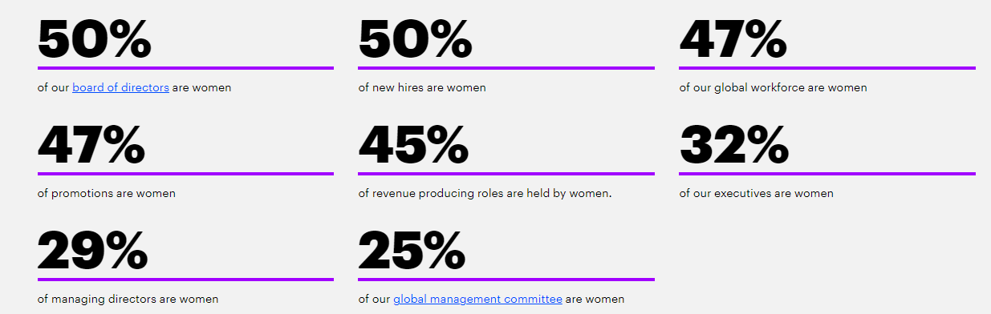
Figure 1: Gender equality in Accenture
(Source: Accenture, 2023)
The leadership of Accenture has acted on their commitment to gender equality by giving targeted support, agile work arrangements, and understandable programs of training and benefits. The organisation has significant objectives to improve gender equality and provide similar scope to all its employees, and due to that reason, the organisation is on its way to attaining “gender parity” by 2025. In addition to that, Accenture has been focusing on providing equal opportunities to disabled employees (Accenture, 2023). Therefore, Accenture is making sure that people with disability have been represented in their organisation. Moreover, leaders of Accenture have been providing workers with disabilities with accessible technology and tools and a basic accommodations program (Accenture, 2023). In addition to that, the leadership is considering cultivating superior awareness through basic training programs for people who have no disability to gain knowledge regarding tools as well as accommodations accessible for superior implementation over teams. Furthermore, to adopt an inclusive culture across the company. Through understanding the strategies of Accenture, other private companies can generate awareness-development through hiring efforts, events, and education programs related to disability to bolster their human resource. With the help of the approaches of Accenture, companies have been able to offer coaching initiatives and mentoring to make sure that people with disabilities can continue to succeed and grow. Moreover, this study is relevant as it provides the significance of diversity and equal opportunity in private companies around the world and through that employee of different backgrounds, gender, disability, and ages can occupy roles at each of the levels, involving top positions of leadership to make the operation f companies successful.

1.5 Research Aim and Objectives
The primary reason for facilitating this investigation is to assess the effect of HRM procedures on service productivity and equal employment opportunities for workers in private companies around the world. Moreover, to narrow the scope of the study, the case of Accenture has been considered.
Furthermore, to achieve the purpose of the study, certain objectives have been created, and those are,
- To critically assess the significance of HRM on service performance with respect to equal employment scopes for workers in private companies and Accenture
- To critically evaluate the issues experienced by HRM while creating equal employment scopes for workers in private companies and Accenture
- To critically analyse the methods implemented by HRM for giving equal scopes and upgrading the performance of employees of private firms and Accenture
- To suggest adequate strategies to the HRM of private companies for boosting management practices for brining in superior scopes to workers and augmenting their service efficiency

1.6 Research Questions
- What is the significance of HRM on service performance with respect to equal employment scopes for workers in private companies and Accenture?
- What are the issues experienced by HRM while creating equal employment scopes for workers in private companies and Accenture?
- What are the methods implemented by HRM for giving equal scope and upgrading the performance of employees of private firms and Accenture?
- What are the suggested suitable strategies for the HRM of private companies for boosting management practices for brining in superior scopes to workers and augmenting their service efficiency?

1.7 Research Structure
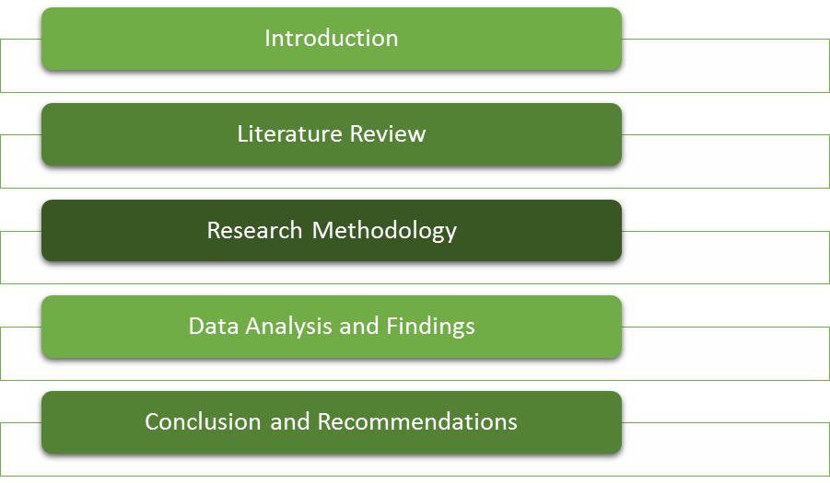
Figure 2: Structure of the research
(Source: Created by Author)
The foremost segment of this dissertation is the “introduction”, and in this segment, a short background of the study related to the effect of HRM practices on the performance of workers and equal employment scopes of workers in private companies and Accenture has been discussed in a proper way. Furthermore, the explanation for carrying out this study is also stated in this chapter through the rationale. In addition to that, the issues that the investigator has been trying to solve through this study are also addressed in this chapter. The questions that will be answered throughout the paper are also directed in this section, along with the purpose of this investigation and the objectives to reach the aim. Following that, in the next section, “the literature review”, the investigator will review journals based on the topic, and with that, the investigator will be including the arguments of scholars to make the study critical and significant. Additionally, “a conceptual framework” and the gaps in the literature that the investigator will face while collecting data from journals will also be declared in this section. In the “methodology” segment, the justification for integrating appropriate methods will be addressed. The procedure of data collection and analysis procedure of that data will also be directed in this chapter. In the “data analysis and findings” segment, both “qualitative” and “quantitative data” will be garnered through interviews and surveys, and that data will be assessed by comparing the information of the literature and the data. In the final chapter, all the chapters will be summarised, and recommendations will be provided in a proper way.

1.8 Research Significance
This investigation connected to the influence of HRM activities on service performance and equal employment opportunities of workers of the private sector and Accenture is significant as, in modern times, “equal employment opportunity” has s significant connection with the performance of workers and the leadership of Accenture is concerned about it. Therefore, the company has come up with various programs to integrate an inclusive culture into the organisation and reduce any kind of discrimination with its policies. Therefore, companies that are operating in the private sector can get proper information on strategies that they can implement to improve employee performance and provide equal opportunities to workers through understanding this investigation. In addition to that, policymakers can get significant details by comprehending this study and creating proper policies of equal employment scope in private companies. Additionally, future researchers who will be working on a similar subject can get proper insights into the data. This study will also contribute to existing literature related to HRM practices.

1.9 Chapter Conclusion
The assessment of the background of this chapter led to the understanding that Accenture has implemented equal employment scopes and diversity and inclusion through integrating several programs and policies, and through that, they have been able to inspire different private sector firms to strategies inclusivity within the operation. Therefore, with this study, companies can acquire proper insights to bolster their performance and organisational culture.

Chapter 2: Literature Review

2.1 Overview
The sections in this chapter have been provided with a plethora of data about the viewpoints of authors and experts that have clarified the aspects of human resources within the IT industry of the world. Through this section, the importance of HRM within the workplaces of the IT companies, and in terms of creating equal opportunities for employment within these companies, have been understood. In addition to this, the challenges that the HRM department has faced in the creation of viable equal opportunities have also been learnt in a thorough manner through this section. Additionally, the strategies that have been implemented by the HR departments in the industry have been explained in a thorough manner.

2.2 Importance of HRM on Service Performance in Terms of Equal Employment for Employees
Promotion of Diversity
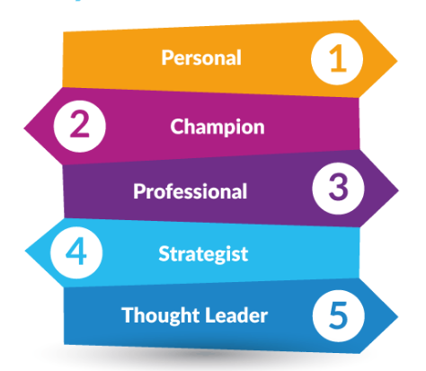
Figure 3: Types of Talents in Companies
(Source: AIHR, 2023)
One of the main benefits that an IT company can achieve through the means of the creation of equal opportunities for everyone is that the diversity within the company in terms of qualities can increase by a large margin, and this can help the company to navigate through a variety of issues. In addition to this, the diversity that is fostered within the organisations can also lead to various levels of innovation within the company. Koburtay, Syed and Haloub (2020) have added that IT companies also look towards diversity within the organisation as this can also elevate the overall balance of the organisation. Moreover, the IT industries can take up new challenges in the market through the means of greater and better diversity.
Career Development Opportunities
The increase in the equality of opportunities within the workplace can motivate employees by a large margin since they can avail equal chances for excelling in their careers. This has been a major point in the workplace, as unequal opportunities within the workplace can decrease the overall morale of the employees as they will feel less valued, and this can lead to conflicts within the workplace. As stated by Kim, Kim and Hwang (2020), equal opportunities by HRM can include the aspects of engaging with the company in an equal manner and expecting the same performance from every employee. Moreover, equal incentives the companies can also increase satisfaction in the workforce.
Improved the Reputation of the Organisation
Equal opportunities in the workplace have been valued by all forms of stakeholders of a company and also among the customers. Nambisan, Zahra and Luo (2019) have mentioned that the efforts of the HRM to maintain equality within the workplace can result in an increase in the overall satisfaction of the customers with the company and also an increase in the overall satisfaction of the stakeholders of the company. According to the research of Bhandari and McGrattan (2021), it has been mentioned that the reputation of the companies has often been formed through the means of equality that has been formed among all the employees within the organisations. The modern business landscape has demanded that companies come up with new plans for increasing inclusivity and equality among all employees within the workplace. Allowing equal opportunities within the companies can help in boosting progress towards such goals in an IT company.
Better Engagement from Employees
Equal employment opportunities in IT companies can give rise to increased satisfaction among customers since they can avail a plethora of facilities that can help them to excel in their respective careers. In addition to this, the teamwork of the employees can also increase by a large margin as the employees can appreciate each other in a better manner. Carli (2020) has mentioned that customers can increase the overall productivity of the entire company through the increased efforts provided by them throughout the research. The increase in the efforts of the customers can also provide impetus to the companies for capitalising on various opportunities that may arise within the market.
Better Recruitment
The increased reputation of the company can increase its position among new talents, and this can make it easier for the companies to attract new talents and also recruit them. This new recruitment among the companies can also increase the potential that they have in the country. According to Trudgett, Page and Coates (2021), recruitment within companies has been a major factor in businesses, which has increased the overall quality of the workforce. The candidates in the market can increasingly favour the company if the HRM stresses the betterment of equality among the employees. Creating equal opportunities in the market can also result in the company being exposed to the international domain of research.

2.3 Challenges of HRM to Create Equal Opportunities for Employees
Creation of Scope
The HRM in IT companies have often struggled to identify the areas which can be strengthened in order to facilitate equal opportunities for everyone. This has happened due to the lack of information about the employees and their needs. Moore and Khan (2020) have mentioned that the HRM department has often been inexperienced, and they have failed to understand the needs of the employees for equal forms of opportunities within the workplace. Moreover, the communication skills of the HRM department play a large role in terms of determining the amount of data that they can gather from the employees. The information about the needs of the employees can increase the overall perception of the human resources managers and employees, who can then take a plethora of steps to maintain equity among the opportunities that have been provided to the employees. Mira, Choong and Thim (2019) have added that the HRM department has also often lacked the training that is needed for them to increase the overall landscape of the creation of opportunities within the companies.
Identification of Gaps
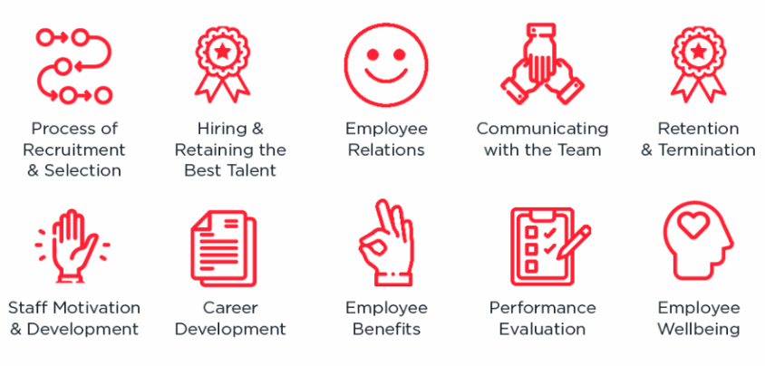
Figure 4: Challenges faced by HR
(Source: Logic Melon, 2023)
One of the main characteristics of the HRM department has been to identify various forms of challenges that the company has gone through in the workplace. This can help the HRM department to incorporate various forms of solutions within the workplace to mitigate the gaps. However, it has often been observed that the training of the HRM personnel has been lacklustre, and this has not allowed them to proactively detect the gaps in equality of employment within companies. Keegan and Den Hartog (2019) have observed that HR departments in companies can be misaligned with respect to the goals of the company, which can also result in the failure to provide equal opportunities to everyone. This is because equal opportunities in the market need to rise from the awareness of the HRM about the direction that the company has headed towards. The lack of general awareness of the leaders about equality has been a major reason behind the inability that HRM has faced to introduce equal employment opportunities.
Aligning Leadership
The alignment of the leadership with the HRM needs to be present in order to for the HRM to increase its efficiency in creating equal employment opportunities for the candidates. The perspectives of the leadership are important in the way through which the organisation is shaped and the way in which the workforce is distributed. Kinnie and Swart (2020) have mentioned that the lack of communication between the leaders and the HRM can create incompatibility and confusion among the companies. In addition to this, the HRM need to seek the agreement of the leaders before taking any steps towards the development of the organisation in terms of employment opportunities. However, the lack between the HRM and the leaders has been a challenge which has left the organisation in a critical state in terms of equality of employment opportunities.

2.4 Harvard HRM Model
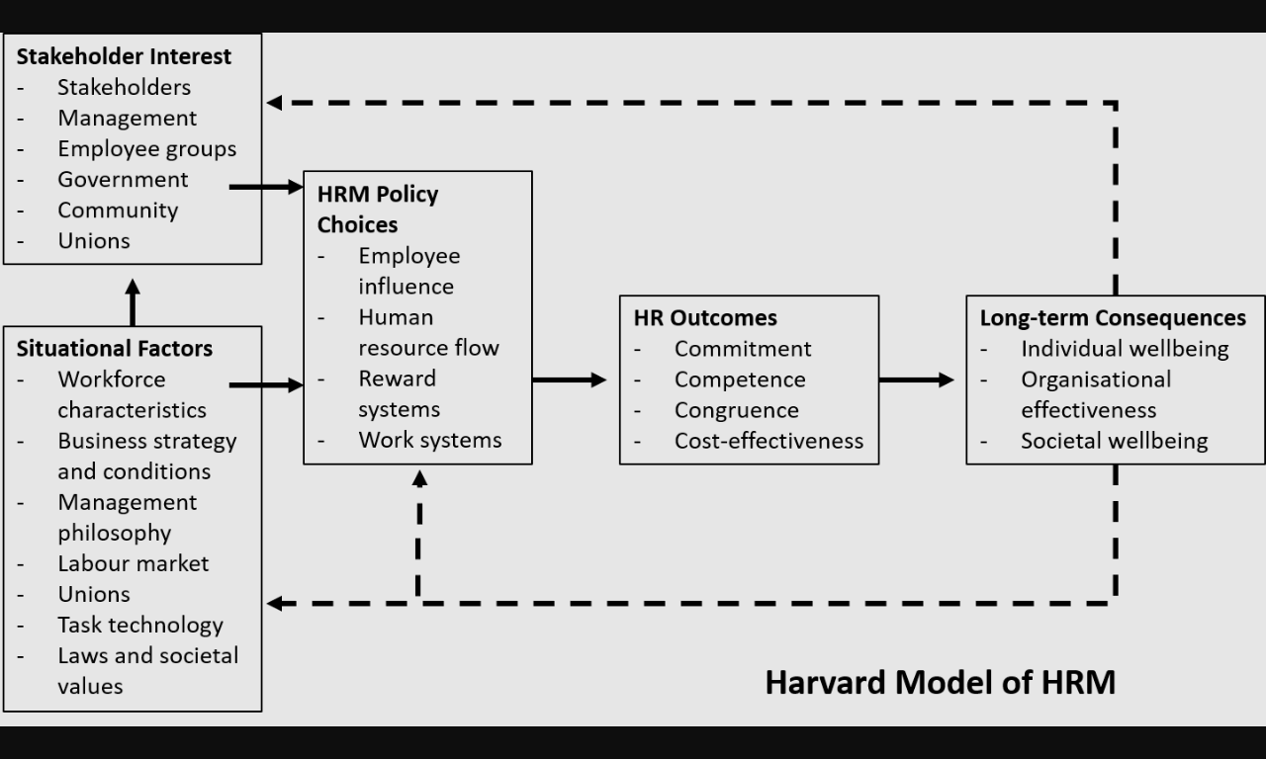
Figure 5: Harvard HRM Model
(Source: Tiwari, Srivastava and Kumar, 2019)
This model can be used to understand the importance of equality in terms of the employment of employees within the IT industry. This model states that the management philosophy of the HRM within the company has been an important factor which can increase the reputation within the market. The management philosophy refers to the beliefs and perspectives that the HRM and the leaders share within the company in terms of the management of the employees. Tiwari, Srivastava and Kumar (2019) have stated that the employee influence within the company can also be large, and this can help in refining the experiences of the HRM. The efficiency of equality in the employment of employees can also increase the aspects of the human resource flow in a company through the means of increased motivation and efforts from the companies. Additionally, the commitment of the workers concerning the firm and the engagement of the employees can be increased through the means of equal provision of employment opportunities.
The Harvard HRM model has contained a potent mix of data about the HRM tactics within the company, and this has also affected the company. Additionally, the stakeholders of the company can also play a role in terms of deciding the level of equality that can be provided in the market in terms of employment. One of the major aspects that companies can learn from this model is the importance of the satisfaction of the existing employees. Tiwari, Srivastava and Kumar (2019) have further mentioned that the training of the HRM employees is important, which can increase the overall productivity of the companies. Identification of various employee groups within the company can help the HRM of the company to gain feedback from them and thereby use these to increase their efficiency.

2.5 Strategies Implemented by HRM for the Creation of Equal Opportunities for Employees
A number of strategies have been applied by the HRM departments within IT companies in order to increase equality in terms of employment opportunities within the companies. These strategies have included an increase in the clarity of the goals of the companies in the long term. This has helped the HRM to set goals and expectations for the employees in a streamlined manner. Infante and Darmawan (2022) have mentioned that this can be achieved by the company through the means of constant communication between the leaders and the HRM department. The communication between the leadership and the HRM in a company can be enhanced through the inclusion of various forms of technological advancements and by training both parties with communication skills. Carnevale and Hatak (2020) have mentioned that companies need to also deliberate on the requirements of the employees and the struggles that they have been facing in the workplace. This can help the company and the HRM to frame a viable strategy for incorporating equality in terms of service opportunities. The leadership and the HRM need to be in agreement with the strategy that has been framed. This is crucial since the companies can set the expectations of the employees in agreement with the goals of the firm in the short term and in the long term. Lopez-Cabrales and Valle-Cabrera (2020) have observed that companies have often integrated the technologies of artificial intelligence (AI) and ML to increase the efficiency of decision-making within the company. This has helped them to decide the direction of the company in the competitive market. Additionally, the companies have also often provided training to the HRM personnel, thereby increasing their efficiency in communicating with the employees in a productive manner.
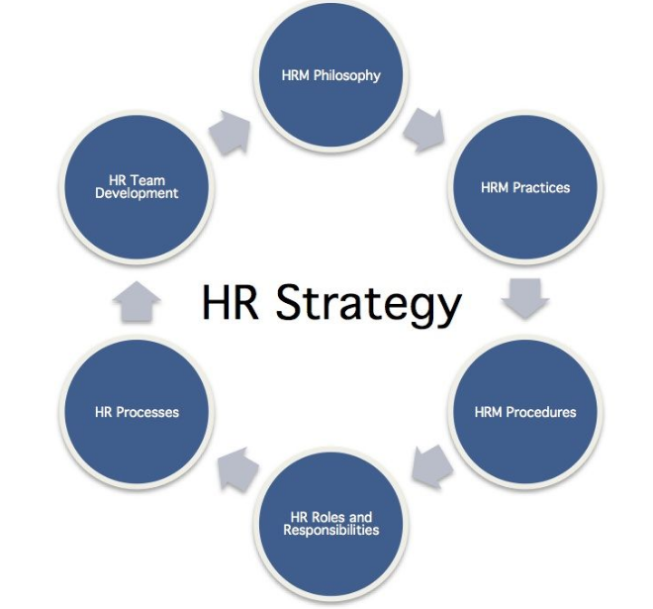
Figure 6: HR Strategies
(Source: The Human Capital Hub, 2023)
Another strategy that the HRM has implemented for the betterment of the provision of equal employment opportunities is to study the competitors who have found success in the market through the provision of equal employment opportunities. Another potent strategy that has worked for numerous companies is to listen to the employees and the complaints that they have. Nhlapo (2020) has fronted that this has helped the companies provide equal treatment to the employees and also equal forms of opportunities in the market. Additionally, companies have often utilised the feedback of the employees to reshape and refine their equality in employment strategies which has increased the reputation of the entities in the competitive market. Another important and common strategy within the company has been to advertise for both the men and the women population. Abdalla Hamza et al. (2021) have mentioned that this has increased the engagement of the male and female candidates in the interviews. In addition to this, this has also increased the satisfaction of the employees within the organisations. The diverse forms of advertisements in the market can also have an effect on the position of the company within the competition.

2.6 Conceptual Framework

Figure 7: Conceptual Framework
(Source: Created by Author)
Through this framework, it has been noticed that equality in employment opportunities has been important to the HRM of an IT company as it can provide the scope to increase the reputation of the company in the market. However, they have faced a few challenges in the training of the HR department, and this has led to challenges in terms of combination with the employees. Companies have made progress through the collection of viable feedback from employees in order to bolster their equality in terms of employment opportunities.

2.7 Literature Gap
One of the gaps that have been noticed in the literature has been the importance of HRM in the provision of equal opportunities in the IT industry. In addition to this, noticeable gaps have been noticed in terms of the challenges that IT companies have faced in terms of creating equal opportunities for employment. Additionally, the data about strategies of HRM for providing equal opportunities have been scarce. These gaps have been massive in the literature, and these will be addressed in this research procedure.

2.8 Summary
This section has exposed that the provision of equal opportunities for employment has been important in terms of the status of the company and in terms of the diversity that the company has in the market. In terms of the challenges that the HRM has faced, it has been found that the lack of training to them has resulted in lacklustre communication skills, and this has affected their communication with the employees. As a result, the companies have not been able to make any forms of meaningful changes in the market in terms of equality in employment.

Chapter 3: Research Methodology

3.1 Overview
This chapter of research will encapsulate all forms of research methodological aspects that have been utilised thoroughly for understanding the impacts that HR practices have had on the situation of equal opportunities and equal employment in the private sector, especially in Accenture. This methodological structure has been built through the assistance of the tool for noon. This has provided all forms of approaches that can be taken and thereby has helped in making a viable decision about selecting the most suitable methods in the research. The philosophy and the approach have been the main characteristics of this process, and the chapter has also included the aspects of ethical considerations and the limitations that the researcher has faced throughout the research.

3.2 Research Onion
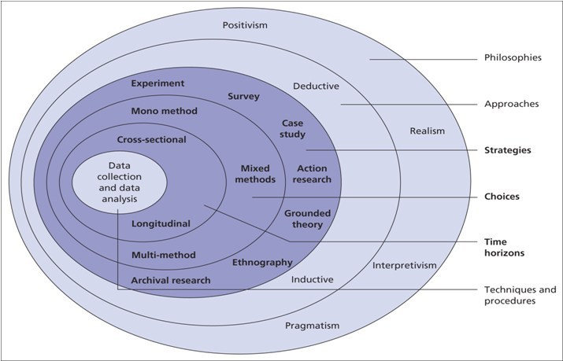
Figure 8: Research Onion
(Source: Saunders et al., 2019)
The onion tool has been taken in order to increase the overall efficiency of the research and to also create viable channels within opportunities based on the subject of the research (Saunders et al., 2019). The onion contained all forms of methods in concentric circles, which made it highly viable for the researcher to select the methods (Saunders et al., 2019).

3.3 Research Paradigm
The onion has been utilised in this research for the selection of the correct form of philosophy, and this has led to the selection of the most appropriate mindset within the research that has accelerated the progress of the research (Bleiker et al., 2019). There are numerous paradigms in the research which could be essential. In this research, the pragmatism philosophy has been selected since it the data could be interpreted in a variety of ways in the qualitative analysis of both qualitative and quantitative information.

3.4 Research Approach
The approach has also been elected from the layers of the onion, and a number of aspects have been investigated before its selection. The pathway of the research is dependent on the research requirements. The second layer of the onion has encapsulated all forms of approaches, and the inductive approach has been designated for this examination (Bairagi and Munot, 2019). The inductive approach has been selected for collecting the data through the pathway of objectives and questions within the research. The deductive approach has not been feasible since hypotheses have not been needed within the investigation.

3.5 Research Choice and Time Horizon
The choice in this research has been formed on the basis of the number and the types of strategies that are needed to be selected for the investigation. There are a number of choices that are present within the onion, and the research has selected the mixed-method choice because a combination of two strategies can provide sufficient information about the impacts of HRM on equal opportunities and employment in Accenture PLC (Newman and Gough, 2020). The mixed-method choice will make it highly convenient and efficient to understand the trends of human resources practices within the company of Accenture PLC (Kumari et al., 2023). A single method will not be utilised since this was not sufficient for this investigation. Another element within the research has been the time horizon which decides the time through which the data is collected within the study. The cross-sectional time horizon can be feasibly utilised for collecting the information from a fixed point in time, which can increase the overall productivity of the procedures.

3.6 Research Strategy
The strategy in the study has been chosen with caution as this leads to a viable data collection procedure that is aligned with the requirements of the companies. The strategy has been chosen on the basis of the choice that has been selected (Islam and Aldaihani, 2022). From the plethora of options, a combination of the case study strategy and the survey strategy has been utilised in a viable manner, thereby increasing the quality of the entire interview procedure. The adoption of a mixed strategy in this research has provided exposure to the data that was needed to meet its aims. The HRM of Accenture PLC has been investigated extensively, and the trends of employment and equality have come forth through this strategy of the company.

3.7 Sampling Technique
The sampling in this research has played a crucial role that has increased the overall quality of the entire investigation. Sampling is the process through which the primary sources in this investigation have been chosen for the collection of data. The sampling in this research also governs the procedures through which the data is gathered within the research. There are a number of options in terms of sampling that have been considered within the research. In this study for investigating the human resources within Accenture PLC, the convenience sampling technique has been chosen for selecting the sample for the survey and for the interviews (Berndt, 2020). The random sampling process has been used in the research as it ascertains that selection bias does not occur in the research.
In this study, 120 employees of Accenture PLC were targeted, from which 100 were finally selected for the research process. In addition to this, 50 mid-level employees from Accenture PLC have been targeted, and 30 employees from them have been taken for the final interview procedures (Berndt, 2020). 100 has been a sizeable sample which has provided a vast array of quantitative information. This, coupled with the qualitative sample for the interviews, has provided an abundance of information about the human resources of the company, which has helped in framing the outcome of this research.

3.8 Data Collection
The collection of data within the research has been done through two methods which are the interviews and a survey procedure. The survey data collection procedure was chosen in this research since the quantitative data is valued for its precision in providing insights about the HRM practices of Accenture PLC in relation to equality in employment and opportunities. On the other hand, the interviews have provided elaborate viewpoints of mid-level employees within the organisation about the treatment of the HR leaders towards them (Pandey and Pandey, 2021). The employees of Accenture PLC were identified from LinkedIn, and they were recruited through email. Invitations were sent to 120 employees, and 100 responses were eventually collected in the research.
The survey was conducted through the means of a questionnaire. The questions for the survey were made using the Likert scale to gain measurable responses. They were of a close-ended nature so that quantitative results could be gathered from the research. A total of 20 questions were included in the questionnaire. Furthermore, the interview questionnaire contained 4 questions only so that the required information could be gathered from the research. These questions were open-ended in nature so that the answers could be received in open-text format and the extensive details regarding their personal perspective could be understood. This questionnaire has been developed on the basis of the objectives that have been selected prior to the beginning of the research. In the case of the interviews, in-depth questions were asked through the portal Google Meet. The 30 interviews lasted for about 1 hour, and a plethora of elaborate information was gathered about the HRM scenario within Accenture PLC.

3.9 Reliability Evaluation
One of the aspects of research is the evaluation of the data that is collected within the research. The evaluation of the reliability of the data within the research has been carried out in order to ensure that the data is without any flaws or errors. In the case of the quantitative data, this has been ensured through the test-retest check. It has been carried out by collecting data from the same sources from Accenture on two different occasions (Quintão, Andrade and Almeida, 2020). These sets of data were tallied to find the level of reliability within the study. In the case of the interview data, the parallel forms reliability checks have been performed as this has provided an easy path for the evaluation of the integrity of the data. Through this process, the researcher asks the same set of questions to the sample through two or more procedures (Moon, 2019). This has provided the reliability of the information and has also provided stability to the investigation. The evaluation of both forms of data has also resulted in better integrity in the entire study.

3.10 Data Analysis
The analysis of data in this investigation has involved two different forms of evaluation techniques due to the presence of two varying natures of data. In the case of quantitative data, the SPSS tool has been implemented that provides the data in statistical form using tables and graphs. This tool has facilitated the evaluation through the procedures of “correlation analysis” and the “descriptive statistical analysis”. These procedures are some of the most viable techniques for the evaluation of quantitative information (Kleinheksel et al., 2020). A wide variety of perspectives have been examined through these forms of data analysis. In the case of qualitative data, the NEO tool has been selected within the research.

3.11 Research Ethics
The ethical considerations within this research have been important since two different methods have been utilised for collecting data from primary samples relating to Accenture PLC. This research demanded a thorough data analysis, and the researcher was involved in a discussion with the “University Research Ethics Committee” about the steps that can be taken to mitigate potential challenges that may arise in the companies (Brandenburg and McDonough, 2019). One of the main areas where the researcher has concentrated in terms of ethical integrity is the confidentiality of the data that has been gathered from various primary sources of information from Accenture PLC. The confidentiality of the data has been protected by storing the data in a safe passcode-protected device, and this was retained in the ownership of the researcher only. The obscurity of the participants was also protected by avoiding the usage of their real names throughout the research.

3.12 Summary
The pragmatism paradigm has been utilised within the study as this has provided support to both the qualitative and the quantitative nature of data. In addition to this, the inductive approach has been selected, which has increased the overall convenience of the entire research procedure. The HRM of the company of Accenture PLC has been evaluated through the means of both quantitative and qualitative data, which has broadened the horizon of the company by a considerable margin. The NEO tool has been utilised for the evaluation of the interview data, and SPSS has been utilised for the analysis of the quantitative information.

Chapter 4: Data Analysis and Findings

4.1 Overview
This particular section of data analysis and findings will illustrate the responses that are obtained from the survey that is held on 100 workers of Accenture for illustrating the importance of HRM in presenting opportunities. Moreover, there will be the utilisation of interviews among the managers to depict the use of the practices by these leaders in an effective manner. The opinions of the respondents helped in analysing the situation in a better manner by contributing to the research by providing their personal opinions on the questions of the study, which met the objectives. The particular chapter was also presenting the summarisation of the key findings from both the literature and the analysis of data section into a single paragraph and forming a comparison between those two to increase the understanding of the investigation. The graph and the table, which are allowing to show the results of the survey, were provided, and all the justifications and statements are following below the table.

4.2 Survey Data Analysis
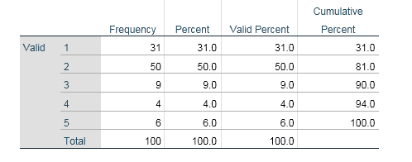
Table 1: Age
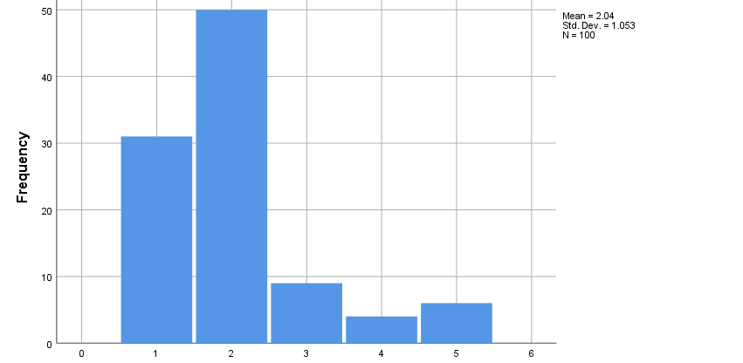
Figure 9: Age
The actual purpose of this survey was to analyse the impact of HRM practices on “equal employment opportunities” as well as the performance of the private sector workers, which is the reason the perception of 100 employees of Accenture has been considered. The first question was related to the age of the participants, and the response led to the understanding that 50 partakers were between the age group of 21 to 25 years, and 31 participants were between 18 to 21 years. It has been observed that 9 participants were between the age group of 25 to 34 years, and 4 respondents were between the ages of 35 to 50 years. There are 6 contributors whose ages are above 50 years. The age group of 21 to 25 years are given more priority as they have experience in working and are able to produce the right information. With the level of experience, the respondents were being able to form a comparison between the companies to assess the different policies of employee benefits given are better or not. Moreover, the aged population are mainly avoided for the survey. The main reason behind it as they are working in the particular company for a long period of time and are unable to differentiate the level of benefits and the uniqueness of the HRM policies on employee growth in the company.
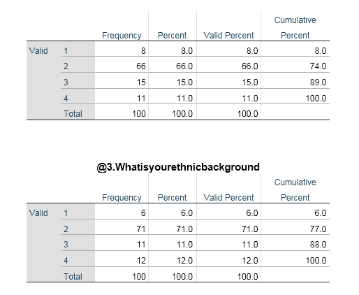
Table 2: Gender
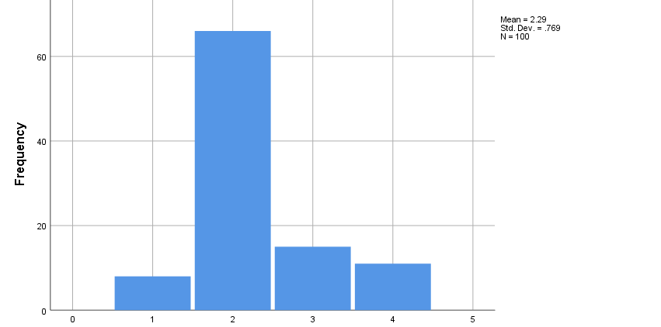
Figure 10: Gender
In this question, the 100 participants of Accenture were enquired about their gender identity; the response has led to the understanding that 66 contributors prefer to identify themselves as male, whereas 8 have identified themselves as female. On the contrary, there were 15 participants who identified themselves as transgender and 11 contributors preferred not to reveal their gender identity. By asking to identify the gender of the respondents, interesting results come out of it. The high number of the transgender population in the participant group and the company suggests that the policy of equality in the workplace, irrespective of gender, has been thoroughly maintained. Moreover, equal opportunities for increasing professional development have been provided by the researcher. Equal chances in the scope of careers and their professional lives have been given by the company. Hence, the title of diverse work culture in the international region has been owned by Accenture. Moreover, the internal management of the company has been understood by the diverse working employees in the company.
Table 3: Ethnicity
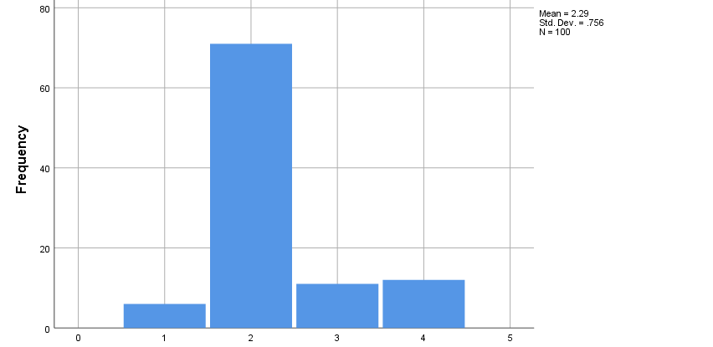
Figure 11: Ethnicity
All 100 employees of Accenture who have taken part in this survey were enquired about their ethical background, and it has been observed that 71 contributors were from Asian backgrounds. The data have suggested that 12 contributors were of Hispanic ethnicity, and 11 contributors identified themselves as African. On the contrary, out of all the participants, 6 were British. The study on the context of the particular question has provided an understanding of ethnic diversity in the organisation. Employees from Diverse culture have been presented, and equal treatment to all the employees have been given. In the international business zone, where Asians are considered the most discriminated section of the population socially in the workforce, Accenture has prioritised the contribution they made to the company. The lack of discrimination in their hiring process is the main reason behind increasing of the perception of the brand towards the employees and the customers have also been made. The results have shown the diversity and equality policies of the company in a more prominent manner.
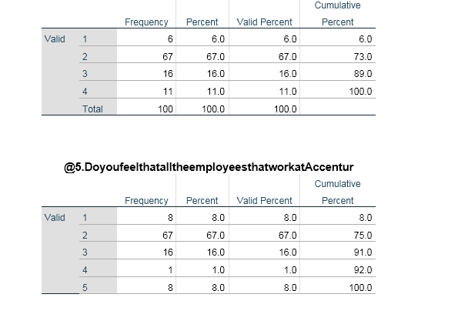
Table 4: Working duration
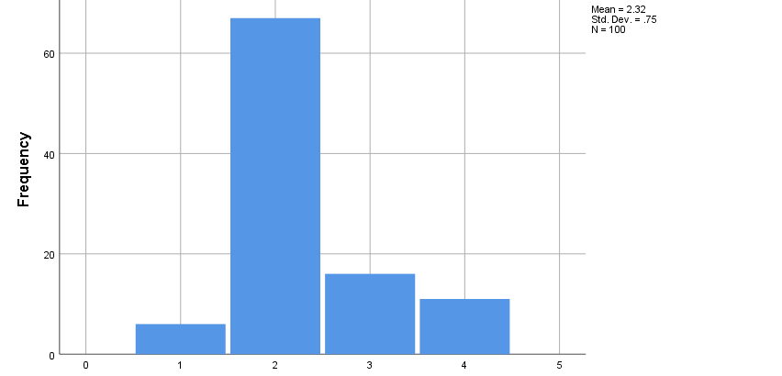
Figure 12: Working duration
In this survey enquire, all of the partakers were asked about how long they have been working in Accenture; among 100 contributors, 67 have mentioned that they have been working for 2 to 5 years, whereas 16 have stated that they have been working for 5 to 10 years. It has been observed that 11 contributors have worked for more than 5 years, and 6 partakers have been working for less than 2 years. This company have a workforce which is both young and experienced. The selection of participants who have a low experience of 2- 5 years in the present company has been selected. The justification for it is to give them the chance of formation of the comparison between the different companies they work for prior to the present one. The formation of comparison in different employment opportunities in the HRM policies has been increasing the outcome, which has been decided by the investigators. However, the low experience, which is less than 2 years, has been avoided by the researcher as they are not yet aware of the complete policies of the HRM department on providing better development areas to the employees.
Table 5: Same Opportunities
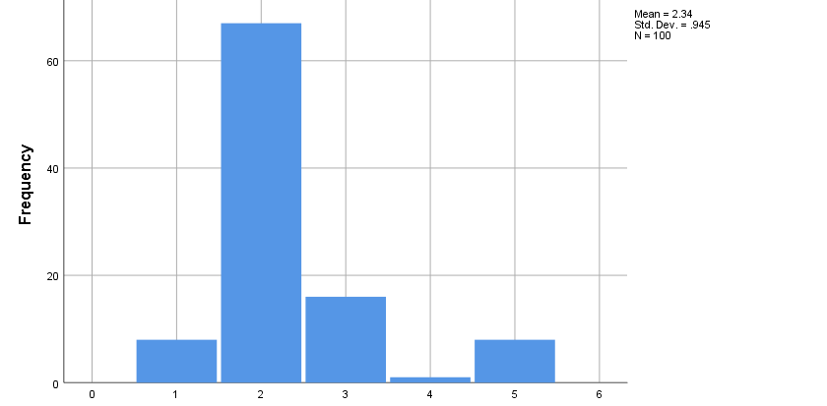
Figure 13: Same Opportunities
All 100 employees of the global IT leader, Accenture, were enquired about their feeling regarding that if they receive equal opportunities at work, there are 67 partakers who have agreed to this statement, and 8 have strongly agreed. 16 contributors preferred to remain in the neutral position, whereas 8 strongly disagreed and 1 disagreed. This indicates that they do not think that in Accenture, they have received equal opportunities. The majority of the respondents are in favour which suggested that the HR in the company have been providing an equal scope of career development in the company. Accenture is known for promoting and encouraging the hiring of a diverse workforce and promoting the well-being of employees. The priority in the need for equality in the opportunities among the employees has also been provided by the company. Hence, the policies have been following the vision and mission statement of the company, which is to balance equality and organisational growth hand in hand. Furthermore, the chances of occurring of any discrimination are much lower; hence only one participant has shown their disagreement with the particular statement.
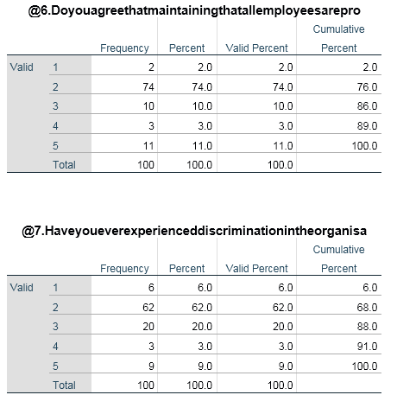
Table 6: Equal employment opportunities
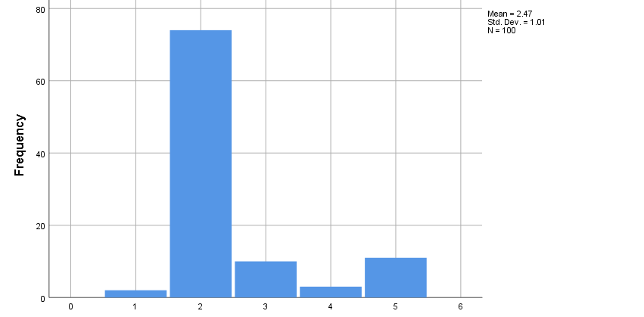
Figure 14: Equal employment opportunities
In this survey query, all 100 participants were asked if they believe providing equal employment opportunities is necessary for Accenture; the gathered data have provided insight that 74 respondents have agreed to this statement, along with 2 participants who have strongly agreed. Whereas 10 partakers opted to stay in the neutral position. 11 respondents strongly disagreed, and 3 disagreed, which means they do not think that the proclamation was true. Equality must be the motto statement of the company. By providing equal growth opportunities to the employees, the productivity and the motivation of the staff have been noted to improve; hence, the company have been prioritising understanding the need of the employees and providing equal treatment and equal scope of development without any discrimination irrespective of any variables. A sense of recognition has started to build among the staff with providing of better opportunities. However, some of the participants disagreed with the mentioned statement as they strongly believed the opportunities must be provided by analysing the contribution they make as providing the same scope sometimes act as the non-motivational factor for the employee who worked really hard.

Table 7: Gender discrimination
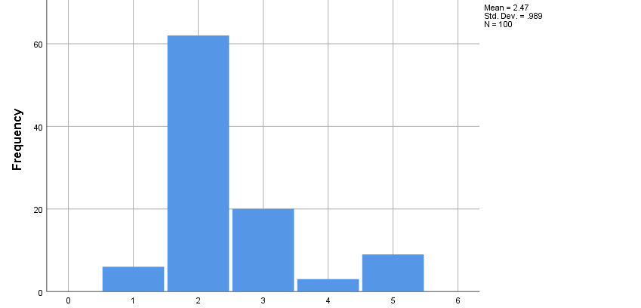
Figure 15: Gender discrimination
In this question, all 100 employees were asked if they have observed any form of discrimination in Accenture regarding organisational opportunities solely due to their gender identity. The response has provided insight that 62 contributors have “agreed”, and 6 participants have strongly agreed with this statement, which means they have faced discrimination. 20 partaker have preferred to remain in the “neutral position” since they do not have a definite answer to this query. On the contrary, 6 participants strongly disagreed, and 3 disagreed with this proclamation since they have not faced any gender discrimination in this IT Company. Despite the notion of not promoting any kind of discretisation in the company, the respondents of the survey have provided different results according to the questions. The majority of the population who have taken participation in the survey have provided that they faced discrimination in the company and that gender discrimination is the major oppressing factor in the company. The believer of pertaining of high gender discrimination has classified gender discrimination have reduced the different engagement of the employees in the company, which have an adverse impact on the process of growth in the company. The minority of the respondents noted that the company had been strictly following the no-discrimination policy, and they did not face any kind of discrimination among the employees and the management during their duration period of work.
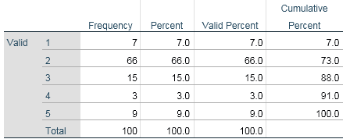
Table 8: Accenture has benefited due to equal opportunities
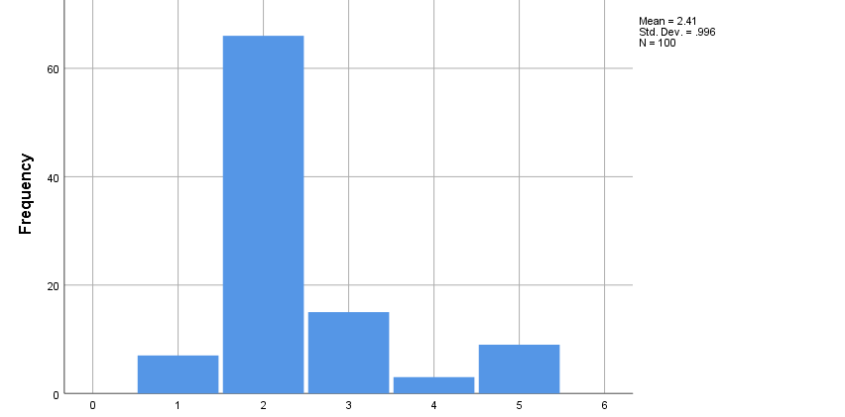
Figure 16: Accenture has benefited due to equal opportunities
All 100 workers of Accenture who have been considered for this research were asked if they believe their company have benefited by providing equal opportunities for the workforce; the response showed that 66 staff have agreed to this statement. 7 respondents strongly agreed, and 15 contributors preferred to stay in the neutral zone. The survey data have shown that 9 participants strongly agreed with this proclamation, along with 3 respondent who disagreed, since they do not think that their company have received any benefits for equal scope in the workplace. Employee motivation is the major factor which has been increasing the growth of the organisation along with the improvement of the performance of the employees. Sand providing a sense of equality and sense of recognition to the employees has a positive impact on the employees. An increase in employee satisfaction with the company has been observed. The function of the company has become balanced, and the stability in the internal environment has also been maintained. The majority of the population has noted the significant benefits and improved employee performance. However, the disagreed section of the respondents personally did not feel any positive changes, and they believe, with or without providing employee benefits, the staff do not improve their performance.
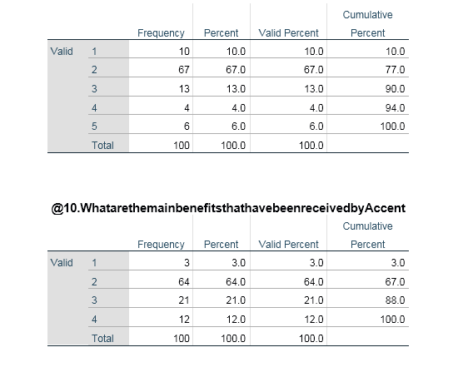
Table 9: Discrimination due to Ethnicity
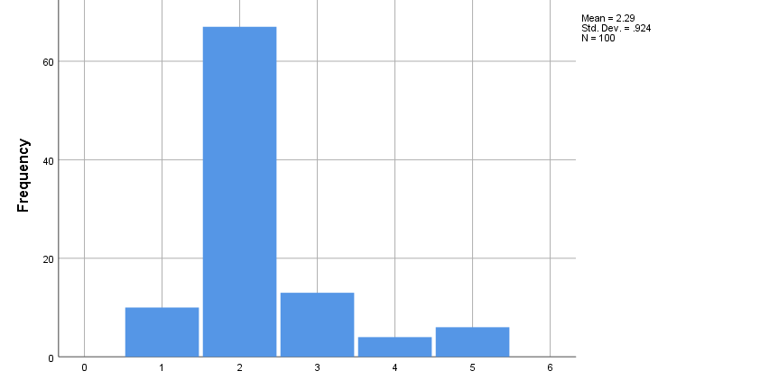
Figure 17: Discrimination due to ethnicity
In this survey question, all the participants were asked if they have faced any form of discrimination in Accenture in the context of career progression due to their ethnicity. The response to the survey has provided the insight that out of 100, 67 respondents have agreed to this and 10 have strongly agreed, which means they have faced discrimination. Furthermore, the data have indicated that 13 participants have remained in the neutral position, whereas 6 respondents strongly disagreed whereas 4 disagreed, which means they have not faced any ethnicity-related discrimination in this IT Company. By conducting the survey, different information on the basis of the discrimination faced by the employees in the company has been assessed. High discrimination on the basis of ethnicity has been found by the researcher according to the responses of the participants. The major section has chosen to believe that they faced different discrimination from their colleagues while working together, and the management did not take any strict action against it; hence, the discrimination has continued for a long period of time. In addition, the satisfaction of the employees has also started to reduce with facing discrimination while working in Accenture from both the management and the other employees.
Table 10: Benefit of equal opportunities
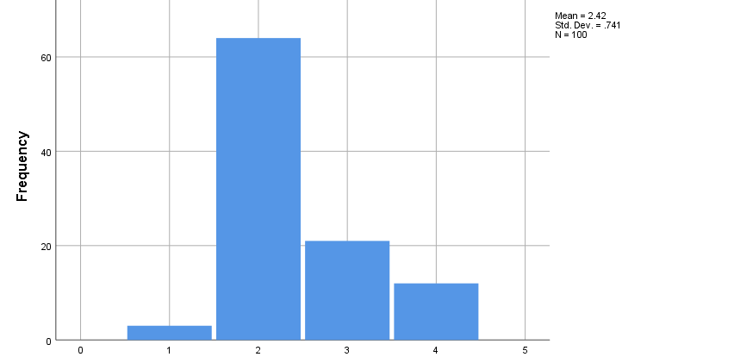
Figure 18: Benefit of equal opportunities
In this query, all the contributors were asked about the main benefits they have attained in Accenture because of equal opportunities. The response showed that 64 participants have the belief that it has simplified the process of recruitment; on the other hand, 21 contributor thinks that it is related to career development. It should be highlighted that for 3 contributors out of the 100, it is related to increased reputation. It needed to be highlighted that 12 have the perception that all the aforementioned benefits are the main benefits of equal opportunity. The participants have noted by reducing any discrimination and providing an equal employee development scope, the recruitment procedure has become more simple as no elimination of the employees in respect of gender and ethnicity was present, and only the most capable employees who are right for the position have been chosen. The particular benefits have a positive impact on the company as the performance of the employees has also started to increase. In addition, the brand image of the company has also been noted to increase with the incorporation of the policy of equal opportunities and provide of the scope of equal career development in the company.

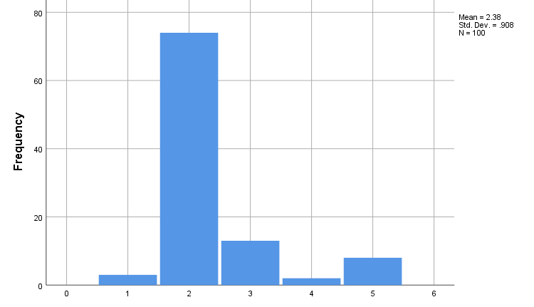
Figure 19: Equal opportunities for Accenture in maintaining a diverse base of the employees
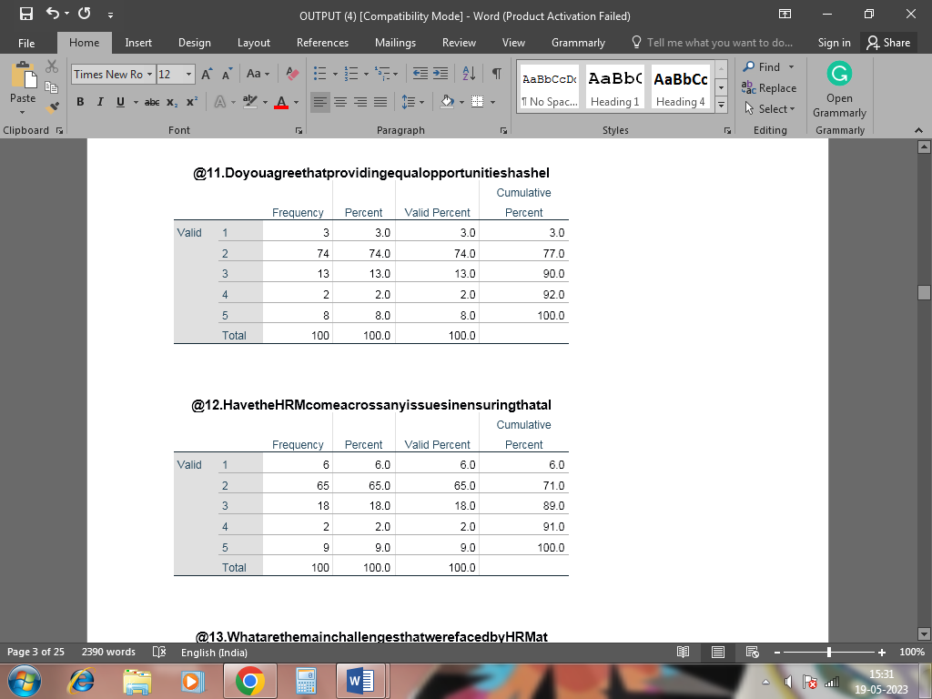
Table 11: Equal opportunities for Accenture in maintaining a diverse base of the employees
The answers from the survey depicted that the equal opportunities that are given to their workers ensure that there is better administration of their diverse workforce, which is needed for addressing that their employees are accepted by these firms, as well as are capable of gaining job satisfaction, which is from proper distribution of opportunities for these employees, in which highest number of responders agreed to the statement that is provided to them. The study has also provided that the company have been prioritising the incorporation of equal employment opportunities for an individual of the same post and task. The motivation of the employees in response to that has started to develop in a significant manner. In addition, the stable management in the internal management of the company has also become much easier in nature. The respondents have also stated that managing the employees has become much easier in comparison to the prior period of time. The improvement in the function and performance of the employees have also been monitored by the researcher by the survey details.
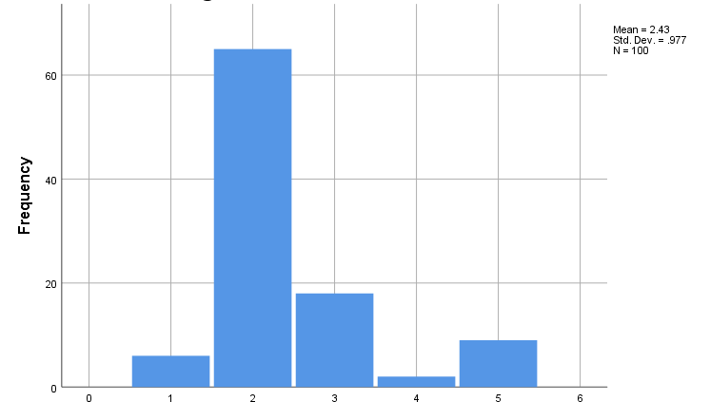
Figure 20: Issues faced by Accenture for managing opportunities for their diverse workforce
Table 12: Issues faced by Accenture for managing opportunities for their diverse workforce
There was a survey conducted among the 100 workers of Accenture that there are challenges in maintaining equal opportunities for their employees, in which there is an inefficient use of their organisational methods. Moreover, it is seen that there is the presence of ineffective communication among their workforce, which is accounted to be the major hindrance in accordance with the statement given by these personalities. “The mean” is 2.43, and “the standard deviation” is 0.977. Better communication is the goal of the organisation, and with the help of communication, more organisational growth has been ensured. However, the lack of communication between the staff with the management has been obstructing the spreading of awareness of equal opportunities among the employees. In addition, the lack of engagement of the employees with the management team has also started to increase with the lack of right and sufficient communication. In addition, the proper method of delivering different policies among the employees is also a challenging factor. However, the main challenge is the factor of lack of communication has been given.
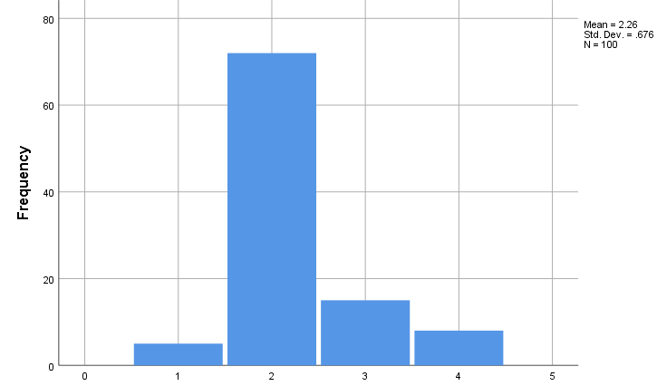
Figure 21: Challenges of Accenture
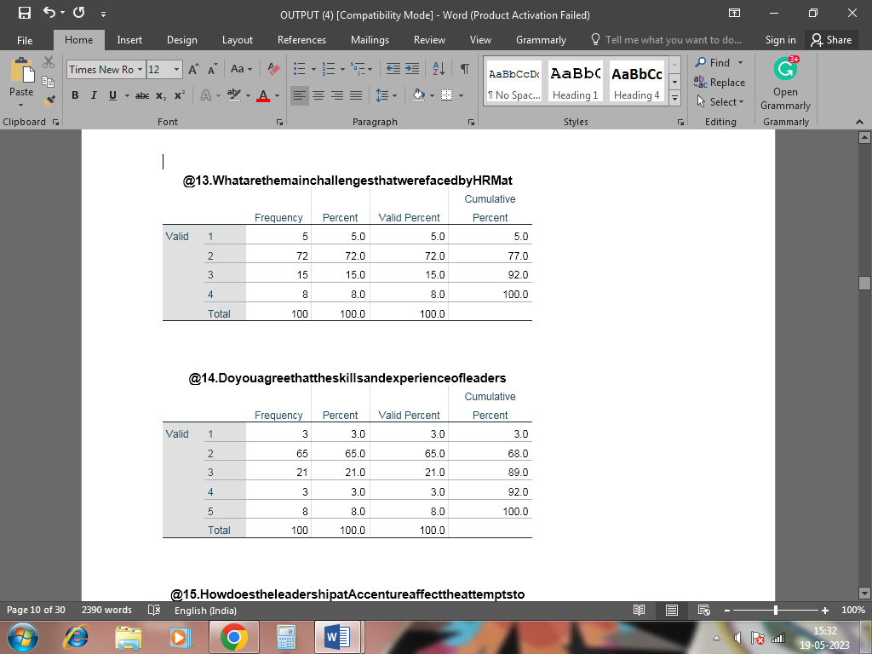
Table 13: Challenges of Accenture
The represented figure illustrates that there is an enhancement seen in profit attainment practices by Accenture through properly providing better opportunities for their work. However, according to the responses lack of communication among these workers, which is a vital element that is necessary for addressing better implications of their organisational practices, further allowing them to attain improper use of their business tactics. “The mean” is 2.26, and “the standard deviation” is 0.676.
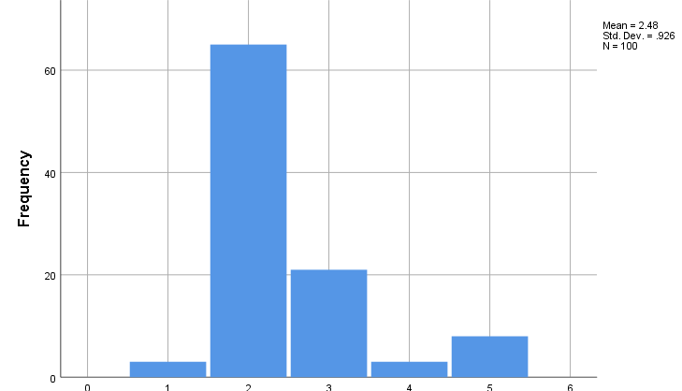
Figure 22: Prominence and skills of leaders in catering equal opportunities
Table 14: Prominence and Skills of Leaders in catering equal opportunities
The presented figure depicts the responses to the survey, which stated that most of the responders agreed with the statement that was presented to them, which ensured that there had been a better use of their firm processes, which is required in deeming an enhancement in their firm processes. Moreover, better-skilled workers are considered to operate with better efficacy which is for administrating their employees in using their firm processes. The study on the empirical data has shown that the Leaders in the IT sector have the main role in increasing and promoting quality in the organisation by implementing several strategies in the organisation for promoting equal employment opportunities in the company. In addition, the satisfaction of the employees also started to balance with the higher competency of the leaders in the organisation. The rate of success and the performance of the employees have started to grow in a drastic manner with the incorporation of high competency among the leaders. Better communication between the employees and the management has also been maintained is the belief that the researcher found from the survey results.

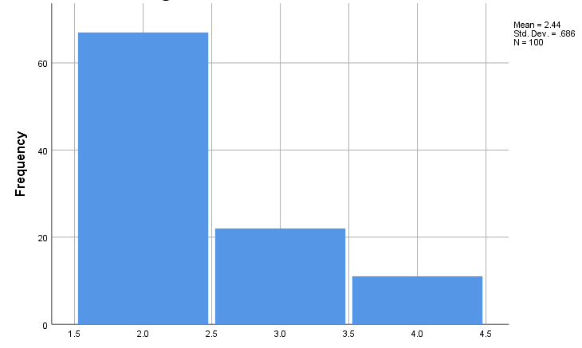
Figure 23: Ways in which an effective HRM provides equal opportunities

Table 15: Ways in which an effective HRM provides equal opportunities
There are several ways, in accordance with the responses that are gained from the survey, in which there is an effective formulation of their organisational practices. Moreover, 67 responses were gained by these companies, which depicted that there is an effective use of their firm processes that is liable for effectively formulating their communication practices inside their organisational processes and knowing the areas in which there is a need for changes and accordingly, the new practices are implicated. “The mean” is 2.44, and “the standard deviation” is 0.686.
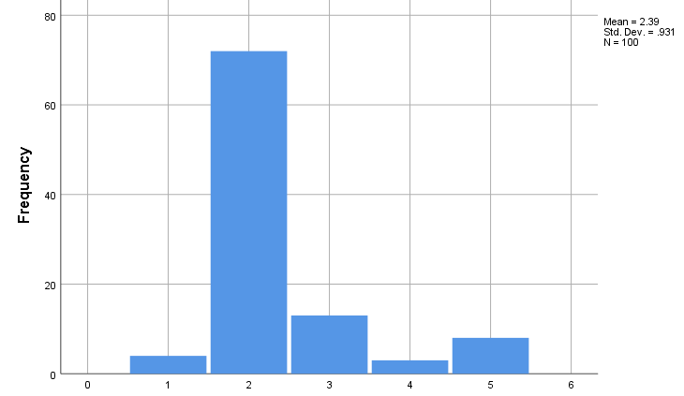
Figure 24: Essential utilisation of new technologies by Accenture
Table 16: Essential utilisation of new technologies by Accenture
The depicted figure illustrates that there is an increase seen in their profit attainment practices, through which there is a proper formulation of their firm processes, which is needed in gaining better attainment of their firm processes which is required in gaining better utilisation of their organisational practices, in which most of the participants agreed with the statement that was presented to them in the form of query. “The mean” is 2.39, and “the standard deviation” is 0.931.
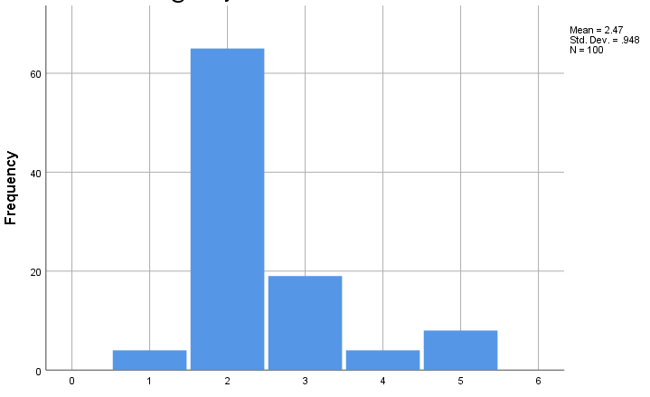
Figure 25: Prominence of communication among the leaders and the workers for more opportunities
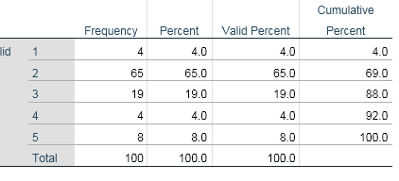
Table 17: Prominence of communication among the leaders and the workers for more opportunities
The replies that are attained from the portion of the workers that were attained from the portion of the survey that was held among the 100 workers of Accenture depicts that there was a higher number of responses attested which stated that their employees agreed with the statement that was catered to them in the form of survey. Moreover, it forms an efficient use of their firm operations, which administrates their employees in an effective manner through which their processes are mitigated in an efficient manner. “The mean” is 2.47, and “the standard deviation” is 0.984.
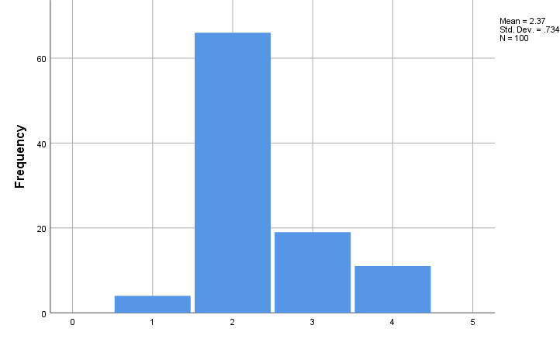
Figure 26: Major strategies that are used by Accenture for providing equal opportunities

Table 18: Major strategies that are used by Accenture for providing equal opportunities
Implementation of processes in formulating communication within the workforce of this company presents their organisational leader with the capability of using their firm processes, which is necessary for generating a hike in the efficacy level of their administration that is done for their employees present in this firm and to depict complement of their organisational methods in an effective manner. “The mean is” 2.37, and “the standard deviation” is 0.734.
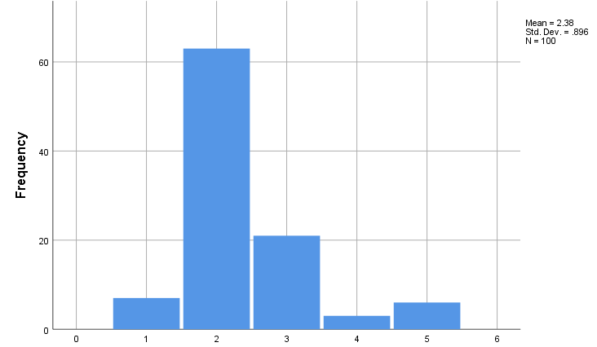
Figure 27: Effect of Culture on organisational processes of Accenture

Table 19: Effect of Culture on organisational processes of Accenture
The depiction of the figure illustrates that there is a hike seen in the efficacy level of their firm processes, which is needed in properly administrating their firm practices in which there is a proper use of their organisational processes and is necessary for depicting an efficacy in their admiration of jobs and opportunities in accordance with their skills. “The mean” is 2..38, and “the standard deviation” is 0.896.
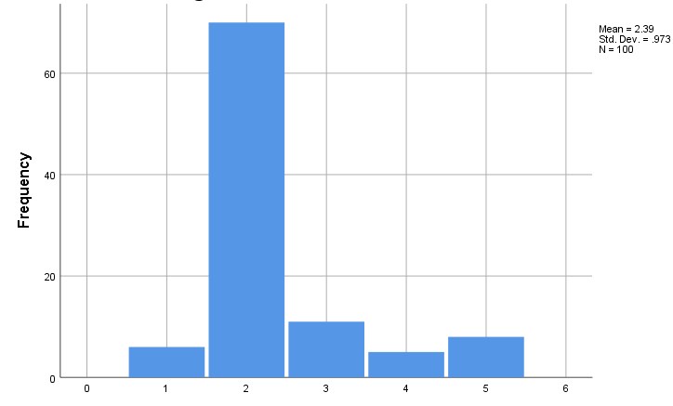
Figure 28: Influence on the growth of the company through effective employment possibilities
Table 20: Influence on the growth of the company through effective employment possibilities
The represented figure that is shown in the presented graph depicts that there are more workers that agree with the statement of the query. Moreover, there was a presence of workers that did not agree with the question from the survey. “The mean” is 2.39, and “the standard deviation” is 0.973.

4.3.1 Correlation Analysis



The above-illustrated chart provides a statistical relationship between the dependent and independent variables, where 1 represents the dependent variable and the values that are changed with respect to the dependent variables are called independent variables. In the dissertation, the variable that is manipulated by the investigator or varies in an experimental study to explore its effects it’s called the Independent variable. Therefore, evaluating dependent and independent variables in the form of survey questions allowed the investigator to be able to statistically bring forth some effective insights regarding this particular topic. It has been seen that employee that working at Accenture are getting equal opportunity is observed to be a dependent variable on the other hand “Marinating the a better workplace culture where employees are getting same employment opportunity”, “ Any sort of discrimination in the organsiation based on the gender” , “Accenture has benefited from maintaining to provide equal opportunities for all workers”, “ Have your organsiation experiencing discrimination in the organsiation based on the ethnicity” “ what ae the main benefits have been received by Accenture because of providing equal opportunity” , Do you agree that providing equal opportunities has allowed Accenture to maintain a diverse employee base”, have the HRM across any issues in make sure that all employee were getting equal scope of growth and opportunity” “what are the major issues encountered by HRM at Accenture in terms of managing to provide equal opportunity” is found to a independent variables where value are 0.434, 0.292 , 0.451, 0.638, 0.472, 0.507, 0.518, 0.556, 0.412, 0.452, 0.674, 0.530, 0.385, 0.347, 0.403. Therefore, the positive correlation value signifies that any positive change in dependent variables that is mentioned earlier in this section has had a positive impact on the independent variable, which establishes a positive correlation between independent and dependent variables.

4.3.2 Descriptive Statistical Analysis
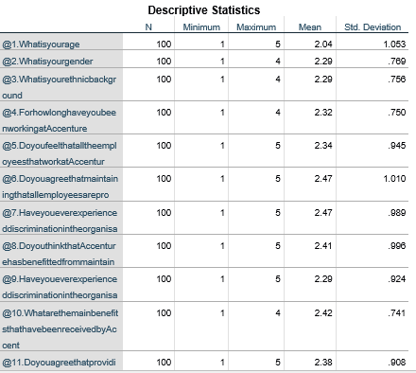

The “descriptive statistical analysis provides viable information regarding the mean and standard deviation of statistical evidence that has been attained by the investigator to carry out a survey among employees of Accenture. The mean and SD values are represented in the form of survey questions Marinating a better workplace culture where employees are getting same employment opportunity”, “ Any sort of discrimination in the organisation based on gender”, “Accenture has benefited from maintaining to provide equal opportunities for all workers”, “ Have your organisation experiencing discrimination in the organisation based on the ethnicity” “ what are the main benefits have been received by Accenture because of providing equal opportunity”, Do you agree that providing equal opportunities has allowed Accenture to maintain a diverse employee base”, have the HRM across any issues in making sure that all employee was getting an equal scope of growth and opportunity” “what are the major issues encountered by HRM at Accenture in terms of managing to provide an equal opportunity”. The mean value are 2.04, 2.29, 2.29, 2.32,2.34,2.47, 2.47,2.41, 2.29,2.42, 2.38, 2.26, 2.48, 2.44, 2.39, 2.47,2.37,2.38, 2.39 on the other hand SD are 1.053,0.693, .0.576,0.750,.945,1.010, .989,.996, .924,.741, .908,.977,0.676, .926,.686, .931,.948,.724, .896. Therefore, the value of the mean is greater than the SD, which means that the value clustered around SD and hence values are highly reliable.

4.3 Thematic Data Analysis
Theme 1: Opportunity
The reply that is given by the manager of Accenture for the query that was for them in the section of interview depicts that there is an essential role seen for the consumers that are part of these firms, through which there is the proper administration of their workforce, which is necessary for them in properly implying their business practices which are needed in obtaining an enhanced interaction from their patrons, which in returns caters them with an increase in the efficacy of their business operations allowing an increase in their efficacy in their profitability. Moreover, the HRM of this firm has the liability of catering to their patrons with their demanded products in their firm practices, which allows them to obtain an advantage in the competition that is carried out in the market of IT firms, instructing them in the attainment of a hiked rate of clients that are willing to formulate their purchase from these corporations.
“The presence of HRM gives us opportunities for properly administrating their workforce, through which our company tactics are formulated in an effective manner”. –Manager 2
The statement gained from a statement that is presented by the participant of the interview depicts that there is an increased motivation and morale of their employees in which there is an attraction of better interaction from the consumers of Accenture, as these workers are considered to be efficient in attaining proper use of their organisational operations, which includes an effective implication of their organisational methods, which instructs them in properly formulating their firm practices, further allowing them to gain an enhancement in their revenue attainment process. Moreover, there is an increase in their organisational processes, which ensures the acquisition of a better level of profit by these corporations. Furthermore, the HRM of these firms caters for these personalities with their demanded products, which is required in depicting an effective utilisation of their tactics and to find out an efficacy in their organisational operations, allowing this firm to increase their brand image through which there is climb noticed in their profit generation.
“The fringe benefits that are presented to our workforce by our HRM is crucial for presenting our consumers with the aspect of job satisfaction, through which there is an increase in morale and motivation of our workforce”. –Manager no 1
Theme 2: Benefits and challenges
In this interview question, the manager was asked about the benefits related to the maintenance of equal opportunities in the global IT company Accenture, and they have the perception that it has the capability of promoting diversity. This also has the capability of boosting the morale of employees from different backgrounds and gender, which over a longer period of time, leads to higher innovation and organisational productivity.
“…I think that establishing an equal organisational culture has helped our company to improve workforce diversity which has a direct connection with workplace morale and productivity.” - Manager 3.
It has been observed that enabling equal opportunities in the workforce has the capability of improving the market reputation, which in a longer period of time, attracts the attention of skilled employees from the diverse pool of talent. As a re result, the company develops a competitive edge over the close competition, which leads to higher sales and profitability. The maintenance of equal opportunity in Accenture has improved the level of employee engagement, due to which all the workers of this company have the willingness to perform their best level of benefit to the company.
“… fostering equality in the workplace has improved the reputation of our company in the world, which is the reason we do not face much problem in recruiting skilled employees in different nations, improving organisational innovation”- Manager 14.
In the present business landscape, IT companies have been facing multiple issues in maintaining equality in the workplace, and the absence of female leaders in Accenture is one of them. Another issue is related to unconscious biases among the male HR manager of this IT company, which lessens the number of female employees in leadership positions.
“….even though my company have implemented multiple training and development programs for our recruiters, still there are a limited number of female employees in the managerial positions. I think unconscious bias is the main reason behind this.”- Manager 28.
Theme 3: Strategies
The employees of Accenture who are taking part in the interview revealed that their organisation have been adopting different strategies so as to ensure that employees who are working in the different working domain of this organisation are getting an equal scope of growth and opportunity which signifies the robustness of HRM practices of Accenture. In changing demographics of the staff are triggering a fresh look at maximising employee performance along with transforming “Human Resource” services, while the advent of emerging technology is creating new opportunities for the HR function of this particular organisation. This way, the managers of Accenture are able to build a workplace culture where employees are able to understand their organisational task in a more effective manner and safeguarding this aspect allowed for the development of an organisational method that allowed HR professionals of this organisation to be able to retain their talented workforce for long duration.
“… Our organisational HRM strategies and practices allowed for the improvement of organisational strategy towards retaining viable candidates with which in terms of talent acquisition and retention our company have gain a stronghold…” employee 3_ Accenture
The employees of Accenture further suggested that their organisation have been taking affirmative action to hire, recruit and train and advance in employment females, minorities, and disabilities protected under state as well as local law. In addition to this, Accenture also pledges to make responsible accommodations for the mental and physical limitations of employees and applicants who are especially disabled and unable to work compared to those who do not have any kind of physical condition. Therefore, maintaining diversity and inclusivity while recruiting candidates from different parts of the globe allowed Accenture to build a culture where applicants, without facing hesitancy, are able to provide their thoughts and ideas while the interviewer is taking their interviews. This sort of imitative that has been undertaken by Accenture allowed them to hire talented workforces who have a decent knowledge regarding the use of modern tools and technologies, which aided this organisation to be able to develop projects for their client segment that come with decent quality.
“… Provide equal scope of growth and opportunity helps our organisation to increase organisational productivity and performance at a certain extent”, which leads to the anticipated business outcome….” Employee 5- Accenture

4.4 Analysis of Interpretation
4.4.1 Importance of HRM for maintaining equal opportunities in the workplace in Accenture
The existing literature sources have provided insight that one of the key benefits of employee diversity is related to the promotion of diversity in the workforce, which leads to better outcomes. It improves innovation, allowing IT companies to cope with the modification in the business landscape (Koburtay, Syed and Haloub 2020). It also has the capability of improving the reputation of the company in the IT sector, which not only attracts new businesses but also grabs the attention of skilled employees (Bhandari and McGrattan 2021). Furthermore, IT companies also look towards diversity within the organisation as this can also elevate the overall balance of the organisation. Moreover, the IT industries can take up new challenges in the market through the means of greater and better diversity which leads to the reputation of the companies often being formed through the means of equality that has been formed among all the employees within the organisations. The modern business landscape has demanded that companies come up with new plans for increasing inclusivity and equality among all employees within the workplace. Allowing equal opportunities within the companies can help in boosting progress towards such goals in an IT company. (Koburtay, Syed and Haloub, 2020). The survey data analysis has provided the information the majority of the participants have stated that providing equal opportunities for all employees has the capability of improving the reputation of the company and simplifying the process of recruitment. The interview data have also provided the insight that the managers of Accenture think that focusing on workplace equality has the capability of improving the reputation of the company, which brings new customers and skilled employees. The assorted data have shown that it has the capability of improving the productivity of the workforce, which improves organisational efficiency.
4.4.2 Challenges of HRM in Accenture concerning carte equal opportunity for employees
The information that is presented in the literature review segment contains some scholarly evidence which depicts that within an organisation, lack of communication between employees HRM and leaders can create confusion among them, as a result of which, in many cases, they are unable to develop a workplace culture where everyone’s needs and expectations are equally addressed (Kinnie and Swart 2020). Moreover, HR departments in companies can be misaligned with respect to the goals of the company, which can also result in the failure to provide equal opportunities to everyone. This is because equal opportunities in the market need to rise from the awareness of the HRM about the direction that the company has headed towards. The lack of general awareness of the leaders about equality has been a major reason behind the inability that HRM has faced to introduce equal employment opportunities (Keegan and Den Hartog 2019). Almost similar results have been found from the “survey data analysis” chapter that highlights that lack of communication of the HRM limits their scope of identifying employees who are performing well, and hence it negatively impacts the potential of the company to provide better employment opportunities to them.
4.4.3 Strategies employed by HRM of Accenture for the development of equal opportunities for staff
The evidence that has been attained from the preexisting literature sources, it could be rationally brought to a conclusion that within the IT sector, the leaders always ensure that employees are getting an equal scope of growth and opportunity so they are willing to perform at their best level which allowed these companies to retain their workforce in the best term. This could be achieved by such businesses through the means of maintaining constant communication between the leaders and the HRM department (Infante and Darmawan, 2022). In addition, HRM has implemented the betterment of the provision of equal employment opportunities to study the competitors who have found success in the market through the provision of equal employment opportunities. Another potent strategy that has worked for numerous companies is to listen to the employees and the complaints that they have towards the company (Nhlapo 2020). The survey data analysis revealed that improving communication has allowed the HRM of Accenture to be able to evaluate frequent needs and expectations of employees in an effective manner, besides allowing this organisation to make their organisation more productive who are always willing to provide their best to carry out their regular work. Moreover, a thematic portion of the research suggested that Accenture provide employment opportunities to those who are physically vulnerable that, make their workplace culture more inclusive.

4.5 Summary
This segment of the research has already provided the perception of the 100 employees of Accenture, and taking the survey among them makes this research inclusive in nature. On the other hand, the interview was also conducted among 30 employees of Accenture, which enabled the investigator to be able to effectively differentiate this segment with respect to the prevailing “Literature review” chapter. The study has provided that the leaders in the IT sector have a role in increasing the process of improvising several strategies to promote employee satisfaction in the business. Providing equal employee benefits of the staffs have been increasing the satisfaction of the employees, and the performance of the staff has also been noted to increase in a drastic manner. In addition, challenges on lack of communication have been the oppressing factors in promoting the aspect of equal opportunities in the areas of the organisation.

Chapter 5: Conclusion

5.1 Conclusion
The introductory chapter of the research assimilates some of the effective segments of the dissertation, namely the background, problem statement and rationale of the research, which all together enabled the development of knowledge which is based on the influence of HRM practices on equal employment scope and opportunities of employees who are working within private sector companies. Through assessing this chapter of the research, it could therefore be brought to a conclusion that in the contemporary year, economic instability has triggered companies that are belonged to the private sector companies are inclined towards hiring employees who use their knowledge, experience and capabilities to ensure the aspect of competitive advantage in this particular sector. With the development of sustainable working conditions for the employee segment, the leaders of the private sector enhance the scope for themselves towards attracting new staff and retaining existing ones in an effective manner. One of the leading private sector Accenture focuses on diversity and inclusivity and implements a specialised training program for their employee segment, which ultimately leads to an increase in employee performance and productivity to a large extent. The introduction segment of the research further concludes that Accenture also offers flexible operation arrangements, resources for mental health and network support which make this company one of the leading market players in the domain of providing employment to the workforce. In recent years, Accenture also promoting gender equality objective in their organisation and provided equal scope to all its employees, and for this reason, this company have been able to achieve gender parity by the year 2025. Additionally, this company has been providing equal employment opportunities to disabled employees, which results in the enhancement of organisational image and recognition at the same time.
Based on the prevailing literature sources, it could be critically concluded that many private sector companies, namely IT firms, nowadays heavily give priority to the aspect of early carrier development opportunities, which increase the equality of opportunities within the workplace, which ultimately increase motivation among the employee. Effective carrier development programs have allowed employees of many private sector companies to be able to increase the overall urgency of them excelling in their careers, which is recognised to be one of the competent HRM practices of private companies in the global. Moreover, gauging the performance of staff have allowed managers of these companies to be able to effectively allocate training program and carrier development opportunity that can facilitate the individual to sharpen up their skills in different field of work, which relates to augmentation of overall productivity of the HRM department of such business regarding the aspect of delivering the better scope of early carrier growth opportunity to the employees. However, HR departments of private sector companies are oftentimes unable to align the business objective and employee expectations which are proven to be the main reason behind the failure of the company to provide an equal scope of early carrier growth and opportunity to the individual. Nevertheless, the “literature review” section of the research also provides viable information regarding the strategies that have been adopted by HRM of private sector companies for the development of equal opportunity for employees. It has been seen that maintaining effective communication between HRM and the leadership has allowed for the development of factors by which companies that are associated with the IT sector have been able to assess the needs and expectations of their employee base in an effective manner and hence provide training to those staffs who are unable to perform at their level best.
According to the methodology segment of the research, it could be brought to a conclusion that the philosophy that is best for quantitative and qualitative research is pragmatism, along with an inductive approach has been used. Moreover, the primary form of data collection technique has been used in this research with the help of surveys and interviews.
The data analysis segment of the research leads to the development of proper comprehension of the knowledge that each research question and objective holds. With the development of knowledge based on the subject, it could conclude that for improving company reputation and image, well-known service-based IT companies in modern times deeply prioritise the aspect of equal employment. In this way, Accenture, in recent years, has been able to retain its organisational staff in an effective manner which facilitated HR managers of this company to streamline the aspect of the recruitment process as per their future business needs and requirements. The findings part of the dissertation further concludes that Accenture also focuses on workplace quality that has the potential to augment the reputation of the company, which assists them in encouraging their employees to work to their full potential. It has been seen that the capability of the company towards product development has been increased when the HRM department anticipates individual needs and expectations in an appropriate manner, and this way, they are able to attain a competitive advantage over their closest competitor. The findings section leads to the development of knowledge regarding the challenges that have been encountered by the HRM department of Accenture, which revealed that lack of communication is considered to be one of the major factors that restart managers to identify employees who performed at their level best. As a result of that, it oftentimes impacts the overall capability of the to provide better employment scope to the employees. In order to eliminate this sort of ambiguity, Accenture has been implementing effective communication channels by which the HR managers have been able to pay attention towards individual needs and where they are lacking eventually acknowledged. By implementing programs related to diversity and cultural inclusivity, Accenture nowadays enhances its scope for itself to bridge the significant gap of gender diversity where female employees are getting an equal scope of employment opportunities with respect to male co-workers. In terms of retaining the workforce, Accenture also attains a greater position in the global market.

5.2 Linking with Objectives
5.2.1 Impact and importance of HRM equal employment and service performance for private sector companies like Accenture
Based on the prevailing literature sources, it could be brought to the conclusion that ensuring diversity and inclusivity is recognised to be a viable asset for private sector companies that are generally providing IT solutions to their client base. It has been seen that ensuring workplace diversity is recognised as a key to reducing ambiguity within the workplace, and hence employees who are belonged to different cultural backgrounds have been able to share their innovative thoughts and ideas without facing any issues. Therefore, IT companies, through diversity, have been able to maintain a healthy work culture where individual needs and requirements are rightly addressed by the HRM (Koburtay, Syed and Haloub 2020). The findings chapter of the dissertation revealed that prior to the recruiting employee from different parts of the globe, one of the well know private sector companies had provided an equal scope of growth opportunities to their existing employees, as a result of which new employees are facing lesser issues while they share their thoughts and ideas to their co-workers. Moreover, workplace quality has allowed Accenture to bridge the skill gaps in their workforces, which over time improves organisational efficiency. Hence, the objective has been fulfilled.
5.2.2 Challenges faced by HRM regarding the employment opportunities and service for employees of Accenture
The critical nature of the scholarly information has allowed the investigator of the research to highlight some of the prominent issues that have been faced by the HRM of private sector organisations, namely IT companies. Therefore, the vastness and criticality of the existing literature section instigate research investigator to bring forth some effective ideas which revealed that the unable to provide equal skilled enhancement training to the staff leads to the degradation of overall performance and productivity of the staffs which signifies the incompetency of HRM department in terms of creating an equal opportunity to their workforce regarding providing training to them (Mira, Choong and Thim 2019). The vivid information that has been found in the section of findings illustrates that lack of communication has caused significant issues to the HRM of private sector companies as, in many cases, the managers who are working in such departments are unable to identify those who are lacking in terms of performance. These types of factors have led to a significant impact on organisational performance in terms of measuring employee productivity and performance in a suitable manner. Therefore, the objective has been established.
5.2.3 Strategies applied by HRM for providing equal opportunity and improving the performance of private sector workers
The scholarly information that already exists within “Literature review” revealed that one of the effects by which HRM managers have been able to find out those who are providing their best towards their regular organisational work through the means of clear constant communication between leaders and staff of the company. Moreover, communication between leadership and the HRM department also turns out to be beneficial for the private sector companies to increase the clarity of the goals of the company in the long run (Infante and Darmawan 2022). The findings segment of the research duly highlighted that, with the help of maintaining effective communication, the HRM managers of Accenture have been able to identify the foremost needs and expectations of the employees in the best terms. Thereby, the objective has been accomplished.

5.3 Limitation
The in-depth knowledge that is comprised in this research paper has so far helped the research investigator to specify the sector, which in this case private sector, namely Accentuate, that has a competent HRM practice by which they are able to provide equal employment opportunity to the employees which are considered to be one of the most important measures towards encouraging diversity and workplace inclusivity at the same time. However, like other research papers, this subject also has its own limitation as HRM practices not just aid public sector companies towards providing equal scope of growth and employment opportunity to the workforce but also help other sectors towards addressing this same aspect. Therefore, in order to understand and gain viable insights from this research topic, the investigator of the research can take an example of other sectors, such as Retail, construction etc., By addressing these gaps in future. The research investigator can be able to assimilate relevant industry knowledge and the company's HRM practices which could lead to the improvement of the outcome of the entire research.

5.4 Recommendations
Over the last couple of years, the higher number of staffs attraction rate is considered to be of the major issues of many businesses, and for this reason, the degradation of organisational productivity and performance has become a very common issue to such companies. Therefore, recommendations to the companies that are belonged to the private sector will be attained through this exhaustive research segment.
5.4.1 Providing Security to the Staff
As a higher staff turnover rate lead to the massive degradation of organisational productivity and performance to a large extent, therefore, the best practice of the HRM department is employee security. In the private sector, there is both an informal contract and a formal contract between the employer and employees Zalisham and Jali (2021). Moreover, providing job security in spite of the type of contract helps multiple private companies to be able to build trust and loyalty among the employee segment and ensures this aspect is recognised to be crucial in terms of gaining better results towards retaining viable candidates (Permarupan et al.2020). Besides this, employment security allowed staff to go home after their organisational work as well as provide for themselves and their families. This particular concept of security can be vital and underpins almost everything that HR does for their organisation.
5.4.2 Hiring the right people
With the development of emerging tools and technologies, companies in modern times can be able to hire the right candidates for their business by which the HR managers can be able to increase skills among their employee segment according to their business requirements. It can be observed that a person who is able to add value to the organisation can be able to sort out different business problems with ease, and hence their chance of getting a leadership position also enhanced over time. Therefore, the HRM department of many private sector companies, prior to hiring new staff, can evaluate the efficiency of their organisational ability towards finding out relevant candidates (Chetty et al.2020). This particular strategy is found to be effective in terms of providing equal scope of employment and growth opportunities to the existing staff who are providing their utmost best towards making their organisational project successful. Moreover, the adoption of effective performance management tactics can be an effective solution for public sector companies towards addressing the foremost needs and expectations of employees regarding key areas of improvement. This particular strategy can be effective in an aspect of eliminating the skills gap between new employees and old ones by which productivity and performance over time can be elevated (Istanti, Negoro and GS 2021).
5.4.3 Fair as well as performance-based compensation
Maintaining diversity and workplace inclusivity can allow for the development of better performance management tactics that HRM of the private sector can rely upon. It can be observed that increased competition between private companies has forced the HRM of such companies to hire a large number of employees as per their business needs and long-term expectations (Tien et al. 2021). However, oftentimes due to the increased client pressure and strict deadlines, HR professionals are unable to acknowledge the financial needs of their workers, which is observed as a main cause of the increased employee turnover rate. However, implementing performance-based compensation can be the best alternative for the private sector that can help HRM of them to identify the foremost financial needs and requirements of the employees, which over time increases the wiliness of staff to provide their best possible level of performance towards their regular work (Strine, and Smith 2020).
5.4.4 training in relevant skills
This is considered to be one of the effective measures that allowed many companies to develop products and services for the customer segment that are effective in terms of meeting their demand and requisite in a simplistic manner. After hiring the best people, HR professionals are required to ensure that they remain the prime candidate in the field (Tien et al.2021). Therefore, providing training to the staff according to their domain of expertise is considered an effective way to build a workforce where individuals are able to learn about new technologies as per their organisational requirements. For instance, employees who have a strong knowledge of JAVA can be able to learn new programming languages more firster in comparison to those who do not have relevant skill sets. The role of the HRM is to bridge the gap between the employee's field of work and new technology so all of them are productively conducting their organisational task.

5.5 Future Research Scope
For accessing this research which is based on the aspect which leads to the development of knowledge regarding the influence of HRM practices on equal employment opportunity along with service performance, the investigator is inclined towards implementing the “Primary Data Collection” technique in the form of survey and interview together. However, similar research in future could be understood with the help of the “secondary data collection” technique as this particular type of data collection technique has the ability to make any research diverse and inclusive at the same time. Moreover, scrutinising credible sources of companies which in this case of Accenture, will help the investigator of the research to focus more on the current employment practices of this company and its future implication in the best terms.

Reference List
Accenture, (2023). Advancing gender equality. News. [Online] Available at: https://www.accenture.com/in-en/about/inclusion-diversity/gender-equality [Accessed on: 10th June, 2023]
Accenture, (2023). Our commitment to inclusion & diversity. News. [Online] Available at: https://www.accenture.com/in-en/about/inclusion-diversity-index [Accessed on: 10th June, 2023]
Adeosun, O.T. and Owolabi, K.E., (2021). Gender inequality: determinants and outcomes in Nigeria. Journal of Business and Socio-economic Development, 1(2), pp.165-181. https://www.emerald.com/insight/content/doi/10.1108/JBSED-01-2021-0007/full/html
Bairagi, V. and Munot, M.V. eds., (2019). Research methodology: A practical and scientific approach. CRC Press. https://books.google.com/books?hl=en&lr=&id=wxaGDwAAQBAJ&oi=fnd&pg=PP1&dq=research+methodology+approach&ots=vvWDP40ut3&sig=HVGB4hIUE-YAlJv7dNSvinGOW_k
Berndt, A.E., (2020). Sampling methods. Journal of Human Lactation, 36(2), pp.224-226. https://journals.sagepub.com/doi/pdf/10.1177/0890334420906850
Bhandari, A. and McGrattan, E.R., (2021). Sweat equity in US private business. The Quarterly Journal of Economics, 136(2), pp.727-781. https://www.nber.org/system/files/working_papers/w24520/w24520.pdf
Bleiker, J., Morgan-Trimmer, S., Knapp, K. and Hopkins, S., (2019). Navigating the maze: Qualitative research methodologies and their philosophical foundations. Radiography, 25, pp.S4-S8. https://ore.exeter.ac.uk/repository/bitstream/handle/10871/39690/JB%20Navigating%20the%20maze.pdf?sequence=1
Blom, R., Kruyen, P.M., Van der Heijden, B.I. and Van Thiel, S., (2020). One HRM fits all? A meta-analysis of the effects of HRM practices in the public, semipublic, and private sector. Review of Public Personnel Administration, 40(1), pp.3-35. https://journals.sagepub.com/doi/pdf/10.1177/0734371X18773492
Borst, R.T., Kruyen, P.M., Lako, C.J. and de Vries, M.S., (2020). The attitudinal, behavioral, and performance outcomes of work engagement: A comparative meta-analysis across the public, semipublic, and private sector. Review of Public Personnel Administration, 40(4), pp.613-640. https://journals.sagepub.com/doi/pdf/10.1177/0734371X19840399
Brandenburg, R. and McDonough, S., (2019). Ethics, self-study research methodology and teacher education (pp. 1-14). Springer Singapore. https://link.springer.com/chapter/10.1007/978-981-32-9135-5_1
Carli, L.L., (2020). Women, gender equality and COVID-19. Gender in Management: An International Journal, 35(7/8), pp.647-655. https://www.wimin.ie/s/Women-Gender-equality-and-COVID-19.pdf
Chetty, R., Friedman, J.N., Hendren, N. and Stepner, M.,(2020). The economic impacts of COVID-19: Evidence from a new public database built using private sector data (No. w27431). national Bureau of economic research. https://opportunityinsights.org/wp-content/uploads/2020/06/Short_Covid_Paper.pdf
Hendri, M.I., (2019). The mediation effect of job satisfaction and organizational commitment on the organizational learning effect of the employee performance. International Journal of Productivity and Performance Management, 68(7), pp.1208-1234. https://feb.untan.ac.id/wp-content/uploads/2020/07/24.pdf
Horváth, D. and Szabó, R.Z., (2019). Driving forces and barriers of Industry 4.0: Do multinational and small and medium-sized companies have equal opportunities?. Technological forecasting and social change, 146, pp.119-132. https://www.sciencedirect.com/science/article/pii/S0040162518315737
Infante, A. and Darmawan, D., (2022). Gender Equality: Women's Involvement in Human Resource Management Practices. Journal of Social Science Studies (JOS3), 2(1), pp.27-30. https://ejournal.metromedia.education/index.php/jos3/article/download/16/22
Islam, M.A. and Aldaihani, F.M.F., (2022). Justification for adopting qualitative research method, research approaches, sampling strategy, sample size, interview method, saturation, and data analysis. Journal of International Business and Management, 5(1), pp.01-11. https://www.researchgate.net/profile/Md-Islam-394/publication/357352896_Justification_for_Adopting_Qualitative_Research_Method_Research_Approaches_Sampling_Strategy_Sample_Size_Interview_Method_Saturation_and_Data_Analysis/links/61c9ed5ab8305f7c4b05d50c/Justification-for-Adopting-Qualitative-Research-Method-Research-Approaches-Sampling-Strategy-Sample-Size-Interview-Method-Saturation-and-Data-Analysis.pdf
Istanti, E., Negoro, B.K. and GS, A.D., (2021). The Effect of Job Stress and Financial Compensation toward OCB and Employee Performance:(Case Study in PT. MENTARI SEJATI PERKASA Private Companies in Surabaya). Media Mahardhika, 19(3), pp.560-570. http://ojs.stiemahardhika.ac.id/index.php/mahardika/article/view/280
Keegan, A. and Den Hartog, D., (2019). Doing it for themselves? P erformance appraisal in project‐based organisations, the role of employees, and challenges to theory. Human Resource Management Journal, 29(2), pp.217-237. https://onlinelibrary.wiley.com/doi/pdf/10.1111/1748-8583.12216
Kim, W., Kim, H. and Hwang, J., (2020). Sustainable growth for the self-employed in the retail industry based on customer equity, customer satisfaction, and loyalty. Journal of Retailing and Consumer Services, 53, p.101963. https://translateyar.ir/wp-content/uploads/2020/07/Sustainable-growth-for-the-self-employed-in-the-retail-industry-based-on.pdf
Kinnie, N. and Swart, J., (2020). Cross‐boundary working: Implications for HRM theory, methods, and practice. Human Resource Management Journal, 30(1), pp.86-99. https://onlinelibrary.wiley.com/doi/abs/10.1111/1748-8583.12239
Kleinheksel, A.J., Rockich-Winston, N., Tawfik, H. and Wyatt, T.R., (2020). Demystifying content analysis. American journal of pharmaceutical education, 84(1). https://www.ajpe.org/content/ajpe/84/1/7113.full.pdf
Koburtay, T., Syed, J. and Haloub, R., (2020). Implications of religion, culture, and legislation for gender equality at work: Qualitative insights from Jordan. Journal of Business Ethics, 164, pp.421-436. https://pure.hud.ac.uk/ws/files/14762372/Paper_JBE_TC_13Sept18_TKJS_003_.pdf
Kumari, S.K.V., Lavanya, K., Vidhya, V., Premila, G.A.D.J.S. and Lawrence, B., (2023). Research methodology (Vol. 1). DARSHAN PUBLISHERS. https://books.google.com/books?hl=en&lr=&id=obG1EAAAQBAJ&oi=fnd&pg=PA9&dq=research+methodology%5C&ots=-g52YptJEF&sig=KKzzd0BYq2Pd5NwU4S2TU0gQ8lw
Lopez-Cabrales, A. and Valle-Cabrera, R., (2020). Sustainable HRM strategies and employment relationships as drivers of the triple bottom line. Human resource management review, 30(3), p.100689. https://fardapaper.ir/mohavaha/uploads/2022/01/Fardapaper-Sustainable-HRM-strategies-and-employment-relationships-as-drivers-of-the-triple-bottom-line.pdf
Mira, M., Choong, Y. and Thim, C., (2019). The effect of HRM practices and employees’ job satisfaction on employee performance. Management Science Letters, 9(6), pp.771-786. http://growingscience.com/msl/Vol9/msl_2019_81.pdf
Moon, M.D., (2019). Triangulation: A method to increase validity, reliability, and legitimation in clinical research. Journal of emergency nursing, 45(1), pp.103-105. https://www.jenonline.org/article/S0099-1767(18)30588-9/abstract
Newman, M. and Gough, D., (2020). Systematic reviews in educational research: Methodology, perspectives and application. Systematic reviews in educational research: Methodology, perspectives and application, pp.3-22. https://library.oapen.org/bitstream/handle/20.500.12657/23142/1007012.pdf#page=22
Nhlapo, T.M.S., (2020). Human resource development strategy for gender equality within the Department of Correctional Services. University of Johannesburg (South Africa). https://ujcontent.uj.ac.za/esploro/fulltext/doctoral/Human-resource-development-strategy-for-gender/9911459007691?repId=124719290007691&mId=135710490007691&institution=27UOJ_INST
Pancasila, I., Haryono, S. and Sulistyo, B.A., (2020). Effects of work motivation and leadership toward work satisfaction and employee performance: Evidence from Indonesia. The Journal of Asian Finance, Economics and Business, 7(6), pp.387-397. https://www.academia.edu/download/78965102/JAKO202017764018192.pdf
Pandey, P. and Pandey, M.M., (2021). Research methodology tools and techniques. Bridge Center. http://dspace.vnbrims.org:13000/jspui/bitstream/123456789/4666/1/RESEARCH%20METHODOLOGY%20TOOLS%20AND%20TECHNIQUES.pdf
Permarupan, P.Y., Al Mamun, A., Samy, N.K., Saufi, R.A. and Hayat, N., (2020). Predicting nurses burnout through quality of work life and psychological empowerment: A study towards sustainable healthcare services in Malaysia. Sustainability, 12(1), p.388. https://www.mdpi.com/609726
Quintão, C., Andrade, P. and Almeida, F., (2020). How to Improve the Validity and Reliability of a Case Study Approach?. Journal of Interdisciplinary Studies in Education, 9(2), pp.264-275. https://www.ojed.org/index.php/jise/article/download/2026/1145
Saunders, M.N., Bristow, A., Thornhill, A. and Lewis, P., (2019). Understanding research philosophy and approaches to theory development. http://oro.open.ac.uk/66370/
Strine, L.E. and Smith, K.M., (2020). Toward fair gainsharing and a quality workplace for employees: How a reconceived compensation committee might help make corporations more responsible employers and restore faith in American capitalism. Harvard Law School. https://heinonline.org/hol-cgi-bin/get_pdf.cgi?handle=hein.journals/busl76&section=6
Sull, D., Sull, C. and Zweig, B., (2022). Toxic culture is driving the great resignation. MIT Sloan Management Review, 63(2), pp.1-9. https://www.culturenow.com.au/wp-content/uploads/2022/01/toxic-culture-is-driving-the-great-resignation.pdf
Tien, N.H., Jose, R.J.S., Ullah, S.E. and Sadiq, M., (2021). Development of human resource management activities in Vietnamese private companies. Turkish Journal of Computer and Mathematics Education (TURCOMAT), 12(14), pp.4391-4401. https://turcomat.org/index.php/turkbilmat/article/download/11311/8753
Tien, N.H., Jose, R.J.S., Ullah, S.E. and Sadiq, M., (2021). Development of human resource management activities in Vietnamese private companies. Turkish Journal of Computer and Mathematics Education (TURCOMAT), 12(14), pp.4391-4401. https://turcomat.org/index.php/turkbilmat/article/download/11311/8753
Tiwari, V., Srivastava, S. and Kumar, D., (2019). Adoption of HRM practices: A practical model-case study of a hotel. IOSR Journal of Business and Management (IOSR-JBM), 21(4), pp.59-63. https://www.researchgate.net/profile/Pankaj-Kumar-141/publication/332394758_Adoption_of_HRM_Practices_A_Practical_Model-Case_Study_of_a_hotel/links/5cb1728e92851c8d22e7bbce/Adoption-of-HRM-Practices-A-Practical-Model-Case-Study-of-a-hotel.pdf
Tyrowicz, J., Terjesen, S. and Mazurek, J., (2020). All on board? New evidence on board gender diversity from a large panel of European firms. European Management Journal, 38(4), pp.634-645. https://www.econstor.eu/bitstream/10419/213851/1/1689879238.pdf
Zalisham, F.A.B.H.A. and Jali, M.N.B.N., (2021). Preliminary Study On It Security Maintenance Management In Malaysia Organizations. PalArch's Journal of Archaeology of Egypt/Egyptology, 18(1), pp.4061-4073. https://archives.palarch.nl/index.php/jae/article/view/6340
Munjuri, M.G. and Maina, R.M., (2013). Workforce diversity management and employee performance in the banking sector in Kenya. DBA Africa management review, 3(1). http://journals.uonbi.ac.ke/damr/article/viewFile/1088/943
Armstrong, C., Flood, P.C., Guthrie, J.P., Liu, W., MacCurtain, S. and Mkamwa, T., (2010). The impact of diversity and equality management on firm performance: Beyond high performance work systems. Human Resource Management, 49(6), pp.977-998. https://www.bl.uk/britishlibrary/~/media/bl/global/business-and-management/pdfs/non-secure/i/m/p/impact-of-diversity-and-equality-management-on-firm-performance-beyond-high-performance-work-systems.pdf
Suprapto, N., Sunarti, T., Wulandari, D., Hidayaatullaah, H.N., Adam, A.S. and Mubarok, H., (2020). A Systematic Review of Photovoice as Participatory Action Research Strategies. International Journal of Evaluation and Research in Education, 9(3), pp.675-683. https://files.eric.ed.gov/fulltext/EJ1274909.pdf
Leisink, P. and Boxall, P., (2021). HRM and social legitimacy in the public sector. In Research Handbook on HRM in the Public Sector (pp. 189-201). Edward Elgar Publishing. https://dspace.library.uu.nl/bitstream/handle/1874/427225/_9781789906615.00022.pdf?sequence=1
Khan, A.J. and Iqbal, J., (2020). Do High Performance Work Practices Increase the Organizational Performance of Public Sector Companies? An Investigation of Mediation Mechanism. Pakistan Journal of Social Sciences, 40(2), pp.1007-1021. http://pjss.bzu.edu.pk/index.php/pjss/article/download/906/823
Tensay, A.T. and Singh, M., (2020). The nexus between HRM, employee engagement and organizational performance of federal public service organizations in Ethiopia. Heliyon, 6(6), p.e04094. https://www.sciencedirect.com/science/article/pii/S2405844020309385
Absar, M.M.N. and Mahmood, M., (2011). New HRM practices in the public and private sector industrial enterprises of Bangladesh: A comparative assessment. International Review of Business Research Papers, 7(2), pp.118-136. https://www.researchgate.net/profile/Monowar-Mahmood/publication/228347518_New_HRM_Practices_in_the_Public_and_Private_Sector_Industrial_Enterprises_of_Bangladesh_A_Comparative_Assessment/links/53fc8c290cf22f21c2f3e82a/New-HRM-Practices-in-the-Public-and-Private-Sector-Industrial-Enterprises-of-Bangladesh-A-Comparative-Assessment.pdf
Trudgett, M., Page, S. and Coates, S.K., (2021). Talent war: Recruiting Indigenous senior executives in Australian universities. Journal of Higher Education Policy and Management, 43(1), pp.110-124. https://www.tandfonline.com/doi/pdf/10.1080/1360080X.2020.1765474?needAccess=true&role=button
Moore, K. and Khan, M.H., (2020). Signalling organizational commitment to employability through job advertisements: the communication of HRD practices to young inexperienced job seekers. Human Resource Development International, 23(1), pp.25-45. https://www.researchgate.net/profile/Katherine-Moore-9/publication/336590167_Signalling_organizational_commitment_to_employability_through_job_advertisements_the_communication_of_HRD_practices_to_young_inexperienced_job_seekers/links/5da77da94585159bc3d43fde/Signalling-organizational-commitment-to-employability-through-job-advertisements-the-communication-of-HRD-practices-to-young-inexperienced-job-seekers.pdf
AIHR, (2023). 8 Best Diversity & Inclusion Certifications of 2023. Blog. [Online] Available at: https://www.aihr.com/blog/best-diversity-and-inclusion-certifications/ [Accessed on: 13th June, 2023]
Nambisan, S., Zahra, S.A. and Luo, Y., (2019). Global platforms and ecosystems: Implications for international business theories. Journal of International Business Studies, 50, pp.1464-1486. https://www.researchgate.net/profile/Satish-Nambisan/publication/332241987_Global_platforms_and_ecosystems_Implications_for_international_business_theories/links/5d3e3b60a6fdcc370a694ade/Global-platforms-and-ecosystems-Implications-for-international-business-theories.pdf
Logic Melon, (2023). Top 10 HR Challenges and How to Handle Them. Blog Post. [Online] Available at: https://logicmelon.com/blog-post/top-10-hr-challenges-and-how-to-handle-them/ [Accessed on: 13th June, 2023]
Carnevale, J.B. and Hatak, I., (2020). Employee adjustment and well-being in the era of COVID-19: Implications for human resource management. Journal of business research, 116, pp.183-187. https://www.ncbi.nlm.nih.gov/pmc/articles/PMC7241356/
The Human Capital Hub, (2023). Does the HR Strategy matter? Articles. [Online] Available at: https://www.thehumancapitalhub.com/articles/Does-The-Hr-Strategy-Matter [Accessed on: 13th June, 2023]
Abdalla Hamza, P., Jabbar Othman, B., Gardi, B., Sorguli, S., Mahmood Aziz, H., Ali Ahmed, S., Sabir, B.Y., Burhan Ismael, N., Ali, B.J. and Anwar, G., (2021). Recruitment and selection: The relationship between recruitment and selection with organizational performance. Hamza, PA, Othman, BJ, Gardi, B., Sorguli, S., Aziz, HM, Ahmed, SA, Sabir, BY, Ismael, NB, Ali, BJ, Anwar, G.(2021). Recruitment and Selection: The Relationship between Recruitment and Selection with Organizational Performance. http://www.journal-repository.theshillonga.com/index.php/ijebm/article/view/3606/3402

Appendix A
Survey questions
- What is your age?
a. 18-21
b. 21-25
c. 25-15
d. 35-50
e Above 50
- What is your gender?
a. Female
b. Male
c. Transgender
d. Prefer not to say
- What is your ethnic background?
a. British
b. Asian
s African
d. Hispanic
- For how long have you been working at Accenture?
a. 0-2 years
b. 2-5 years
c. 5-10 years
d. more than 5 years
- Do you feel that all the employees that work at Accenture are provided the same opportunities?
a. strongly agree
b. agree
c. neutral
d. disagree
e. strongly disagree
- Do you agree that maintaining that all employees are provided with equal employment opportunities is necessary for firms?
a. strongly agree
b. agree
c. neutral
d. disagree
e. strongly disagree
- Have you ever experienced discrimination in the organisational based on your gender that has reduced your organisational opportunities?
a. strongly agree
b. agree
c. neutral
d. disagree
e. strongly disagree
- Do you think that Accenture has benefitted from maintaining to provide equal opportunities for all employees?
a. strongly agree
b. agree
c. neutral
d. disagree
e. strongly disagree
- Have you ever experienced discrimination in the organisational based on your ethnicity that has reduced your opportunities for career progression?
a. strongly agree
b. agree
c. neutral
d. disagree
e. strongly disagree
- What are the main benefits that have been received by Accenture because of providing equal opportunities?
a. increased reputation
b. increased ease of recruitment
c. career development
d. all of the above
- Do you agree that providing equal opportunities has helped Accenture to maintain a diverse employee base?
a. strongly agree
b. agree
c. neutral
d. disagree
e. strongly disagree
- Have the HRM come across any issues in ensuring that all the employees were equal opportunities/?
a. strongly agree
b. agree
c. neutral
d. disagree
e. strongly disagree
- What are the main challenges that were faced by HRM at Accenture in terms of managing to provide equal opportunities?
a. lack of training
b. lack of communication skills of the HRM
c. lack of awareness in leaders regarding equality
d. all of the above
- Do you agree that the skills and experience of leaders play an important role in providing equal opportunities?
a. strongly agree
b. agree
c. neutral
d. disagree
e. strongly disagree
- How does the leadership at Accenture affect the attempts to provide equal opportunities to all staff?
a. ensure the employees are provided rewards and bonuses solely based on merit
b. maintaining communication with employees
c. identifying the areas that need to be strengthened
d. all of the above
- Do you think that the adoption of new technologies affects the capability of the organisation to provide equal opportunities to all the employees?
a. strongly agree
b. agree
c. neutral
d. disagree
e. strongly disagree
- Do you consider that communication between the leaders and the employees affects the ability to provide equal employment opportunities?
a. strongly agree
b. agree
c. neutral
d. disagree
e. strongly disagree
- What are the key strategies that have been used by Accenture so that they are enabled to provide equal opportunities to all staff?
a. focusing on understanding the needs of employees
b. improving communication skills
c. Taking feedback from employees
d. all of the above
- Do you agree that the organisational culture affects the ability to provide equal employment opportunities?
a. strongly agree
b. agree
c. neutral
d. disagree
e. strongly disagree
- Do you agree that equal employment opportunities affect the growth of companies?
a. strongly agree
b. agree
c. neutral
d. disagree
e. strongly disagree

Appendix B
Interview Questions
- Do you consider that providing equal employment opportunities to all employees is necessary for organisations?
- What are the benefits that were attained by Accenture by emphasising giving employment opportunities?
- What are the main hindrances that caused issues for Accenture in terms of giving employment opportunities?
- What are the most effective strategies that were used by Accenture that ensure that all the employees were given equal employment opportunities?

