

Wales Institute of Science and Art:
Applied Computing

Undergraduate On-Line Induction Programme

Tuesday, 22nd September 2020

Year 2: All returning and Direct Entry students

 | Tuesday, 22nd September
LEVEL 5 STUDENTS
10:00am | Welcome
Teams Link to Join or https://bit.ly/2FCfgly | Covid-19: Social distancing and expectations

UG Programme stream talks with question & answer sessions
- Level 5 Structure
- Online Library information and Student Services resources
- Careers
- Timetables
- Questions
- Breakout: Programme Specific Information with Q&A led by Programme managers

Group 1: Click here to join via Teams or https://bit.ly/3mxdtP9
BSc/HNC/HND Computing
BSc/HNC/HND Computing (Data and Information Systems)

Group 2: Click here to join via Teams or https://bit.ly/33EONM6
BSc/HNC/HND Computing (Games Development)
BSc/HNC/HND Computing (Software Engineering)
BSc/HNC/HND Computing (Web Development)

Group 3: Click here to join via Teams or https://bit.ly/3iT4CFD
BSc/HNC/HND Computing (Computer Networks and Cybersecurity)

Group 4: Click here to join via Teams or https://bit.ly/3hGTUk3
BA Computer Games Design
BA Computer Animation

Group 5: Click here to join via Teams or https://bit.ly/3hCxDUl
BEng/HNC/HND Electrical and Electronics Engineering

11:30am | Break
12.00pm | SOAC computer lab/network orientation  - Logging on and remote access  Questions
13:00pm | Finish

Staff List – 2020/21

 | Name |  | Room | Email
 | Andrew Baker |  |  | andrew.baker@uwtsd.ac.uk
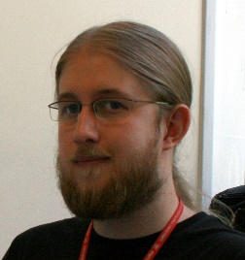 | Dr Tim Bashford |  |  | tim.bashford@uwtsd.ac.uk
 | Dr Carlene Campbell |  |  | carlene.campbell@uwtsd.ac.uk
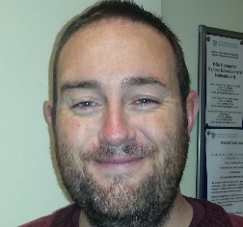 | Lee Cobley |  |  | lee.cobley@uwtsd.ac.uk
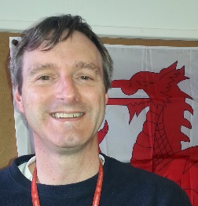 | Dr Michael Dacey |  |  | michael.dacey@uwtsd.ac.uk
 | Gordon Dickers |  |  | gordon.dickers@uwtsd.ac.uk
 | Beverley Holland |  |  | beverley.holland@uwtsd.ac.uk
 | Nitheesh Kaliyamurthy |  |  | n.kaliyamurthy@uwtsd.ac.uk
 | Gareth Jones |  |  | gareth.jones@uwtsd.ac.uk
 | Dr Gary Jones |  |  | gary.jones@uwtsd.ac.uk
 | Sue Maw |  |  | sue.maw@uwtsd.ac.uk
 | Dr Steve Mosey |  |  | stephen.mosey@uwtsd.ac.uk
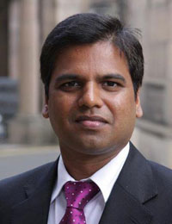 | Dr Kapilan Radhakrishnan |  |  | kapilan.radhakrishnan@uwtsd.ac.uk
 | Professor John Rees |  |  | john.rees@uwtsd.ac.uk
 | Gaynor Thomas |  |  | gaynor.thomas@uwtsd.ac.uk
 | Associate Professor Nik Whitehead |  |  | nicola.whitehead@uwtsd.ac.uk
 | James Williams |  |  | james.williams@uwtsd.ac.uk

