

Assessment 1

Individual Business Model Canvas with entrepreneurial reflection

- Student ID number: 2133909
- Student name: Roxana Ionica Macarie
- The module title: Entrepreneurship BMIH5001
- Lecturer name: Chris Wilkin
- Word Count: 2200

Part 1 Essay
Hospitality industry is constantly going through innovation and differentiation that allows to attract customers (Barringer and Ireland, 2018). Combination of entertainment and technology is core part of Magic Mirror Photo Booth that can attain more customers. This essay focuses on Business Model Canvas (BMC) for the Magic Mirror Photo Booth through identifying different aspects that are essential or making the decisions and draw insights on hospitality practices.
The first aspect of the Magic Mirror Photo Booth's BMC is to identify customer segments. Hence, Williams (2021) cited that targeting audience spans through proper engagement with couples, corporate clients, event planners, and individuals celebrating various occasions are essential. Each segment requires proper justification that can allow Magic Mirror Photo Booth aims to implement as per requirements. Magic Mirror Photo Booth mainly focuses to do business all over the UK. For instance, engaged couples in the Magic Mirror Photo Booth provides unique and interactive experience for weddings. Besides, customisable features can allow to make sure seamless process as per wedding theme that can allow to provide a memorable addition for celebration. In addition, corporate clients can attain benefit from the changing entertainment element on booth that adds engaging value for professional gatherings. Moreover, event planners require collaborative approach and Magic Mirror Photo Booth make sure constant integration in event design. Lastly, individuals celebrating birthdays, anniversaries, and other special occasions can enjoy personalised experience for creating lasting memories.
Magic Mirror Photo Booth's mainly focuses on creating value proposition. Setting different viewpoint rather than traditional photo booth can increase customer attention for Magic Mirror Photo Booth. Besides, innovative 360-degree video feature can provide competitive advantages for attaining better experience for the event guest of Magic Mirror Photo Booth. Providing different benefits can also ensure growing demand for guests. Global market growth requires proper focus and market research through identifying increasing interest in different experiences. Maintaining cutting-edge technology can also allow increase Magic Mirror Photo Booth positions through offering more than just a photo booth.
Besides, seeking financial or capital investment can allow us to ensure marketing activities. Major assets that are require for the business is strong customer network and social media engagement that can allow to ensure competitiveness. Besides, online presence and social media channel are the key resources for marketing and customer engagement activities. Additionally, strategic partnerships with suppliers can allow smooth supply of innovative resources that can allow our small family business as core event in the UK.
Analysing website and active social media platforms are essential for competitive advantage. For instance, Similarweb data is helpful for identifying effective digital channels and optimising online presence. Online advertising can allow Magic Mirror Photo Booth to reach specific demographics through creating unique offerings. Besides, making sure engaging content on social media platforms can enhance overall contribution for increase community and excitement. My target audience are couple, planning for marriage and different event organisations in UK through using Facebook, Instagram and TikTok because this are free. Analysing Similarweb allowed to find out current event situation and social media presence of target audience in UK. Competitors in UK mostly uses social media networking to attract customers (Similarweb, 2023). In addition, establishment of physical presence is also essential that can increase networking. Hence, participating in exhibitions and networking events can increase visibility and provide opportunities for direct interaction with potential clients and partners. Moreover, collaborations with event organisers can allow to expand Magic Mirror Photo Booth in the events sector.
Building and maintaining strong customer relationships are essential for continuous success of the Magic Mirror Photo Booth. The customer-centric practices consist of personal assistance and self-service facilities. In addition, Méndez-Picazo et al. (2021) cited that employing skilled technicians for on-site support during events helps smooth operations. Besides, seeking financial or capital investment can allow us to ensure marketing activities. Major assets that are require for the business is strong customer network and social media engagement that can allow to ensure competitiveness. Besides, online presence and social media channel are the key resources for marketing and customer engagement activities. Additionally, strategic partnerships with suppliers can allow smooth supply of innovative resources that can allow our small family business as core event in the UK. Moreover, making sure adequate engagement is essential for increasing customer relationships. Hence, collecting feedback through surveys and other channels can help Magic Mirror Photo Booth to continuously improve services. Listening to customer requires proper incorporation as per suggestions that can allow to increase trust and loyalty. One of the contemporary examples is Capture Pod which is known for customer focuses approaches by surveying event guests. Hence, studying customer reviews and feedback allows to provide deep insights of improving Magic Mirror Photo Booth's customer relationships.
Revenues are generated through event bookings for photo booth and 360 video services. Focusing strong pricing strategy based on the event, packages and others can allow to increase revenue (Rae, 2008). We have many types of the packages, starting from 2 hours, 3 hours, extra cost for any extra hours, depends. For example, packages for 3 hours, included: customization, quick distribution, hight quality, assistance throughout the event, unlimited 4K videos, light poles, private gallery online, set up. Besides, pricing strategy includes packages as per service duration, features, and customise services. Personalised photo, instant printing, table props, and unlimited 4k videos are also part of services. Additional revenue is generated through premium services for custom branding and photo booth. Payment collection channel includes online platforms for secure transactions to clients. Moreover, monetisation model include transparent and competitive pricing can help small family business attain competitive advantages across the UK. Making sure transparent pricing strategy can allow Magic Mirror Photo Booth to increase client understanding of service value. The competitive pricing as per market situation standards can provide flexibility to make sure different customer segments. For instance, researching competitors' pricing models can allow better advantage for Magic Mirror Photo Booth's pricing strategy.
The success of the Magic Mirror Photo Booth mainly related to key resources in product development, operations, and customer satisfaction. Timmons & Spinelli (2008) cited that evaluating these resources can make sure physical, human, and financial benefits for Magic Mirror Photo Booth. For instance, high-quality camera equipment can allow best photo and video quality against competitors of Magic Mirror Photo Booth. Besides, skilled technicians are highly essential for team management in booth operation during events. Hence, allocating financial resources for purchasing equipment, maintenance, and marketing campaign positions is essential for Magic Mirror Photo Booth to make sure continuous growth and innovation.
Key activities of Magic Mirror Photo Booth and 360 Video Photo are making sure product development and problem-solving. For instance, product development through analysis of photo event market competitors and research can allow to help. Constant innovation of booth design, incorporating latest technology and providing unique customer experience for event guests can allow grab attention. Latest technology such as UHD video, GoPro Hero 11, implementation on Photo, cinematic video editing and others are the part of Magic Mirror Photo Booth. For instance, Diandra and Azmy (2020) argued that regular maintenance and technical development is highly essential to ensure smooth operations. Addressing problem solving activities are essential to reduce barriers. Besides, market and problem-solving activities through deep insights are also beneficial for the business. For instance, Facebook boosting, participating in wedding venues, social media posts, listening to the organisers are essential to collect more information. Hence, providing better customer services through offering personalised suggestions can allow to enhance customer satisfaction. Moreover, social media marketing, network development and others can allow to expand client satisfaction. Network building is an essential task for our photo booth and 360 video that can help to attain success in family-run business.
Magic Mirror Photo Booth and 360 Video Photo business in the UK mainly focuses on creating strong partnership. For instance, connection with equipment suppliers through creating constant technical support for events (Frese et al., 2023). Equipment suppliers such as booth materials, technical instruments for video making, third party editors are the part of Magic Mirror Photo Booth and 360 Video Photo business. Besides, creating strategic alliance with event organisers can allow to increase market reach and provide mutual promotional benefits. Motivation of business is enhancing relationship, business growth and creating better experiences. Our main partnership, Reyeah company China, (International supplier) due to having low cost and best price, Touchpix software (American supplier) due to having the best quality software, provide diverse resources that can allow to make sure amazing photo booth experience, equipment supply, technical support and constant innovation. Hence, collaborating with the suppliers can allow to expand small family business and deliver the best services in major events across UK.
Cost structure of Magic Mirror Photo Booth and 360 Video Photo focuses in diverse areas through identifying key factors related to create and deliver best services. Fixed cost of our business is equipment purchase and maintenance fees that stay constant as per number of events. Variable costs are staff wages and material customisation that charges of different events participation. For instance, development of cost-effective practices allows to acquire and maintain equipment for high end experience (Audretsch and Fiedler, 2023). Marketing expenses include digital campaigns, online advertising, and participation in industry events. Skilled technicians, customer service employees, and marketing professionals are major areas of cost structure that can allow smooth operation. Hence, budget is allocated to employee development, training and marketing innovation.
In conclusion, the Magic Mirror Photo Booth focuses with innovative practices, customer-centric, and strategic partnerships can allow to fulfil unique areas in competitive event entertainment. The Business Model Canvas provides comprehensive framework for making sure the best decision. As such, understanding diverse customer segments can create a balance in the cost structure. For instance, skilled technicians and customer service employees can allow for smooth functional services. Besides, seeking financial or capital investment can allow us to ensure marketing activities. Major assets that are require for the business is strong customer network and social media engagement that can allow to ensure competitiveness. Besides, online presence and social media channel are the key resources for marketing and customer engagement activities.

Part 2 Reflective Essay
Introduction
Going through the in-class questionnaires and assessments helped me to identify different areas of my entrepreneurial and managerial motivations and characteristics. I will use Gibbs Reflective Cycle to critically evaluate my experience for making a deeper understanding of the implications.
Description
The journey of business proposal goes through questionnaires designed to make sure entrepreneurial orientations. For instance, I have gone through business development such as business model and entrepreneurial practices. Going through market research for business proposal also allowed to enhance my professional practices. Answering entrepreneur questionnaire allowed to find out I have entrepreneurial potential with a score between 36-48.
In particular, the tests were meant to show my traits, skills, and areas where I could improve. The Get2Test also helped me make my goal of getting things done quickly and well clear. The analysis of this test shows that I have 75% in Need for achievement, 50% in Need for autonomy, and 50% on Creative tendency. This shows that in need for achievement area, I have a strong drive to set and reach challenging goals, a trait that could help me achieve in many situations. I can work on my need for autonomy and creative tendency scores.
Feelings
Going through the business canvas model increased my curiosity, self-reflection, and vulnerability. I have examined entrepreneurial questionnaire during this module that allowed to find out my self-discovery, entrepreneurship practices and strengths on business model. For instance, entrepreneurial motivations and characteristic allowed to find out my capabilities in risk-taking, responsibility and financial considerations. Moreover, questionnaire on entrepreneurship helped me to find out that I have potentiality in entrepreneurship and navigate on the entrepreneurial practices through taking risk and thinking strategically.
Evaluation
Putro et al. (2022) cited that critical evaluation of different areas can allow to make sure better understanding of different practices. Evaluating my entrepreneurial questionnaire helped me to evaluate my score on business practices on entrepreneurial potential and mindset. For instance, I have learned balanced approach seeking taking risks that are essential for decision making. Moreover, long-term consequences and a strategic development for attaining profits allowed to find out better idea. Furthermore, I have identified my lacking on motivation practices and challenges on understanding different business areas that I need to focus more for my personal career development.
Analysis
Adequate analysis of the experience is essential for entrepreneurial and managerial practices (Terán-Yépez et al., 2020). I have gone through diverse entrepreneurship skill in the entrepreneur questionnaire. For instance, analysing entrepreneurial questionnaire helped me to find out my entrepreneurial profile. Taking risk and adaptability allowed to make sure smooth practices in strategic decision making. Questionnaire analysis allowed me to find out awareness of financial considerations and risk taking through providing a foundation for going through different areas of entrepreneurship.
Conclusion
This reflective process also helped to identify my strengths in entrepreneurship, creativity, and communication in both entrepreneurial and managerial practices can help me to move further. I have further analysed balance between calculated risk-taking and conscientious planning that are essential for business model.
Action Plan
Action plan focuses on diverse analysis practices that are essential for developing further (Mmbaga et al., 2020). I have identified different areas of lacking during this reflection that I need to reduce. For instance, practicing more on business strategy development, risk taking, and entrepreneurship skill can allow me to make the most effective decision.
Personal Development
For my personal development practices, I need to make sure continuous process. Adequate collaboration between entrepreneurial and managerial practices can allow me to make sure constant growth. Critical evaluation of different areas can allow to make sure better understanding of different practices. For instance, I have evaluated diverse results that motivated me to understand entrepreneurial and managerial practices in the right direction.
References
Barringer, B. R. & Ireland, R.D. (2018) Entrepreneurship: Successfully Launching New Ventures, 4th Ed., Prentice Hall: New Jersey.
Diandra, D. and Azmy, A., 2020. Understanding definition of entrepreneurship. International Journal of Management, Accounting and Economics, 7(5), pp.235-241.
Méndez-Picazo, M.T., Galindo-Martín, M.A. and Castaño-Martínez, M.S., 2021. Effects of sociocultural and economic factors on social entrepreneurship and sustainable development. Journal of Innovation & Knowledge, 6(2), pp.69-77.
Mmbaga, N.A., Mathias, B.D., Williams, D.W. and Cardon, M.S., 2020. A review of and future agenda for research on identity in entrepreneurship. Journal of Business Venturing, 35(6), p.106049.
Putro, H.P.N., Rusmaniah, R., Mutiani, M., Jumriani, J. and Subiyakto, B., 2022. The relevance of social capital in efforts to develop entrepreneurship education. Journal of Education and Learning (EduLearn), 16(3), pp.412-417.
Rae, D. (2008) Entrepreneurship: from opportunity to action, 2nd Ed., Basingstoke: Palgrave Macmillan.
Randerson, K., 2023. Family entrepreneurship: a perspective article. Journal of Family Business Management.
Rickman, C., & Roddick, D. (2013) The Small Business Start-Up Workbook: A step-by-step guide to starting the business you’ve dreamed of. London, How To Books.
Similarweb, 2024; Events performance in UK; available at: https://pro.similarweb.com/#/digitalsuite/websiteanalysis/overview/website-performance/*/999/3m?webSource=Total&key=theweddingguideuk.com (Accessed on: 4/2/2024)
Terán-Yépez, E., Marín-Carrillo, G.M., del Pilar Casado-Belmonte, M. and de las Mercedes Capobianco-Uriarte, M., 2020. Sustainable entrepreneurship: Review of its evolution and new trends. Journal of Cleaner Production, 252, p.119742.
Timmons, J. & Spinelli, S. (2008) New Venture Creation: Entrepreneurship for the 21st Century, McGraw Hill: Boston.
Williams, S. (2021) FT Guide to Business Start Up: The most comprehensive guide for entrepreneurs, 32nd Ed., Financial Times Press: Harlow.

Appendix

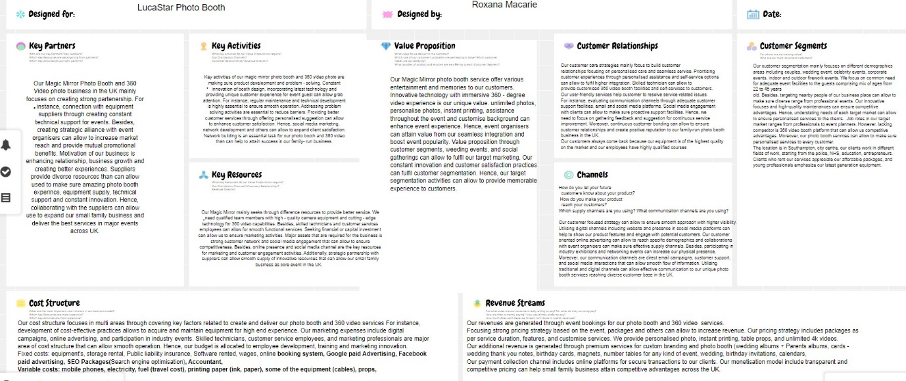

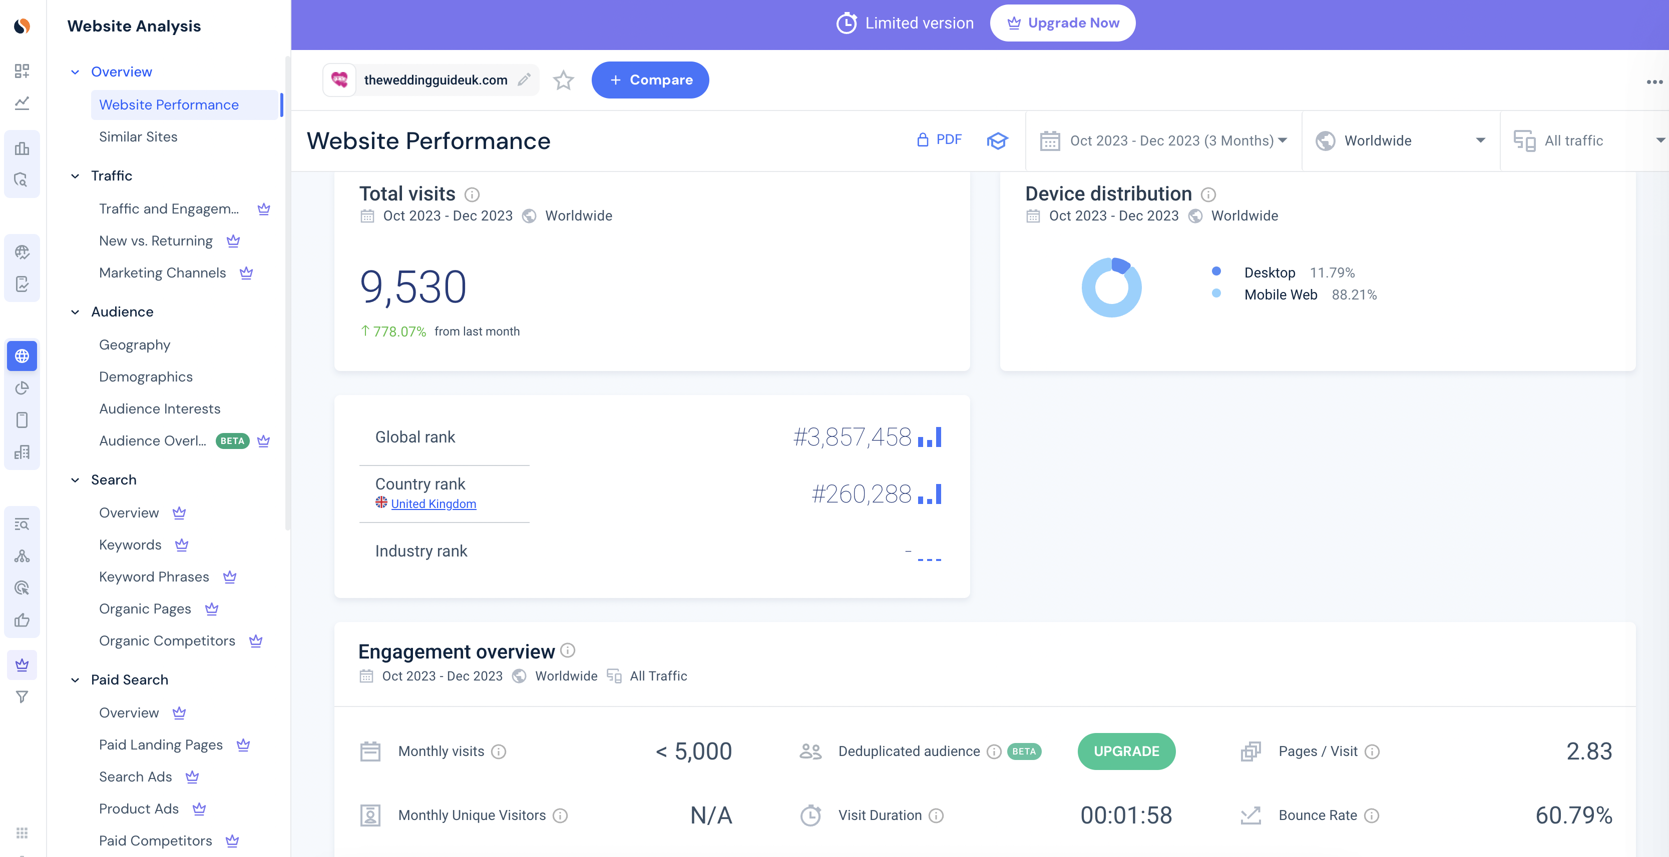

Photo booth industry of UK (Source: Similarweb, 2024)

