Student Name: Ahmed Jah
Student Name: 2415343
Module Number BMHP5014
Lecturer's Name: Caroline Salami

BMHP5014
CHANGEMAKERS: CREATIVITY AND VALUE CREATION

Co-designing a Hybrid Discharge-Navigation Service
Creativity, leadership and value creation for the common good in health and social care

ONLINE PORTFOLIO

Introduction
Health and social care services face a persistent challenge at hospital discharge: responsibility moves rapidly from multidisciplinary teams to patients, carers, primary care and community providers, yet information and support often remain fragmented. This portfolio applies creativity, leadership, value creation and contemporary technology to design a hybrid discharge-navigation service for adults living with multiple long-term conditions. The proposed service includes a plain language digital care plan, printable options, medication reminders, community resources and a designated navigator that will reach out within seventy-two hours. Less intensive transitional interventions (LTCIs) have the potential to decrease readmission, and more comprehensive packages are not always better (Tyler et al., 2023). Patient-experience evidence is less clear since many discharge interventions have had mixed or neutral findings and are poorly implemented (Jesus et al., 2024). As a result, the portfolio sees innovation as a structured practice of reframing, co-designing and testing and learning. Its central argument is that creativity contributes to the common good only when patient-defined value, equity, clinical safety, workforce capacity and resource stewardship are evaluated together.

Exercise 1: Reframing the Challenge Through Empathy
My first learning exercise was to shift the problem frame from “reducing readmissions” to an understanding of the whole discharge journey. A small performance target may lead to premature discharge or to shift work to families. Empathy mapping, however, focuses on the things that patients see, hear, understand, fear and need before and after discharge from hospital. Human-centred design is suitable because it ensures interventions are developed based on people's capabilities and contexts, not on the basis of professional assumptions (Leary et al., 2022). This would involve patients, carers, ward nurses, pharmacists, social workers, general practitioners, voluntary organisations and digital people.
This enquiry would likely identify a number of interrelated shortcomings: clinical language is not easy to decipher; medicine changes without proper explanation; carers are receiving information too late; appointments compete for attention; and digital messages are based on literacy, connectedness and confidence. Value co-creation enhances the analysis as value is produced through interactions between patients, professionals, families and community networks, rather than through a service that is delivered to passive recipients (Peng et al., 2022). However, it may turn into symbolic if the senior professionals dominate the discussion or the more articulate patients are overrepresented. I would include interpreters, accessible materials, payment for people with lived experience to participate, and a number of ways to participate. A public decision log would be made to show which suggestions were accepted, adapted or rejected, and why. The design question becomes: how can each person be discharged from hospital with a clear, realistic and integrated set of instructions without losing any of their choice or adding more to their load?

Exercise 2: Creative Ideation, Co-design and Prototyping
The second exercise applies divergent and convergent thinking. At divergence, participants would suspend judgement and embrace questions like “How might we?” and reverse assumptions and rapid sketching. These could include One Page print out plan, Photo of medicines, named navigator, Preferred channel reminders, Carer alerts with consent, community services directory and a seventy-two-hour call. Creativity is not only the production of the new but also the capacity to come up with alternatives that react differently to the same evidence.
Convergence would employ a weighted decision matrix, including desirability, clinical safety, equity, feasibility, cost, and environmental impact and evidential strength. One concept that was selected, “My Next Steps”, requires the patient to commit to three priority actions prior to discharge. These are recorded in a plain-language plan available digitally and on paper. Reminders are provided in format of choice, high risk questions not answered are escalated, and the navigator links the patient to community support. A digital-patient-experience framework as shown in figure 1 is helpful as it connects the dots between influencing factors, design goals, evaluation standards, ideation, and testing, rather than treating interface design as a final cosmetic step (Wang et al., 2022).
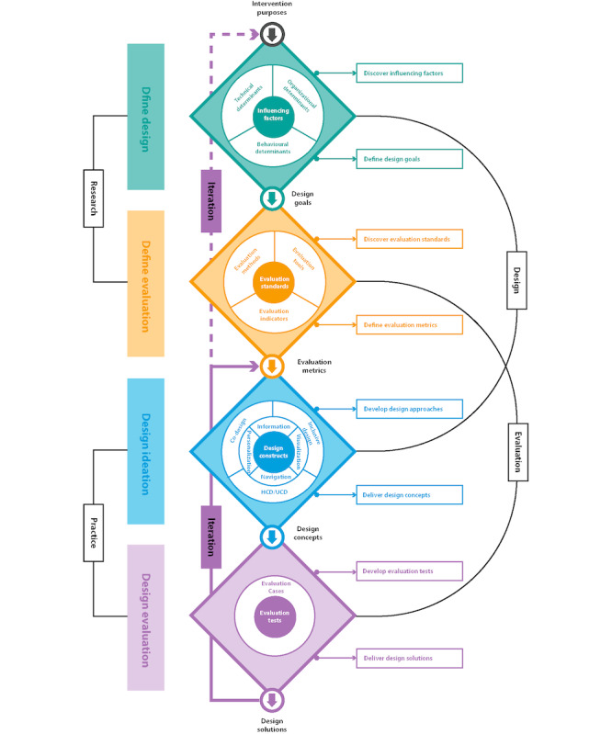
Figure 1. Digital patient experience design and evaluation framework. Source: Wang et al. (2022), Journal of Medical Internet Research, 24(8), e37952. Reproduced under CC BY 4.0.
Low fidelity paper screens, role play and think aloud tests, would reveal problematic wording, too many steps and inaccessible assumptions prior to procurement. Co-design must still be treated critically. An umbrella review revealed that participant involvement was frequently not reported adequately, and all of the included reviews were of critically low methodological quality (Kilfoy et al., 2024). Workshops can thus give a sense of inclusion, but not of devolved decision-making. In addition, hybrid teams have to navigate disparate research and development cultures between the healthcare and digital design sectors (Duffy et al., 2022).

Exercise 3: Leadership and Interprofessional Collaboration
Implementation crosses organisational and professional boundaries, so leadership cannot depend on one enthusiastic individual. I would set up a design group that would include patient partners and carer partners, patients' discharge nursing, pharmacy, social care, information governance, digital services, primary care, and a voluntary sector representative. A shared purpose would be turned into concrete responsibilities; clinicians would remain responsible for making clinical decisions; navigators would coordinate agreed actions; digital specialists would keep their reliability; and patient partners would have equal authority over accessibility, and experience.
Transformational leadership can help to communicate purpose and allow experimentation and link routine activities to safer transitions. Its effects are not automatic, however, because improved outcomes are mediated through empowerment, commitment, job satisfaction and the quality of the work environment (Ystaas et al., 2023). So I'd link vision with protected testing time, quick feedback, training and escalation paths that are apparent Inclusive leadership is also crucial as staff creativity relies on psychologically safe environments and confidence that questions will not be met with interpersonal punishment (Fu et al., 2022). During review meetings, junior staff would speak first in front of senior staff, and evidence that contradicted their views would not be undermined.
Information would be considered as conflict. For Pharmacy, the focus might be on getting the right medicine and for Operational managers, it's about making the discharge as quick as possible – both these interests can be measured against a common aim of a safe, timely transition. Weekly learning huddles and a live risk register and a RACI matrix would facilitate coordination but not generate too many meetings. Evidence from primary care shows that collaboration requires team readiness, shared decision-making, communication, coordination and integration of different competences (Sirimsi et al., 2022). The exercise shifted my thinking about leadership from pushing towards a pre-determined response to facilitating the creation of a better answer where expertise, uncertainty and constructive challenge interact.

Exercise 4: Value Creation and an Enterprising Mindset
Value creation requires more than demonstrating that patients like the service or that the hospital saves money. The proposed pathway is valuable if patients are aware of their next steps, carers are provided with timely information with their consent, professionals do not have to re-explain, community organisations are provided with appropriate referrals and preventable harm is reduced. This is co-created value since the different actors bring knowledge, time, relationship and technology together, across institutional boundaries (Peng et al., 2022). The common good also needs to be considered in terms of distribution: a simple average improvement is not enough if those with disability, limited English, low incomes or poor digital access are impacted the least.
An enterprising mindset sees limitations as a field for innovation. Instead of building a big platform right away, they would experiment with a "minimal viable service" using existing records, secure messaging and community directories. Funding would be disbursed in stages, contingent upon certain, predetermined learning levels. This method mitigates the sunk cost fallacy and weak assumptions can die easily. Evidence-based practice may yield clinical and financial benefits, but results on return on investment are inconsistent and reported in only a few studies (Connor et al., 2023). Thus, the business case should be based on assumptions, ranges, opportunity costs and uncertainty rather than optimistic savings and present them as facts.
Value-based healthcare provides a useful but incomplete lens. Studies often prioritize process, cost and clinical outcomes and patients' reported outcomes and experiences are less frequently used (Kidanemariam et al., 2023). Evaluation should therefore take into account patient-defined goals, confidence, treatment burden and qualitative accounts as well as readmission and cost. It should also explore unintended consequences such as unpaid carer work, staff alert fatigue and ‘unfunded demand’ on voluntary organisations. Enterprise in health and social care is ethically defensible in that it is mobilising scarce resources to generate sustainable, fair benefit instead of simply shifting expenditure elsewhere.

Exercise 5: Contemporary Technology, Ethics and Inclusion
Technology enables the pathway but is not its purpose. The digital plan would be accessible, useful in the language of choice, have carer access with consent, reminders and community links, and have an auditable escalation route. Data minimisation would limit data collection to information necessary for continuity and evaluation. Role-based access, encryption, retention limits, incident procedures and data-protection impact assessment would help ensure confidentiality. AI would not be able to make autonomous risk decisions during the pilot for a variety of reasons, including the need to first prove local validity, explainability, bias monitoring and human oversight.
Digital inclusion must shape the service from the beginning. People with impairments encounter barriers when products are not designed around varied sensory, cognitive, motor and contextual needs, and their involvement is frequently insufficient (Henni et al., 2022). Tests would then include screen reading software, keyboard navigation, font size, written comprehension, low bandwidth, and issues of dexterity. Print, telephone and face-to-face routes would have equal status rather than being inferior fallbacks.
Digital partnerships have the potential to enhance communication, self-monitoring, and individualised support and care plans, but they can also undermine professional-patient relationships and contribute to an unequal workload (Wannheden et al., 2022). The navigator would then relay to the user who monitors information, and expected response times and which concerns are of urgency for clinical contact. Figure 1 reinforces that organisational and social environments influence digital experience alongside functionality and interface design. Responsible innovation is the harder middle ground of innovation: choose the simplest technology possible to achieve the stated goal, maintain human relationships, and constantly investigate who is benefiting, who is being burdened and who is being left out.

Exercise 6: Implementation, Evaluation and Reflective Development
The service would start on one medical ward connected with one community pathway for a twelve-week period in order to test the model. Baseline data would be taken prelaunch, and fortnightly cycles of Plan-Do-Study-Act would be implemented. Process measures would include completed plans, teach-back documentation, follow-up within seventy-two hours and successful community connections. Outcomes would include patient confidence, medication discrepancies, unplanned service use and thirty-day readmission. A balancing of measures would focus on staff time, volume of alerts, delay in discharge and workload for carers. The results would be broken down by age, disability, language and digital access, to ensure that overall gains do not mask the increase in inequality.
Progression would depend on evidence rather than enthusiasm. Expansion would depend on acceptable safety, workload and participation as well as improvement in one or more patient valued outcomes without worsening in other outcomes. Tyler et al. (2023) demonstrate that simpler models can perform as well or better than more complex ones when it comes to readmission prediction, and adding additional features would require specific justification. Figure 2 shows that comparative evidence network employed in that analysis; the thickness of the lines is not indicative of effectiveness, but rather the number of studies, thus preventing over-interpretation of a visually pleasing diagram. Qualitative interviews would clarify the reasons behind the outcomes and highlight adaptations not detected by numerical indicators. Patient-experience studies also have mixed results, which means that claims of success should be made with caution (Jesus et al., 2024).
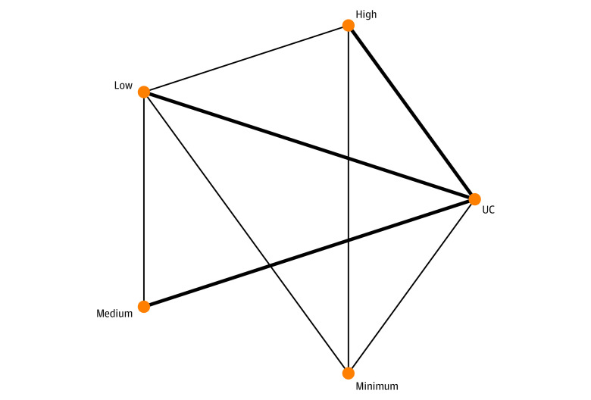
Figure 2. Network meta-analysis evidence structure for 30-day readmissions. Source: Tyler et al. (2023), JAMA Network Open, 6(11), e2344825. Line thickness indicates the number of included studies; UC means usual care. Reproduced under CC BY 4.0.
Reflection changed my initial thought that creativity was about creating new ideas. I now understand it as reframing problems, listening across power differences, combining evidence, testing assumptions and stopping weak ideas. In future, disconfirming evidence, quieter voices and ethics trade-offs will feature in all reviews. The pathway should become a learning system whose monthly governance meeting examines variation, complaints, near misses and suggestions with patient partners sharing authority over changes.

Conclusion
This portfolio integrates empathy, disciplined creativity, collaborative leadership, value analysis, ethical technology and evaluation into a realistic response to unsafe discharge. The hybrid navigation pathway is purposefully low-tech: a plain sailing navigation plan, a point person, community-based and non-digital options. Its uniqueness is in the way that these elements are organised around patient priorities and shared learning instead of the addition of technology for its own sake. Some key limitations identified by critical analysis are participation bias, uncertain financial returns, implementation burden, digital exclusion and transfer of tasks to carers/community organisations. These risks warrant incremental testing, clear leadership and willingness to restructure and/or terminate the intervention. This approach addresses the concern of the module around creativity for the common good, and the development of transferable skills in evidence appraisal and facilitation, communication, and digital literacy, risk management and responsible decision making.

Reference List
Connor, L., Dean, J., McNett, M., Tydings, D.M., Shrout, A., Gorsuch, P.F., Hole, A., Moore, L., Brown, R., Melnyk, B.M. and Gallagher-Ford, L. (2023) ‘Evidence-based practice improves patient outcomes and healthcare system return on investment: findings from a scoping review’, Worldviews on Evidence-Based Nursing, 20(1), pp. 6–15. doi: 10.1111/wvn.12621.
Duffy, A., Christie, G.J. and Moreno, S. (2022) ‘The challenges toward real-world implementation of digital health design approaches: narrative review’, JMIR Human Factors, 9(3), e35693. doi: 10.2196/35693.
Fu, Q., Cherian, J., Ahmad, N., Scholz, M., Samad, S. and Comite, U. (2022) ‘An inclusive leadership framework to foster employee creativity in the healthcare sector: the role of psychological safety and polychronicity’, International Journal of Environmental Research and Public Health, 19(8), 4519. doi: 10.3390/ijerph19084519.
Henni, S.H., Maurud, S., Fuglerud, K.S. and Moen, A. (2022) ‘The experiences, needs and barriers of people with impairments related to usability and accessibility of digital health solutions, levels of involvement in the design process and strategies for participatory and universal design: a scoping review’, BMC Public Health, 22, 35. doi: 10.1186/s12889-021-12393-1.
Jesus, T.S., Stern, B.Z., Lee, D., Zhang, M., Struhar, J., Heinemann, A.W., Jordan, N. and Deutsch, A. (2024) ‘Systematic review of contemporary interventions for improving discharge support and transitions of care from the patient experience perspective’, PLOS ONE, 19(5), e0299176. doi: 10.1371/journal.pone.0299176.
Kidanemariam, M., Pieterse, A.H., van Staalduinen, D.J., Bos, W.J.W. and Stiggelbout, A.M. (2023) ‘Does value-based healthcare support patient-centred care? A scoping review of the evidence’, BMJ Open, 13(7), e070193. doi: 10.1136/bmjopen-2022-070193.
Kilfoy, A., Hsu, T.-C.C., Stockton-Powdrell, C., Whelan, P., Chu, C.H. and Jibb, L. (2024) ‘An umbrella review on how digital health intervention co-design is conducted and described’, npj Digital Medicine, 7(1), 374. doi: 10.1038/s41746-024-01385-1.
Leary, M., Cacchione, P.Z., Demiris, G., Carthon, J.M.B. and Bauermeister, J.A. (2022) ‘An integrative review of human-centered design and design thinking for the creation of health interventions’, Nursing Forum, 57(6), pp. 1137–1152. doi: 10.1111/nuf.12805.
Peng, Y., Wu, T., Chen, Z. and Deng, Z. (2022) ‘Value cocreation in health care: systematic review’, Journal of Medical Internet Research, 24(3), e33061. doi: 10.2196/33061.
Sirimsi, M.M., De Loof, H., Van den Broeck, K., De Vliegher, K., Pype, P., Remmen, R. and Van Bogaert, P. (2022) ‘Scoping review to identify strategies and interventions improving interprofessional collaboration and integration in primary care’, BMJ Open, 12(10), e062111. doi: 10.1136/bmjopen-2022-062111.
Tyler, N., Hodkinson, A., Planner, C., Angelakis, I., Keyworth, C., Hall, A., Jones, P.P., Wright, O.G., Keers, R., Blakeman, T. and Panagioti, M. (2023) ‘Transitional care interventions from hospital to community to reduce health care use and improve patient outcomes: a systematic review and network meta-analysis’, JAMA Network Open, 6(11), e2344825. doi: 10.1001/jamanetworkopen.2023.44825.
Wang, T., Giunti, G., Melles, M. and Goossens, R. (2022) ‘Digital patient experience: umbrella systematic review’, Journal of Medical Internet Research, 24(8), e37952. doi: 10.2196/37952.
Wankhede, C., Åberg-Wennerholm, M., Dahlberg, M., Revenäs, Å., Tolf, S., Eftimovska, E. and Brommels, M. (2022) ‘Digital health technologies enabling partnerships in chronic care management: scoping review’, Journal of Medical Internet Research, 24(8), e38980. doi: 10.2196/38980.
Ystaas, L.M.K., Nikitara, M., Ghobrial, S., Latzourakis, E., Polychronis, G. and Constantinou, C.S. (2023) ‘The impact of transformational leadership in the nursing work environment and patients’ outcomes: a systematic review’, Nursing Reports, 13(3), pp. 1271–1290. doi: 10.3390/nursrep13030108.

