Report for Entrepreneurship Assignment 2 2019 –



January 2019

MODULE NAME: Entrepreneurship
Name: Samuel lockley
Student Number: 1704902

Table of Contents

1. eXECUTIVE sUMMARY 1
2. Introduction 2
2.1 Report Remit…………………………………………………………………………………………………2
2.2 What is an Entrepreneur…………………………………………………………………………………2
2.3 Who is Masahiro Sakurai?....................................................................................2-3
3. ENTREPRENEURIAL MOTIVATION……………….……………………………………………………….4
3.1 Psychological………………...……………………………………………………………………………4
3.1.1 Nature Versus Nurture…………………………………………………………………………4-5
3.2 Socio-Cultural………………….………………………………………………………………………….5
3.2.1 Entrepreneurial Spirit Index……………………………………………………………………5-6
3.3 Economic and Environmental………….…………………………………………………………7-8
4. CONCLUSION………………………………………………………………………………………………….9
5. References…………………………………………………………………………………………………10

List of Figures
- Figure 3-1……………………………………………………………………………………………….5
- Figure 3-2………………………………………………………………………………………….……6
- Figure 3-3……………………………….………………………………………………………………7

- eXECUTIVE sUMMARY

This report will be considering whether a man by the name of Masahiro Sakurai can be considered an entrepreneur by looking at various theory on what makes an entrepreneur as well as statistics regarding his home country of Japan. An entrepreneur is considered to be someone who is able to see opportunity in risks and turn them into a positive outcome (Goffee & Scase , 1987, p. 1) the implication of this being that it is possible for anyone to be an entrepreneur and that there are no particular barriers so long as they are able to acknowledge opportunities in risks (Kirzner, 2015). Another definition being someone who is able to locate a gap in an existing market or new one entirely (Schumpeter, 1959), With such broad definitions it can be difficult to work out which one more appropriately describes those who are entrepreneurs. Sakurai himself is best known for his work as a game developer, who started when he was only a teenager and still taking on major projects in his early twenties. Getting tired of being restricted by various factors he decided to found his own company called Sora Ltd, in which he takes personal responsibility for resolving all problems that arise when working on a project. Looking at the nature versus nurture model in which there is a belief that the traits of an entrepreneur are either taught to them by their role models or they are simply born with them (Mccrae, Et Al, 2000). It is clear to see that Sakurai is influenced purely by his nature, the traits that he was born with. The social environment of his home country of Japan is not a place that seems to actively encourage that sort of behaviour, with most being afraid of failure themselves, whereas Sakurai is not. Being able to accept failure and learn from it, is considered an apparent trait of an entrepreneur according to renowned entrepreneur Richard Branson (2013). The stress of workloads has reached the point where he has made comments in an interview about a possible early retirement (Famitsu, Sakurai, 2015) however despite that he has decided to continue pushing forwards. Showing that regardless of the workload he is determined to produce the quality games that he wants to achieve following the theory set by Krisha (2013) that entrepreneurs are never satisfied with what they have currently achieved. The economic and environmental climate of Japan would also normally hold people back from becoming entrepreneurs there with the country being hit by earthquakes fairly regularly (The Geological Society, 2012), making large impacts on the economy (Figure 3-3, Focus Economics, 2018). Despite that Sakurai has made efforts to strive forth regardless, showing that his determination is evident. Overall it can be quite easy to see how Sakurai can be considered an entrepreneur with meeting various criteria regarding the typical traits of an entrepreneur as well as fighting against the social norms and even the weather itself.

- Introduction

  - Report Remit

This report will be based on the Japanese game developer and business owner, Masahiro Sakarai, in an attempt to ascertain whether he can be considered an entrepreneur by modern standards, A number of different theories and aspects pertaining to the topic will also be considered when determining whether Masahiro Sakarai is an entrepreneur, such as the level of entrepreneurial motivation of his home country, which in this instance would be Japan, as well as the socio-cultural stigmas and economic aspects an example being with how the highly disruptive weather impacts local businesses and the populace as whole, as well as the psychology and traits considered to be common with most entrepreneurs.

2.2 What is an Entrepreneur?
According to Goffee and Scase (1987, p. 1) entrepreneurs can be considered those who are willing to take risks and turn them into opportunities so that they can make a path in life for themselves as well as being able to innovate on already existing ideas to make the fill a new or existing and possibly stagnant market (Schumpeter, 1959) this would assume that an entrepreneur is to be considered somewhat of a specialist. Baker (2005) believes that entrepreneurs focus not on the market needs but what resources they have available to them in order to discover opportunity. Another scholar (A, Constant, 2007) describes entrepreneurship as a very important part of a country’s economy and prosperity in part due to how it helps to tackle unemployment at least in the case where larger business is formed. There are also those known as intrapreneurs who have the makings of an entrepreneur yet either prefer to be in the employment of others or have yet to take that final step into becoming an entrepreneur. This type of behaviour is encouraged in several businesses to be able to exploit new potential opportunities (Pinchot, 1985). Examples of businesses that encourage this type of thinking are the likes of Google and Facebook. With the sheer volume of interpretations, sometimes to the point of contradictory, it can be impossible to tell whether someone falls under the classification of an entrepreneur or not as they may fit one definition yet be contradicted by another.

  - Who is Masahiro Sakurai?
Sakurai is a video game developer who first started his career when he was only a teenager, becoming a director of a whole project at the age of only 21, creating what would later become one of Nintendo’s most well-known and popular characters, Kirby. He is also regarded as the leading factor in the revival of a character that had been shelved for over two decades (Nintendo Life, 2014). He would later yearn for greater freedom and go on to form his own company called Sora Ltd in 2009 which would still work alongside the much larger company Nintendo (Kotaku, 2009). . In an interview with Official Nintendo Magazine (Sakurai, 2008) he stated, ‘’I decide what goes in the game; nobody else.’’ This could appear as being over controlling, however, it is more likely so that he can ensure that the games he is developing, achieves the quality he believes that people expect from him. At this point the popularity of the games he was creating was at an all-time high. It is possible that this could be linked to McClelland’s Theory of Achievement (1961) as he believes that entrepreneurs are more likely to take responsibility for solving issues and tasks in order to ensure a positive outcome. He does, however, stand his ground even against the demands of the public, but still ensures that the content appeals to them. All in all, this shows him as an assertive figure in the gaming industry.

- Entrepreneurial Motivation

  - What is Entrepreneurial Motivation?

According to Krishna (2013), entrepreneurial motivation is the state of an entrepreneur in which they are driven to achieve the goals they have set their sights on. As this is a process that will always continue, the entrepreneur will never be fully satisfied in their achievements, possibly explaining why so many entrepreneurs continue what they are doing despite attaining their vast fortunes or reputation. Shane (et al, 2003) makes the point that entrepreneurs follow the mentality that’s you cannot win a game you do not play; thus, it could be believed that this is a motivating factor for entrepreneurs, seeing every risk and opportunity as a game to be played and won for the rewards that it gives. Knight (2012) appears to also be a supporter in this belief as he believes that risk can also lead to profit. Shane (et al, 2003) also goes on to state that this is all an ‘’Evolutionary process’’ this coincides with Krisha’s (2013) beliefs that they are never satisfied due to this constant change. Sakurai always goes above and beyond when creating his video games despite the workload, to the point of making comments in an interview with the gaming magazine Famitsu (Sakurai, 2015) about early retirement due to level of stress he faces from the high expectations placed on him to maintain the quality of the games he produces, however, he continues on despite it as he is never fully satisfied with what he has made and wants to make the next iteration better than the last, this appears to reflect the opinions of both Shane (2003, et al) and Krishna (2013). The fact that he continues despite this, could also be a sign of determination, which will be discussed as a possible trait of an entrepreneur.

3.2 Psychological
3.2.1 Nature Versus Nurture
There are many traits that can be attributed to those who can be considered entrepreneurs, Entrepreneurs appear to share traits such as a strong determination to overcome the vast workload that would be faced in the initial start-up. That they are risk takers seizing adversity by the horns and making the situation beneficial where most would not. They are highly confident so that they are able to negotiate the deals that they need to establish themselves. To understand that failure is a part of the entrepreneurial game and to take it as a learning experience to try again. Richard Branson (2013) discusses that it is how an entrepreneur deals with failure, is what sets them apart from the others and describes failure in terms of business as the ‘’secret to success’’. Gartner (1988), however, seems to disregard these traits as to whether the entrepreneur will end up being successful in their endeavours or not. It is believed that these traits can either be born with or learn over time in a theory known as Nature versus Nurture which is based on whether a person is more influenced by those around them in the way of role models and emulating their behaviours or a more extreme example being a person’s parents are business owners and attempt to force their own values on their child at a young age. Nature believes that the way everyone acts is built into their genes the moment they are born (Mccrae, Et Al, 2000).
3.3 Socio-Cultural
3.3.1 Entrepreneurial Spirit Index
The Entrepreneurial Spirit Index (E.S.I), is a way of measuring three factors regarding a country’s populace, indicating how likely someone is to become an entrepreneur. This is a concept established by the Global Entrepreneurship Monitor (Global Entrepreneurship Monitor, 2018) in order to gather information worldwide. The three factors are,
- Entrepreneurial awareness, where people are able to notice the changes in patterns, people’s needs, interests etc (Ardichvili, A 2003).
- Opportunity perception in which people are able to see if it is possible to turn a risk into something with a positive outcome for the one taking the risk.
- Entrepreneurial self-efficacy which is the persons belief in their own skill set to be able to achieve whatever they set out to achieve.
Looking at Japan specifically it would appear that Japan is currently the lowest of all countries in terms of E.S.I with a decline in E.S.I of -0.95.
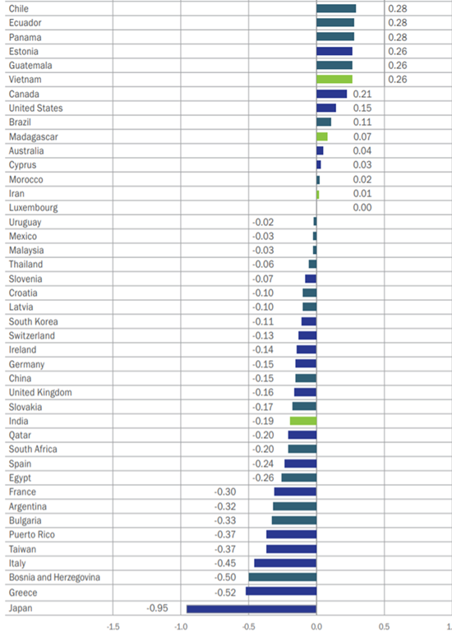
Figure 3-1 (Global Entrepreneurship Monitor, 2018)
It would seem from the report that the main thing holding Japan back from its entrepreneurial spirit is the populaces overall fear of failure with 41.2% of all those interviewed stating that as a reason why they would not attempt to start their own business, as well as very few saying they have the intention to do so to begin with. Due to these figures it could be believed that the theory of nature versus nurture could play a part. With regards to Sakurai this is evidence that he is more influenced by nature than nurture, this is due to Japan’s apparent stance regarding entrepreneurs, not being one to encourage those who wish to become one. Meaning it is more in his nature as to why he decided to strike out and develop his own business and act in the way he does.

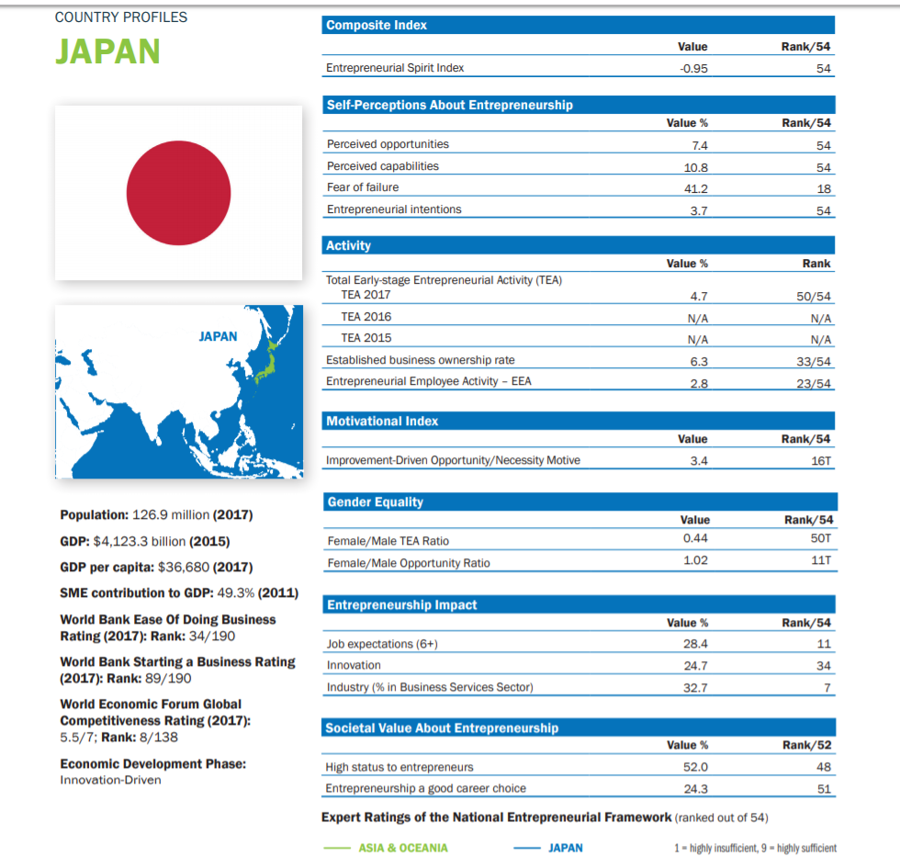
Figure 3-2 (Global Entrepreneurship Monitor, 2018)
Sakurai seems to be an exception in that he sees risk or in his opinion, opportunity where other Japanese people would not and is not afraid to take these risks in order to get the outcome that he desires even if it possible that it may result in failure, despite the majority of Japan having a fear of such outcomes. This is a sign that Sakurai is not afraid of failure and as stated previously, that understanding failure is a part of being an entrepreneur is a common trait that entrepreneurs share. As mentioned prior, Shane (et al, 2003) discusses the theory of taking risks, it can be believed that although it is more commonly attributed as an economic theory, it can also be linked to others such as in this instance.
3.4 Economic and Environmental factors
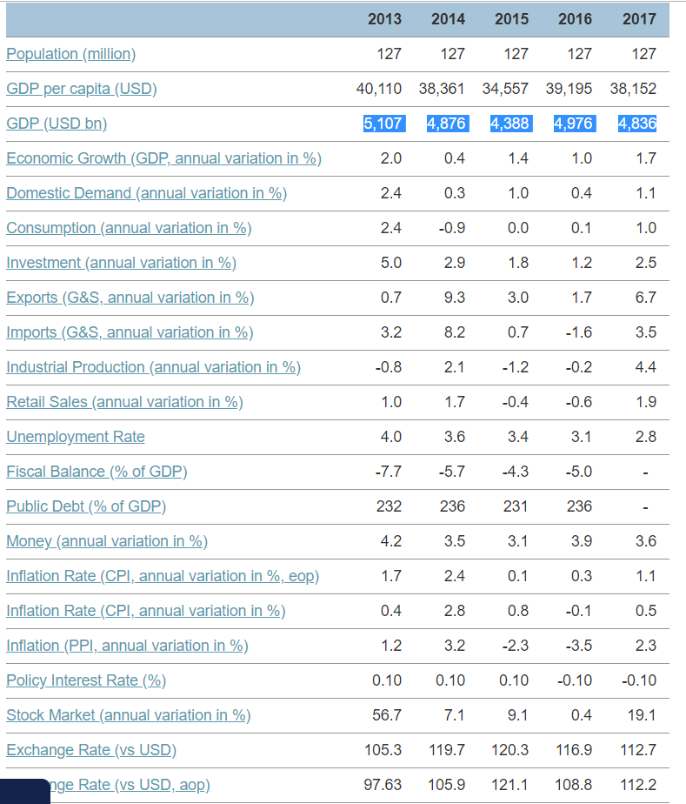
The Japanese Economy has been disrupted a number of times over the years by various natural disasters that shook the island nation ranging from tornadoes to earthquakes to tsunamis caused by those earthquakes. As can be seen by the data below Japan is struggling in certain aspects, this could be because they are possibly still recovering from the Tohoku earthquake and tsunami which devastated japan causing upwards of $360 billion worth of damage to the country and over 15,000 deaths (The Geological Society, 2012). Not presented in the data are the potential after effects of the typhoon that hit Japan, along with other disasters earlier this year, causing at least $84 billion worth of damages as well as disrupting local airlines and shipping companies. (Japan Times, 2018)
Figure 3-3 (Focus Economics, 2018)
However, despite all these setbacks to the country’s economy entrepreneurs such as Sakurai persevere and make do with what has been handed to them and attempt to recover from the tragedies that strike, not letting these disasters disrupt his plans for any longer than necessary so that he can meet his goals. It is quite possible that with the knowledge that natural disasters occur regularly in japan that plans could have been made prior to minimise the damage to his business so that it can get back up and running as soon as possible. Shackle (2017) seems to suggest that entrepreneurs are creative and imaginative especially when doing their work in an environment that is uncertain, which the conditions which japan face seem to fit that.

- Conclusion
Overall, Sakurai has the traits of an entrepreneur as he is able to take on board the large volume of work required as well as ensuring all problems that arise are personally dealt with (McClelland, 1961). He is also not afraid of failure, whereas the majority of those in Japan seem to, thus being one to break the mould in this regard (Figure 3-2, Global Entrepreneurship Monitor, 2018). He then goes on to learns from these mistakes which can be seen from when his games do not turn out to well in the eyes of the public then he continues on to improve and ensure things are better with the next iteration If we were to conclude that he is indeed an entrepreneur then it would be obvious he was born with these traits rather than had them slowly nurtured over time by role models due to the public perception on taking risks and entrepreneurs as a whole. The social aspects of being an entrepreneur were of course not the only factors that should have held him back, the environment and economic state of Japan is far from ideal for those who wish to set up and run their own businesses with regular natural disasters such as earthquakes, typhoons and tsunamis hitting the country and making major negative impacts on its economy. Yet, despite this continues on and ensures that his business operations thrive regardless. He also fits the theory behind entrepreneurs provided by both Shane (2003, et al) and Krishna (2013) in that he is rarely ever satisfied with what he has currently achieved. Thus, with all the evidence that has been covered, Sakurai could be considered an entrepreneur to most, falling into the entrepreneurial definition set by Goffee and Scase (1987, p. 1) as being someone who is willing to take a risk where a large proportion of his country was not, as well as potentially a successful one to many with fans worldwide that hope he continues to be so.

- References
Ardichvili, A., Cardozo, R. and Ray, S., 2003. A theory of entrepreneurial opportunity identification and development. Journal of Business venturing, 18(1), pp.105-123.
Baker, T. & Nelson, R.E. (2005). Creating something from nothing: Resource construction through entrepreneurial bricolage. Administrative Science Quarterly, 50(3), 329–366.
Branson, R., 2013. Richard Branson on the Secret to Success: Failure.. [Online]
Available at: https://www.entrepreneurmag.co.za/advice/personal-improvement/self-development/richard-branson-on-the-secret-to-success-failure/
[Accessed 02 01 2019].
Constant, A., Shachmurove, Y. and Zimmermann, K.F., 2007. What makes an entrepreneur, and does it pay? Native men, Turks, and other migrants in Germany. International Migration, 45(4), pp.71-100.
Focus Economics, 2018. Japan Economic Outlook. [Online]
Available at: https://www.focus-economics.com/countries/japan
[Accessed 28 12 2018].
Gartner, W.B., 1988. “Who is an entrepreneur?” is the wrong question. American journal of small business, 12(4), pp.11-32.
The Geological Society, 2012. Plate Tectonic Stories. [Online]
Available at: https://www.geolsoc.org.uk/Education-and-Careers/Plate-Tectonic-Stories/Outer-Isles-Pseudotachylytes/Tohoku-Earthquake [Accessed 28 12 2018].
Global Entrepreneurship Monitor, 2018. Global Report 2017/2018, Wellesley: Global Entrepreneurship Research Association (GERA).
Global Entrepreneurship Monitor, 2018. WHAT IS GEM?. [Online]
Available at: https://www.gemconsortium.org/index.php/about/news
Goffee, Robert, and Scase, Richard, eds. Entrepreneurship in Europe: The
Social Processes. London: Croom Helm, 1987.
Japan Times, 2018. Dozens injured as ‘very strong’ Typhoon Trami makes landfall in Wakayama. [Online] Available at: https://www.japantimes.co.jp/news/2018/09/30/national/typhoon-trami-injures-45-southern-japanese-islands-heads-straight-mainland/#.XCZVkVz7RPY
[Accessed 28 12 2018].
Kirzner, I.M., 2015. Competition and entrepreneurship. University of Chicago press.
Knight, F.H., 2012. Risk, uncertainty and profit. Courier Corporation.
Krishna, M., 2013. Entrepreneurial motivation: a case study of small scale entrepreneurs in Mekelle, Ethiopia. Journal of Business Management & Social Sciences Research, 2(1), pp.1-6.
Kotaku, 2009. Want To Peek Inside Smash Bros. Creator's New Office?. [Online]
Available at: https://kotaku.com/5314117/want-to-peek-inside-smash-bros-creators-new-office [Accessed 30 12 2018].
McClelland, D.C., 1961. The achievement society. Princenton, NJ: Von Nostrand.
McCrae, R.R., Costa Jr, P.T., Ostendorf, F., Angleitner, A., Hřebíčková, M., Avia, M.D., Sanz, J., Sanchez-Bernardos, M.L., Kusdil, M.E., Woodfield, R. and Saunders, P.R., 2000. Nature over nurture: temperament, personality, and life span development. Journal of personality and social psychology, 78(1), p.173.
Nintendo Life, 2014. Developer Profile: Masahiro Sakurai. [Online]
Available at: http://www.nintendolife.com/news/2014/09/developer_profile_masahiro_sakurai [Accessed 30 12 2018].
Pinchot, G. 1985. Intrapreneuring: Why You Don’t Have to Leave the Corporation to Become an Entrepreneur. Harper & Row, New York.
Sakurai, M., Famitsu Magazine. [Interview], 2015.
Sakurai, M. Official Nintendo Magazine - Super Smash. Bros. Brawl. [Interview] 2008.
Schumpeter, J.A., 1959. Storia dell'analisi economica. Vol. 1, Dai primordi al 1790. Bollati Boringhieri.
Shackle, G.L.S., 2017. Epistemics and economics: A critique of economic doctrines. Routledge.

