BSc/HND Computing Portfolio
Databases and Application Development
ACCA5026

Harry Owen
2213114

Databases and Application Development
Task 2

Entity-relationship diagram (ERD) showcasing the database schema and relationships between tables.
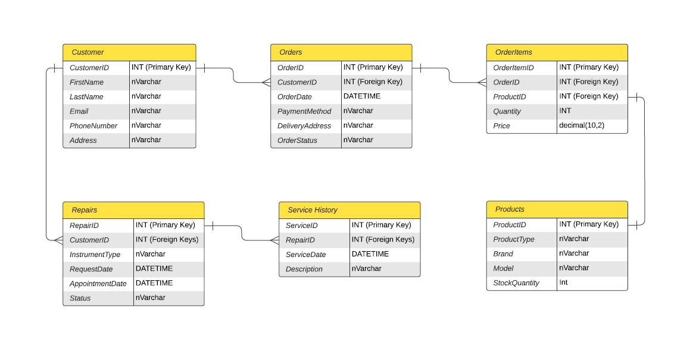
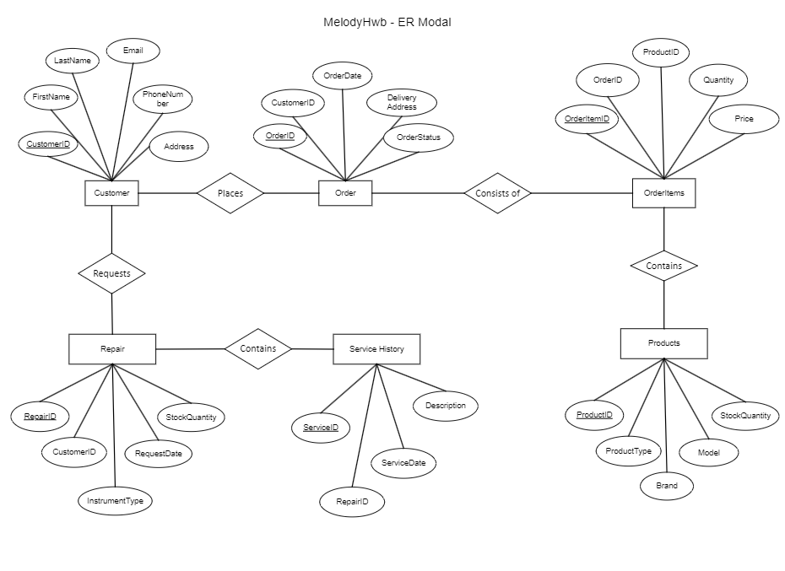
Detailed descriptions of each table, including field names, data types, and constraints.
Product Table
Field Name | Purpose | Data Type | Constraint
ProductID | The field is used as my primary identifier for each product within my product table. | INT (auto-incrementing identity)  Storing whole numbers. | Primary Key Constraint  This is unique to the record in the database for identification purposes, which I have used as my primary identifier for each product within the product table.  I have also placed an auto-increment identity, to make adding new records more efficient, by automatically increasing each record based on the last record created.
ProductType | I have created this field to group individual instrument types, as this would help with sales reporting. | NVARCHAR(100)  Variable-length Unicode character data. | I have set a max character length of 100.  I have also used the NOT NULL constraint. Which when defined, cannot be empty or have a NULL value. By doing so, this helps enforce data integrity and ensures that key data exists in each record.
Brand | I created this field to group product manufacturers, as some can often make different types of instruments. | NVARCHAR(100)  Variable-length Unicode character data. | I have set a max character length of 100.  I have also used the NOT NULL constraint. Which when defined, cannot be empty or have a NULL value. By doing so, this helps enforce data integrity and ensures that key data exists in each record.
Model | This is the specific model or version of the product. | NVARCHAR(100)  Variable-length Unicode character data. | I have set a max character length of 100.  I have also used the NOT NULL constraint. Which when defined, cannot be empty or have a NULL value. By doing so, this helps enforce data integrity and ensures that key data exists in each record.
Price | The sale price for each product within the table, to be used when creating transactions. | DECIMAL(10, 2)  Exact numeric data type for storing fixed-point decimal numbers. | I have also used the NOT NULL constraint. Which when defined, cannot be empty or have a NULL value. By doing so, this helps enforce data integrity and ensures that key data exists in each record.
StockQuantity | This is the stock level for each product within the table.  This will also be used when transacting, by deducting stock quantities after each sale.  This could also be used when processing returns by adding additional stock. | INT  Storing whole numbers. | I have used a CHECK constraint, which is is used to enforce specific conditions on the values within a column. For example, in my table the constraint ensures that stock quantities are never a negative number, which is more appropriate when managing physical stock.

Customer Table
Field Name | Purpose | Data Type | Constraint
CustomerID | The field is used as my primary identifier for each customer within my customer table. | INT (auto-incrementing identity)  Storing whole numbers. | Primary Key Constraint  This is unique to the record in the database for identification purposes, which I have used as my primary identifier for each customer within the customer table.  I have also placed an auto-increment identity, to make adding new records more efficient, by automatically increasing each record based on the last record created.
FirstName | The first name of the customer. | NVARCHAR(50)  Variable-length Unicode character data. | I have set a max character length of 50.
LastName | The surname name of the customer. | NVARCHAR(50)  Variable-length Unicode character data. | I have set a max character length of 50.
Email | This is the specific model or version of the product. | NVARCHAR(50)  Variable-length Unicode character data. | I have set a max character length of 100.  I have applied a UNIQUE constraint, which ensures that all values in a column are unique to each record. In this case, each customer's email must be unique to each customer.
PhoneNumber | Contact telephone number for each customer. | NVARCHAR(20)  Variable-length Unicode character data. | No constraints
Address | Registered address for each customer. | NVARCHAR(MAX)  Variable-length Unicode character data. | No constraints

Orders
Field Name | Purpose | Data Type | Constraint
OrderID | The field is used as my primary identifier for each Order within my Order table. | INT (auto-incrementing identity)  Storing whole numbers. | Primary Key Constraint  This is unique to the record in the database for identification purposes, which I have used as my primary identifier for each order within the Order table.  I have also placed an auto-increment identity, to make adding new records more efficient, by automatically increasing each record based on the last record created.
CustomerID | This is the customer record, associated to the customer placing the order. | INT  Storing whole numbers. | Foreign Key Constraint  This determines a relationship between tables by referencing the primary key in another table, ensuring referential integrity.  Within my order table, the customerID is used to reference a record for the customer placing the order.
OrderDate | The date the order was placed.  This can be used when creating sales reports to determine peak sales performance over a period of time. | DATETIME | No constraints
Order Status | This will record the stages of the ordering process. For example, ‘Order Placed’, ‘Order Processing’, Order Dispatched’. | NVARCHAR(20)  Variable-length Unicode character data. | No constraints

OrderItems
Field Name | Purpose | Data Type | Constraint
OrderItemID | This is my primary identifier for a specific item placed on order. As each order may contain multiple items, I felt it was more appropriate to create a separate table for each item, which can be associated to an individual order. | INT (auto-incrementing identity)  Storing whole numbers. | Primary Key Constraint  This is unique to the record in the database for identification purposes, which I have used as my primary identifier for each Item within the OrderItems table.  I have also placed an auto-increment identity, to make adding new records more efficient, by automatically increasing each record based on the last record created.
OrderID | This is the order record the item will be associated to. | INT  Storing whole numbers. | Foreign Key Constraint  This determines a relationship between tables by referencing the primary key in another table, ensuring referential integrity.  Within my OrderItem table, the OrderID is used to reference and group individual items placed within an order.
ProductID | This is the identifier for the product being placed on order, referenced from my Product table. | INT  Storing whole numbers. | Foreign Key Constraint  This determines a relationship between tables by referencing the primary key in another table, ensuring referential integrity.  Within my OrderItem table, the productID is used to reference the product being placed on order.
Quantity | The amount of a certain product being ordered. | INT  Storing whole numbers. | I have used a CHECK constraint, which is is used to enforce specific conditions on the values within a column.  For example, in my table the constraint ensures that stock quantities available in order to fulfil the order requirements.

Repairs
Field Name | Purpose | Data Type | Constraint
RepairID | This is my primary identifier for a repair being carried out for a customer. | INT (auto-incrementing identity)  Storing whole numbers. | Primary Key Constraint  This is unique to the record in the database for identification purposes, which I have used as my primary identifier for each repair within the Repairs table.  I have also placed an auto-increment identity, to make adding new records more efficient, by automatically increasing each record based on the last record created.
CustomerID | This is the customer record, for whom the repair is being carried out. | INT  Storing whole numbers. | Foreign Key Constraint  This determines a relationship between tables by referencing the primary key in another table, ensuring referential integrity.  Within my Repairs table, the CustomerID is used to reference customer requesting the repair.
InstrumentType | I have created this field to group individual instrument types, as this would help with sales reporting. | NVARCHAR(20)  Variable-length Unicode character data. | No constraints.
RequestDate | The date the order was requested. | DATETIME | No constraints
AppointmentDate | The date the appointment was allocated to carry out the repair. I did this for reporting purposes and tracking the duration of the repair. | DATETIME | No constraints
Status | The status of the repair. For example, ‘In progress’ and ‘Repaired’. | NVARCHAR(20)  Variable-length Unicode character data. | No constraints

Service History
Field Name | Purpose | Data Type | Constraint
ServiceID | This is my primary identifier for a specific service history. | INT (auto-incrementing identity)  Storing whole numbers. | Primary Key Constraint  This is unique to the record in the database for identification purposes, which I have used as my primary identifier for each service within the Service History table.  I have also placed an auto-increment identity, to make adding new records more efficient, by automatically increasing each record based on the last record created.
RepairID | This is each repair that can be associated to a specific service history. | INT  Storing whole numbers. | Foreign Key Constraint  This determines a relationship between tables by referencing the primary key in another table, ensuring referential integrity.  Within my Service History table, the RepairID is used to group repairs associated to a specific service history.
ServiceDate | The date of the service being carried out. | NVARCHAR(20)  Variable-length Unicode character data. | No constraints.
Description | Details related to the service being carried out. | DATETIME | No constraints

