
Skills for the Workplace
Module Assignment Submission
Student Name: | Medi Williams
Student Number: | 2025488
Module No: | BMSK6003
Module Title: | Leading and Implementing Workplace Change

Statement of Confirmation of Authenticity
By the act of making this submission, the student declares that this is the work of the student named above. The work has not, in whole or in part, been knowingly presented elsewhere for assessment, or where assessment has been built on a previous assessment, this has been identified. Where materials have been used from other sources it has been properly acknowledged. If this statement is untrue, the student acknowledges that an assessment offence has been committed.
Attention is drawn to the plagiarism and unfair practice policies of both the University and of ILM.
Permission for ILM to use this script
ILM uses learners’ submissions – on an anonymous basis – for assessment standardisation. By submitting, both the centre and the learner agree that ILM may use this script on condition that identifying information is removed. However, if you are unwilling to allow ILM use this script, please refuse by ticking the box: □

Table of Contents
Introduction 2
1.0 Critically analyse the current forces for change in the organisations micro and macro environment that can impact workplace culture and capability. 2
1.1 Change 2
1.1.1 Strategic Transformational Change 2
1.1.2 People-Centric Organisational Change 3
1.1.3 Structural Change 3
1.1.4 Remedial Change 4
1.2 Identifying current forces that influence change within the NHS. 4
1.2.1 SWOT 4
1.2.2 PESTLE 5
1.3 Workplace culture and change ability 6
1.3.1 Culture 6
1.3.2 Capability 7
2.0 Evaluate how organisational stakeholders can be efficiently led through complex workplace change. 8
2.1 Stakeholder Analysis 8
2.2 Change Management and Principles of Change Management 8
2.2.1 Principles of Change Management 8
2.2.2 Change management 10
2.3 Leadership and Implementing Change 10
Conclusion 11
References 13
Appendix A - SWOT Analysis 17
Appendix B – Pestle Analysis 18
Appendix C – Stakeholder Analysis 19
Appendix D – Kubler Ross Change Curve 20
Appendix E - “Four barriers to making change in the NHS” 21
Appendix F – Power Interest Grid 22
Appendix G – Delivery Plan 23
Appendix H Risk Register and Matrix 24
Appendix I – A Positive Epidemic – 25
Appendix J - NHS Change 26

Introduction
Research undertaken will critically analysis the effects of current forces derivative to the National Health Service (NHS) in relation to its micro and macro environs that influenced a change framework. It will address the impact of various changes the organisation undertake identifying where impact is greatest. Moreover, analysing the effect on individuals and workplace culture, whilst examining the capability of organisations to commence change.
Additionally, consideration of what measures are used to consult and prepare for change that can effectively ease transition within an organisation is offered and reports theorises on how change management models can assist leaders and/or change agents to engage with stakeholders to navigate the journey to ensure clear communication, effective transition and sustainability.
Furthermore, it will draw on examples from the authors own workplace to show contrasting behaviour, seeking to introduce theoretical and empirical examples as appropriate to develop a greater understanding of the impacts of change management.

1.0 Critically analyse the current forces for change in the organisations micro and macro environment that can impact workplace culture and capability.

1.1 Change
Present climates dictates, organisational movement and change are driven from both macro and micro environments. (Esparcia & Argente, 2012). Companies are confronted by numerous challenges such as new technology, legislation changes or environment as seen in recent years with the enormous impact created by the pandemic, leading to almost all sector organisations having to adapt and change. (Millar et al., 2012). Reflected by Macredi and Sandom (1999) ‘the unstable environmental conditions in which modern organisations operate mean that the ability to successfully manage change has become a key competitive asset.” Concurrently, Nickols (2004) asserts “the response to changes over which the organisation exercises little or no control”. Therefore, acknowledging that these forces are ungovernable by organisations.
The author agrees and additionally posits it is a fundamental need for organisations to embrace change to innovate and be reactive to forces impacting performance and growth. However, in application of change, organisations need understanding of their strategic positioning to determine the most suited change management for application. (Greenwood & Hinings, 1993).
There are four main types of organisational change, which have varied degrees of influence on organisations during change use of methodologies whether people oriented or structural. The author uses examples of NHS change impact as an organisation and contrasting that of their own workplace where relevant.

1.1.1 Strategic Transformational Change
This defines long-term organisational strategy, requiring planning and is used to redefine vision, mission and values. Change used in this manner can be implemented in stages in relatively small-scale interventions progressing with incremental changes and works well in large organisations such as the NHS.

Without doubt, the NHS has varied implementations of change and must continuously adapt to varied forces that impact operations. Strategic Transformational Change in such an organisation must be communicated clearly to adapt from its current format to its desired future state. Essentially, strategic transformational change identifies gaps, in particular those areas achieving growth targets, increasing efficiency, improving product quality and responding to market shifts. (Kochan & Dyer, 1993)
During its 75th year, NHS England developed a strategic change framework, initially addressing gaps within the service, aiming to improve capability and delivery teams. (Appendix A). Developed as a long-term strategy with its own change model based on intrinsic motivators such as their values and what is meaningful and significant with the potential to deliver power and energy to embrace delivering successful yet sustainable transformation. Whilst extrinsic motivators were the demand for the service to perform. Such influencing drivers defined and shaped the focus of change (NHS England, 2018)

1.1.2 People-Centric Organisational Change
Research indicates this change focusses on affects to individuals such as recruitment, succession planning evolving roles, and responsibilities. Within organisations people-centric change is predominantly navigated by the Human Resource (HR) departments. Challenges can be staff retention, lack of job role defining skills and recruiting new talent.
Dr Nichola Ashby (Head of Learning and Practice Development, Royal College of Nursing), reports one macro environmental influence in the lack of recruitment, as being the removal of training bursary funding, creating fundamental barriers for those wanting to enter the profession. Consequently, fewer qualified nursing staff are completing their training, creating a deficit in skills and specialism recruitment. (Guardian, 2022). Additionally, the fear of early retirement by doctors is creating recurrent recruitment drives. Another external factor to consider in the NHS practice, is the overseas recruitment drive by various countries. As seen in recent months, offering substantial benefits to a work life balance. With continued pressure being exerted on NHS staff the opportunity to work in a warm climate with greater family and social time is an attractive prospect, consequently increasing the number of staff leaving the NHS. (Parr, 2023).
With such macro environments impacting on NHS recruitment pressures increases to those servicing its delivery with consequences seen in long term sickness and burnout. (NHS Workforce Recruitment Challenges in Healthcare Industry, n.d.) Therefore, the poses, it is common practice to utilise a people centric change methodology as a continuum within HR in the NHS. However, little marketing has been carried out to support recruitment which could potentially increase workforce and advertised in a way that is an exciting prospect and an invigorating organisation to work for. This would also help shift a weakness into an opportunity.

1.1.3 Structural Change
Organisational structural change can encompass legislative, mergers, acquisitions, and the creation of new departments. Internal influences can be the redefining of departmental structures, the involvement of new technology and acquisition or moving of premises. With these factors there are noticeable impacts on organisational microenvironments, such as the re-training of staff on new technology or upskilling expertise and specialisms in the subject field. Acquisitions and relocation require planning and may involve several departments and, moreover in some instances, patients. Transitionally, the initial change will be designed and developed and involve estates and departmental hierarchy, however the delivery will involve service delivery staff. Implementation may be carried out in a staged approach, however,
within the NHS if patients are involved then the change need is immediate upon implementation due to the possibility of life saving equipment also being a factor to consider. (Peneder et al., 2003)
The author posits, in this approach, the NHS would benefit from deploying Lewin’s Change Management Model (1952), whereby unfreezing current practice will involve unveiling the change vision and strategy with the transition taking place during the change stage and refreeze capturing the working practice and its location. The author agrees that Lewin’s model in this context is still relevant to address change implantation based on current forces and immediate change reactiveness needed

1.1.4 Remedial Change
Remedial changes are subject to forces causing immediate action for modification. Never seen in greater context than the Covid-19 pandemic, where all services, including that of the NHS had no alternative but to react, adapt and implement curative measures. An example of such change was in the author’s own workplace, where almost instantaneously teaching transferred to an online delivery provision. Changing the constant into the unknown again, is replicant of Lewin’s Change Management Model (1952), however, the author also posits, the use of Prosci’s change model of has similarity, delivered in three phases through preparation defining success, impact and approach, introduction and management of change through plan, act, and adapt actions and phase three sustain output reviewing activity, transfer ownership and activate the sustainment. A very succinct method, that has the agility to move quickly in instances as highlighted in the example outlined. (Prosci, 2021) and (Hiatt, J., & Creasey, T. J. (2003).

1.2 Identifying current forces that influence change within the NHS.

1.2.1 SWOT
In identifying and to establish the driving factors of change within the NHS, a SWOT analysis was conducted. In doing so, this gave the author greater clarity on forces for change. Undertaking a SWOT analysis gives opportunity for an organisation to identify areas for development, such as service, hiring and promotion decisions and investment of resources.
Prominently recruitment and staffing are accentuated for numerous reasons across all pillars of the SWOT analysis. (Appendix A). Whilst benefits to employment within the NHS offers career pathway opportunities for progression and personal growth, combined with stable occupation, external environments clearly impact greatly on retention, skillset and recruitment. Also reported within the same research is the response to a staff survey where the admission by 40% of the staff surveyed indicated impact on wellbeing due to work related pressure and stress. (The King's Fund, 2019).
Further consideration as a noted impact, is the increasing aging population. In essence, advancements in patient care and treatment increases living age, which signifies NHS being a victim of its own success. However, greater life expectancy, creates more demand on the service in both community and clinical treatment perspective. In an observation, one report by Kirby (2020), identifies the following data in support of the above statement.

“In July 2019, a record number of accident and emergency (A&E) patients waited more than four hours to be seen. As experts warned the health service was ‘struggling to cope’, NHS performance statistics revealed 275,526 patients were seen after the targeted time last month compared with 208,083 in July 2018, an increase of almost a third (32.4%). This is also the highest number for July since current records began in August 2010. Of these, 436 patients waited more than 12 hours – almost 200% higher than in July 2018. The figures show overall admissions at A&E departments have also hit records levels – rising 6% in a year to reach 2.27 million last month. A record number of people are also waiting for routine operations in England, and around 4.4 million people were waiting to start treatment in June. In some hospitals the waiting lists have recently risen by more than 50%.”
(Kirby, 2020).
Counterintuitively, therefore highlighting, the greater the service pressure the more likelihood of staff burnout, early retirement, or sourcing alternative employment due to the indicated consequent rising pressures on service. (NHS England, 2018a). Moreover, the author recognises the additional measure of the threat of funding cuts, creates significant impact across service, staffing, capital growth, creating a circular cycle throughout the strengths, weaknesses and threats.
Opportunities recognized within the same research, do pose some factors that can also be considered as remedial practice to counteract potential issues. Development of a new marketing initiative can support areas of recruitment and positively promote the NHS, which can in the long term encourage additional applicants for job vacancies and the NHS as being an incredible place to work, this would reverse the observation within the SWOT and turn a weakness into an opportunity.

1.2.2 PESTLE
Whilst a SWOT analysis identifies key components within the current organisational practice and its centred micro environments, greater powers may further impact on organisations from a macro environment perspective. Conducting a PESTLE analysis aids organisations in understanding the wider picture to formulate decision making for change. Identifying where trigger factors may be imminent or approaching from such environs, allows solution finding and implementation of change, to counteract the affects driven by such environs. (Buye, R. 2021).
A PESTLE analysis on the NHS was an exercise undertaken as part of this research to determine the criticality of current forces which can impact on the organisation. (Appendix C). The research indicates parity in some driving forces being both intrinsic and extrinsic. Such as, lack of technical skilled staff, staff ill health
An example which is prevalent is the technical skilled staff shortage, with bursaries cut and funding reduced, NHS has difficulty in employing skilled staff but also resourcing continuous professional development, essential in being at the forefront of servicing patients in pioneering ways and advancing treatments, to create a greater life expectancy. (NHS England, 2022)
The author understands where challenges are apparent, implementing a change methodology will assist in overcoming such barriers. Arguably, learning and development leads can work closely with academic partners in supporting this; within the authors work setting certain qualifications to support progression within the NHS is advantageous for both parties.
Within academia, the authors workplace, it increases enrolment thereby increasing funding drawdown by the institution adding to financial buoyancy, and for the NHS increases skilled staff and supports staff progression. The authors institution classes their local health board as a key account and works closely to devise and develop both progression pathways and new qualifications to support advancement. Invariably there is funding to support the employees within the institutions gift, which is outside of the health board’s budgets, beneficial therefore, to both parties. Giving also, the opportunity to closely monitor new development to safeguarding for the future by reacting to changing environs quicker.

1.3 Workplace culture and change ability

1.3.1 Culture
The ethos of the NHS culture is identified as

“an organisational culture that puts patients first, promotes trust, respect and equality and are sufficiently open and transparent such that staff feel able to challenge each other robustly, regardless of status, without fear and are encouraged to come forward when difficulties arise”.
(Bell, 2017)
Organisational change must be underpinned with the correct structures and frameworks to be effective and are aligned with embedded organisational cultures. Moreover, it is advantageous for both employers and employees to share the same vision and opinion and are equally committed to the change. (Bennett et al., 1994). Equally shared by Fitz-Enz (1997), reiterated by Gibson et al., (2000) is asserted that change would only be achieved if aligned to organisational strategy which was connected to its culture and systems perceived to be the only way to outperform competitors.
Recognition and understanding of the organisational culture, invariably draws on the strength of a leader to be attuned to emotional intelligence. Vakola et al. (2004) studied 137 professionals from various organisations, undertook a self-analysis report on the correlation of personal traits, emotional intelligence, in addition to attitudinal behaviour in relation to organisational change. Results indicated not only confirmation of the existence of correlation, moreover, the significance being, practicality and added value benefit to adopting emotional intelligence within the organisational change model or framework.
In agreement the author recognises the importance of emotional intelligence being used within the phases of change to support employees through the process, whilst conducting the change in a manner which can enthuse, encourage, and motivate employees in conjunction with understanding any trepidation and fear to the unknown or adverse reaction to change, therefore managing change sympathetically.
As indicated by Kubler Ross Change Curve (1969) (Appendix D), change can create an emotional chain reaction which can fluctuates between feelings. Also posited by Itzen & Newman (2003), and indicated by Waddell, et al. (2017) those who are institutionalised in a particular culture, behaviour or practice are inflexible to change, further asserting women are below men in agreement to change. Derived from the lack of cognizance of female aptitude and potential for advancement and career development within the organisational culture of the NHS. (Bolden et al., 2019)
Open communication and preparatory communication by way of consultation is highly important for employees and stakeholders to feel part of the process and that their voices are heard and matter. This eases any animosity or hostility to change. (Schlossberg, 2011). Developing a communication strategy is a way of counteracting or addressing the issues head on. Explaining the value of change, its necessity, the driving forces behind it and more importantly what does the change mean for them personally in initial communication and subsequently keeping stakeholders informed through the implementation.
The author has seen this first hand within their own organisation, whereby, such emotions have been seen when a process change has been implemented to increase productivity. Whilst a small change, it can upset the ‘Status Quo’, with long standing department employees who have become accustomed to a particular process. Involving staff at the outset supresses the anxiety and nervousness around the change element. However, as an emotional intelligent leader, the author is not oblivious to the conflict this can bring and involves the employees through consultation regarding the process implementation and how it works best for them. This can mean interim roll out of the process between departments or taking on board thoughts of process change by employees which aligns to the change management process and alignment to procedural change. Supported by Hankin (2005) who stated accepting differences in employees offering an inclusive environment shows they are valued and heard. Furthermore, Mabin, Forgeson and Green (2001) warns of the danger mitigation of such requirements can be the cause and effect of resistance to change.
Kotters 8 Step Change Model (1996), supports the same methodology, by way of the leader exposing organisational culture with visions of change communicated throughout a team, reinforcing new values and beliefs amongst employees.

1.3.2 Capability
Asserted by Allcock et al. (2015), there are four key factors that hinder change within the NHS, again prominently, capability appears significantly as shown in Appendix E.
One identified prolific capability and skills deficit within the NHS is the adaptation to digital transformation. Not only in the form of data information and knowledge but in that of innovation and new technology (Brice & Almond, 2020).
Already transparent in research undertaking, this can severely inhibit technical staff expertise, profoundly impacting on patient care and recovery. Acknowledged by the NHS in their Agility to Respond to Change report (n.d.), exerting:-
“Developing agility and resilience is not always prominent in workforce education and training. There is a need to support new and existing staff to learn these skills in the ever-changing NHS environment”.
(Agility to Respond to Change, n.d.).

The author accentuates the need to be mindful that these areas are addressed and factored into the planning process of change implementation by way of training and continuous professional development (CPD). Without such measures change implementation can fail.
Furthermore, as previously illustrated within several research studies mentioned and identified as a driver of change, is the organisational wide lack of skills, created by influencing factors such as funding cuts, bursary removal and early retirement. Therefore, in agreement the author observes, to construct organisational change one must consider how to overcome such capability barriers.
The author concludes, the current forces are drivers of change and can instigate numerous reactions and therefore change is to be managed effectively, must be planned efficiently and engaged with employees and stakeholders through consultation and clear communication, in order to deploy an effective and successful change implementation. In addition, whilst the SWOT and PESTLE can identify current forces for change, some may be led through past experiences and need to also be considered. Use of a planning model such as that illustrated by Deming (1952). The preparatory work is in the planning phase outlined in his Plan Do Check Act (PDCA) model, giving a structure to model the planning phase with accuracy. (Deming, 1952)
What has clearly been identified is the need for cautionary measures to avoid culture conflict by involvement of known quantities that influence change, however, it is never a linear process, therefore preparation, planning, assessment of risks and understanding the main change factor i.e., people centric, will determine the best course of action and also the best methodology model to be deployed for an effective and moreover successful implementation of change directive based on current drivers.

2.0 Evaluate how organisational stakeholders can be efficiently led through complex workplace change.

2.1 Stakeholder Analysis
Friedman and Miles (2006) assert, “Stakeholder engagement is the process of effectively eliciting stakeholders’ views on their relationship with the organisation/programme/project”. Whilst this statement captures the essence of stakeholders, identifying those that are prevalent to the organisation change, by their importance, influence and impacting level of change on them can be deduced by use of a stakeholder analysis.
A power/interest grid was used to determine the level of interest in replication of that introduced by Murphy and Willmot (2010) model. (Appendix F) Distinguishing, stakeholder holds high power and high level of interest, for example, employees, should be managed closely throughout the change and local trade and businesses kept satisfied. The quadrant methodology gauges the power of each stakeholder.
Appendix C, identifies stakeholders impacted by the framework change which affects several departments, staff and environs within the NHS following identification of change drivers in the SWOT and PESTEL analysis, constructed on the Friedman and Miles’ model (2006). In its undertaking the demarcation of its primary and secondary function in relation to the organisation was established prioritising the level of importance in a ratio of high > low, indicative also to the identified drivers of change rated 1 to 3. Conducting the analysis establishes the engagement in relation to their controlling power, vital for the organisation to achieve its change goals and objectives. Lindgreen and Swaen (2010).

2.2 Change Management and Principles of Change Management

2.2.1 Principles of Change Management
Change management is referred to as a process of modification adjustment or renovation. (Hartmann & Lussier, 2020). Change is not only based on how and why but importantly the who; internal and external stakeholders (Fusch et al 2020). Moreover, in adopting change having an understanding of the change, it’s impact and its change to the norm, where common understanding and goals are distorted and no longer prevalent but that of the unknown (Bisel & Arterburn, 2012). Miller et al (2010) posits change initiatives are best undertaken by leaders with knowledge of the key components and dynamics of the change and employees who closest to change also known as change agents. (Sherman & Garland, 2007).
The author agrees this, also conveying that change conflict can occur if not carried out effectively. Barr and Dowding (2012) offer three states of conflict derivative of relationships are, intrapersonal, interpersonal and inter-group. Individual’s conflict for example can occur from confusion in understanding of the role, with inter-group involving two or more team members with different goals or visions, and interpersonal generating friction or a challenge for power or resentment of other. The aid of a change management tool can assist in managing such behaviour with clear guidance and communication set out in a development plan. (McKibben, 2017).
Abbas (2022) determines 5 key principles of change management which can be implemented to assist organisation through an efficient transition for successful change: - planning, communication, involvement, training and support, and measuring progress and success. (Abbas, 2022)
Change planning is a critical and fundamental part, the use of a change management plan with timebound milestones and/or work packages can navigate the process efficiently. Importantly, involving people from across the organisation gives strength to the adoption of change.
The author identifies with this and within their own workplace undertakes a development plan. This is defined by work packages significant to the change being implemented. As seen in Appendix G, this example is the implementation of a project that has both financial and outcome-based performance measures which will impact across delivery within Gower College Swansea. It has numerous elements to implementing change from recruitment through to monitoring and evaluating. As with that asserted by Abbas (2022) the author has factored Stakeholder engagement by introducing them in the form of a Steering group, used to formulate communication strategies and as outlined will take place bi-monthly until the last two months, to ensure clear communication and those identified as being strategically impacted or of significant power interest have a clear voice in the direction the project.
Training is factored following recruitment, through induction and within project initiation, aiding in assuring capability and knowledge of the techniques, processes and project delivery. Furthermore, as seen in the development plan, performance review and monitoring and evaluation meetings have been structured within the communication strategy. Predominantly these will factor the internal stakeholders who have active participation in the delivery of the project and will have a more detailed operational meeting, reviewing procedures, statistics and performance.
Monitoring of the project will be seen across each of these meetings with key statistics being outlined at Steering group level, however, further detailed analysis is the driver for the performance review and monitoring meetings, whereby achievement against Key Performance Indicators will be assessed and reviewed, undertaking risk mitigation where or if needed. In this case, there is need for risk mitigation to pre-determine such factors, the author also conducted a risk analysis with mitigation solutions as part of the planning process. However, it is difficult to identify unknown or unseen commodities which cannot be factored. (Annex H).
In undertaking such principles of change management, the author establishes a robust strategy for implementation and clear guide for change agents to follow, easing the transition of change. Additionally, concurs their methods are resonant of the ADKAR change model (Hiatt, 2003), advocating raising the awareness, through initial consultation, promoting the desire for change, equips people with the infrastructure and knowledge to embark on change. Training ensures the capability and satisfactory skillset, and finally, reinforcement, continues the sustainability and support of stakeholders.

2.2.2 Change management
Imperatively Change Management (CM) is suggested, focuses on both the softer elements of change such as culture, leadership and motivation. However, for success invariably it is measured by the hard defining factors, therefore, should be led with clear communication and competent personnel (J. S. Oakland & Stephen Tanner, 2007).
It is often asserted, that leaders will transition change without consideration for the effects of the softer elements of change, such as the impact on individuals, personalities their capabilities or aspirations, posing risk of failure due to lack of consideration to the human factor. (Dawson, P. & Andriopolous, C. 2017).
Emotional change transition experienced by individuals is examined in The Bridges Transition Model (1991), the model comprises of three phases. The first is identified as commencing unexpectantly at the ‘end’. Showing the initial reaction of individuals when faced with change, accompanied by fear and in trepidation. Neutrality is identified as the middle stage where transition occurs from the norm to the unknown materialising in low morale in adapting to new variations. Finally, the acceptance of change, seen as a new beginning, whereby morale raises, creating a more positive adoption of change. (Bridges, W. 1991).
Used in combination with a change management model, can minimize disruption and discord, communication through common vocabulary, creates way for greater understanding and ability to leverage a shared vision and goal, improving morale and successful change implementation. (Miller. J. 2017).
Within the NHS it is reported that emotional intelligence transformational leader and staff nurses implementing change within the organisation accounted for 34.3 % of nurses staying within the profession indicating the relationship was that of a trusted and understanding nature. (Wang et al., 2018). Which emphasises the difference that can be made by effective leadership in implementing change and addressing key challenges to staff retention outlined through the SWOT and PESTLE analysis.
The author agrees the need to observe such softer elements effects, adding that emotional intelligence capabilities of leaders or change agents should be examined prior to determining the correct agent for instructing change. An autocratic leader lacks some emotional intelligence traits, therefore can inflict unconscious bias, creating conflict lowering morale and resistance. Therefore, an attuned leader to such elements, such as a democratic leader, would deploy change considering on all aspects. This has been established and evidenced within research undertaken in a study carried out by Zhang et al. (2020). Whereby the project was implemented by an autocratic leader. The leadership style created negative emotion and power distance with stakeholders, generating vast resistance to change, even with mediation implemented there was a negative outcome to the project’s success.

2.3 Leadership and Implementing Change
Various change model supports the application of change. However not all will be the most conducive for a leader or organisation. McKinsey 7 S Model (1980) demonstrates a model of approach that allows for an understanding of the practical elements in addition to that of emotional. Delivered in a staged approach it conveys an understanding of the organisation, creating opportunity for employees to evolve with the change.
Arguably comparable to that of Kotter’s 8 Step Change Model (1996), equally delivered in sequential stages that are followed in succession with time bound measures. Both are appropriate to use in conjunction with organisational driven change or that of a people centric approach as it utilises an engagement approach that factors organisations culture and staff contribution.
Kotter (1996) asserts that a strong leader must possess a strong receptive personality with conviction to back their vision. Additionally, Newcombe (2005) states leaders must consider continually the effect of the environment when undertaking the application of their vision. (Newcombe 2005). In doing so leaders will draw followers and trust amongst stakeholders.
As defined by Shapiro (2010), creating contagious commitment in change is centred around people and understanding the correct time to leverage and apply pressure to achieve a successful initiative. The concept suggests that ideas spread, however, are not driven by themselves. Therefore, concurring with Kotter (1996) and Newcombe (2005) that adept leaders will use a people centric approach. Creating an air of excitement can move individual from apathetic (nonchalant individuals) through the process of incubators to that of advocates (those who are excited by what change can bring). However, the stages of change can equally reverse or even miss a stage reverting to apathetic when there is no backing or movement to the change vision. (Appendix I). Leaders must show conviction and not stagnant movement as it may result in lack of trust, discouragement and demoralisation amongst stakeholders.
However, in relation to the NHS they developed a model (Appendix J) that centred on a shared vision. Its components combine both models of McKinsey( 1980 and Kotter (1996), in such that they have configured a process of change which encompasses 7 stages and aligns with that of system drivers, motivation and mobilisation, performance management, measurement of change, the tools for improvement and moreover, leadership by all and spread and adoption of change. This can be argued also, it takes into account that outlined by Shapiro (2010) in enthusing others to participate in the journey. NHS assert this model was developed to ensure all factors contributing to change are considered to aid in a successful outcome. (NHS England, 2018).
The author uses the same methodology when constructing projects which implement change within their own workplace. However, in addition, once the above stages has been carried out and following the stakeholder analysis, will identify two more stages to assist in the ease of stakeholder relationships such as a communication plan (which can be seen within the development plan (Appendix G) and that of the risk assessment also seen within the same appendix. The author advocates this approach, given that this will support clear communication with stakeholder and identify threats that may hinder the transition of change.

Conclusion
In conducting change within an organisation successfully, it is imperative that continuous assessment of environs is assessed to ensure innovation, demand for change and influencing factors are considered.
Once change is identified through these, clear communication and guidance must be deployed. Leaders must be attuned and knowledgeable in implementing change whilst undertaking consideration of organisational culture. Furthermore, imperatively, assessment of organisational capability and react to such change, must play a significant role in ensuring skillsets are appropriate or training is factored to equip individuals to undertake their roles reinforcing organisation capacity, avoiding failure of adopting new processes and techniques.
Gauging the significance and importance of the power influence of stakeholders, giving the correct information at the appropriate times. Constant evaluation and monitoring must be instilled within the development plan, to assess, identify weaknesses, and implement new measures if necessary to aid successful change transition. Moreover, it is apparent that no one standalone measure can determine positive change; it is a combination of all outlined within this report that creates a robust leadership and implementation of change to achieve success.

References
Abbas, T. (2022, October 20). 5 Key Principles of Change Management. CMI. https://changemanagementinsight.com/5-key-principles-of-change-management/
Agility to respond to change. (n.d.). Transformation Partners in Health and Care. Retrieved August 7, 2023, from https://www.transformationpartnersinhealthandcare.nhs.uk/resource/agility-respond-change/
Allcock, C., Dormon, F., Taunt, R., & Dixon, J. (2015). Constructive comfort: accelerating change in the NHS Policy analysis. https://www.health.org.uk/sites/default/files/ConstructiveComfortAcceleratingChangeInTheNHS.pdf
Bell, J. (2017, November 2). Organisational culture in the NHS. Tavistock Consulting. https://tavistockconsulting.co.uk/organisational-culture-nhs
Bennett, R., Fadil, P., & Greenwood, R. T. (1994). Cultural Alignment in Response to Strategic Organizational Change: New Considerations for a Change Framework. 6(4), 474.
Bisel, R. S., & Arterburn, E. N. (2012). Making sense of organizational members’ silence: A sensemakingresource model. Communication Research Reports, 29(3), 217–226. https://doi.org/10.1080/08824096.2012.684985
Bolden, R., Adelaine, A., Warren, S., Gulati, A., Conley, H., & Jarvis, C. (2019). Clear Print Version Inclusion: The DNA of Leadership and Change A review of theory, evidence and practice on leadership, equality, diversity and inclusion in the National Health Service. https://www.leadershipacademy.nhs.uk/wp-content/uploads/dlm_uploads/2019/06/BLFI-Literature-review-Clear-Print-Version.pdf
Brice, S., & Almond, H. (2020). Health Professional Digital Capabilities Frameworks: A Scoping Review. Journal of Multidisciplinary Healthcare, Volume 13, 1375–1390. https://doi.org/10.2147/jmdh.s269412
Bridges, Miller, Julie L. (2017). "Managing Transitions: Using William Bridges’ Transition Model and a Change Style Assessment Instrument to Inform Strategies and Measure Progress in Organizational Change Management" Scholarship and Professional Work. https://digitalcommons.butler.edu/librarian_papers/74 W. (1991) Managing Transitions, Addison Wesley
Buye, R. (2021). Critical examination of the PESTEL Analysis Model. Project: Action Research for Development.
culcahmadjeffrie. (2018, March 20). Leadership & Change. Leading in a Changing World. https://culcahmadjeffrie.wordpress.com/2018/03/20/leadership-change/
Dawson, P. & Andriopolous, C. (2017). Managing change, creativity & innovation. 3rd edn. London; Sage Publications Ltd p.203
Esparcia, S., & Argente, E. (2012, July 1). Forces That Drive Organizational Change in an Adaptive Virtual Organization. IEEE Xplore. https://doi.org/10.1109/CISIS.2012.64
Fitz-enz, J. (1997). The truth about best practices: What they are and how to apply them. Human Resource Management, 36(1), 97–103. https://doi.org/10.1002/(sici)1099-050x(199721)36:1%3C97::aid-hrm16%3E3.0.co;2-b
Friedman, L. and Miles, S. (2006) Stakeholders Theory and Practice. Oxford University Press
Gibson, J. L., Donnelly, J. H., & Ivancevich, J. M. (2000). Organizations : behavior, structure, processes. Irwin/Mcgraw-Hill.
Greenwood, R., & Hinings, C. R. (1993). Understanding Strategic Change: the Contribution of Archetypes. Academy of Management Journal, 36(5), 1052–1081. https://doi.org/10.5465/256645
Guardian. (2022). NHS workforce recruitment challenges in healthcare industry. NHS Workforce Recruitment Challenges in Healthcare Industry. https://recruiters.theguardian.com/advice/nhs-recruitment-challenges
Hankin, H. (2005). The new workforce: Five sweeping trends that will shape your company’s future. New York: American Management Association.
Hartmann, N. N., & Lussier, B. (2020). Managing the sales force through the unexpected exogenous COVID-19 crisis. Industrial Marketing Management, 88, 101–111. https://doi.org/10.1016/j.indmarman.2020.05.005
Hiatt, J., & Creasey, T. J. (2003). Change Management: The People Side of Change. Prosci Learning Center Publications.
J. S. Oakland & Stephen Tanner (2007) Successful Change Management, Total Quality Management & Business Excellence, 18:1-2, 1-19, DOI: 10.1080/14783360601042890
Kirby, R. (2020). Dealing with the NHS staff recruitment and retention crisis. Trends in Urology & Men’s Health, 11(1), 20–21. https://doi.org/10.1002/tre.730
Kochan, T. A., & Dyer, L. (1993). Managing transformational change: the role of human resource professionals. The International Journal of Human Resource Management, 4(3), 569–590. https://doi.org/10.1080/09585199300000037
Kotter, J. (1996) ‘Kotter's 1996 change model’. Journal of Management Development. 31. pp. 764-782.
Kotter, J. (1996) Leading change. Cambridge, MA: Harvard Business Press.
Kotter, J. and Heskett, J. (1992) Corporate Culture and Performance, London, Macmillan
Kubler-Ross, E. (1969) The Five Stages of Grief
Lewin, K. (1952) Selected theoretical papers. London: Tavistock.
Lindgreen, A., and Swaen, V. (2010) ‘Corporate social responsibility’. International journal of management reviews. 12(1). pp. 16-23
Mabin, V.J., Forgeson, S., & Green, L. (2001) ‘Harnessing resistance: Using the theory of constraints to assist change management’. Journal of European Industrial Training. 25(2/3/4). pp. 168-191
Macredie, R.D., Sandom, C., & Paul, R.J. (1998) Modelling for change: An information systems perspective on change management models
McKibben, L. (2017). Conflict management: importance and implications. British Journal of Nursing, 26(2), 100–103. PubMed. https://doi.org/10.12968/bjon.2017.26.2.100
Millar, C., Hind, P., & Magala, S. (2012). Sustainability and the need for change: organisational change and transformational vision. Journal of Organizational Change Management, 25(4), 489–500. https://doi.org/10.1108/09534811211239272
Miller, L. C., Jones, B. B., Graves, R. S., & Sievert, M. C. (2010). Merging silos: Collaborating for information literacy. Journal of Continuing Education in Nursing, 41(6), 267–272. Http://doi.org/10.3928/00220124-20100401-03
NHS England. (2018a). NHS England - Change Model. England.nhs.uk; NHS England. https://www.england.nhs.uk/sustainableimprovement/change-model/
NHS England. (2018b). The change model guide. In NHS England (pp. 1–32). https://www.england.nhs.uk/wp-content/uploads/2018/04/change-model-guide-v5.pdf
NHS England. (2022). NHS England» Strategic Drivers. Www.england.nhs.uk. https://www.england.nhs.uk/about/equality/equality-hub/national-healthcare-inequalities-improvement-programme/our-approach-to-reducing-healthcare-inequalities/strategic-drivers/
Nickols,F.(2004).Change management 101:A primer. Available at: https://nickols.us/change.htm.
Parr, E. (2023, February 16). Australia minister to visit UK in bid to “steal” doctors. Pulse Today. https://www.pulsetoday.co.uk/news/workforce/australia-minister-to-visit-uk-in-bid-to-steal-doctors/
Peneder, M., Kaniovski, S., & Dachs, B. (2003). What follows tertiarisation? structural change and the role of knowledge-based services. The Service Industries Journal, 23(2), 47–66. https://doi.org/10.1080/02642060412331300882
Prosci. (2021). Prosci Methodology. Www.prosci.com. https://www.prosci.com/resources/articles/prosci-methodology
Schlossberg, N. K. (2011). the challenge of change: the transition model and its applications. Journal of Employment Counseling, 48(4), 159–162. https://doi.org/10.1002/j.2161-1920.2011.tb01102.x
Shapiro, A. (2010) Creating Contagious Commitment. 2nd edn. Hillsborough, North Carolina: Strategy Perspective.
Sherman, W. S., & Garland, G. E. (2007). Where to bury the survivors? Exploring possible ex post effects of resistance to change. SAM Advanced Management Journal, 72(1), 52–64.
The King's Fund. (2019). NHS Leadership and culture: Our Position. The King’s Fund. https://www.kingsfund.org.uk/projects/positions/NHS-leadership-culture
Vakola, M., Tsaousis, I., & Nikolaou, I. (2004). The role of emotional intelligence and personality variables on attitudes toward organisational change. Journal of Managerial Psychology, 19(2), 88–110. https://doi.org/10.1108/02683940410526082
Waddell, et al. (2017) Organisational Change: Development and Transformation. 6th Ed.
Wang, L., Tao, H., Bowers, B. J., Brown, R., & Zhang, Y. (2018). When nurse emotional intelligence matters: How transformational leadership influences intent to stay. Journal of Nursing Management, 26(4), 358–365. https://doi.org/10.1111/jonm.12509
William Edwards Deming. (1952). Elementary Principles of the statistical control of quality a series of lectures. Tokyo Nippon Kegaku Gijutsu Remmei.
Zhang, Y., Gao, P., Zhang, J., & Lu, L. (2020). Effect of authoritarian leadership on user resistance to change: evidence from IS project implementation in China. Industrial Management & Data Systems, ahead-of-print(ahead-of-print). https://doi.org/10.1108/imds-11-2019-0619

Appendix A - SWOT Analysis

NHS – SWOT Analysis
Strengths  - Experts in developing and delivering clinical and healthcare provision  - Only large-scale public provider of healthcare in the UK  - Extensive Infrastructure  - Large scale employer of both specialist and administrative staff  - Forefront of technological advancing treatments  - Growth and expansion | Weaknesses  - Technology advancement creates problematic issues for recruitment  - Increased ageing population generates pressure on services and delivery  - Response times have increased  - Pay disparity to other occupations can pose lack of recruitment  - Estates not progressing as rapidly as services require
Opportunities  - Develop wider marketing strategies to raise profile and encourage recruitment  - Increase partnership working with private, community, councils and voluntary sectors  - Creates career progression pathways  - Stable career | Threats  - Other countries offering greater work life balance enticing staff to relocate  - Technological advancement out ways skilled staff availability  - Cost for recruiting specialist staff impact on financial budgets  - Increased number of staff retiring early  - Further Public Funding Cuts

Appendix B – Pestle Analysis

NHS PESTLE analysis

Political | Legislative changes, No pay increases and strike action, funding cuts, union disputes,
Economical | Less job security, recession, less income within budgets, budget restraints, lack of qualified staff
Social | Detriment to wellbeing, increased pressure on staff, amenities losing trade such as their restaurants and cafés, lack of resources, staff sickness, reduction in access to wellbeing services, staff burnout,
Technological | Less research and innovation, lack of budgets for new advanced technology, lack of technology in some hospitals to perform operations and lack of technical trained staff in each hospital
Legal | Local government restrictions, employment laws and contractual rights, employee’s sickness and wellbeing.
Environment | Lack of qualified personnel, lack of PPE equipment, reputation in disarray due to waiting times for emergency operations following the pandemic, increase on demand on services and greater resource pressures within community field.

Appendix C – Stakeholder Analysis

NHS Stakeholder Analysis

 | Stakeholder | Interests | Estimated Impact | Estimated Priority
Primary | Staff | Value for money  Access to training  Social interaction  Progression  Learning | High | 1
Primary | Management | Access to resources  Training  Financial security | High | 1
Primary | Partners/Collaborators | Shared resources  Financial gain  Investment | High/Medium | 1/2
Secondary | Local Government | Funding  Socio/economic effects | High  High/Medium | 1  1/2
Secondary | Community | Local businesses and trade  Environment  Impact of aging population  General public | Low  Medium  Medium  Medium | 3  1/2  2  2
Secondary | Other unions and associations | Wellbeing and protection of workforce | High | 1
Secondary | Research and Innovation | Continuation of research and studies  Access to resources and technically skilled staff | High  Medium | 1  2
Secondary | Funding councils | Financial support  Fiscal policies | High  High | 1  1

Appendix D – Kubler Ross Change Curve

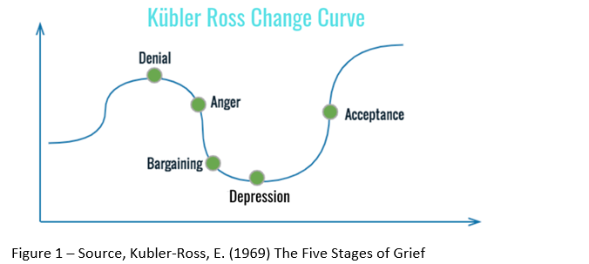

Appendix E - “Four barriers to making change in the NHS”

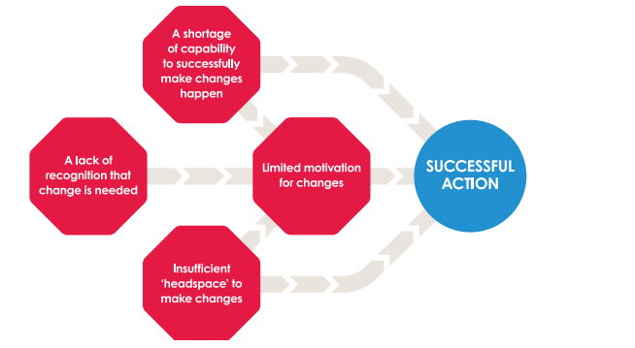
Figure 2 – Source “four barriers to making change in the NHS” - Constructive comfort: accelerating change in the NHS Policy analysis. P.12. (Allcock et al, 2015).

Appendix F – Power Interest Grid
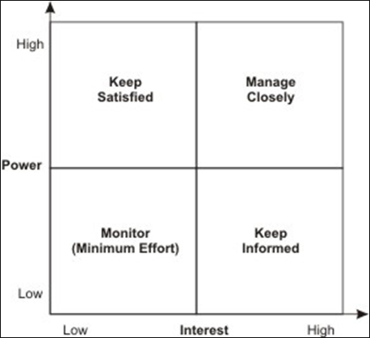

Appendix G – Delivery Plan

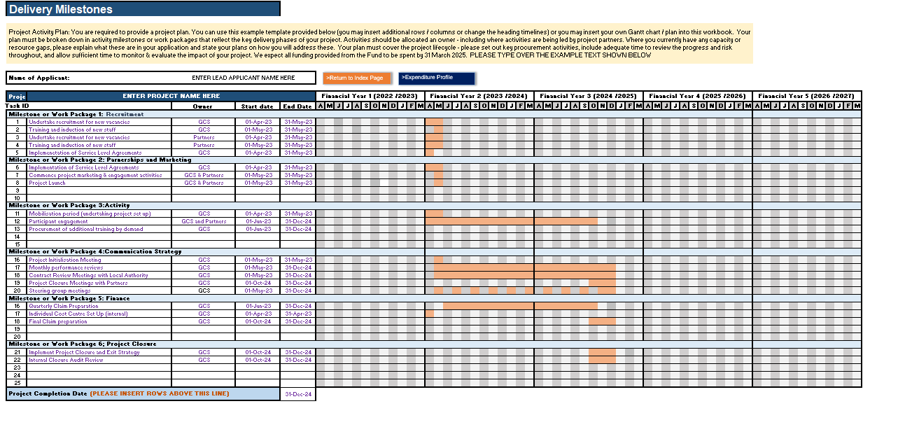
Source Medi Williams – Gower College Swansea 2023

Appendix H Risk Register and Matrix
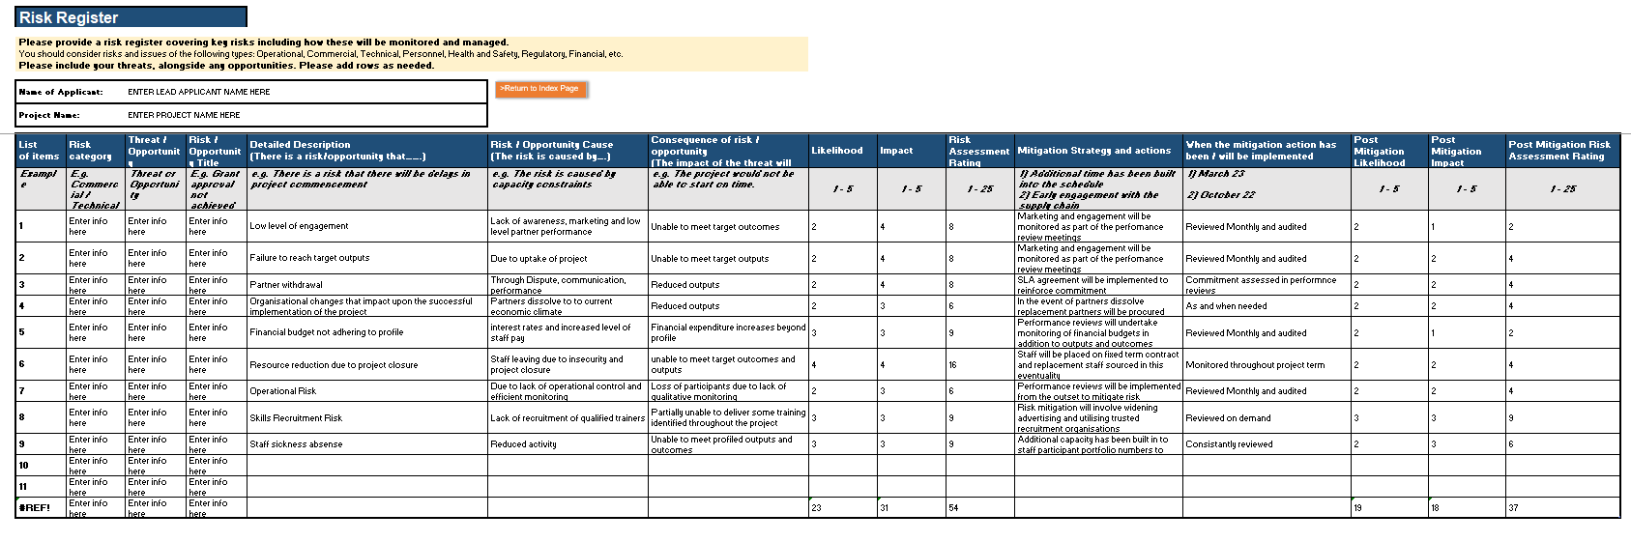
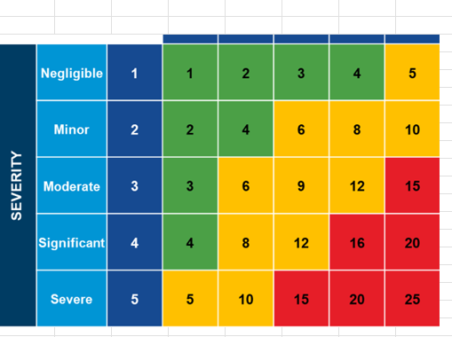
Source Medi Williams -Gower College Swansea 2023

Appendix I – A Positive Epidemic –

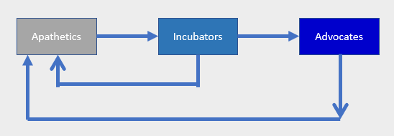
Source - Shapiro, A. (2010) Creating Contagious Commitment.

Appendix J - NHS Change

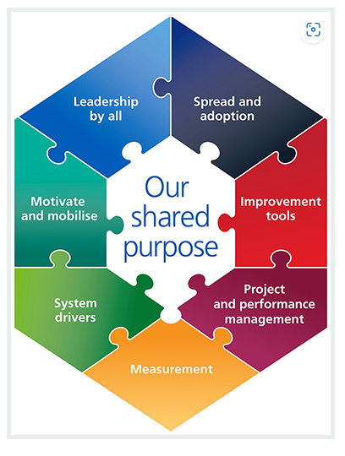
Model – Source .nhs.uk, sustainable improvement, change-model (2018)

