

ACCA4024 Networks and Cyber Security Essential (PUW)
Synthesize a solution to a potential real-life scenario

Abstract
SteelForm Manufacturing Ltd (SFM) is a modern manufacturing company that is vulnerable to threats such as Malware, Phishing attacks, Unauthorised access and Industrial espionage that can impact the business's manufacturing processes and sensitive business data. This report explores the risks of cybersecurity for SFM and proposes a full range of strategies to help strengthen SFM's cyber defences against both internal and external attackers. The suggested strategy emphasises bolstering the security of the network, better data governance, access controls, better monitoring, and effective incident response strategies. The solution will enable the SFM to become more resilient, protect critical business assets and offer secure manufacturing.

Contents
Report 4
Introduction 4
Threat Identification and Risk Analysis 5
Cybersecurity and Data Governance Policies 6
The protection of endpoints from Malware and Prevention. 8
Network Monitoring and Incident Response Plan 9
Staff Training and Security Awareness Programme. 10
Conclusion 11
References 12
Presentation 13
Introduction 13
Current Cybersecurity Challenges Facing SFM 14
Recommended Cybersecurity Strategy 15
Technical Security Improvements 16
Incident Response and Monitoring 17
Suggestions for employee awareness and training 18
Implementation Roadmap 19
Conclusion 20
References 21

Report

Introduction
It has transformed the manufacturing sector with its innovations and new technologies like the Internet of Things (IoT), automated manufacturing systems, artificial intelligence, and cloud-based management systems. The technologies have enabled organisations to be more efficient, lower production costs, and make better decisions based on real-time data. SteelForm Manufacturing Ltd (SFM) has adopted solutions to smart manufacturing, such as the use of sensors, automated machinery and cloud-connected production management systems (Sujatha, Prakash and Jhanjhi, 2022). These kinds of technology are not only bringing competitive advantages to the business, but they are also exposing the business to cyber threats. In recent times, malware attacks, phishing attacks on procurement staff and unauthorised access attempts have been reported, necessitating a better implementation of cybersecurity. The purpose of this report is to examine the cybersecurity risks to SFM and to suggest ways to improve the security posture of SFM.

Threat Identification and Risk Analysis
As operational technology (OT) and information technology (IT) are increasingly interconnected, many cybersecurity risks have emerged in modern manufacturing environments. The IoT sensors, automated machines, and cloud-based production systems provide SteelForm Manufacturing Ltd (SFM) with an increased attack surface that can be used by cybercriminals (Bécue, Praça and Gama, 2021).
2.1 External Cybersecurity Threats
One of the largest external threats to SFM is ransomware. Ransomware attacks are made up of malicious software that encrypts a company's data and then prevents access to it until a ransom is paid. Ransomware can have a devastating effect in a manufacturing environment by shutting down production systems, resulting in delays, customer and financial losses, and harm to a company's reputation.
One of the big threats is phishing and social engineering attacks. Employees are a common go-to for cybercriminals via emails that purport to be from trusted companies and ask users to open malicious attachments, click on links that lead to malware, or post their logon information (Prinsloo, Sinha and Von Solms, 2019). The procurement employees might be exposed to more hazards, since they are required to communicate with suppliers regularly and deal with financial transactions.
Manufacturing companies are also growing increasingly concerned with attacks on the supply chain. SFM is dependent on third parties for supplies, software and technology, which can lead to risks in third-party systems. The attacker may be able to gain indirect access to the SFM network by exploiting the system of a trusted supplier.
2.2 Internal Cybersecurity Threats
Threats can come from within - whether it's a deliberate or inadvertent act by an employee. A company insider who has access to sensitive design information, customer data or business information can be tempted to use the information in ways that they do not intend. It is possible for an employee who has access to the company information to misuse it for personal gain or to spy on the company (Rudenko et al., 2022).
Another internal risk is the lack of access management. If employees have access to production networks or sensitive databases, attackers who gain access to a compromised employee account could gain access to critical systems. The fundamental principle of implementing the concept is thus the principle of least privilege, which gives users access to only what is necessary to perform their job functions.
IoT and Operational Technology Risks
The new vulnerabilities were introduced by the addition of IoT devices and automated machinery. Numerous industrial devices are used regularly, some of which may not always receive security updates. Insecure network connections, outdated firmware and weak authentication methods can allow attackers to manipulate devices or to gain information about the operation of the device (Petrenko, 2022). If an attack is successful against SFM's production environment, it can impact manufacturing operations, cause damage to the machinery, reduce the quality of the product and create safety concerns. Thus, the security of IoT and OT systems must be a concern of the organisation's cybersecurity plan.

Cybersecurity and Data Governance Policies
To safeguard the organisation's digital assets, production systems and sensitive business information, a robust cybersecurity policy framework is crucial for SteelForm Manufacturing Ltd (SFM). Security policies give employees explicit rules and procedures to follow to keep information safe and secure, and ensure that technology controls are used uniformly throughout the organisation (Raimundo and Rosário, 2022).
Access Control Policy
Access control is a necessary security feature in which only certain users have access to the company's resources. SFM should have the capability to use the Role-Based Access Control (RBAC) model, which will enable employees to have access to certain portions of the system depending on their role. As a case in point, production engineers might need access to manufacturing systems, and procurement employees might only need access to supplier and purchasing applications (Wai and Lee, 2023).
The principle of least privilege should be followed; users should not be "granted access to more information than they need to do their work. The use of multi-factor authentication (MFA) for all critical systems, especially cloud platforms and remote access services, should also be implemented.
Access reviews should be conducted regularly to make sure that any unused permissions are detected and deleted when the role of employees has changed or when they have left the organisation. This will keep insider abuse at bay and won't provide an attack territory with unused accounts.
Network Security Policy
The network infrastructure needs to be protected by both technical controls and network design, which should be done in accordance with SFM. Segments should be used to separate corporate IT systems from OT (operational technology) systems. This will result in an incident to office systems that will not impact industrial machinery and production networks ( Tuptuk and Hailes, 2018).
Network traffic can be monitored, and suspicious activity can be detected with the use of firewalls, intrusion detection systems (IDS) and intrusion prevention systems (IPS). The remote connection to production systems should be secured (in use of secure communication protocols) and limited.
Data Governance and Protection Policy
The types of data that can be handled by SFM—customer data and production data—in addition to valuable engineering designs, require data governance. There should be a data classification system in place that includes various degrees of sensitivity, including public, internal, confidential and highly confidential data. Data retention policies might also be put in place to guarantee that data is retained, provided it is necessary and securely erased as soon as it is no longer needed (Sobb, Turnbull and Moustafa, 2020). These practices help to ensure that the Data Protection Principles are followed and that the risk of divulging unnecessary data is reduced.
Incident Response Policy
SFM will have a formal incident response policy that will be used to deal with any incidents efficiently and effectively. The policy needs to establish the responsibilities for identifying, reporting, controlling and recovering from security incidents.
The incident response team should comprise the IT department, management and the operational department that is affected. Normal procedures to be followed for typical incidents (malware infection, phishing attacks, etc.). The cybersecurity and data governance policies will establish a solid framework and guidelines to manage and protect data, minimising potential risks and enhancing the cyber-resilience of SFM (Jbair et al., 2022).
The strategy to implement and the actions to mitigate.
Once the challenges of cybersecurity have been identified for SteelForm Manufacturing Ltd (SFM), the next step should be to ensure that effective mitigation measures are put in place to minimise the likelihood and impact of a cyber incident. A combination of technical solutions, organisational procedures and employee responsibilities is necessary to effectively establish a stronger security posture.

The protection of endpoints from Malware and Prevention.
Advanced endpoint security solutions should be deployed on all of the employees' computers, servers and connected devices for SFM. Older virus protection software might not be as effective in protecting them from newer and more advanced viruses. An Endpoint Detection and Response (EDR) solution can be used to keep an eye on events around the clock, automatically find out if something is amiss and take action when suspicious activity is detected (Ryalat, ElMoaqet and AlFaouri, 2023). Any equipment linked to the company network should adhere to strict security measures. This encompasses regular software updates, the right configuration and uninstallation of unnecessary software. There has to be an integrated patch management system, which will help speed vulnerability detection and repair.
Data Backup and Recovery Strategy (DR)
To ensure SFM's security, it is essential to implement a strong backup system to safeguard against ransomware threats and system failures. The organisation should adopt a 3-2-1 backup policy: 3 backup copies of the important data, on 2 media, 1 copy is offsite.
All backups should be tested periodically to see if data can be recovered if an emergency occurs. Loss of production data, engineering designs and business-critical information should be given priority as it can have a significant impact on manufacturing operations.
Monitor a network in a secure manner.
Use Security Information and Event Management (SIEM) technology to collect and analyse various systems security events for SFM. SIEM solutions can detect unusual activities, like multiple failed logon attempts, unusual network traffic or suspicious access attempts (Williams, Soulet and Siraj, 2022).
Continuous monitoring enables the security team to detect attacks in the early stages and take action in time before significant damage is caused. Protecting communication between office networks, production systems and IoT devices requires the use of intrusion detection systems and network monitoring solutions as well.
IoT and Operational Technology Security
Automated machinery and the IoT sensors required in SFM require some type of security measures. All devices should be equipped with different authentication credentials, and default passwords should be changed as soon as they have been installed. Regular firmware updates should be made to reduce vulnerabilities. It is essential to isolate the IoT devices and industrial control systems from business networks. When one system is compromised, it hinders the attackers' movement. The operational technology environment must only be accessible by authorised users as well.

Network Monitoring and Incident Response Plan
SteelForm Manufacturing Ltd (SFM) must have a robust monitoring and incident response process to be able to identify cyber threats and to mitigate the impact of cyber incidents. The systems have to work all year round; if an attack is not detected and mitigated in time, then the production processes may be heavily affected, with losses of financial resources and damage to the reputation.
The incident response procedure should be formalised and based on known and accepted cybersecurity best practices. The first step in this process is identification, analysing security alerts to determine if a true security incident has taken place. If confirmed, the incident will then move to containment, isolating affected systems to reduce damage (Rudenko et al., 2022). The next step is eradication, which includes removing malicious and/or unauthorised access mechanisms from the environment. Following this, recovery can follow in which services are restored and monitored to ensure that normal operations are once again maintained. The streamlined incident response process is:
Security Alert Detected
↓
Incident Investigation
↓
Threat Confirmed?
↓
Contain Affected Systems
↓
Remove Threat and Fix Vulnerabilities
↓
Restore Normal Operations
↓
Review Incident and Improve Security Controls
With continual monitoring and a systematic response process, SFM has the potential to limit the impact of cyber-attacks and expand its ability to safely operate manufacturing processes.

Staff Training and Security Awareness Programme.
Human behaviour is one of the largest areas of an organisation's Cyber Security. Though numerous risks can be addressed with technical security controls, others may be addressed through phishing, social engineering, and unintentional disclosure of data by employees. Hence, SteelForm Manufacturing Ltd (SFM) should have a continual program to create cybersecurity awareness among all employees on the responsibility they have in protecting the company's systems and information (Wai and Lee, 2023).
All new employees should be subjected to the training programme, which starts with cybersecurity induction training. The following security training should be given: basic concepts of security, how to recognise suspicious emails, how to use the internet safely and how to report security incidents. Staff need to be aware that cybersecurity is a responsibility of all in the organisation, not just IT.
Continuous phishing simulations should be conducted to help educate employees on social engineering attacks. Such simulations can be used to gauge the need for more training, especially in procurement and finance departments, often favourite targets of attackers.
The success of the programme should be measured by the percentage of employees participating in the programme, phishing simulation results, and reporting on the number of security incidents. Regularly keeping staff informed of cybersecurity improvements will help foster a culture of cybersecurity and decrease the chances of successful attacks.

Conclusion
The company, SteelForm Manufacturing Ltd (SFM), has witnessed tremendous opportunities to contribute to a more productive, efficient, and effective operation as the new Industry 4.0 technologies increasingly enter the fray. In addition, the reliance on IoT devices, automated machinery and cloud systems has also ushered in new cybersecurity threats that can exist in the manufacturing process and impact sensitive information and business continuity. SFM can be implemented to establish a framework and structured approach for cybersecurity risk management utilising the NIST Cybersecurity Framework, SFM and recognised frameworks (e.g., ISO/IEC 27001) and the CIA Triad principles.

References
Bécue, A., Praça, I. and Gama, J., 2021. Artificial intelligence, cyber-threats and Industry 4.0: Challenges and opportunities. Artificial Intelligence Review, 54(5), pp.3849-3886.
Jbair, M., Ahmad, B., Maple, C. and Harrison, R., 2022. Threat modelling for industrial cyber-physical systems in the era of smart manufacturing. Computers in Industry, 137, p.103611.
Petrenko, S., 2022. Developing a Cybersecurity Immune System for Industry 4.0. River Publishers.
Prinsloo, J., Sinha, S. and Von Solms, B., 2019. A review of Industry 4.0 manufacturing process security risks. Applied Sciences, 9(23), p.5105. https://doi.org/10.3390/app9235105
Raimundo, R.J. and Rosário, A.T., 2022. Cybersecurity in the internet of things in industrial management. Applied Sciences, 12(3), p.1598.
Rudenko, R., Pires, I.M., Oliveira, P., Barroso, J. and Reis, A., 2022. A brief review of the Internet of Things, Industry 4.0 and cybersecurity. Electronics, 11(11), p.1742. https://doi.org/10.3390/electronics11111742
Ryalat, M., ElMoaqet, H. and AlFaouri, M., 2023. Design of a smart factory based on cyber-physical systems and Internet of Things towards Industry 4.0. Applied Sciences, 13(4), p.2156.
Sobb, T., Turnbull, B. and Moustafa, N., 2020. Supply chain 4.0: A survey of cyber security challenges, solutions and future directions. Electronics, 9(11), p.1864.
Sujatha, R., Prakash, G. and Jhanjhi, N.Z. eds., 2022. Cyber Security Applications for Industry 4.0. CRC Press.
Tuptuk, N. and Hailes, S., 2018. Security of smart manufacturing systems. Journal of Manufacturing Systems, 47, pp.93-106. https://doi.org/10.1016/j.jmsy.2018.04.007
Wai, E. and Lee, C.K.M., 2023. Seamless Industry 4.0 integration: A multilayered cyber-security framework for resilient scada deployments in cpps. Applied Sciences, 13(21), p.12008.
Williams, B., Soulet, M. and Siraj, A., 2022, June. A taxonomy of cyber attacks in smart manufacturing systems. In 6th EAI International Conference on Management of Manufacturing Systems (pp. 77-97). Cham: Springer International Publishing.

Presentation

Introduction
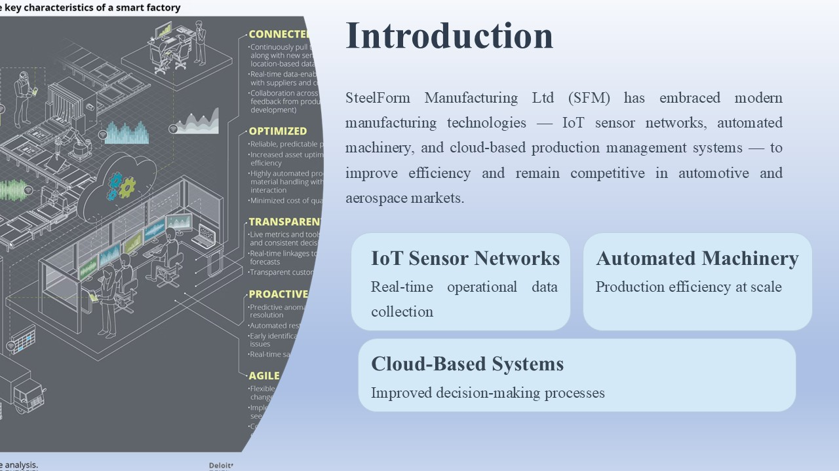SteelForm Manufacturing Ltd (SFM) has become active in the application of modern manufacturing technologies to improve production efficiency and remain competitive in both automotive and aerospace applications. The company has implemented the Internet of Things (IoT) sensor network, automated machinery, and cloud-based production management systems to collect real-time data on its operations, improving its decision-making processes (Jamwal et al., 2021). This presentation provides an overview of the main cybersecurity issues highlighted for SFM and offers suggestions to improve the security profile of the organisation. The proposed solution is to minimise cyber risks, enhance capabilities to respond to incidents, bolster critical systems, and foster a more cyber-aware workforce.

Current Cybersecurity Challenges Facing SFM
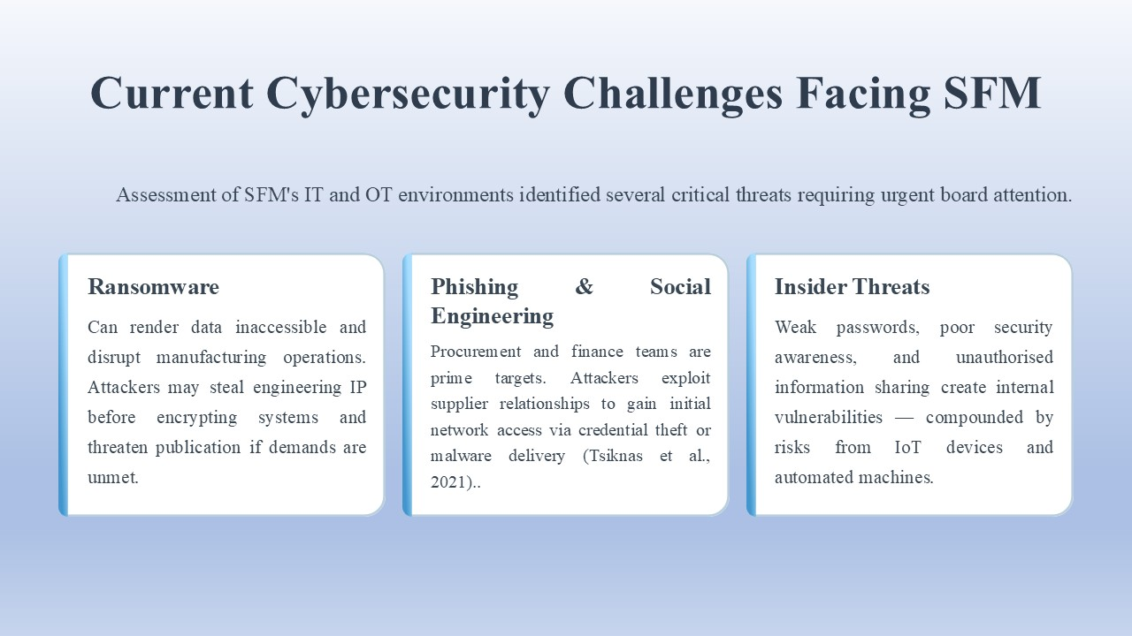The SFM environment was assessed, and several cybersecurity threats were found in both the information technology (IT) and operational technology (OT) systems.
Ransomware is the big challenge. Ransomware can cause the data to be inaccessible by making it unreadable. This applies equally in a manufacturing setting, where it could disrupt the manufacturing process and impact the ability for SFM to meet the needs of customers. Attacks may also include the theft of engineering information that is valuable to the attackers before the encryption of systems and the potential threat to publish the data if the systems are not decrypted (Tsiknas et al., 2021).
Phishing and social engineering are also possible threats. Employees, particularly the procurement and finance teams, may receive phishing e-mails that are designed to steal their logon information or to download malware onto their computers. The external suppliers will need to deal with employees regularly, and the attackers can gain initial access to the company's networks using social engineering techniques.
Internal threats should also be considered. Employees can be oversharing and inadvertently or intentionally share sensitive information. Vulnerabilities are created from weak password practices, poor security awareness and unauthorised sharing of information. Moreover, the application of IoT Devices and automated machines in SFM poses extra dangers (Tan and Samsudin, 2021).

Recommended Cybersecurity Strategy
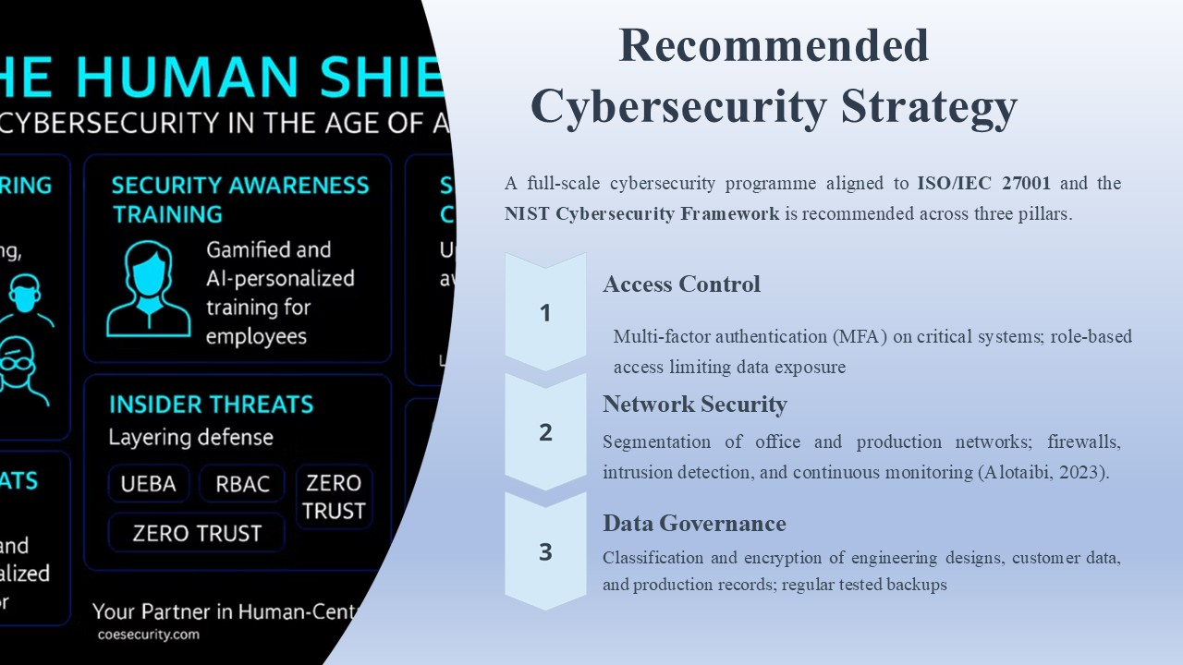To mitigate these risks, SFM needs to have a full-scale cybersecurity program that adheres to known cybersecurity standards such as ISO/IEC 27001 and the NIST Cybersecurity Framework.
The first is to enhance their access control system. SFM should implement multi-factor authentication (MFA) in critical systems to minimise the chance of stolen passwords. Also, there should be role-based access control, which means that employees will be able to access only the information which is required for their work (Alotaibi, 2023).
The second recommendation is to increase the security of the network. The company should divide the office network from the production network using network segmentation. This decreases the chances of an attack impacting business systems and getting into manufacturing operations. Firewalls, intrusion detection systems, and ongoing network monitoring also should be implemented.
The third recommendation is related to data governance. The sensitivity of information needs to be classified, and SFM applied in relation to that. All engineering designs, customer information and production data are encrypted and securely stored, which is confidential (Mirani et al., 2022). Ransomware protection and recovery in the event of system failures should also be made easy through regular backups.

Technical Security Improvements
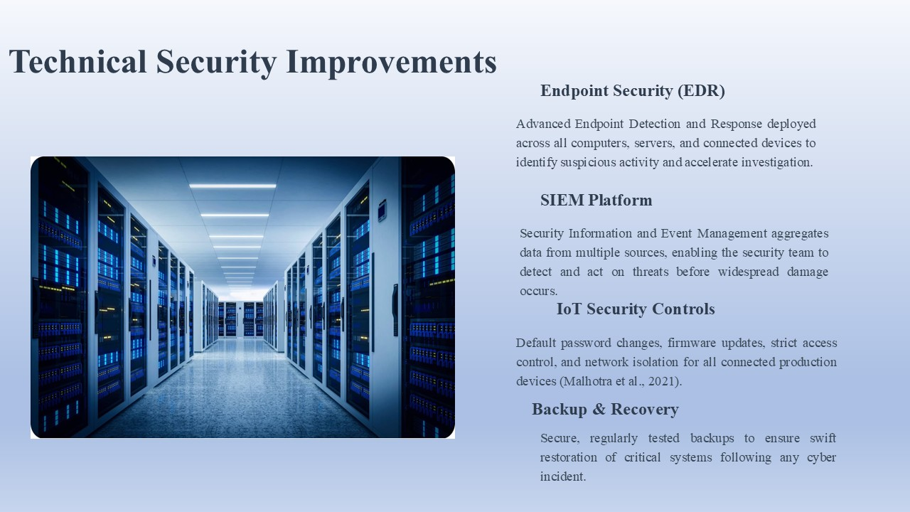There are various recommendations to improve SFM to mitigate and counter cyber threats.
Computers, servers and connected devices should have endpoint security solutions installed. The advanced Endpoint Detection and Response (EDR) features can help identify suspicious activity and help the investigator rapidly investigate an attack.
A Security Information and Event Management (SIEM) system also needs to be implemented. Security information from several sources is gathered and analysed to identify unusual events—this is known as SIEM technology (Malhotra et al., 2021). This enables the security crew to find threats before they can be widespread and take action before any destructive damage is done.
IoT security must be given special consideration as the connected devices are a part of SFM's production environment. Recommended controls include changing default passwords, firmware updates, access control and isolating IoT devices from critical networks.
A good backup/restore plan should also be created. SFM's secure and regularly tested backups allow for restoration of important systems after cyber incidents.

Incident Response and Monitoring
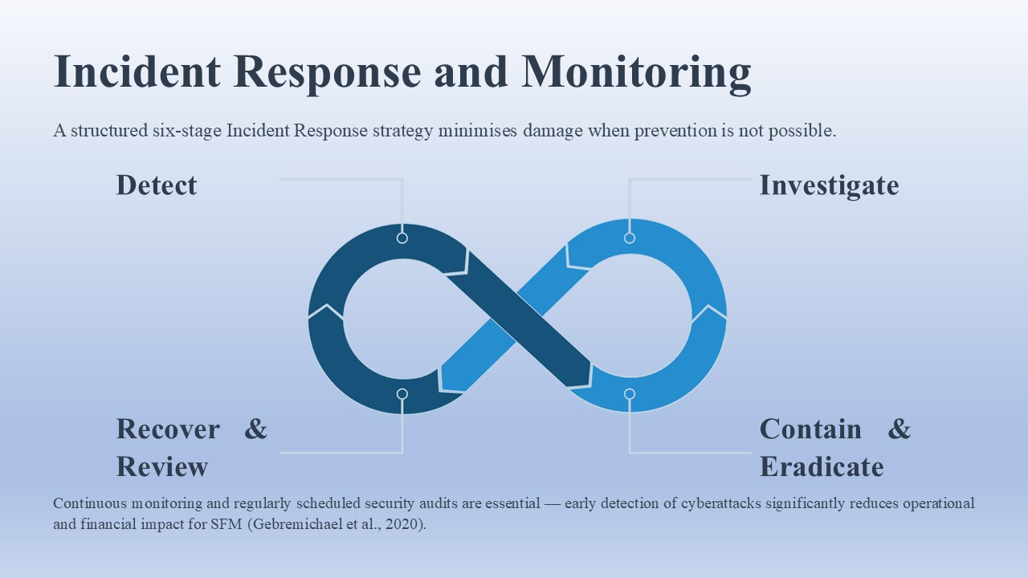Many times, the prevention of a cybersecurity incident is not possible, which means there needs to be an effective response process to minimise the damage created by the incident. The Incident Response strategy that is planned is based on six stages:
- Detection: Security monitoring tools detect abnormal usage or possible threats.
- Investigation: Security team members review the alert and determine the impact of the incident.
- Containment: Infected systems are quarantined to prevent the spread.
- Eradication: Malware, unauthorised accounts, or vulnerabilities are eliminated.
- Recovery: Systems are restored and monitored to ensure operations are normal (Gebremichael et al., 2020).
- Review: The incident is analysed for enhancement of future security controls.
It is important to monitor continuously because an early detection of cyberattacks will help to reduce their impact. There should be regularly scheduled security audits and vulnerability testing.

Suggestions for employee awareness and training.
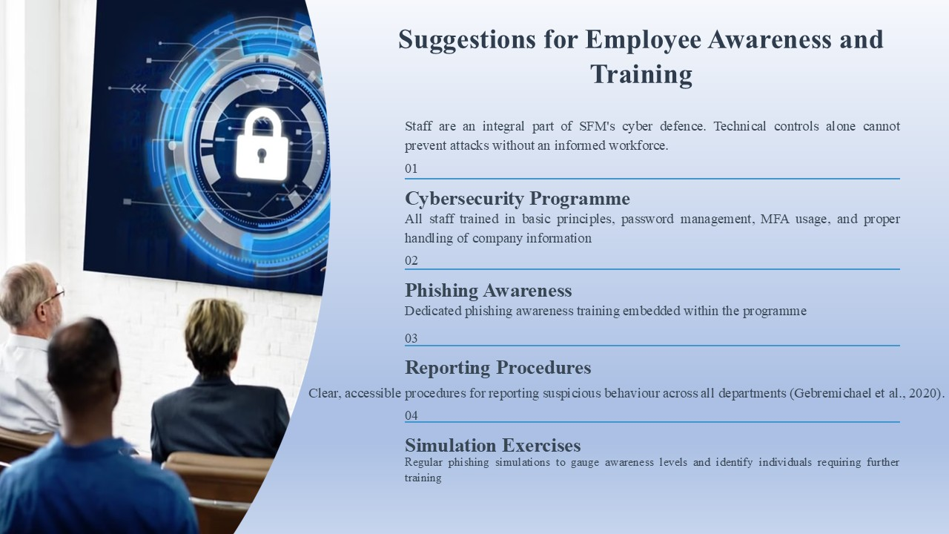Staff are an integral part of the SFM's cyber protection. Staff need to be aware that security risks or attacks cannot be prevented by technical controls.
A cybersecurity programme for all staff should be provided. The programme should consist of:
- Basic cybersecurity principles
- Password management guidance
- Multi-factor authentication usage
- Phishing awareness training
- Company information is adequately handled.
Procedures to report suspicious behaviour in place.
Phishing simulation exercises should be regularly carried out to gauge and assess employee awareness and identify those in need of improvement.

Implementation Roadmap
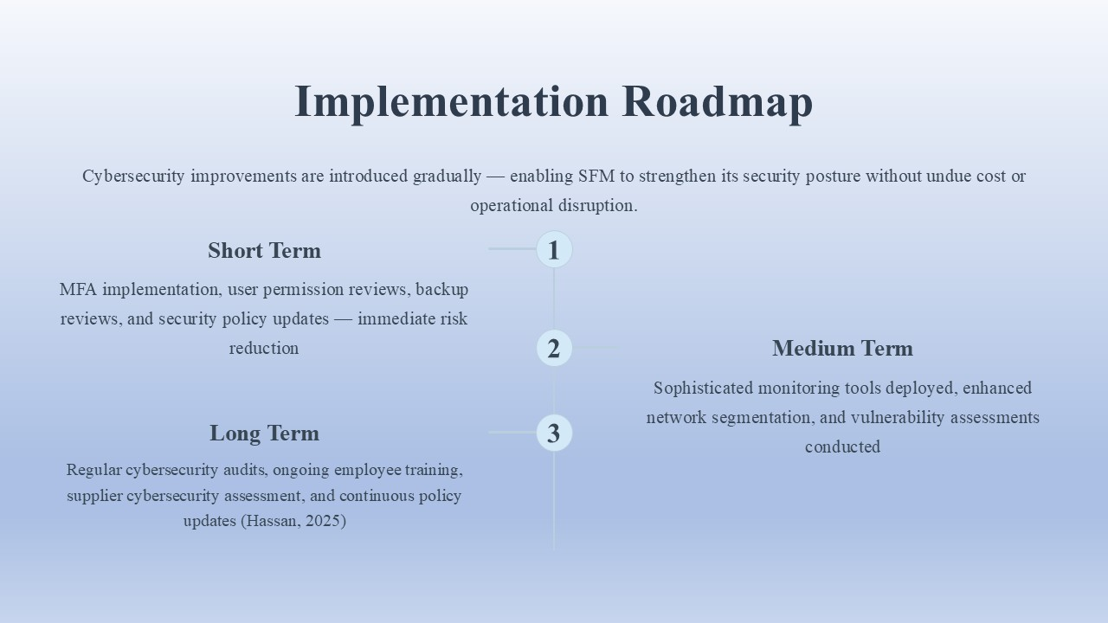The suggested cyber security improvements can be put in place gradually.
Immediate risk reductions, such as MFA implementation and user permission reviews, backup reviews, and security policy updates, should be addressed in the short term in the context of SFM. In the medium term, the company should use sophisticated monitoring equipment, enhance network segmentation, and perform vulnerability assessments. In the future, SFM will also continue to have their cyber security regularly audited and assessed, train its employees in cyber security, identify its suppliers' cyber security, and regularly update its policies (Hassan, 2025). This is a step-by-step process, enabling the organisation to improve security without having to worry about cost and disruption.

Conclusion
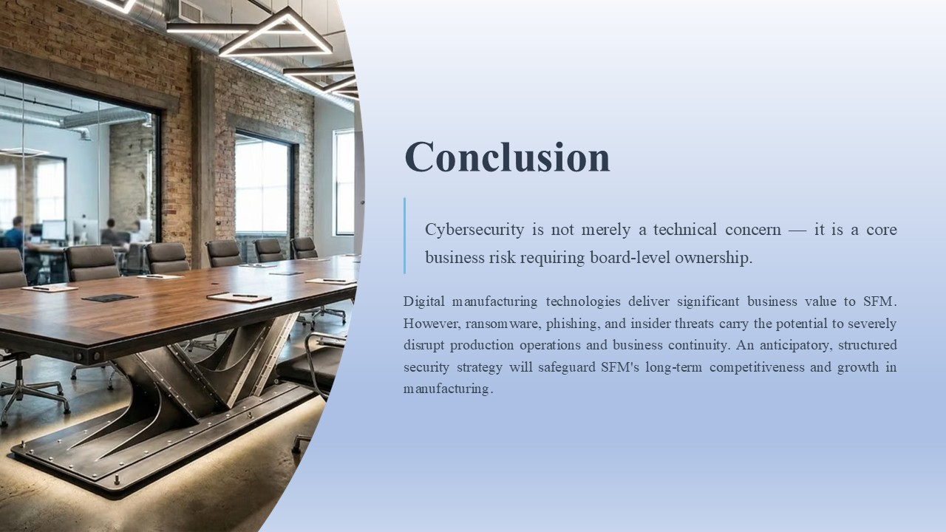The applications of these technologies present a great business value to SFM, especially with the implementation of digital manufacturing technologies, and with growing concerns about cybersecurity. The production operations and business continuity impacts from ransomware, phishing and insider threats and vulnerabilities could be enormous. For the board, Cybersecurity is more than a technical, it is a business concern.

References
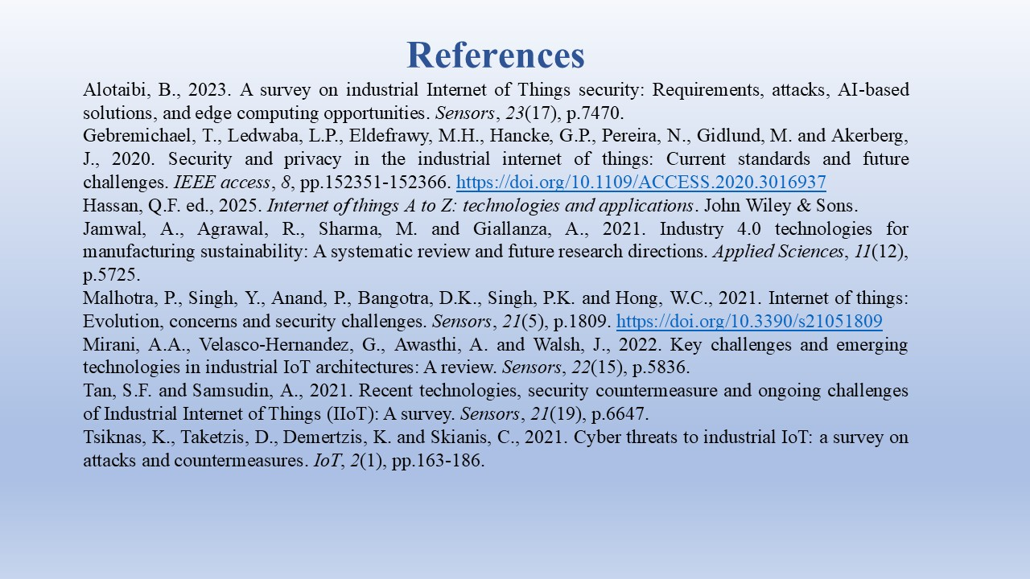Alotaibi, B., 2023. A survey on industrial Internet of Things security: Requirements, attacks, AI-based solutions, and edge computing opportunities. Sensors, 23(17), p.7470.
Gebremichael, T., Ledwaba, L.P., Eldefrawy, M.H., Hancke, G.P., Pereira, N., Gidlund, M. and Akerberg, J., 2020. Security and privacy in the industrial internet of things: Current standards and future challenges. IEEE Access, 8, pp.152351-152366. https://doi.org/10.1109/ACCESS.2020.3016937
Hassan, Q.F. ed., 2025. Internet of things A to Z: technologies and applications. John Wiley & Sons.
Jamwal, A., Agrawal, R., Sharma, M. and Giallanza, A., 2021. Industry 4.0 technologies for manufacturing sustainability: A systematic review and future research directions. Applied Sciences, 11(12), p.5725.
Malhotra, P., Singh, Y., Anand, P., Bangotra, D.K., Singh, P.K. and Hong, W.C., 2021. Internet of things: Evolution, concerns and security challenges. Sensors, 21(5), p.1809. https://doi.org/10.3390/s21051809
Mirani, A.A., Velasco-Hernandez, G., Awasthi, A. and Walsh, J., 2022. Key challenges and emerging technologies in industrial IoT architectures: A review. Sensors, 22(15), p.5836.
Tan, S.F. and Samsudin, A., 2021. Recent technologies, security countermeasure and ongoing challenges of Industrial Internet of Things (IIoT): A survey. Sensors, 21(19), p.6647.
Tsiknas, K., Taketzis, D., Demertzis, K. and Skianis, C., 2021. Cyber threats to industrial IoT: a survey on attacks and countermeasures. IoT, 2(1), pp.163-186.

