Childhood Obesity – An Epidemic

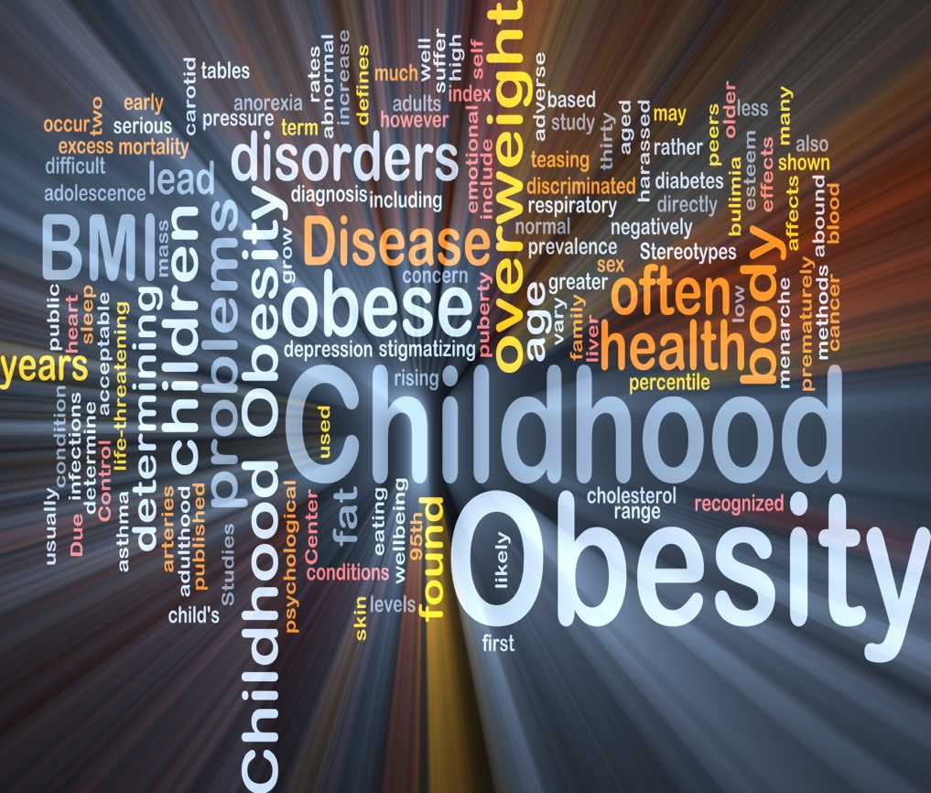

(Sisters in Health, 2015)

Introduction

Childhood obesity has been described by Public Health England (2018) and Cole (2017) as one of the most serious public health challenges of the 21st Century. This is echoed by Hedley et al (2004) and Koplan et al (2005) (cited in Garasky, Stewart, Gunderson, Lohman and Eisenmann, 2009) who note how it remains to be one of the most important health issues among children today. The severity of the issue is noted by Benton who estimated in 2004 that seven percent of the entire population of the world is obese. However, it is worth noting that this figure was reported fifteen years ago and there is a strong possibility due to environmental, societal and personal changes in people’s lives that this figure may have increased. The Government Office for Science noted this in 2007 stating how ‘society has rapidly changed over the last five decades’ and went on to further identify how changes have occurred in work patterns, transport and food production and sales.
The Royal Society for Public Health (2018) highlights how the United Kingdom (UK) has one of the highest levels of obesity in Europe and the National Institute for Health and Care Excellence (NICE) goes on to note how it also has the highest rates of childhood obesity (Nursing Standard, 2013). With the levels of obesity so high in the UK in both adults and children it does not come as surprise that it has been identified that children with obese parents are more likely to be obese themselves (National Assembly for Wales, 2014). Cole (2007) highlights how many feel that it is genetics which contributes towards child obesity and that fatness is ‘passed down’. However, I feel it is the parental influences they have on their children’s lives, something which is echoed by Larkin (2013, pg.47) who states how ‘parents exert a critical influence over their children’s health and well-being’. This practice log hopes to explore this in more detail and will begin by considering the current rates of childhood obesity including figures reported by the UK Government in 2017 that nearly a third of children aged two to fifteen are overweight or obese. Further consideration will then be given to the causes of childhood obesity, with the Welsh Government (WG) (2012) noting how poor diet is a major contributing factor along with the significant drop in children’s activity levels identified by Wanless (2004, pg.101). The practice log will aim to identify the factors which may contribute to the causes of obesity. Bronfenbrenner’s ecological model will be used to help identify these. Boonpleng, Park and Gallo, (2013) suggest that childhood obesity is the result of a number of ecological factors. Bronfenbrenner (1979; 1989) highlights how the child is placed at the centre of the ecological environment and the surrounding systems have influence over a number of the factors, including their family and society (Davison & Birch, 2001, cited in Boonpleng, Park and Gallo, 2013). One aspect which will be considered is how children from low income backgrounds have higher rates of obesity than their better off peers (Gov.uk, 2017; HM Treasury, 2008). This was reiterated by the Children’s Commissioner for Wales in 2019 who noted how children living in poverty are likely to have poor diets as making healthy choices can be difficult for many families. The practice log will then go on to look at the significant impact childhood obesity can have on children’s lives, not only from a health and physical point of view but also on their health and well-being. Wanless (2004, pg.95) highlights how obesity can reduce a person’s life expectancy by nine years and Finch and Searle (2005, cited in Larkin, 2013, pg.44) go on to note that due to the increasing rates in childhood obesity ‘children today will die at a younger age than their parents will’. The WG (2012) identifies that there are long standing concerns about the numbers of children who are overweight or obese, but what are they doing to prevent and reduce this? The practice log will consider some of the policies and strategies which are in place in Wales. One of these is the Healthy Eating in Schools (Wales) Measure 2009 which sets out requirements for local authorities and governing bodies to promote healthy eating and drinking in maintained schools (National Assembly for Wales, 2014; WG, 2014). Another approach which will be considered is the recommendation to introduce a ban on advertising foods high in fat and sugars before 9pm (Royal College of Paediatrics and Child Health, nd). However, I feel that this is reactive approach to take as those foods which are high in fat and sugar will still be readily available. The practice log will conclude by considering some recommendations for the future including how parents and children can be better informed about the impact obesity can have on their lives (Wanless, 2004, Pg.96). Furthermore, it will note how educating parents and children about the importance of a well-balanced diet and of being physically active may help to reduce childhood obesity.

Rates of childhood obesity

It has already been noted how the UK has the highest rates of child obesity in Europe (Nursing Standard, 2013; Shah, Hagell and Cheung, 2019) and the National Assembly for Wales (2014) suggests that for children it represents a serious public health problem. The RCPCH (nd) highlight how almost one in five children are overweight or obese when they start primary school. This is echoed by the Department of Health (cited in Larkin, 2013, pg.38) who went on to report in 2009 that this figure rises to more than a third by the time they leave. The UK Government confirmed this in 2017 when they reported that nearly a third of children aged two to fifteen are overweight or obese. Furthermore, in Wales an annual report produced in 2016-17 found that 12.4% of four and five year old children are classed as obese (Smith, 2018). Rates of childhood obesity remain consistently high and the National Assembly for Wales (2014) predicts that they will continue to rise. This is echoed by the RCPCH (nd) who estimate that by 2020 half of all children will be overweight or obese and the Government Office for Science (2007) goes on to suggest that by 2050, twelve percent of all children under the age of sixteen could be obese. It is worth noting how these figures are obtained and although it is clear that childhood obesity is an issue the figures may not be a true representation of how healthy children are. Baker (2018) highlights how the Body Mass Index (BMI) is the most commonly used method but it is not always definitive and the National Obesity Forum (nd) goes on to note how childhood is a time of development and BMI may not be an accurate measurement, instead, age and gender specific BMI centile charts are used.

Causes

Graham (2009, Larkin, 2013, pg.47) states how childhood is ‘an unparalleled time during which external influences both good and bad can influence an individual’s health and well-being across the whole life course’. Tedstone (2018) and Public Health England (2018) go on to highlight how obesity is a complex problem and can be affected by multiple factors including; environmental, societal and personal. Some other influences include behaviour, ethnicity, culture, social deprivation and obesity in the family (National Assembly for Wales, 2014; Public Health England, 2018; Gov.uk. 2017). Many of these influences can be associated with Bronfenbrenner’s ecological system and it can be adapted and used to consider how the different elements impact up on childhood obesity. Bronfenbrenner (1979; 1989) suggests that at the centre of the ecological system is the child and they are then surrounded by the micro, meso, exo and macrosystems. All of which impact upon a child’s life. (Davison & Birch, 2001, cited in (Boonpleng, Park and Gallo, 2013). The first of these causes to be considered which I feel is the root cause of obesity will be energy imbalance.

Energy Imbalance

Benton (2004) highlights how weight gain occurs when the intake of energy exceeds its use. This is echoed by the World Health Organization (2018) who note that ‘the fundamental cause of obesity is an energy imbalance between calories consumed and calories expended’. This suggests to me from the current figures regarding the number of children who are currently obese in Wales that they are taking in more energy through food than they are using through activity. The UK Government (2017) suggests that this overconsumption of calories is caused by the amount of sugar and fat children are having through food and in particular sugar sweetened drinks. However, I would argue that regardless of the amount of sugar and fat that is in food if children are eating too many calories they will gain weight regardless of where those calories come from. The WHO (2018) recognises there has been an increase in the intake of energy dense foods that are high in fat and a decrease in physical activity. These two will now be considered as separate causes of childhood obesity.

Physical Activity

Wanless (2004, pg.101) identifies how there has been a significant drop in children’s activity levels in recent years and a number of contributing factors have been recognised as the reason for this, including; greater use of cars for shorter journeys, lower sports participation, parental reluctance to allow children to play outdoors and greater access to television and computers. The WHO (National Assembly for Wales, 2014) recommends that children participate in at least one hour of moderate exercise five times a week. This is echoed by the Chief Medical Officers of England, Scotland, Wales and Northern Ireland who state that ‘all children and young people (aged 5-18) should engage in moderate to vigorous intensity physical activity for at least 60 minutes and up to several hours every day’ (National Assembly for Wales, 2019, pg.13). However, the WG reported in 2019 that only fifty one percent of children aged three to seventeen are meeting these guidelines (National Assembly for Wales, 2019). Furthermore, the National Assembly for Wales (2019) went on to note that physical activity is being squeezed out of school timetables due to curriculum pressures.

Diet

Children’s diets have changed dramatically in recent years and Palmer (2015, pg.23) highlights how highly processed junk food is becoming more popular and is more readily available. This is echoed by Wanless (2004, pg.96) who notes that people are snacking more and consuming drinks which contain high amounts of sugar. Furthermore, there has been a significant increase in the number of meals eaten out by many families which contain higher amounts of fat and more calories than those eaten at home (Wanless, 2004, pg.96). Palmer (2015, pg.23) notes that for many families ‘it is the fastest, easiest way to satisfy hunger’. However, I would argue that due to its lack of nutritional value I do not think it would satisfy hunger for very long meaning that children will turn to other food almost straight away. Furthermore, mass produced foods are tasty because of the high quantities of sugar, fat, salt and food additives to disguise it’s poor quality (Palmer, 2015, pg.23). This then leads to children developing a preference for these foods (Jebb, cited in Palmer, 2015, pg.24) and can lead to an addiction to junk food. This highlights how environmental factors can impact upon obesity (You Tube, Ecological Model of Childhood Obesity, 2014). Maya Adam (You Tube, Ecological Model of Childhood Obesity, 2014) suggests there has been a significant increase in portion sizes, especially with fast and processed food and goes on to note how children are eating more food in general and drinking more calories through sugary drinks (You Tube, Ecological Model of Childhood Obesity, 2014).

Stress

There are many different types of stress which can impact families lives including; family disruption, conflict and mental and physical health problems. Hedley et al. (2004) and Koplan et al. (2005) (Garasky, Stewart, Gunderson, Lohman and Eisenmann, 2009) highlight how stressful experiences may be associated with childhood obesity and Garasky, Stewart, Gunderson, Lohman and Eisenmann (2009) go on to note that stress may indirectly lead to poor eating habits and lower physical activity levels. This can be linked back to the increase in meals eaten out by many families. There is a lot of pressure on families to be in work, this is evident from the recent introduction of the £60 million pound investment in new childcare projects across Wales (British Broadcasting Cooperation, 2019). It will be made available to all working parents and will include an additional twenty hours of free childcare every week. Therefore, many families may find it is easier to eat out or buy easy to cook processed meals. There is also an increasing number of meal deals available in many restaurants and cafes. An example of this is in a popular supermarket where you can feed a family of four for ten pounds in their onsite café (Good to Know, 2019). Another cause of stress for many families is financial strain and the RCPCH reported in 2017 that three in ten children in the UK live in poverty. Furthermore, Al Aynsley Green (2019, pg.133) identifies how childhood obesity is strongly associated with deprivation and disadvantage. This will be considered in further detail.

Poverty

The RCPCH (nd) suggests there is a strong relationship between deprivation and obesity. This is echoed by Smith (2018) who notes that children in the most deprived counties of Wales have a far higher chance of being obese than those in the most affluent. Furthermore, the Children’s Commissioner for Wales noted in 2019 that children living in poverty are more likely to have a poor diet. This is something which was also highlighted by the WHO in 2018 noting how ‘obesity was once considered a high income country problem but is now more prevalent in low income countries’. The RCPCH State of Child Health report published in 2017 found that poor nutrition can come about as a result of the inability to afford enough healthy food. This can result in children from low income households experiencing problems with nutrition and can lead to childhood obesity (Gill and Sharma, 2004). Public Health Wales reported figures in 2015 which provide evidence of this noting that for obesity alone, 13.5% of children in the most deprived areas were obese, compared to 9.8% in the least deprived areas. The RCPCH (20170 suggest this is down to the higher cost of more nutrient-rich foods therefore, it comes as no surprise that in Wales since 2008 (NHS Wales, 2019) there has been a reduction in spending on fruits and vegetables. Angela Donkin and Michael Marmot from the UCL Institute of Health Equity (RCPCH, 2017) note that in order to get all the nutrients needed from food more money needs to be spent. However, for parents on a very low income who cannot afford to waste food this may not be an option (RCPCH, 2017). Furthermore, there is also the difficulty in allowing children to be more physically active and many children do not have access to a garden or safe outdoor space near their home (RCPCH, 2017). This highlights how society can impact on children becoming obese. Maya Adam (You Tube, Ecological Model of Childhood Obesity, 2014) notes how convenience foods are much better value for money and choosing healthy food over cheaper processed foods can be difficult. The choice for many families will be between letting their child go hungry in order to feed them more nutrient rich foods or putting their health at risk to ensure they are not hungry.

Genetics

The National Assembly for Wales (2014) highlight how children who are obese are highly likely to remain so in adulthood and they go on to suggest that children of obese people are more likely to be obese themselves. But what are the reasons for this? Many feel that genetics contributes to child obesity and that fatness is ‘passed down’ (Coles, 2007). However, I strongly disagree with this and believe it is more to do with the family environment than poor genes. This is echoed by Eaton, Konner and Shostak (1988, cited in Yeung and Hills, pg.3) who suggest that the human gene pool has not changed in the last thirty five thousand years but the living environment has transformed dramatically. Furthermore, Cole (2017) goes on to highlight how child obesity didn’t become a concern until the 1980’s, if it was an issue of genes then surely we would have seen increases much sooner. It is hard to not consider the extent to which parents play a role in determining whether their child is obese and Larkin (2013, pg.49) highlights how they influence both the quality and quantity of their children’s dietary intake and their levels of physical activity. Griggs and Walker (2008) and the National Assembly for Wales (2014) both note how the family environment may be a cause of obesity due to the shared eating habits and activity patterns. All of these highlight how both society and the environment impact on children becoming obese. Maya Adams (You Tube, Ecological Model of Childhood Obesity, 2014) suggests that many families now lead a more sedentary lifestyle and along with the increase in shorter car journeys screen time has increased. Furthermore, the eating habits of others can influence what children are eating at home (You Tube, Ecological Model of Childhood Obesity, 2014). Obesity is a particular problem during childhood as it often persists into adulthood and increases the likelihood of future health problems (Griggs and Walker, 2008). This then takes us onto the consider the further impacts of childhood obesity.

Impact of childhood obesity

Finch and Searle (2005, cited in Larkin, 2013, pg.44) note that the life threatening effects on health and well-being have led to fears that increasing obesity rates in childhood threaten ‘to reverse the gains in longevity made during the last hundred years’. Obesity impacts individuals and their lives in many different ways (Tedstone, 2018) and the Royal Society for Public Health (2018) identified how childhood obesity has significant consequences for children’s physical and mental health. Furthermore, Hedley et al. and Koplan et al. (2004; 2005, cited in, Garasky, Stewart, Gunderson, Lohman and Eisenmann, 2009) highlights how these consequences can extend into adulthood.

Obese children face a number of health problems including; increased cholesterol, hypertension and asthma and high blood pressure (Morrison, Shin, Tarnopolsky and Taylor, 2015, cited in Powell, Engelke and Swason, 2018; Smoak et al., 1987, cited in Garasky, Stewart, Gunderson, Lohman and Eisenmann, 2009). Furthermore, the UK Government noted in 2017 that obese adults are seven times more likely to become a type 2 diabetic than adults of a healthy weight.

As well as the significant health risks of childhood obesity there are also risks to children’s mental health (RCPCH, nd) and Schwimmer et al. (2003, cited in Schell-Busey, Connell and Kahle, 2017) notes that being overweight is considered ‘one of the most stigmatising and least socially acceptable conditions in childhood’. Stunkard and Burt (1967, cited in Yeung and Hills, 2007, pg.1) echo this highlighting how children who are obese may experience teasing and social isolation. As well as leading to being bullied obesity cause children to suffer from low esteem, anxiety, depression and poor body image (Public Health England, 2018; Morrison, Shin, Tarnopolsky and Taylor, 2015; Powell, Engelke and Swason, 2018; RCPCH, nd).

There are also large costs to the economy and the UK Government highlighted in 2017 how more money is spent each year on obesity than on the police, fire service and judicial system combined. Furthermore, a foresight report carried out by the Government Office for Science in 2007 estimated that the cost of obesity on the National Health Service was £4.2 billion. This figure is estimated to rise to £8.3 billion in 2025 and £9.7 billion in 2050. Figures in Wales are just as concerning and the WG published a report in 2011 (Public Health Wales, 2015)
which highlighted the estimated cost of obesity for the NHS in Wales was over £73 million a year.

The figures relating to childhood obesity are concerning but when you consider them alongside the impact that obesity has on children’s lives not only throughout their childhood but into adulthood they are even more concerning. But what is being done to try and reduce childhood obesity?

Reducing Obesity

There needs to be continued efforts by the UK Government to reduce childhood obesity (RCPCH, nd) and Tedstone (2018) identifies how just as there are many causes to obesity, multiple approaches are needed to tackle it. This is echoed by the RCPCH who note that no single intervention or policy can be implemented to deal with the issue. The Government Office for Science (2007) goes on to suggest that tackling the obesity crisis requires change and action on a number of levels including; personal, family, community and national. This can be linked back to Bronfenbrenner’s ecological system, if the causes of obesity come from a number of different systems surrounding the child then change also needs come from each of those different systems.

The WG has so far responded to childhood obesity by developing programmes which focus on promoting regular physical activity and on maintaining a healthy diet. One way which this has been done is through the Every Child Wales programme (NHS Wales, 2019; Smith, 2018), launched in 2017 it provides information for families on how to ensure their child maintains a healthy weight. There are a number of easily accessible resources on their website, however, as a parent myself I knew nothing about this programme. I would also argue that the WG is placing responsibility on tackling childhood obesity on families whilst doing very little themselves to help support them. This is echoed by the Royal College of Nursing who highlights how many health promotions are based on the premise that individuals have control over their health related behaviours (National Assembly for Wales, 2014). An example of this would be step eight ‘give children fruit and vegetables every day’ (NHS Wales, 2019). It has been reported by NHS Wales (2019) how price reductions on fruit and vegetables increase their purchase but we are seeing a reduction in spending on fruits and vegetables so that would suggest to me that they cost too much compared to cheaper processed food. As the Children’s Commissioner for Wales (2019) goes on to note we should be making healthier choices more accessible for children not harder.

I agree with Nursing Standard (2013) who note that rather than advice parents need encouragement to help their child to change their behaviour. This is echoed by Susan Jebb (Palmer, 2015, pg.29) who suggests that establishing eating habits to keep children in good shape for the rest of their lives is ‘a key way to invest in their futures’. Parents provide meals and snacks for their children so ultimately they have the control over what they eat (NHS, 2014). Furthermore, they have control over how physically active they are. The NHS (2014) note how it is important for parents to encourage a good pattern of eating, including; eating together at the table and modelling the eating habits they wish their children to follow (NHS, 2014). I would also argue that the same applies for keeping them physically active. Children should be encouraged where possible to go outside and play or find an activity which everyone can participate in together.

Children need to eat a diet which helps them grow and develop in a healthy way (Bhaskar, 2011) and although it is not always necessary for children to count calories the American Heart Association (2019) suggests that being aware and knowing how many calories your child needs per day can help them to maintain a healthy weight. Just like adults children should only be eating enough calories to maintain a healthy weight and WeCan (nd) notes how this will be different for each child and will be dependent on their age, gender and how active they are.

The Welsh NHS Confederation (2017) note how advertising and marketing of high fat and sugar food and drink has been shown to influence purchases, consumption and food preferences, especially for children. It comes as no surprise then that in 2007 the UK government banned junk food advertising during children’s television programmes (RCPCH, nd). Although many parents felt this was a step in the right direction I would argue that the food is still readily available and as Palmer (2015, pg.27) notes it is usually this junk that is on offer and easier for parents to buy and feed to children. I do not feel that advertising bans will help in changing parents or children’s understanding about obesity and is a very reactive approach.

In addition to this the UK Government introduced a soft drinks levy for producers (Gov.uk, 2017) and is working alongside the food industry to reduce portion sizes and sugar in food and drinks (Tedstone, 2018). Furthermore, another proposal is to place a calorie cap on certain single serving products (Gov.uk, 2017). However, as I previously noted without education on calorie consumption and the importance of a healthy diet I do not feel these are effective approaches.

In 2009 the WG (2014) introduced The Healthy Eating in Schools (Wales) Measure 2009, it places a duty on local authorities and governing bodies to promote healthy eating and drinking in maintained schools (WG, 2014). The WG (2014) go on to note how the food and drink provided in schools can make a positive contribution towards giving children a healthy balanced diet. A positive example of how schools should be teaching children the benefits of healthy eating, although not in Wales, it at Washingborough Academy (GOV.UK, 2017) in Lincoln. It has developed its own allotment and vegetable beds where children are able to grow their own food. They also have an oven for children to make their own pizzas. Furthermore, children are able to take part in food education on a weekly basis. In a time where educational funding appears to be cut and more emphasis is placed on testing and doing well this is a breath of fresh air.

Conclusion

To Conclude, it is clear from the increasing rates of obesity that it is a serious health concern for children not only now but also for the future. Neil Postman (1984, cited in Aynsley-Green, 2019, pg.7) stated ‘Children are the living messages to a time we will not see’. If the estimated rates of obesity highlighted by the Government Office for Science (2007) who note that by 2050, twelve percent of all children under the age of sixteen could be obese it is not a message we should be looking forward to seeing. Smith (2018) highlights how tackling childhood obesity not only prevents the development of health issues associated with adult obesity but suggests that prevention is much easier than treatment. This is something which is echoed by the Royal Society for Public Health (2018) who identify how difficult it is to reverse obesity in adulthood so it is crucial that prevention in childhood is prioritised. I agree with both of these and feel the reactive approaches that appear to be adopted by the UK Government are ineffective. The Welsh NHS Confederation (2017) note how action is needed throughout society to create environments that encourage healthier behaviours. But how can this be achieved? I feel that it is down to education, as a parent myself the number of calories my children need has never been made known to me. Wanless (2004, pg.96) echoes this suggesting that parents should be provided with guidance on how many calories children should be eating. Furthermore, Munro (2005) notes how educating parents about healthy lifestyle choices can help to prevent and reduce childhood obesity. Public Health Wales (2015) highlight how a number of solutions are needed to tackle obesity and these need to come from a number of different systems, all of which were identified in Bronfenbrenner’s ecological system. They include; politics, culture, and the environment. The UK Government (2017) echoes this noting how long term change will only be achieved through the engagement of schools, communities, families and individuals. Finally, the Government Office for Science (2007) identifies how it will take several decades to reverse the factors that are driving current obesity trends. But if we do not start now it will be too late.

