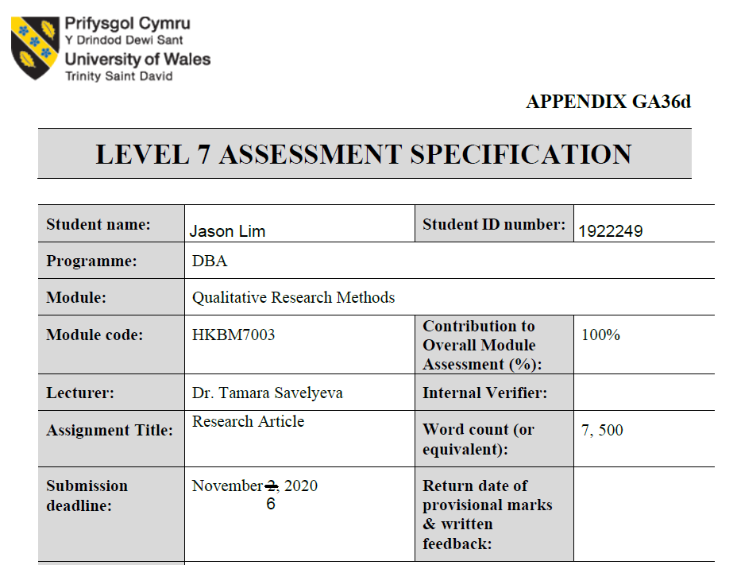

HKBM7003: Qualitative Research Methods

BY JASON LIM (1922249)

LECTURER: Dr. Tamara Savelyeva

research proposal:

A Qualitative STUDY on compassionate leadership during covid 19 in hong kong context

Abstract
Title – A qualitative study on compassionate leadership during COVID19 in Hong Kong context.
Purpose – The purpose of this paper is to research into the future and relevance of physical offices in Hong Kong after pandemic from a compassionate leadership perspective. This proposal lays out the research methodologies and approaches for this project. It will inform on the existing paradigms on staff engagement in Hong Kong thus reflecting current culture and development and how they may be shifted after COVID-19. The two objectives of this study:
i) Understanding employee engagement issues faced by companies’ senior management during COVID-19 in Hong Kong,
ii) Conceptualising a descriptive model exploring the influence of compassionate leadership that differ from traditional leaderships in a pandemic environment.
Study design and method - The methodology chosen for this research is Phenomenological approach. This methodology aims to capture the principle and understanding of leaders under the influence of Compassionate Leadership in decision making on working from home arrangement, employee engagement and relationships between stakeholders during the pandemic. The primary data collection will be questionnaire via emails, face to face interviews with participants and peer debriefing to check on the integrity of data collected. The purposive sampling approach will not be generalised to have an in-depth understanding and gathering of different perspectives on compassionate leadership. The units of analysis will be selected sample group of around 20 to 50 participants who are in different level of leadership position. The data collected will be studied with the purpose of conceptualising a framework on Compassionate Leadership.
Assumption - The author’s initial assumption is that compassionate leadership will have contribution to the furtherance of leadership theory. It addresses the gap on the humanistic side of leadership as most leadership theories address the intellectual prominence of leadership. The strengths of compassionate leadership are promoting long term relationship with stakeholders moving away from zero-sum game mentality, focused on the positivity, life giving elements and self-fulfilling environment. This framework focuses on ‘the human centric approach’ in leadership.
Originality and value - The author’s project is to document the participants’ experience on compassionate leadership through qualitative research, conceptualise a framework with the collected data, observe for compassionate leadership behaviours during COVID 19 pandemic. It is foreseen that this publication can contribute to leadership and organisation development theory. It will inform on existing knowledge and literature to validate the author’s choice on qualitative methodologies chosen for this research.
Keywords – Qualitative Research; Phenomenology; Compassionate Leadership, Leadership

Evaluation of a current research article
This appreciative but critical review aims to address the presentation of the research paper in the Construction Innovation to adopt qualitative research, published by the Australian researcher of University of New South Wales, Professor Sidney Newton. This article is on leadership research in the context of a construction industry. This article is reflectively “studying the leadership and examining potential new directions in the construction industry” [Newton, 2009]. As the author reflects on the current turbulent situation and noted that leadership research has been reinvigorated. This paper commences with taking stock of “what do we know about leadership?”. It points out to different aspect in leadership research from personal qualities, traits, and behaviours and even if leadership is nurtured and developed. There are no conclusive results in those researches but one thing is certain that a blanket approach is not appropriate to leadership as commented by Bennis (2007). The author also notes that leadership could surface in different levels of an organisation, differ due to cultural settings and the array of different goals and motivations.
The author brings up several points by referring to Toor and Ofori (2008) that encourage future direction for leadership research in this article:
- Design a broader set of leadership constructs
- Looking beyond senior leader
- Involve qualitative and longitudinal methodologies and not exclusively quantitative analysis
- More on development programs and interventions rather than descriptive research methods
- Having a more objective measurement framework rather than based on the perceptions of others and self-assessment instruments.

This article identifies two principle barriers:
- Leadership is neither a set of personal qualities nor particular styles of leadership but identify leadership is an activity.
- Qualitative research was underrepresented in the research of social phenomenon like leadership.
The author points out qualitative research is facing difficulty getting published due to the following reasons:
- Clear tradition and emphasis on quantitative methods in the construction research community.
- Lack of expertise in the qualitative methods.
The author states that this article is designed as “an editorial review of current literature and reflective critique of leadership research specific to construction industry” (Newton, 2009).
The article calls to explore leadership in its depth, and not only breath, by suggesting employing qualitative methods. The article’s nonsystematic literature review is a qualitative approach itself. Although the author states the method in two words-- 'literature review"-- without further detailing his methodological claim, this paper may be safely classified as a qualitative research paper.
Now that this article is classified under qualitative research, it is important to understand that there are four philosophical assumptions namely Ontological, Epistemological, Axiological and Epis (Savelyeva, 2020). The research philosophy for this paper can be categorized as Epistemological. Epistemology refers to the assumptions about knowledge and how it can be obtained (Hirschheim, 1992). The researcher expresses the underrepresentation of qualitative methodology in comparison with the entrenched and trusted quantitative methodology. This article also clearly omits quantitative methods in its content. This omission demonstrates the author’s philosophy in writing this paper to elevate the focus on qualitative methods and exemplified by making minimal mention about quantitative methods and/or mixed methods.
The author identifies the paradigms of quantitative methodology in research in the context of construction industry. The paradigms are that empirical studies in the construction industry are conducted under quantitative analysis and the clear tradition and emphasis on quantitative methods published in construction journals.
The author’s theoretical perspective is in line with interpretivist research.
This article demonstrates the characteristics of a interpretivist research to test the following theories:
- “Leadership is neither a set of personal qualities nor particular styles of leadership but rather it is an activity” (Newton, 2009, p. 130).
- “A move to more qualitative research methodologies, or at least a better mix of qualitative and quantitative methods” (Newton, 2009, p. 131)
From a theoretical perspective, both inductive reasoning and deductive reasoning can be used in qualitative research. In the context of this article, the author’s approach is inductive reasoning. This article’s theoretical approach is ‘bottom-up’ when the author listed empirical data in the article then suggest future directions for research to form theory using grounded theory methodology (Newton, 2009).
Inductive reasoning’s approach is using empirical data to build a theory while deductive reasoning is narrower than inductive reasoning as the latter is to test or confirm a theory. The author’s suggestion shall require researchers to start with understanding the empirical data on those issues. These empirical data might reveal some trends and patterns leading to tentative hypotheses, where the researcher can explore and build a theory. (Myers, 2013).
In the words of Denzin & Linkoln [1994] on qualitative research which “is a set of interpretive practices, privileges no single methodology over any other. As a site of discussion, or discourse, qualitative research is difficult to define clearly. It has no theory, or paradigm, that is distinctly its own.”
This article is written for the Construction Innovation journal and the readers might not be researchers or have research background, therefore the author has to write in a layman way that convey the conducive factors to conduct qualitative research in leadership in the construction industry. The structure of this article did not allow us to clearly separate its methodology part due to, perhaps, the journal scope and publication requirements, or per author's choice to ease the academic style for broader readership. This could be a strength, or a weakness, depending on how the readers view it.
There is a brief mention on grounded theory in the article. This may be an example of qualitative research methodology provided by the author or it could be his preferred research method.
The main argument of this article is the field of leadership should embrace qualitative approaches. This article reveals no data collection methods. There is no mention or suggestion about data collection method, or the kind of data to be collected.
The author appears to be a reflexive writer who uses rhetorical questions while delivering the main messages of the study points to his intention to converse with the readers and overcome limitations of the academic writing style.
The author’s writing style for this article is striking a balance between a researcher and a journalist. The article is written to cater to a wide base of readers who may not understand the serious syntax style of academic writing and the author’s message may not be conveyed to those readers, who are in leadership position. In the same token, fellow researchers may not take it seriously if the article is written in layman’s terms and thus impeded on future direction of leadership research in the construction industry.
Another intention is to use this article to promote qualitative research on leadership in the construction industry. It is important for the author to present the differences between qualitative research and quantitative research and their strengths and weaknesses so the readers can be influenced that qualitative research is not inferior to quantitative research but simply different approach to research. Understanding the basic, qualitative research has a focus on text while quantitative research is focus on numbers (Myers, 2013).
Qualitative research is best for studying a particular subject in-depth and that is leadership research in the case of this article. The downside with qualitative research is the difficulty in generalizing sample to larger population. However, qualitative research still allows generalize from qualitative research to theory.
Although the author places the leadership research in the context of the construction industry. The author also pointed out that leadership could emerge at different levels of an organization setting.
Bryman et al (1996) pointed out that contextual differences between similar organizations can illuminate variations in leadership processes and their impact. Paying attention to contextual factors and their importance due to the implicit valorization of context-specific research rather than research which advocate universal prescriptions. The emphasis of context in qualitative research imply a rampant relativism, since occupational and organizational imperatives and values that can result in such diverse groups as developers and contractors to set great store by leaders with common orientations to leadership.
The construction industry is considered as an industry dominated by men. The representation of female in this industry is between 9% to 13% which is extremely low (Norberg & Johansson, 2020). The author may add gender as a context in the research.
The author may also want to consider education as a context in the research. This industry has a large mixture of educated and uneducated people. They do not have the same level of education, but they may hold leadership positions. Highly educated office staff may not be in a higher leadership position than an uneducated construction manager in term of responsibilities, knowledge management and know-how. More data is required on this context.
The context for this article is the construction industry but leadership exists in all industry and therefore what leadership research is learned from the construction can be transferrable to other industries.
The article is missing qualitative research design. Suggesting a research design might propagate the application of qualitative research as a methodology if well presented. The paper can serve as a conduit to inform and also educate non-believers of qualitative research, who might have the misconception that qualitative research has no robust and systematic research processes but simply gathering data perceived as weak.
There were five research methods discussed during HKBM7003 module, which are phenomenological approach, ethnographic approach, grounded theory approach, case study approach and ethnomethodology approach (Savelyeva, 2020). The author cites that grounded theory is particularly relevant to qualitative methodology as this is a methodology accepts by the quantitative researchers (Newton, 2009).
To support the author’s citation of grounded theory method for qualitative research, grounded theory is “very useful in developing context-based, process-oriented description and explanations of organizational phenomena” (Myers, 1997, p. 104).
The grounded theory approach can be structured or less structure for inductive data analysis. Apparently, there are two different schools of approach. Structured approach is advocated by Strauss and Corbin, while Glaser advocates for the less structured. It is understood that Glaser was critical about the four prescriptive steps of coding (open, axial, selective, and ‘coding for process’) as he prefers the emergent nature of grounded theory. The emergent nature of grounded theory allows the data to speak for themselves (Glaser, 1992). This article appears to lean towards the less structured inductive data analysis under grounded theory method without any mention about coding but a “generative approach” is recommended (Newton, 2009).
This article can also mention data collection method(s) use in qualitative research. The author’s approach to this article is making it more accessible and palatable to the readers in the construction industry, who might not have research background. Keeping the readers’ profiles in mind, the author can cater his approach by elaborating in simple terms on types of methods, concept of purposeful sampling and sampling strategies to make this research paper more relevant for qualitative research. This aspect is important to strengthen the research on leadership research in the context of construction industry.
There are many data collection methods under qualitative research. Data can be collected through questionnaires, interviews, focus group and observation. More importantly is the application of the concept of purposeful sampling to narrow variations and explore similarities (Savelyeva, 2020).
Bryman (2004) observed that even though there is no prominent method of data collection in qualitative research but it should not rely on one single method. Many qualitative researches heavily rely on data collection via questionnaire from participants where the explanation for the lack of observation method incorporated in these researches was due to three factors:
- time,
- what/who to observe,
- cost
Bryman et al (1996) also in their paper discerned four different kinds of qualitative research’s data collection techniques as below:
- Participant observation and the examination of documents.
- Multiple-case-study design to make detailed examinations of participants.
- Semi-structured interviews with participants.
- Invites participants to describe in detail on specific topics like leadership philosophy or leadership practices.
The above research designs provide a basis for non-qualitative researchers to get an ideal of qualitative research design can be multidimensional by applying multi-methods and not relying on a single method like questionnaire.
This article apparently adopted a nonsystematic review of literature. There are propositions of systematic literature review to make the research more compelling (Sweeney, et al., 2019). However, a systematic literature review is usually associated with quantitative research, which is not the intention of the author. Snyder (2019) acknowledges literature review is about building on existing knowledge and propagates the importance of literature review as a methodology. Literature review can play a major role in qualitative research if conducted in semi-systematic approach or integrative approach. Semi-systematic review, also known as narrative review approach, is “designed for topics that have been conceptualized differently and studied by various groups of researchers within diverse disciplines and that hinder a full systematic review process” (Wong et al.,2013 in Snyder, 2019 p335). Integrative review aims “to assess, critique, and synthesize the literature on a research topic in a way that enables new theoretical frameworks and perspectives to emerge” (Torraco,2005 in Snyder, 2019 p335) where “most integrative literature reviews are intended to address mature topics or new, emerging topics” (Snyder, 2019 p335).
Interviews can add richness and credibility to primary data in qualitative research. The interview process with participants can be structured, semi-structured and unstructured. Each type of interview has its own advantages and disadvantages. Interviews will provide access to quality data for leadership research as proposed in the article. The researchers can formulate questions prior to the interview or allow the interviewees to freely speak during the interview (Myers, 2013). No one interview method is better than the other but depend more on the nature of the interview, topics of the interview and particularly the participants. There are many potential problems and pitfalls but one most common pitfall is elite bias, where researchers will interview only senior management or CEOs (Myers, 2013). This bias will impede the emergent nature of grounded theory research because the data collected will not be 360 degree but only top level, which may not paint the full picture.
The author mentions in this article that “there is an overwhelming emphasis on descriptive research methods, and next to nothing on the development programs and interventions that might foster and sustain effective leadership in the future.” raised by Toor and Ofori (Newton, 2009, p. 130). The author may consider suggesting future research by positioning this research in human resource context.
In conclusion of this critique, the recommended readers are various stakeholders in the construction industry. This article provides an entry level of understanding to leadership research for readers of this journal but something more substantial is required for influencing experienced researchers to consider adopting qualitative research, especially quantitative researchers.

Research proposal

Introduction
The study of compassionate leadership has become an important aspect of navigating in the turbulent and chaotic world amplified by the recent COVID 19 pandemics. In the words of Shuck, et al (2019) that “the transformative power of compassion is critical to leader performance and has garnered increasing interest in business settings” (p. 537). This aptly raises a succinct point on compassionate leadership research is that substantive contributions have been made toward the conceptual understanding of compassion, but not much empirical work has been carried out on the relationship between compassion and leader performance (Shuck, et al., 2019). The author shares the same view that aspiring leaders who develop compassionate leadership will reap immense benefits as leaders but more importantly, as a person. To put the research into context, the author intends to conduct the research during the COVID 19 pandemic in Hong Kong.
The coronavirus pandemic was first discovered in December 2019 in China. It had wreaked havoc and resulted in soaring death tolls across the world. Countries were locked down and many companies encouraged their staff to work from home. (World Health Organisation, 2020)
In Hong Kong, companies faced unprecedented challenges that most had to close and left many vacant offices in the market [Gerrity, 2020]. This phenomenon might have a long-lasting impact. As companies experimented with employee engagement by allowing them to work from home for extended period. (Lingnan University, 2020)
Twitter was the first few to introduce policies that allow staff to work from home forever (Fung, 2020).
Further research should be conducted to find out if work from home forever is a temporary phenomenon or a major leap into future of work where cloud is the business place signalling a paradigm shift that offices might not be an organisation artifact in future (Lingnan University, 2020). Such paradigm shift will require a different leadership style to navigate that unchartered territory as it involved decisions that are more on humanity than business related.
Traditional leadership theories from Great Man theory to Transformation Leadership may find it challenging in current pandemic situation as those in leadership positions cannot rely simply on their cognitive ability (Bolden, et al., 2003). Cognitive ability in problem-solving does not mean having ability to handle the emotional stress that come with the pandemic situation and the ongoing impacts on the organisation.
In such a crisis, a different style of leadership may be required. A leadership that possess the qualities and competencies identified in the established leadership theories but lead with compassion, empathy, understanding and love. During and post pandemic situation, where the economy and even the world could be reset, will require leadership that can look beyond profit and loss but seeing staff and even clients as fellow human beings (Davies, 2020).
This proposal is to research into employee engagement during and after the pandemic from a compassionate leadership perspective in Hong Kong. This proposal lays out the research methodologies and approaches for this project. This research will be answering the call for further research from Shuck, et al’s (2019) research paper on compassionate leadership. It will inform on the existing paradigms on employee engagement, current culture, and organisational development and how they may be shifted after COVID-19 in Hong Kong.

Philosophical Assumptions
There are four philosophical assumptions namely Ontological, Epistemological, Axiological and Epis (Savelyeva, 2020). The research philosophy for this research can be categorized as Epistemological. Epistemology refers to the assumptions that the author made about knowledge and design data collection techniques to obtain them (Hirschheim, 1992).
The author’s primary research motivation stems from his faith as a Christian. He sees the world is getting more turbulent and chaotic cause by various macro factors like political differences, corporate greed, and social injustice. He turns to the bible and taking inspiration from the leadership styles of Jesus Christ and some of the other bible characters that exhibit compassionate leadership to better people’s lives better with no discrimination.
The author has spent more than 20 years in the commercial world and many years as senior management where he experiences different types of leadership style from Great Man Theory to Transformational Leadership, these different leadership theories have evidences in making changes but the question is whether these leadership theories are making the world a better place or the leaders a better person. The author has met leaders who do not fit into the leadership theories yet leaving a deep impression for their gentle yet firm demeanour, empathy and authenticity. The author could not find a leadership that fit those leaders, but he now finds compassionate leadership is the best fit to describe those leaders. The world has many intelligent leaders but not enough compassionate leaders.
The author’s research is to fill that gap by championing compassionate leadership through his research.

Purpose, Aims and Objectives
Diagram 1: Purpose, Aims and Objectives

Purpose
The purpose of this research is conceptualising a framework on Compassionate Leadership, with an intention to contribute to leadership and organisational development theory, and specialisation on this topic in Asian context.
This research opens opportunities to conceptualise a framework on compassionate leadership and contribute to leadership and organisational development theories in Asian context. Many leadership styles that have been recognised focus on the analytical power of leaders (Cowen, 2018) but not many propagate to lead with the heart (McGovern, 2014). A framework on Compassionate leadership is about connecting leaders with various stakeholders and making decisions from an empathy perspective (West, et al., 2017).

Aim
The aim of this project is to conceptualise a compassionate leadership framework using phenomenology method. Currently, there are limited empirical studies on compassionate leadership (Shuck, et al., 2019). The author notes that traditional leadership theories focus on charisma and intelligence while compassionate leadership focuses more on the empathy of leaders. The goal of this project is focused on studying and understanding staff engagement and decision making under compassionate leadership, and the influence on leadership and organisational development.

Objectives
The two objectives of this research are:
i) Understanding employee engagement issues faced by companies’ senior management during COVID-19 in Hong Kong,
ii) Conceptualising a descriptive model exploring the influence of compassionate leadership that differ from traditional leaderships in a pandemic environment.
There are currently limited literature as not much empirical studies are conducted on compassionate leadership in business and management context (Shuck, et al., 2019). The author holds deep conviction that a compassionate leadership framework on developing compassionate leaders is necessary for the future. It is important as the world is changing expeditiously, and many decisions make with empathy will be more appropriate than decisions make with intelligence. This is an important contribution as this framework is driving towards leadership and organisational development in Asian context. A literature on this framework can provide insights for further reference. (Creswell & Poth, 2014)

Research Significance
The common culture in the commercial world is to play by the rules and stick to what had worked in the past, however Hong Kong is under tremendous stress under current pandemic environment. There may be a significant economic disruption in near horizon.
Current literatures point out that most leadership styles focus on intelligence and the world needs more compassionate leaders (Zulueta, 2016). This project is to study current approach from existing leadership theories to compassionate leadership. This framework moves away from deficit-based approach. This conceptual framework is new and as such making the research more exciting and challenging at the same time. A change of paradigm of this magnitude requires a different approach, a positive approach!
The main output for this project is a conceptual framework for understanding and advancing leadership and organisational development theories on compassionate leadership.
Although there is plenty of literature on compassionate leadership, but they are not many empirical studies to address spontaneous demands and pressures from the commercial world (Shuck, et al., 2019). There is also limited research on this topic conducted in Asia. Researching on this topic may result in wider acceptance of compassionate leadership as a leadership development in Asian context that link acceptance of valuable tacit knowledge and commercially available academic knowledge. This output is to bridge expectation gaps between organisation’s wants, leaders’ expectations, and employees’ deliverables.
This research aims to open dialogues in this field in leadership and organisational development by conducting qualitative research on compassionate leadership.

Compassionate Leadership
A compassionate leader could be seemed as soft for demonstrating their humanity. Compassionate leaders are not weak because it takes a lot of courage for a person to be willing to put themselves in a vulnerable position. Compassionate leadership is about making tough decisions with empathy. A compassionate leader is comfortable of oneself to be authentic. (Grant, 2008)
Atkins and Parker (2012) define compassion as a process involving feeling and action. West and his team outlined the relationship of compassionate leaders and problem-solving through demonstration of four compassionate behaviours in attending, understanding, empathising, and helping that create a compassionate culture (West, et al., 2017).
Leader who exhibit wisdom, soul and spirituality will be a compassionate leader as they will be able to make sound decision that put people first from a compassion perspective. comparing to other leadership styles of achieving results with little respect to other living beings.
Holistically, compassionate leadership build on the competencies of a leader as identified in leadership theories but leading with compassion, empathy, love and understanding.
Compassionate leadership will look at current pandemic crisis differently by putting people first. Their decisions will place more concerns for their people not just for publicity but genuinely care about their staff’s wellbeing, rather than company’s profitability.
Diagram 2: Conceptualising the Compassionate Leadership Framework
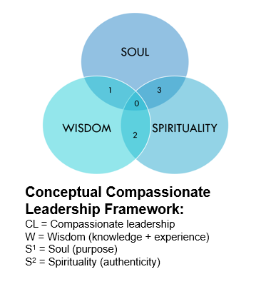

Wisdom (Knowledge + Experience)
Wisdom is an essential part in creating inner meaning for self-transcendence that is indispensable to leadership (McKenna, et al., 2009). Aristotle pointed to interdependence of practical wisdom and moral virtue in leadership (Parellada, 2005).
Wisdom has a critical role to play in compassionate leadership as it is required to make sound judgement especially in current pandemic situation. There is a succinct difference between wisdom and intelligence. Intelligent leaders may not have wisdom, but a wise leader will have intelligence. Wisdom is multifaceted and intelligence is not the one and only requirement (Rani & Devi, 2017).
Leader that does not exhibit wisdom (knowledge + experience) may be reflected in the decisions they make that may be detrimental to the company as they may not have the required mental ability in making sound judgement.
Continuously learning and doing to accumulate knowledge and experience.
A compassionate leader would demonstrate that they have more than intelligence but also wisdom. This construct can be demonstrated and measure by the quality and effectiveness of their decisions during times of uncertainty.

Soul (Purpose)
The essence of purpose-driven leadership is much more focused on the rationale and purpose encompasses life’s meaning and indicates what one lives for one’s deepest aspirations (Cardona, et al., 2019).
A purpose provides not only a direction but a mission to achieve greatness in one’s life. A leader without a purpose in life is like a ship without a rudder and unable to reach its destination or full potential.
Leader that does not exhibit a soul (purpose) may make decisions that does not have a defined purpose to decide what may be best for the company. Purpose is like a compass and loss of direction could be detrimental to a company resulting in its ability to survive during crisis. A leader’s purpose is not developed or discovered overnight but a journey that requires a lot of efforts and forge through deep reflections.
Knowing oneself through years of reflections and understanding oneself to lead with a life that is purpose driven.
A compassionate leader can reflect deeply to discover their life passion and values that translate into a purpose-driven lifestyle. This construct can be observed from the passion and drive to making an impact in people and organisation.

Spirituality (Authenticity)
Authenticity is the free and natural expression of core feelings, motives, and inclinations (Kernis, 2003). Leroy, Palanski and Simons (2012) observed that authentic leaders are more aware of the values that drive their decision so that the values align with their words and actions.
Authenticity is important in compassionate leadership because being authentic means a leader is not faking his behaviors but instead walking their talks.
Authenticity could be measured based on standardised scores on these components - leadership behaviours, future orientation, and ethical climate of the organisation (Jensen & Luthans, 2006).
Leader that does not exhibit spirituality (authenticity) may make decisions to benefit themselves as they might lack moral parameters and far remove from their own aspirations and values. Other noticeable effects could be observed in their relationships with stakeholders. Lack of authenticity results in relationship built on sand and not long lasting.
Ability to face vulnerability in public domain. Being authentic to build long lasting rapport and relationships.
A compassionate leader will demonstrate his authenticity when he is comfortable in drawing positive psychological capacities and encourage greater self-awareness and self-regulated positive behaviour. Such leaders also possess positive attributes that have optimistic outlook (Jensen & Luthans, 2006).

Methodologies, Methods, Source and Outcomes
In Creswell, et al’s (2014) words on social constructivism where “individuals seek understanding of the world in which they live and work. They develop subjective meanings of their experiences—meanings directed toward certain objects or things. These meanings are varied and multiple, leading the researcher to look for the complexity of views rather than narrow the meanings into a few categories or ideas. The goal of research, then, is to rely as much as possible on the participants’ views of the situation. Often these subjective meanings are negotiated socially and historically. In other words, they are not simply imprinted on individuals but are formed through interaction with others (hence social construction) and through historical and cultural norms that operate in individuals’ lives” (p. 60). The author will apply the phenomenology method under social constructivism to observe and study compassion as a phenomenon.
The author wants to study and make sense of this phenomenon in a leadership context. The author will adopt the phenomenology method to study compassionate leadership in Hong Kong context. The author chooses phenomenology method as compassion is a phenomenon (Shuck, et al., 2019). This phenomenon is a unique experience to every individual who responds to personal suffering (Lilius, et al., 2011). The aims are to develop a complete, accurate clear and articulate description and understanding of compassionate leadership can benefit individuals and organisations. The aims can be achieved through qualitative research’s data collection methods to collect rich and thick data from the participants.

Diagram 4: Methodologies, Methods, Source and Outcomes
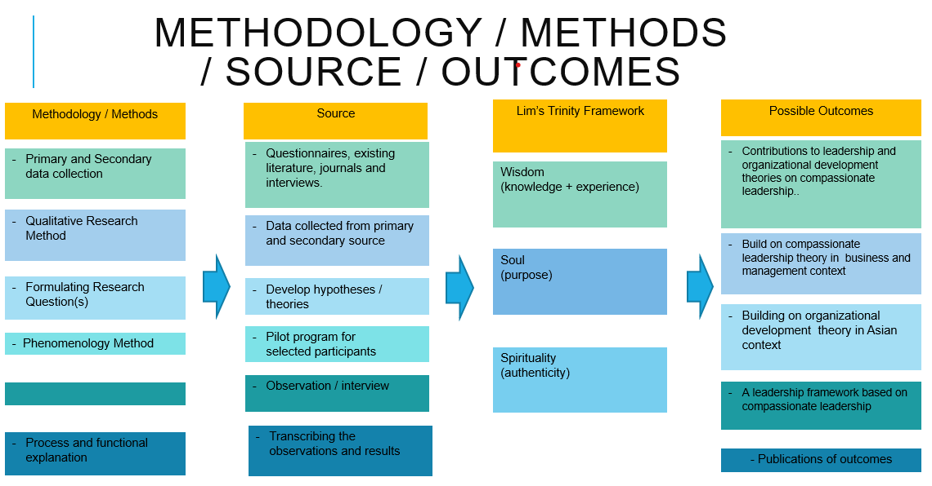

Phenomenology Method
The author will be adopting phenomenology method for this research. The phenomenology method is adopted to capture the essence of experience of leaders’ compassionate behaviours (Creswell & Poth, 2014). This method is chosen as there are limited literature on compassionate leadership behaviour. Phenomenology method enables the author to understand the unique experience on this phenomenon, which is compassion, of the participants. The participants in this research will share their experiences and this method allows findings to emerge rather than impose (Shuck, et al., 2019; Creswell & Poth, 2014). Data will be collected through different tools like conversations, interviews, questionnaires, and peer debriefing.

Data Collection Techniques
The research will start with the planning and designing of the entire blueprint of this research after setting the parameters deriving from insights collected from peers, professors, and leaders in the business world. Concurrently, the author will determine and define the questions for questionnaire. The questionnaire will be approved by the university, together with the research proposal.
The preparation to collect the data will include scheduling interviews with relevant people to gain insights from their perspectives. The insights collected will be put through a couple of pilot testing before sending out to the field. Interviews and questionnaires will also be utilised for collecting data in the field.
The author will perform purposive sampling to select appropriate participants for questionnaires and interviews. The appropriate participants will be nominated by peers, professors, and leaders from the business world. The author will approach selected participants to complete the questionnaire and follow by interviews. This interview is planned to be semi-structured, which will involve the use of some pre-formulated questions but not strictly adhere, to allow some controls on the pace and topic of the interview yet allowing the interviewees to freely express themselves without being overly restrictive. All interviews will be scheduled an average of 75 to 90 mins, which could be face to face, over the phone or via video conferencing. The interviews will be audio recorded with the participant’s consent. The audio from the interviews will be transcribed and the transcribed verbatim will be sent to participants to check for accuracy. A journal will be kept by the researcher to note down the interviewee’s behaviours during the interview.
The interview transcripts will be reviewed and analysed by the author. The purpose of the review is to search for emergent themes and patterns through coding the transcripts. The open coding will tag and label recurring words to identify emergent themes. These codes will be entered into a codebook and updated consistently and regularly during the research. Axial coding will emerge to identify core phenomenon, which is compassionate leadership, in this research. The author will create categories around the core phenomenon. These codes will then be marked to the transcripts. The codes in the codebook will be used for constructing models that identify the themes, concepts, beliefs, and behaviours that link them together (Myers, 2013).
The author will keep both procedural memos and analytical memos during the research to document the entire process. The set of procedural memos will include the journal recording the interviewees’ body language and behaviours and reflections of the interviews with participants during the research. Keeping analytical memos to record the author’s ideas and inspirations during the process. The memos will form an important of the analytic induction to develop causal explanations of a phenomenon from one or more participants (Myers, 2013).

Timeline
The time starts upon approval duly received from the University to commence the research program. This research will have six stages focusing critical element in each stage and become more manageable after taking the limited resources into consideration (Yin, 2003) .
Diagram 5: Proposed timeline

Caveats
The results from this project can be affected by the following constraints and limited resources:
- Funding
Funding is a common constraint among researchers without grants and/or financial supports from universities and corporations.
- Time
The author faces time pressure as a part time research to complete the research within the projected timeframe. This will be acutely felt during data collection and analysis stages.
- Manpower
The author does not have the luxury of hiring a research team to assist with his research.
- Possible change to research subjects/participants
The current turbulent situation in Hong Kong may see participants leaving their positions due to personal reasons and/or business circumstances.

Ethical considerations
The following ethical considerations in this research as follow:
- Standard for human participation
Respect for human rights, privacy, and legal capacity.
- Confidentiality
The author will conduct this research with utmost confidentiality by safekeeping participants’ information and any information obtain during the course of this research.
- No harm
This research shall conduct the research with integrity and cause no harm to all participants and university.
- Intellectual property
Information, ideas, and property obtain from participants or during the research shall be respected and not disclose to third party without prior consent.
- Permissions
Getting consent from the university before conducting research, from the participants to participate in the research, and prior to audio recording during interviews.

Summary
The purpose of pursuing this doctorate is to quench a thirst for knowledge triggered from the author’s strong belief that compassionate leadership can make the world a better place. He is embarking on this journey of discovery about compassionate leadership. He believes that compassionate leadership will be a leading leadership theory in future where the world needs more compassionate leaders than intelligent leaders. The author develops deep knowledge in several areas of interest. The areas of interest are philosophy, positive psychology, compassionate leadership, organisational development, and innovation. Admittedly, the transdisciplinary knowledge could be developed through reading literatures deeply on these topics, but the author found no satisfaction by keeping the knowledge to himself. A wider calling is to share and transfer the knowledge to more people. It was decided to achieve the dissemination to more people by pursuing a doctorate. Through this research, the possibilities of opening more channels for disseminating this knowledge are immense.
This research refers to phenomenology approach in building compassionate leadership theory and conceptualise a framework for business and management in Hong Kong context. Most frameworks and theories on leaderships are developed in Western countries, which may not address Asian culture when such concepts are introduced in Asia. Frameworks in Western countries lacks empathy to Asians’ learning differences and culture inculcated since a tender age. This research looks for differences or similarities and provides links to generate positive impact in leadership development by exploring compassionate leadership framework.
The timeframe for the whole project is projected to be 2 years. This is a phenomenology method research conducted within a specific time to prevent the project from overrun.
The constraints identified for this research program are time, funding, possible change to research subject/participants, and manpower to manage the research program. These are not unique problems, but they must be overcome to ensure completion of the research program as planned.
In conclusion, this research program may result in an empirical study of compassionate leadership that could lead to understanding of the transformational power of compassionate leadership in a disruptive and chaotic world from a business and management perspective in Hong Kong context.

References
Atkins, P. & Parker, S., 2012. Understanding individual compassion in organisations: the role of appraisals and psychological flexibility. Academy of Management Review, 37(4), pp. 524-46.
Bennis, W., 2007. The challenges of leadership in the modern world. American Psychologist, 62(1), pp. 2-5.
Bolden, R., Gosling, J., Marturano, A. & Dennison, P., 2003. A Review of Leadreship Theory And Competency Framework. [Online]
Available at: https://ore.exeter.ac.uk/repository/handle/10036/17494
[Accessed 20 07 2020].
Bryman, A., 2004. Qualitative Research on Leadership: A Critical But Appreciative Review. The Leadership Quarterly, Volume 15, pp. 729-769.
Bryman, A., Stephens, M. & Campo, C., 1996. The Importance of Context: Qualitative Research and The Study of Leadership. Leadership Quarterly, 7(3), pp. 353-370.
Cardona, P., Rey, C. & Craig, N., 2019. Purpose-driven Leadership. In: C. Rey, M. Bastons & P. Sotok, eds. Purpose-driven Organizations. London: Palgrave Macmillan, pp. 57-71.
Cowen, A., 2018. About Leaders: 8 Leadership Styles: Which One Are You?. [Online]
Available at: https://aboutleaders.com/8-leadership-styles-one/#gs.c6sd82
[Accessed 15 07 2020].
Creswell, J. & Poth, C., 2014. Qualitative Inquiry & Research Design: Choosing Among Five Approaches. 4th Edition ed. London: Sage.
Davies, K., 2020. Compassionate Leadership During the COVID-19 Pandemic. Aircraft Maintenance Technology, Apr/May, p. 48.
Denzin, N. & Linkoln, Y., 1994. Handbook of qualitative research. London: Sage.
Fung, B., 2020. CNN Business "Twitter will let some employees work from home 'forever'". [Online]
Available at: https://edition.cnn.com/2020/05/12/tech/twitter-work-from-home-forever/index.html
[Accessed 12 July 2020].
Gerrity, M., 2020. World Property Journal. [Online]
Available at: https://www.worldpropertyjournal.com/real-estate-news/hong-kong/hong-kong-real-estate-news-jll-2020-property-market-monitor-hong-kong-office-rents-may-2020-hong-kong-commercial-real-estate-report-12001.php
[Accessed 05 07 2020].
Glaser, B. G., 1992. Emergence vs Forcing: Basics of Grounded Theory Analysis. Mill Valley, CA: Sociology Press.
Grant, K., 2008. Who Are the Lepers in Our Organizations?: A Case for Compassionate Leadership. Business Renaissance Quarterly , 3(2), p. 75.
Hirschheim, R., 1992. Information Systems Epistemology: An Historical Perspective. In: R. Galliers, ed. Information Systems Research: Issues, Methods and Practtical Guidelines. Oxford: Blackwell Scientific, pp. 28-60.
Jensen, S. & Luthans, F., 2006. Entrepreneurs as Authentic Leaders: Impact on Employees' Attitudes. Leadership & Organization Development Journal, 12, 27(8), pp. 646-666.
Jensen, S. M. & Luthans, F., 2006. Entrepreneurs as Authentic Leaders: Impact on Employees' Attitudes. Leadership & OrganizationDevelopment Journal, 27(8), pp. 646 - 666.
Kernis, M., 2003. Toward a Conceptualizeation of Optimal Self-Esteem. Psychological Inquiry, 14(1), pp. 1-26.
Leroy, H., Palanski, M. E. & Simons, T., 2012. Authentic leadership and behavioral integrity as drivers of follower commitment and performance. Journal of Business Ethics, 107(3), pp. 255-264.
Lilius, J. M. et al., 2011. Understanding Compassion Capbility. Human Relations, 64(7), pp. 873-899.
Lingnan University, 2020. Survey Findings on Working from Home under COVID19. [Online]
Available at: https://ln.edu.hk/research-and-impact/research-press-conferences/survey-findings-on-working-from-home-under-covid19
[Accessed 10 07 2020].
Malhotra, N. K., 2007. Marketing Research: An Applied Orientation. 6th ed. Upper Saddle River, NJ: Pearson/Prentice Hall.
McGovern, G., 2014. Harvard Business Review: Lead from the Heart. [Online]
Available at: https://hbr.org/2014/03/lead-from-the-heart
[Accessed 15 07 2020].
McKenna, B., Rooney, D. & Boal, K. B., 2009. Wisdom principles as a meta-theoretical basis for evaluating leadership. Leadership Quarterly, 20(2), pp. 177-190.
Myers, M. D., 1997. Qualitative Research in Information System. MIS Quarterly, 21(2), pp. 241-42.
Myers, M. D., 2013. Qualitative Research in Business & Management. 2nd Edition ed. London: Sage.
Newton, S., 2009. New Directions in Leadership. Construction Innovation, 9(2), pp. 129-132.
Norberg, C. & Johansson, M., 2020. “Women and “Ideal” Women”: The Representation of Women in the Construction Industry. [Online]
Available at: https://doi.org/10.1007/s12147-020-09257-0
[Accessed 02 November 2020].
Parellada, R., 2005. Aristotle's Theory of Practical Wisdom. The Modern Schoolman, 83(1), pp. 1 - 18.
Rani, G. S. & Devi, M. S., 2017. Relationship between intelligence and wisdom in older adults. IMPACT : International Journal of Research in Humanities, Arts and Literature (IMPACT : IJRHAL), 5(9), pp. 7-12.
Savelyeva, T., 2020. Lecture 2: Methods of data collection and analysis, Lecture notes, Qualitative Research Methods HKBM7003. Hong Kong: University of Wales Trinity Saint David - Hong Kong Management Association, delivered 27 September 2020.
Savelyeva, T., 2020. Lecture 3: Methods of data collection and analysis, Lecture notes, Qualitative Research Methods HKBM7003. Hong Kong: University of Wales Trinity Saint David-Hong Kong Management Association, delivered 3 October 2020.
Shuck, B. et al., 2019. Does Compassion Matter in Leadership? A Two-Stage Sequential Equal Status Mixed Method Exploratory Study of Compassionate Leader Behavior and Connections to Performance in Human Resource Development. Human Resource Development Quarterly, Volume 30, pp. 537-564.
Snyder, H., 2019. Literature review as a research methodology: An overview and guidelines. Journal of Business Research, Volume 104, pp. 333-339.
Sweeney, A., Clarke, N. & HIggs, M., 2019. Shared Leadership in Commercial Organizations: A Systematic Review of Definitions, Theorectical Frameworks and Organizational Outcomes. International Journal of Management Reviews, Volume 21, pp. 115-136.
Toor, S.-u.-R. & Ofori, G., 2008. Taking leadership reserach into future: a review of empirical studies and new directions for research. Engineering, Construction and Architectual Management, 15(4), pp. 352-371.
West, M., Eckert, R., Collins, B. & Chowla, R., 2017. Caring to change: How compassionate leadership can stimulate innovation in health care. [Online]
Available at: https://www.kingsfund.org.uk/publications/caring-change?gclid=EAIaIQobChMI-IiV1rzy6gIVtMEWBR3pwQhUEAAYASAAEgJhBvD_BwE
[Accessed 15 07 2020].
World Health Organisation, 2020. Novel Coronavirus – China. [Online]
Available at: https://www.who.int/csr/don/12-january-2020-novel-coronavirus-china/en/
[Accessed 20 07 2020].
Yin, R. K., 2003. Case study research: Design and methods. 3rd ed ed. Thousand Oaks, CA: Sage.
Zulueta, P. C. d., 2016. Developing compassionate leadership in health care: an integrative review. Journal of Healthcare Leadership, Volume 8, pp. 1-10.

