Module: ACCA5029_Network_Programmability
Lecturer: Dr. Muhammad Azeem Abbas
Assignment Title: Part 1
Student ID: 2113437
Student Name: Carol Cernea

Table of Contents
Summary 3
How cloud computing has impacted the industry. 3
Why is important? 6
How the job role of network professionals has evolved 7
How RESTful Web Services facilitate these changes. 7
SDN heavily adapted by industry 8
Some of the benefits of SDN included: 9
Conclusion 10
References 11

Summary

In this report will be discussed technical issues related to internet networks, the purpose of this essay is to demonstrate and understanding of the students of virtualisation for the deployment of applications studying during this term at Network Programmability. Furthermore, will critically evaluate the evolution of cloud computing infrastructure, how evolved during the times and what the industry intends to achieve in the future, moreover, will be given few examples on how the tech industry has been influenced by this new technology and how the professionals have evolved to meet the technical challenges of the cloud computer industry. We started using this technology without realizing it, from viewing clips on YouTube, to movies on Netflix, or music on Amazon music, also from the NHS track and trace system or to applying for a new credit card via internet banking. All this apps stored the information on cloud servers

How cloud computing has impacted the industry.

Before explaining how the industry has been impacted by cloud computing, we need to understand and explain what the IT is and what is stand for, also a brief explanation about the history will be given. The IT was a revolutionary technology and today influenced our life and economy more than ever, every aspect of our life is influenced by technology and the contribution it has brought is enormous. The first mechanical computer device was conceptualised and invented by English mechanical engineer and polymath Charles Babbage in the early 19th century. Called the ‘Difference Engine,’ it was originally created to aid in navigational calculations. Often referred to as the ‘Father of the Computer’, Babbage came up with the more general ‘Analytical Engine’ in 1833 which could be used in fields other than navigation. Funding constraints meant that Babbage died without seeing his machine completed, however his son Henry completed a much simpler version of the machine in 1888, which was successfully demonstrated to the public in 1906. [8], and since then the journey of this technology that can be improved all the time and has unlimited resources has begun. Recently when we are speaking about computer or IT there was a rise of a term ‘cloud’. Cloud computing is a terminology of new rise in technology, if until few years ago traditionally all data was stored locally, now we are moving away from local servers and machine through cloud servers.
The world is facing a new industrial revolution, and this will influence the new technologies that will help to implement this new revolution are ready to appear, these new technologies will cooperate very closely and will be the basis of the new transformations. For example, AI, Cloud computing and 5g networks plus cyber security will be very closely linked, and one cannot exist without the other. Each new industrial revolution influenced the human life, but the next one will influence even harder, and how we utilize new technologies will transforms the way we live, work and thinking, will shape our future for the next generations. The latest in technological shifts, referred to as the Fourth Industrial Revolution, blurs the lines between our physical and digital world. The emergence of artificial intelligence (AI), the internet of things (IoT), mobile device advancements, 3D printing, robotics, biotechnology, quantum computing, nanotechnology and more has unleashed a wave of endless possibilities.[6]
The biggest company in this domain build servers farm huge data centres As was mention before the world is accelerating faster than ever, and everybody is traveling very fast, cloud computing gives to everybody permission for accessing all the data from all over the world using only one account and password, so everyone is one click away from his data. According to Gartner, global spending on public cloud products is growing at an annual rate of 20.4% and is likely to reach $600 billion in 2023. Gartner projects that end-user spending on Infrastructure as a Service (IaaS) is growing at 30.6% year-over-year.[7]
The leader of Cloud Computing is Amazon AWS which led the market with almost 40% following by Microsoft Azure, Alibaba, and Google. These company are using two types of cloud: Public and Private Cloud.
According to VMWare, the different of public and private cloud is “in its simplest, a private cloud is a service that is completely controlled by a single organization and not shared with others. While a public cloud is a subscription service that is also offered to any and all customers who want similar services.” [12]
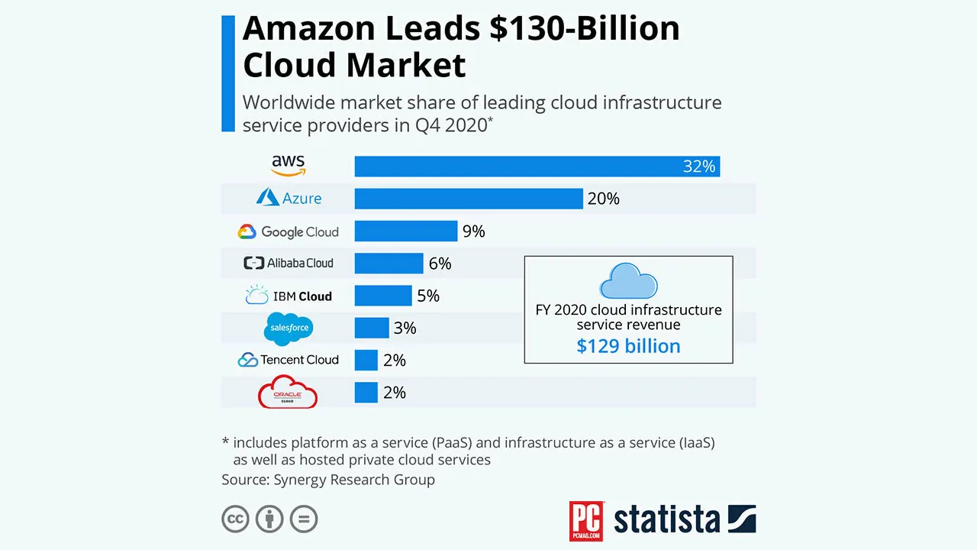
[Figure 1 - Infographic source: statista.com]
And because this technology is beyond what we can imagine, the biggest players in this field are already investing in new technologies such as:
- Quantum Computing
Quantum computers employ the principles of quantum physics to enable complex algorithmic calculations and process large data sets in a short amount of time. A supercomputer can provide powerful encryption capabilities for electronic communications and increase network security. [7]
- Edge Computing
Cloud providers are moving closer to the edge to respond to the growth of 5G, Internet of Things (IoT) devices, and latency-sensitive applications. Edge computing is not new to the tech industry glossary, but companies are increasingly adopting it. [7]
- Secure Access Service Edge (SASE)
Companies using SASE can benefit from cloud-based network security services such as security gateways, firewalls, and zero-trust network access (ZTNA). SASE is a robust architecture that gives businesses peace of mind, allowing them to deliver new services quickly and securely through the cloud. [7]
- Cloud Region
The geopolitical fragmentation of regulations, trade protectionism, and industry standards create new, separate compliance ecosystems. Vertical and regional data services and cloud ecosystems are undergoing a consolidation process. [7]
- Green Cloud
The extensive infrastructure, electricity, and cooling required for cloud computing significantly increase a business's environmental impact. The US Department of Energy found that data centers consume 2% of the total electricity used in the United States. The average data center uses between 10 and 50 times more energy per floor than a typical commercial office building. [7]
- 6G networking
Chinese testing 6G network - Purple Mountain Laboratories, based in Nanjing, has achieved a single-wavelength net rate of 103.125 Gbps and a dual-wavelength terahertz wireless transmission with a net rate of 206.25 Gbits/sec, which it claims is the highest transmission record of terahertz real-time wireless communication publicly reported in the world. [3]

Why is important?

Cloud computing is very revolutionary way how people and business is accessing data and servers, in the last year become very popular due to low pricing and high profitability. Everything done on internet it all takes data, this data is processing by computers called servers. The managing the traditional servers used a lot of human resources such as: time, money, and energy. When customers and big part of the companies migrate to the cloud, it is really just outsourcing, The leading Cloud company which has been given earlier handle many IT services and integrate all of them into an portal so business can only focus of what they are doing the best. Cloud computing is an IT model for enabling anytime, anywhere, convenient, on-demand network access to a shared pool of configurable computing resources. In simple terms, cloud computing refers to the delivery of hosted services over the internet that can be quickly provisioned and decommissioned with minimal management effort and less intervention from the service provider. [5]

How the job role of network professionals has evolved

In an industry that evolves very quickly, to be a relevant employee and to be able to be competitive in the future, training is needed all the time. The roles of network professionals and network security engineers have evolved over the past decade as a result of the rapid innovation of IT. Today the networks are more sophisticated than ever, and many organisations are moving to splitting old fashion network technology to network automation capabilities to accelerate problem solving. The specifics have fundamentally changed, despite the fact that the overall picture for network architects, who manage the planning, construction, and maintenance of networks, may appear to be essentially unchanged. One of good explanation of how this job role evolve is in the following article on Empiric.com, “For one thing, network engineers are increasingly being expected to use code in support of software-defined networking (SDN). In a blog post, Anand Oswal, Senior VP of Engineering for Cisco’s Enterprise Networking Business, describes this process as being a shift towards a new role, with engineers ultimately set to become network programmers.” [4] If before Network professionals handle installing and configuring of the system in order to ensure network security, today as the author suggest they have to evolve and learn Network programming.

How RESTful Web Services facilitate these changes.

The REST stand for Representational State Transfer application programming interface. These days all application using this architecture Client (front) and Server (back end). Many cloud providers use the REST architectural style (Representational State Transfer) for offering such computational resources. However, these cloud providers face challenges when designing and exposing REST APIs that are easy to handle by end-users and/or developers. Yet, they benefit from best practices to help them design understandable and reusable REST APIs.[10]
The Client need to communicate with the Server to get or save the data. The communication between these two usually is using HTTP protocol (Hypertext Transfer Protocol), after this steep the REST is coming into the picture, because REST is an application programming to help interface between Client and Server. The RESTful Web Services had a huge influence on these changes because give possibility to every single client with minimum basic IT knowledge to manage servers, virtual machines, and much more. Also, RESTful support HTTPS for Hypertext Transfer Protocol Secure and SSL Secure Sockets Layer which makes the apps very secure. RESTful APIs can be looked on as the glue that connects the cloud service providers and cloud service consumers. For example, application developers requiring to display a weather forecast can consume the Google Weather API. In this section, we will look at the applicability of RESTful APIs for provisioning resources in the cloud. [5]

SDN heavily adapted by industry

If in the past the networks were supervised by engineers, this requires the use of a very large human and financial resource. That's why in order to meet the needs of the time we live in, and with the cloud commuting boom, a new network was necessary. It sounds crazy to say, but traditional networking, as we often think about it, is largely a thing of the past. Cloud computing, remote working, multi-device management – they all require us to approach networking entirely differently. What used to be about two computers “talking” to each other, is now about facilitating constant, real-time information sharing – on a massive scale, across devices that are rarely (if ever) in the same building. [1]
During these amazing transformation in the technology industry, and this transformation come with very challenging aspects. To create a strong and cost-effective connection is using the software defined networking or SDN, and this is works by virtualization network, given new features and security, instead manually set up the network the SDN can help the Network engineers for programming and to adapt dynamically, and this will transform the network become more intelligent. Also, because the network algorithms know what happed in the network can easily detect and block any vulnerability or threats.
Over the past two decades, networks have come under increased traffic demands and increased scrutiny as both organizations and consumers increasingly rely on network connectivity for sales, customer service, internal communications, and document sharing [9]
Organizations can enable innovation with SDN by creating new types of applications, services, and business models in a record amount of time and with less hassle than before. Organizations can create new services and new paths for revenue with dynamic applications and a more efficient workflow. Network functions can be run on less-expensive off-the-shelf hardware, reducing capex. [6]

Some of the benefits of SDN included:
1. Greater Reliability via Automation
SDN is a great option for large, complex networks that require lots of up-time. It gives engineers the ability to re-route networks on the fly. For example, when an outage occurs, a software defined network can be configured to automatically reroute around that area and maintain the connections your users need. [1]

2. More Efficient Network Management
SDN offers real-time visibility into your network performance. This visibility gives you the ability to optimize your network’s performance and to drive its efficiency (as well as that of your team’s).[1]

3. Cost-Savings
In the past, the most effective way to ensure network availability was through redundancy, which of course comes with additional equipment and circuits and costs. Because SDN offers the real-time ability to automatically reroute or to stand-up new functions and routes, you can increase your nines of uptime without adding new hardware and increasing costs.[1]

4. Faster Scalability
SDN offers automated scaling-up (and scaling down). This ability, combined with the additional visibility it brings, gives engineers the operational ability to normalize traffic across a wide space, and to do it quickly and seamlessly.[1]
• Why standards, such as JSON and REST have been selected and utilised. Specifically consider interoperability.[1]

Conclusion
In conclusion, Recent technological developments like cloud computing could potential to transform and reshape the world significantly. It has and offer a wide range of benefits to offer both individuals and businesses. For instance, it lowers operating costs for businesses by spending less on maintenance and software upgrades and focusing more on the businesses themselves and innovation in the field where they worked. However, there are more difficulties that cloud computing is facing right now. People have a lot of doubts about how safe and private their data is stored and using, and one very good example of bad practice by a big tech company is Facebook. Worldwide standards or laws do not apply to data provided by cloud computing or the AI. Two of the biggest investors in these industries is United States and China. Despite being one of the most technologically advanced countries, the US and China lacks data protection rules compared to Europe. However, the world is facing many challenging and this enormous market that is at the beginning must have strict and safe rules for citizens. And the competition should be as fair as possible, and the big companies should not cannibalize each other. But once there are international norms and regulations accepted by everybody, cloud computing and AI will transform the future

References

[1] ‘4 Benefits of Moving to Software-Defined Networking | GDIT’. https://www.gdit.com/perspectives/latest/4-benefits-of-moving-to-software-defined-networking/ (accessed Nov. 27, 2022).
[2] F. Petrillo, P. Merle, N. Moha, and Y.-G. Guéhéneuc, ‘Are REST APIs for Cloud Computing Well-Designed? An Exploratory Study’, in Service-Oriented Computing, Cham, 2016, pp. 157–170. doi: 10.1007/978-3-319-46295-0_10.
[3] ‘Chinese laboratory hails 6G breakthrough with record speed test’, IT PRO. https://www.itpro.co.uk/infrastructure/network-internet/361927/chinese-laboratory-hails-6g-breakthrough-speed-test (accessed Nov. 27, 2022).
[4] ‘How the Role of the Network Engineer is Changing’. https://empiric.com/blog/network-engineer-role-changing/ (accessed Nov. 27, 2022).
[5] P. Ramchandani, ‘RESTful APIs role in Cloud, IoT, social media and emerging technologies’, Packt Hub, Jun. 01, 2018. https://hub.packtpub.com/restful-apis-cloud-iot-social-media-emerging-technologies/ (accessed Nov. 27, 2022).
[6] T. Systems, ‘The Fourth Industrial Revolution: Cloud Computing and Cybersecurity’, Taylored Systems | Indianapolis, Dec. 17, 2019. https://www.taylored.com/blog/the-fourth-industrial-revolution-cloud-computing-and-cybersecurity/ (accessed Nov. 27, 2022).
[7] Y. P. Lead Product Marketing, ‘The Future of Cloud Computing: 5 Trends You Must Know About’. https://bluexp.netapp.com/blog/cvo-blg-the-future-of-cloud-computing-5-trends-you-must-know-about (accessed Nov. 27, 2022).
[8] ‘The History of Information Technology | Complete I.T.’, Jan. 13, 2021. https://www.complete-it.co.uk/the-history-of-information-technology/ (accessed Nov. 27, 2022).
[9] ‘Why Is Software-Defined Networking (SDN) Important?’, SDxCentral. https://www.sdxcentral.com/networking/sdn/definitions/what-the-definition-of-software-defined-networking-sdn/why-sdn-important/ (accessed Nov. 27, 2022).
[10] F. Petrillo, et al, Are REST APIs for Cloud Computing Well-Designed? An Exploratory Study, Service-Oriented Computing, vol. 9936. 2016.
[11] F. Richter, “Infographic: Amazon, Microsoft & Google Dominate Cloud Market,” Statista Infographics, 15-Nov-2022. [Online]. Available: https://www.statista.com/chart/18819/worldwide-market-share-of-leading-cloud-infrastructure-service-providers/. [Accessed: 27-Nov-2022].
[12] “Private cloud vs. public cloud: What is the difference?: Vmware glossary,” VMware, 15-Nov-2022. [Online]. Available: https://www.vmware.com/topics/glossary/content/private-cloud-vs-public-cloud.html. [Accessed: 21-Nov-2022].

