

PROGRAM NAME: BA BUSINESS MANAGEMENT
MODULE NAME & CODE: INTERNATIONAL FINANCIAL MANAGEMENT (LCBB6002)
ASSIGNMENT TITLE: ASSESSMENT 1 WRITTEN REPORT

NAME OF LECTURER: DR KONSTANTINA MARI
STUDENT NAME AND NUMBER: PAVEL BODUSHKI (2023711)

WORD COUNT: 1,511
SUBMISSION DATE: 03-05-2023
Table of Contents
Introduction 3
Main body 3
Dividend distribution policy 3
Efficient market hypothesis (EMH) 4
Project appraisal 6
Conclusion 7
References 8

Introduction
The essay considers the case of Tesco – a public retail company with more than a century of existence (Reuters, 2023; BSH, 2023). Tesco is the market leader with more than 27% in market share; hence, its performance could be indicative of the entire sector (Marketing Week, 2023). With annual revenue of £65.8 billion and market capitalisation of £20.4 billion, as of April 2023, Tesco is a structurally important retailer (Reuters, 2023). The essay provides a critical discussion of dividend policies, investment appraisal methods and efficient market hypothesis.

Main body

Dividend distribution policy
Dividends are money paid to shareholders usually once per year as a part of the realised profits (Arnold, 2012). Tesco has a strategy of gradually increasing the level of dividends on a consistent basis. Currently, the company aims at distributing 50% of its earnings as dividends to shareholders (Tesco, 2023). In 2022, Tesco had a net profit of £2.2 billion (Tesco, 2023). In total, the company paid £731 million to shareholders for the same period (Tesco, 2023). This means that Tesco distributed 33.2% of its profit to shareholders – below the objective of 50%.
Tesco distributed 10.9 pence per share as dividend in 2022 (Tesco, 2023). This is an increase by 19.1% in comparison to 2021 (Tesco, 2023). The following chart shows the distributed dividend in the last five years. It is worth noting that Tesco has managed to consistently increase the size of its dividends in real terms (Tesco, 2023).
Figure 1 – Paid dividend per share (pence)
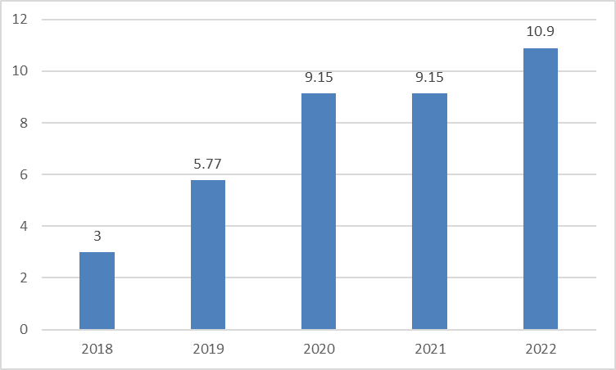
Source: Tesco (2023)
In terms of dividend yield, a value of 4.05% was achieved (Tesco, 2023). The yield is calculated by considering the average share price of 268.5 pence for 2022 (Tesco, 2023). The dividend yield is higher than the risk-free rate of 1.38%, applicable for year 2022 (Tesco, 2023). This is a positive development because Tesco’s share is more volatile and the premium return on company’s dividend adequately reflects the level of risk for shareholders.
The following chart compares the value of Tesco’s share and distributed dividends vis-à-vis the performance of the FTSE 100 index. This comparison is relevant because Tesco is a constituent of the index. Findings indicated that the FTSE 100 index increased by 85% during the analysed 10-year period (Tesco, 2023). In contrast, Tesco managed to add only 17% to the value of shareholders – considerably lagging the index (Tesco, 2023). The negative impact of the accounting scandal in 2014-2015 is also evident due to the considerable decline in Tesco’s value in this period (Tesco, 2023). It is also worth noting that Tesco has performed relatively well in the last several years when compared to the FTSE 100 value (Tesco, 2023).
Figure 2 – Comparison of returns: Tesco’s share vis-à-vis the FTSE 100 index
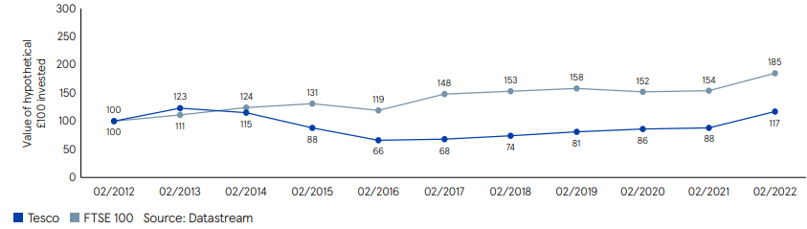
Source: Tesco (2023)
The dividend distribution policy of Tesco is relatively adequate. Findings shows the ability of Tesco to consistently increase dividend payments per share, as well as offer returns higher than the risk-free rate. Nevertheless, Tesco must further strengthen its performance and meet its 50% profit distribution objective. This may also stimulate the share price growth prospects, so that Tesco meets the performance of the general index.

Efficient market hypothesis (EMH)
EMH emphasises on the efficiency of capital markets (Fama, 1970). The theory assumes that all securities have a fair price which accurately reflects all available information to market participants (Fama, 1970). Information availability and instantaneous access to information are two main pillars of EMH supporting market the argument for market efficiency. Based on this, EMH suggests that asset prices are fairly determined and any discrepancies between the fair and actual values are quickly removed in efficient markets (Fama, 1970). It is also worth noting that asset prices tend to engage in a “random walk” type of movement over time (Fama, 1970).
These key propositions of EMH have considerable implications on investors and decision makers at capital markets. The existence of fair price means that investment decisions are based on rationality. Moreover, all information is available to market participants, and no one can gain competitive edge and generate excessive returns (Fama, 1970). In a random walk environment, any form of additional analysis – fundamental or technical – is irrelevant for predicting asset prices under the EMH propositions.
Overreliance on EMH should be avoided by Tesco’s decision makers in real-life. There are certain assumptions behind EMH which do not reflect the actual situation in the marketplace. First, there are transaction costs which make markets less efficient than proposed in the model. Second, there may be insiders in real life who have more information than ordinary investors. In general, insider trading continues to happen in some cases, even though it is illegal (CLS, 2023).
Moreover, it is worth mentioning that investors are human beings and have emotions. It is argued that there is herding at markets and emotional decision-making based on fear, greed and other emotions – key postulates of behavioural finance (Kumar, 2017). Therefore, asset prices may diverge from their fair value based on the dominant market sentiment.
The following chart about the share price of Tesco in the last 12 months is presented. The price is trending: decline between May and October 2022, followed by an uptrend (Reuters, 2023). Such price changes are far from being categorised as random walk. Apparently, there are patterns which violate the EMH’s propositions for random walk.

Figure 3 – Tesco’s share price change (pence)
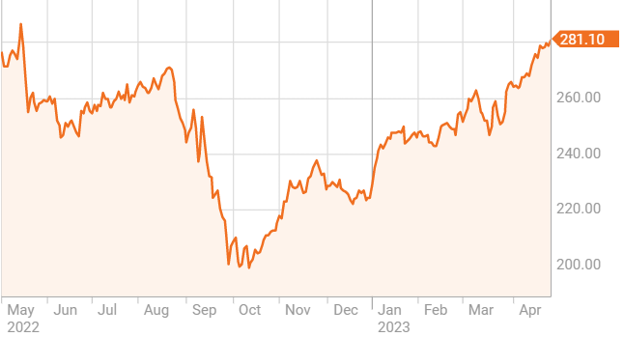
Source: Reuters (2023)
Considering all, financial markets appear to be quite complex. Hence, reliance on EMH alone cannot fully explain the developments of asset prices. Objective analysis requires an assessment of prevailing sentiment, whereas market efficiency also depends on low transaction costs and elimination of insider trading.

Project appraisal
The most popular investment/project appraisal methods are critically evaluated in this part of the essay. The payback period is simple to use and delivers quick results showing the necessary time to repay an investment (Afonso and Cunha, 2009). While repayment period is one of the most relevant pieces of information for investors and decision makers at Tesco, the method has key disadvantages. It may include unrealistic projections regarding future cash flows (Broadman et al., 2006). Moreover, the method ignores any relevant events beyond the repayment point of time (Broadman et al., 2006). As argued by Atril (2011), ignoring the time value of money is the most important disadvantage of the payback method. Thus, the actual real-term value of future proceedings is usually overestimated (Atril, 2011).
Decision makers also apply the accounting rate of return (ARR) – a method of measuring the average level of profitability (Pike and Neale, 2012). ARR can quickly assess the average profitability by assessing the annual levels of profitability based on expected net profit and initially invested amount (Pike and Neale, 2012). ARR delivers straightforward and quick information to decision makers but is also lacks a recognition of the time value of money concept (Berk et al., 2012). The focus on profitability also ignores the information regarding cash flows. The average profitability level based on ARR also ignores performance fluctuations in each of the respective years of a project.
Both previously mentioned methods ignore time value of money. Given the current high rate of inflation of 10.1%, the time value of money is quite relevant in real-life (Trading Economics, 2023). The makes the use of net present value (NPV) quite relevant because the method discounts the nominal value of future cash flows to find the real one; thereby, reflecting changes in inflation (Berk et al., 2012). Nevertheless, Tesco’s decision makers should avoid unrealistic assumptions regarding the discount rate, as this is a risk for inaccurate measurements of a project’s performance (Berk et al., 2012). Moreover, NPV ignores other contextual factors which may reflect the financial performance of a project (Zizlavsky, 2014).
Decision makers at Tesco also have extensive information needs which makes the use of internal rate of return (IRR) quite relevant. By showing the discount factor, which makes a project have a NPV value of zero, decision makers are informed about the risk and profit potential of an investment (Berk et al., 2012). Thus, they can compare the different between the actual discount factor and the IRR value to assess the buffer prior to start losing money on a project. In practice, IRR is complex to calculate and require time and focus. Similarly, to NPV, IRR also ignores some relevant contextual factors affecting the actual performance of a project (Magni, 2010).
Each of the discussed project appraisal methods has advantages and disadvantages; hence, decision makers at Tesco should use multiple methods. Methods, which incorporate the time value of money, should be preferred given the actual loss of money value in the recent inflationary environment.

Conclusion
To conclude, the essay explored important concepts in finance. Decision makers at Tesco can further improve the dividend policy, as well as apply a range of project appraisal methods. In terms of EMH, the evidence shows that it is not the most optimal way of determining the fair value of Tesco’s share price. Various types of valuation methods can be explored as a part of future research in the field.

References
Afonso, P. and Cunha, J. (2009) Determinants of the Use of Capital Investment Appraisal Methods: Evidence from the Field, [online] Available: https://core.ac.uk/download/pdf/55617649.pdf [Accessed: 22 April 2023]
Arnold, G. (2012) Corporate Financial Management. Aston: Financial Times Prentice Hall
Atril, P. (2011) Financial Management for Decision Makers. 4th edition, Financial Times Prentice Hall
Berk, J. DeMarzo, P. and Harford, J. (2012) Fundamentals of Corporate Finance. 2nd edition, Boston, Massachusetts: Prentice Hall
Boardman, C., Reinhart, W. and Celec, S. (2006) The Role of the Payback Period in the Theory and Application of Duration to Capital Budgeting, Journal of Business Finance & Accounting, Vol. 9, pp. 511 - 522.
Business Strategy Hub (BSH) (2023) TESCO SWOT Analysis 2023 | SWOT analysis of TESCO, [online] Available: https://bstrategyhub.com/tesco-swot-analysis-2019swot-analysis-of-tesco/ [Accessed: 25 April 2023]
Cornell Law School (CLS) Insider trading, [online] Available: https://www.law.cornell.edu/wex/insider_trading#:~:text=Congress%20has%20criminalized%20these%20insiders,trading%20and%2C%20since%20U.S.%20v [Accessed: 28 April 2023]
Fama, E. (1970) Efficient Capital Markets: A Review of Theory and Empirical Work, Journal of Finance, Vol. 25(2), pp. 383-417.
Kumar, R. (2017) Perspectives of strategic finance. In Strategic Financial Management Casebook, [online] Available: https://www.sciencedirect.com/topics/social-sciences/behavioral-finance#:~:text=Behavioral%20finance%20theory%20suggests%20that,price%20from%20reflecting%20economic%20fundamentals [Accessed: 28 April 2023]
Magni, C. (2010) Average Internal Rate of Return and Investment Decisions: A New Perspective, The Engineering Economist, Vol. 55. DOI:10.1080/00137911003791856
Marketing Week (2023) Market share, top UK ads, diversity: 5 interesting stats to start your week, [online] Available: https://www.marketingweek.com/grocery-market-share-top-uk-ads-agency-diversity-5-interesting-stats/ [Accessed: 25 April 2023]
Pike, R. and Neale, B. (2012) Corporate Finance and Investment. 5th edition, Financial Times Prentice Hall
Reuters (2023) Tesco PLC, [online] Available: https://www.reuters.com/markets/companies/TSCO.L/ [Accessed: 25 April 2023]
Tesco (2023) Annual Report and Financial Statements 2022, [online] Available: https://www.tescoplc.com/media/an0cp1co/tesco-annual-report-2022.pdf [Accessed: 25 April 2023]
Zizlavsky, O. (2014) Net Present Value Approach: Method for Economic Assessment of Innovation Projects, Procedia – Social and Behavioural Sciences, Vol. 156(1), pp. 506-512.

