Programme: BSc (Hons) Health and Social Care
Module: Digital Transformation in the Health and Care Professions
Module code: BMHP6026
Assignment Title: Component 1: Written Report
STUDENT NAME : AHMAD SAMAN
STUDENT NUMBER: 2330541
Table of Contents
1.Introduction 3
2. Selected digital innovation and its impact 3
3. Workforce: changes in job roles, role competency 4
4.Service Delivery: Changes in Day-to-Day Healthcare Services 5
5. Patient/Service User: Perceptions and Experiences of Care 6
6.Community impact on Patient and Service Location, Family Members, Co-Production, and Public Health 7
7. Conclusion and Recommendation 8
References 9

1.Introduction
For the health and care professions in the healthcare organisations rapidly changing digital transformation has become a key driver of change. Through the adoption of different innovative technologies it helps healthcare organisations in improving accessibility, efficiency and quality of care (Stoumpos, Kitsios and Talias, 2023). In the last decade, Remote consultation technology is considered as one of the most significant digital innovations within the UK healthcare sector specifically in the NHS. Telehealth/Virtual Consultations allows healthcare professionals to deliver care through telephone and video appointments (Haleem et al., 2021). From the time-period of Covid-19, the use of Remote consultation technology has transformed the way services are accessed and provided. This report examines the implementation of remote consultations and evaluates their impact on the workforce, service delivery, patients/service users, and communities.

2. Selected digital innovation and its impact
Remote consultations as a digital healthcare innovation helps healthcare professionals in providing clinical advice, assessment and follow-up care. It is done through telephone or video appointments rather than traditional face-to-face interactions. During the Covid-19, as a result of the lockdown situation the demand for Remote consultations in the NHS has increased. Healthcare delivery in the NHS has transformed and improved through this innovation. It also enhances the overall healthcare accessibility by reducing travel requirements, and supporting continuity of care. NHS (2025), indicates that 4.4 million online consultation requests were submitted to NHS GPs in 2024 which increases and becomes 6.5 million in 2025. The telehealth market in the UK is expected to reach a projected revenue of $9,563.0 million by 2033 with a CAGR of 9.2% from 2026 to 2033 (Refer to Figure 1).
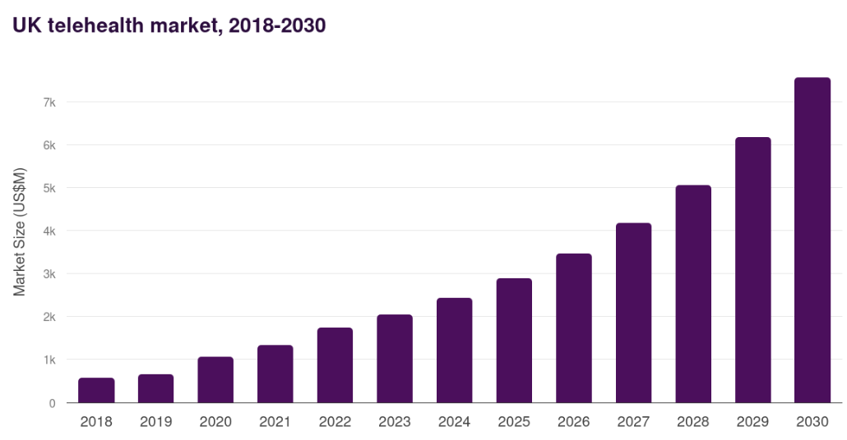
Figure: UK Telehealth Market
(Source: Grand View Research, 2024)
Several factors influence the overall success of remote consulting for practices (Refer to Figure 2). Practices need to work collaboratively with their local population and the individual needs of their patients to ensure the right clinicians are seeing the right patients in the right way (NHS England, 2023).
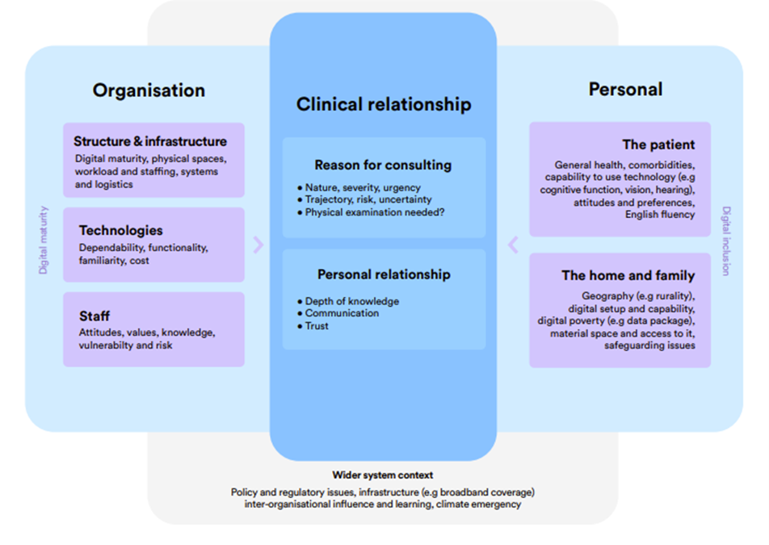
Figure 2: Factors influencing remote consultations
(Source: NHS England, 2023)
For both the healthcare providers and patients, the impact of remote consultations is significant. Effective remote consultations services help in increasing service efficiency, reduce waiting times, and improve access for individuals with mobility limitations or those living in rural areas (NHS, 2025). However, besides having advantages, challenges like digital exclusion, technological difficulties, and limitations in conducting physical examinations are there. As a result of rising demand for convenient healthcare services, the growth potential of remote consultations remains high. It focuses on ongoing NHS digital transformation strategies, and advancements in communication technologies. Therefore, effective remote care will continue to play an important role in future healthcare delivery.

3. Workforce: changes in job roles, role competency
Workforce practices within the NHS have transformed significantly as a result of the implementation of remote consultations. Increased flexibility in service delivery is considered as the key major advantage of remote consultations. It helps healthcare professionals to conduct consultations from different locations while maintaining continuity of care (Ladds et al., 2023). Productivity can be improved through remote consultations by reducing time spent on non-clinical activities like preparing consultation rooms and managing patient flow. During the COVID-19 pandemic, NHS England used online and video consultations that deliver the best care to patients (NHS, 2021). Shift in general practice to delivering a ‘total triage’ model of care enabled by online, video and telephone consultations (NHS, 2021). 500,000 NHS staff benefit from telecom deals which also help NHS staff, care homes and care providers upgrade existing connectivity during COVID-19 response (NHS, 2021). In professional roles and competencies, remote consultations adoption has also required changes. Effective digital skills, including the use of video platforms, electronic health records, and virtual communication techniques needs to be aware by healthcare staff. In modern healthcare practice, these competencies are known as effective essential components. However, to assist clinicians and patients with technology-related issues, some organisations have introduced digital support roles. It creates new employment opportunities within the healthcare workforce. Receiving ongoing training of healthcare professionals in digital technologies, virtual communication, and remote clinical assessment, helps in the successful implementation of remote consultations. Staff confidence can be improved through continuous professional development. It also helps in safe decision-making by ensuring the effective delivery of digital healthcare services.
However, besides the opportunities remote consultations also consist of challenges. Without physical examinations, Healthcare professionals may find it more difficult to assess patients (Alharbi et al., 2025). This can increase the risk of missed clinical signs and diagnostic uncertainty. As mentioned by CQC (2025), there is a growing concern among clinicians for the limitations of remote assessments for complex or high-risk conditions. Furthermore, due to the effective changes in digital care the demand for training for staff with limited technological experience has increased. Managing large volumes of virtual appointments and responding to digital communications also raises the workload pressure. Chaloner et al. (2025), suggested that although remote consultations improve efficiency in some settings, it can create additional administrative tasks. This ultimately creates a digital fatigue among healthcare professionals. Therefore, despite having advantages, remote consultations face issues on which adequate training, technological support, and appropriate clinical governance is needed to ensure safe and effective practice.

4.Service Delivery: Changes in Day-to-Day Healthcare Services
In healthcare organisations like the NHS, day-to-day delivery of healthcare services has changed due to the introduction of Remote consultations. The use of remote consultations in the NHS helped patients to access care through telephone or video appointments rather than attending healthcare facilities in person (Higgs, 2020). While managing growing patient demand, this transformation has increased service accessibility and allowed healthcare providers to maintain continuity of care. During the COVID-19 pandemic in 2020, eConsult in the NHS was available through the app to more than 2,200 practices, covering 20 million patients (Higgs, 2020). Remote consultations remain an established feature of NHS services despite face-to-face appointments. Capability in improving efficiency is a primary advantage of remote consultations. In the NHS, from remote consultations, without travelling to healthcare settings patients receive medical advice, prescription reviews, follow-up appointments, and management of minor conditions. This helps in reducing waiting times, minimise missed appointments, and enable healthcare professionals to manage larger patient volumes. By enabling faster access to healthcare services, these efficiency gains can improve patient outcomes. It also helps in reducing delays in diagnosis and treatment. More effective management of acute and long-term health conditions can be supported by earlier intervention and improved continuity of care. According to Khanji et al. (2023), remote consultations were particularly effective for routine follow-up care and administrative consultations, contributing to more efficient use of clinical resources.
However, the impact on service delivery also faced some challenges. Complex health conditions need physical examination which makes remote consultations less suitable for diagnosing those illnesses or assessing symptoms that depend on visual or tactile assessment. Overall service delivery can be disrupted due to technical issues such as poor internet connectivity, software failures, or difficulties accessing digital platforms which further affect the quality of care (Kim, Coiera and Magrabi, 2020). Furthermore, Chaloner et al. (2025), suggests that when clinicians are unable to gather sufficient information remotely, remote consultations may lead to additional follow-up appointments. This potentially reduces anticipated efficiency gains. Therefore, effectiveness of remote consultations depends on appropriate patient selection, reliable digital infrastructure, and the continued availability of face-to-face care.

5. Patient/Service User: Perceptions and Experiences of Care
In the healthcare sector, patients’ perceptions and experiences have improved due to effective accessibility and convenience. Nowadays patients can receive medical advice without travelling to healthcare facilities, through telephone and video appointments. This reduces both time and financial costs. For the individuals with mobility limitations, long-term health conditions, and those living in geographically isolated areas, these benefits are particularly valuable. As per NHS England (2020), 436,788 online consultation requests across 44 practices the median time to respond was 38 minutes during core hours (NHS England, 2020). 76% of patients said the online system was better than the previous system (based on 22,528 responses) (NHS England, 2020). As a result of effective flexibility and efficiency, many patients perceive remote consultations positively. During the COVID-19 pandemic, NHS England reported high levels of patient satisfaction with remote healthcare services (Coleman, 2021). Approximately 83% of service users indicate a positive experience. Patients benefit mostly from good access to healthcare providers, spending less time waiting in line and being able to go to their appointments from home. Chronic disease consultations with a remote provider could help to ensure sustained communications with the health care provider and ongoing monitoring of chronic conditions.
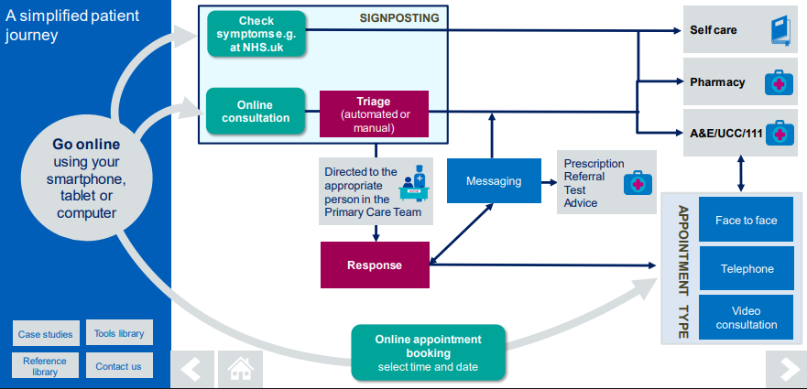
Figure 3: Patient Journey in the NHS
(Source: NHS England, 2020)
Remote consultations have a negative impact on patient experiences in certain situations. The development of trust and rapport between patients and healthcare professionals, might be reduced due to the absence of face-to-face interaction. For some patients remote appointments are less personal and due to this they feel that the quality of communication is reduced. According to ONS (2021), 6.3% of adults in the UK had never used the internet in 2020 and older adults are the most common proportion of this group. However, some individuals may face barriers while accessing digital healthcare services. Moreover, in remote care, concerns on privacy, confidentiality, and the inability to conduct physical examinations sometimes reduces patient confidence. It highlights the mixed impact of this innovation on patient experiences.

6.Community impact on Patient and Service Location, Family Members, Co-Production, and Public Health
Through changing the way healthcare services are accessed across different geographical locations, Remote consultations puts a vital impact on communities. Remote consultations helps to reduce barriers associated with distance, transportation, and travel costs for patients living in rural or underserved areas. This helps individuals to access healthcare services more conveniently and enhances overall engagement with healthcare providers. Digital healthcare technologies are identified as an important strategy by the NHS Long Term Plan which further helps in increasing access to care and reducing geographical inequalities in service provision (NHS, 2021). The innovation has also an impact on the family members and informal carers. Through the help of remote consultations, relatives and carers participate in appointments from different locations. It helps to improve communication and support shared decision-making. For older adults and individuals with complex health needs who may require assistance in understanding treatment options or managing long-term conditions it is very effective (Allcock et al., 2024). Through these involvement principles of co-production reflects, where in planning and delivering care, patients, families, and healthcare professionals collaborate. As per the viewpoint of a public health perspective, during the COVID-19 pandemic remote consultations helps to maintain healthcare access. This also reduces the risk of infection transmission. NHS Online will provide a huge boost to patient waiting times, delivering the equivalent of up to 8.5 million appointments and assessments (NHS England, 2025). Besides that, environmental sustainability goals within the NHS are maintained as reduced travel to healthcare facilities contributes to lower carbon emissions. Therefore, to address digital exclusion, healthcare organisations should provide digital literacy support by improving affordable internet services access. Also, maintaining an alternative face-to-face care options for individuals who are unable to engage with digital technologies will also be helpful.
However, there are some community-level challenges. Individuals from lower socioeconomic backgrounds, and those with limited access to digital technologies, can be affected by digital exclusion. According to Improvement Service (2020), 6.3% of adults in the UK have never used the internet, within older age-groups this figure is much higher; 11.4% for the 65-74 population. It highlights ongoing barriers to digital healthcare access. Conversely, remote consultations may also widen existing inequalities for groups who are unable to engage effectively with digital services despite improving healthcare accessibility and community participation.

7. Conclusion and Recommendation
Within UK health and social care the development of Remote consultations is considered as a significant digital innovation. This innovation helps in transforming the way healthcare services are delivered and accessed. Particularly for individuals in rural areas and during periods of service disruption like COVID-19 pandemic, Remote consultations have enhanced accessibility, improved service flexibility, and enabled continuity of care. Workforce efficiency, service delivery, patient convenience, and community engagement are some of the benefits of using this technology. But some challenges include digital exclusion, barriers to physical assessments, need for additional training, and issues with possible quality of the patient–professional relationship. This demonstrates that non-uniform access to benefits from remote consultations.
- It is essential for healthcare organisations to invest in maintaining their digital infrastructure and cultivating their staff's digital competence, to make the best use of digital consultations.
- They also must have a strong clinical governance structure. This is also the push for disadvantaged populations to be digitally literate and have access to technology.
- A balance of remote and in-person services will support equitable, safe and patient-centred health care delivery.

References
Alharbi, A.F., Rababa, M., Alsuwayl, H., Alsubail, A. and Alenizi, W.S. (2025). Diagnostic challenges and patient safety: The critical role of accuracy – A systematic review. Journal of Multidisciplinary Healthcare, [online] Volume 18, pp.3051–3064. doi:https://doi.org/10.2147/jmdh.s512254.
Allcock, J.A., Zhuang, M., Li, S. and Zhao, X. (2024). Landscape of Digital Technologies Used in the National Health Service in England: Content Analysis. JMIR formative research, 8, pp.e51859–e51859. doi:https://doi.org/10.2196/51859.
Chaloner, C., Stevenson, F.A., Rehill, N., Halvorsrud, K., Raine, R. and Barratt, H. (2025). What is the impact of a shift to remote consultations? A qualitative interview study in primary and secondary healthcare. BMJ Open, 15(6), p.e097633. doi:https://doi.org/10.1136/bmjopen-2024-097633.
Coleman, L. (2021). People’s views about remote access to appointments during the Covid-19 pandemic – compilation of evidence. [online] Available at: https://www.healthwatchbrightonandhove.co.uk/sites/healthwatchbrightonandhove.co.uk/files/People%27s%20views%20about%20remote%20consultations%20-%20compilation%20of%20evidence.pdf [Accessed 11 Jun. 2026].
CQC (2025). The state of care in independent online primary health services Findings from CQC’s programme of comprehensive inspections in England. [online] Available at: https://www.cqc.org.uk/sites/default/files/20180322_state-of-care-independent-online-primary-health-services.pdf [Accessed 11 Jun. 2026].
Grand View Research (2024). UK Telehealth Market Size & Outlook, 2030. [online] Grandviewresearch.com. Available at: https://www.grandviewresearch.com/horizon/outlook/telehealth-market/uk [Accessed 11 Jun. 2026].
Haleem, A., Javaid, M., Singh, R. and Suman, R. (2021). Telemedicine for healthcare: Capabilities, features, barriers, and Applications. Sensors International, 2(2), pp.100–117.
Higgs, T. (2020). Launching online consultations in the NHS App during COVID-19. [online] NHS Digital. Available at: https://digital.nhs.uk/blog/transformation-blog/2020/launching-online-consultations-in-the-nhs-app-during-covid-19 [Accessed 11 Jun. 2026].
Improvement Service (2020). The impact on advice service users of increasing the use of digital access routes. [online] Available at: https://www.improvementservice.org.uk/__data/assets/pdf_file/0021/38181/impact-on-advice-service-users-of-increasing-the-use-of-digital-access-routes.pdf [Accessed 11 Jun. 2026].
Khanji, M.Y., Gallagher, A.M., Rehill, N. and R. Andrew Archbold (2023). Remote consultations: review of guiding themes for equitable and effective delivery. Current Problems in Cardiology, 48(8), pp.101736–101736. doi:https://doi.org/10.1016/j.cpcardiol.2023.101736.
Kim, M.O., Coiera, E. and Magrabi, F. (2020). Problems with health information technology and their effects on care delivery and patient outcomes: A systematic review. Journal of the American Medical Informatics Association, [online] 24(2), pp.246–250. doi:https://doi.org/10.1093/jamia/ocw154.
Ladds, E., Khan, M., Moore, L., Kalin, A. and Greenhalgh, T. (2023). How have remote and digital approaches impacted continuity? A mixed-studies systematic review. British Journal of General Practice. [online] doi:https://doi.org/10.3399/BJGP.2022.0398.
NHS (2021). NHS England» Digital and Technology. [online] NHS England. Available at: https://www.england.nhs.uk/mat-transformation/matrons-handbook/digital-and-technology/ [Accessed 11 Jun. 2026].
NHS (2025). NHS England» Millions more online consultation submissions by patients to practices in September. [online] England.nhs.uk. Available at: https://www.england.nhs.uk/2025/10/millions-more-online-consultation-submissions-by-patients-to-practices-in-september/ [Accessed 11 Jun. 2026].
NHS England (2020). Using Online Consultations In Primary Care Implementation Toolkit. [online] Available at: https://www.england.nhs.uk/wp-content/uploads/2020/01/online-consultations-implementation-toolkit-v1.1-updated.pdf [Accessed 11 Jun. 2026].
NHS England (2023). Remote Consulting. [online] www.england.nhs.uk. Available at: https://www.england.nhs.uk/long-read/remote-consulting/ [Accessed 11 Jun. 2026].
NHS England (2025). NHS England» New NHS online hospital to give patients more control over their care. [online] England.nhs.uk. Available at: https://www.england.nhs.uk/2025/09/new-nhs-online-hospital-to-give-patients-more-control-over-their-care/ [Accessed 11 Jun. 2026].
ONS (2021). Internet users, UK: 2020. [online] www.ons.gov.uk. Available at: https://www.ons.gov.uk/businessindustryandtrade/itandinternetindustry/bulletins/internetusers/2020 [Accessed 11 Jun. 2026].
Stoumpos, A.I., Kitsios, F. and Talias, M.A. (2023). Digital Transformation in healthcare: Technology Acceptance and Its Applications. International Journal of Environmental Research and Public Health, [online] 20(4). Available at: https://www.mdpi.com/1660-4601/20/4/3407 [Accessed 11 Jun. 2026].

