Assignment Title: “Sustainable Development Goals to Improve Health, Well-being and Sustainable Development in the UK”

  - Lecturer’s Name: Chloe Harriers and Parese Ahmed

Module Name: Health, Well-being, and Sustainable Development
Module Code: BMHP6021
Student Name: Nazreen Akhtar
Student ID: 2128933

Table of Contents
Section 1: Introduction 3
Section 2: Introduction to Concepts 4
2.1 Well-being 4
2.2 Sustainable Development 4
2.3 Health 5
2.4 Sustainable Development Goals (SDGs) 5
Section 3: Goal A 7
3.1 Definition of Goal 1: No Poverty 7
3.2 UK Strategies to Implement No Poverty 7
3.3 Critical Review of the No Poverty Strategies 8
3.4 Progress Made in Implementing No Poverty 9
3.5 Challenges in Implementing No Poverty 9
3.6 Impact on Health, Well-being, and Sustainable Development 10
3.7 Recommendations 11
Section 4: Goal B 12
4.1 Definition of Goal 2: Zero Hunger 12
4.2 UK Strategies to Implement Zero Hunger 12
4.3 Critical Review of the Zero Hunger Strategies 13
4.4 Progress Made in Implementing Zero Hunger 14
4.5 Challenges in Implementing Zero Hunger 14
4.6 Impact on Health, Well-being, and Sustainable Development 15
4.7 Recommendations 15
Section 5: Conclusion 17
References 18

Section 1: Introduction

This report aims to evaluate the progress made by the UK in achieving two Sustainable Development Goals (SDGs) established by the United Nations: Goal 1 - No Poverty, and Goal 2 - Zero Hunger. However, solving these goals is inherently tied up in bettering public health outcomes and the sustainable development of the UK healthcare sector. In the UK, the National Health Service (NHS) is fundamental to the improvement of health, well-being, and sustainable development. Achieving these objectives, however, will need a comprehensive approach that will tackle the systemic causes of poverty and hunger, both of which are important determinants of health and well-being.
This report critically assesses the UK's current strategies, programs, and initiatives to tackle poverty and hunger and their impact on health and well-being. It looks at to what extent these efforts are consistent with overarching objectives of sustainable development and to what extent difficulties have been encountered in their implementation. Additionally, the report highlights policy gaps towards achieving these SDGs and provides evidence-based recommendations to improve the UK's approach to doing so. Poverty and hunger are among the best-known obstacles to health equity and sustainable development (Garg and Singh, 2022). The first goal, No Poverty, aims to end poverty in all its forms, such as income inequality, social exclusion, and the lack of basic services (UNDP, 2024). At the same time, Goal 2 which is Zero Hunger, aims to end hunger and ensure access by vulnerable people to the nutritious food they need (UNDP, 2024).
This report analyses two of the most important UK strategies or programs aimed at each of these targets within the scope of this work. As such, it critically reviews their effectiveness and assesses how progress is being made in helping to alleviate poverty and hunger-related health disparities. The report also talks about resource constraints, policy gaps, and socio-economic inequalities that block the implementation. The report synthesises these insights to offer actionable recommendations for improving the effectiveness of existing strategies and for advancing a sustainable, health-oriented development agenda. This report underlines the need to tackle poverty and hunger as underlying health and development goals and a route map for taking the UK's action on them forward.

Section 2: Introduction to Concepts

2.1 Well-being

Well-being relates to a state of healthiness, happiness, or comfort and ranges between physical, mental, and social dimensions (Topp et al., 2015). It is more than the absence of illness since it involves a person's overall quality of life. Well-being is critical in healthcare as it relates to productivity, being able to live a rewarding life, and being socially engaged. World Health Organisation (WHO, 2024) asserts that public health objectives necessarily entail well-being as a means of combating social determinants and inequalities.
Critically, well-being is widely acknowledged as critical, but measurement of well-being remains an ongoing issue. Subjective well-being escapes traditional indicators such as GDP; the objective is to develop holistic frameworks, such as the OECD's Better Life Index. Nevertheless, such indices are deemed to be too subjective and not easily standardised across populations (Kõrreveski, 2011). Moreover, since sustainable well-being depends on solving systemic problems, like poverty and hunger, it is relevant to Sustainable Development Goals 1 and 2.

2.2 Sustainable Development

Sustainable development is defined by the Brundtland Report as 'a development which meets the current needs of present generation without compromising the ability of future generations to meet their own needs (Pearce and Atkinson, 1998).' It incorporates three key pillars: economic, social, and environmental sustainability. Ensuring that societal progress neither depletes resources, impairs inequalities, nor harms ecosystems is a principal imperative to sustainable development.
In healthcare terms, sustainable development refers to access to health services that are equitable to the reduction in the environmental footprint of healthcare systems and the elimination of social determinants such as housing and education (Hajian and Kashani, 2021). NHS, for example, has adopted initiatives to reduce its carbon footprint and deliver healthcare that is in alignment with sustainable development principles.
However, critics claim that even in the UK, where it is high-income, economic interests often outweigh sustainable development. Sakalasooriya (2021) argued that policy inconsistencies and a gap in global accountability are what prevent meaningful progress. In addition, while sustainable development is integrated into healthcare policies to a limited extent, there is an absence of protracted resilience as people's safety is reliant on provisions from public reserves to address the impact of crises such as the COVID-19 pandemic.

2.3 Health

The WHO's definition of health is a state of complete physical, mental, and social well-being and not merely the absence of disease or infirmity (WHO, 2024). The holistic definition underlines the multidimensionality of health, which is linked to goodness and sustainable development. Individual and societal productivity, economic growth, social stability, and other objectives all depend on health.
For the UK, health, poverty, and hunger are interconnected. They (social determinants of health) are profoundly affected by social determinants like income, education, and housing. For instance, Marmot (2014) have shown that people living in deprived areas of the UK have life expectancies considerably less than those of the richest. The disparities in health systems reflect the necessity for health systems to encompass the underlying socio-economic factors.
The WHO's definition of health is one that critics say is too idealistic, setting an impossible standard for health systems to achieve. Topp et al. (2015) argued that concentrating on 'complete' well-being can take consciousness of sensible, incremental improvements in healthcare delivery. The definition, however, has also been criticised for not reconciling intermittent noises against cultural and individual representations of health with ensuing consequences for being within the healthy range.

2.4 Sustainable Development Goals (SDGs)

The SDGs for their 'availability' in 17 global objectives set by the United Nations in 2015 to address the major challenges of time, such as poverty, inequality, climate change, and health (Hajian and Kashani, 2021). SDGs are important because they provide a holistic basis for promoting inclusive development while protecting environmental resources.
The SDGs stress the interdependence of global problems and call for cross-sector collaboration. For example, when hunger is reduced, health outcomes are enhanced and educational attainment and economic productivity. Amongst other things, SDGs have influenced UK policies like the Child Poverty Strategy and the Food Security Strategy in their attempt to tackle socio-economic inequalities.
Despite offering needed meaning about what is important to the future of humanity, the SDGs have been criticised for being too wide and lacking enforceability. According to Sakalasooriya (2021), the goals tend to be ambitious, so they often get fragmented implementation in which countries put economic goals ahead of (social and environmental) targets. In the UK, although progress on SDGs has been made, critics indicate that there has been no consistent policy alignment and an unacceptable level of resource allocation (Perry et al, 2021). Additionally, while the SDGs promote inclusivity, not all or some marginalised groups are included in policy frameworks, thus rendering initiatives meant to reach these targets ineffective.
Well-being, sustainable development, health, and SDGs are embedded. Well-being is a key reference indicator of sustainable development and is considered an indicator of the success of health systems as well as socio-economic policies (Garg and Singh, 2022). Like sustainable development, the concepts of resilient health systems address similar issues such as poverty, hunger, and other things that directly impact health outcomes.
These concepts are operationalised in the UK through, for example, the NHS Long Term Plan concentrating on Integrated Care Systems and the elimination of health inequalities (Perry et al, 2021). However, the implementation of these efforts faces hurdles, including funding constraints, political instabilities, and the concomitant requirement for institutional transformation. While discrete measures aimed at reducing child poverty and food insecurity have made progress, it is also important to recognise that such efforts are merely drops in the ocean in the face of systemic dynamics, including socio-economic inequalities and between and within regional disparities.
Most critically, however, the UK has tended to take the short-term gain over long-term sustainability. For example, while it is creating awareness to cut down the costs of healthcare, it has sidelined preventive expenses, which initially tackle the root reasons behind this, like poverty and hunger.

Section 3: Goal A

3.1 Definition of Goal 1: No Poverty

The first of the Sustainable Development Goals (SDGs) predicts ending poverty in all its forms everywhere by 2030 (UNDP, 2024). Based on that definition of poverty, the United Nations defines it as the 'lack of basic resources and income to meet essential needs such as food, shelter and health (UN, 2024).' Measures used to measure no poverty are the proportion of people below the line of international poverty ($2.15 a day) (UN, 2024), the prevalence of multidimensional poverty and social protection. Poverty is a priority because it is one of the drivers of social injustice and access to health and perpetuates cycles of disadvantage that deny well-being and impede human development.
Absolute and relative measures of poverty are used in the UK context. Relative poverty is about households' income compared to the median income, being less than 60% of the median income (House of Commons Library, 2024). The picture below shows that at least a quarter and possibly more of the UK population, including more than four million children, live in poverty as of 2022 (House of Commons Library, 2024), a pressing reason to pursue this target.
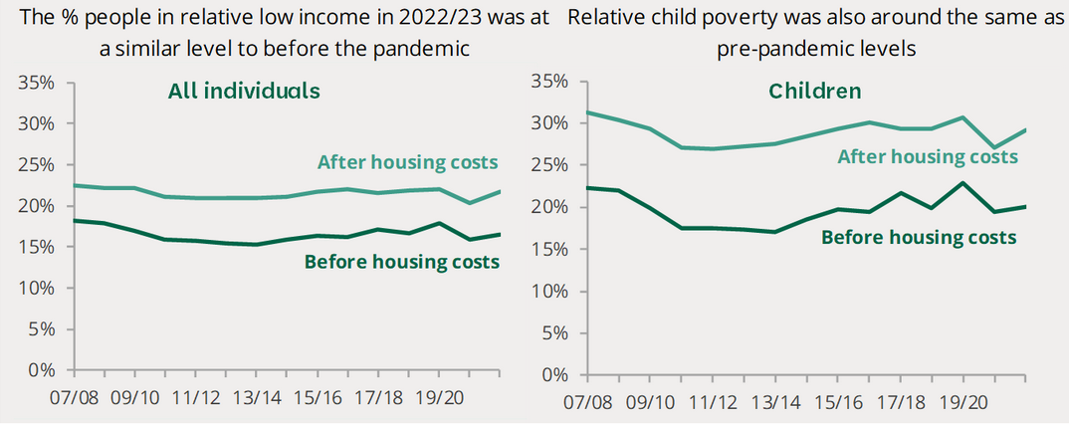
Figure 1: Low Income in the UK (Source: House of Commons Library, 2024)

3.2 UK Strategies to Implement No Poverty

Universal Credit (UC): Universal Credit is a welfare program that was introduced in 2013 (GOV.UK, 2024). It is supposed to be a simplification of benefits; it is supposed to support low-income families, unemployed people, and people who are disabled. In some ways, it is essentially a triple play on one payment by offering benefits whilst at the same time bringing in financial safety nets and having work incentives.
Child Poverty Strategy: Aiming to lower child poverty and food insecurity, the UK government has in place some child poverty measures like the "Holiday Activities and Food Programme" and "Healthy Start Scheme" (GOV.UK, 2024). These strategies focus on increasing educational outcomes, increasing quality opportunities for parents and direct support for levels of needs.

3.3 Critical Review of the No Poverty Strategies

Universal Credit (UC): UC was designed to be easy to cut poverty, but the implementation has been widely criticised. The system, Cheetham et al. (2019) argued, makes the problem even more complex through long delays in payments, which have exacerbated levels of financial difficulty among many recipients and made them more reliant on food banks and high levels of debt. In 2021, research by the Trussell Trust (2024) found that 52 percent more people used food banks in areas where UC had already been rolled out.
Additionally, UC's reliance on the digital application process has made barriers for these vulnerable populations like the elderly or people without internet. However, the five-week wait between the first payment renders it fairly worthless as a safety net; in fact, many households have been plunged into crisis (Etherington, 2020).
However, proponents say that UC encourages work by reducing the benefit 'cliff edge', which means people stop claiming all benefits as soon as they get a job. Early evaluations show modest improvements in employment rates among recipients but fail to overcome the persistence of poverty among those in low-wage jobs (Griffiths et al., 2022).
Child Poverty Strategy: Some of the targeted support to disadvantaged families has been successful in tackling child poverty under the Child Poverty Strategy. The Holiday Activities and Food Programme provides free meals during school holidays and reached over one million children in 2022 (GOV.UK, 2024). The Healthy Start Scheme has also helped pregnant women and young children living in low-income households to get more nutritious food.
However, these have been criticised as being too small in scope and far too underfunded. While such programs have a positive impact on child poverty rates, they are 'offset' due to cuts to welfare benefits and local authority budgets, says the End Child Poverty (2024), meaning the rates of child poverty remain stubbornly high. Nevertheless, such strategies, critics say, only treat symptoms such as low pay and housing insecurity.

3.4 Progress Made in Implementing No Poverty

Reducing poverty has seen progress in the UK, although some demographic groups have done better than others. Improvements in state pensions and other benefits, such as Winter Fuel Payments, have reduced pensioner poverty dramatically in the past 20 years (The Guardian (2024), for example. One important way that reduced child poverty rates in the early 2000s occurred through targeted interventions, including tax credits and increases in public spending on education (IFS, 2024).
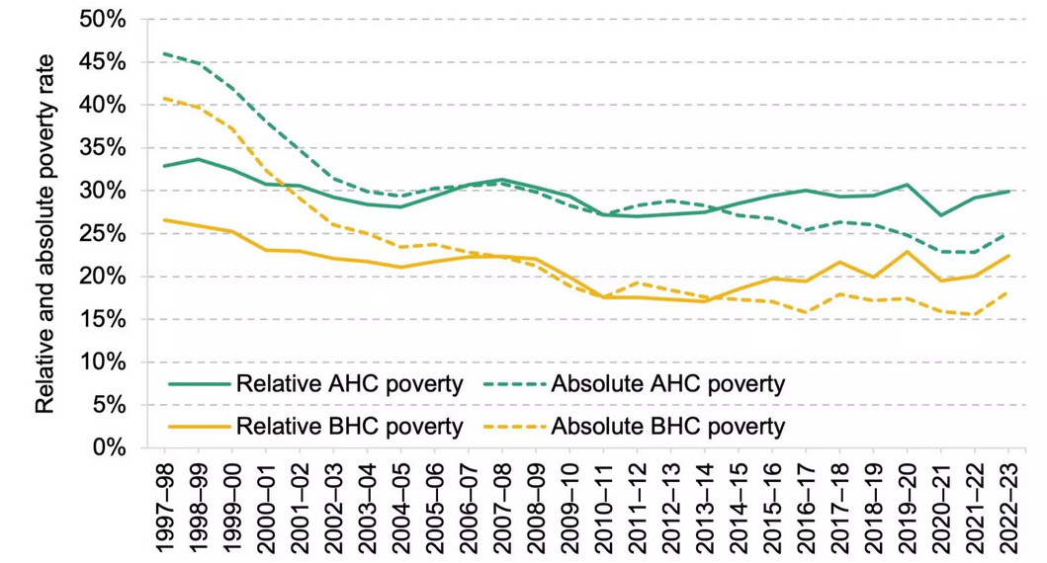
Figure 2: Reduced Child Poverty Rates (Source: IFS, 2024)
However, in recent years, progress has stalled, and poverty has risen as a result of economic austerity measures and the effects of the COVID-19 pandemic. During the pandemic, the Resolution Foundation (2022) noted that around 700,000 more people, which includes around 300,000 children, became poorer. In 2023, this cost-of-living crisis has only compounded the financial pressures on low-income households, making the need for stronger and more sustainable anti-poverty measures clear.

3.5 Challenges in Implementing No Poverty

Economic Inequalities: The main barrier to reducing poverty in the UK continues to be income disparities. The Office for National Statistics (2022) highlights that wealth inequality, as is the case, is widening; the richest 10% own nearly half of the country's wealth. What these disparities do is perpetuate cycles of poverty and expand the limit on social mobility.
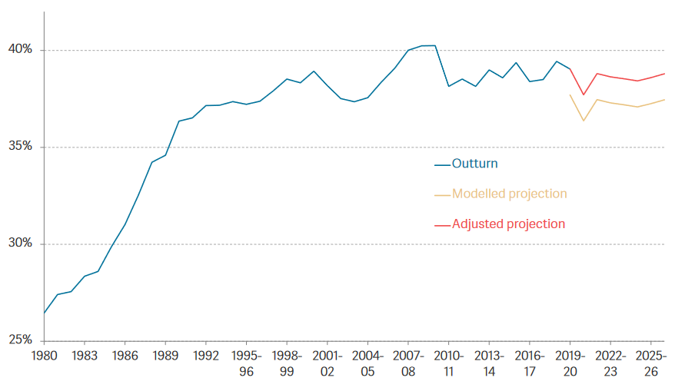
Figure 3: Income Inequality Over the Years (Source: Resolution Foundation, 2022)
Insufficient Social Protection: Initiatives like UC do not close the gap in social protection for many households. Benefit caps and freezes and the expectation of the five-week waiting period for UC reduce the utility of UC in reducing poverty.
Regional Disparities: There is a big variation in poverty rates in the UK, and they are higher in certain areas, such as the Northeast and West Midlands (Action for Children, 2024). These disparities correspond to structural inequalities in access to employment, housing, and public service provision.
Impact of Economic Shocks: The cost-of-living crisis and the new normal, the COVID-19 pandemic, has caused household finances to be stretched, and people are forced to rely on food banks more. Inflation and rising energy costs have disproportionately intensified already high levels of poverty and food insecurity among low-income households.

3.6 Impact on Health, Well-being, and Sustainable Development

Access to nutritious food, stable housing, or healthcare is limited, and this directly affects health and well-being. In the Marmot review, it was highlighted that people in poverty are more likely to live with chronic illnesses and mental illness and live shorter lives than people in consumption (IHE, 2020). Poverty also undermines sustainable development by reinforcing poverty, provoking reliance on these services and the stress it places on public resources, as well as perpetuating social disparities.
Take, for illustration, food insecurity, an important dimension of poverty, which ends in malnutrition and eating diseases like weight problems and diabetes. Nor is that the only cost for all the good the NHS does when illness strikes, it also incurs huge costs in dealing with preventable illnesses associated with low rates of poverty.

3.7 Recommendations

Strengthen Social Protection: Working to get rid of the five-week wait for Universal Credit, raise benefit levels in line with inflation, and make the digital system more accessible for those who are most vulnerable (Cheetham et al., 2019).
Invest in Affordable Housing: Increase the funding for social housing and introduce rent caps to reduce housing insecurity, a first-class cause of poverty.
Enhance Targeted Support: Growing up successful initiatives like the Healthy Start Scheme and Holiday Activities and Food Programme so that they reach all eligible families.
Address Regional Disparities: Reducing regional inequalities through the implementation of place-based strategies of job creation, education and infrastructure development in regions of deprivation (The Guardian, 2024).
Promote Living Wages: Strengthening the policies to guarantee fair wages and prevent the in-work poverty that constitutes a large part of poverty in the UK (Griffiths et al., 2022).

Section 4: Goal B

4.1 Definition of Goal 2: Zero Hunger

The second Sustainable Development Goal (SDG) hopes to end hunger, achieve food security, improve nutrition, and promote sustainable agriculture by 2030 (UNDP, 2024). Hunger is the lack of enough food to meet daily caloric needs, resulting in physical health and mental health impacts. The Food and Agriculture Organisation (FAO, 2024) notes that hunger is about more than just a lack of food: it is also a lack of food that is both nutritious and safe.
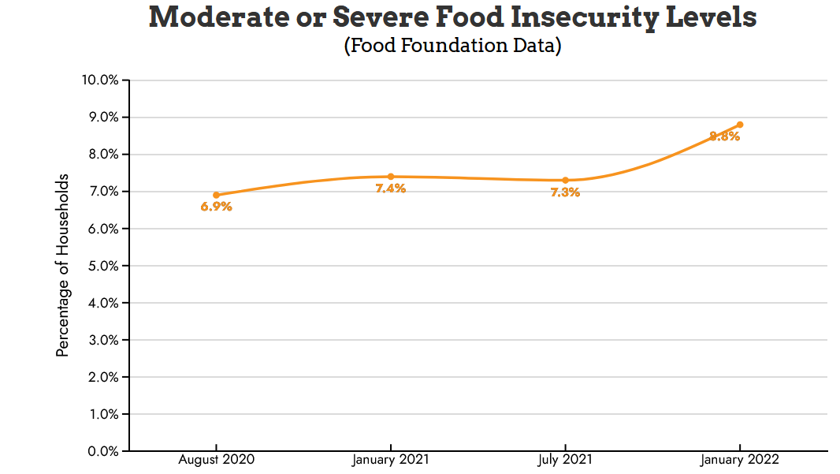
Figure 4: Food Insecurity in the UK (Source: Food Foundation, 2022)
In the UK, food insecurity, or a lack of consistent access to sufficient food, is an increasing problem. In 2022, around 9.3 million adults and 4 million children experienced food insecurity, compounded by the COVID-19 pandemic and cost-of-living crisis, says the Food Foundation (2022). The rationale for this goal is that hunger undermines health, well-being, and sustainable development by causing malnutrition, chronic disease, and a lack of productivity.

4.2 UK Strategies to Implement Zero Hunger
National School Breakfast Programme (NSBP): First launched in 2018, this initiative serves free, healthy breakfasts to children in disadvantaged areas in order to fight child hunger and enhance educational outcomes (EEF, 2022). Family Action is managing the program on behalf of Magic Breakfast.
FareShare and Surplus Food Redistribution: It is a UK charity that redistributes surplus food from the food industry to charities and community groups to make it available to vulnerable populations so they can have nutritious meals (Fareshare, 2024). This initiative combats hunger while also reducing food waste.

4.3 Critical Review of the Zero Hunger Strategies

National School Breakfast Programme (NSBP): Since 2011, the NSBP has had significant success in addressing child hunger, and over 1,775 schools participated in 2022 (Family Action, 2023). The Education Endowment Foundation (2022) studies showed that free breakfast access helps improve concentration, attendance, and academic performance, more so for disadvantaged areas.
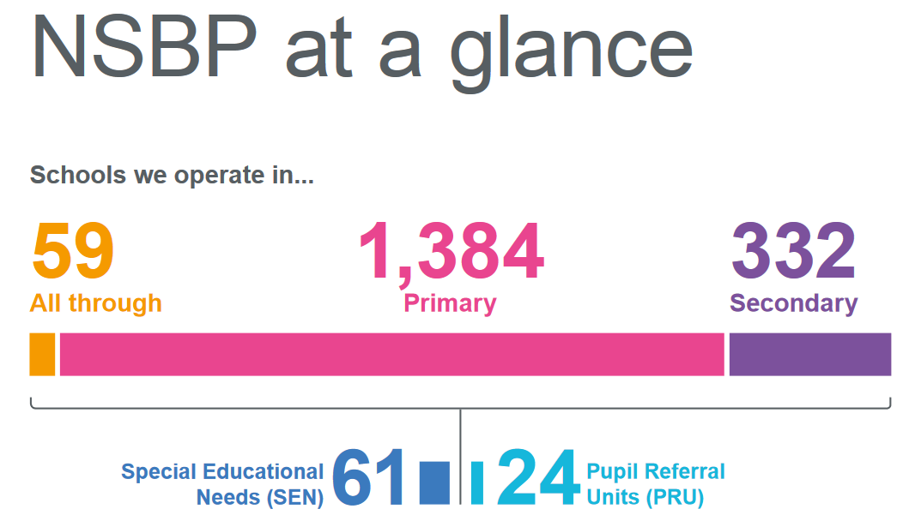
Figure 5: NSBP Operations (Source: Family Action, 2023)
However, the program has funding and scalability problems. In 2021, the NSBP's reach, and effectiveness were curtailed with a loss of government funding. However, the Food Foundation (2023) argued that the program does not deal with the root causes of food insecurity, low household income, and unemployment. It has been criticised for addressing immediate hunger but not tackling the issues that cause it. Moreover, it raises concerns over sustainability and overreliance on external partnerships with charities, such as Magic Breakfast.
Surplus Food Redistribution through FareShare: Last year, FareShare redistributed enough food to create over 7 billion meals and has been key in ensuring less food ends up in the bin to reduce food poverty and food waste (Fareshare, 2024). The initiative also helps community-based organisations such as food banks, shelters, and schools support broader social well-being.
Although some have been successful, a systemic flaw has limited how much impact FareShare has. Most food redistribution is aimed at treating the symptoms of hunger rather than at the cause, income inequality, and poverty. Logistical issues such as the cost of surplus food transportation and unequal distribution across regions have also been drawn to critics. Also, the reliance of the initiative on surplus food is, to some extent, an ethical problem surrounding the quality and consistency of food given to vulnerable populations (Facchini et al., 2018).

4.4 Progress Made in Implementing Zero Hunger

Programs and community initiatives that have reduced hunger and increased food security in the UK have had some success there. For example, school meal programs have expanded to thousands of children annually. In addition, there have emerged food redistribution networks like FareShare to provide people, especially vulnerable groups, with food and reduce food waste (Fareshare, 2024).
However, progress has been uneven, with a string of recent setbacks. A cost-of-living crisis has seen food insecurity rise sharply, which has seen food bank usage reach record levels. The Trussell Trust (2024) says that in 2022–2023, 3 million emergency food parcels were handed out, 37 percent higher than before the pandemic began. The effect of hunger on public health is getting worse, and similarly, malnutrition-related hospital admissions have risen.

4.5 Challenges in Implementing Zero Hunger

Economic Pressures: Low-income households are finding it harder than ever before to afford to eat healthy food due to rising inflation, stagnant wages, and high living costs. According to the Food Foundation (2023), over 20 percent of UK households have cut meals or reduced portion sizes because of cost pressures.
Inadequate Policy Coordination: Hunger and food insecurity are multi-faceted problems that do not respond to policy according to sector but require coordinated policy responses across sectors in healthcare, agriculture, and social welfare. Proponents say current strategies are integrated but fail to address systemic inequalities.
Regional Disparities: In regions with higher unemployment and lower average incomes, like the Northeast and parts of Wales, food insecurity is disproportionately higher (Action for Children, 2024). Such disparities masked by other socio-economic inequalities are largely meaningless when it comes to the effectiveness of national initiatives.
Sustainability Concerns: This is not a sustainable solution, and programs like FareShare do a vital job of dealing with the immediate need but are ultimately reliant on surplus food. Along with addressing food production systems, waste management, and equitable distribution, an approach that comes from a long-term perspective is required.
Health Implications: Poor nutrition and hunger have been associated with obesity, diabetes, and cardiovascular diseases. More effective hunger alleviation strategies would cost billions to the NHS every year and help mitigate the spending on diet-related illnesses (Abusaada and Elshater, 2024).

4.6 Impact on Health, Well-being, and Sustainable Development

Hunger leads directly to malnutrition and other diet-related diseases, which undermine health. Developmental delays, mental health problems, and poor academic performance are more common in children living in food-insecure households, and the more times a poor household falls into poverty, the more often the family will cycle back into a disadvantage.
From the point of view of well-being, hunger exacerbates stress, anxiety, stigma, mental health, and social cohesion. In addition, it also has impacts on sustainable development, considering that food security exacerbates inequalities, lowers productivity in work, and raises the strain on public services like health and education.
However, practices in agriculture and food waste are also in concert with environmental degradation, which opposes the broader goals of sustainable development. To address hunger requires a holistic approach addressing both environmental, economic and social dimensions.

4.7 Recommendations

Expand and Fund School Meal Programmes: Bringing increased funding into the National School Breakfast Programme and increasing eligibility to more schools. Provide universal free school meals so that no child in any socio-economic background is left hungry (Action for Children, 2024).
Strengthen Social Safety Nets: Secondly, improve the welfare programs to allow channels for low-income households to afford healthy food. Increasing benefit levels, including indexing them to inflation and reducing barriers to access, are all part of it.
Invest in Sustainable Agriculture: Small-scale farmers should be rewarded and their dependence on imports mitigated.
Improve Policy Coordination: Integrate various efforts of health, education, and agriculture in the design of a cross-sectoral task force to address the issue of food insecurity. This would mean a more holistic and more effective response to hunger (Facchini et al., 2018).
Address Regional Disparities: Use place-based strategies to address food insecurity in high-risk regions around job creation, community support, and affordable food access.
Enhance Food Redistribution Systems: Help provide more logistic support initiatives such as FareShare with equitable distribution to high-quality food standards.
Public Awareness Campaigns: Run launch campaigns that get the word out on healthy eating and reducing food waste.
Monitor and Evaluate Progress: Build measures and report back to how it is doing with coming in on SDG 2 targets, keeping things in check so it improves continually.

Section 5: Conclusion

This report has critically examined the progress and challenges in achieving two key Sustainable Development Goals (SDGs), Goal 1: No Poverty and Goal 2: Zero Hunger, as relevant to the UK's healthcare and well-being landscapes. These goals were highlighted as important, and poverty and hunger were recognised as basic obstacles to health, well-being, and sustainable development. It reported on how the UK sought to tackle poverty with Universal Credit and the Child Poverty Strategy. Although these measures have reduced financial hardship and energy poverty to some extent, there is a range of entrenched problems: systemic inequities, inflation, and barriers to access. Areas in which these strategies could be improved were addressed with recommendations for enhanced policy integration, additional funding, and more targeted support of vulnerable populations.
The examination of initiatives designed to achieve Zero Hunger, including the National School Breakfast Programme (NSBP) and FareShare, found that the efforts have worked to overcome immediate hunger and food insecurity in many individuals and families. It has not helped, however, that regional disparities and the ongoing cost of living crisis have meant long-term progress is hindered by an overreliance on surplus food systems. There was a need for systemic solutions to ensure a stronger social safety net, robust investment in sustainable agriculture, and better coordination across sectors.
The goals were both critically evaluated for their broader impact on health, well-being, and sustainable development. Poverty and hunger were found to worsen inequalities in health, increase malnutrition and chronic diseases, and put pressure on public services such as the NHS (Garg and Singh, 2022). These issues are both a moral imperative and important for creating a healthier, more equitable society capable of supporting sustainable development.
It also noted several overarching challenges, including economic pressures and poor policy coordination, as well as regional disparities, that impede the implementation of strategies needed to achieve these SDGs (Abusaada and Elshater, 2024). However, achieving inclusion over these barriers necessitates an inclusive approach that cuts across economic, social, and environmental dimensions and helps to build such progress. However, since the UK has gone beyond its limits in accomplishing Goals 1 and 2, it should adopt more robust, sustainable, and inclusive strategies. By taking the recommendations set out, the UK will take major steps to remove poverty and hunger, bringing greater health, well-being, and sustainable development for all.

References

Abusaada, H. and Elshater, A. (2024). Developing a guiding framework based on sustainable development to alleviate poverty, hunger and disease. Archnet-IJAR: International Journal of Architectural Research, 18(2), pp.432-452.
Action for Children (2024) Where is child poverty increasing in the UK? Available at: https://www.actionforchildren.org.uk/blog/where-is-child-poverty-increasing-in-the-uk/ (Accessed: 25 November 2024)
Cheetham, M., Moffatt, S., Addison, M. and Wiseman, A. (2019). Impact of Universal Credit in North East England: a qualitative study of claimants and support staff. BMJ open, 9(7), pp.029611.
Education Endowment Foundation (2022) Magic Breakfast. Available at: https://educationendowmentfoundation.org.uk/projects-and-evaluation/projects/magic-breakfast (Accessed: 25 November 2024)
EEF (2022) National School Breakfast Programme. Available at: https://educationendowmentfoundation.org.uk/projects-and-evaluation/projects/national-school-breakfast-programme (Accessed: 25 November 2024)
End Child Poverty Coalition (2024) Local Child Poverty. Available at: https://endchildpoverty.org.uk/child-poverty-2024/ (Accessed: 25 November 2024)
Etherington, D. (2020). Challenging welfare conditionality and insecure work. In Austerity, Welfare and Work (pp.115-132). Policy Press.
Facchini, E., Iacovidou, E., Gronow, J. and Voulvoulis, N. (2018). Food flows in the United Kingdom: The potential of surplus food redistribution to reduce waste. Journal of the Air & Waste Management Association, 68(9), pp.887-899.
Family Action (2023) Food for Thought. Available at: https://family-action.org.uk/wp-content/uploads/2024/07/NSBP-Impact-report-v11-LOWRES.pdf (Accessed: 25 November 2024)
FAO (2024) Hunger and food insecurity. Available at: https://www.fao.org/hunger/en (Accessed: 25 November 2024)
Fareshare (2024) FareShare’s Impact. Available at: https://fareshare.org.uk/wp-content/uploads/2023/09/FareShare-Impact-Report_Sep2023.pdf (Accessed: 25 November 2024)
Food Foundation (2022) Food Insecurity During the Pandemic. Available at: https://foodfoundation.org.uk/publication/government-data-food-insecurity-during-pandemic-data-story (Accessed: 25 November 2024)
Garg, N. and Singh, B. (2022). Sustainable Development-Adopting a Balanced Approach between Development and Development Induced Changes. ECS Transactions, 107(1), pp.15.
GOV.UK (2024) An introduction to Universal Credit. Available at: https://assets.publishing.service.gov.uk/government/uploads/system/uploads/attachment_data/file/263960/universal-credit-an-introduction.pdf (Accessed: 25 November 2024)
GOV.UK (2024) Holiday activities and food programme. Available at: https://www.gov.uk/government/publications/holiday-activities-and-food-programme/holiday-activites-and-food-programme-2024#:~:text=The%20holiday%20activities%20and%20food%20(%20HAF,children%20and%20young%20people%20in%20this%20country. (Accessed: 25 November 2024)
GOV.UK (2024) Holiday activities and food programme. Available at: https://www.gov.uk/government/publications/holiday-activities-and-food-programme/holiday-activities-and-food-programme-2021 (Accessed: 25 November 2024)
Griffiths, R., Wood, M., Bennett, F. and Millar, J. (2022). Couples navigating work, care and Universal Credit. Institute for Policy Research, University of Bath.
Hajian, M. and Kashani, S.J. (2021). Evolution of the concept of sustainability. From Brundtland Report to sustainable development goals. In Sustainable resource management (pp.1-24). Elsevier.
House of Commons Library (2024) Poverty in the UK: statistics. Available at: https://commonslibrary.parliament.uk/research-briefings/sn07096/ (Accessed: 25 November 2024)
IFS (2024) Child poverty. Available at: https://ifs.org.uk/publications/child-poverty-trends-and-policy-optionshttps://ifs.org.uk/publications/child-poverty-trends-and-policy-options (Accessed: 25 November 2024)
IHE (2020) Marmot Review 10 Years On. Available at: https://www.instituteofhealthequity.org/resources-reports/marmot-review-10-years-on/the-marmot-review-10-years-on-full-report.pdf (Accessed: 25 November 2024)
Kõrreveski, K. (2011). Measuring well-being and quality of life using OECD indicators. Quarterly bulletin of statistics Estonia, 4(11), pp.38-44.
Marmot, M. (2014). Review of social determinants and the health divide in the WHO European Region. World Health Organization. Regional Office for Europe.
Office for National Statistics (2022) Income and wealth. Available at: https://www.ons.gov.uk/peoplepopulationandcommunity/personalandhouseholdfinances/incomeandwealth (Accessed: 25 November 2024)
Pearce, D. and Atkinson, G. (1998). The concept of sustainable development: An evaluation of its usefulness ten years after Brundtland. Revue Suisse d Economie Politique et de Statistique, 134, pp.251-270.
Perry, B., Diprose, K., Taylor Buck, N. and Simon, D. (2021). Localizing the SDGs in England: challenges and value propositions for local government. Frontiers in Sustainable Cities, 3, pp.746337.
Resolution Foundation (2022) Living Standard Outlook. Available at: https://www.resolutionfoundation.org/app/uploads/2022/03/Living-Standards-Outlook-2022.pdf (Accessed: 25 November 2024)
Sakalasooriya, N. (2021). Conceptual analysis of sustainability and sustainable development. Open Journal of Social Sciences, 9(03), pp.396.
The Guardian (2024) Winter fuel payment cuts may force 100,000 pensioners ‘below poverty line’. Available at: https://www.theguardian.com/society/2024/nov/19/winter-fuel-payment-cuts-may-force-100000-pensioners-below-poverty-line (Accessed: 25 November 2024)
Topp, C.W., Østergaard, S.D., Søndergaard, S. and Bech, P. (2015). The WHO-5 Well-Being Index: a systematic review of the literature. Psychotherapy and psychosomatics, 84(3), pp.167-176.
Trussell Trust (2024) End of year stats. Available at: https://www.trussell.org.uk/news-and-research/latest-stats/end-of-year-stats (Accessed: 25 November 2024)
UN (2024) Ending Poverty. Available at: https://www.un.org/en/global-issues/ending-poverty (Accessed: 25 November 2024)
UN (2024) Goal 1: End poverty in all its forms everywhere. Available at: https://www.un.org/sustainabledevelopment/poverty/ (Accessed: 25 November 2024)
UNDP (2024) Goal 1 - No poverty. Available at: https://www.undp.org/sustainable-development-goals/no-poverty (Accessed: 25 November 2024)
UNDP (2024) Goal 2 – Zero Hunger. Available at: https://www.undp.org/sustainable-development-goals/zero-hunger (Accessed: 25 November 2024)
WHO (2024) Social determinants of health. Available at: https://www.who.int/health-topics/social-determinants-of-health (Accessed: 25 November 2024)

