Introducing the Modern Workplace
Assessment 1
Name:Bianca-Florentina Mirica
Student id: 2030299
Module code:LCBB4003
Lecturer:Dudley Ofon

Table of Contents
Introduction 3
“Gibb’s Reflective Model” 4
Conclusion 9
Reference 10

Introduction
The report will be discussing the Gibbs reflective model to visualise my experience of preparing a presentation within a team. Evaluation will be made on the steps I undertook to complete the presentation relative to the skills and knowledge I gained.

“Gibb’s Reflective Model”
Gibbs’ reflective model can be defined as the framework through which reflection can be drawn in a structured manner to evaluate the actions and experiences one gained during a particular situation (Adeani et al., 2020). In Gibbs’ reflective model, there are six stages through which my overall experience of working within a team to prepare the presentation will be discussed.
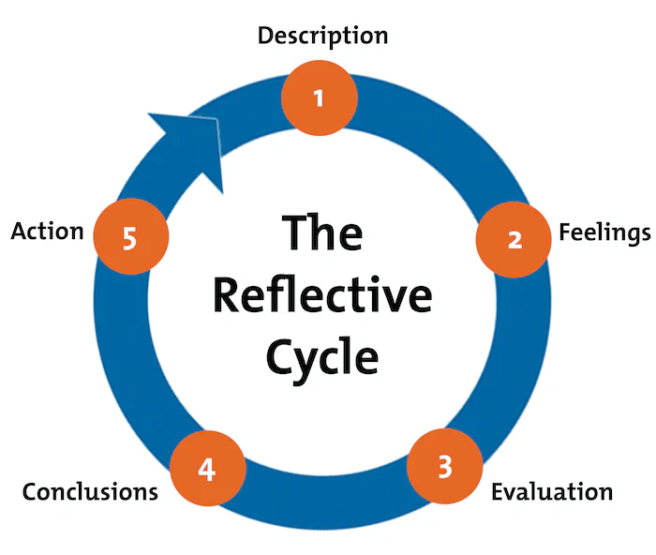
Figure No.1- Gibbs’ Reflective Cycle
(Source: Yaacob et al., 2021)
Description of the experience: I had to work with a group of people who were my colleagues on a project where we had to prepare a presentation. I was the leader of the team and decided the overall process that we need to take to develop a good presentation. I decided on the company of the presentation on which the team will be working which was, British Airways. I delegated different tasks to each of the members and I performed the task of allocating all the information gained by other colleagues. There were some of the members of the team who could not perform accordingly because their research skills were weak. This is because of which our team could not manage the plans I made that needed to be followed to complete the presentation.
Feelings: During the preparation of the presentation I felt very good because I was the leader of the team and I got the opportunity of making plans and delegating tasks. The task of arranging the information was delegated to me and it helped me to gain presentation skills which I believe will help me in future. The best thing about working in a team was that every colleague was very cooperative and helpful to one another. This is because of which our team could work with more precision and were able to complete the task within the stipulated time frame.
Evaluation of the experience: While preparing the presentation the one thing that went well was the delegation of tasks to each member. Each colleague I was working with was proficient in what I delegated to carry on an activity. They cooperated throughout the process of preparing the presentation and also everyone helped one another to perform various tasks. However, there was also a thing that did not go well was that a colleague had lack of research skills. The colleague was assigned with gaining information on how theories related to leadership can be used in the chosen company. The colleague could not gain the factual information due to which other members could not complete their task on time. This was the reason our team could not complete the task on time and the plan did not go as it was articulated.
Analysis: The presentation my team was working on was to understand and gain knowledge on the behaviours of the team which enabled me and the other colleagues to work collaboratively. The steps and plans made to complete the presentation have allowed me and my team to gain valuable insights into how the modern workplace works. The assignment helped our team to also develop an overall understanding of the history and working process of British Airways within the tourism and hospitality industry. We as a team have been able to bring specific information about the topic of the assignment which has also enabled every member to learn and gain new skills and knowledge.
Conclusion: From the overall process my team and I took to complete the assignment has helped us complete the task within the stipulated time frame. I learned that my communication skill has been very helpful because of which I was able to lead the team in the right manner. Time management skill I will consider another strength which has allowed me to manage my time to complete my role in a team efficiently. The other members' cooperation has also played an active role in leading us on the right path and working according to the plans. However, there are certain skills that I need to improve so that if in the future certain situation arises again where a team member fails to understand their task I can help them effectively. The skills such as research skills, active listening and problem-solving can help to work actively and eliminate issues while working in a team.
Action plan: In completing the presentation, our team faced issues in researching authentic and reliable information for the topic. Therefore, to eliminate the issues of inadequate information development and the creation of confusion among team members I will be focusing on certain skills in the following ways-
Specific | Measurable | Achievable | Relevance | Time-frame
Research Skill | I will measure my research skill by assessing my knowledge of different types of research such as primary, qualitative or quantitative and so on. | To improve my research skills, I will be looking into different sources and then I will verify information gathered from various sources. Most importantly I will take advantage of library sources and library websites for research guides. | It will help me to locate appropriate information and thereby I will be able to evaluate certain data to develop evidence and relevance of the topic (Ruzycki and Ahmed, 2022). | 3 Months
Active Listening | I will measure my active listening skills by understanding if I can make open-ended questions to other people and if I am paying attention to their body language. | Active listening means paying attention to implicit and explicit information, therefore, I will be focusing on other individuals' intent and purpose in making claims on certain things. I will therefore learn to make open-ended questions so that I can make conclusions. | Through this skill, I will be able to understand and trust other members’ situations and feelings. Thus I will be empowered to support others to achieve the common goal (Jones et al., 2019). | 4 Months
Problem Solving | To measure my problem-solving skills, I will be measuring my ability to perform certain hypothetical situations and asking questions to understand how I will be acting in the situation. | I will develop my problem-solving skills by identifying the problems and determining the root cause that led to certain circumstances. I will mainly focus on the ways I can act in certain situations so that I can understand how certain issues can be solved from different perspectives. | I will be able to prioritise a task with more focus which will also enable me to manage time intelligently. Thus, with the improvement in problem-solving skills, I will be able to work under pressure (Treffinger et al., 2023). | 6 months
Table No.1- Smart Objectives
(Source: Created by the learner)

Conclusion
Thus after analysing my performance in completing the presentation assignment, I can therefore conclude that improving my problem-solving, listening and research skills can allow me to enhance my knowledge and understanding to work within a team. Thus, I will ensure that within 6 months I can enhance the mentioned skills.

Reference
Adeani, I.S., Febriani, R.B. and Syafryadin, S., (2020). Using GIBBS’reflective cycle in making reflections of literary analysis. Indonesian EFL Journal, 6(2), pp.139-148.
Jones, S.M., Bodie, G.D. and Hughes, S.D., (2019). The impact of mindfulness on empathy, active listening, and perceived provisions of emotional support. Communication Research, 46(6), pp.838-865.
Ruzycki, S.M. and Ahmed, S.B., (2022). Equity, diversity and inclusion are foundational research skills. Nature Human Behaviour, 6(7), pp.910-912.
Treffinger, D.J., Isaksen, S.G. and Stead-Dorval, K.B., (2023). Creative problem solving: An introduction. Routledge.
Yaacob, A., Mohd Asraf, R., Hussain, R.M.R. and Ismail, S.N., (2021). Empowering Learners' Reflective Thinking through Collaborative Reflective Learning. International Journal of Instruction, 14(1), pp.709-726.

