Digital Era
Ben Hughes

Contents page

Section 1 – Introduction P3

Section 2 - 500 words summary on the topic of essential skills and employment P4

Section 3 – Mind map of unit linkages. P5

Section 4 – All the AI units are completed.
4.1 - unit 0 notes P6/7
4.2 - unit 0 replies P7
4.3 - unit 1 notes P7/8/9/10/11/12
4.4 - unit 1 replies P12/13
4.5 - unit 2 notes P13/14/15
4.6 - unit 2 replies P15
4.7 - unit 3 notes P16/17/18/19/20/21
4.8 - unit 3 replies P21
4.9 - unit 4 notes P21/22/23/24/25/26
5 – unit 4 replies. P27

Section 6 – Completion of AI units P28/29

Section 7 – Conclusion P31

Section 8 – Reference list P31/32

Section 1
Introduction: Learning in the Digital Era
The digital era is a broad concept encompassing the entire domain of digital technologies, including the internet, computers, and communication networks, which have become deeply integrated into all aspects of modern life
This assignment explores the concept of learning in the digital age. It will examine five key units:
- Preparing for Higher Education
- Becoming a Digital Learner
- Becoming a Team Player
- Virtual Collaboration
- Becoming a Lifelong Learner
To support the analysis, mind maps will be used to compare and summarize the content of each unit. The primary focus of this assignment is to highlight the significance of digital learning in today's world and to explain why acquiring digital skills is essential for personal and professional development.

Section 2
Summary:
Success in both academic and employment relies heavily on the development of essential skills. There are core abilities that allow individuals to perform effectively across a range of tasks. One of the most essential skills is communication, effective verbal and written communication is important as it allows individuals to get their ideas out and share their information accurately and it can allow them to build strong relationships within the employment environment. (university of east, Anglia, n.d.) Another essential skill for study and employment is problem solving and critical thinking, students and employees who can work things out quickly and analyze complex situations make good judgments and come up with effective solutions are more often than not the best students and employees, developing these skills will help during employment and study work.

Another essential skill for study and employment could be teamwork, teamwork is a vital skill to have in life and working effectively with others requires cooperation, respect and adaptability, which will then allow them to improve as a team and reach goals more accurately and together as a team, being able to function as a team not only improves workplace productivity but also supports the development of leadership qualities.(NFER, 2024). in today's digitals era, a common essential skill required for study and employment is digital literacy this is a very important skill, employers expect graduates to use technology confidently from managing spreadsheets and databases to analyzing performance and statistics, being confident with digital literacy is also very important for study and students. Another important essential skill for study and employment is time management and organization enables individuals to meet deadlines and prioritize tasks that need to be done soon, it also helps maintain balance between responsibilities, students must manage their time effectively because they will need to hand in coursework etc. on time and employees will need to manage time effectively as they must meet performance targets and organization is essential for this. (Cottrell, 2019).

Also, another essential skill could be self-management and resilience. These skills are also important as these skills provide you with self-motivation continuously improving and dealing with any failures or setbacks. Failures and setbacks happen to everyone so having the skill to be resilient is essential because it allows you to keep on working to achieve the goals for example within study it could be getting a good grade and within employment it could be reaching a specific set goal that has been set. (clarke,2018) Lastly, an essential skill for employment and study is professionalism and a positive attitude, these skills are essential towards success by having these skills it will make life a lot easier and enjoyable within the employment era and study era.

Section 3
Mind map
The interconnected nature of these units is illustrated through the use of arrows, which demonstratess how each component builds upon the others. Together, they contribute to the development of one's identity, learning approach, interpersonal skills, and adaptability within the digital era.

Unit 0 notes – 4.1
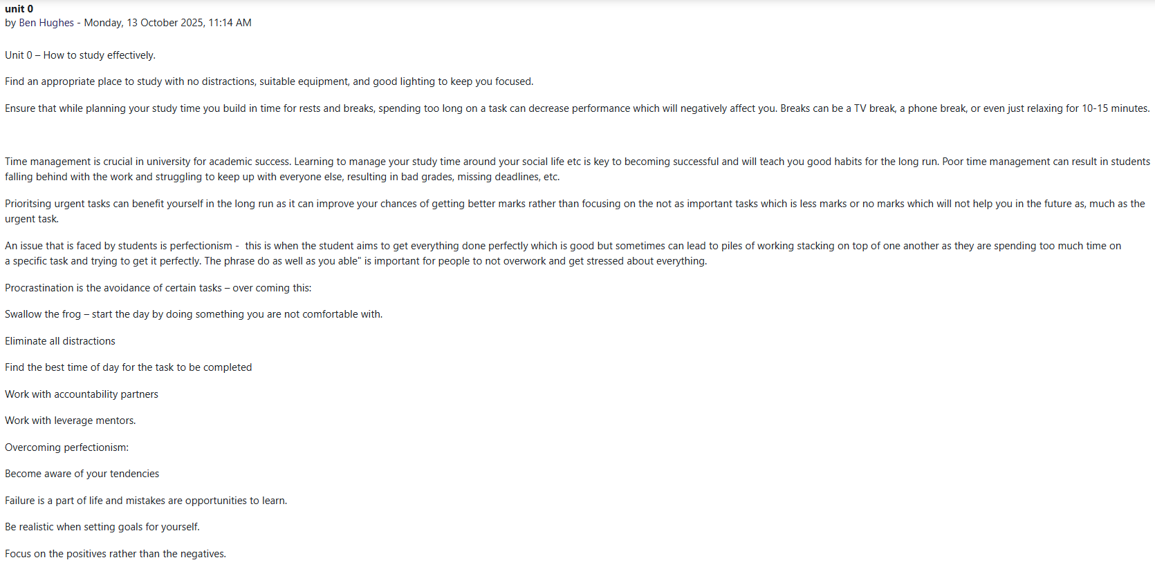
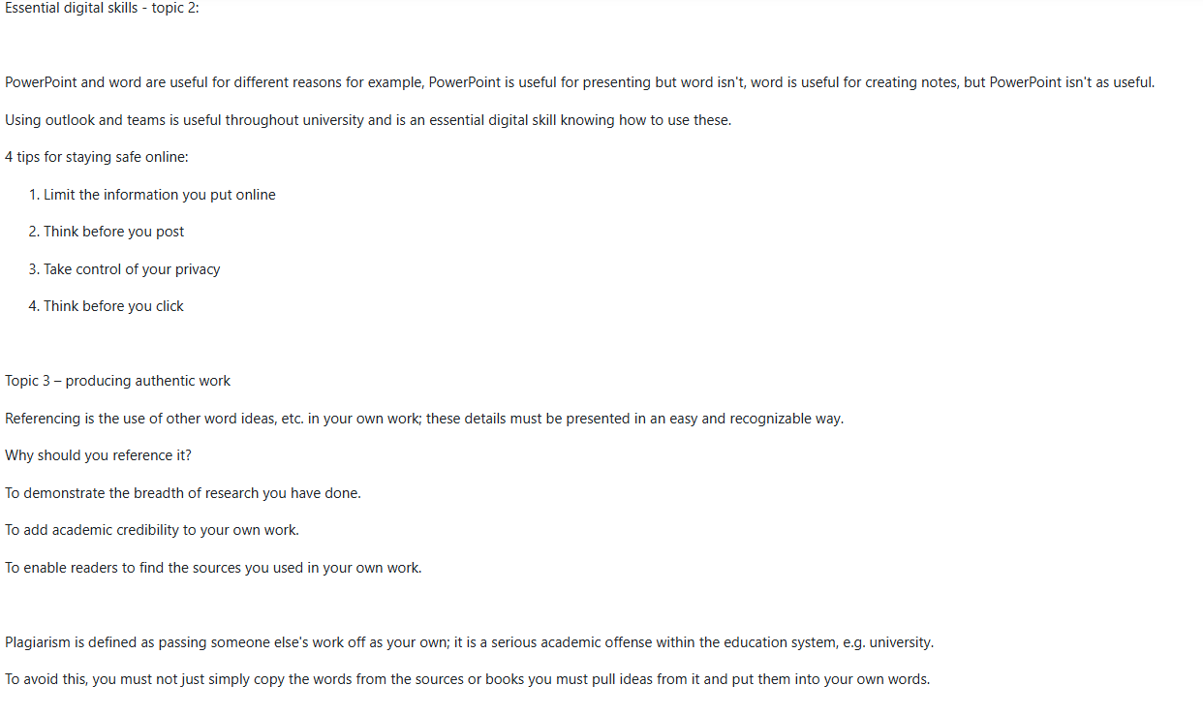

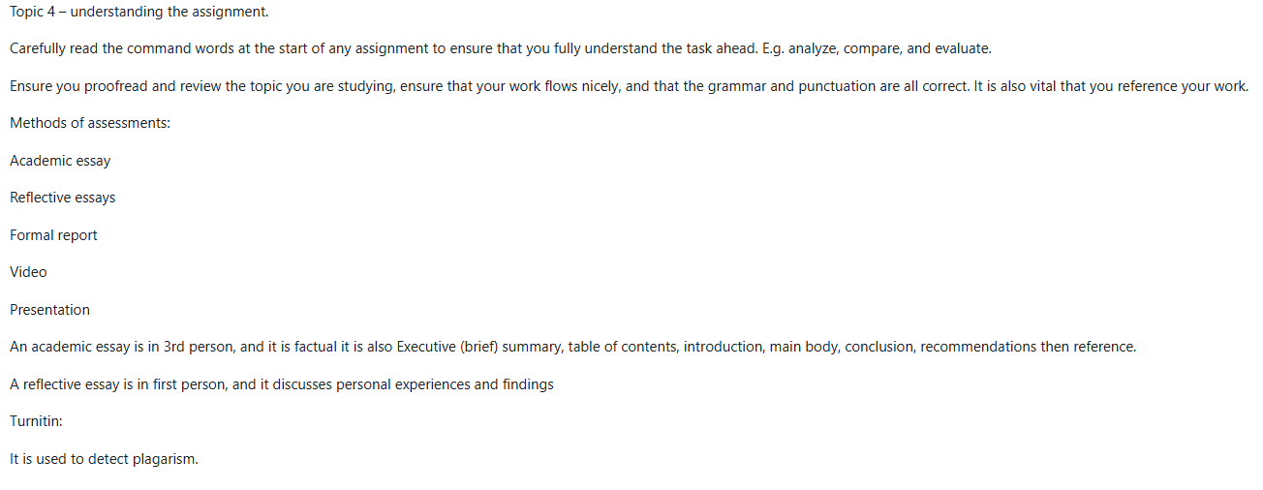

Unit 0 replies – 4.2
Unit 1 – notes – 4.3

Unit 1 – replies 4.4
Unit 2 – notes 4.5
Unit 2 – replies 4.6
Unit 3 – notes 4.7

Unit 3 – replies 4.8
Unit 4 – notes 4.9
Unit 4 – replies 5.0

Section 6 – Completion of the AI units.

Section 7 – Conclusion
Following extensive research across the five units, I have gained a deeper understanding of the multifaceted skills required to thrive in the digital era. These include, but are not limited to, teamwork, time management, and resilience. I have also recognized the importance of developing confidence in using digital tools and platforms, as digital competence is increasingly essential in both academic and professional contexts. Mahmud, M.M. & Wong, S.F. (2022). States that being up to date with the digital era is vital.
Furthermore, this assignment has highlighted the seriousness of plagiarism and the potential consequences associated with it. However, through the course of these units, I have learned various strategies and acquired practical skills to help avoid plagiarism and maintain academic integrity.

Section 8 – Reference list.
NFER. (2024). Teamwork is essential. [Online]. National Foundation for Educational Research. Last Updated: 23 July 2024. Available at: https://www.uea.ac.uk/uea-life/student-support/employability-skills-for-students [Accessed 11 November 2025].

University of East Anglia (n.d.) Employability Skills for Students. [Online] Available at: https://www.uea.ac.uk/uea-life/student-support/employability-skills-for-students (Accessed: 10 November 2025

Cotrell. (2019). 50 ways to manage time. [Online]. . Last Updated: 25 April 2019. Available at: https://blackwells.co.uk/bookshop/product/50-Ways-to-Manage-Time-Effectively-by-Stella-Cottrell/9781 [Accessed 10 November 2025].

Clarke. (2018). Rethinking graduate employability: The role of capital, individual attributes, and context. [Online]. Studies in Higher Education. Available at: https://doi.org/10.1080/03075079.2017.1294152 [Accessed 11 November 2025].

Adobe for education. (2021). how to create a video with adobe creative. [Online]. adobe creative. Available at: https://www.youtube.com/watch?v=alFd-9Z-fnU [Accessed 11 November 2025].

Mahmud, M.M. & Wong, S.F. (2022). The importance of 21st century skills among the undergraduates. [Online]. Frontiers in Education. Available at: https://www.frontiersin.org/journals/education/articles/10.3389/feduc.2022.950553/full [Accessed 11 November 2025].

Havard university. (2000). essay structure. [Online]. Essay structure. Available at: https://writing center.fas.havard.edu/pages/essay-structure [Accessed 11 November 2025].
Cambridge dictionary. (2022). Definition of fake news. [Online]. Cambridge dictionary. Last Updated: 23 May 2022. Available at: https://dictionary.cambridge.org/dictionary/english/fake-news [Accessed 11 November 2025].

oxford lexico. (2022). definition of misinformation. [Online]. Lexico. Available at: https://www.lexico.com/definition/misinformation [Accessed 11 November 2025].

